SUPPLEMENTARY MATERIAL

Captions:
Table S1: Assay results for the determination of the studied drugs in pure form by the proposed and comparison methods
Figure S1: FT-IR spectra of CQDts.
Figure S2: Typical TEM image of CQDts.
Figure. S3: 2³ FFD half normal plots and Pareto charts plots of the effects on the chromatographic responses at alpha=0.05 for a- Lercanidipine b- Nimodipine c- Nifedipine.
Figure. S4: 2³ FFD interaction plots and main effect plots for chromatographic responses by data means type a- Lercanidipine b- Nimodipine c- Nifedipine.

Figure. S5: Stern-Volmer plots (at different temperature settings) for a- Lercanidipine

b- Nifedipine

Table S1: Assay results for the determination of the studied drugs in pure form by the proposed and comparison methods
Compound | Proposed Method |  |  | Comparison methods [5,11,25]
Compound | Amount taken  (µg/mL) | Amount found  (µg/mL) | % Found | % Found
Lercanidipine | 0.5 | 0.507 | 101.72 | 99.20
Lercanidipine | 3 | 2.944 | 98.05 | 100.82
Lercanidipine | 7 | 7.048 | 99.61 | 99.73
Lercanidipine | 10 | 9.998 | 101.69
Lercanidipine | 15 | 15.043 | 99.74
Lercanidipine | 20 | 19.959 | 99.90
Mean | 100.12 |  |  | 99.92
± S.D. | 1.40 |  |  | 0.83
t-test | 0.16 (2.37)
F-test | 1.72 (19.3)
Nimodipine | 0.5 | 0.499 | 99.78 | 100.54
Nimodipine | 3 | 3.000 | 100.02 | 99.47
Nimodipine | 5 | 4.991 | 99.82 | 100.18
Nimodipine | 10 | 9.994 | 99.94
Nimodipine | 17 | 17.069 | 100.40
Nimodipine | 20 | 19.947 | 99.73
Mean | 99.95 |  |  | 100.06
± S.D. | 0.25 |  |  | 0.54
t-test | 0.29 (2.37)
F-test | 4.67 (5.79)
Nifedipine | 0.5 | 0.5024 | 100.48 | 100.79
Nifedipine | 3 | 2.9612 | 98.71 | 99.22
Nifedipine | 7 | 6.9803 | 99.72 | 100.26
Nifedipine | 10 | 10.0538 | 100.54
Nifedipine | 15 | 15.0660 | 100.44
Nifedipine | 20 | 19.9362 | 99.68
Mean | 99.93 |  |  | 100.09
± S.D. | 0.71 |  |  | 0.80
t-test | 0.28 (2.37)
F-test | 1.27 (5.79)
N.B. *Mean of three determinations.
ª The values between parentheses are the tabulated t and F values at P = 0.05[43].
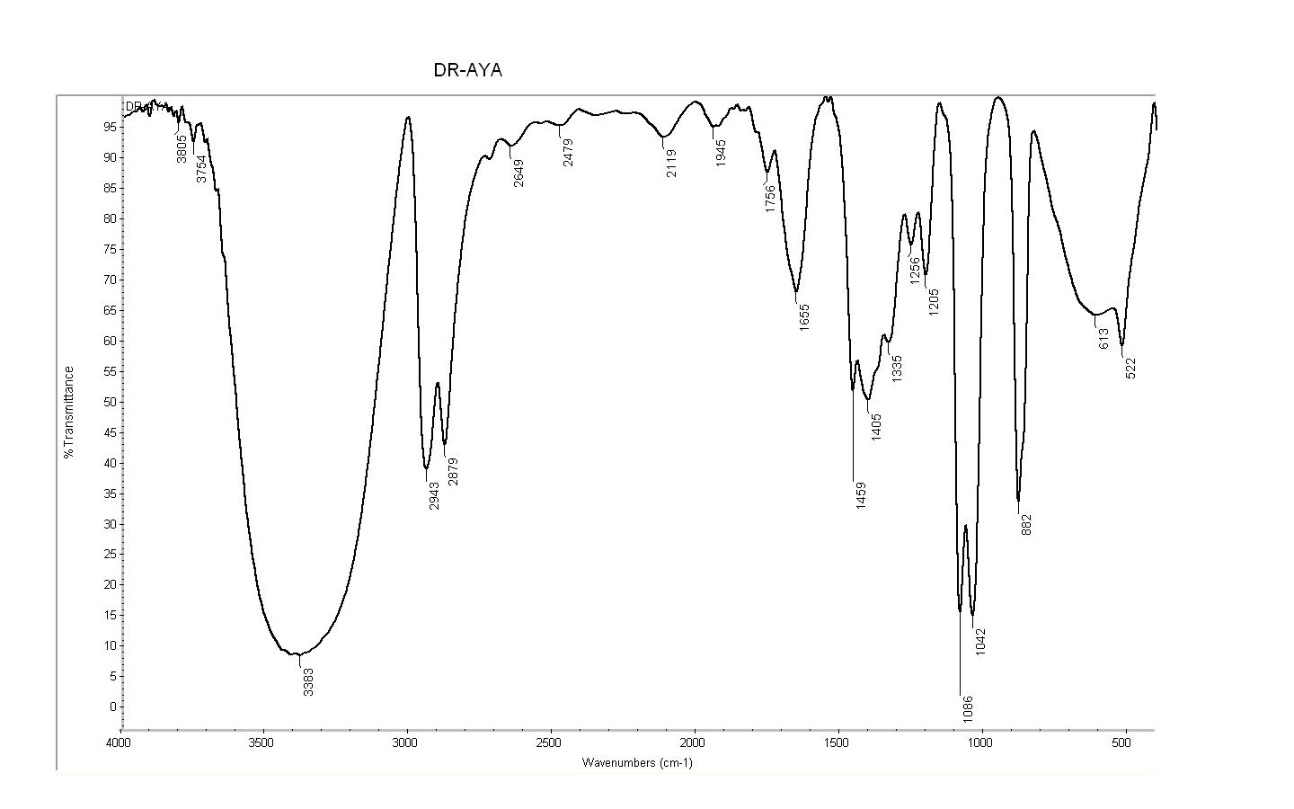
Figure S1: FT-IR spectra of CQDts.

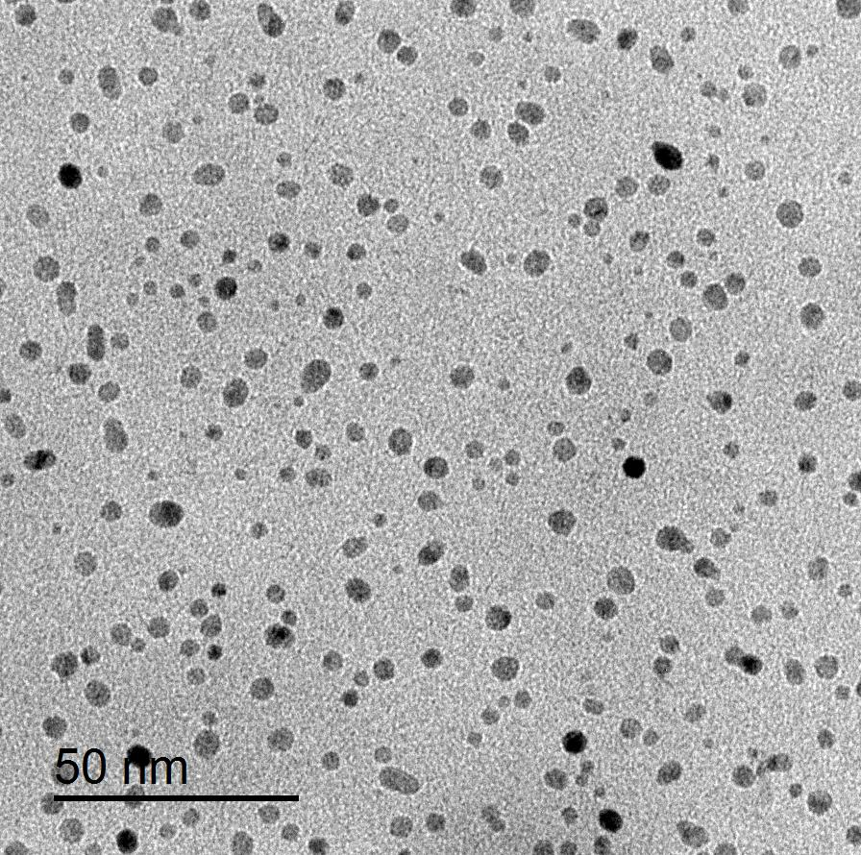

Figure S2: Typical TEM image of C CQDts.

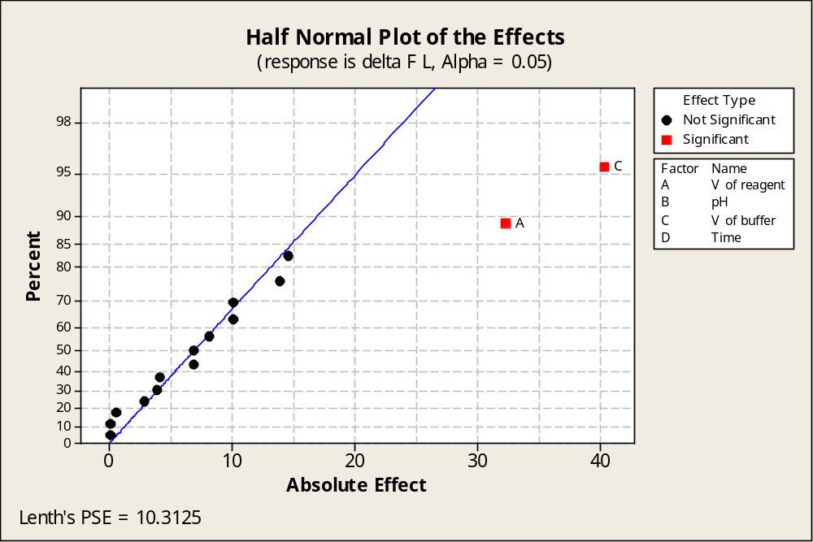
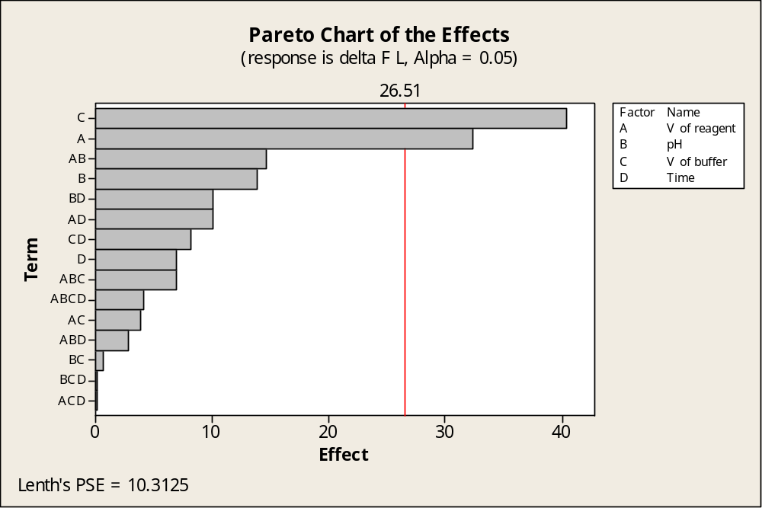
Figure. (S3-a): 2³ FFD half normal plots and Pareto charts plots of the effects on the chromatographic responses at alpha=0.05 for Lercanidipine
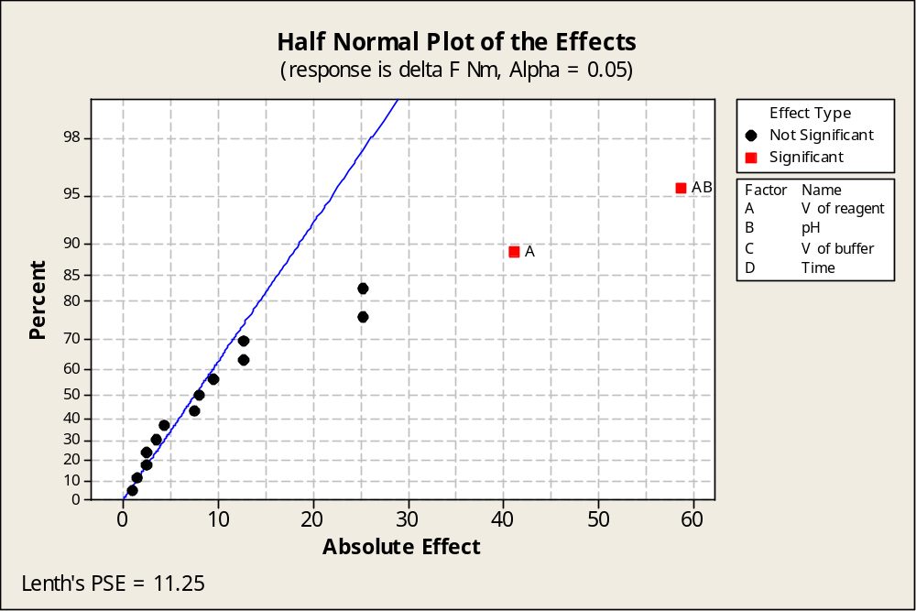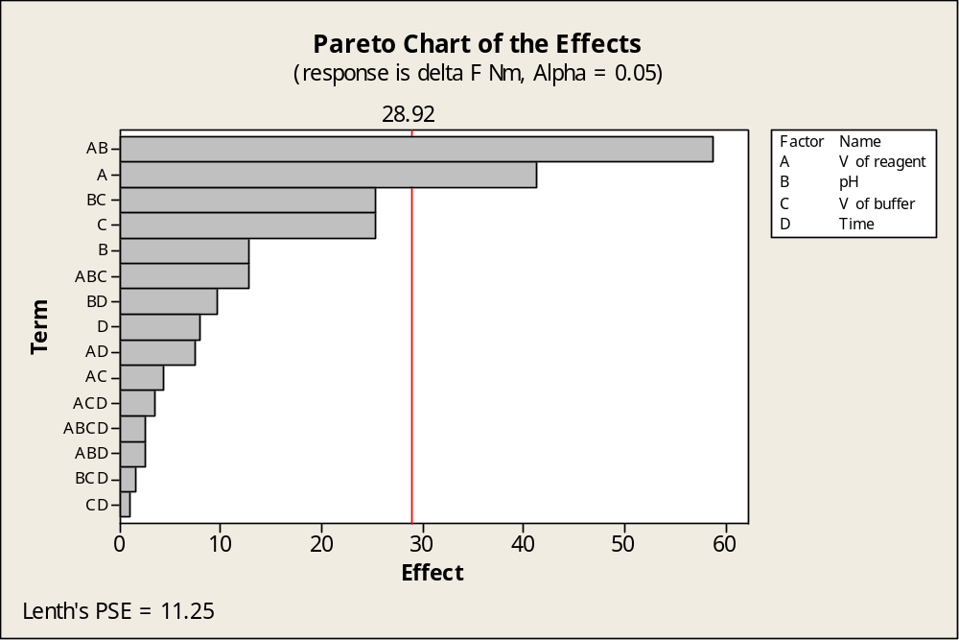
Figure. (3S-b): 2³ FFD half normal plots and Pareto charts plots of the effects on the chromatographic responses at alpha=0.05 for Nimodipine
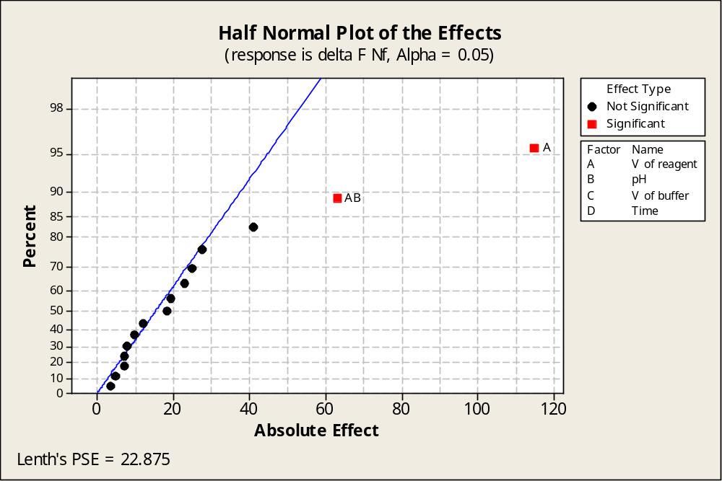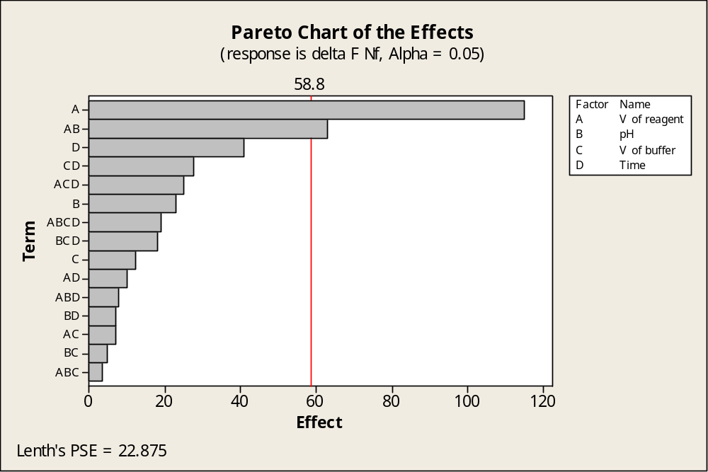
Figure. (S3-c): 2³ FFD half normal plots and Pareto charts plots of the effects on the chromatographic responses at alpha=0.05 for Nifedipine
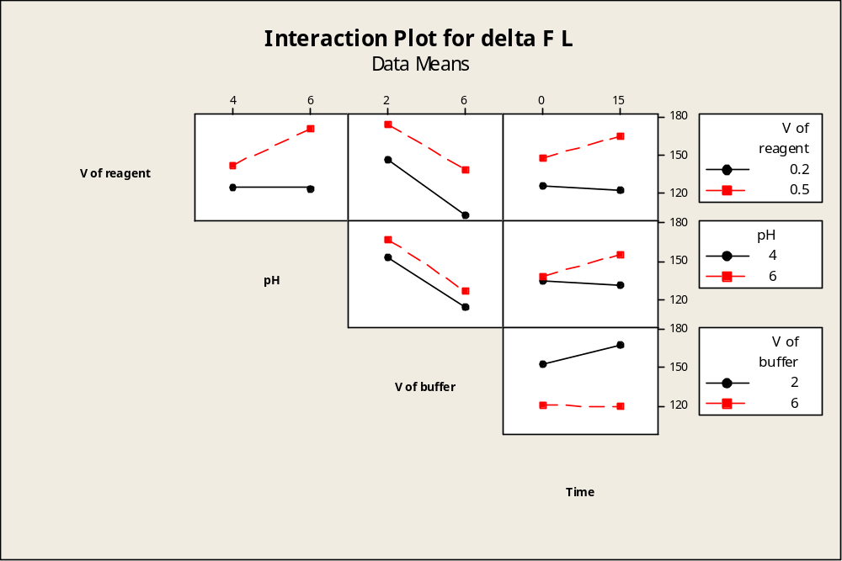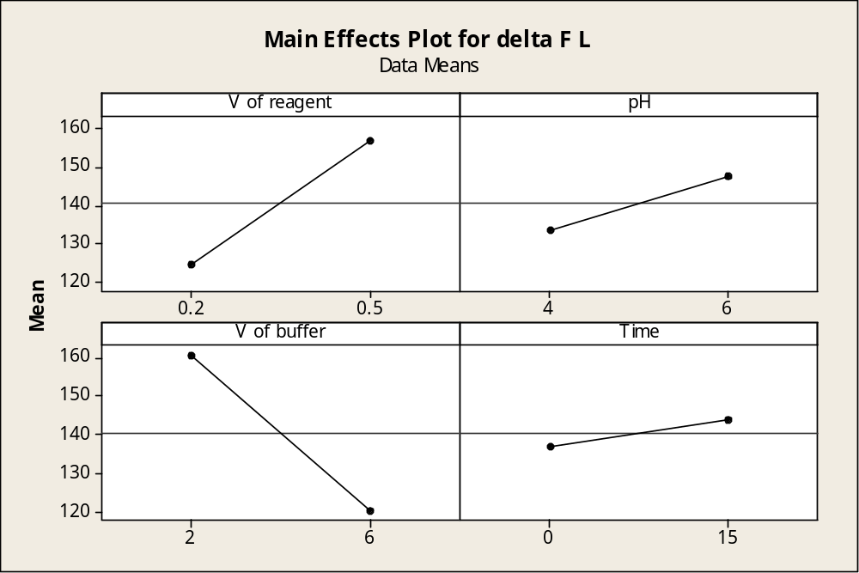
Figure. (S4-a): 2³ FFD interaction plots and main effect plots for chromatographic responses by data means type for Lercanidipine.
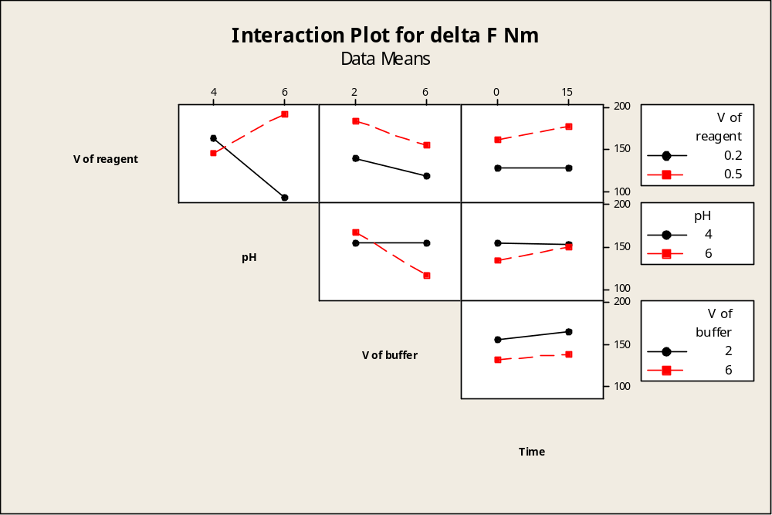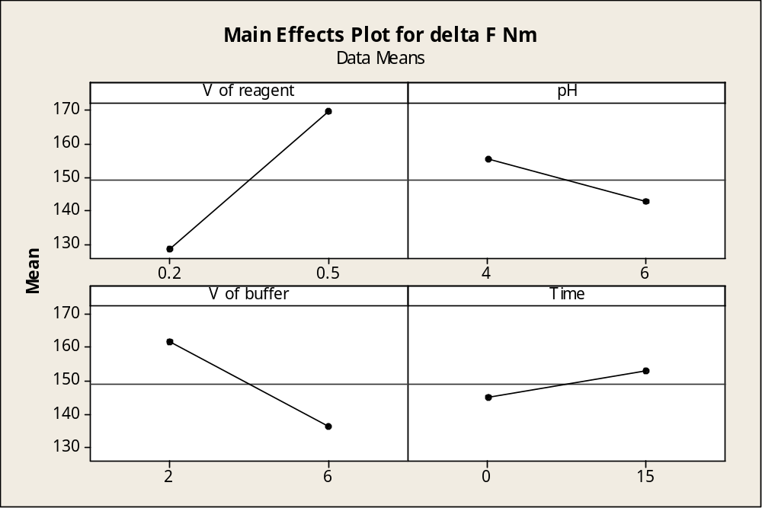
Figure. (S4-b): 2³ FFD interaction plots and main effect plots for chromatographic responses by data means type for Nimodipine.
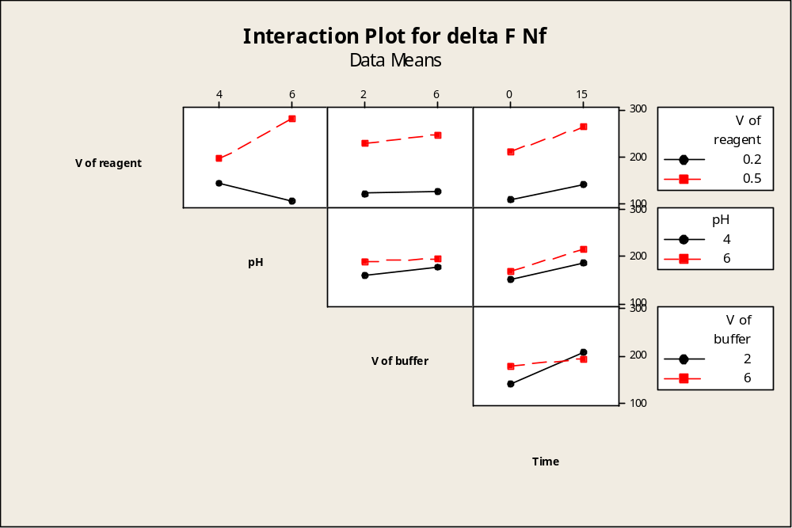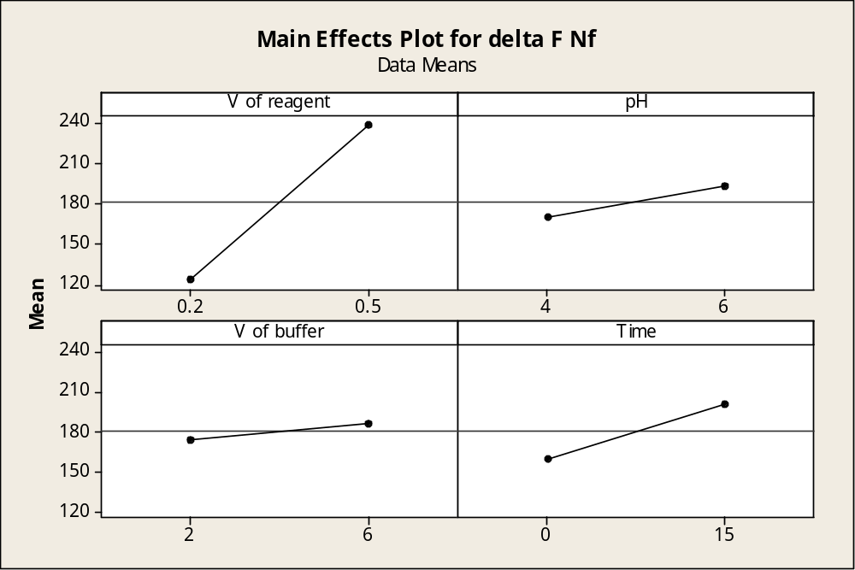
Figure. (S4-c): 2³ FFD interaction plots and main effect plots for chromatographic responses by data means type for Nifedipine.

Figure. (S5-a): Stern-Volmer plots (at different temperature settings) for Lercanidipine

Figure. (S5-b): Stern-Volmer plots (at different temperature settings) for Nifedipine

