Supplementary Information

Supplementary Notes
- Comparison between an ASIC with free running on-chip oscillator and a clock frequency divider approach
Wireless remotely powered microsensors need a system clock to run their microelectronic circuits, particularly the digital finite state machine (FSM) which handles data encoding, packetization, and timing control. One widely accepted approach for the generation of a clock in an RFID microchip is an on-chip oscillator [1], the simplest version of which generates a free-running clock constructed mainly by inverters. The singular advantage of this on-chip oscillator is its small current consumption. In our current implementation on TSMC 65 nm mixed-signal/RF low-power CMOS foundry process, the current consumption was approximately 6 μA drawn assuming a regulated 0.8 V supply voltage as in the circuit simulation of Supplementary Fig. 1b. However, for an unregulated voltage supply, voltage increases with incoming RF power and can lead to a significant rise in current consumption and clock frequency of the oscillator (Supplementary Fig. 1b-c). Even with an on-chip voltage regulator, such as the prototype ASIC that we built, there was noticeable variation in clock frequencies across chips as illustrated in Supplementary Fig. 10, due to on-chip power level and process variance. Additional instabilities in the oscillator circuit and environmental factors added to the variance up to ± 1,000 ppm (clock drift). Therefore, while an on-chip oscillator offers a compact and low-power path to the autonomous generation of a system clock in an RF microsensor chip, clock variance and drift cause an increase in the computational burden and system latency of the demodulation whereby the use of an on-chip oscillator may be most useful for small networks of sensors.
On the other hand, there are some examples of deriving timing signals directly from the baseband carrier (Tx) using a frequency divider [2-5]. In our case, we took the baseband frequency as 915 MHz and simulated a 5-stage true single-phase clock (tspc) frequency divider to generate a 28.59 MHz system clock (Supplementary Fig. 1a). For a regulated voltage supply of 0.8 V, the dividers and buffer consume approximately 4 µA. However, the operation of dividers and buffers is restricted to a narrow range (compared to an unregulated case; see Supplementary Fig. 1c) since the residual DC component in the input signal increases proportional to the Tx power and results in the saturation of the input buffer. Therefore, in this preliminary study, we used an unregulated voltage supply leading to a nominal current consumption of up to 14 μA by the clock divider. Our design is not optimized, however, and more sophisticated RF circuit configurations using a regulated voltage supply could achieve lower current consumption as well as a wider range of harvested RF power.
In sum, using frequency dividers typically increases the system current consumption when compared to an on-chip oscillator circuit. In a tradeoff, the tags benefit from negligible clock variance and become nearly independent of the energy harvesting efficiency. For demodulation, we need only a single set of matched filters (3 phases) to decode sensor data (within a finite timeslot estimated from the fixed clock frequency) which has the benefit of accelerating the computational process significantly. For comparison, the multiple matched filter method using 31 filter sets to compensate for clock drift (chips with the on-board freely running oscillator) took up to 16 seconds per node to demodulate a 1-second-long data packet (511-bit Gold code) when using a single GPU (NVIDIA GeForce RTX 3090). In the case of the clock frequency divider approach, the computation consumed a mere 12 ms whereas most of the actual signal processing time was consumed during data preparation and peak detection. Supplementary Fig. 12c summarizes the dependence of the demodulation time on the length of the Gold code. We note that, for wearable or portable applications, the process can be further accelerated by adding parallel processing elements such as in a field programmable gate array (FPGA) to achieve practical real-time on-the-field use of the ASBIT protocol.
- The network capacity of the ASBIT RFID network
To estimate the ideal network capacity for the proposed ASBIT RFID network in the simplified limit of equal backscattered amplitude $S$ from all nodes (i.e. ignoring the near-far problem), the SNR can be defined as follows, accounting for interference among all nodes [6-8]

$SNR=S/{[\left(N-1\right)×S+ η]}$ (1)

where N is the number of nodes in the network and $η$ is the background noise from spurious interference plus thermal noise within the total spread bandwidth $W$. The ratio of energy per bit to noise power spectral density (${E_{b}}/{N_{0}}$) can be expressed as

${E_{b}}/{N_{0}}=\frac{W/R}{\left(N-1\right)+{(η}/{S)}}$ (2)

while $R$ denotes the bit data rate before spreading. Then, the network capacity in terms of the number of supported nodes becomes
$N=1+\frac{W/R}{{E_{b}}/{N_{0}}}-\frac{η}{S}$ (3)

Here, $W/R$ is generally referred to as the CDMA processing gain, $L_{c}$. Given that $W≈1/{T_{c}}$ ($T_{c}$ is the chip duration, the chip defined as each bit in the Gold code) for a given predefined bit rate $R$, this equation implies that the maximum allowable number of nodes increases as the chip duration becomes shorter and the Gold code gets longer, which demands wider bandwidth $W$. In our case, the bandwidth $W$ is limited to 20 MHz by the present ASIC constraints. Since the bit rate $R$ is inversely proportional to the length of the Gold code, $L_{c}$ and thus the network capacity is simply proportional to the length of the Gold code. Assuming an application acceptable event error rate (EER) of 10⁻³ for a path loss is 40 dB, and imposing a requirement for ${E_{b}}/{N_{0}}$ of 7 dB for 511-bit Gold code, we obtain that a single CDMA channel can accommodate 169 nodes in the ASBIT protocol with a thermal noise density of -174 dBm/Hz. However, under the assumption of sparsity in the ASBIT scheme with only some 5% of band utilization per node, the network capacity of the ASBIT protocol for the case of a 511-bit Gold code is estimated to be 3,380 nodes. In this ideal limit, one has ignored the impact of e.g. clock variance across nodes, clock drift at each node, and the amplitude variance (near-far problem) which reduce the actual limits the network capacity. However, in the extensive simulations carried out in this paper, we have explicitly included the non-ideal factors in assessing the practical network capacity of the ASBIT protocol.

- Defining signal-to-noise ratio in an RF microsensor network
An unambiguous definition of signal-to-noise (SNR) for a distributed microsensor network requires that one defines specific conditions at hand. The main variable is the distribution of backscattered amplitudes across the sensor population at the receiver. In our simulation testbed, we first set a nominal amplitude to value 1 and allowed an amplitude distribution across nodes to vary from 1 to 2 uniformly - except for the simulations illustrated in Fig. 4e-f and Supplementary Fig. 12b. In the latter case, we included a range of near-far amplitude ratios, namely 1:2, 1:4, 1:6, and 1:10 to more fully assess the performance of the ASBIT protocol. Then, we added backscattered waveforms from multiple nodes assigning node-specific amplitude to simulate the collectively transmitted signal $Y\left(t\right)$ at the receiver. And, we further added a complex Additive White Gaussian Noise (AWGN) contribution $Y\left(t\right)$. This noise model simulates the contribution of electronic noise in the RF transceiver system and RF path loss. While adding Gaussian noise to the backscattered signals $Y\left(t\right)$ from multiple nodes, we first normalized the power of $Y\left(t\right)$ as a means to mimic the automatic gain control in the software-defined radio (SDR) at the transceiver hub. In so doing the operative SNR value for each chip was properly accounted for while it varied in each chip depending on its backscattering amplitude.

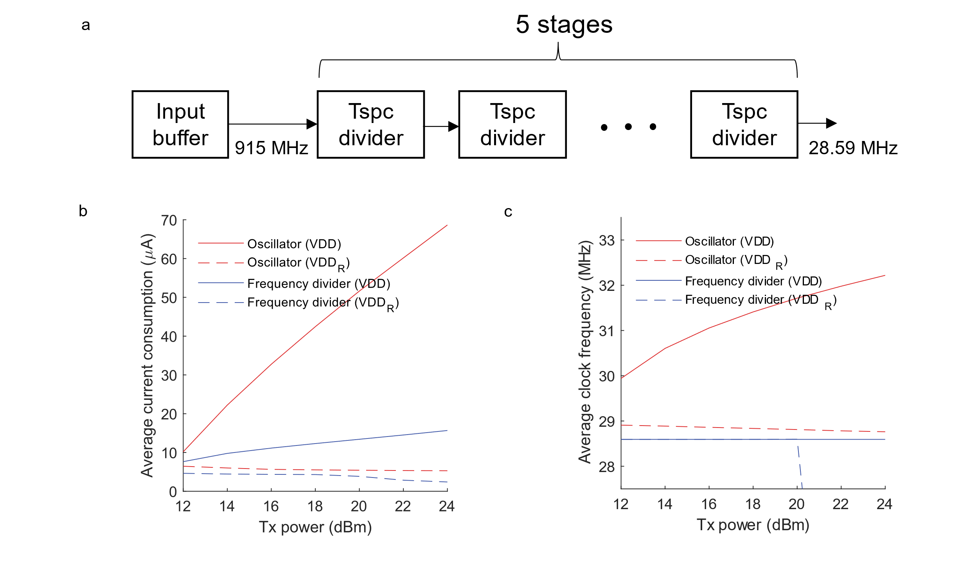
Supplementary Figure 1. a) Schematic of a 5-stage true-single-phase-clocking (tspc) frequency divider to down-convert incoming Tx carrier (at 915 MHz) to the system clock (at 28.59 MHz). b) Dependence on the Tx power of the current consumption by the 5-stage divider (including an input buffer) and that of the oscillator, respectively. Here we modeled wireless power transfer in a 2-coil system in electromagnetic calculations where the receiver coil has a size of 500 µm × 500 µm (coil design based on an HFSS simulation; Ansys tool). c) Variation of the average clock frequency in the oscillator and the 5-stage tspc frequency divider, respectively, as a function of Tx power. Abbreviation: VDD_{R}: regulated VDD.

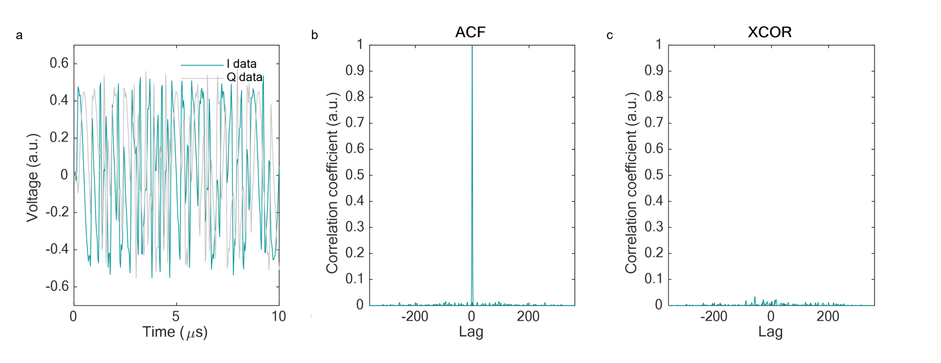
Supplementary Figure 2. A waveform example of a 127-bit Gold code sequence and associated correlation properties. a) Simulated transient IQ signal of Gold code (green: I data, gray: Q data). b) Auto-correlation (ACF) trace for a particular Gold code. c) Cross-correlation (XCOR) between two Gold code sequences. Note: the amplitudes of ACF and XCOR traces are normalized identically.

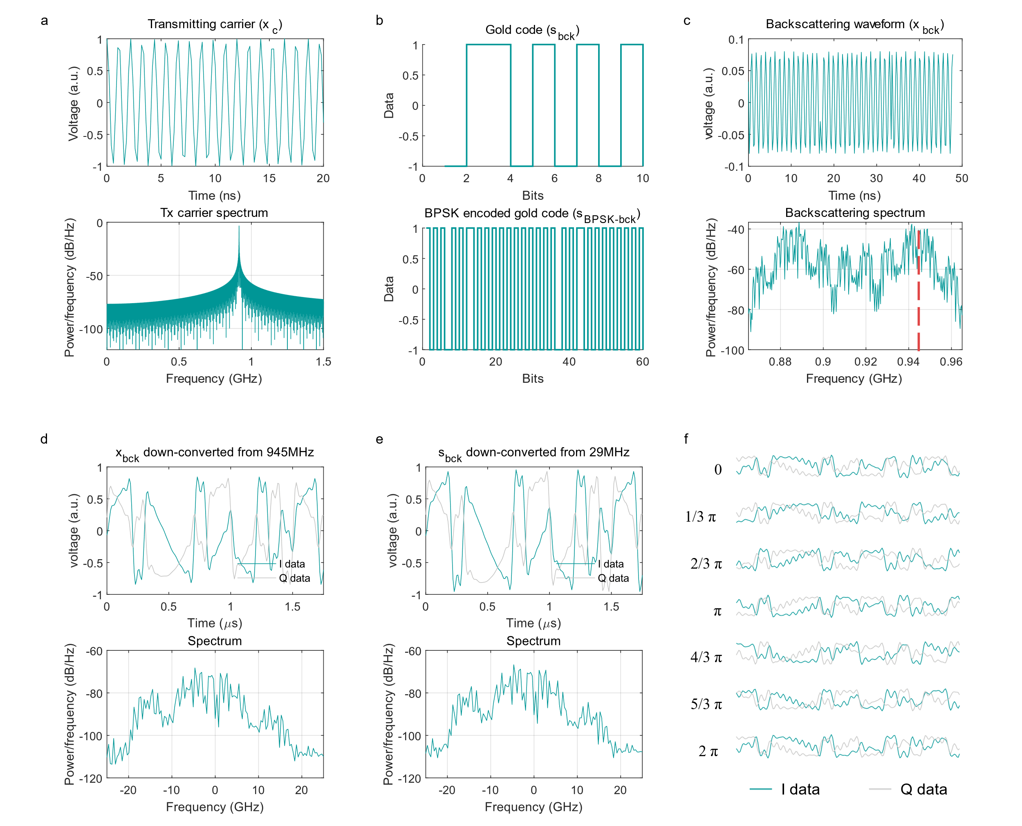
Supplementary Figure 3. A simulated RF waveform following equations (1)-(6) in Methods (“Modeling of backscattering signals from RF microsensors”). a) Transmitted 915 MHz carrier wave (x_{c}) in equation (1) (time resolution 200 ns) and its spectrum. b) Gold code sequence (s_{bck}) encoded by binary phase shift keying (BPSK) as the digital waveform s_{BPSK-bck}. c) Backscattered signals (x_{bck}) generated by modulating x_{c} by s_{BPSK-bck}, and the corresponding spectrum of x_{bck}. The red dotted vertical line shows the center of the target side band (946 MHz; i.e. 915 MHz + clock of the target node at 31 MHz); d) I and Q data of x_{bck} waveforms down-converted from 945 MHz to DC displaying a 1 MHz residual clock frequency, i.e. the particular node clock frequency subtracted by nominal clock frequency of 30 MHz; its spectrum reflecting the bandwidth of the bit sequence (10 Msps). e) Waveforms of I and Q data and the spectrum of them obtained by down-converting s_{bck} from 29 MHz with a residual clock frequency of 1 MHz. According to equation (5), x_{bck} waveforms down-converted from 945 MHz to DC should be equivalent to that of s_{bck} down-converted from 29 MHz to DC. f) Examples of phase dependent I and Q data waveforms with the residual clock of 3 MHz, which shows that the waveform determined by the phase delay and the sampling phase (See Methods for the detailed description).
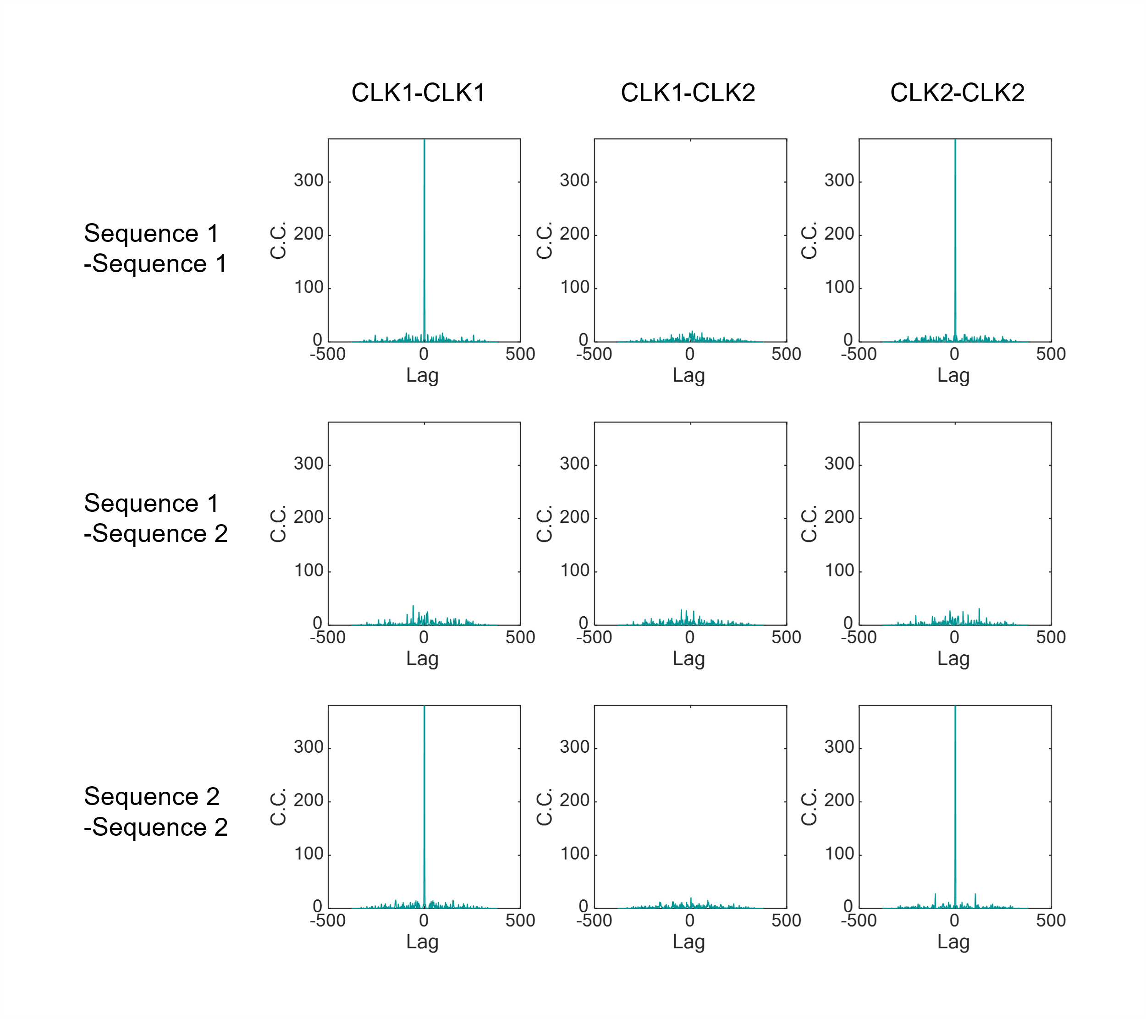
Supplementary Figure 4. Correlation coefficient (C.C.) between Gold code waveforms for two types of bit sequences and clock frequencies. Plots in the four corner panels of the figure show autocorrelation of four possible target waveforms; and the other panels show the corresponding cross-correlations. Note how each sensor node generates its distinct waveform based on a Gold code sequence and a residual clock frequency. In the plots, CLK1 is taken as 30 MHz, CLK2 as 30.1 MHz; the Gold code is 127-bit long.

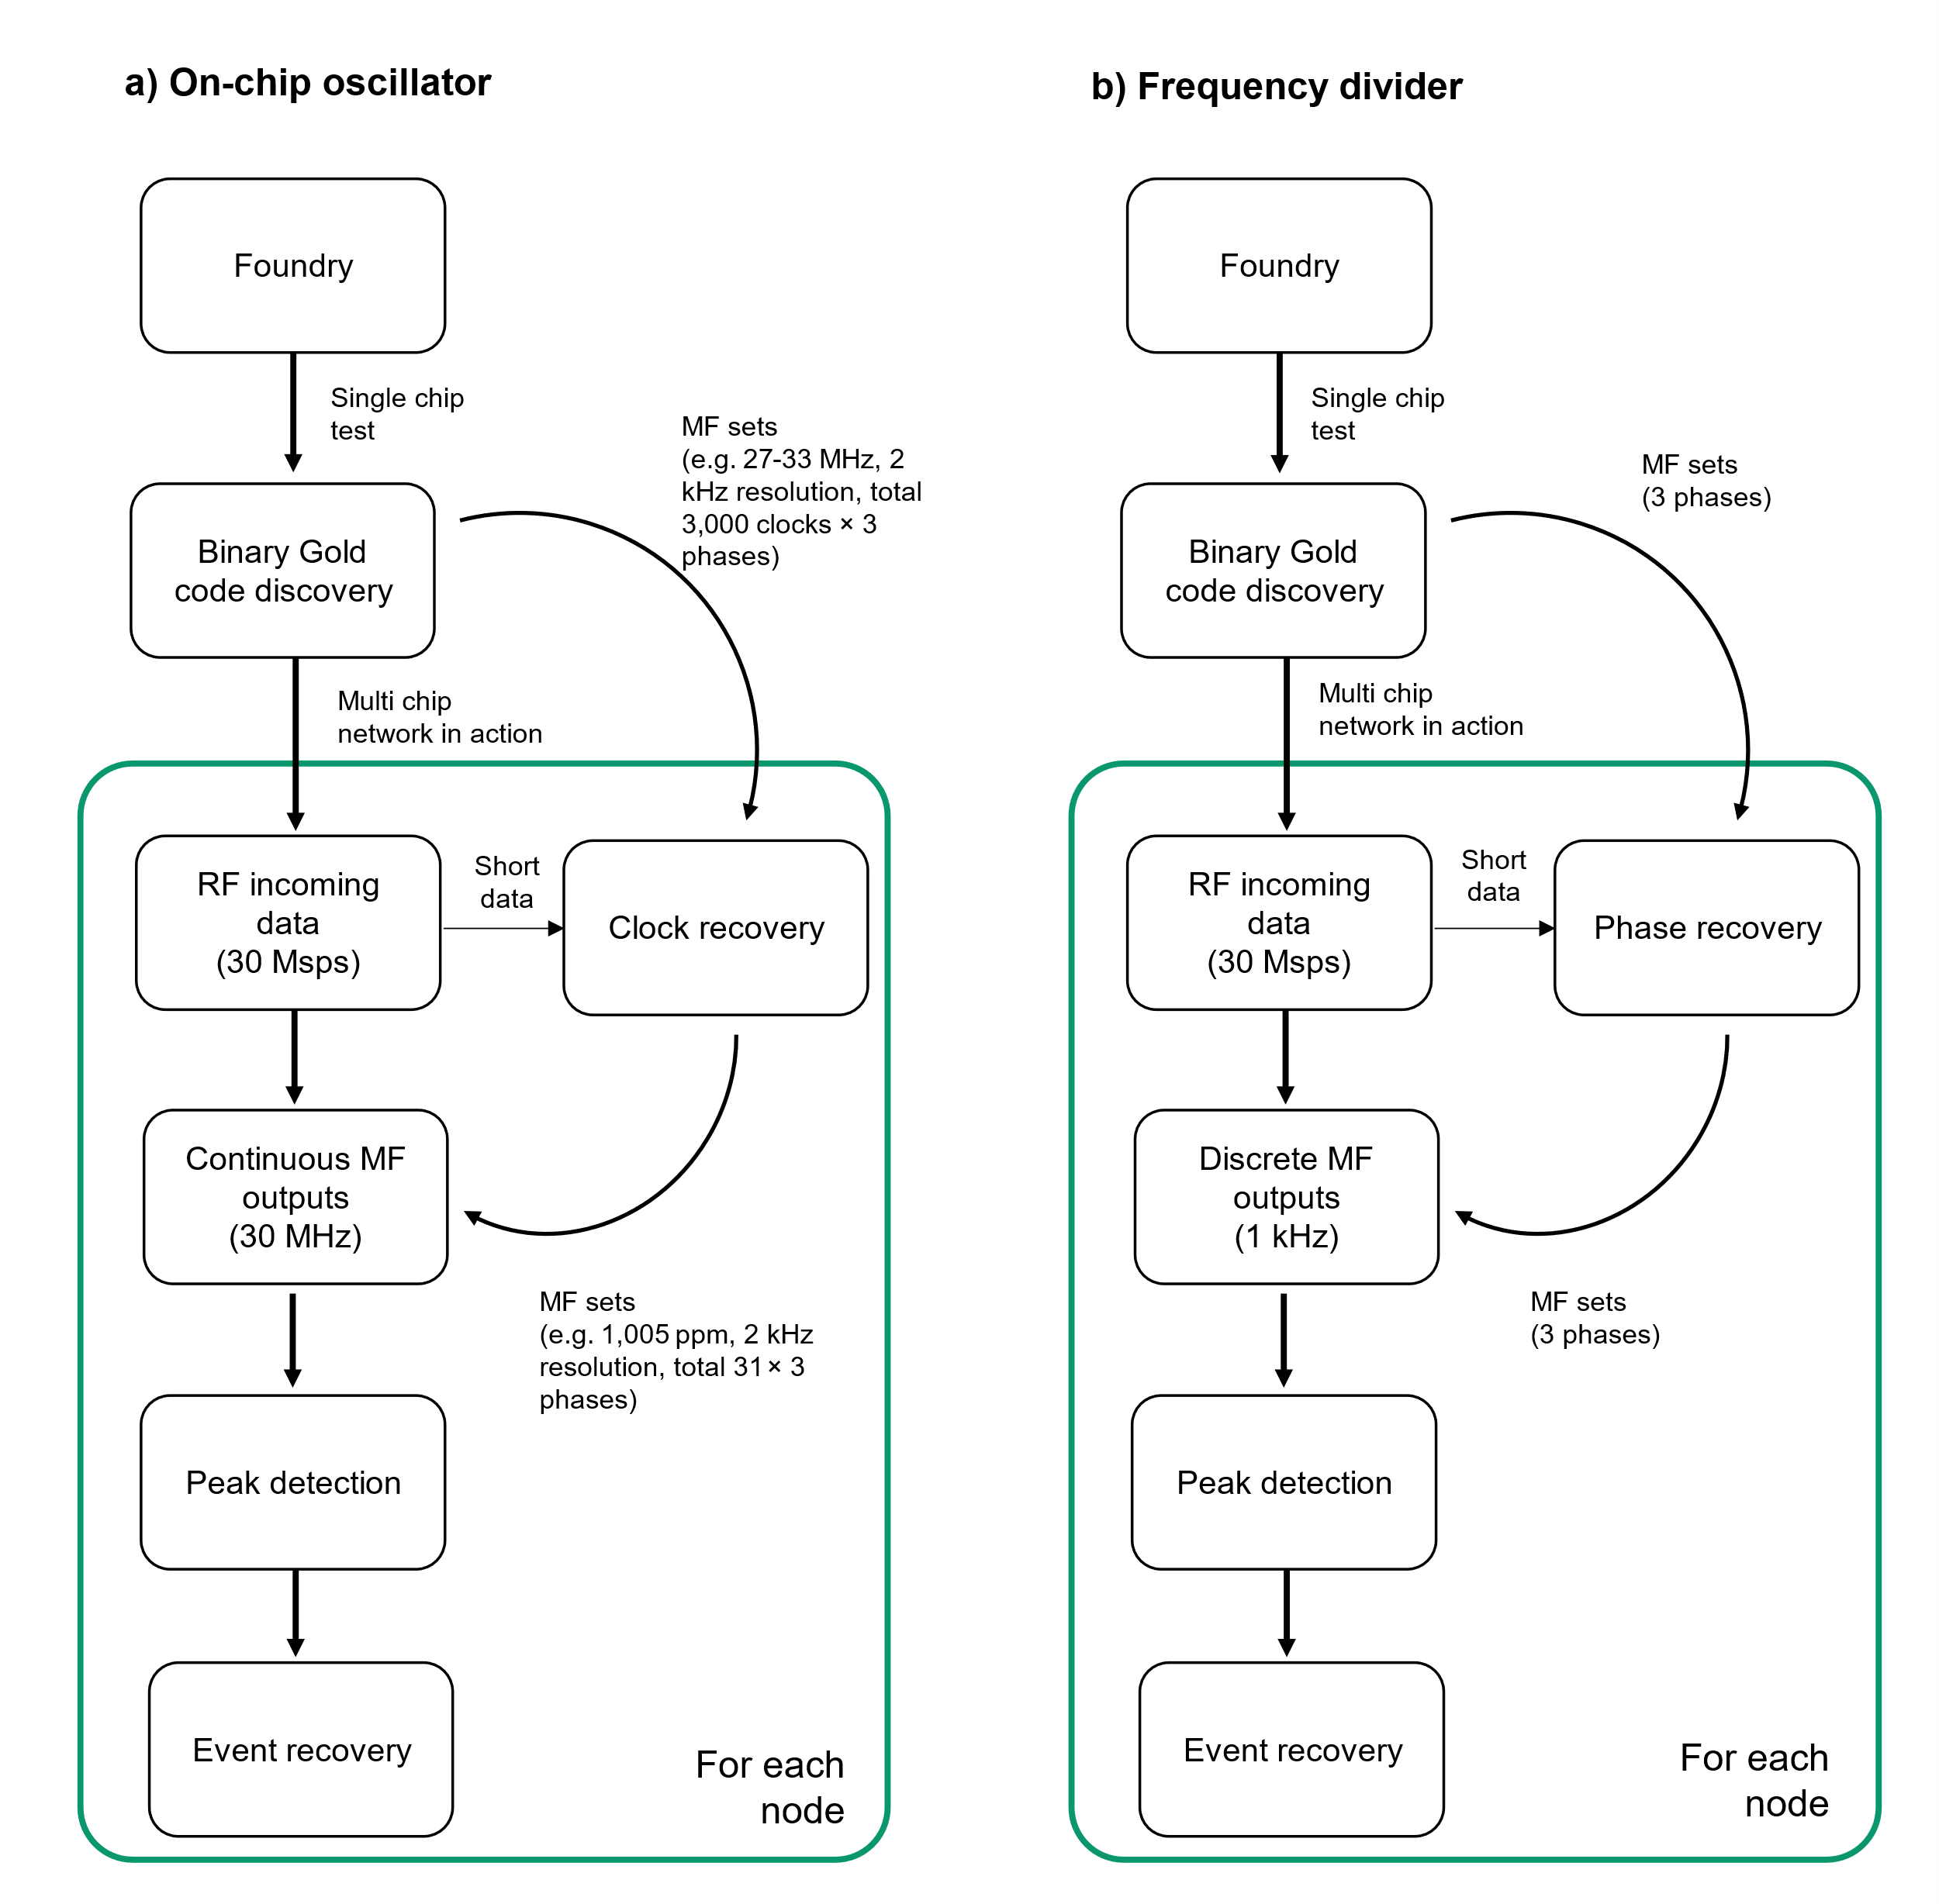
Supplementary Figure 5. Flow chart of the event recovery process, i.e. demodulation for ensembles of RF microsensors encoded according to the ASBIT protocol with a) free running oscillator for the on-chip system clock or b) baseband carrier derived frequency divider for clock generation. Abbreviation: MF: matched filter.

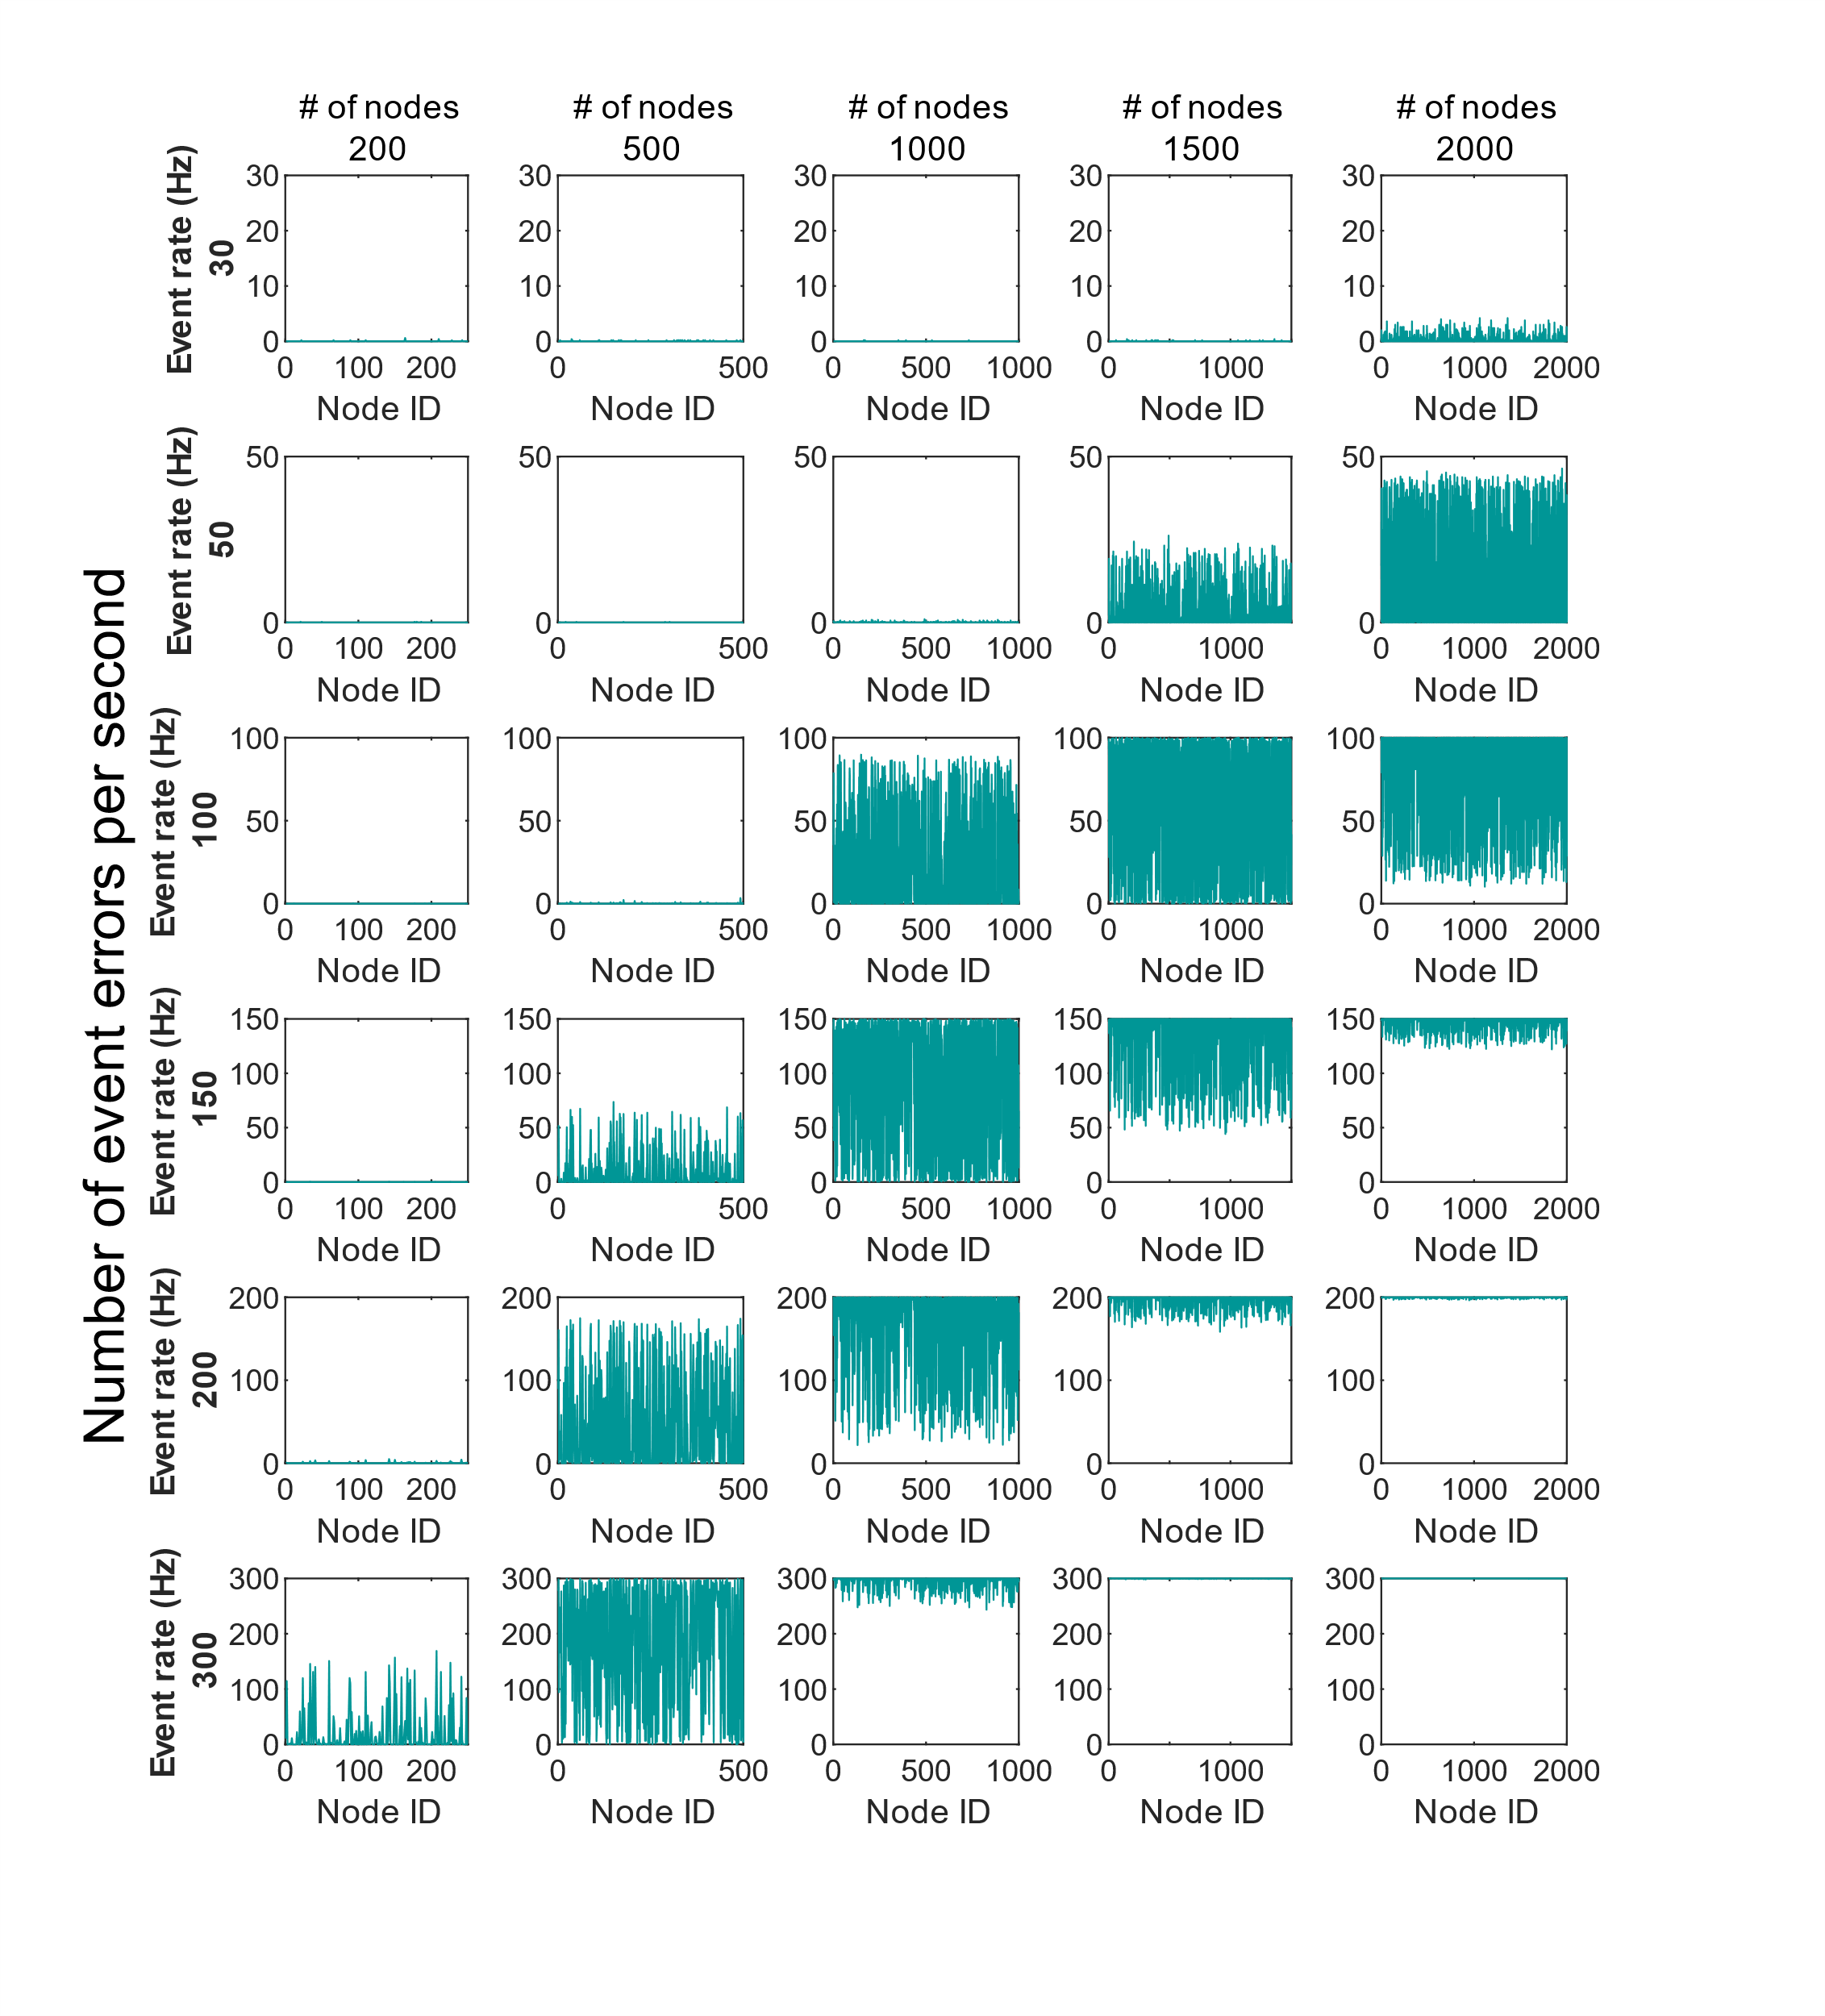
Supplementary Figure 6. Illustrating the network capacity of the ASBIT protocol: The number of event errors per second for each sensor node depending on the event rate and the total number of nodes in the network where a bit “one”, defines an event, per second expressed as the event rate for each node. (Here for an SNR of 3.23 dB, simulation duration of 5 seconds).

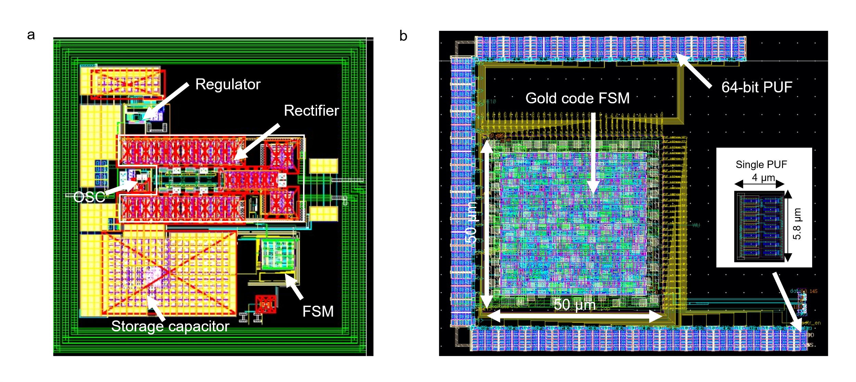
Supplementary Figure 7. a) Layout of a wireless prototype RF microchip. The power harvesting rectifier and storage capacitor occupy the most of circuit area while the size of the finite state machine (FSM) is a mere fraction of the total. b) The size of FSM generating the Gold code occupying 50 µm × 50 µm, and the layout of the physically unclonable function (PUF) circuit with a unit size of 4 µm × 5.8 µm. The PUF provides a random number unique to each microchip to seed the synthesis of its unique Gold code. While larger 64-bit PUF was used in this chip for other identification purposes, only 11 bits of the PUF were used to seed sequence for a 2,047-bit Gold code.

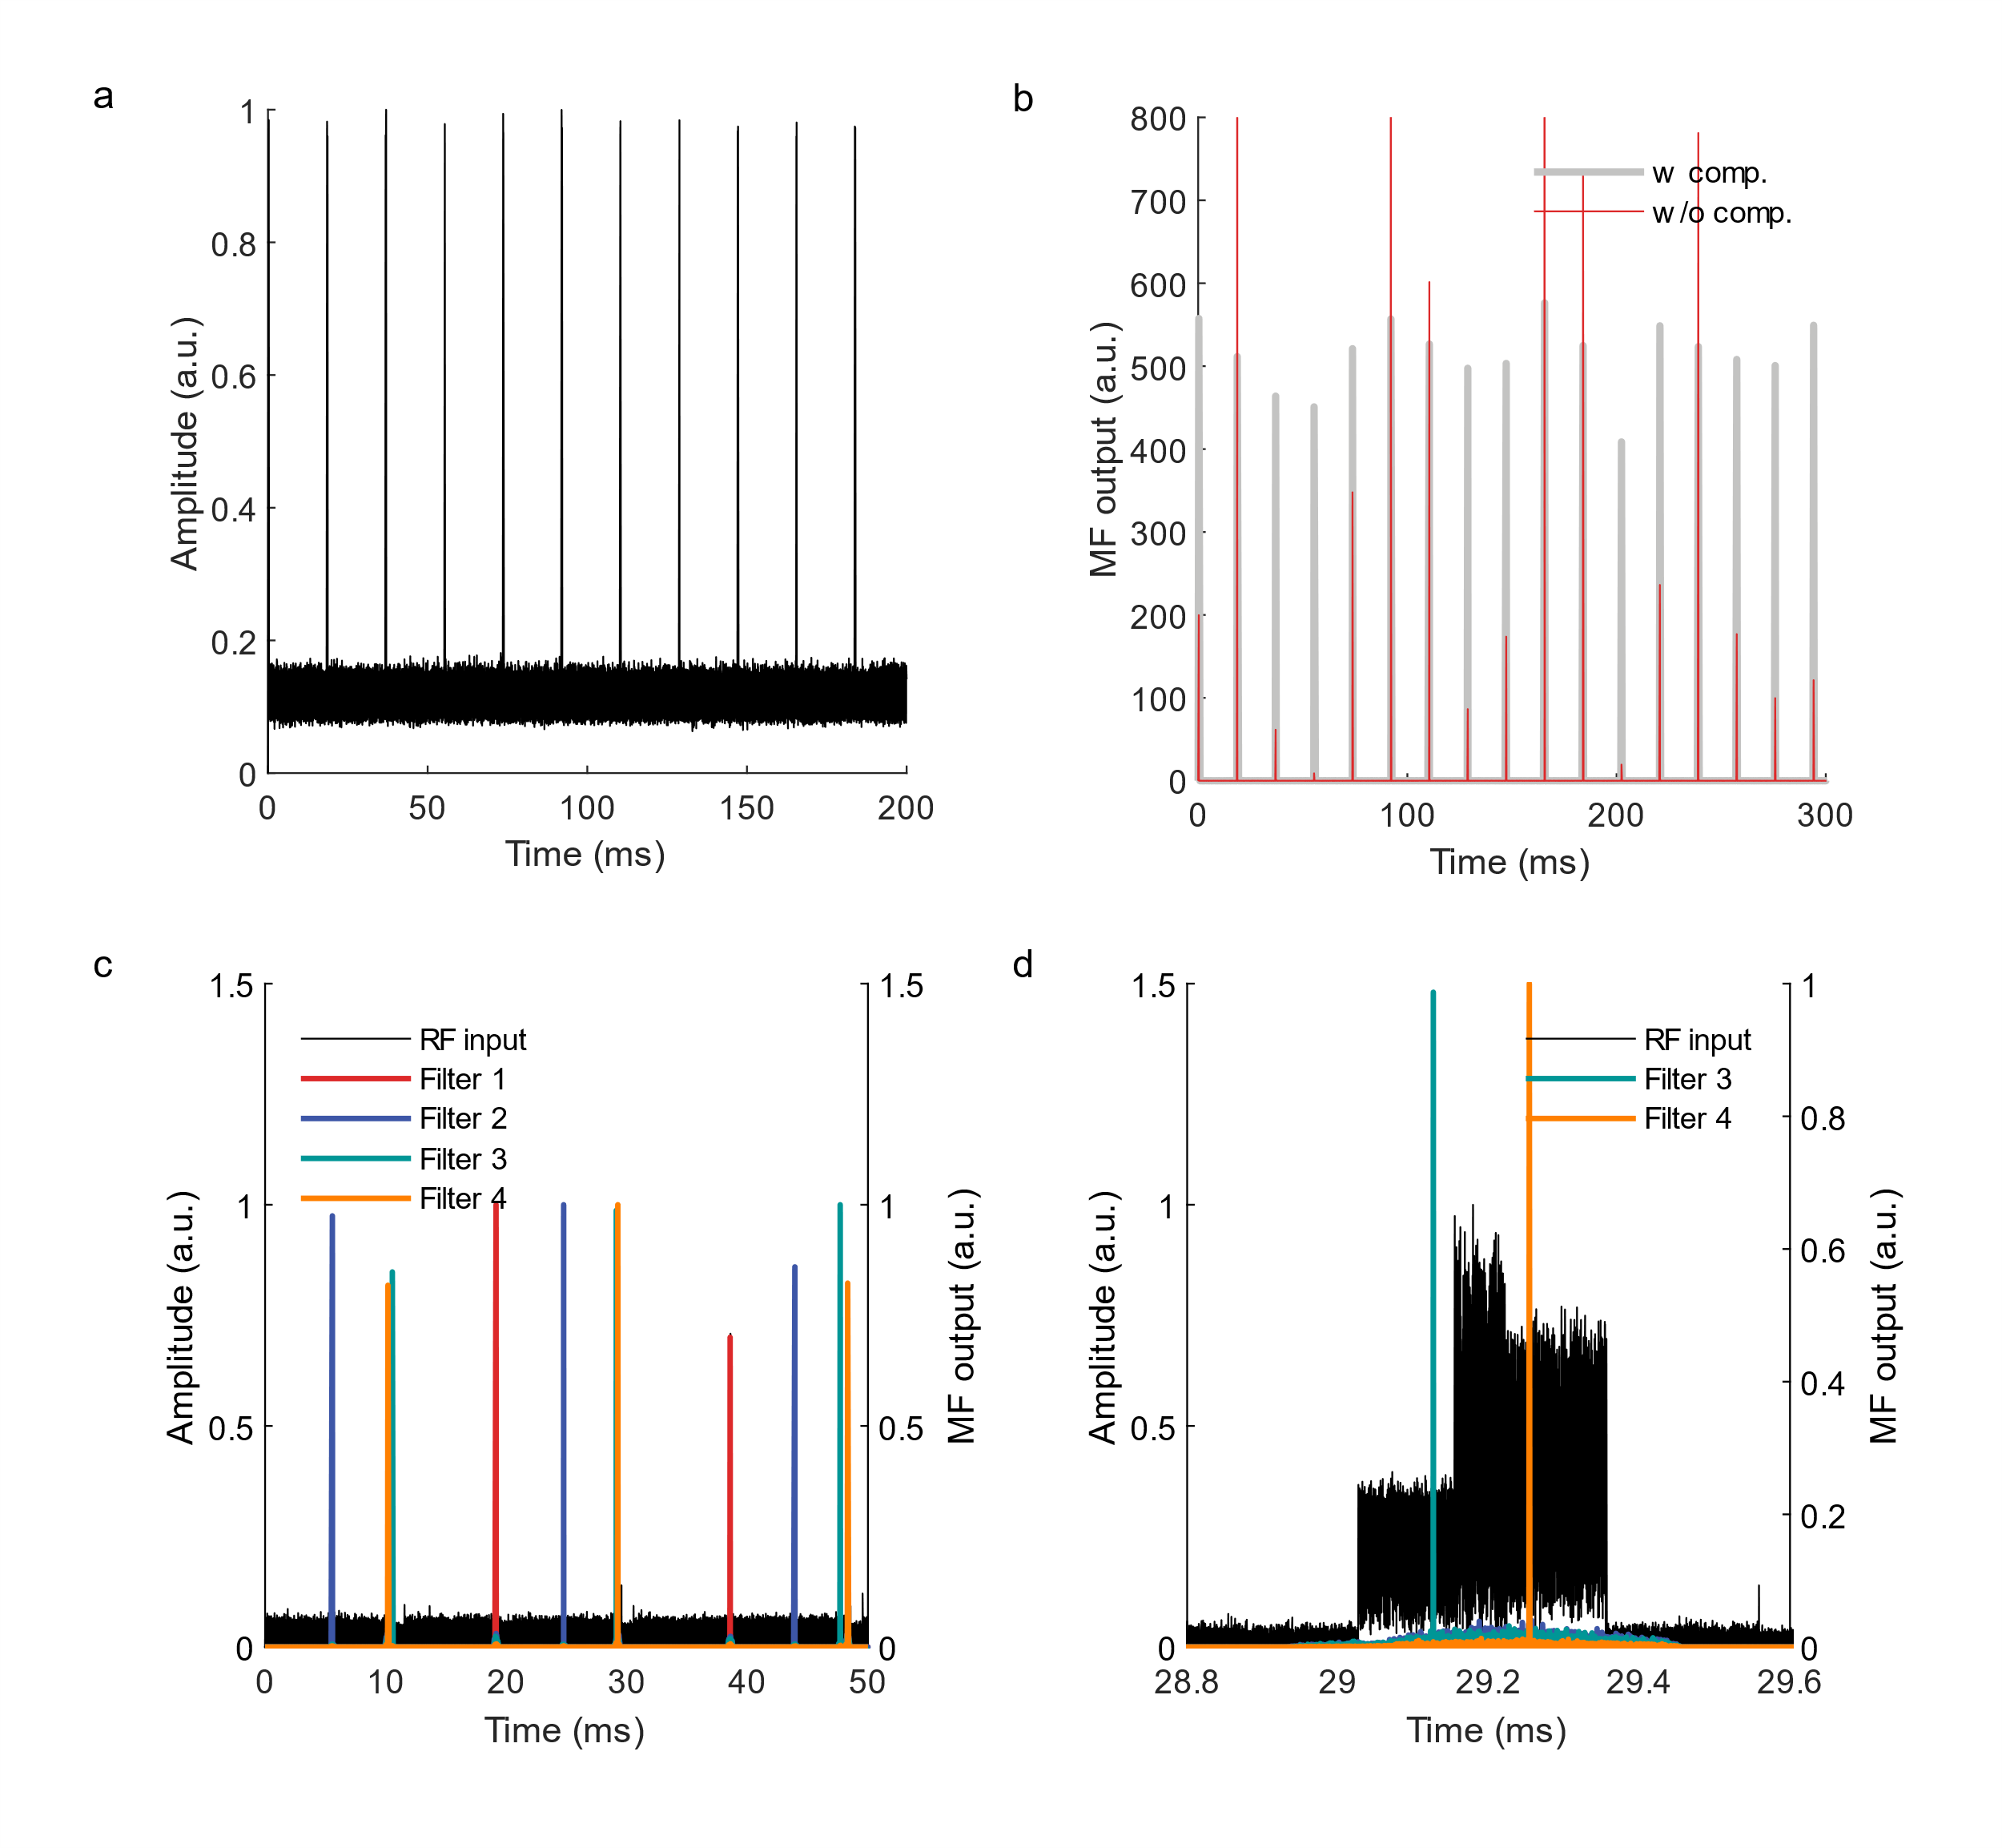
Supplementary Figure 8. a) Transient plots of the RF amplitude received from a single chip showing a series of backscattered events at 20 msec intervals. Each chip backscattered a unique 2,047-bit Gold code through binary phase shift keying (BPSK) modulation. b) Transient matched filters (MF) outputs from only a single matched filter or multiple sets of matched filters for the clock drift compensation. c) Backscattered data from four wireless chips each with its Gold code sequences (“RF input”) and the matched filter output solved using four different sets of matched filters specifically calibrated for each chip. d) Outputs from matched filter sets for chip 3 (Filter 3) and matched filter sets for chip 4 (Filter 4) during a collision event between backscattered signals from two chips. Abbreviation: comp.: compensation.

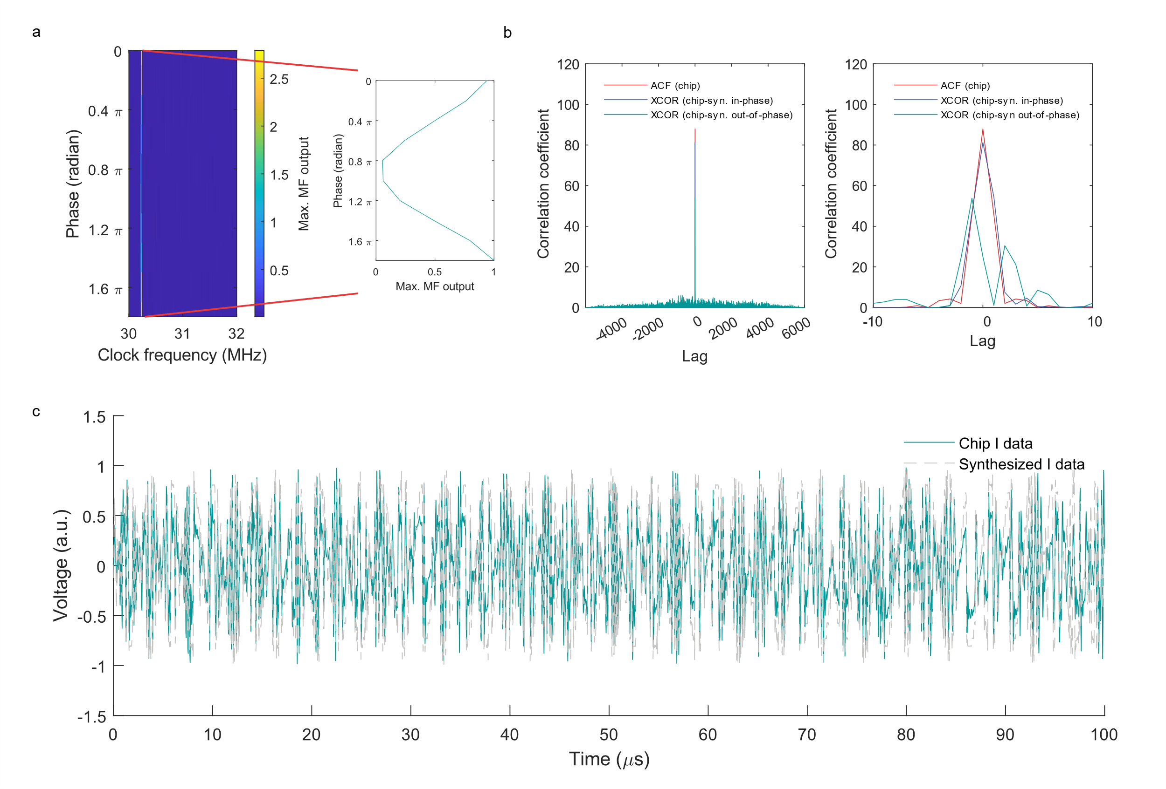
Supplementary Figure 9. a) Maximum matched filter outputs solved by using the received data from the prototype wireless RF microchip using matched filters synthesized for various phases and clock frequencies (left) and a snapshot when chip clock frequency matches the center frequency of the matched filter (right). This step is needed to retrieve the clock frequency of the chip using matched filters. To discover the clock frequency, we synthesized all possible 3,000 matched filters (2 kHz resolution) × 3 phases and compared the maximum matched filter output. By finding the particular clock frequency that shows the highest correlation, one can determine the precise on-chip clock frequency. b) Auto-correlation (ACF) of the backscattered signal from the target chip and cross-correlation (XCOR) between the experimental chip data and the synthesized data (in-phase and out-of-phase). The purpose is to show how the simulator can accurately reconstruct the original analog waveform transmitted from the chip by using the pre-discovered Gold code sequence and the recovered clock frequency/phase. c) The I-portion of data received from the chip (green), compared with the synthesized I-waveform for a 100 µsec time bin (gray). Abbreviation: sny. Synthesized.

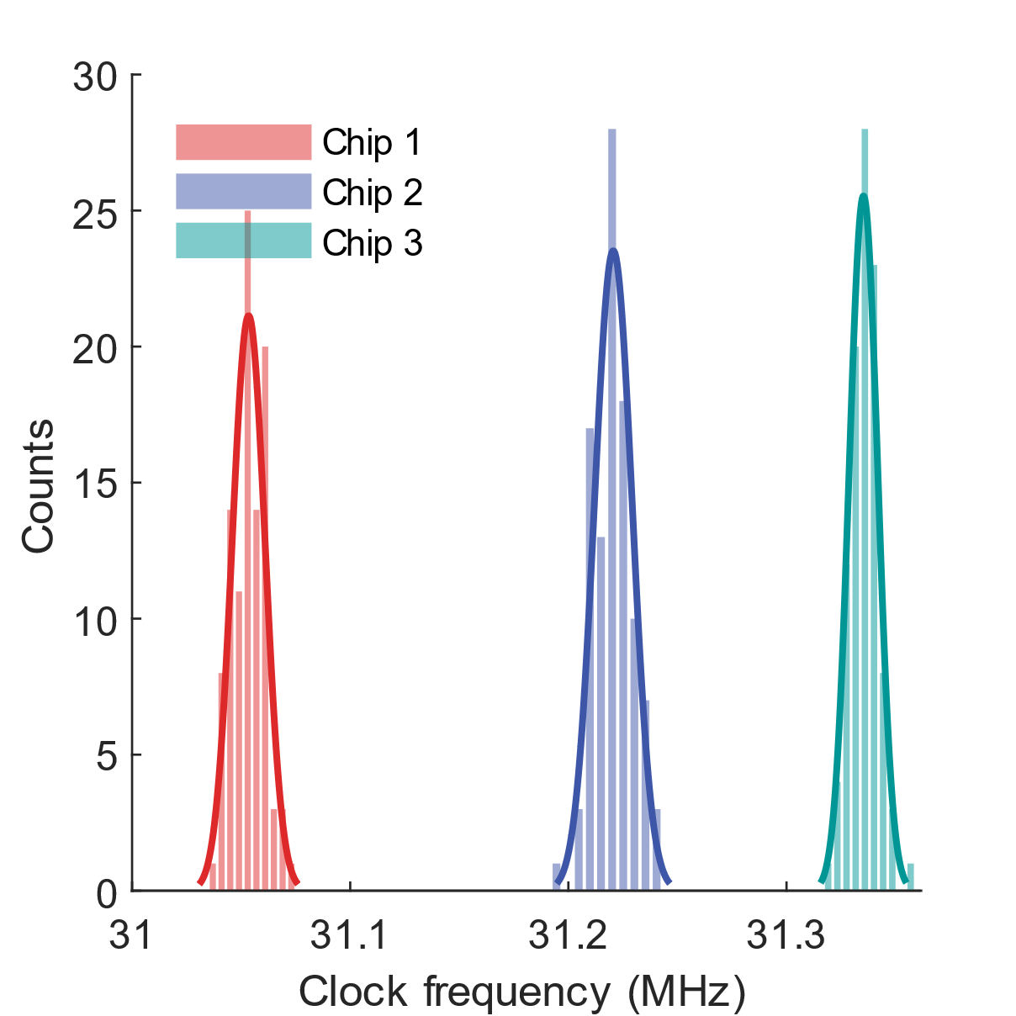
Supplementary Figure 10. Histogram for distribution of the clock frequency for three chips (200 backscattered packets in each) showing a clock drift of approximately 1,000 ppm in a 5-second window.

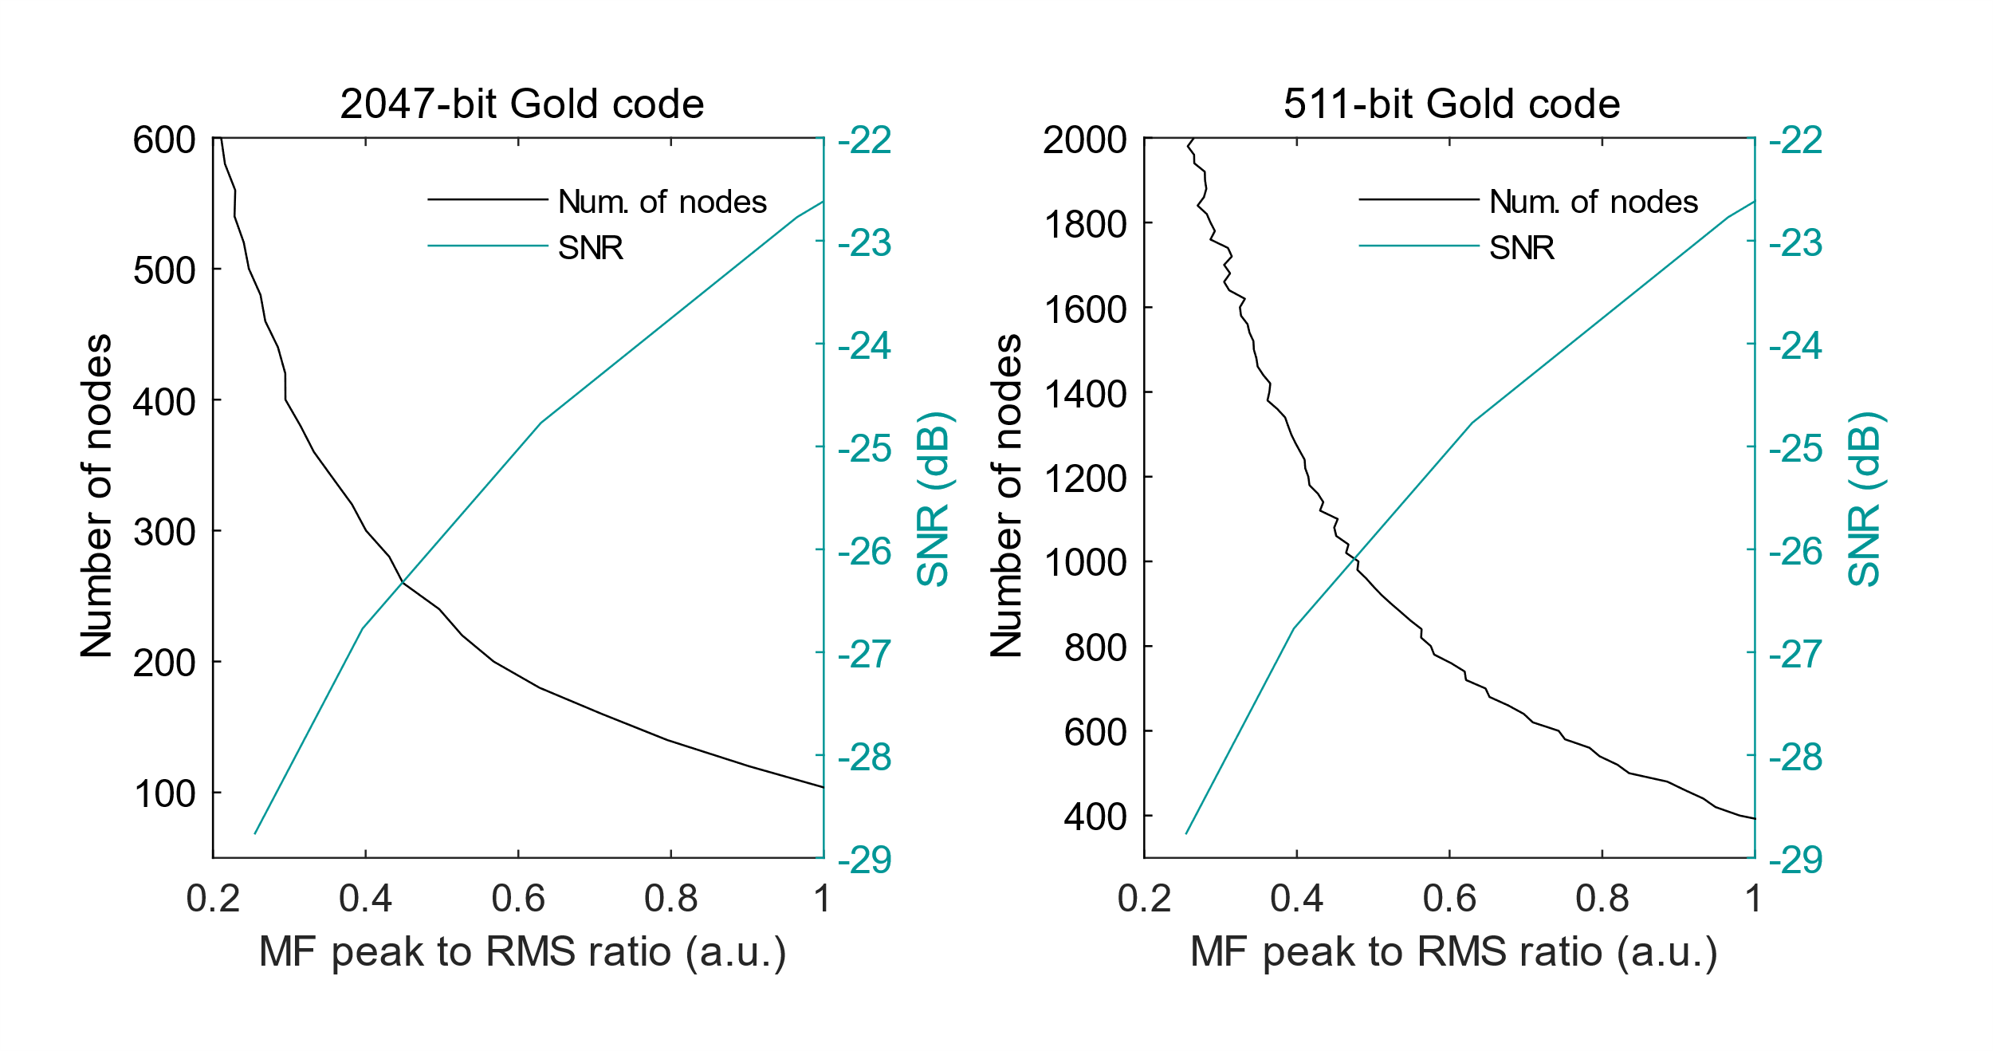
Supplementary Figure 11. The number of simulated nodes generating background signals, assuming SNR of 3.23 dB, equivalent to the noise added to the measured signal from the prototype ASBIT chips. Plots were computed by comparing the matched filter (MF) peak of the target chip during backscattering to the RMS of the matched filter outputs determined by background noise signals (averaged over 6 backscattering packets). Since this chip uses a 2,047-bit Gold code, we assume that other nodes also use a 2,047-bit or 511-bit Gold code where the latter is closer to the optimal length. Each node detects events at a 50 Hz average rate. The clock drift over time is taken as ±1,005 ppm.

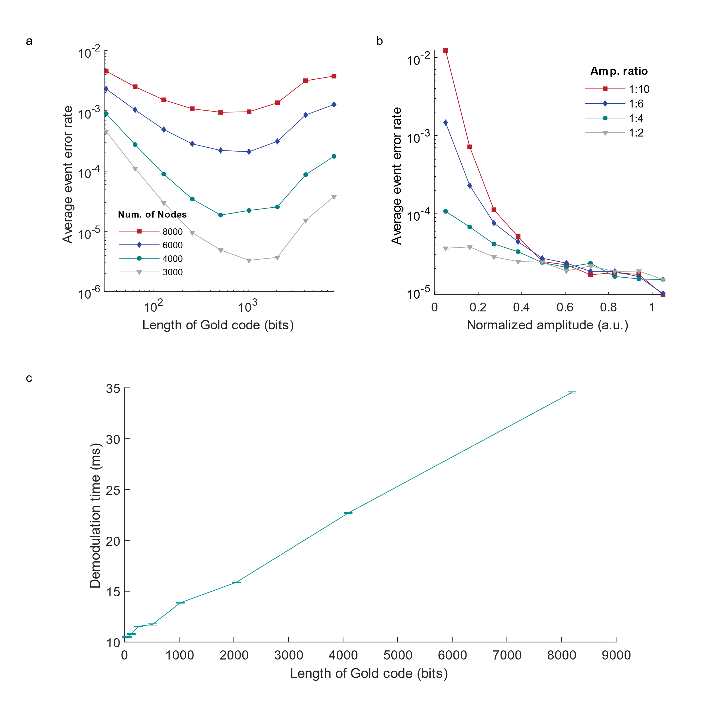
Supplementary Figure 12. a) Average EER for different sizes of the network, given an average 50 Hz event rate and an SNR of 3.23 dB, using different lengths for the Gold code. b) The average EER depending on normalized backscattering amplitude (bin size of 0.1) for a population of 1,000 sensor nodes given 1:2, 1:4, 1:6, and 1:10 near/far ratio for the backscattered signal amplitudes. c) Computing time needed for demodulation of the 1-second long clip of ASBIT signals per node, showing a linear increase with the length of the Gold code.

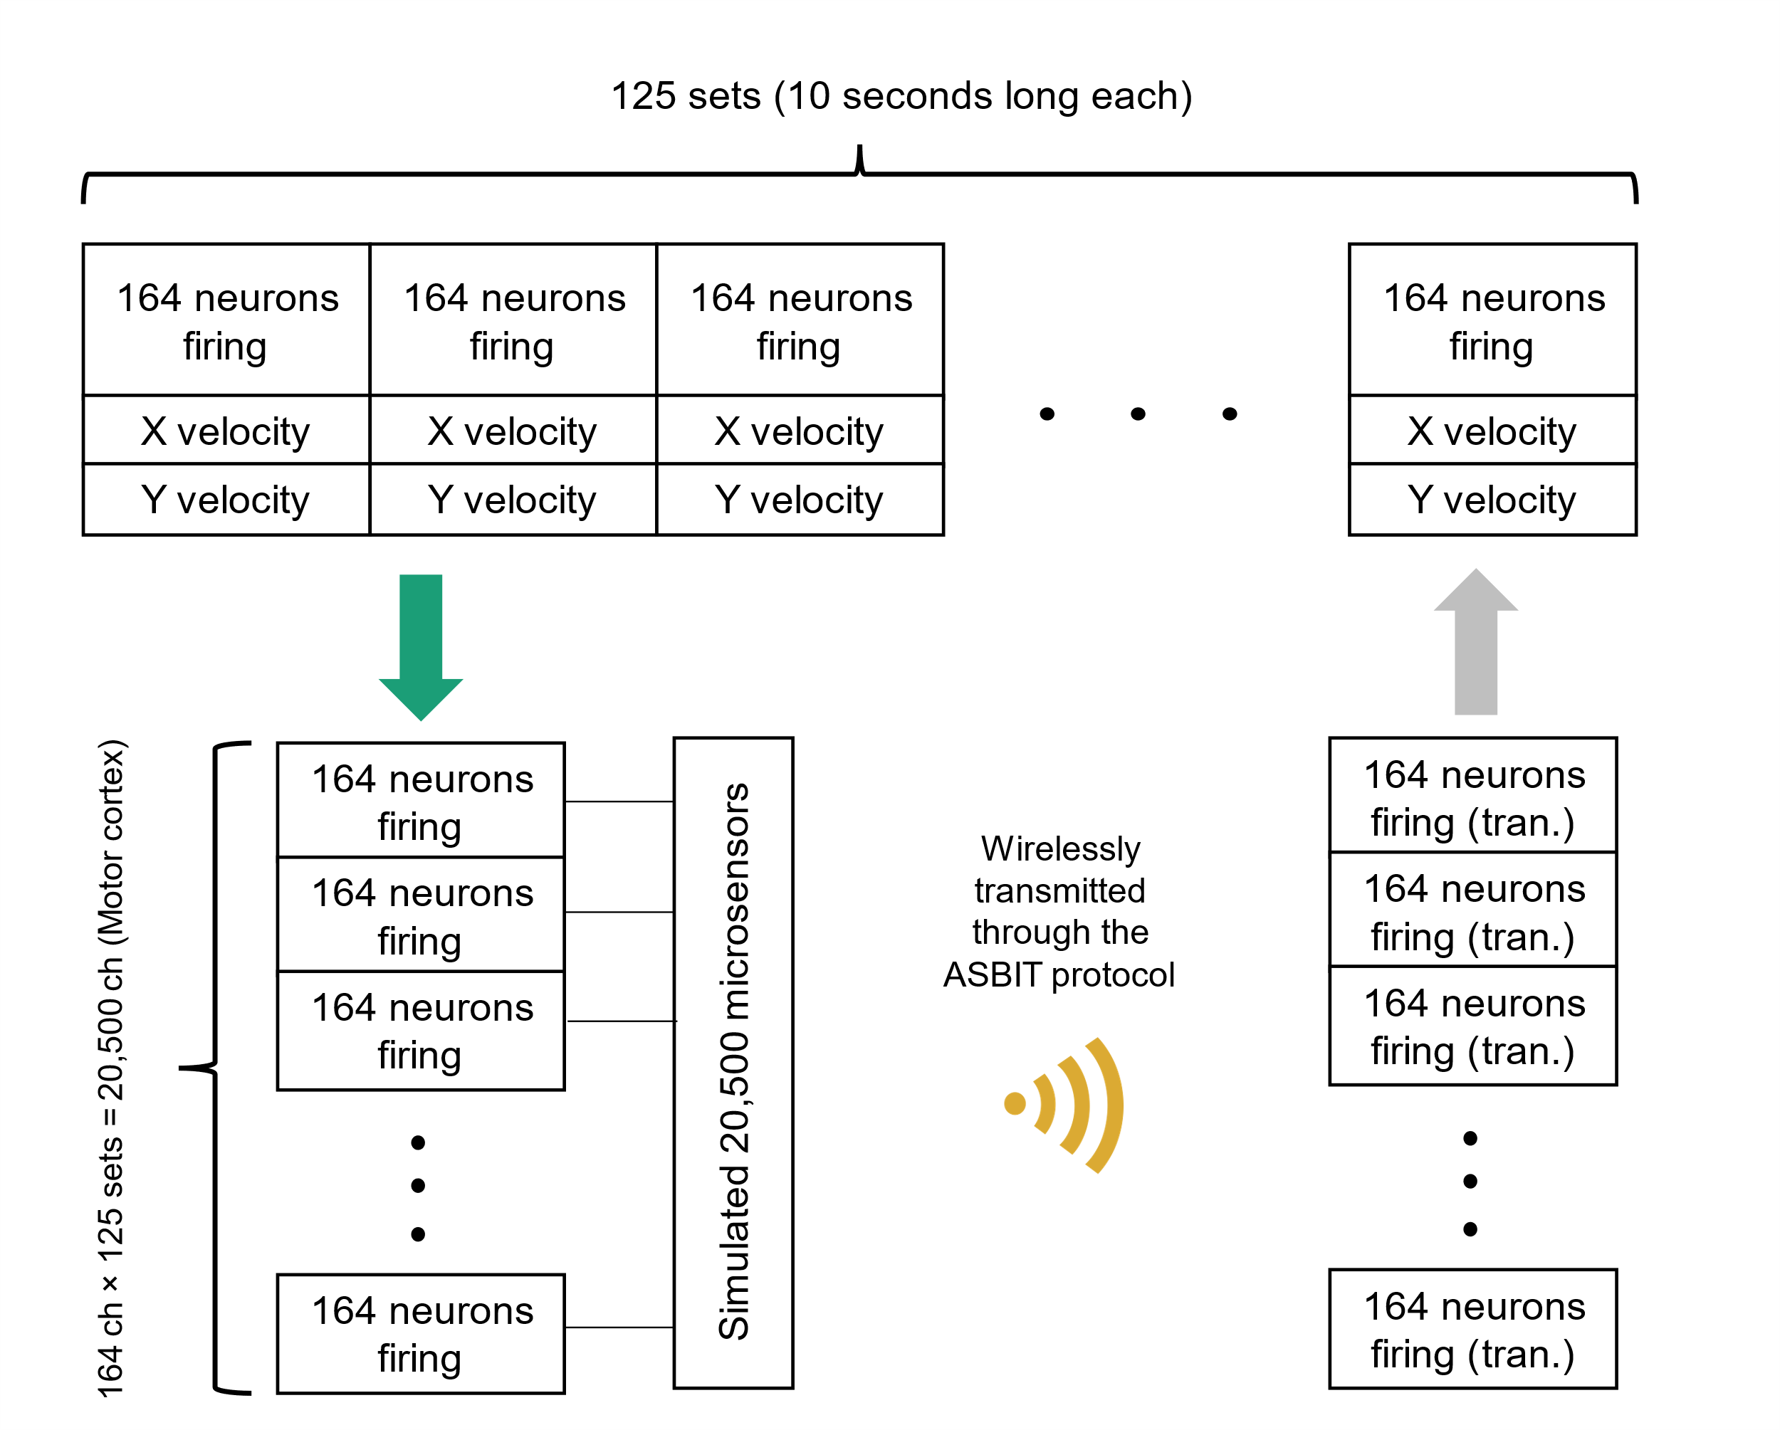
Supplementary Figure 13. Scheme for preprocessing multichannel primate electrophysiological neuronal spike data, recorded from the primate cortex by wired microelectrode arrays and here inputted to the ASBIT protocol as if transmitted by an ensemble of wireless microsensors. Since experimentally available neural data was limited to only 164 spiking channels whereas the network capacity of the ASBIT protocol can reach up to several tens of thousands, we stitch the datasets to generate the equivalent of 20,500 channels of primary cortical M1 data (164 neurons × 125 datasets) as well as 36,360 channels of combined motor and somatosensory M1 + S1 neural data (164 neurons × 125 datasets + 52 neurons × 305 datasets). Following the ASBIT transmission from the corresponding number of microsensors, we reconstituted and mapped the data back into the original number of channels for use of this data to train a neural network model for brain-machine interface (BMI)-relevant neural decoding. All experimental neural data obtained from [9, 10]. tran.: transmitted.

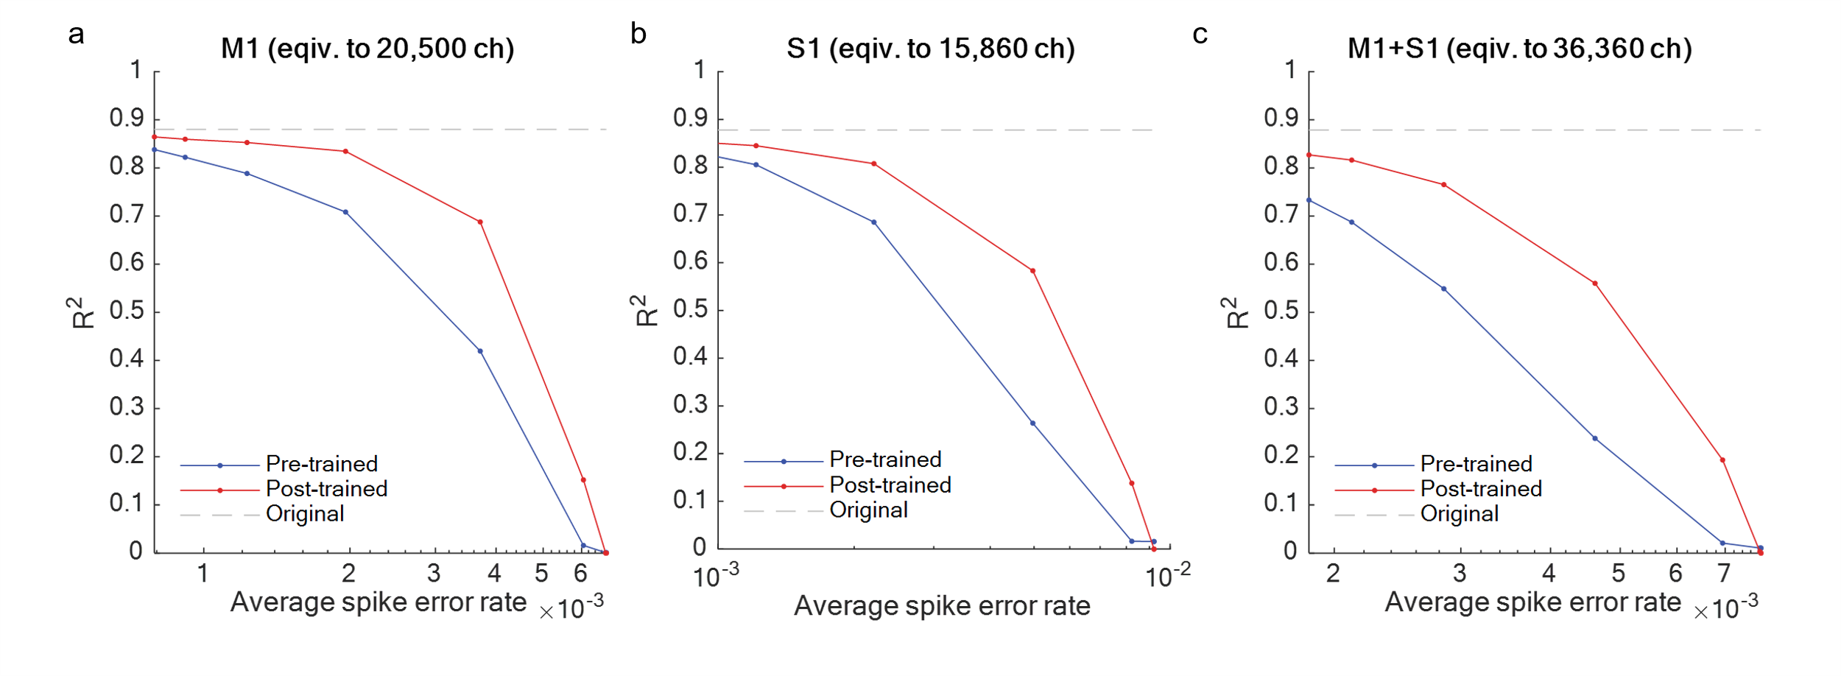
Supplementary Figure 14. Goodness of fit, R², evaluated on testing sets and its dependence on the Spike Error Rate (SER), equivalent to EER, given (a) 20,500 channels M1 data (164 neurons × 125 datasets), (b) 15,860 channels S1 data (52 neurons × 305 datasets), and (c) 36,360 channels M1+S1 data (164 neurons × 125 datasets + 52 neurons ×305 datasets). Pre-trained LSTM decoders, trained with the original spike data, and post-trained LSTM decoders, trained with neural data transmitted through the ASBIT protocol, are compared. The performance of decoders using original spike data only is shown in the gray dotted line to show the maximum achievable R² in these datasets. M1: primary motor cortex, S1: primary sensory cortex.

Reference
- Lee, J. et al. Neural recording and stimulation using wireless networks of microimplants. Nature Electronics 4, 604–614 (2021).
- Yin, J. et al. A system-on-chip EPC gen-2 passive UHF RFID tag with embedded temperature sensor. IEEE Journal of Solid-State Circuits 45, 2404–2420 (2010).
- Man, A. S. et al. Design and implementation of a low-power baseband-system for RFID tag. In 2007 IEEE International Symposium on Circuits and Systems, 1585–1588 (IEEE, 2007).
- Baghaei-Nejad, M. et al. A remote-powered RFID tag with 10Mb/s UWB uplink and -18.5 dBm sensitivity UHF downlink in 0.18 µm CMOS. In 2009 IEEE International Solid-State Circuits Conference-Digest of Technical Papers, 198–199 (IEEE, 2009).
- Hwang, Y.-S. & Lin, H.-C. A new CMOS analog front end for RFID tags. IEEE Transactions on Industrial Electronics 56, 2299–2307 (2009).
- Proakis, J. G., Salehi, M., Zhou, N. & Li, X. Communication systems engineering, vol. 2 (Prentice Hall New Jersey, 1994).
- Gilhousen, K. S. et al. On the capacity of a cellular CDMA system. IEEE transactions on vehicular technology 40, 303–312 (1991).
- Turkmani, A. M. & Goni, U. Performance evaluation of maximal-length, Gold and Kasami codes as spreading sequences in CDMA systems. In Proceedings of 2nd IEEE International Conference on Universal Personal Communications, vol. 2, 970–974 (IEEE, 1993).
- Glaser, J. I. et al. Machine learning for neural decoding. Eneuro 7 (2020).
- Benjamin, A. S. et al. Modern machine learning as a benchmark for fitting neural responses. Frontiers in computational neuroscience 56 (2018).

