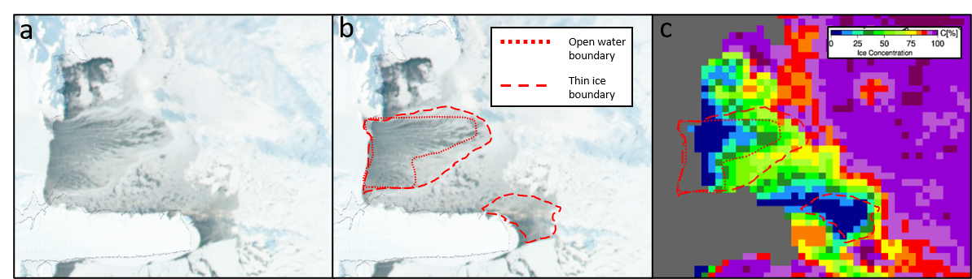
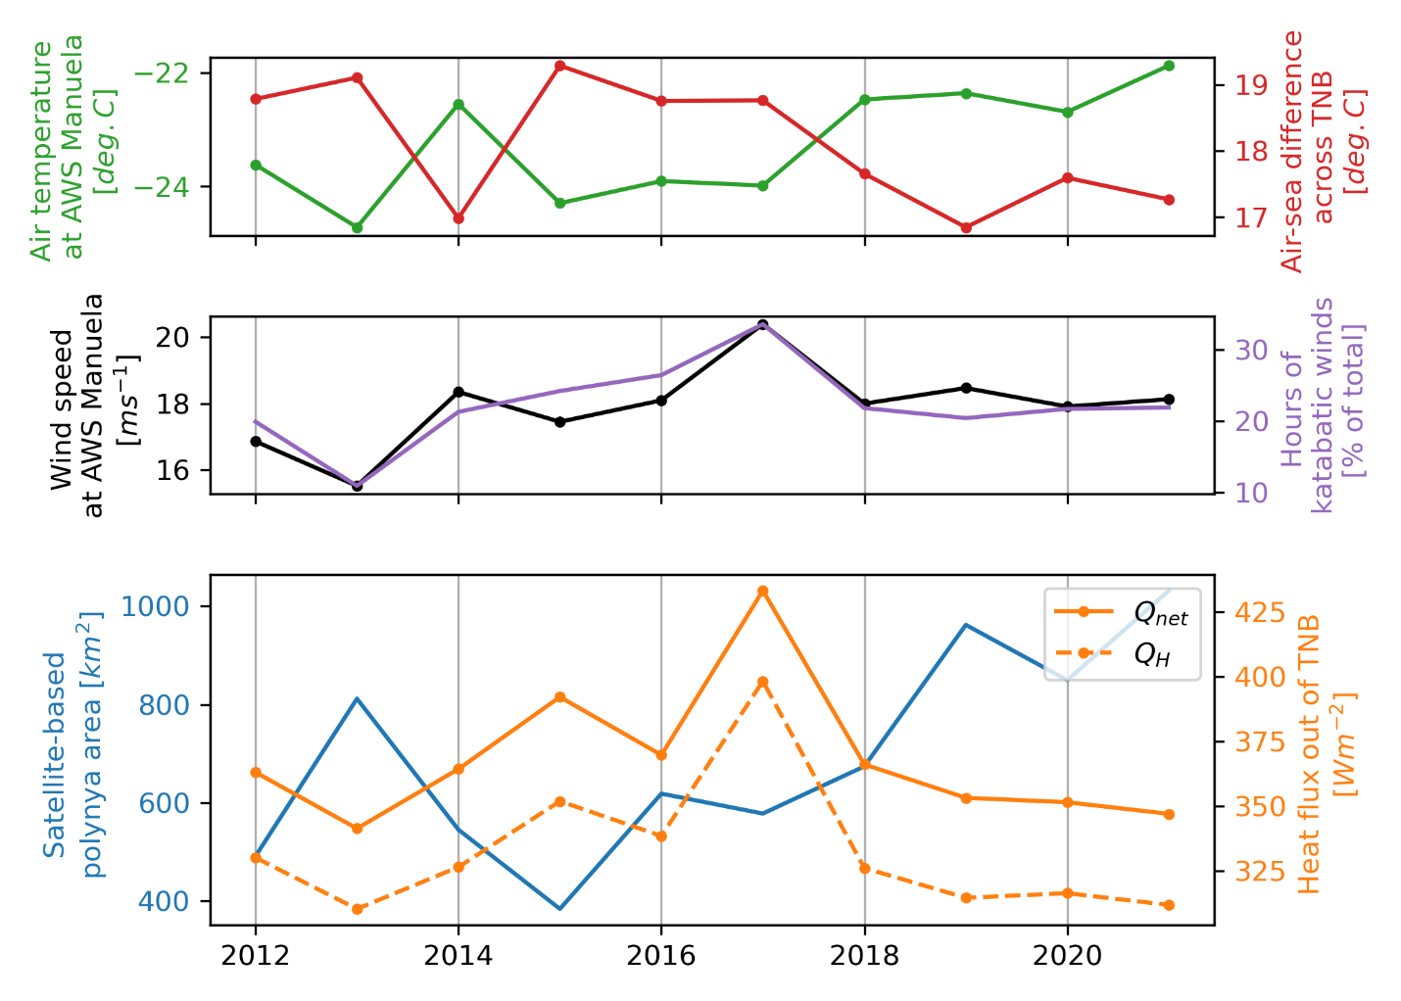
Supplemental Figure 1. Interannual timeseries of a) Air temperature at AWS Manuela and the ERA5 air-sea temperature difference used to parameterize sensible heat flux, b) Average wind speeds at AWS Manuela and total number of hours of katabatic winds (wind speeds $>25 m s^{-1}$), and c) polynya area calculated from satellite-derived SIC maps and parameterized heat fluxes. Both are averaged across the months of July-October.

Supplemental Figure 2. Example comparison between a) visual imagery and c) passive microwave-derived sea ice concentration product from the same day. Panel (b) shows visually-identified open water area (dotted outline) and thin ice areas (dashed outline), which are also shown overlaid in panel (c).

a
b
c

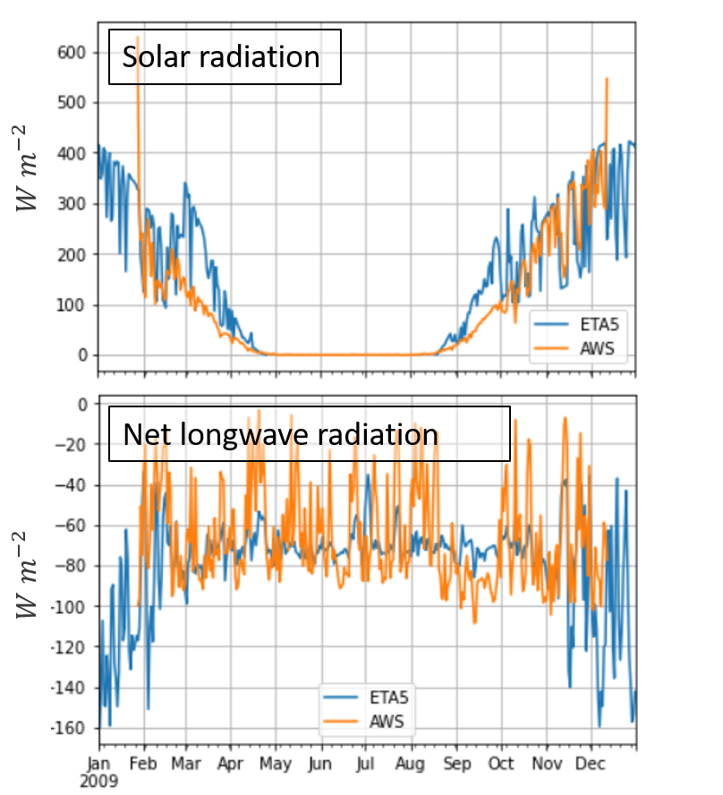
Supplemental Figure 3. Comparison of measurements of solar and net longwave radiation from AWS Rita in 2009 with parameterizations calculated using ERA5 variables.

Supplementary Table 1. HSSW production rates estimated during each identified production event from satellite-derived polynya area and brine rejeciton inferred from in-situ measurements of near-surface salinity. Katabatic wind statistics in the 3 weeks, 2 weeks, 1 week, and 3 days preceding each event are also shown.
Date | HSSW Production [Sv] | Polynya  Area [$km^{2}$] | $\frac{dm}{dt}$ [$g m^{-2} s^{-1}$] | Average katabatic wind event strength [$m s^{-1}$] |  |  |  | Average katabatic wind event duration [hours]
 |  |  |  | 3 weeks | 2 weeks | 1 week | 3 days | 3 weeks | 2 weeks | 1 week | 3 days
2017-06-19 | 0.26 | 253 | 0.093 | 27.3 | 27.24 | 27.37 | 28.16 | 7.36 | 6.43 | 6.83 | 9.25
2017-06-25 | 0.35 | 68 | 0.57 | 28.15 | 28.36 | 28.77 | 30.19 | 9.22 | 9.88 | 11.00 | 13.00
2017-07-04 | 0.32 | 430 | 0.032 | 28.77 | 28.91 | 27.33 | 28.23 | 12.85 | 1300 | 7.86 | 10.25
2017-07-07 | 0.43 | 615 | 0.011 | 28.76 | 28.86 | 27.85 | 29.23 | 16.00 | 15.90 | 17.50 | 36.00
2017-07-14 | 0.32 | 479 | 0.025 | 28.64 | 28.53 | 29.73 | 34.77 | 18.50 | 19.44 | 14.60 | 53.00
2017-07-14 | 0.34 | 479 | 0.022 | 28.68 | 28.58 | 29.81 | 35.14 | 18.58 | 19.56 | 14.80 | 54.00
2017-07-18 | 0.38 | 752 | 0.036 | 28.212 | 29.33 | 30.63 | 29.53 | 17.62 | 27.00 | 33.33 | 9.67
2017-07-30 | 0.29 | 303 | 0.025 | 28.92 | 28.30 | 29.75 | 31.73 | 15.33 | 10.0 | 12.00 | 18.00
2017-07-31 | 0.13 | 313 | 0.010 | 28.71 | 28.16 | 29.11 | 29.43 | 13.79 | 9.08 | 9.86 | 9.80
2017-07-31* | 0.15 | 371
2017-08-08 | 0.92 | 1601 | 0.022 | 27.54 | 27.78 | 27.04 | 27.85 | 7.23 | 8.44 | 7.00 | 6.00
2017-08-14 | 0.52 | 1162 | 0.028 | 27.81 | 27.28 | 28.41 | 26.79 | 9.45 | 9.071 | 12.50 | 6.00
2017-08-20 | 0.38 | 342 | 0.040 | 27.25 | 27.74 | 27.08 |  | 7.94 | 8.29 | 2.67
2017-08-27 | 0.5 | 557 | 0.013 | 27.45 | 27.11 | 27.12 | 26.93 | 6.47 | 4.27 | 4.88 | 5.20
2017-08-28 | 0.27 | 361 | 0.019 | 27.40 | 27.11 | 27.12 | 26.66 | 6.87 | 5.083 | 5.89 | 5.00
2017-08-29 | 0.33 | 273 | 0.021 | 27.57 | 27.19 | 27.25 | 26.52 | 7.27 | 6.82 | 9.50 | 8.40
2017-09-02 | 0.61 | 684 | 0.010 | 27.75 | 28.04 | 27.91 | 30.22 | 1027 | 12.17 | 14.75 | 25.33
2017-09-12 | 0.18 | 176 | 0.048 | 28.96 | 29.85 | 29.04 | 29.34 | 15.38 | 17.73 | 9.86 | 8.50
2017-09-13 | 0.77 | 576 | 0.034 | 29.26 | 30.46 | 30.84 | 34.76 | 16.94 | 21.40 | 16.80 | 30.00
2017-09-14 | 0.81 | 967 | 0.027 | 29.22 | 31.07 | 31.81 | 35.88 | 19.47 | 25.67 | 21.40 | 66.00
2017-09-18 | 1.44 | 977 | 0.062 | 30.57 | 30.95 | 34.41 | 33.20 | 23.00 | 20.25 | 37.00 | 3.00
2017-09-18* | 1.17 | 791
2017-09-18 | 1.15 | 449 | 0.097 | 30.60 | 31.00 | 34.62 | 33.61 | 23.00 | 20.25 | 37.00 | 3.00
2017-09-22 | 0.50 | 342 | 0.045 | 30.39 | 30.66 | 29.47 | 28.73 | 21.92 | 23.25 | 17.40 | 12.40
2017-09-26 | 0.53 | 166 | 0.024 | 29.51 | 29.33 | 27.91 | 25.87 | 18.83 | 21.50 | 10.86 | 7.00
2017-09-30 | 0.65 | 313 | 0.037 | 28.72 | 27.95 | 26.06 | 26.25 | 17.5 | 11.56 | 4.25 | 1.50
2017-10-12 | 0.78 | 264 | 0.042 | 26.78 | 28.10 | 26.44 | 26.44 | 6.8 | 9.50 | 8.00 | 8.00
2017-10-18 | 0.84 | 508 | 0.025 | 28.67 | 29.50 | 29.50 | 31.95 | 10.25 | 14.50 | 14.50 | 19.00
2017-10-30 | 1.49 | 2246 | 0.022 | 28.21 | 28.50 | 27.99 | 27.99 | 9.6 | 9.50 | 4.50 | 4.50
Mean | 0.58 | 580 | 0.052

Supplementary Table 1. [continued]
Date | Average katabatic wind event frequency [$week^{-1}$]
 | 3 weeks | 2 weeks | 1 week | 3 days
2017-06-19 | 3.7 | 3.5 | 6.0 | 9.3
2017-06-25 | 3.0 | 4.0 | 4.0 | 4.7
2017-07-04 | 4.3 | 5.0 | 7.0 | 9.3
2017-07-07 | 4.7 | 5.0 | 6.0 | 4.7
2017-07-14 | 4.0 | 4.5 | 5.0 | 2.3
2017-07-14 | 4.0 | 4.5 | 5.0 | 2.3
2017-07-18 | 4.3 | 3.5 | 3.0 | 7.0
2017-07-30 | 4.0 | 5.0 | 5.0 | 7.0
2017-07-31 | 4.7 | 6.0 | 7.0 | 11.67
2017-08-08 | 7.3 | 9.0 | 11.0 | 9.3
2017-08-14 | 6.7 | 7.0 | 4.0 | 2.3
2017-08-20 | 5.7 | 3.5 | 3.0 | 0
2017-08-27 | 5.0 | 5.5 | 8.0 | 11.7
2017-08-28 | 5.0 | 6.0 | 9.0 | 14.0
2017-08-29 | 5.0 | 5.5 | 6.0 | 11.7
2017-09-02 | 5.0 | 6.0 | 8.0 | 7.0
2017-09-12 | 5.3 | 5.5 | 7.0 | 4.7
2017-09-13 | 5.3 | 5.0 | 5.0 | 2.3
2017-09-14 | 5.0 | 4.5 | 5.0 | 2.3
2017-09-18 | 4.0 | 4.0 | 2.0 | 2.3
2017-09-18 | 4.0 | 4.0 | 2.0 | 2.3
2017-09-22 | 4.3 | 4.0 | 5.0 | 11.7
2017-09-26 | 4.0 | 4.0 | 7.0 | 4.7
2017-09-30 | 3.3 | 4.5 | 4.0 | 4.7
2017-10-12 | 1.7 | 1.0 | 1.0 | 2.3
2017-10-18 | 1.3 | 1.0 | 2.0 | 2.3
2017-10-30 | 1.7 | 2.0 | 2.0 | 4.7

Supplementary Table 2. Coefficients of determination ($R^{2}$) calculated for the linear regressions of a sliding window ($n=10$) of HSSW production rates and each katabatic wind statistic given in Supplementary Table 1. Only values for significant correlations ($p value<0.05$) are shown.
Window | Average katabatic wind event strength [$m s^{-1}$] |  |  |  | Average katabatic wind event duration [hours] |  |  |  | Average katabatic wind event frequency [$week^{-1}$]
 | 3 weeks | 2 weeks | 1 weeks | 3 days | 3 weeks | 2 weeks | 1 week | 3 days | 3 weeks | 2 weeks | 1 week | 3 days
1 |  |  |  |  |  |  |  |  | 0.65 | 0.51 | 0.40
2 | 0.64 |  |  |  |  |  |  |  | 0.60 | 0.51
3 |  |  |  |  |  |  |  |  | 0.65 | 0.47
4 |  |  |  |  |  |  |  |  | 0.63 | 0.47
5 |  |  |  |  |  |  |  |  | 0.61 | 0.47
6 |  |  |  |  |  |  |  |  | 0.62 | 0.40
7 |  |  |  |  |  |  |  |  | 0.55
8 |  |  |  |  |  |  |  |  | 0.51 | 0.42
9 |  |  |  |  |  |  |  |  | 0.40
10
11 | 0.61 | 0.41 | 0.77 | 0.44 | 0.58 |  | 0.85
12 | 0.69 | 0.51 | 0.80 | 0.51 | 0.66 |  | 0.86 |  | 0.65 |  | 0.51
13 | 0.49 |  | 0.79 | 0.52 | 0.48 |  | 0.85 |  | 0.52 | 0.52 | 0.70 | 0.46
14 | 0.47 | 0.42 | 0.81 | 0.48 | 0.47 |  | 0.90 |  |  |  | 0.72 | 0.43
15 |  |  | 0.65 |  | 0.40 |  | 0.75 |  |  |  | 0.66
16 |  |  | 0.49 |  |  |  | 0.65 |  |  |  | 0.50
17 |  |  | 0.48 |  |  |  | 0.63 |  |  |  | 0.54
18 |  |  |  |  |  |  |  |  |  |  | 0.42

Supplementary Table 3. Coefficients of determination ($R^{2}$) calculated for the linear regressions of a sliding window ($n=10$) of polynya area and each katabatic wind statistic. Only values for significant correlations ($p value<0.05$) are shown.
Window | Average katabatic wind event strength [$m s^{-1}$] |  |  |  | Average katabatic wind event duration [hours] |  |  |  | Average katabatic wind event frequency [$week^{-1}$]
 | 3 weeks | 2 weeks | 1 weeks | 3 days | 3 weeks | 2 weeks | 1 week | 3 days | 3 weeks | 2 weeks | 1 week | 3 days
1 |  |  |  |  |  |  |  |  | 0.88 | 0.59 | 0.46
2 | 0.59 |  |  |  |  |  |  |  | 0.89 | 0.62
3 |  |  |  |  |  |  |  |  | 0.69 | 0.61
4 |  |  |  |  |  |  |  |  | 0.67 | 0.61
5 |  |  |  |  |  |  |  |  | 0.64 | 0.53
6 |  |  |  |  |  |  |  |  | 0.63 | 0.49
7 |  |  |  |  |  |  |  |  | 0.66 | 0.49
8 |  |  |  |  |  |  |  |  | 0.73 | 0.70
9 |  |  |  |  |  |  |  |  | 0.77 | 0.66
10 |  |  |  |  |  |  |  |  | 0.60 | 0.51
11
12
13 |  |  |  | 0.44
14 |  |  |  | 0.59
15 |  |  |  | 0.60
16 |  |  |  | 0.61
17 |  |  | 0.48 | 0.64 |  |  | 0.42
18

Supplementary Table 4. Coefficients of determination ($R^{2}$) calculated for the linear regressions of a sliding window ($n=10$) of brine rejection rates ($\frac{dm}{dt}$) and each katabatic wind statistic. Only values for significant correlations ($p value<0.05$) are shown.
Window | Average katabatic wind event strength [$m s^{-1}$] |  |  |  | Average katabatic wind event duration [hours] |  |  |  | Average katabatic wind event frequency [$week^{-1}$]
 | 3 weeks | 2 weeks | 1 weeks | 3 days | 3 weeks | 2 weeks | 1 week | 3 days | 3 weeks | 2 weeks | 1 week | 3 days
1
2
3

4 |  |  |  |  |  |  |  |  |  |  | 0.42
5 |  |  |  |  |  |  |  |  |  |  | 0.50 | 0.49
6 |  |  |  |  |  |  |  |  |  |  | 0.49 | 0.53
7 |  |  |  |  |  |  |  |  |  |  | 0.52 | 0.48
8 |  |  |  |  |  |  |  |  |  |  |  | 0.48
9 |  |  |  |  |  |  |  |  |  |  |  | 0.51
10 |  |  |  |  |  |  |  |  |  |  |  | 0.43
11 | 0.52 | 0.41 | 0.46 |  | 0.49 |  |  |  |  |  | 0.52
12 | 0.64 | 0.46 | 0.62 |  | 0.58 |  | 0.55 |  |  | 0.45 | 0.62
13 | 0.71 | 0.50 | 0.69 |  | 0.62 |  | 0.66 |  | 0.52 | 0.57 | 0.38
14 | 0.60 | 0.44 | 0.67 |  | 0.50 |  | 0.64 |  |  |  | 0.67
15 | 0.59 |  | 0.54 |  | 0.48 |  | 0.53 |  |  |  | 0.63
16 |  |  | 0.43 |  |  |  | 0.46 |  |  |  | 0.44
17 |  |  |  |  |  |  | 0.51
18 |  |  | 0.44 |  |  |  | 0.61

Supplemental Methods
Supplemental Figure 3. Example comparison between visual imagery and a passive microwave-derived SIC product. The dotted red line depicts open water identified in the visual imagery by the presence of wind streaks, which corresponds to a SIC threshold of 30%. Dashed lines outline a secondary area bounded by an accredted ridge of thick sea ice.
Calculation of Surface Heat Fluxes
Total heat flux, $Q_{net}$, is calculated as $Q_{net}=Q_{s}+Q_{b}+Q_{S}+Q_{L}$, with fluxes out of the ocean defined as negative by convention.
Incoming Shortwave Radiation
Incoming solar radiation is estimated according to:
$Q_{s}=\left(1-α\right)C_{c}T_{r}S_{a}cosη$
Where $α$ is the albedo of the water surface, 0.08, after ^{1,2} for conditions of no ice cover, $C_{c}$, is a cloud cover correction, $T_{r}$ is the transmittance ratio of a clear sky atmosphere, $S_{a}$ is the solar constant, 1353 $Wm^{-2}$, and cos$η$ is the cosine of the zenith angle of the Sun. The cloud cover correction is calculated as
$C_{c}=α_{1}+α_{2}C^{α_{3}}$
Where $α_{1}=1, α_{2}=0.6, α_{3}=3$ ³ and $C$ is total cloud cover from ERA5 re-analysis. ⁴ introduced a Zillman-type ⁵ model for the transmittance ratio of a clear sky atmosphere modified for polar regions
$T_{r}=\frac{cosη}{β_{1}cosη+\left(β_{2}+cosη\right)e\left(T_{d}\right)β_{3}+β_{4}}$
With $β_{1}=1,β_{2}=1,β_{3}={10}^{-5},β_{4}=0.046$ and $e\left(T_{d}\right)$ is the water vapor pressure in Pascals calculated from ERA5 2-meter dew point temperature, $T_{d}$, in Kelvin ⁶ :
$e\left(T_{d}\right)=611 ×{10}^{7.5(T_{d}-273.16)/(T_{d}-35.86)}$
The cosine of the zenith angle of the sun follows ⁷
$cosη=\sin{ϕ}\sin{δ}+\cos{ϕ}\cos{δ}\cos{h}$
Values of $cosη<0$ (indicating the sun is below the horizon) are masked and the corresponding calculations of $Q_{s}$ are set to 0. Latitude, $ϕ$, is set to -75$°$ for Terra Nova Bay ). The solar inclination angle ($δ$) is given by
$δ=23.44°\cos{(172-d)}$
Where $d$ is the day of year. The solar hour ($h$) is
$h=(12-t_{s})×15$
where $t_{s}$ is local solar time, which is a corrected local time given by
$t_{s}=local time+TC/60$
where TC is a correction factor
$TC=4\left(longitude-LSTM\right)+EoT$
In Terra Nova Bay, the longitude is 165°E and the local standard time meridian (LSTM) is 195$°E$. The Equation of Time (EoT) is an empirical equation that corrects for the eccentricity of the Earth's orbit and the Earth's axial tilt ⁸.
$EoT=9.87\sin{2B}-7.53\cos{B}-1.5\sin{B}$
Where $B=360/365(d-81)$.
Net Longwave Radiation
Net longwave radiation flux is calculated as
$Q_{B}=4εσT_{A}^{3}\left(T_{A}-SST\right)+εσT_{A}^{4}(0.39-0.05\sqrt{e\left(T_{d}\right)} )(1-χC^{2})$
Here, 𝜀 is open ocean emissivity, 0.95, $σ$ is the Stephan-Boltzman constant $5.67×{10}^{-8} Wm^{-2}K^{-4}$, $T_{A}$ is ERA5 two-meter air temperature in Kelvins, SST is ERA5 sea surface temperature in Kelvins, and $χ$ accounts for changes in cloud type with latitude, ranging from 0.5 at the equator and 1 at the poles. We select a value of 0.82 for Terra Nova Bay based on Table 9 in Budyko (1974) for the latitude of 75°S.
Turbulent Heat Fluxes
Sensible heat flux is given by
$Q_{H}=ρ_{a}C_{P}C_{H}|\overline{V}|(T_{A}-SST)$
The density of dry air $ρ_{a}$ is calculated using the Ideal Gas Law, $P/(286T_{a})$, where $P$ is ERA5 pressure at mean sea level in Pa. $C_{P}$is the specific heat of dry air, 1004 $J{kg}^{-1}$⁹, $C_{H}$ is the transfer coefficient for sensible heat, $|\overline{V}|$ is the magnitude of the wind, calculated as $\sqrt{u_{10}^{2}+v_{10}^{2}}$, where $u_{10}$ and $v_{10}$ are the u and v components of the ETA5 10-meter neutral wind ($ms^{-1})$.
Latent heat flux is given by
$Q_{E}=ρ_{a}L_{E}C_{E}|\overline{V}|(q_{A}-q_{s})$
The latent heat of vaporization ($L_{E}$) is $2.5 ×{10}^{6}Jkg^{-1}$ ¹⁰. $C_{E}$ is the exchange coefficient for latent heat, which is considered to be roughly equivalent to $C_{H}$ ^{11–13}. The water vapor mixing ratios of the air at 10m ($q_{a}$) and at the sea surface ($q_{s}$) are calculated as
$q_{a}=\frac{0.622e}{p_{s}-0.378e}$
$q_{s}=\frac{0.622e_{s}}{p_{s}-0.378e_{s}}$
where $e$ is vapor pressure and $e_{s}$ is saturation vapor pressure in Pascals. The surface pressure, $p_{s}$, is taken to be the ERA5 mean sea level pressure in Pascals.
$e=611×{10}^{a(T_{A}-273.16)/(T_{A}-b)}$
Where $\left(a,b\right)=(9.5, 7.66)$ if an ice cover exists and $\left(a,b\right)=(7.5, 35.86)$ if it does not ⁶. No ice cover is assumed here. For the calculation of $e_{s}$, $T_{A}$ is substituted for the ERA5 2-meter dew point temperature in Equation 19.

1. Budillon, G., Fusco, G. & Spezie, G. A study of surface heat fluxes in the Ross Sea (Antarctica). Antarctic Science 12, 243–254 (2000).
2. Maykut, G. A. Large-scale heat exchange and ice production in the central Arctic. Journal of Geophysical Research: Oceans 87, 7971–7984 (1982).
3. Laevastu, T. Factors affecting the temperature of the surface layer of the sea. undefined (1960).
4. Shine, K. P. Parametrization of the shortwave flux over high albedo surfaces as a function of cloud thickness and surface albedo. Quarterly Journal of the Royal Meteorological Society 110, 747–764 (1984).
5. Zillman, J. W. A study of some aspects of the radiatron and heat budgets of the southern hemisphere oceans. Bureau of Meterology, Australia Meteorological Studies, (1972).
6. Murray, F. W. On the Computation of Saturation Vapor Pressure. Journal of Applied Meteorology and Climatology 6, 203–204 (1967).
7. Markus, T., Kottmeier, C. & Fahrbach, E. Ice Formation in Coastal Polynyas In the Weddell Sea and Their Impact on Oceanic Salinity. in Antarctic Sea Ice: Physical Processes, Interactions and Variability 273–292 (American Geophysical Union (AGU), 1998). doi:10.1029/AR074p0273.
8. Milne, R. M. 593. Note on the Equation of Time. The Mathematical Gazette 10, 372–375 (1921).
9. Glossary of meteorology. (American Meteorological Society, 1959).
10. Haltiner, G. J. & Martin, F. L. Dynamical and Physical Meteorology. (McGraw-Hill, 1957).
11. Andreas, E. L. & Murphy, B. Bulk Transfer Coefficients for Heat and Momentum over Leads and Polynyas. Journal of Physical Oceanography 16, 1875–1883 (1986).
12. Bunker, A. F. Computations of Surface Energy Flux and Annual Air–Sea Interaction Cycles of the North Atlantic Ocean. Monthly Weather Review 104, 1122–1140 (1976).
13. Large, W. G. & Pond, S. Sensible and Latent Heat Flux Measurements over the Ocean. Journal of Physical Oceanography 12, 464–482 (1982).

