Table 1: Demographic Characteristics of Respondents
Variables | Frequency (n=219) | Percentage (%)
Gender
Female | 136 | 62.1
Male | 83 | 37.9
Age
15 – 19 | 119 | 54.3
20 – 25 | 100 | 45.7
Schools
Ansong SHS | 93 | 42.5
Pentecost VTI | 52 | 23.7
Royals SHS | 74 | 33.8
Form
Form 2 | 91 | 41.6
Form 3 | 128 | 58.4
Ethnicity
Akan | 79 | 36.1
Ewe | 62 | 28.3
Ga/Dagbme | 46 | 21
Guan | 13 | 5.9
Gruma/Bimo | 2 | 0.9
Other | 17 | 7.8
Religion
Orthodox | 43 | 19.6
Pentecostal/Charismatic | 151 | 68.9
Traditionalist | 2 | 0.9
Muslims | 13 | 5.9
None | 10 | 4.6
Area of Residence (Region)
Greater Accra | 173 | 79
Western North | 4 | 1.8
Volta Region | 10 | 4.6
Central Region | 20 | 9.1
Eastern Region | 6 | 2.7
Other Regions | 6 | 2.7
Area of Residence (Town)
Gbawe | 100 | 45.7
Weija | 38 | 17.4
Other places in Accra | 51 | 23.3
Outside Greater Accra | 30 | 13.7
Monthly stipend (GHS)
10 – 100 | 64 | 29.2
110 – 200 | 48 | 21.9
210 – 300 | 42 | 19.2
310 – 400 | 16 | 7.3
410 – 500 | 22 | 10
510 + | 27 | 12.3
Residence type
Boarding | 101 | 46.1
Day | 67 | 30.6
Hostel | 51 | 23.3

Table 2: Risk Perception Variables
Variables | M | SD | Skewness | Kurtosis
Effects | 1.74 | 0.69 | 0.61 | 0.72
Anxiety | 1.88 | 0.74 | 0.44 | 0.26
Exposure | 1.81 | 0.75 | 0.64 | 0.34
Uncontrollable | 1.88 | 0.85 | 0.89 | 0.95

Source: Field Survey, 2021

Table 3: Kruskal Wallis test between Students’ Earthquake Risk Perception and Demographic Characteristics
 | Effects |  | Anxiety |  | Exposure |  | Uncontrollable
Constant | K | p | K | p | K | p | K | p
School | 34.30 | 0.00 | 32.78 | 0.00 | 18.00 | 0.00 | 33.40 | 0.00
Gender | 0.94 | 0.33 | 1.18 | 0.28 | 2.10 | 0.15 | 0.50 | 0.00
Age | 4.48 | 0.00 | 1.80 | 0.01 | 1.50 | 0.02 | 6.40 | 0.00
Form | 6.44 | 0.00 | 2.90 | 0.05 | 3.01 | 0.04 | 6.70 | 0.00
Religion | 3.64 | 0.45 | 0.64 | 0.95 | 0.53 | 0.97 | 1.73 | 0.78
Ethnicity | 3.04 | 0.69 | 3.30 | 0.65 | 1.06 | 0.95 | 1.93 | 0.85
Region | 3.68 | 0.59 | 5.85 | 0.32 | 5.02 | 0.41 | 3.59 | 0.69
Town | 5.87 | 0.12 | 6.56 | 0.08 | 3.49 | 0.32 | 6.04 | 0.11
Monthly stipend | 3.20 | 0.66 | 1.13 | 0.95 | 0.51 | 0.99 | 2.87 | 0.72
Residency type | 1.11 | 0.78 | 0.76 | 0.86 | 0.30 | 0.96 | 0.54 | 0.91

Key; H = ≤ 1.00, p = 0.00
Source: Field Survey, 2021

Table 4: Level of Disaster Risk Perception of Schools
 |  |  | Ansong | Pentecost | Royal | Composite
Interactions |  |  | Β | β | β | β
Meta-Concentration | <- | Effects | -0.43 | -0.32 | -0.74 | 0.18
Meta-Concentration | <- | Uncontrollable | 0.13 | 0.12 | 0.54*** | -0.21
Meta-Concentration | <- | Anxiety | -0.27 | -0.39 | -0.29 | 0.05
Meta-Concentration | <- | Exposure | 0.32 | 0.27 | 0.53*** | -0.37
Meta-memory | <- | Effects | -0.03 | -0.13 | -0.09 | 0.02
Meta-memory | <- | Anxiety | -0.03 | -0.05 | 0.44* | 0.02
Meta-memory | <- | Exposure | 0.00 | 0.45* | 0.01 | 0.01
Meta-memory | <- | Uncontrollable | -0.01 | -0.06 | 0.01 | -0.09
Meta-memory | <- | Meta-concentration | 0.63*** | 0.63*** | 0.63*** | 0.61***
CMIN/DF |  |  | 1.32 | 1.34 | 2.43 | 3.24
GFI |  |  | 0.95 | 1.00 | 0.98 | 0.90
CFI |  |  | 1.00 | 0.90 | 0.96 | 1.00
RMSEA |  |  | 0.65 | 0.67 | 0.59 | 0.60
Source: Field Survey, 2021
Key: p = < 0.05 =*, p = < 0.01=***
Table 5: Level of Disaster Risk Perception of Age groups
 |  |  | Age  15 -19 | Age  20-25 | Composite (All age groups)
Interactions |  |  | β | β | Β
Meta-concentration | <-- | Effects | -0.64 | -0.05 | -0.37
Meta-concentration | <-- | Uncontrollable | 0.21 | -0.15 | 0.05
Meta-concentration | <-- | Anxiety | -0.05 | -0.38 | -0.21
Meta-concentration | <-- | Exposure | 0.42* | 0.54* | 0.51*
Meta-memory | <-- | Exposure to earth | -0.03 | 0.05 | 0.02
Meta-memory | <-- | Effects | -0.17 | -0.02 | -0.09
Meta-memory | <-- | Uncontrollable | 0.01 | -0.01 | 0.01
Meta-memory | <-- | Anxiety | 0.45* | -0.04 | 0.02
Meta-memory | <-- | Meat- concentration | 0.58*** | 0.64*** | 0.61***
CMIN/DF |  |  | 3.45 | 4.36 | 5.30
GFI |  |  | 0.95 | 0.89 | 0.98
CFI |  |  | 0.98 | 0.96 | 1.00
RMSEA |  |  | 0.52 | 0.51 | 0.60
Key: p = < 0.05 =*, p= < 0.01=***
Source: Field Survey, 2021
Table 6: Level of Disaster Risk Perception per Forms
 |  |  | Form 2 | Form 3 | Composite
Interactions |  |  | Estimate | Estimate | Estimate
Meta-Concentration | <-- | Effects | -0.74 | -0.20 | -0.20
Meta-Concentration | <-- | Uncontrollable | 0.53* | -0.10 | 0.05
Meta-Concentration | <-- | Anxiety | -0.29 | -0.20 | -0.40
Meta-Concentration | <-- | Exposure | 0.53* | 0.04 | 0.18
Meta-memory | <-- | Effects | -0.09 | -0.10 | -0.10
Meta-memory | <-- | Uncontrollable | 0.04 | -0.01 | 0.01
Meta-memory | <-- | Anxiety | 0.43* | 0.46* | 0.02
Meta-memory | <-- | Exposure | 0.01 | 0.02 | 0.02
Meta-memory | <-- | Meta-concentration | 0.63*** | 0.59*** | 0.61***
CMIN/DF |  |  | 3.24 | 2.43 | 1.43
GFI |  |  | 0.89 | 1.00 | 0.84
CFI |  |  | 0.89 | 0.98 | 1.00
RMSEA |  |  | 0.56 | 0.56 | 0.59

Table 7: Earthquake Risk Perception on Students’ Meta-memory and Meta-concentration
Interactions |  | Risk Factors | β
Meta-Concentration | <--- | Effects | -0.37
Meta-Concentration | <--- | Uncontrollable | 0.05
Meta-Concentration | <--- | Anxiety | -0.21
Meta-Concentration | <--- | Exposure | 0.18
Meta-memory | <--- | Effects | -0.09
Meta-memory | <--- | Uncontrollable | 0.01
Meta-memory | <--- | Anxiety | 0.02
Meta-memory | <--- | Exposure | 0.32*
CMIN/DF |  |  | 1.41
GFI |  |  | 0.98
CFI |  |  | 0.99
RMSEA |  |  | 0.56
Key: p = < 0.05 =*, p = < 0.01=***

Appendix 1
Factor Analysis on Students’ Level of Earthquake Risk
Item | Components |  |  |  |  |  | Communalities
 | 1 | 2 |  |  | 3 | 4
Exposure
I am likely to experience earthquake disaster on campus before I graduate | 0.84 |  |  |  |  |  | 0.76
Disaster poses a great threat to campus | 0.83 |  |  |  |  |  | 0.81
It is likely I could be harmed in disaster on campus | 0.68 |  |  |  |  |  | 0.67
Anxiety
Earthquake makes me worry when I am on campus |  | 0.88 |  |  |  |  | 0.83
Disaster makes me dread when I am on campus |  | 0.87 |  |  |  |  | 0.89
When I think of earthquake disasters, I get depressed |  | 0.75 |  |  |  |  | 0.82
Effect
I think earthquake possess financial damage on campus |  |  |  |  | 0.79 |  | 0.91
When earthquake occurs school will stop for a long time |  |  |  | 0.83 |  |  | 0.93
I have constant feelings that earthquake will happen to me on campus |  |  |  | 0.84 |  |  | 0.94
Uncontrollable
When earthquake happens on campus, I cannot protect myself |  |  |  |  |  | 0.88 | 0.92
Disaster plans cannot be successfully be implemented during earthquake |  |  |  |  |  | 0.89 | 0.94
I do not trust school management about disaster |  |  |  |  |  | 0.88 | 0.86
Total Eigenvalues | 6.28 |  | 1.42 | 0.98 |  | 0.68
% of Variance | 57.06 |  | 12.93 | 8.94 |  | 6.15
Cumulative % | 57.06 |  | 69.99 | 78.9 |  | 85.08
Source: Field Survey, 2021
Key: p = < 0.05 =*, p= < 0.01=***
Appendix 2
Factor Analysis of Effects of Earthquake Risk perception on Students’ Metacognition
Item |  | Component | Communalities
 | 1 | 2
Meta-Concentration
I am able to understand all concepts taught from the start to end during the class and practical attachments | 0.85 |  | 0.84
I am good at concentrating during lessons, workshops and practical attachments | 0.83 |  | 0.78
I have no trouble in keeping concentration during conversations with my teachers and friends | 0.81 |  | 0.72
I am good at concentrating when reading subject textbook and listening to teachers in class | 0.70 |  | 0.75
Meta-Memory
I am good at remembering conversation I had with my teachers and friends |  | 0.86 | 0.84
I am good at remembering the content of lessons and reproduce it well during exams and assessments |  | 0.82 | 0.83
I have no trouble remembering where I have put my handouts and textbooks |  | 0.56 | 0.82
Total Eigenvalues | 5.226 | 682
% of Variance | 65.33 | 8.53
Cumulative % | 65.33 | 73.85

Source: Field Survey, 2021
Key: p = < 0.05 =*, p= < 0.01=***
Appendix 3 Students’ Level of Earthquake Risk perception

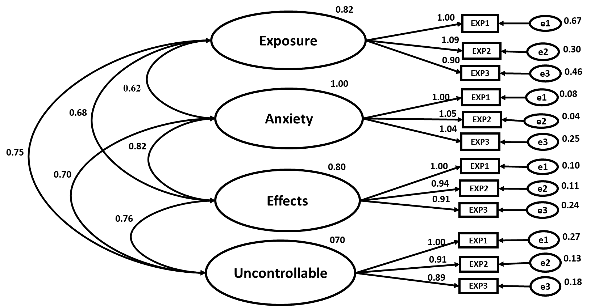

Appendix 4 Validity on Students’ Level of Earthquake Risk Perception
Latent Variable | CR | AVE | MSV | MaxR  (H) | Exposure | Anxiety | Effects | Uncontrollable
Exposure | 0.82 | 0.60 | 0.43 | 0.84 | 0.77
Anxiety | 0.90 | 0.75 | 0.52 | 0.91 | 0.65*** | 0.86
Effects | 0.88 | 0.79 | 0.66 | 0.90 | 0.59*** | 0.72*** | 0.88
Uncontrollable | 0.95 | 0.87 | 0.66 | 0.97 | 0.50*** | 0.59*** | 0.81*** | 0.93

Appendix 5 Eeffects of Earthquake Risk perception on Students’ Metacognition.

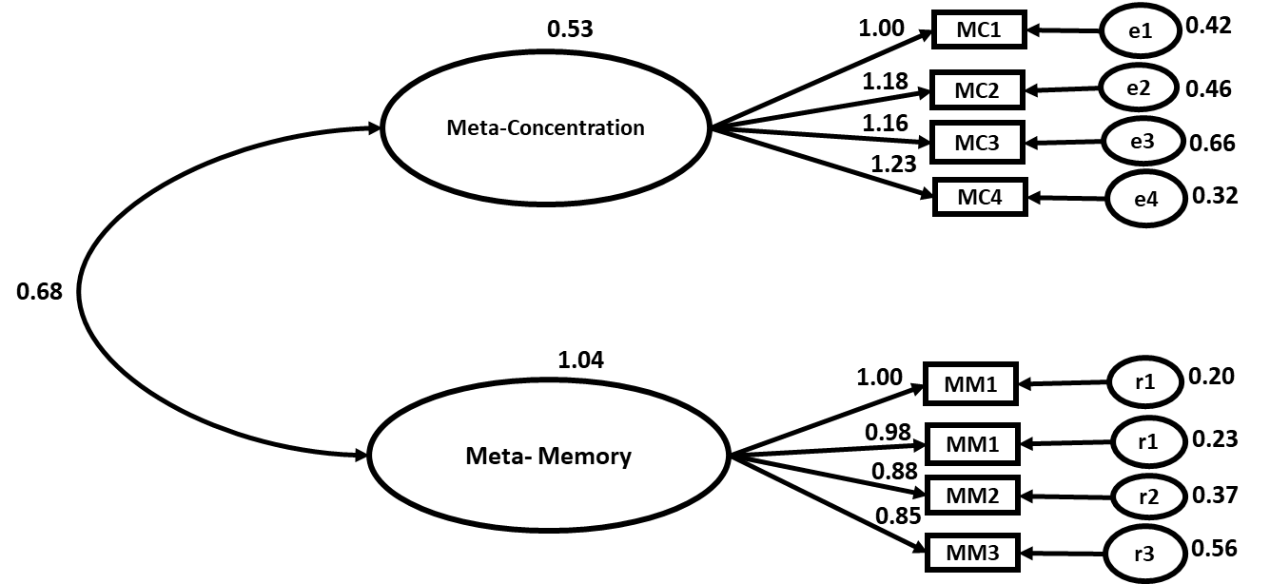

Appendix 6 Validity on the Effect of Earthquake Risk Perception on Students’ Metacognition
Hypothetical variable | CR | AVE | MSV | MaxR(H) | Meta-Concentration | Meta-Memory
Meta-Concentration | 0.92 | 0.74 | 0.51 | 0.94 | 0.9
Meta-Memory | 0.86 | 0.61 | 0.51 | 0.88 | 0.898*** | 0.779

