Supplementary Material

Dispersive Liquid - Liquid Microextraction for the Determination of Sulfonamide Residues in Egg Samples
Eskinder, Teklu.^{1,2*}, Dube, S.¹, Nindi, M.M.³

1. Department of Chemistry, College of Science Engineering and Technology, Science Campus, University of South Africa, Corner Christian de Wet and Pioneer Avenue Florida Park, Roodeport 1709, Gauteng, South Africa
2. Department of Chemistry, College of Natural and Computational Sciences, Debre Berhan University (DBU), Debre Berhan, Ethiopia
3. Institute for Nanotechnology and Water Sustainability (iNanoWS), the Science Campus, College of Science Engineering and Technology
*Correspondence should be addressed to eskinderteklu7@ gmail.com

min
1
2
3
4
5
mAU
0
20
40
60
80

SGD
SAM
SAA
SDZ
STZ
SPY
SMR
SMT
SMM

SCP
SMX
SSO
SBZ
SQZ
SSA

Figure S1 A chromatogram of 15 separated sulfonamide standards (100 µg L⁻¹) at 265 nm. Chromatographic conditions: flow rate of 1.8 mL min⁻¹, column temperature 40 °C, injection volume of 5 μL, wavelength of 265 nm. A binary mobile phase comprising of solvent A (0.1% FA water) and solvent B (acetonitrile) with a gradient elution program of 10% B (0 - 1 min), 40% B (1 - 4 min), and 60% B (4 - 6 min)

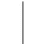
mAU

8
6
4
2
0
1
2
3
4
5 min

Figure S2. A chromatogram of blank egg sample. Chromatographic conditions: flow rate of 1.8 mL min⁻¹; column temperature 40 °C; injection volume of 5 μL; wavelength of 265 nm. A binary mobile phase comprising of solvent A (0.1% FA in water) and solvent B (acetonitrile) with a gradient elution program of 10% B (0 - 1 min), 40% (1 - 4 min) and 60% B (4 - 6 min).


mA
U
1.
5

1
0.
5

0
-
0.5
SMX
- 1
1
2
3
4
5
mi
n

Figure S3. A chromatogram of real egg sample. Chromatographic conditions: flow rate of 1.8 mL min⁻¹; column temperature 40 °C; injection volume of 5 μL; wavelength of 265 nm. A binary mobile phase comprising of solvent A (0.1% FA in water) and solvent B (acetonitrile) with a gradient elution program of 10% B (0 – 1 min), 40% B (1 - 4 min) and 60% B (4 - 6 min).

Table S1
Compounds | Structures | CAS Number | K_{OW} | pKa Values  (pKa₁, pKa₂, pKa₃) | Reference
SGD | 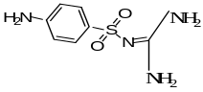 | 57-67-0 | -1.07 | 0.5± 0.1; 0.4 ± 0.1; 3.3 ± 0.4 | (Msagati and Nindi 2004)
SAM | 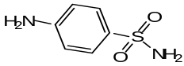 | 63-74 - 1 | -0.67 | 2.4; 10.4 | (Dub etal 2011)
SAA | 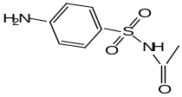 | 144 - 80-9 | 0.11 | 1.3 ± 0.1; 5.6 ± 0.5 | (Msagati and Nindi 2004)
SDZ | 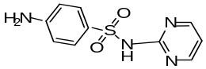 | 68-35-9 | 0.81 | 1.6 ± 0.1;6.8 ± 0.50; 0.35 ± 0.2 | (Msagati and Nindi 2004)
STZ | 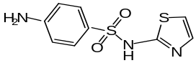 | 72-14 - 0 | 0.72 | 0.7 ± 0.1;7.8 ±0.5;2.3±0.5 | (Msagati and Nindi 2004)
SPY | 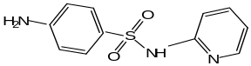 | 444-83-2 | 1.07 | 0.8±0.1;8.0±0.5, 2.90 ±0.5 | (Msagati and Nindi 2004)
SMR | 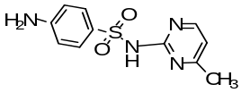 | 127- 97- 7 | 0.14 | 1.6 ± 0.1, 6.9 ± 0.5, 0.4 ± 0.1 | (Msagati and Nindi 2004)
SMT | 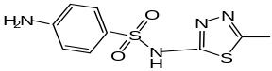 | 144 - 82-1 | 0.53 | 1.2± 0.1;7.0 ± 0.5 | (Msagati and Nindi 2004)
SMM | 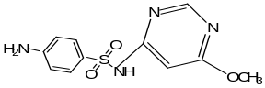 | 1220 - 83-3 | 0.89 | 0.8 ± 0.1, 6.7 ± 0.5, 2.9 ± 0.4 | (Msagati and Nindi 2004)
SCP | 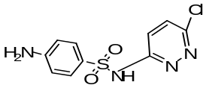 | 80-32-0 | 2.04 | 1.80, 5.70 | (Msagati and Nindi 2004)
SMX | 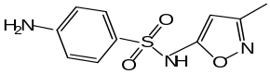 | 723- 46 - 6 | 0.89 | 1.4 ± 0.1, 7.7± 0.5 | (Msagati and Nindi 2004)
SSO | 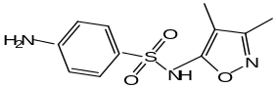 | 127-69-5 | 1.01 | 1.50, 5.00 | [(Abdallah etal 2014)
SBZ | 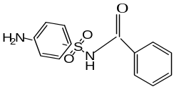 | 127 - 71 - 9 | - | 1.1±0.1; 5.90±0.5 | Msagati and Nindi 2004)
SQZ | 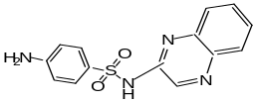 | 59 - 40 - 5 | 1.69 | -1.4 ± 0.3 ,1.2 ± 0.1, 7.6 ± 0.3 | (Msagati and Nindi 2004)
SSA | 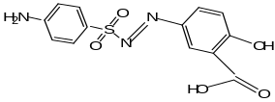 | 599 - 79 -1 | 3.8 | 1.9 ± 02; 2.9 ± 0.1; 1.2 ± 0.2; 7± 0.5 | (Msagati and Nindi 2004)

