SUPPORTING INFORMATION

Parallel synthesis of condensed pyrimidine-thiones and their antitumor activities
Buer Song ^{1,2}, Lifei Nie ¹, Khurshed Bozorov ^{1,3}, Rustamkhon Kuryazov ^{3,4}, *, Haji Akber Aisa ^{1,2,}, Jiangyu Zhao ^{1,*}
¹ State Key Laboratory Basis of Xinjiang Indigenous Medicinal Plants Resource Utilization, Xinjiang Technical Institute of Physics and Chemistry, Chinese Academy of Sciences, South Beijing Rd 40-1, Urumqi, 830011, P.R. China
² University of Chinese Academy of Sciences, 19 A Yuquan Rd, Beijing, 100049, P.R. China
³ Faculty of Chemistry, Samarkand State University, University blv. 15, Samarkand, 140104, Uzbekistan
⁴ Urgench State University, Kh. Olimjon st. 14, Urgench, 220100, Uzbekistan

¹H, ¹³C NMR spectrums and HRMS of compounds 12a-12aa and 13a-13aa

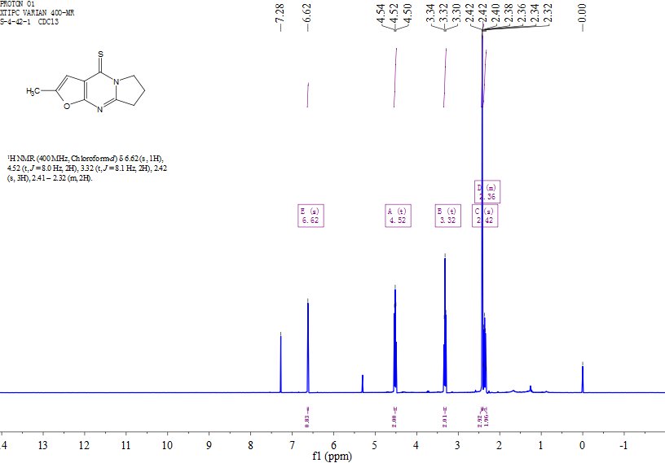
Figure S1. ¹H NMR spectrum of 12a
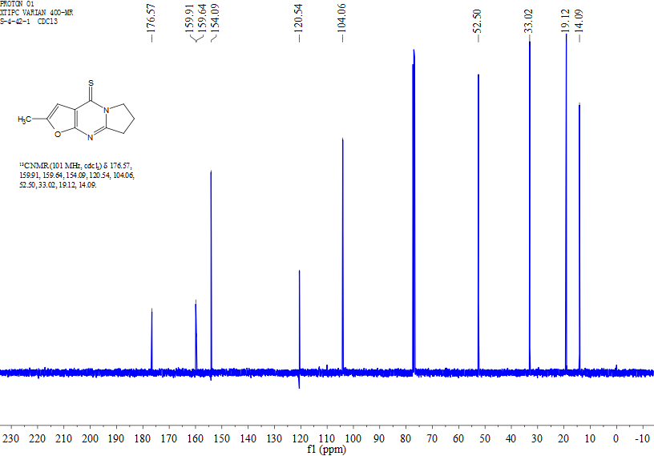
Figure S2. ¹³C NMR spectrum of 12a

Figure S3. HRMS of 12a
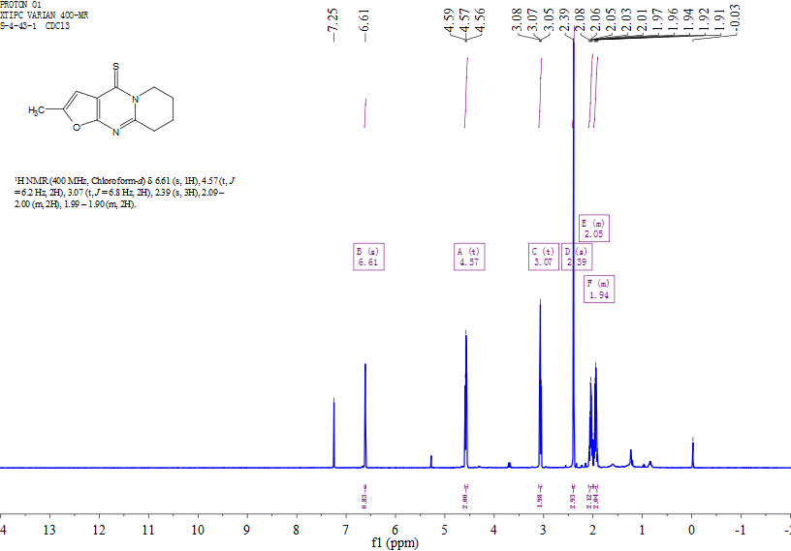
Figure S4. ¹H NMR spectrum of 12b

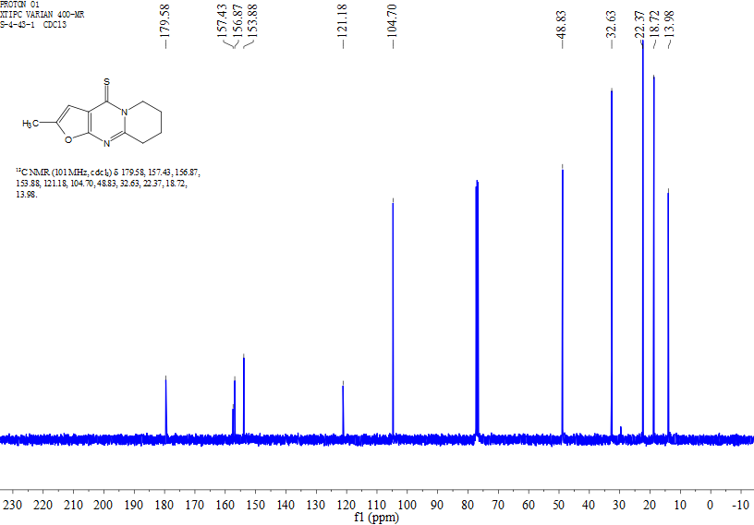
Figure S5. ¹³C NMR spectrum of 12b
Figure S6. HRMS of 12b

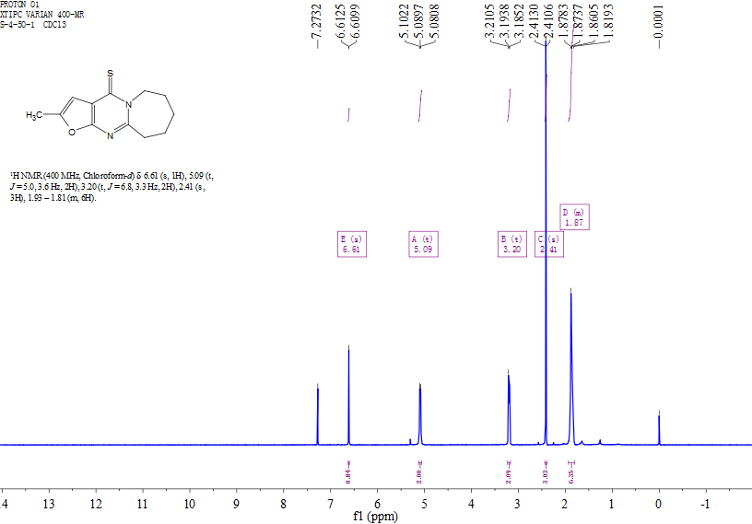
Figure S7. ¹H NMR spectrum of 12c
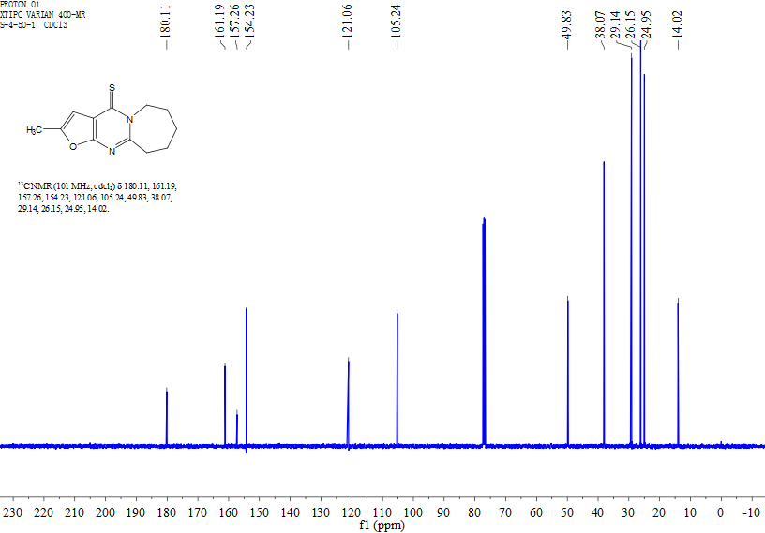
Figure S8. ¹³C NMR spectrum of 12c

Figure S9. HRMS of 12c
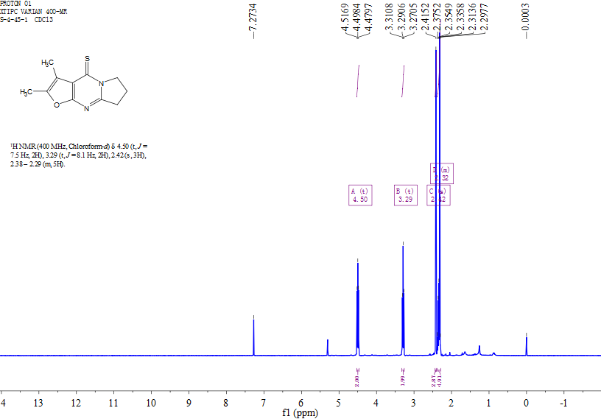
Figure S10. ¹H NMR spectrum of 12d

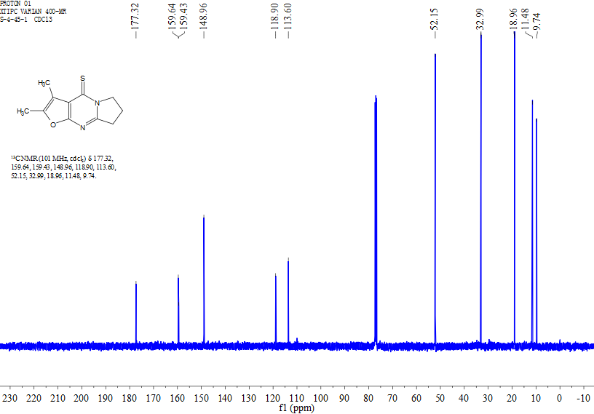
Figure S11. ¹³C NMR spectrum of 12d
Figure S12. HRMS of 12d

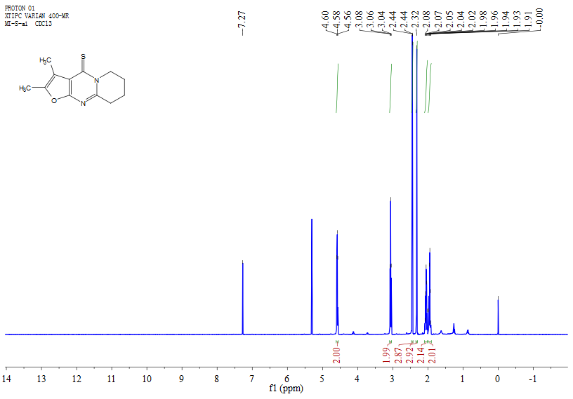
Figure S13. ¹H NMR spectrum of 12e
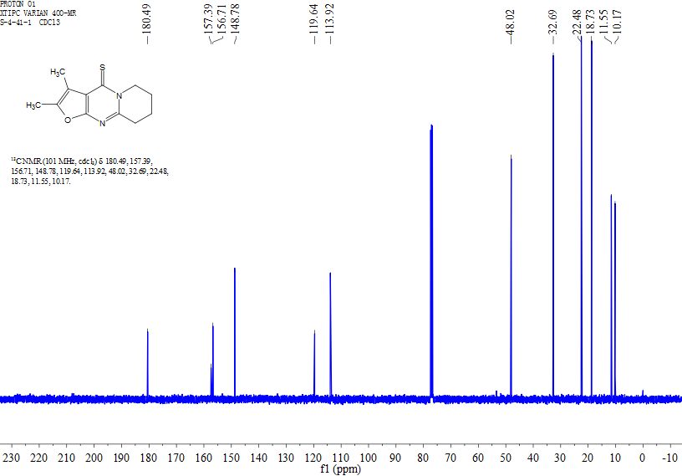
Figure S14. ¹³C NMR spectrum of 12e

Figure S15. HRMS of 12e
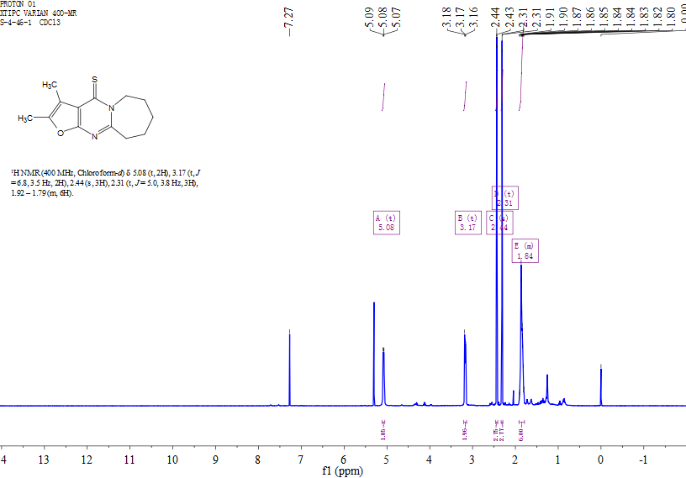
Figure S16. ¹H NMR spectrum of 12f

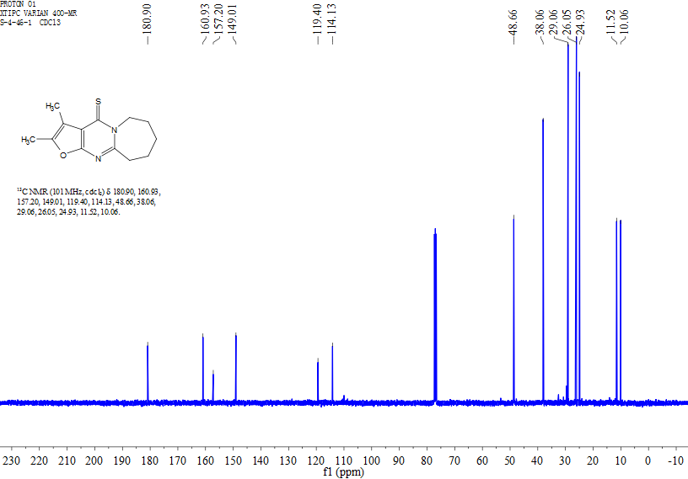
Figure S17. ¹³C NMR spectrum of 12f
Figure S18. HRMS of 12f

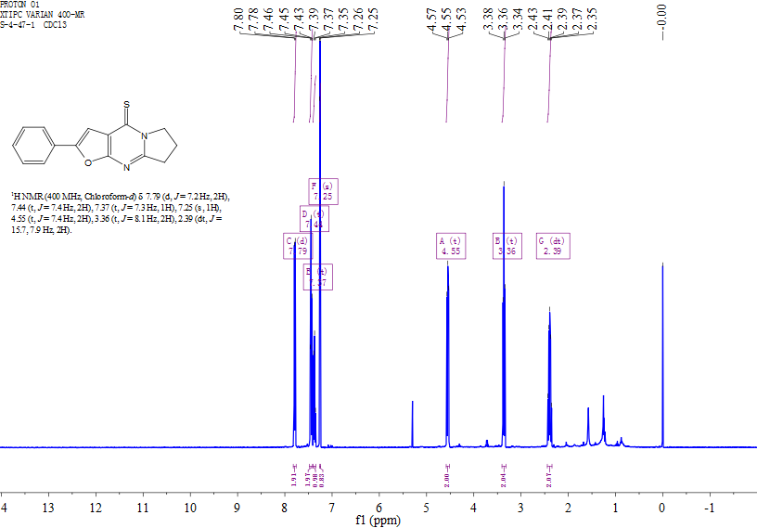
Figure S19. ¹H NMR spectrum of 12g
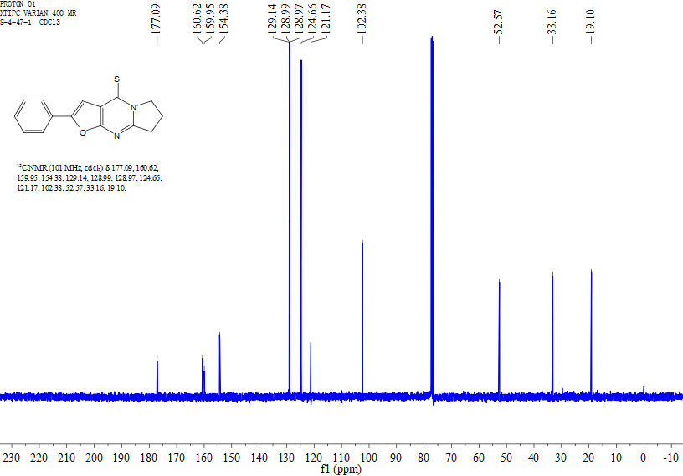
Figure S20. ¹³C NMR spectrum of 12g

Figure S21. HRMS of 12g
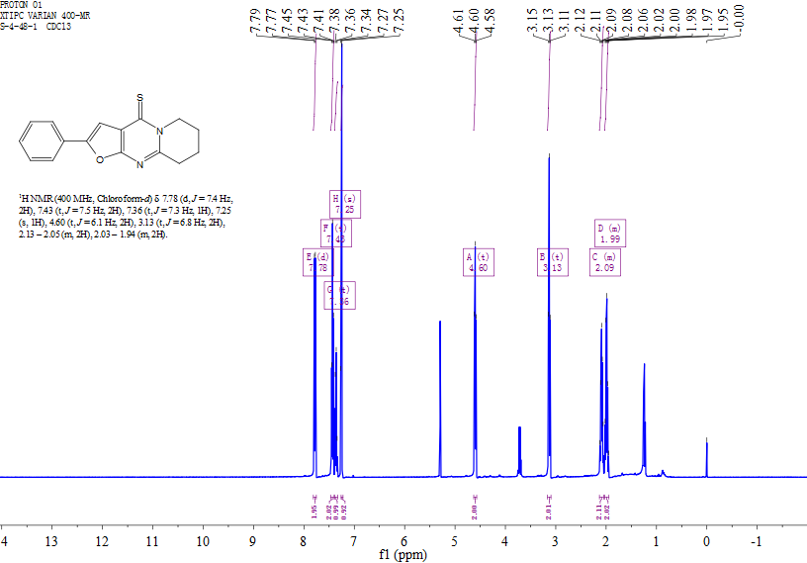
Figure S22. ¹H NMR spectrum of 12h
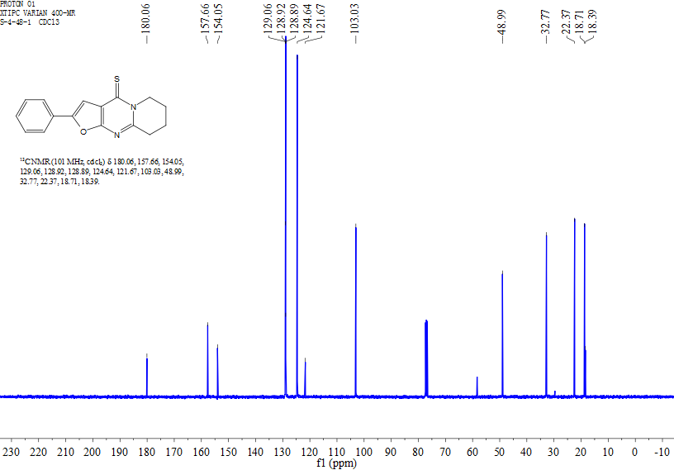
Figure S23. ¹³C NMR spectrum of 12h
Figure S24. HRMS of 12h

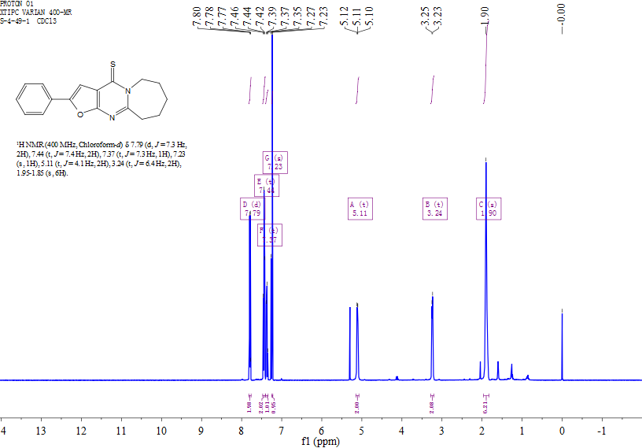
Figure S25. ¹H NMR spectrum of 12i
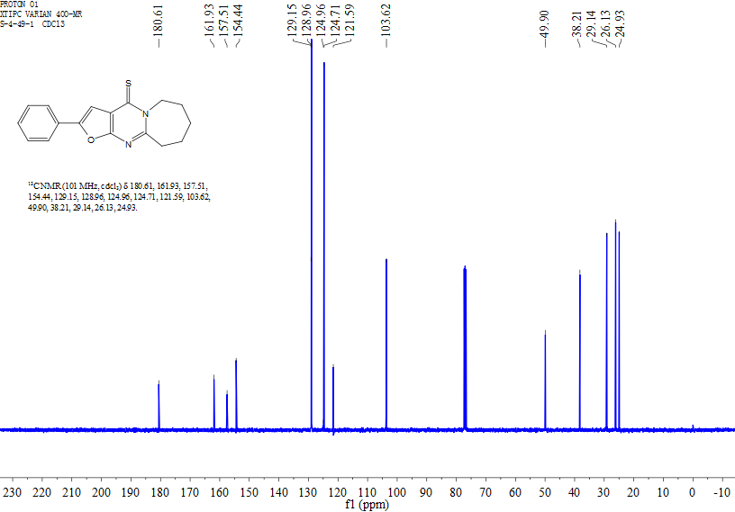
Figure S26. ¹³C NMR spectrum of 12i

Figure S27. HRMS of 12i
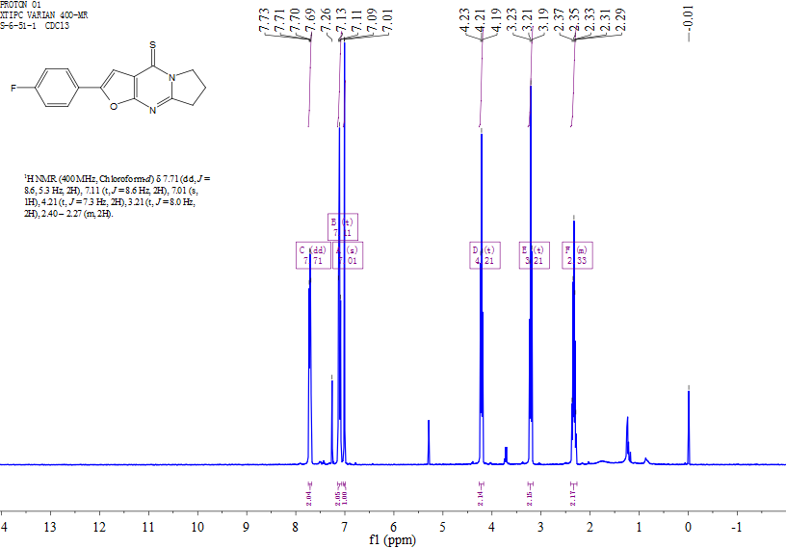
Figure S28. ¹H NMR spectrum of 12j
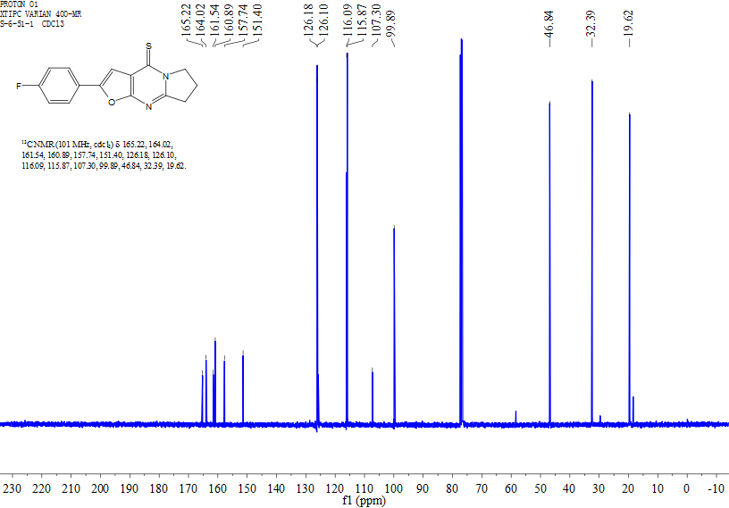
Figure S29. ¹³C NMR spectrum of 12j
Figure S30. HRMS of 12j

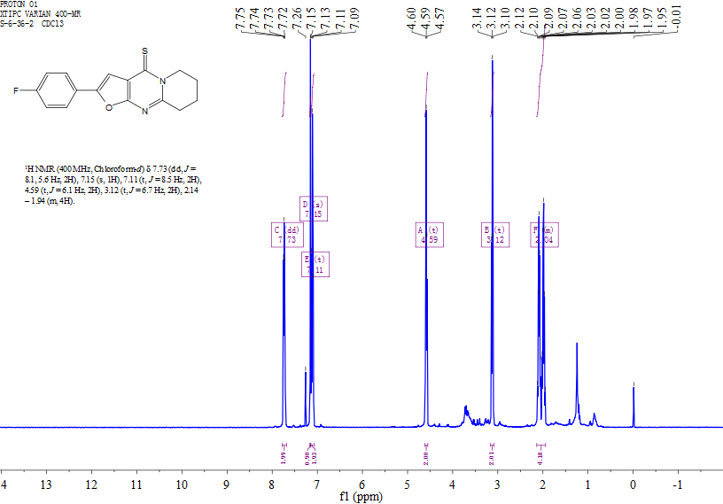
Figure S31. ¹H NMR spectrum of 12k
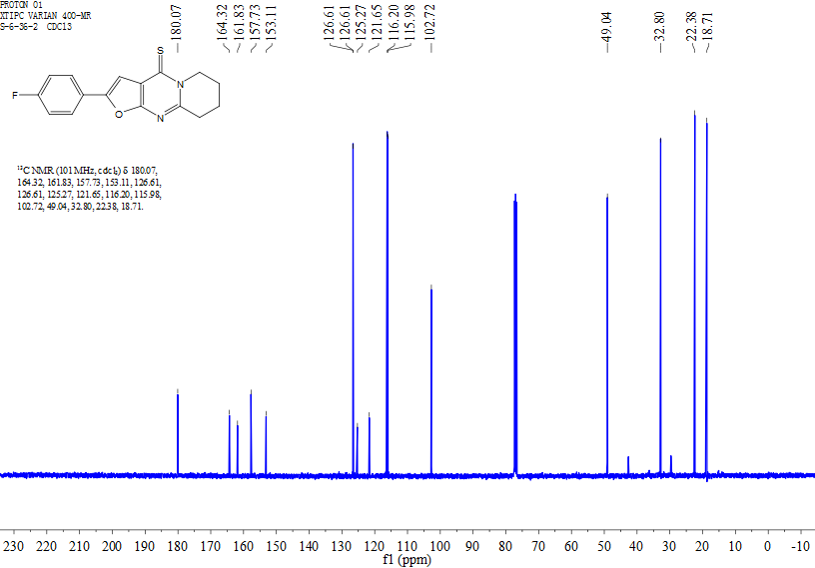
Figure S32. ¹³C NMR spectrum of 12k

Figure S33. HRMS of 12k
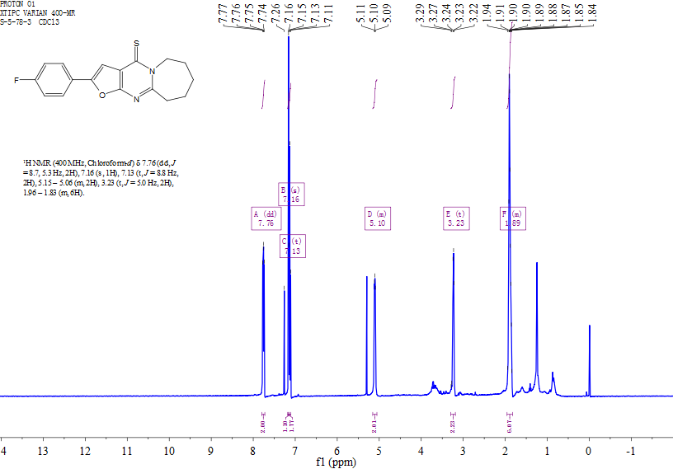
Figure S34. ¹H NMR spectrum of 12l

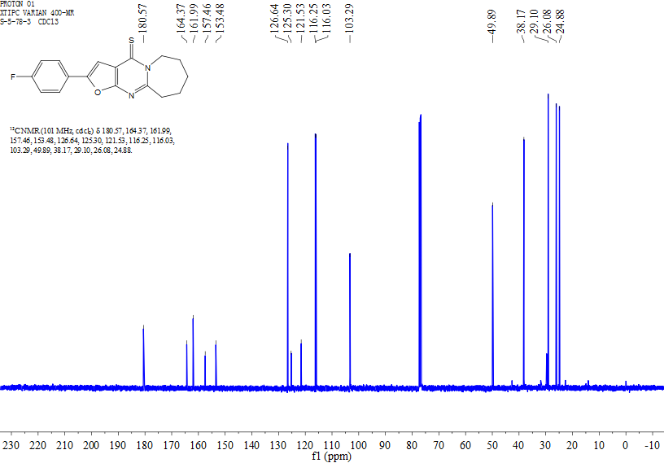
Figure S35. ¹³C NMR spectrum of 12l
Figure S36. HRMS of 12l

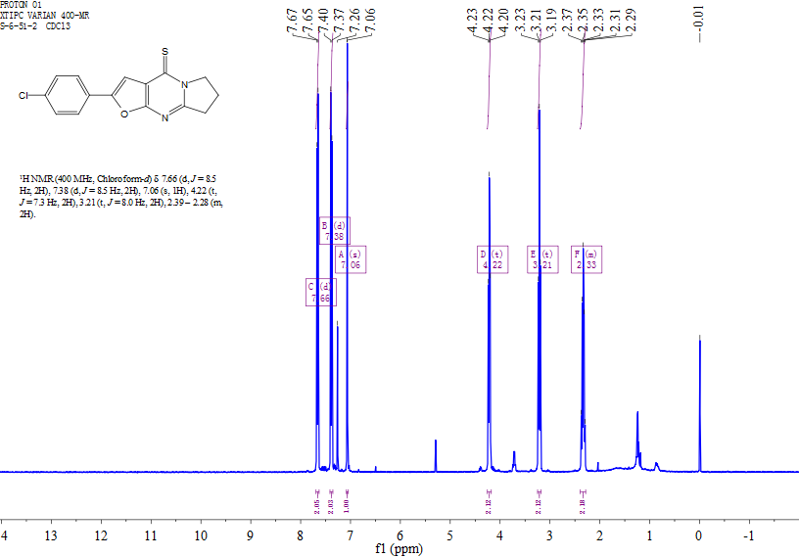
Figure S37. ¹H NMR spectrum of 12m
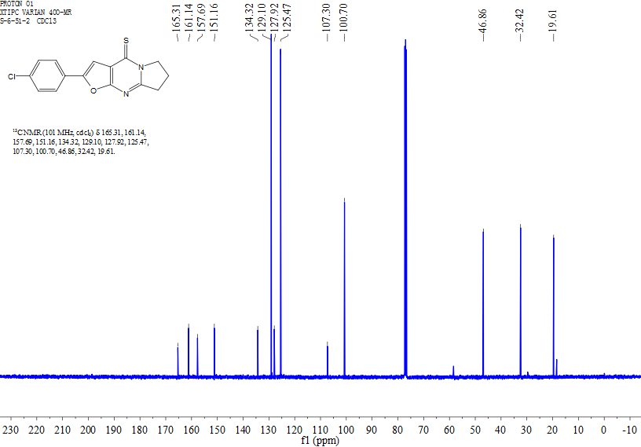
Figure S38. ¹³C NMR spectrum of 12m

Figure S39. HRMS of 12m
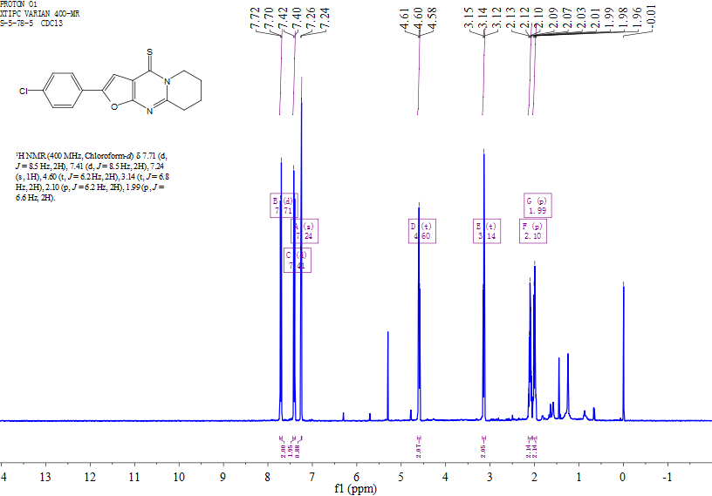
Figure S40. ¹H NMR spectrum of 12n

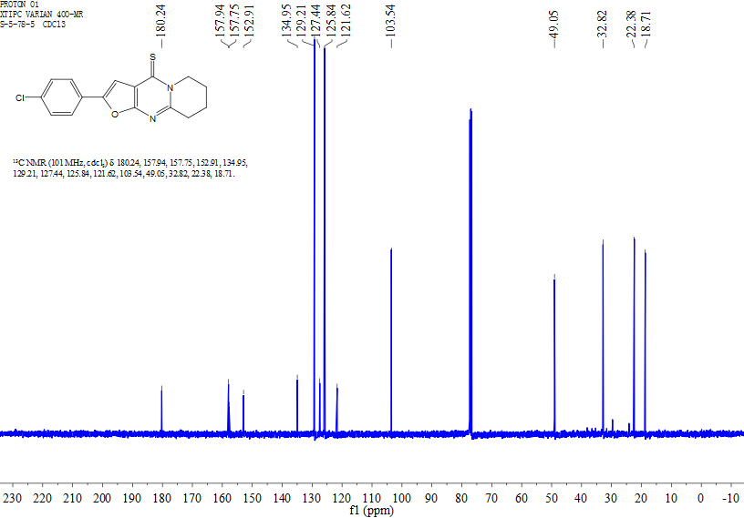
Figure S41. ¹³C NMR spectrum of 12n
Figure S42. HRMS of 12n

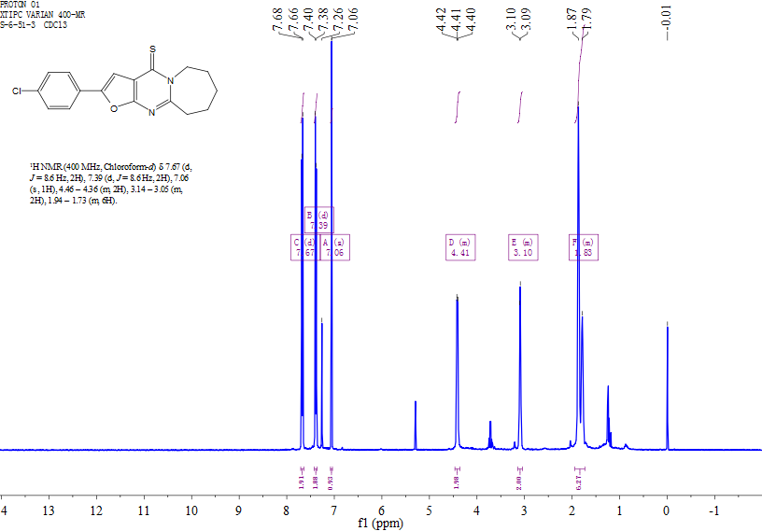
Figure S43. ¹H NMR spectrum of 7o
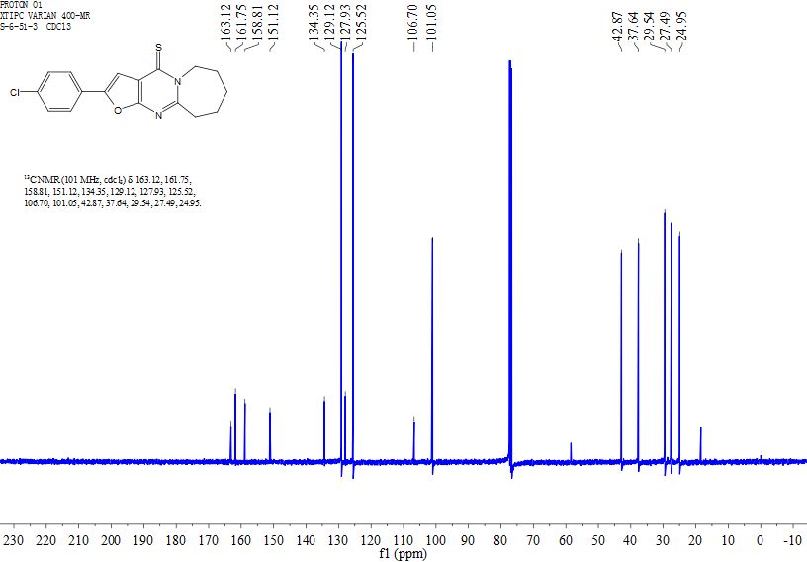
Figure S44. ¹³C NMR spectrum of 7o

Figure S45. HRMS of 12o
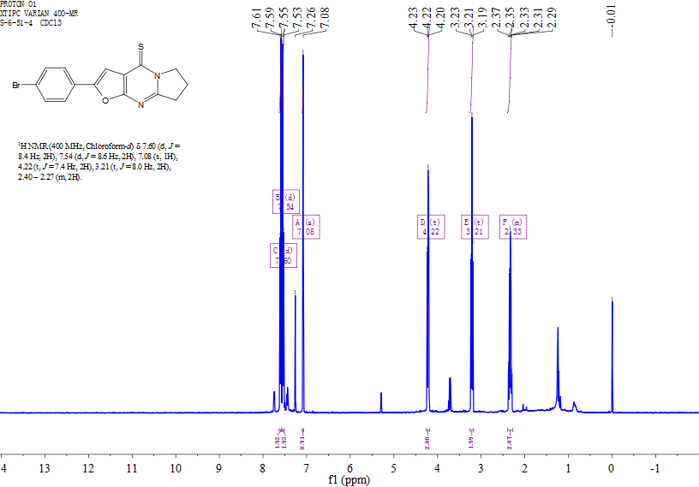
Figure S46. ¹H NMR spectrum of 12p

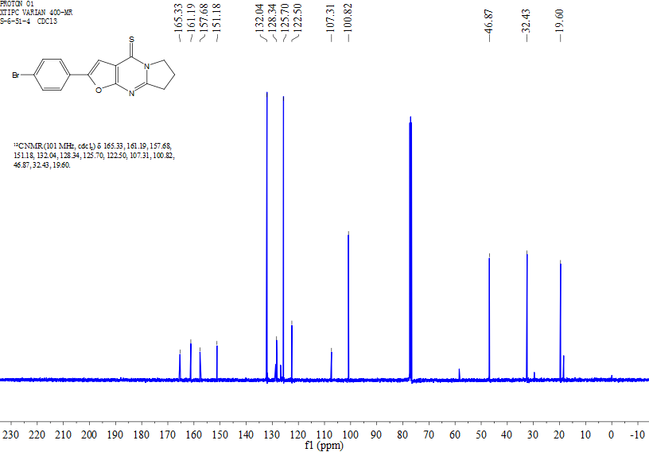
Figure S47. ¹³C NMR spectrum of 12p
Figure S48. HRMS of 12p

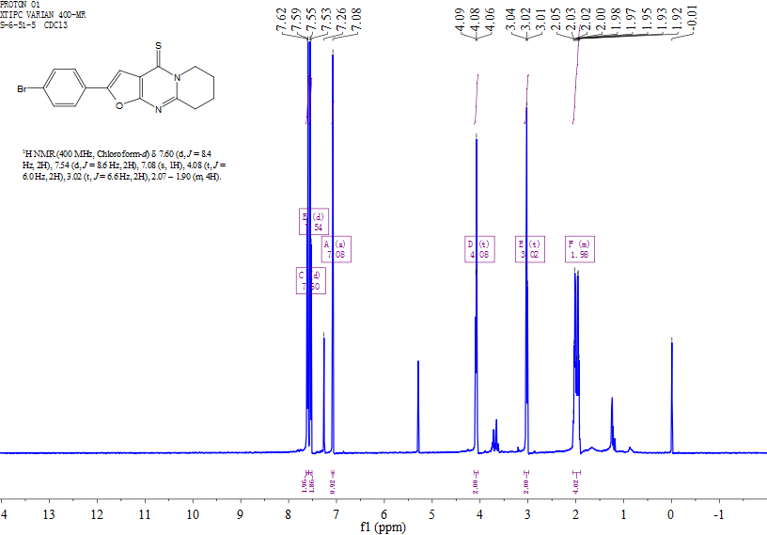
Figure S49. ¹H NMR spectrum of 12q
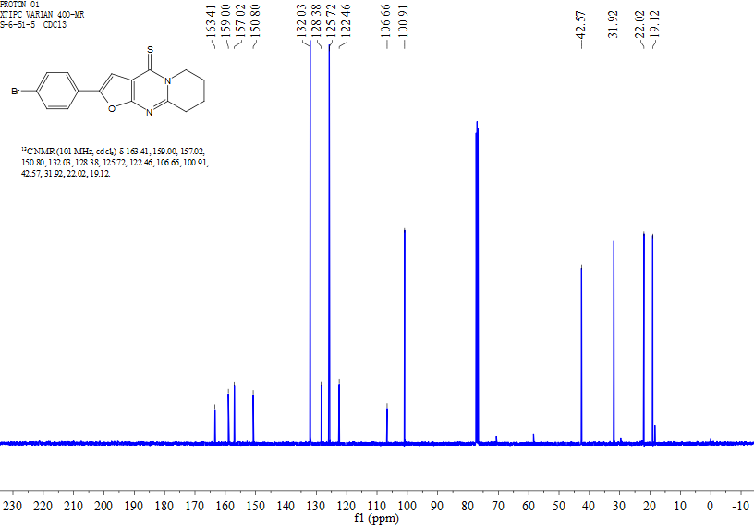
Figure S50. ¹³C NMR spectrum of 12q

Figure S51. HRMS of 12q
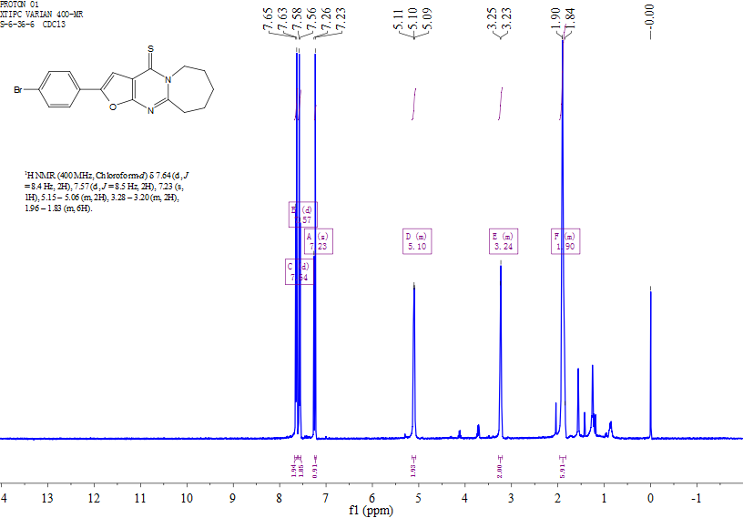
Figure S52. ¹H NMR spectrum of 12r

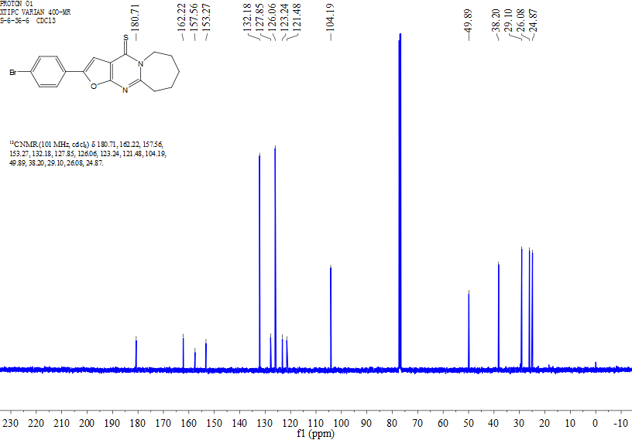
Figure S53. ¹³C NMR spectrum of 12r
Figure S54. HRMS of 12r

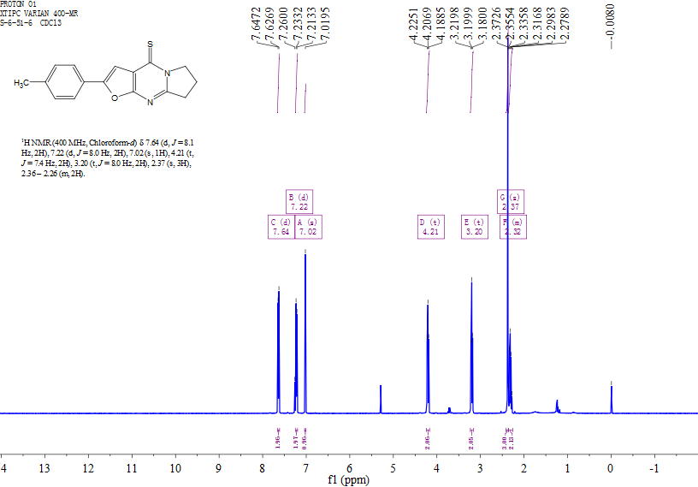
Figure S55. ¹H NMR spectrum of 12s
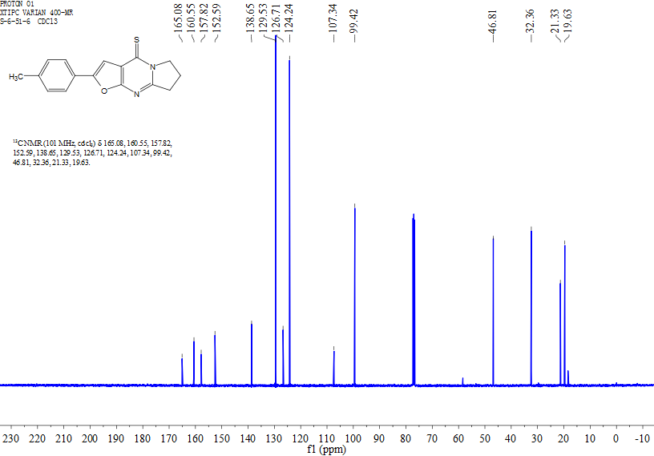
Figure S56. ¹³C NMR spectrum of 12s

Figure S57. HRMS of 12s
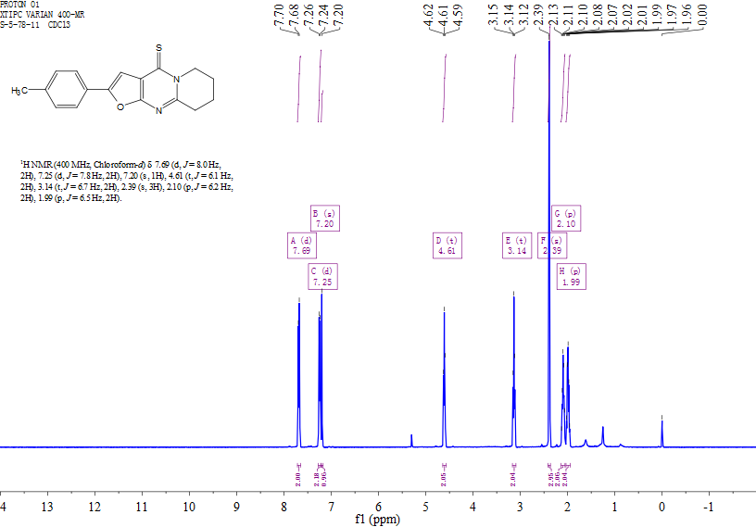
Figure S58. ¹H NMR spectrum of 12t

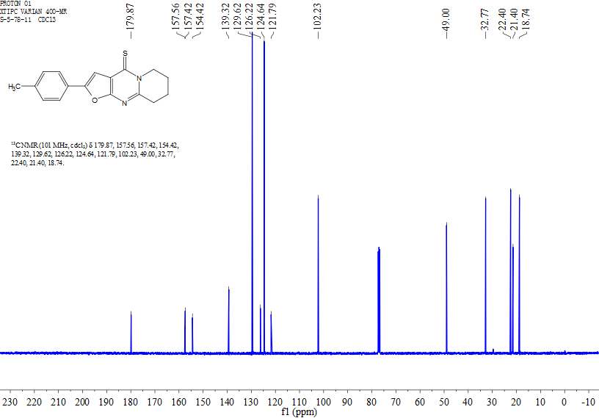
Figure S59. ¹³C NMR spectrum of 12t
Figure S60. HRMS of 12t

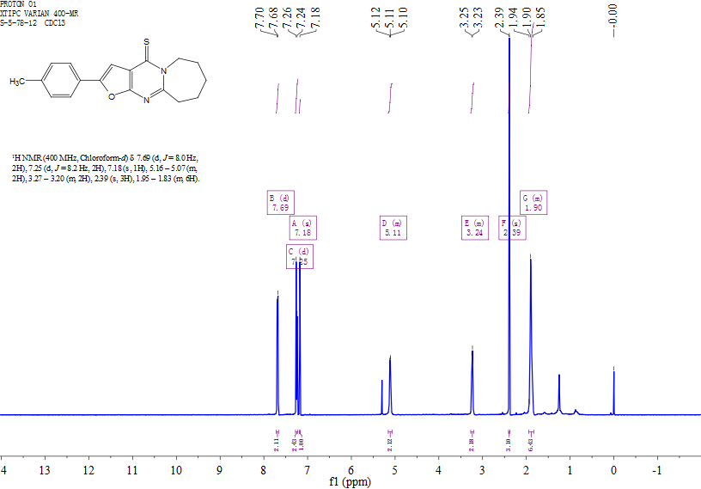
Figure S61. ¹H NMR spectrum of 12u
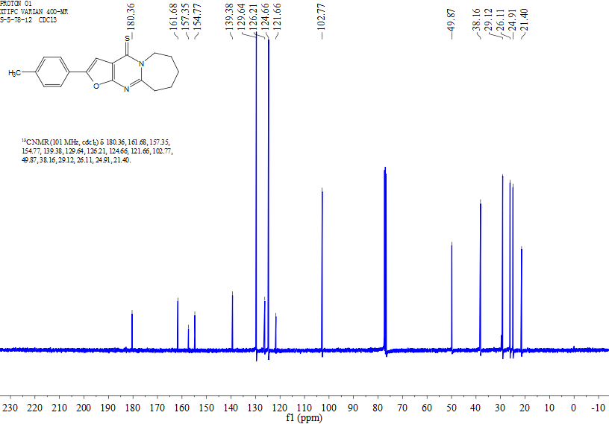
Figure S62. ¹³C NMR spectrum of 12u

Figure S63. HRMS of 12u
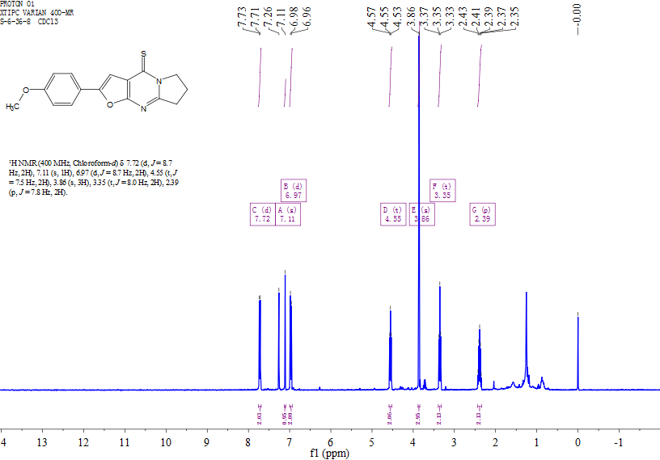
Figure S64. ¹H NMR spectrum of 12v

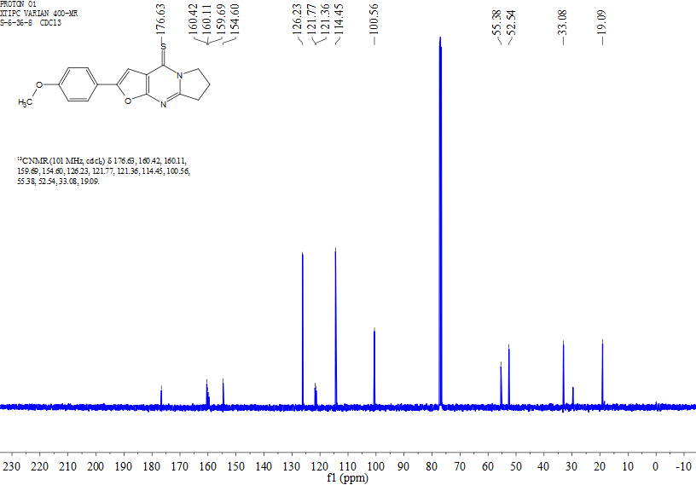
Figure S65. ¹³C NMR spectrum of 12v
Figure S66. HRMS of 12v

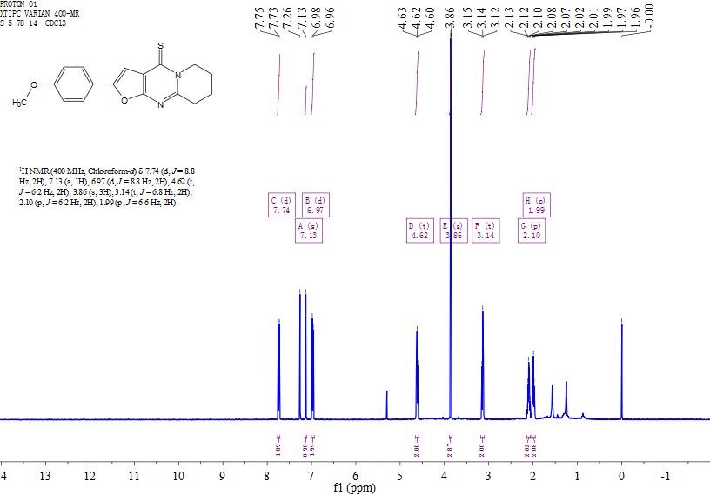
Figure S67. ¹H NMR spectrum of 12w
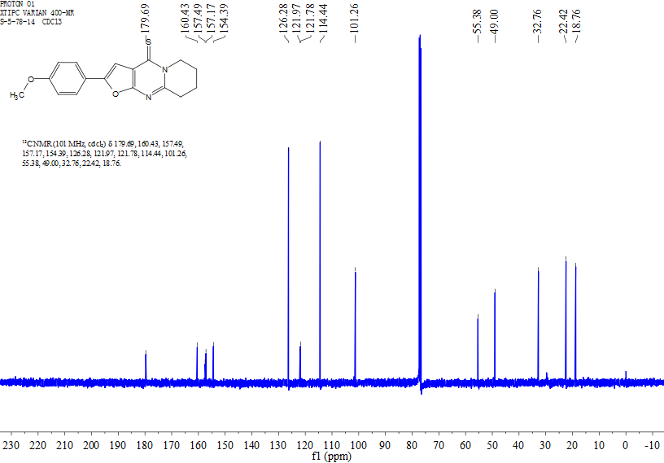
Figure S68. ¹³C NMR spectrum of 12w

Figure S69. HRMS of 12w
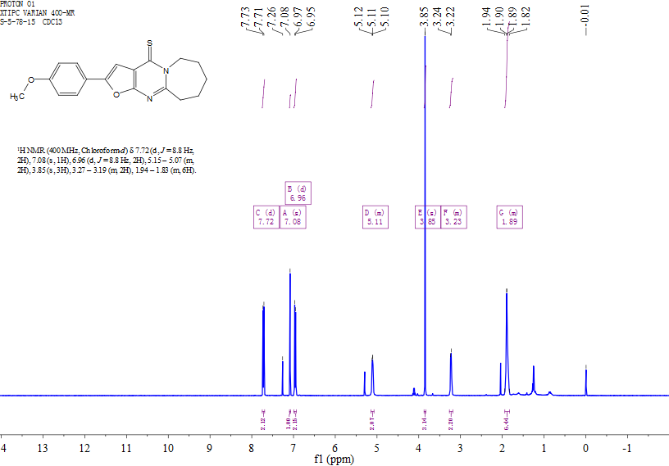
Figure S70. ¹H NMR spectrum of 12x

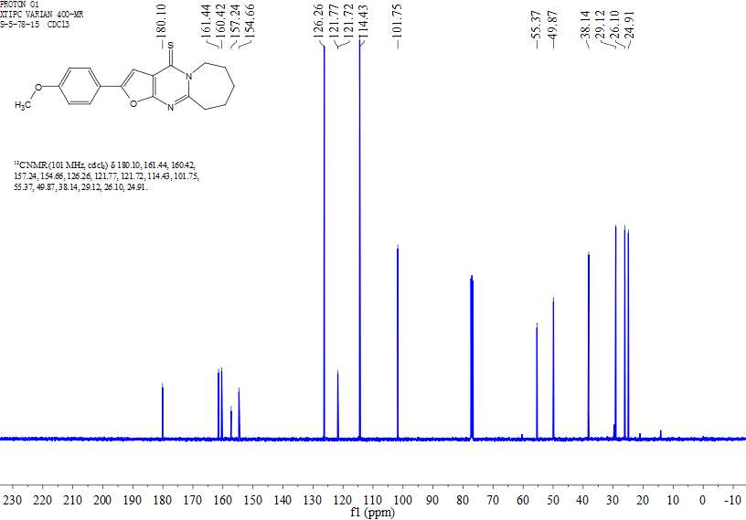
Figure S71. ¹³C NMR spectrum of 12x
Figure S72. HRMS of 12x

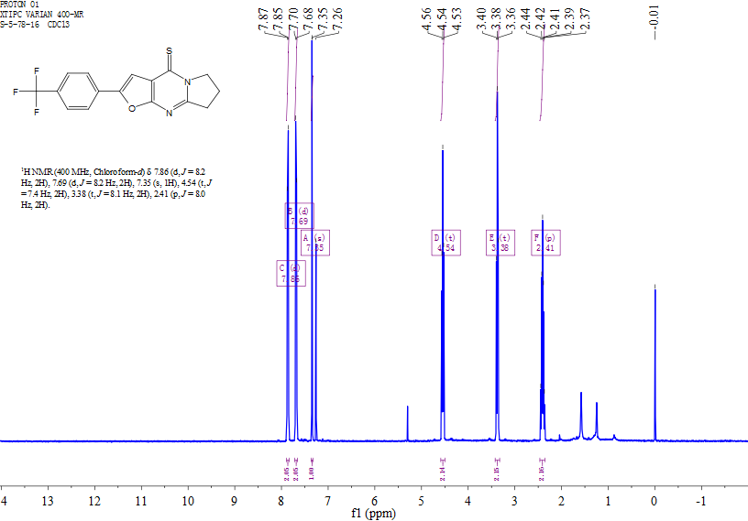
Figure S73. ¹H NMR spectrum of 12y
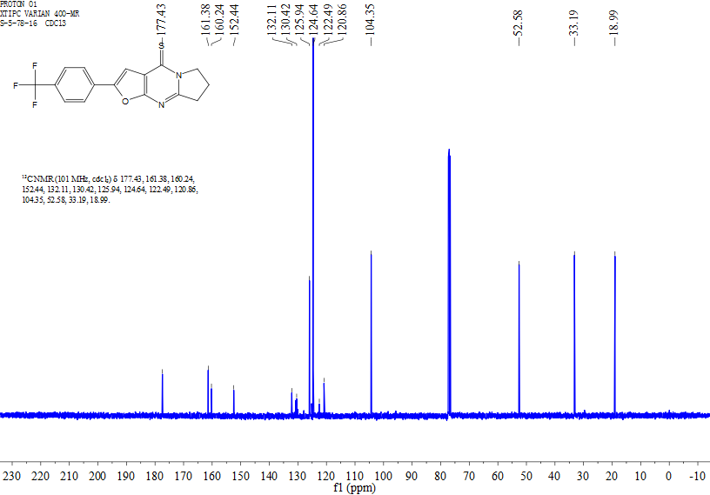
Figure S74. ¹³C NMR spectrum of 12y

Figure S75. HRMS of 12y
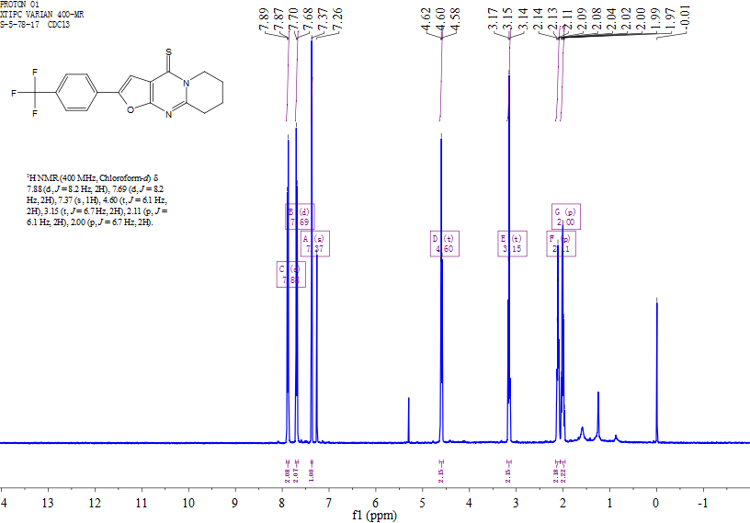
Figure S76. ¹H NMR spectrum of 12z

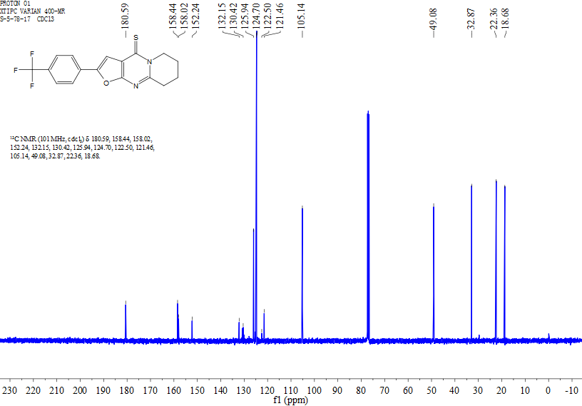
Figure S77. ¹³C NMR spectrum of 12z
Figure S78. HRMS of 12z

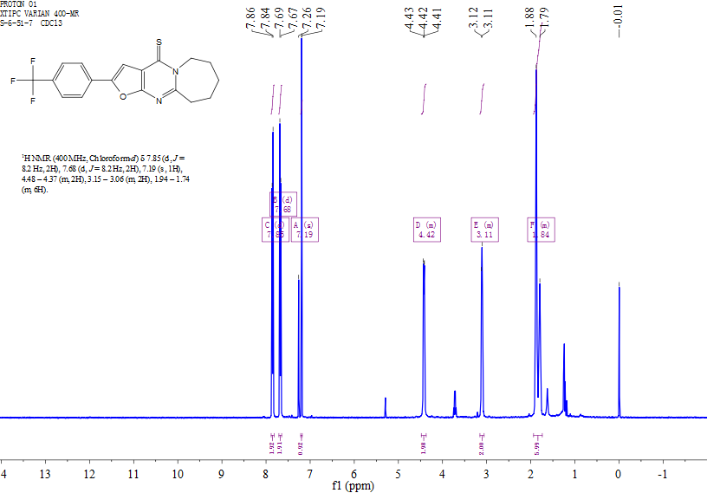
Figure S79. ¹H NMR spectrum of 12aa
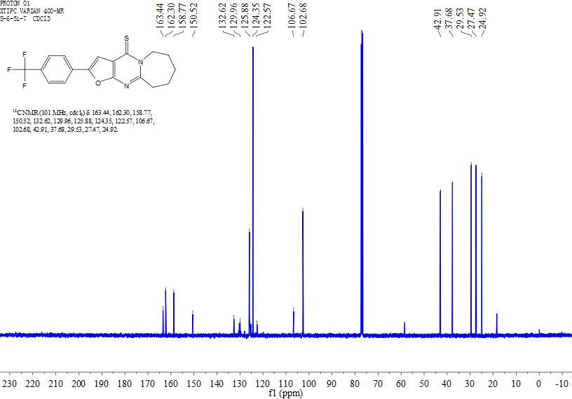
Figure S80. ¹³C NMR spectrum of 12aa

Figure S81. HRMS of 12aa
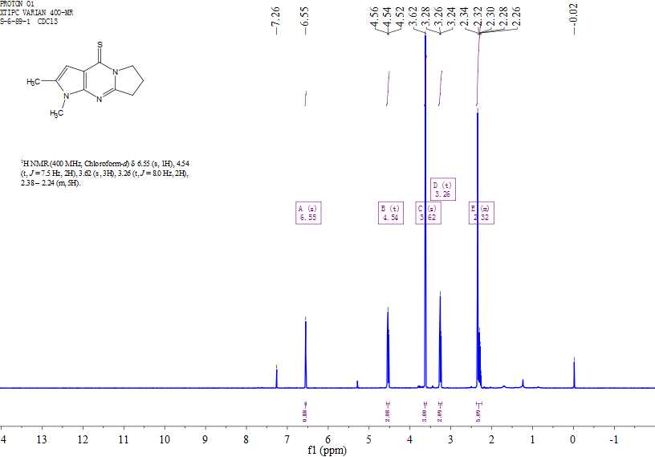
Figure S82. ¹H NMR spectrum of 13a

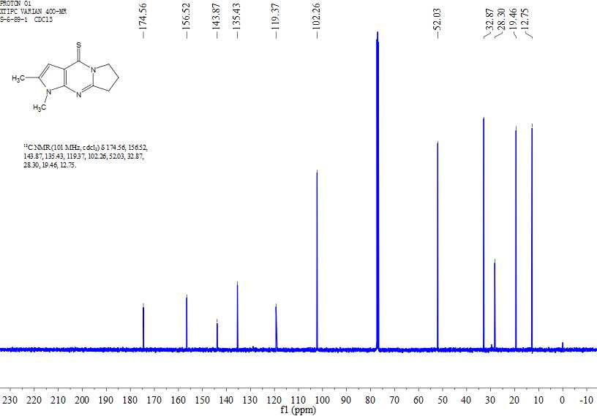
Figure S83. ¹³C NMR spectrum of 13a
Figure S84. HRMS of 13a

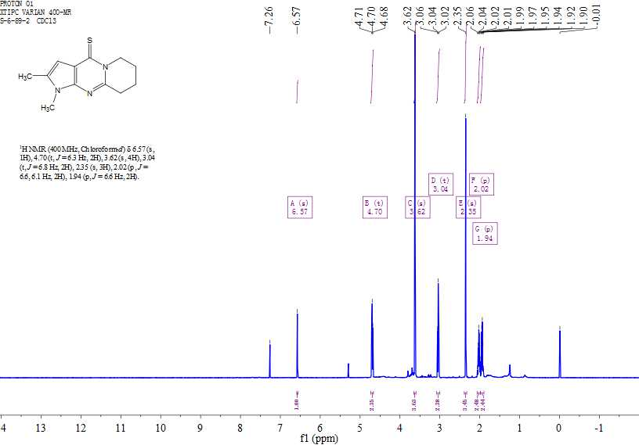
Figure S85. ¹H NMR spectrum of 13b
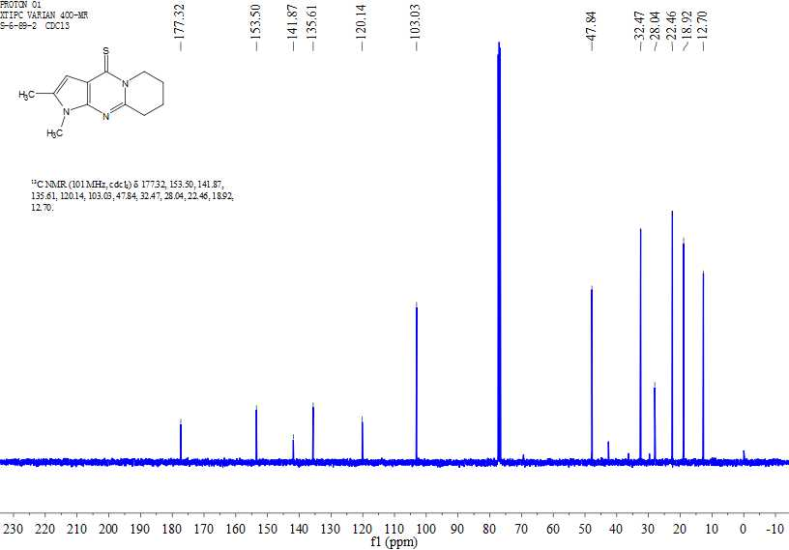
Figure S86. ¹³C NMR spectrum of 13b

Figure S87. HRMS of 13b
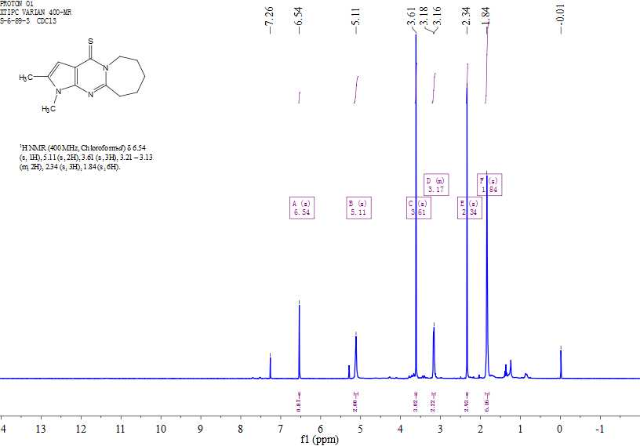
Figure S88. ¹H NMR spectrum of 13c

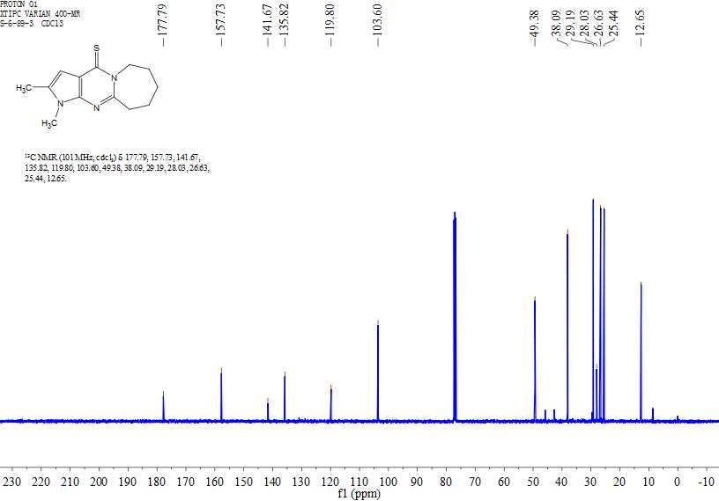
Figure S89. ¹³C NMR spectrum of 13c
Figure S90. HRMS of 13c

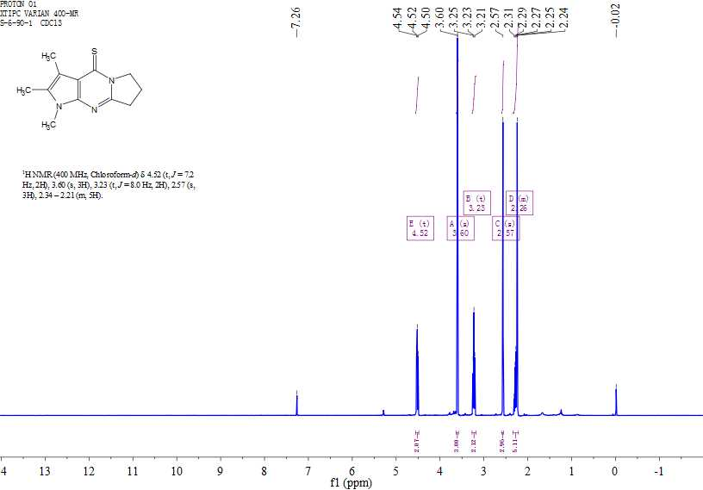
Figure S91. ¹H NMR spectrum of 13d
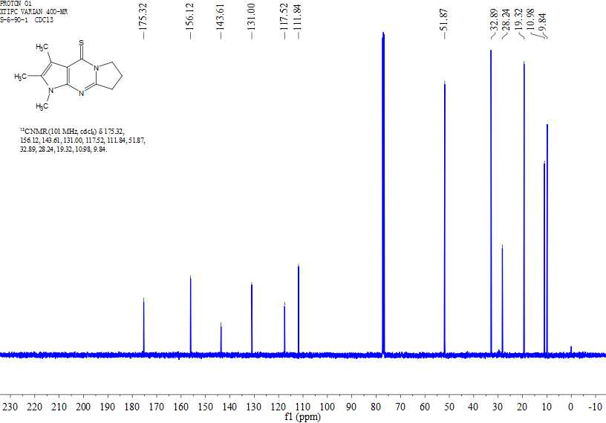
Figure S92. ¹³C NMR spectrum of 13d

Figure S93. HRMS of 13d
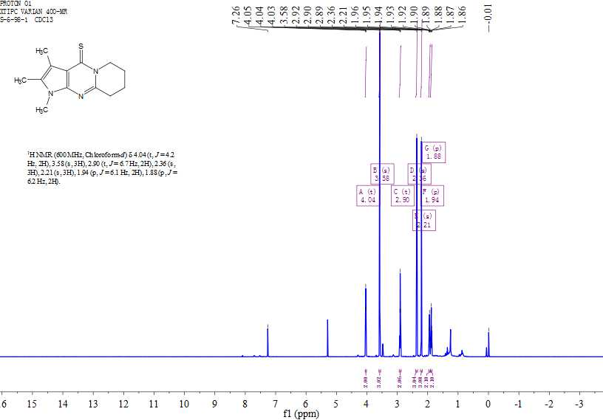
Figure S94. ¹H NMR spectrum of 13e

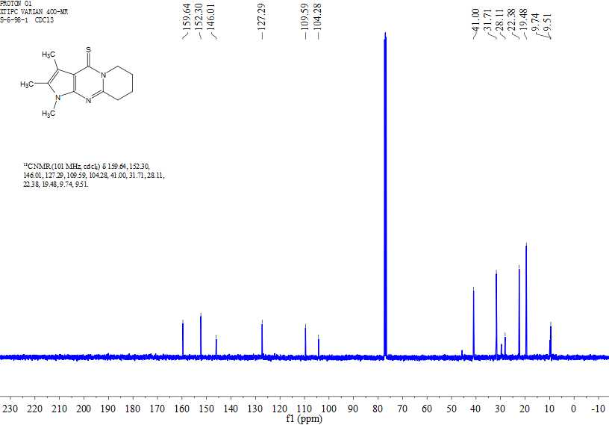
Figure S95. ¹³C NMR spectrum of 13e
Figure S96. HRMS of 13e

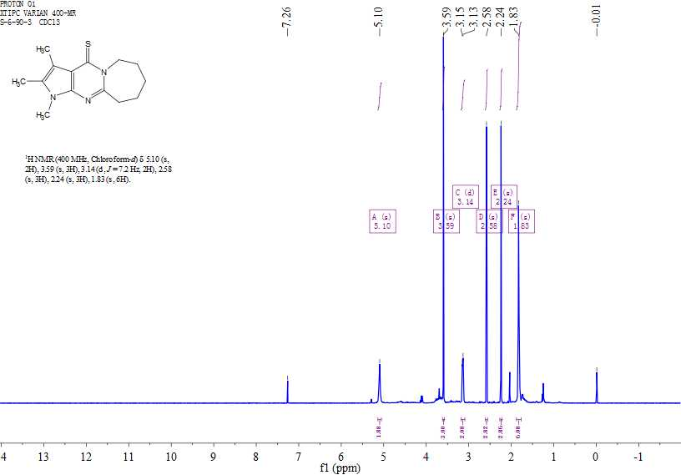
Figure S97. ¹H NMR spectrum of 13f
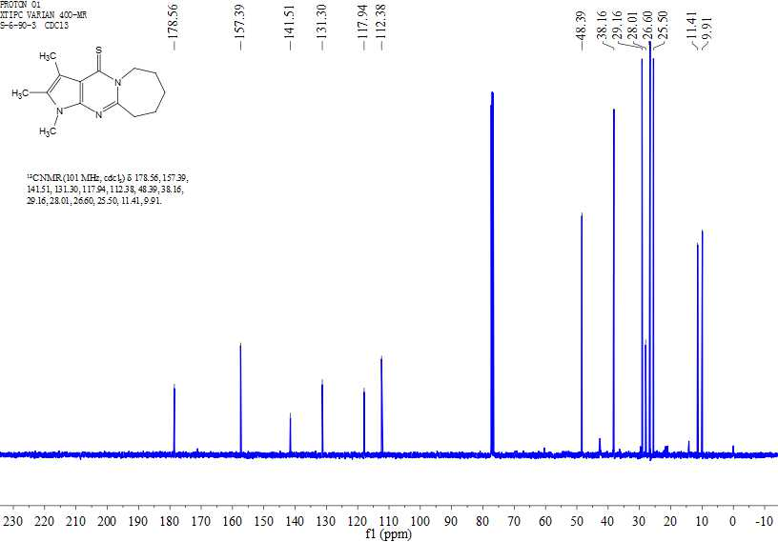
Figure S98. ¹³C NMR spectrum of 13f

Figure S99. HRMS of 13f
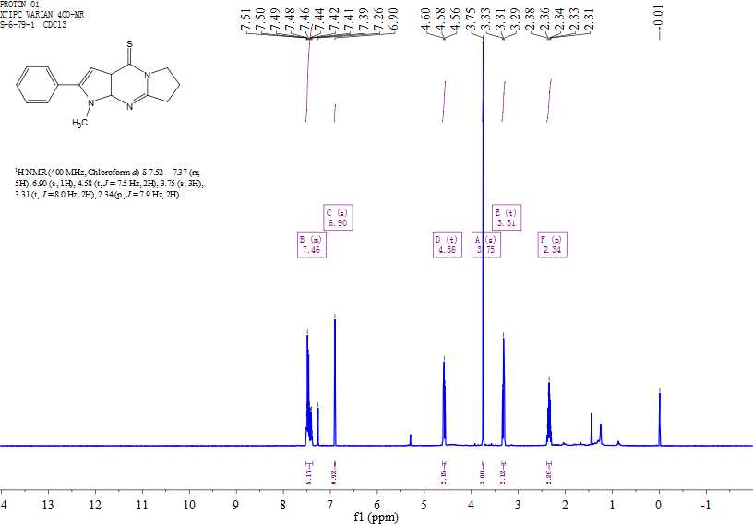
Figure S100. ¹H NMR spectrum of 13g

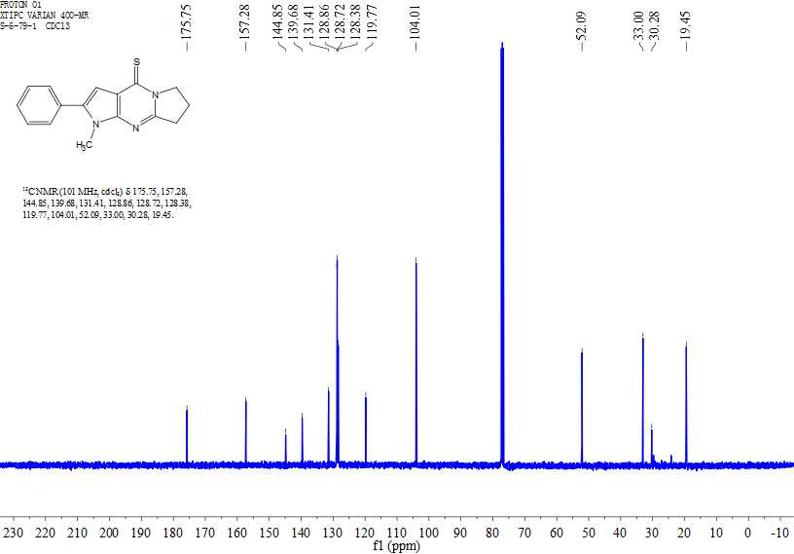
Figure S101. ¹³C NMR spectrum of 13g
Figure S102. HRMS of 13g

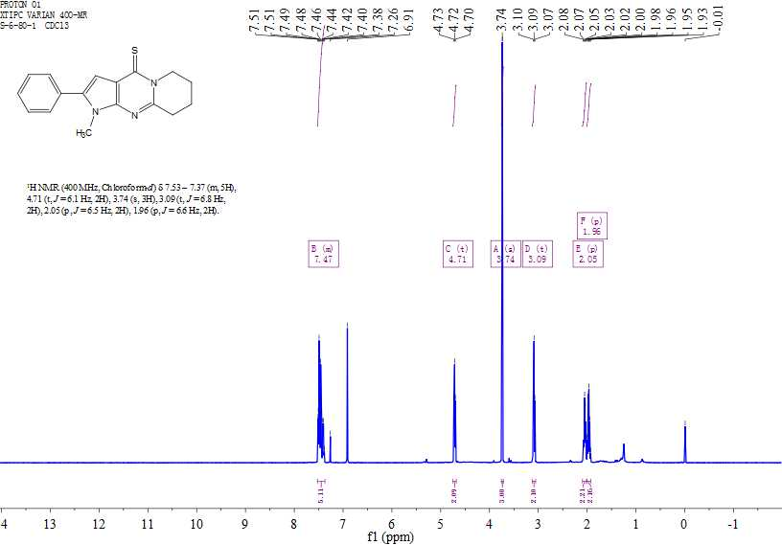
Figure S103. ¹H NMR spectrum of 13h
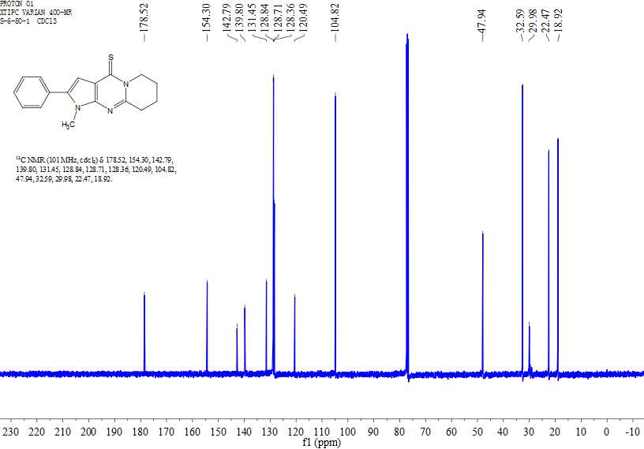
Figure S104. ¹³C NMR spectrum of 13h

Figure S105. HRMS of 13h
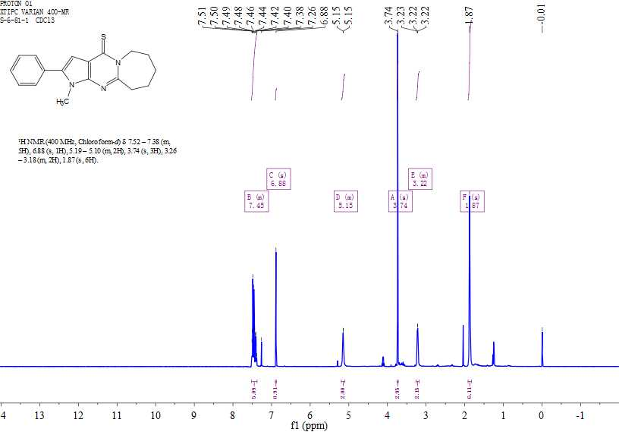
Figure S106. ¹H NMR spectrum of 13i

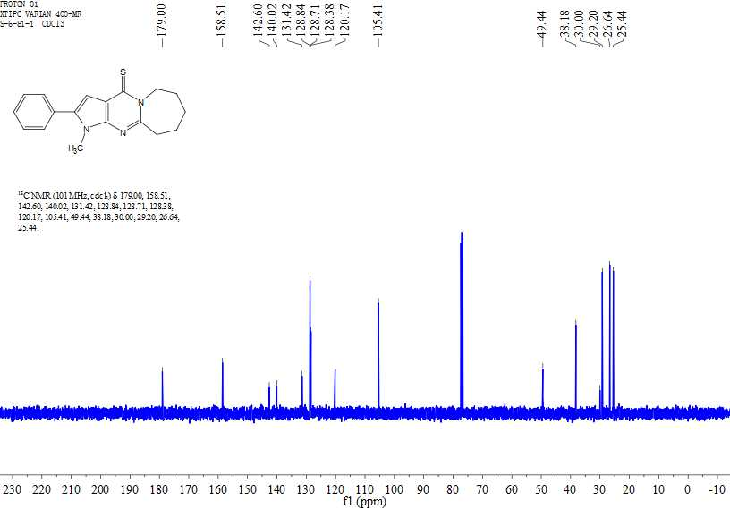
Figure S107. ¹³C NMR spectrum of 13i
Figure S108. HRMS of 13i

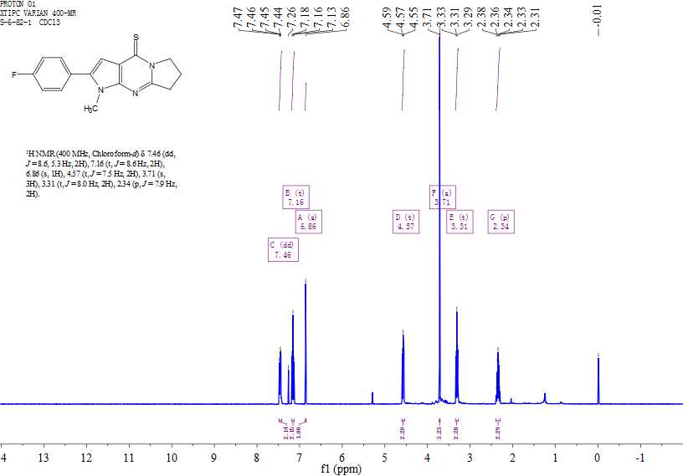
Figure S109. ¹H NMR spectrum of 13j
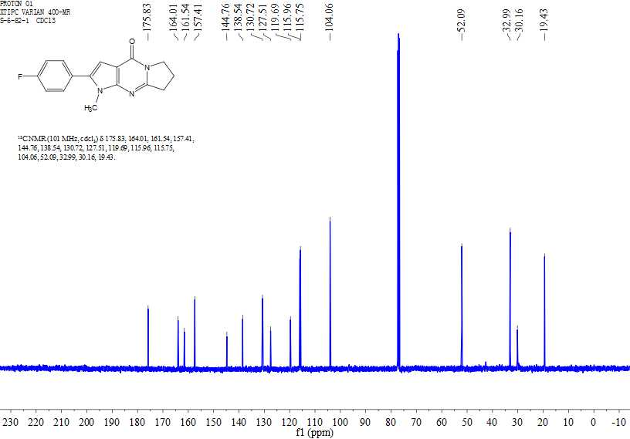
Figure S110. ¹³C NMR spectrum of 13j

Figure S111. HRMS of 13j
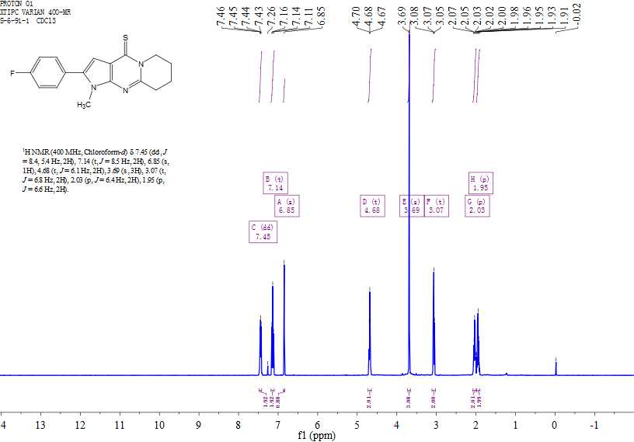
Figure S112. ¹H NMR spectrum of 13k

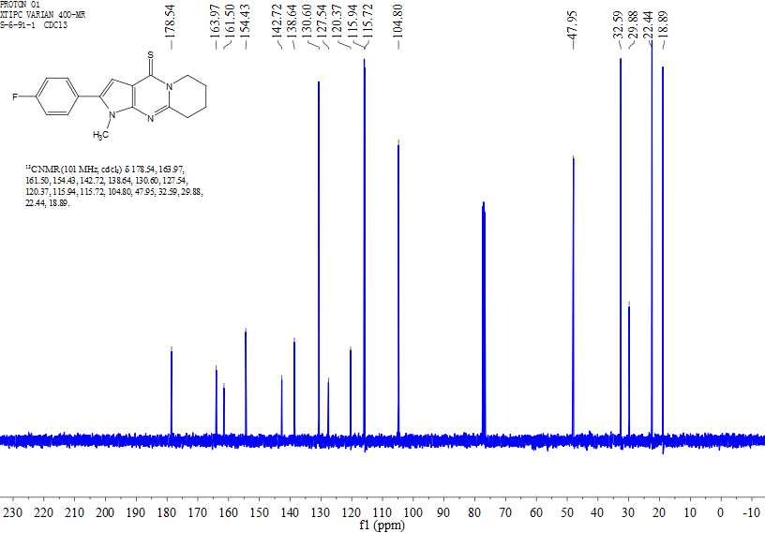
Figure S113. ¹³C NMR spectrum of 13k
Figure S114. HRMS of 13k

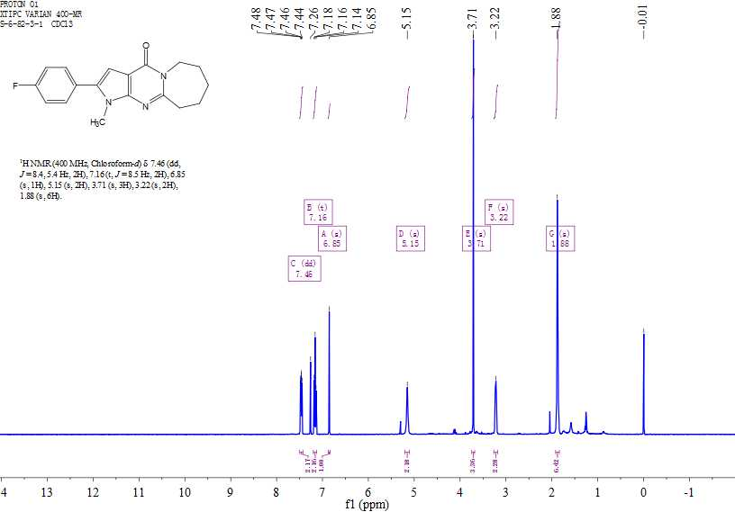
Figure S115. ¹H NMR spectrum of 13l
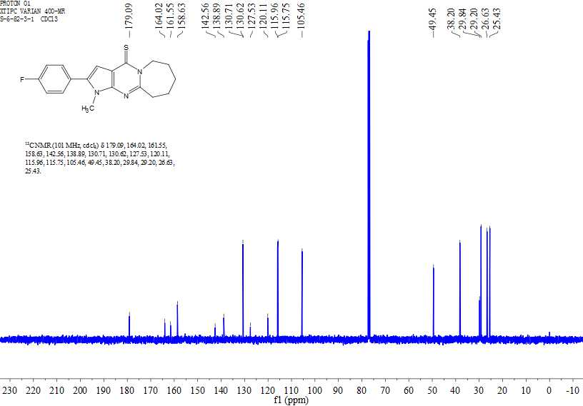
Figure S116. ¹³C NMR spectrum of 13l

Figure S117. HRMS of 13l
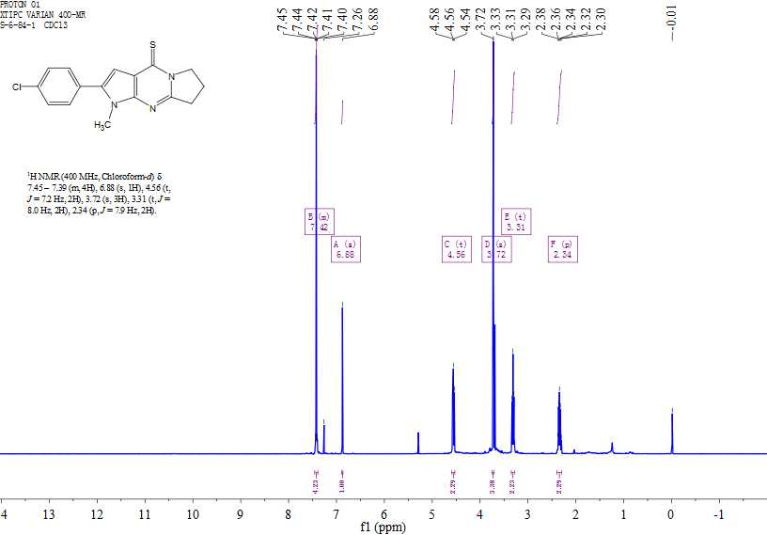
Figure S118. ¹H NMR spectrum of 13m

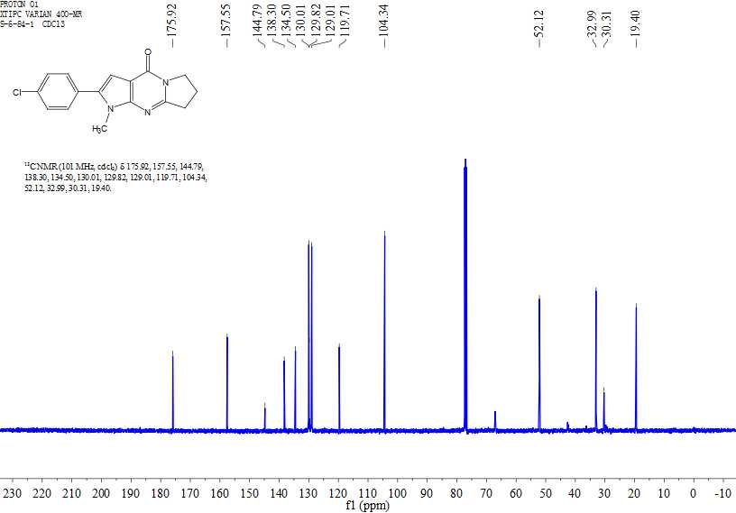
Figure S119. ¹³C NMR spectrum of 13m
Figure S120. HRMS of 13m

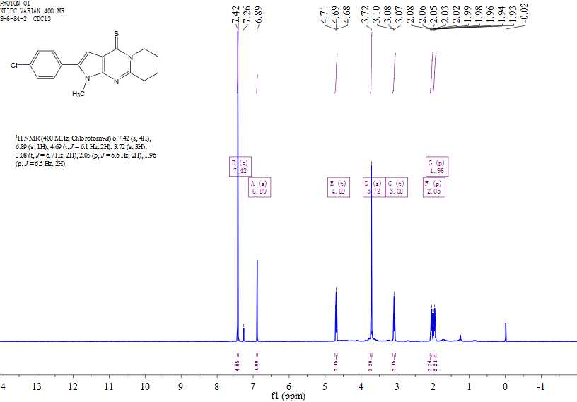
Figure S121. ¹H NMR spectrum of 13n
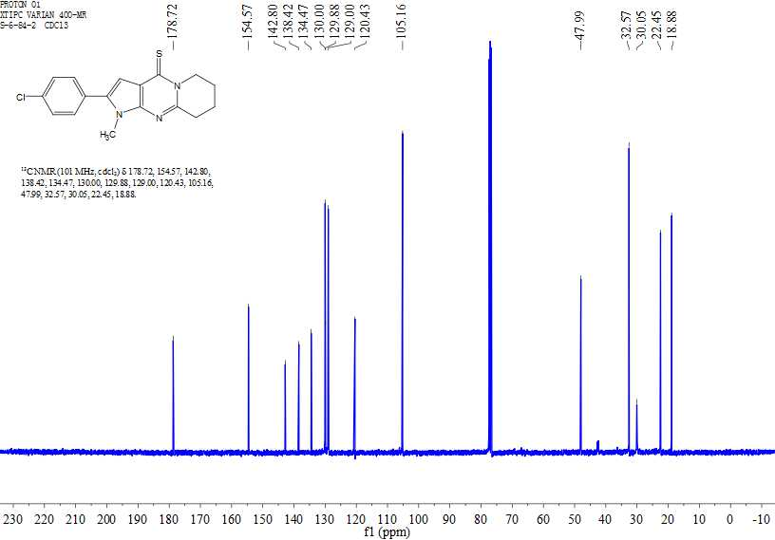
Figure S122. ¹³C NMR spectrum of 13n

Figure S123. HRMS of 13n
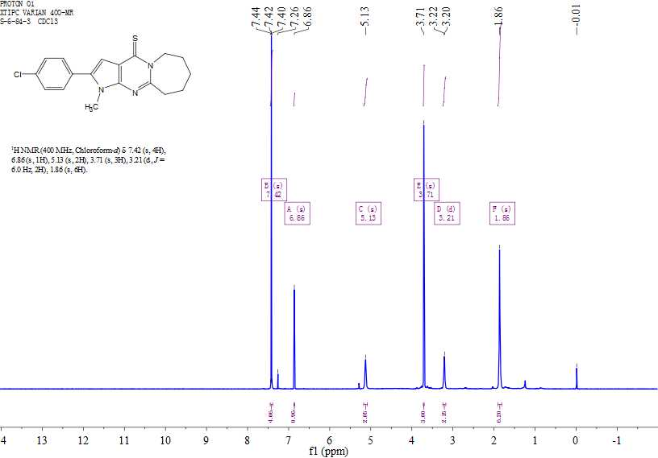
Figure S124. ¹H NMR spectrum of 13o

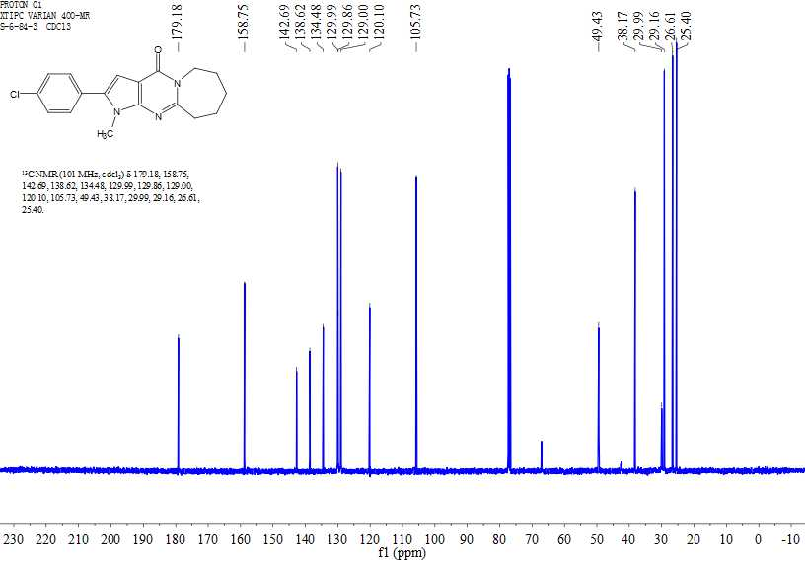
Figure S125. ¹³C NMR spectrum of 13o
Figure S126. HRMS of 13o

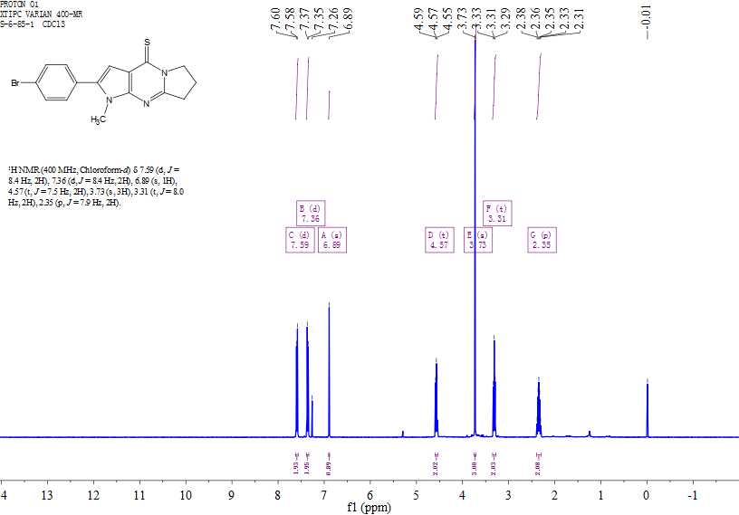
Figure S127. ¹H NMR spectrum of 13p
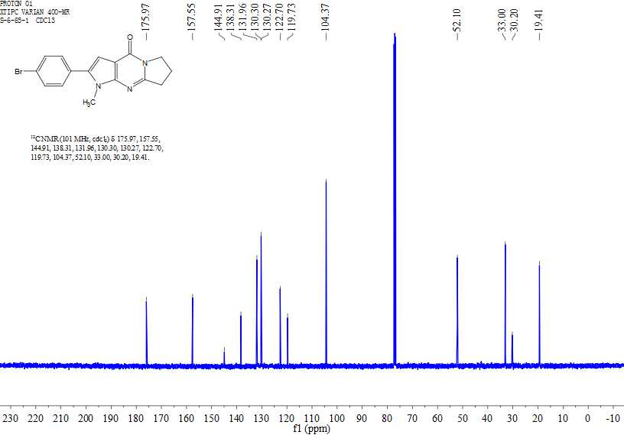
Figure S128. ¹³C NMR spectrum of 13p

Figure S129. HRMS of 13p
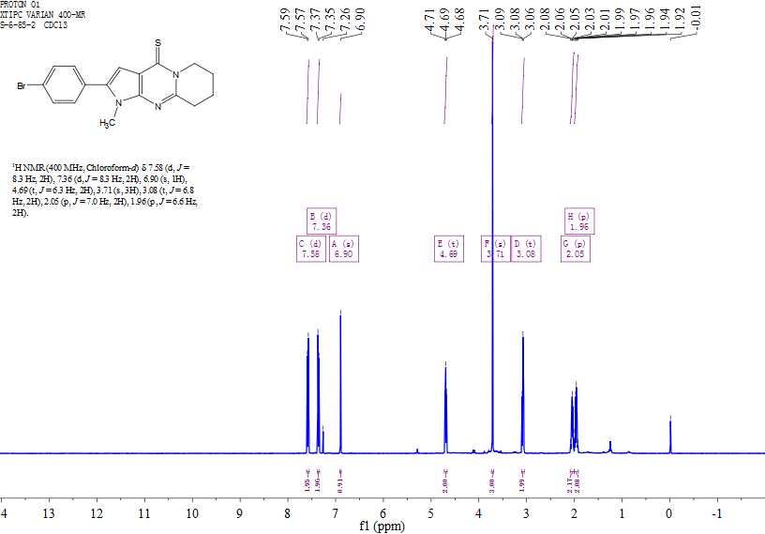
Figure S130. ¹H NMR spectrum of 13q

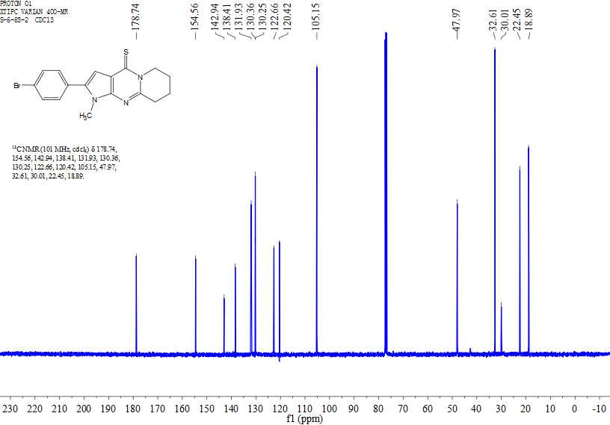
Figure S131. ¹³C NMR spectrum of 13q
Figure S132. HRMS of 13q

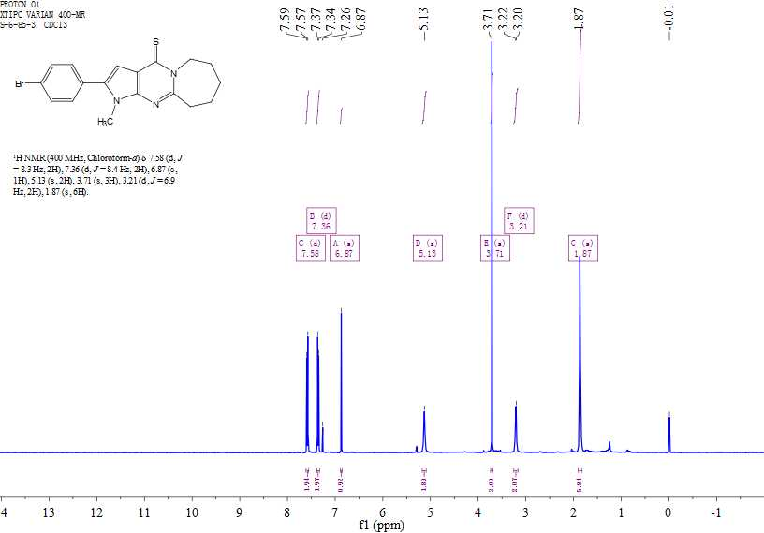
Figure S133. ¹H NMR spectrum of 13r
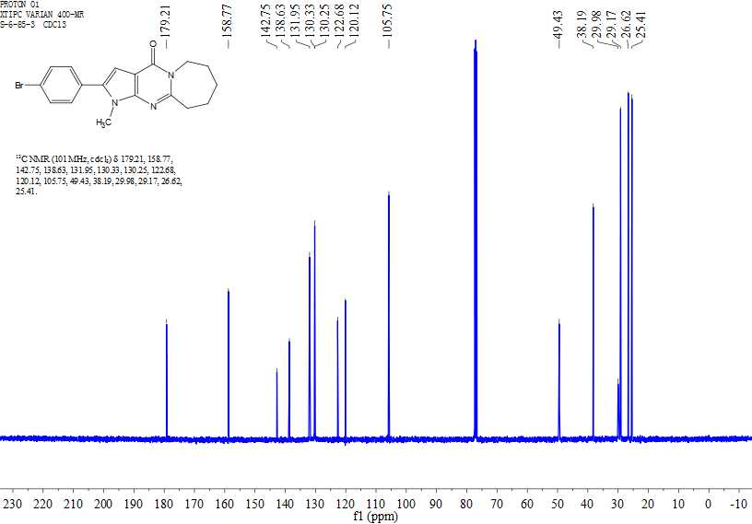
Figure S134. ¹³C NMR spectrum of 13r

Figure S135. HRMS of 13r
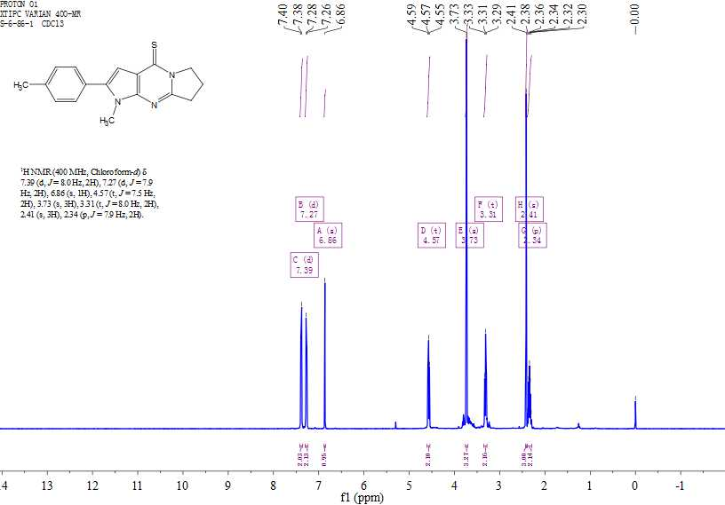
Figure S136. ¹H NMR spectrum of 13s

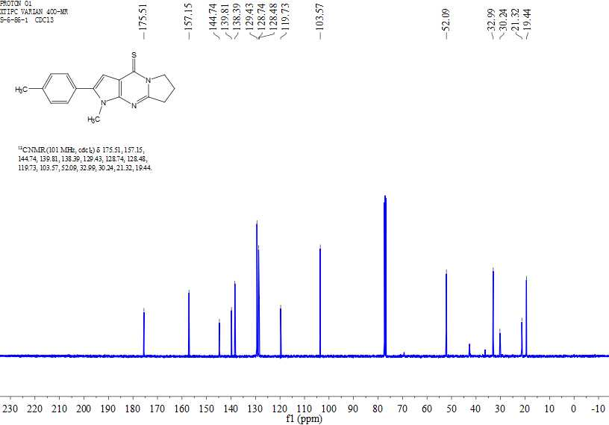
Figure S137. ¹³C NMR spectrum of 13s
Figure S138. HRMS of 13s

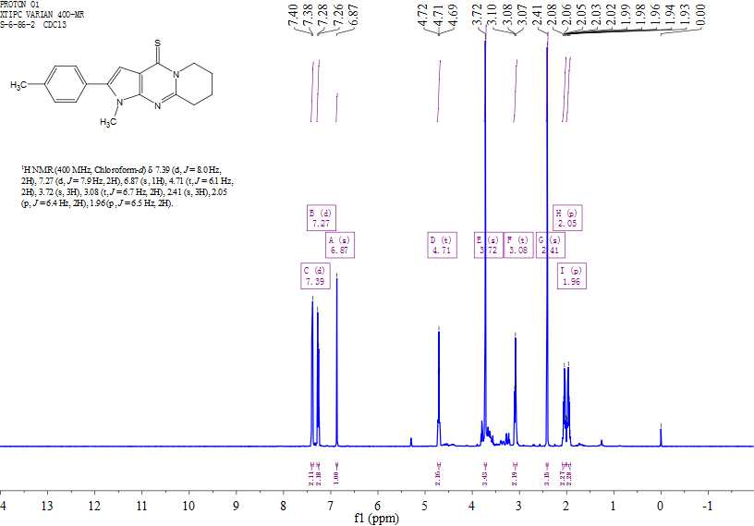
Figure S139. ¹H NMR spectrum of 13t
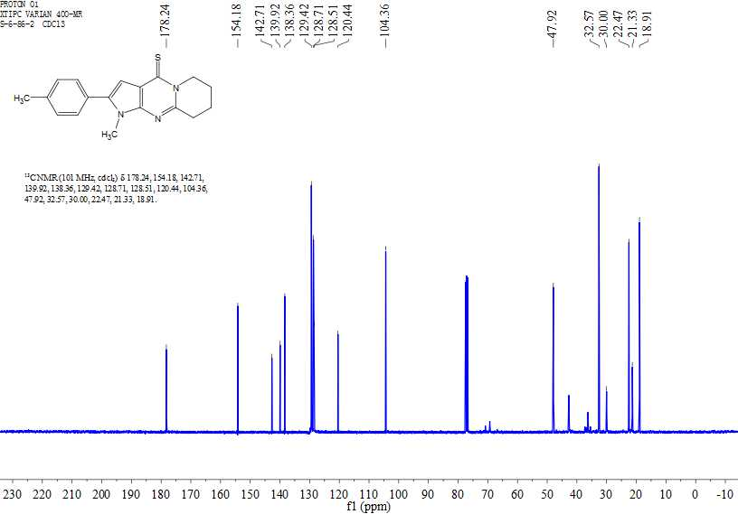
Figure S140. ¹³C NMR spectrum of 13t

Figure S141. HRMS of 13t
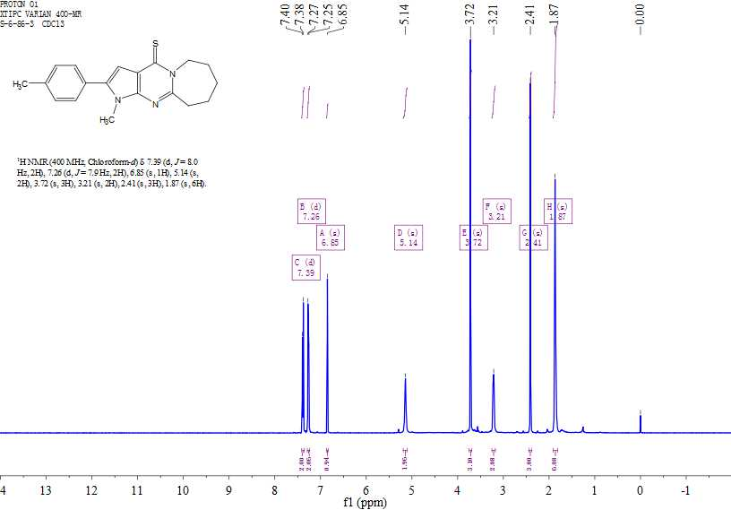
Figure S142. ¹H NMR spectrum of 13u

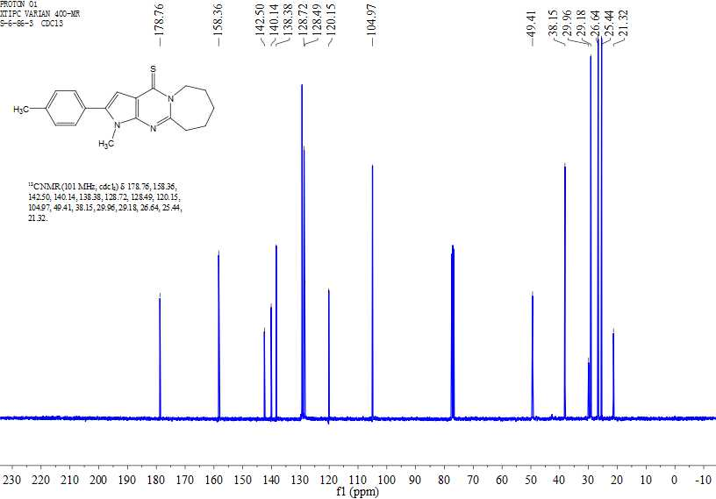
Figure S143. ¹³C NMR spectrum of 13u
Figure S144. HRMS of 13u
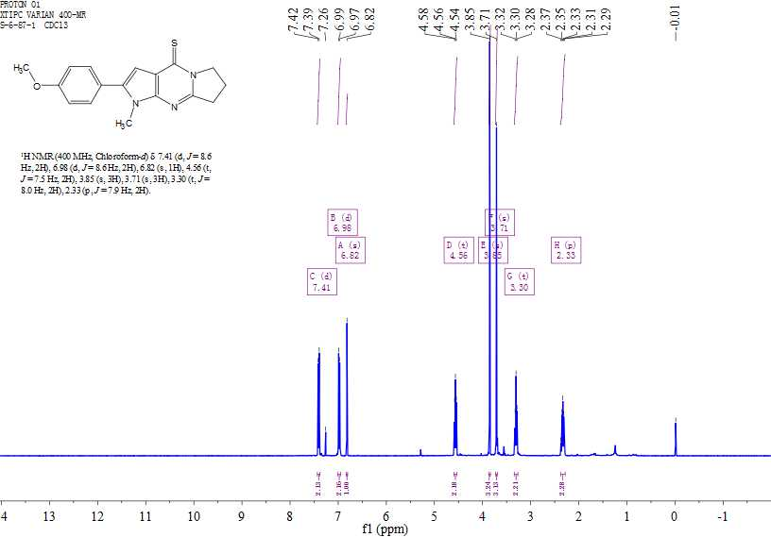
Figure S145. ¹H NMR spectrum of 13v
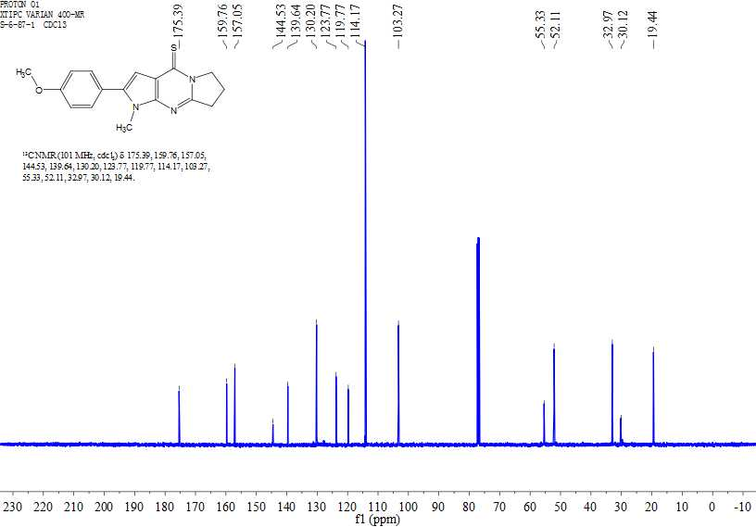
Figure S146. ¹³C NMR spectrum of 13v
Figure S147. HRMS of 13v
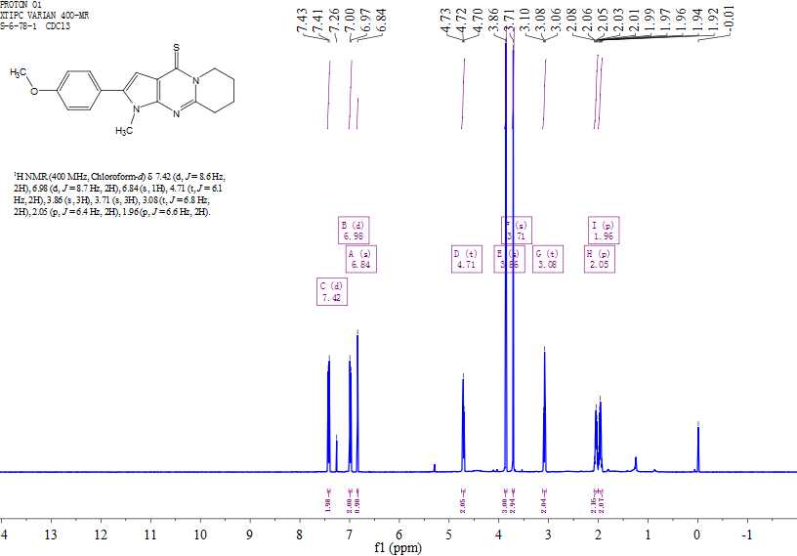
Figure S148. ¹H NMR spectrum of 13w

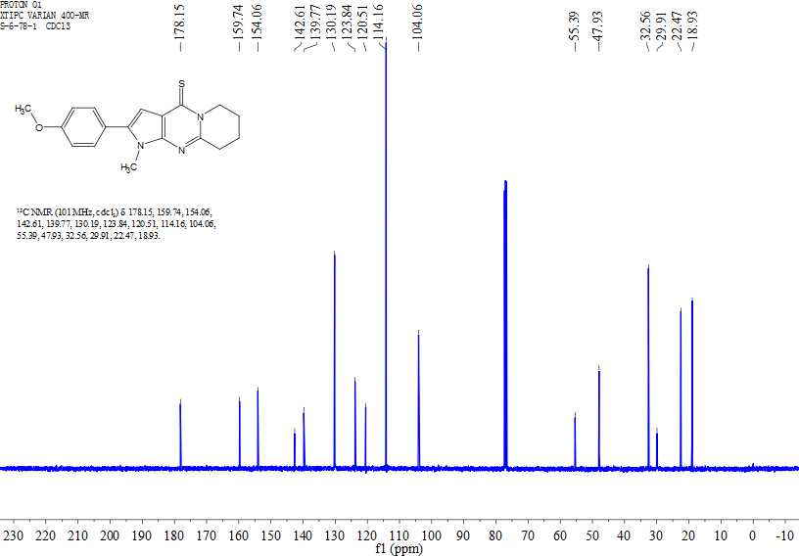
Figure S149. ¹³C NMR spectrum of 13w
Figure S150. HRMS of 13w

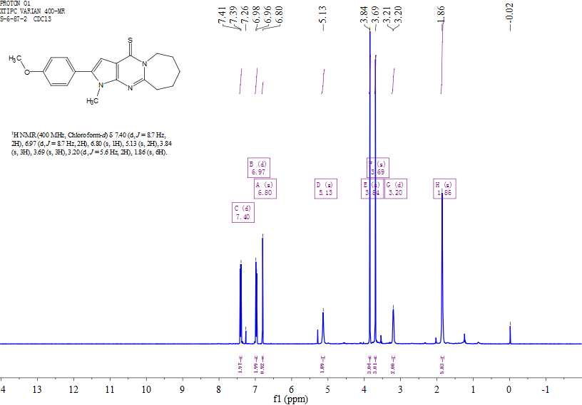
Figure S151. ¹H NMR spectrum of 13x
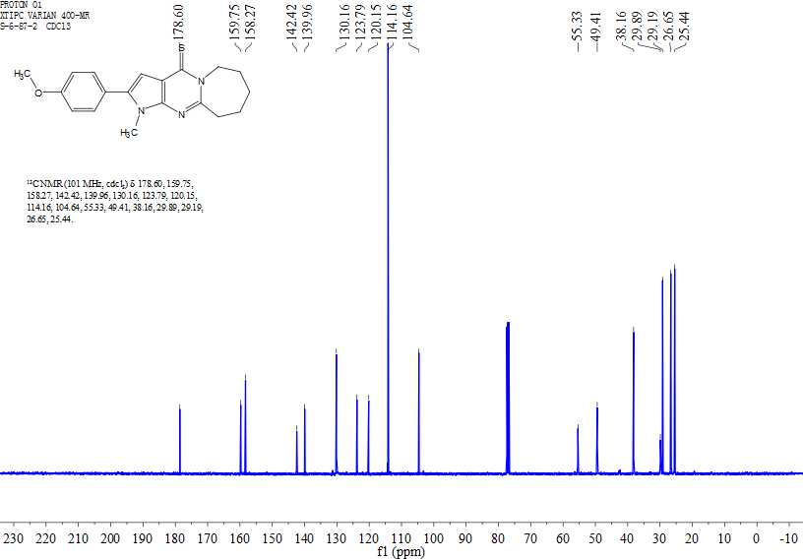
Figure S152. ¹³C NMR spectrum of 13x

Figure S153. HRMS of 13x
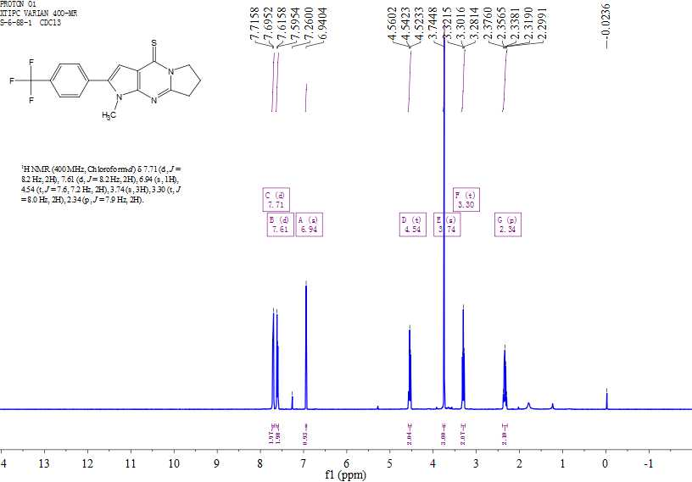
Figure S154. ¹H NMR spectrum of 13y

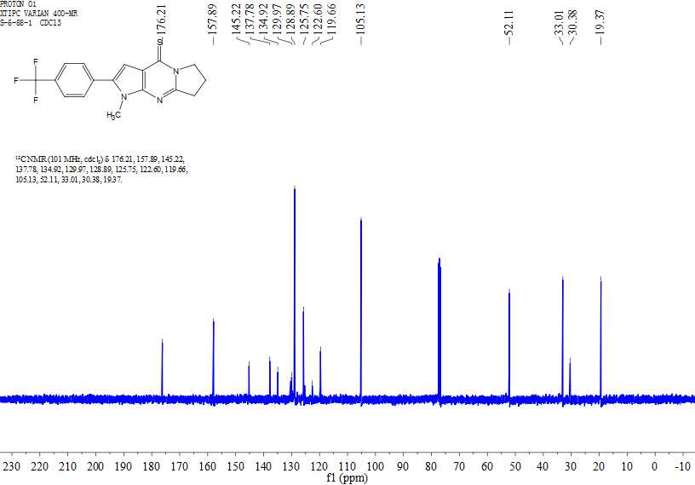
Figure S155. ¹³C NMR spectrum of 13y
Figure S156. HRMS of 13y

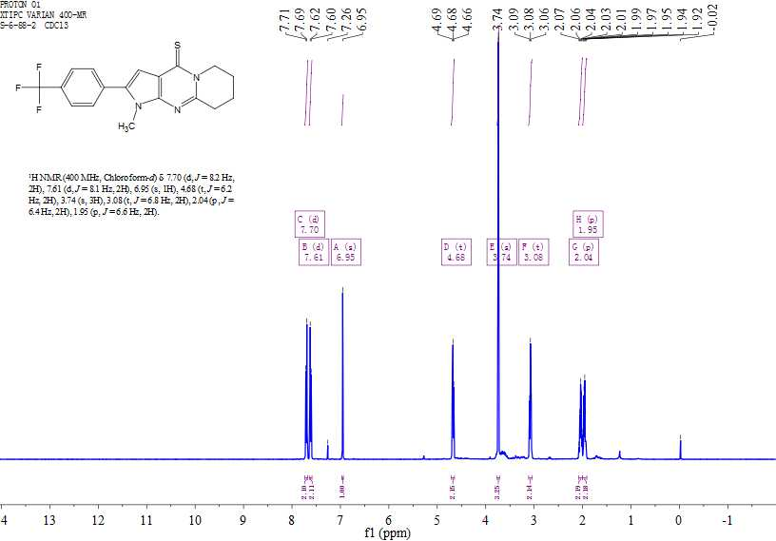
Figure S157. ¹H NMR spectrum of 13z
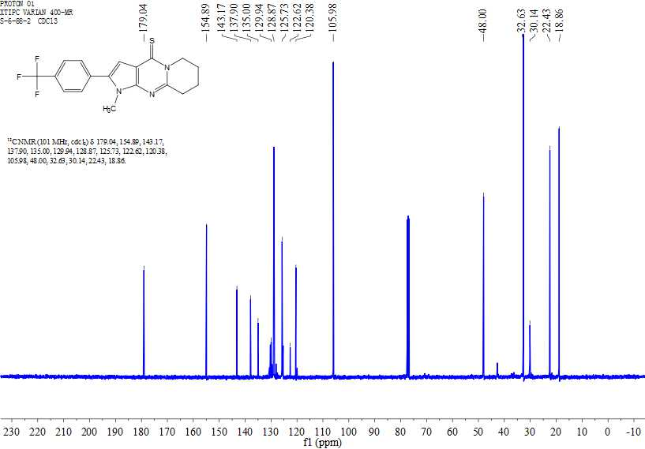
Figure S158. ¹³C NMR spectrum of 13z

Figure S159. HRMS of 13z
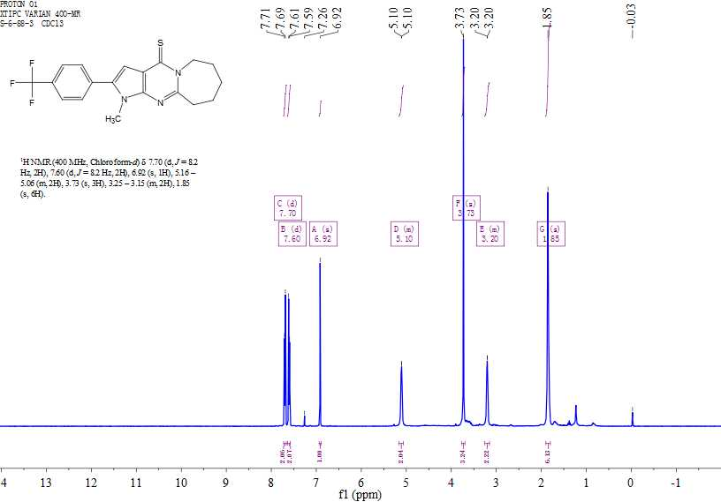
Figure S160. ¹H NMR spectrum of 13aa

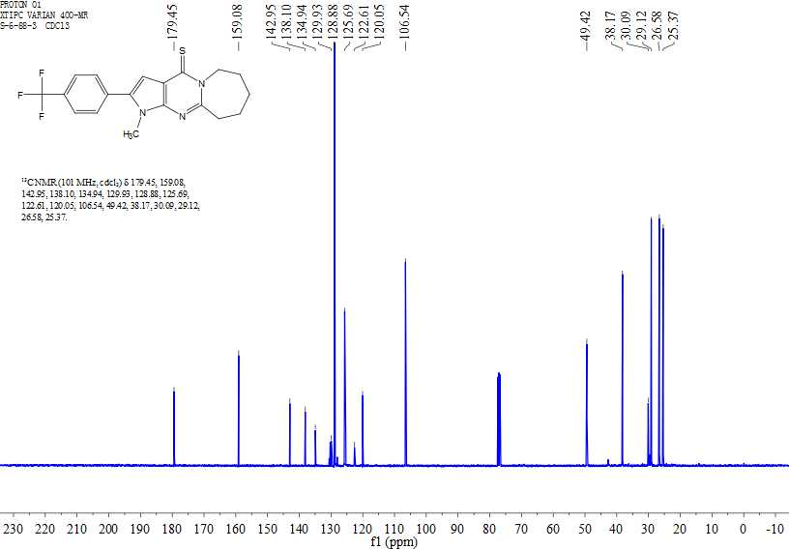
Figure S161. ¹³C NMR spectrum of 13aa
Figure S162. HRMS of 13aa

Corresponding author. E-mail addresses: haji@ms.xjb.ac.cn (H.A.A.); zhaojy@ms.xjb.ac.cn (Z.J.)

