Supplementary Information
Picrate salts with bipyridine derivatives: Intra and intermolecular aspects
Ana L. S. Mouraª, Pedro H. Machadoª and Rodrigo S. Corrêa^{a,*}
ªDepartamento de Química, ICEB, Universidade Federal de Ouro Preto, Ouro Preto, MG, CEP 35400-000, Brazil
*e-mail: rodrigocorrea@ufop.edu.br

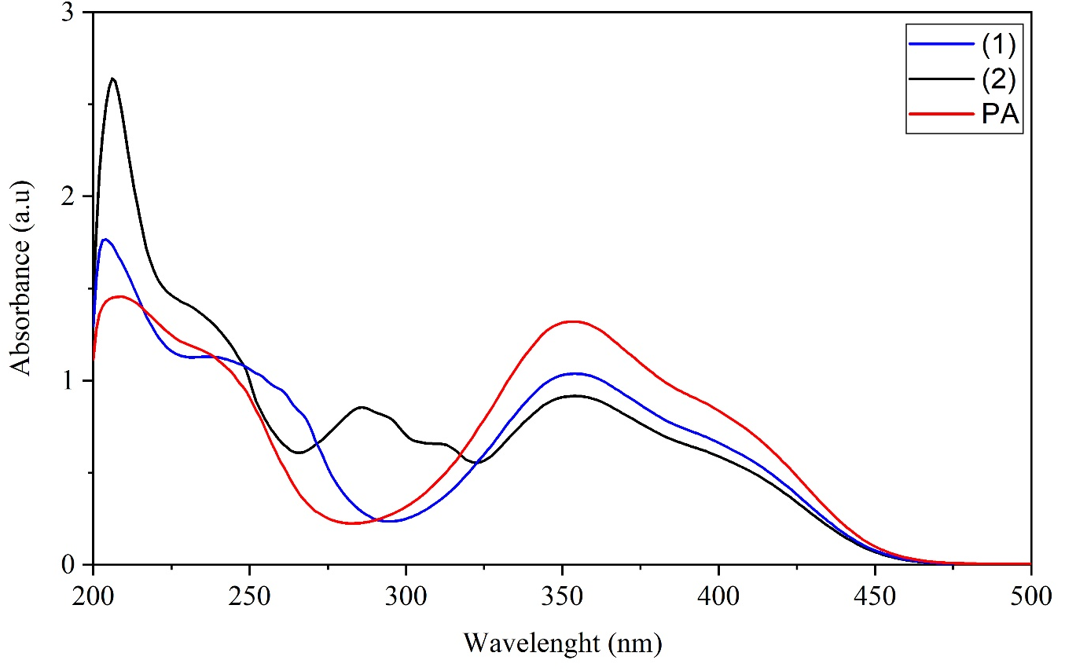
Figure S1 Absorption spectra for compounds 1 (blue), 2 (black) and picric acid (red)
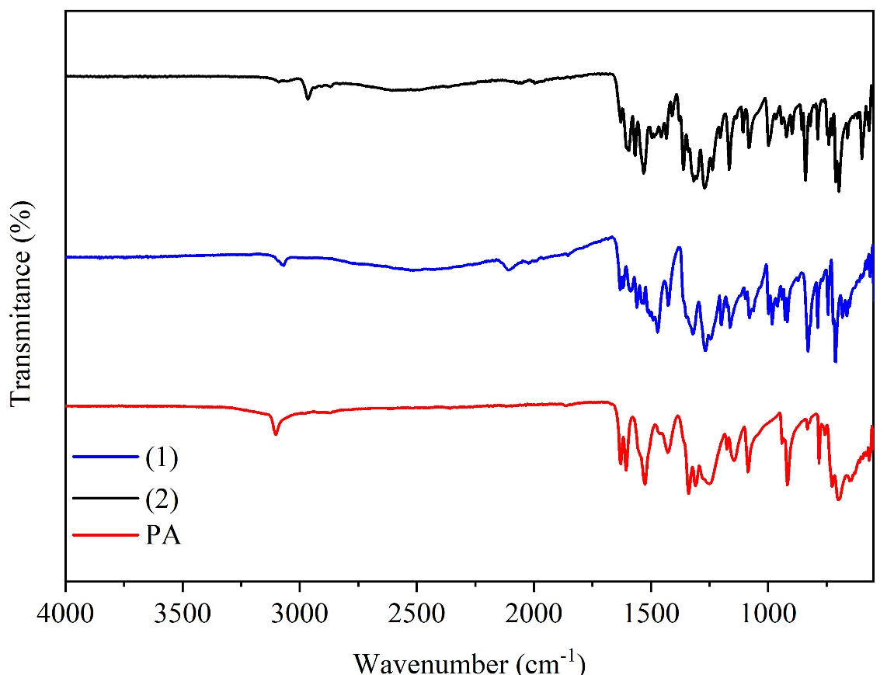
Figure S2 Infrared spectra for compounds 1 (blue), 2 (black) and picric acid (red)

Átomos | Distâncias (Å) | Átomos | Ângulos (°)
1
C1-O1 | 1.233(4) | O2-N2-O3 | 122.40
C24-O31 | 1.217(4) | O4-N4-O5 | 121.91
C2-N2 | 1.457(8) | O6-N6-O7 | 121.37
C4-N4 | 1.436(4) | C1-C2-N2-O2 | -33(1)
C6-N6 | 1.454(3) | C1-C2-N2-O3 | 145.9(7)
N1-H1 | 0.860(2) | C3-C2-N2-O2 | 144.8(9)
N2-O2 | 1.159(17) | C3-C2-N2-O3 | -36(1)
N2-O3 | 1.237(13) | C3-C4-N4-O4 | -1.1(4)
N4-O4 | 1.222(4) | C3-C4-N4-O5 | 179.4(3)
N4-O5 | 1.240(3) | C5-C4-N4-O4 | 178.4(3)
N6-O6 | 1.224(3) | C5-C4-N4-O5 | -1.0(4)
N6-O7 | 1.217(3) | C1-C6-N6-O6 | -175.9(2)
 |  | C1-C6-N6-O7 | 4.3(3)
 |  | C5-C6-N6-O6 | 3.0(3)
 |  | C5-C6-N6-O7 | -176.8(2)
2
C1-O1 | 1.244 | O2-N2-O3 | 121.51
C20-C29 | 1.502 | O4-N4-O5 | 123.93
C29-C30 | 1.517 | O6-N6-O7 | 122.62
C29-C31 | 1.506 | C20-C29-C30 | 108.23
C29-C32 | 1.489 | C20-C29-C31 | 112.15
C27-C33 | 1.508 | C20-C29-C32 | 107.47
C33-C34 | 1.508 | C27-C33-C34 | 106.74
C33-C35 | 1.505 | C27-C33-C35 | 110.32
C33-C36 | 1.529 | C27-C33-C36 | 110.71
C2-N2 | 1.435 | C1-C2-N2-O2 | 150(2)
C4-N4 | 1.456 | C1-C2-N2-O3 | -26(3)
C6-N6 | 1.571 | C3-C2-N2-O2 | -26(3)
N1-H1 | 0.860 | C3-C2-N2-O3 | 157(3)
N2-O2 | 1.213 | C3-C4-N4-O4 | 7(2)
N2-O3 | 1.214 | C3-C4-N4-O5 | -171(1)
N4-O4 | 1.225 | C5-C4-N4-O4 | -175(2)
N4-O5 | 1.213 | C5-C4-N4-O5 | 8(2)
N6-O6 | 1.047 | C1-C6-N6-O6 | -74(3)
N6-O7 | 1.153 | C1-C6-N6-O7 | 86(3)
 |  | C5-C6-N6-O6 | 104(3)
 |  | C5-C6-N6-O7 | -95(3)
 |  | N1-C22-C23-N7 | -169.4(3)

Table S1 Bond distances and angles for compounds 1 and 2

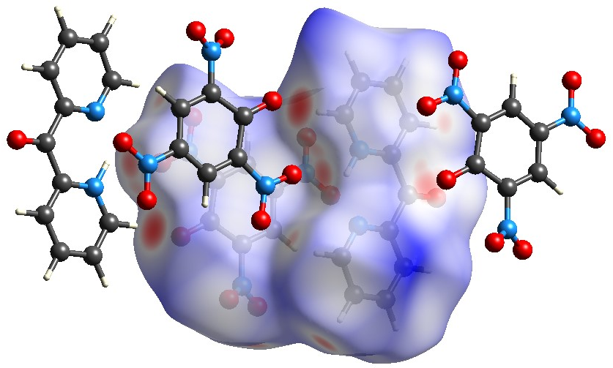
Figure S3 Mapping of the Hirshfeld Surfaces for compound 1

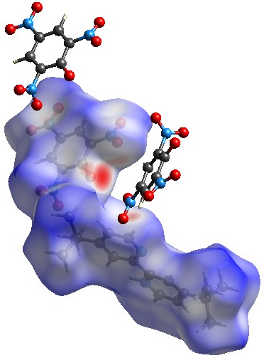
Figure S4 Mapping of the Hirshfeld Surfaces for compound 2

Figure S5 Percentage of contributions of the principle interactions for compounds 1 and 2

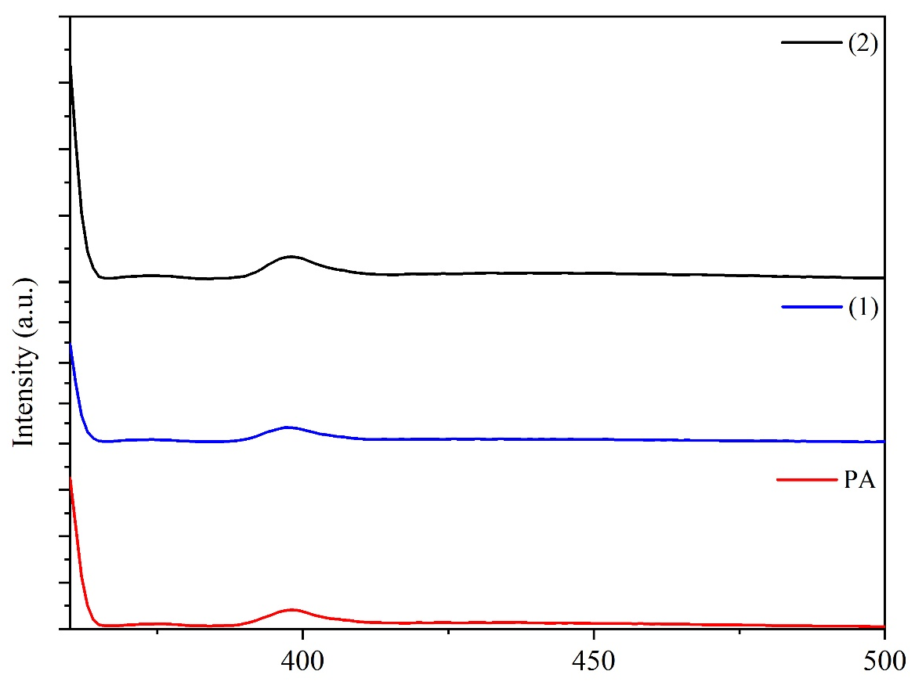

Figure S6 Emission spectra for the compounds 1 (blue), 2 (black) and picric acid (red)

