Supplementary Information: InSpectra – A Platform for Identifying Emerging Chemical Threats

Authors: Mathieu Feraud¹*, Jake W. O’Brien^{1,2}*@, Saer Samanipour^{1,2}*@, Pradeep Dewapriya¹, Denice van Herwerden², Sarit Kaserzon¹, Ian Wood³, Cassandra Rauert¹, Kevin V. Thomas¹
1: Queensland Alliance for Environmental Health Sciences (QAEHS), The University of Queensland
2: Van ’t Hoff Institute for Molecular Sciences (HIMS), University of Amsterdam
3: School of Mathematics and Physics, The University of Queensland, St. Lucia, Queensland, Australia
*: these authors contributed equally
@: corresponding authors – j.w.obrien@uva.nl and s.samanipour@uva.nl

Code Availability
Table S1 Source code for packages used within InSpectra
Algorithm | Journal | Source Code
ProteoWizard | (1) | https://proteowizard.sourceforge.io/download.html
Self-Adjusting Feature Detection | (2) | https://bitbucket.org/SSamanipour/safd.jl/src/master/
Componentisation | (3) | https://bitbucket.org/SSamanipour/compcreate.jl/src/master/).
Universal Library Search Algorithm | (3) | https://bitbucket.org/SSamanipour/ulsa.jl/src/master/

Parameters Used
Table S2 Parameters used for demonstration of the workflows
Suspect Screening
Parameter | Value | Units | Definition
mode | Positive |  | Mode of the Mass Spectrometer
mz_thresh | 30 to 900 | Da | Minimum and Maximum m/z values to consider
Int_thresh | 500 | Count | Minimum Intensity needed for consideration
mass_tol | 0.05 | Da | Predicted mass accuracy of the analyser of the MS/MS
iso_depth | 5 |  | The number of peaks in the isotopical distribution.
ret_window | 0.5 | % | Retention time tolerance window
SAFD
mz_thresh | 0 to 550 | Da | Minimum and Maximum m/z values to consider
int_thresh | 150 | Count | Minimum Intensity needed for consideration
max_numb_iter | 20000 | Count | The maximum number of iterations that the algorithm will perform. For a normal LC-HRMS chromatogram 20000 iterations are usually enough to reach convergence
max_t_peak_w | 300 | Scans | The maximum number of scans within a chromatographic feature. This parameter depends of the sampling rate and the type of analysed chemicals. For example, for pharmaceuticals and a sampling rate < 3 Hz, 30 scans would be a good choice for this parameter. For the safd_s3D, this parameter should be set to much higher values, for example 300 for sampling rates < 3 Hz.
res | 20000 |  | The expected mass resolution of the instrument. For example for a QToF system a nominal resolution of 20000 appears to be a good starting point whereas for an OrbiTrap 30000 would be adequate. This parameter is used as a first guess for the algorithm during the data processing.
min_ms_ w | 0.02 | Da | The minimum peak width in the mass domain. For small masses (e.g. 60 < m/z < 250 Da), this parameter usually overwrites the peak mass peak width estimated via Resolution (i.e. "res").
r_thresh | 0.75 |  | The R2 threshold for the Gaussian fit. Too high and risk having too many FN and too low risk having FP.
min_int | 1000 | Count | The minimum intensity for the features to be detected. For QToF instruments this parameter should be set to ~ 1000.
sig_inc_thresh | 5 | % | The parameter for the detection of the overlapping features in the time domain. This parameter is set in percent and as an integer. The optimized value for this parameter is ~ 5.
S2N | 2 |  | The signal to noise ratio for the feature list filtering set as an integer. A value larger than 2 tends to produce good results with the previously tested data.
min_peak_w_s | 3 | Scans | Another feature list filtering parameter to remove the features that have less seconds than this threshold. This parameter, also, is set as an integer and for a generic chromatographic run ~ 3 seconds has shown to produce reliable results.
Componentisation
mass_win_per | 0.8 | % | The percentage of the peak width in the mass domain used for the calculation of mass tolerance. The typical value for this parameter with a nominal mass resolution of 20000 is 0.75.
ret_win_per | 0.5 | % | The percentage of the peak width in the time domain used for the calculation of retention time tolerance. The typical value for this parameter with a nominal mass resolution of 20000 is 0.75.
delta_mass | 0.004 | Da | The KMD deviation used for the detection of isotopes. A value of 0.004 is associated with less than 5% rate of false positive detection.
min_int | 300 | counts | The minimum intensity of the MS2 ions to be considered meaningful (i.e. not noise).
Universal Library Search Algorithm
weights | [1,1,1,1,1,1,1] |  | - The number of matched fragments in the measured spectrum.  - The number of matched fragments in the library spectrum.  - The mass error of precursor ion.  - The average mass error of matched fragments.  - The standard deviation of the mass error of the matched fragments.  - The forward match factor to rank the potential candidate for each component.  - The reverse match factor to rank the potential candidate for each component.

Table S3 Chromatographic conditions of the samples analysed for the demonstration of the workflows.
Time (min.) | Flow rate (mL/min.) | Mobile phase %
Time (min.) | Flow rate (mL/min.) | A | B
Stormwater
0.00 | 0.4 | 95 | 5
1.00 | 0.4 | 95 | 5
4.00 | 0.4 | 50 | 50
17.00 | 0.4 | 1 | 99
20.00 | 0.4 | 1 | 99
20.10 | 0.4 | 95 | 5
23.00 | 0.4 | 95 | 5
Blood and serum
0.00 | 0.4 | 90 | 10
0.50 | 0.4 | 50 | 50
8.00 | 0.4 | 1 | 99
13.00 | 0.4 | 1 | 99
13.50 | 0.4 | 90 | 10
20.00 | 0.4 | 90 | 10
Wastewater
0.00 | 0.4 | 95 | 5
10.00 | 0.4 | 5 | 95
12.00 | 0.4 | 5 | 95
12.10 | 0.4 | 95 | 5
14.00 | 0.4 | 95 | 5

Table S4 SWATH data independent analysis window parameters
Precursor ion start mass (Da) | Precursor ion end mass (Da) | DP (V) | DP spread (V) | CE (V) | CE spread (V) | Time bin to sum
100 | 150 | 80 | 0 | 35 | 5 | 4
149 | 190 | 80 | 0 | 35 | 5 | 4
189 | 225 | 80 | 0 | 35 | 5 | 4
224 | 260 | 80 | 0 | 35 | 5 | 4
259 | 295 | 80 | 0 | 35 | 5 | 4
294 | 330 | 80 | 0 | 35 | 5 | 4
329 | 365 | 80 | 0 | 35 | 5 | 4
364 | 400 | 80 | 0 | 35 | 5 | 4
399 | 600 | 80 | 0 | 35 | 5 | 4
599 | 1100 | 80 | 0 | 35 | 5 | 4

Table S5 Proteowizard MsConvert parameters
Name | Comment
mzXML | Converts the file to the mzXML format
32 | Set default binary encoding to 32 bit precision.
threshold absolute 100 most-intense | the intensity for a peak to be considered in a file must be greater than 100.

“mzXML” :
“32”: set default binary encoding to 32-bit precision.
“threshold absolute 100 most-intense”: the intensity for a peak to be considered in a file must be greater than 100.

Figure S1 Further Comparisons of extracted ion chromatograms
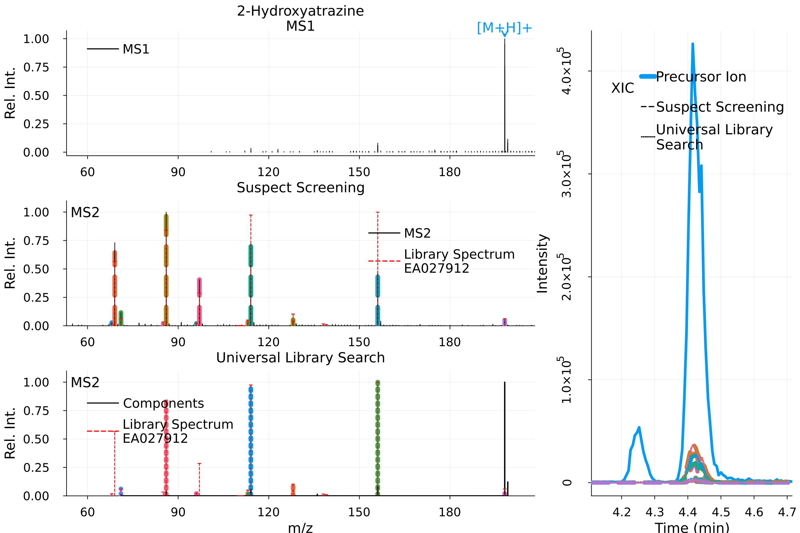
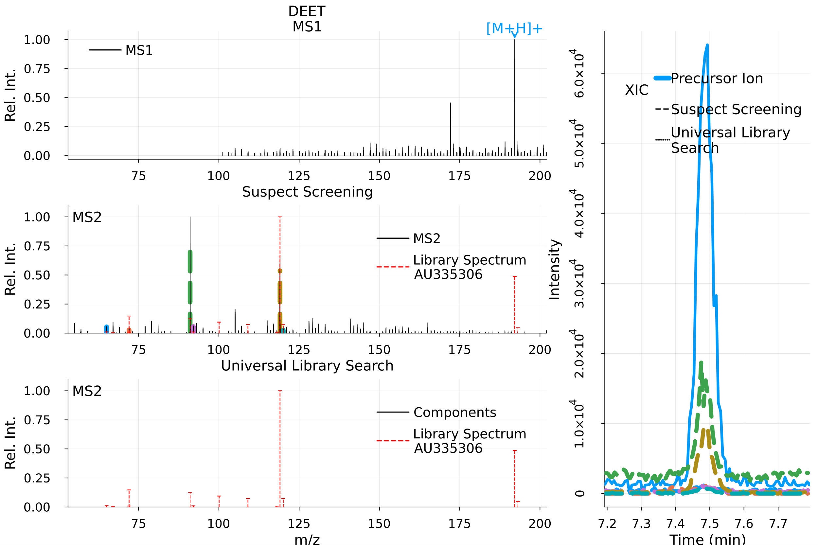
Figure S2 MS2 output of MZmine for stormwater on sample 09/06/2020 used by ULSA to create a component.
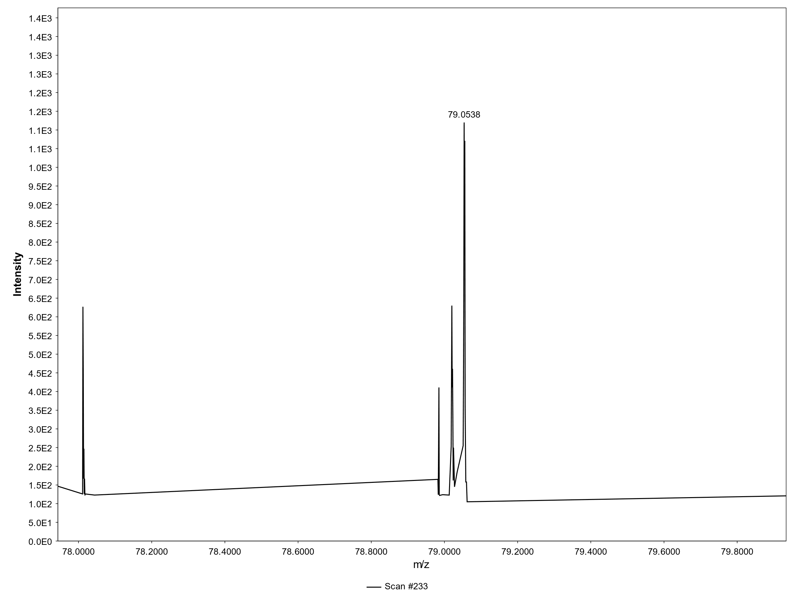

References:
1. Pedrioli PG, Eng JK, Hubley R, Vogelzang M, Deutsch EW, Raught B, et al. A common open representation of mass spectrometry data and its application to proteomics research. Nat Biotechnol. 2004;22(11):1459-66.
2. Samanipour S, O’Brien JW, Reid MJ, Thomas KV. Self Adjusting Algorithm for the Nontargeted Feature Detection of High Resolution Mass Spectrometry Coupled with Liquid Chromatography Profile Data. Analytical Chemistry. 2019;91(16):10800-7.
3. Samanipour S, Reid M, Baek K, Thomas KV. Combining a deconvolution and a universal library search algorithm for the non-target analysis of data independent LC-HRMS spectra. Environ Sci Technol. 2018.

