Table 1(a): Durability analysis of indigenous facemask
Parameters | 0 washes | 5 washes | 10 washes | 20 washes | 30 washes
Breathability |  | 
Appearance
Fit
Candle Flame Extinguishing Test | Passed | Passed | Passed | Passed | Passed
Shape & Size
Water Repulsion  (Hold up time in Seconds) | 252 | 247 | 235 | 227 | 157
Images for Comparison | 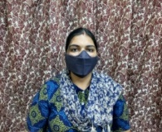  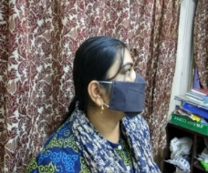 | 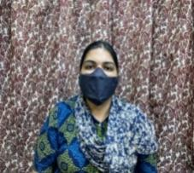  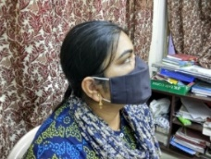 | 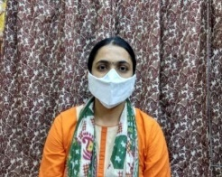  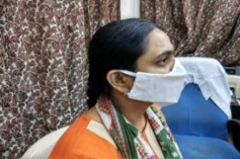 | 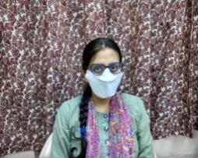  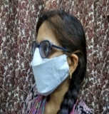 | 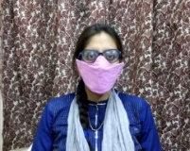  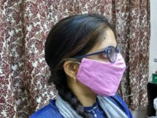
Table 1(b): Durability analysis of commercial facemask
Parameters | 0 washes | 5 washes | 10 washes | 20 washes | 30 washes
Breathability |  | × | × | × | ×
Appearance |  | × | × | × | ×
Fit |  | × | × | × | ×
Candle Flame Extinguishing | Failed | Failed | Failed | Failed | Failed
Shape & Size |  | ×  (Shrinking observed) | × | × | ×
Water Repulsion  (Hold-up time in sec) | 3 sec | 2 | 1 | 0 | 0
Images for Comparison | 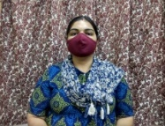  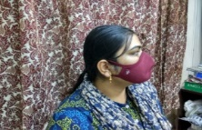 | 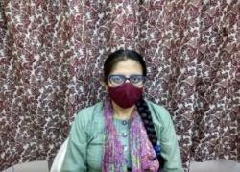  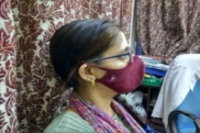 | 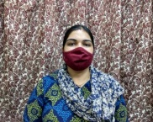  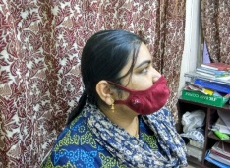 | 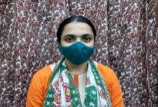  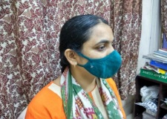 | 