Pilot-scale drinking water distribution system to study water quality changes during transport
Supplementary Information
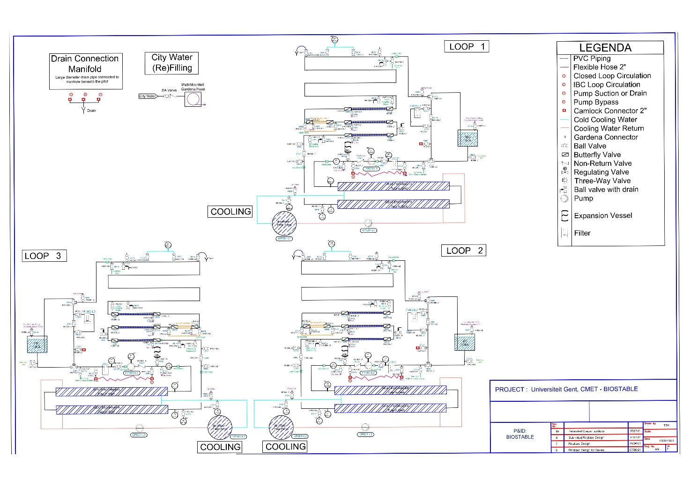Fig S1: Piping and Instrumentation Diagram (P&ID) of the DWDS pilot plant.
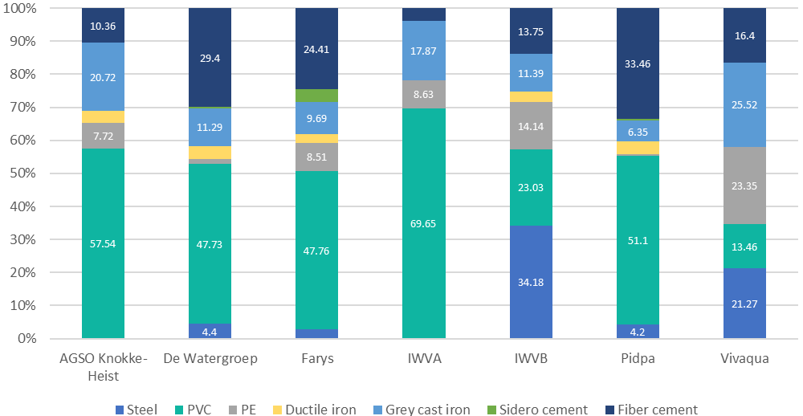
Fig S2: Distribution of materials in drinking water distribution piping in Flanders, adapted from KPMG Global Asset Management Competence Center (modified from Aquaflanders, 2018). In the X axis, the DW production companies in Flanders are named. PVC is most widely used today, followed by fiber cement. Almost all new piping that is being installed is either PE or PVC. For simplicity, the data labels have been plotted only when the value is larger than 4%. Supply line: >150 mm. Distribution pipe: <150 mm (min: 25 mm, max 350mm)
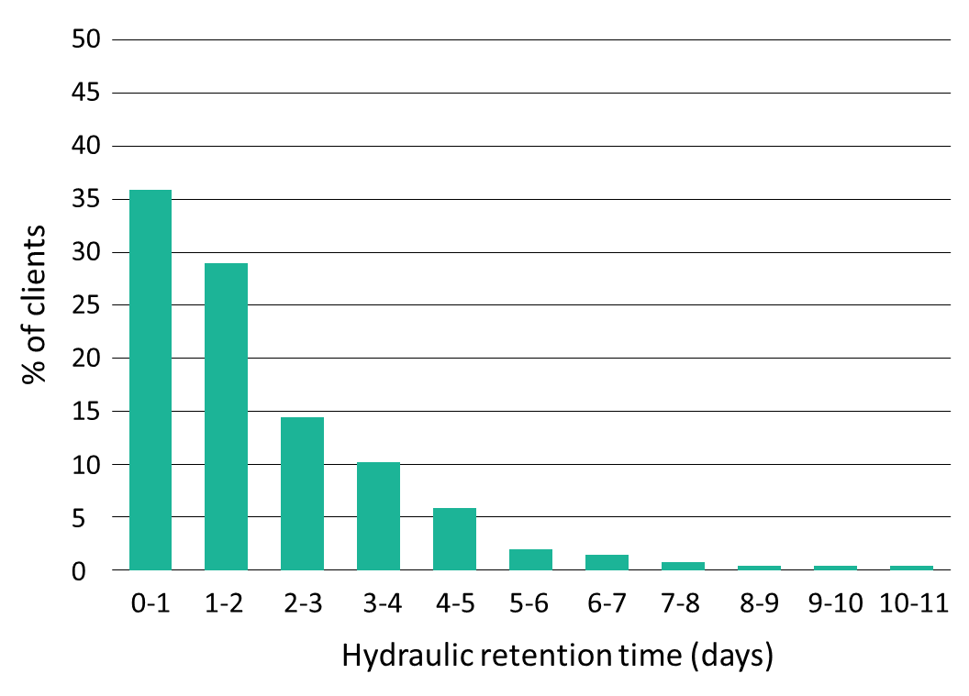
Fig S3: Hydraulic retention time (HRT) of water in the low-pressure DWDS. 95% of customers receive their drinking water with a HRT < 5 days . Most (35%) customers receive it within 1 day. Data from the Flemish drinking water company FARYS (2021, internal study).

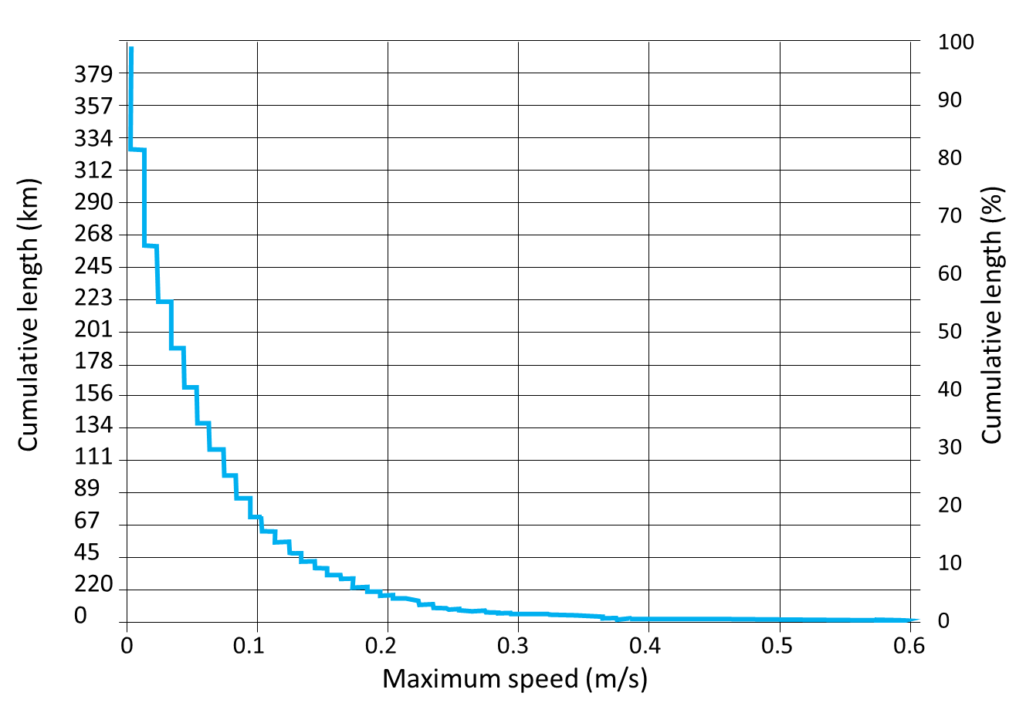
Fig S4: Distribution of flow velocities in a distribution network near Bruges (data from FARYS, internal study). A flow velocity of 0,08 m/s corresponds with a cumulative length of approximately 89 km.

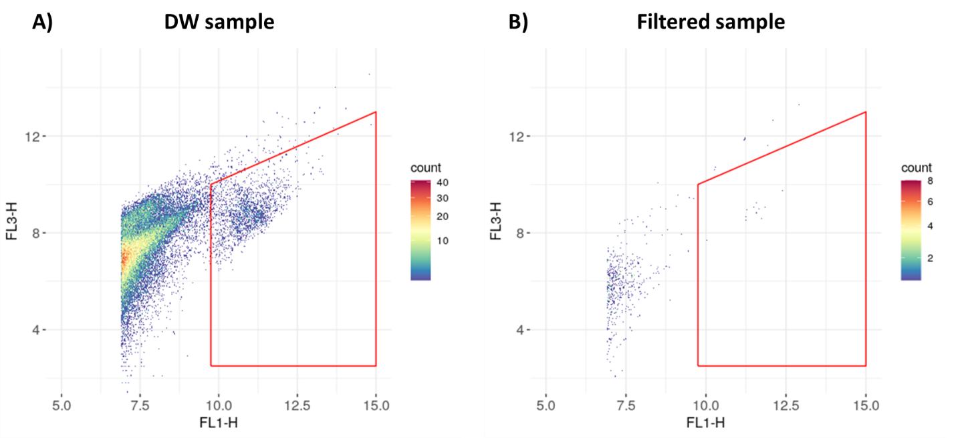
Fig S5: Gating strategy for the flow cytometry (FCM) experiments. A) DW sample taken on day 0, AM at the end of the loop. B) Same DW sample as in A, filtered with a 0.22 µm as control for the background.
Table S1: Flowrates from the pump are transformed into a linear flow velocity and vice versa assuming a diameter of 80 mm in a circular pipe section.
Flowrate (m³/h) | Flowrate (L/min) | Flow velocity (m/s)
0,50 | 8,33 | 0,03
1,00 | 16,67 | 0,06
1,45 | 24,17 | 0,08
5,20 | 86,67 | 0,29
10,00 | 166,67 | 0,55

Table S2: Quality of the water used for the pilot experiment, analyzed by the local company FARYS. Standards in drinking water were stablished according to the maximum authorized concentration according to the Flemish Government Decree of 13/12/2002. B = ISO 17025 accreditation in drinking water and groundwater; B0 = ISO 17025 accreditation in drinking water; B1 = ISO 17025 accreditation in surface water; ; B2 = ISO 17025 accreditation in swimming pool water. E = approval according to VLAREL in drinking water and groundwater; E0 = approval in drinking water; E1 = approval in surface water and wastewater; E2 = approval in surface water
Parameter | Unit | Method | Results | Standards in drinking water
Color | - | WAC/II/A/002 | Absent | Absent
Turbidity | - | Visual | Absent | Absent
Odor | - | WAC/II/A/003 (E0) | Absent | Absent
Taste | - | WAC/II/A/003 (E0) | Absent | Absent
Temperature | °C | WAC/II/A/003 (E/E1/B1/B2) | 19,8 | 25,0
Hydrogen ion concentration (20°C) | pH units | WAC/II/A/005 (E/B/B1/B2) | 7,8 | 6,5-9,2
Conductivity for electricity (20°C) | μS/cm | WAC/II/A/004 (E/B/B1) | 449 | 2100
Hardness | °F | WAC/II/A/009 (E/B) | 17,5 | 67,5
Chloride | mg/l | WAC/III/C (E/E2/B/B1) | 40 | 250
Nitrate | mg/l NO3 | WAC/III/D/031 (E/E2/B/B1) | 6,36 | 50,00
Nitrite | mg/l NO2 | WAC/III/D/031 (E/E2/B/B1) | <0,015 | 0,100
Amonium | mg/l NH4 | WAC/III/D/021 (E/E2/B/B1) | <0,05 | 0,50
Fluoride | mg/l | WAC/III/C (E/E2/B/B1) | 0,24 | 1,5
Free chlorine residues | µg/l | WAC/II/A/011 (E0/B0/B2) | <60 | 250
Alkalinity | mg/l | WAC/II/A/006 (E/B2) | 161 | -
Saturation index | - | Calculation | 0,29 | -0.5
Sulfates | mg/l | WAC/III/C (E/E2/B/B1) | 54 | 250
Orthophosphate | µg/l P2O5 | WAC/III/C (E/E2/B/B1) | <15 | -
Coliforms | /100 mL | WAC/V/A/002 (E/E2/B/B1) | 0 | 0
Escherichia coli | /100 mL | WAC/V/A/002 (E/E2/B/B1) | 0 | 0
Enterococci | /100 mL | WAC/V/A/003 (E/E2/B/B1) | 0 | 0
Clostridium perfrigens | /100 mL | WAC/V/A/007 | 0 | 0
Colony counts (22°C) | /ml | WAC/V/A/001 (E/E2/B/B1) | 41 | -
Aluminium | µg/l | WAC/III/B/011 (E/B) | 76 | 200
Iron | µg/l | WAC/III/B/011 (E/B) | <10 | 200
Lead | µg/l | WAC/III/B/011 (E/B) | 5,4 | 10
Manganese | µg/l | WAC/III/B/011 (E/B) | <2,0 | 50
Nickel | µg/l | WAC/III/B/011 (E/B) | 11 | 20
Sodium | mg/l | WAC/III/B/011 | 33 | 200
Potassium | mg/l | WAC/III/B/011 (E/B) | 3,4 | -
Clacium | mg/l | WAC/III/B/011 (E/B) | 57 | 270
Magnesium | mg/l | WAC/III/B/011 (E/B) | 7,6 | 50
Bromate | µg/l | WAC/III/C (E0/B0) | <1,0 | 10
Chlorate | µg/l | WAC/III/C (B0) | 200 | 700
Chlorite | µg/l | WAC/III/C (B0) | <1,0 | 700
Non-purgeable organic carbon | mg/l | WAC/III/D/050 (E/E2/B/B1/B2) | 1,52 | -
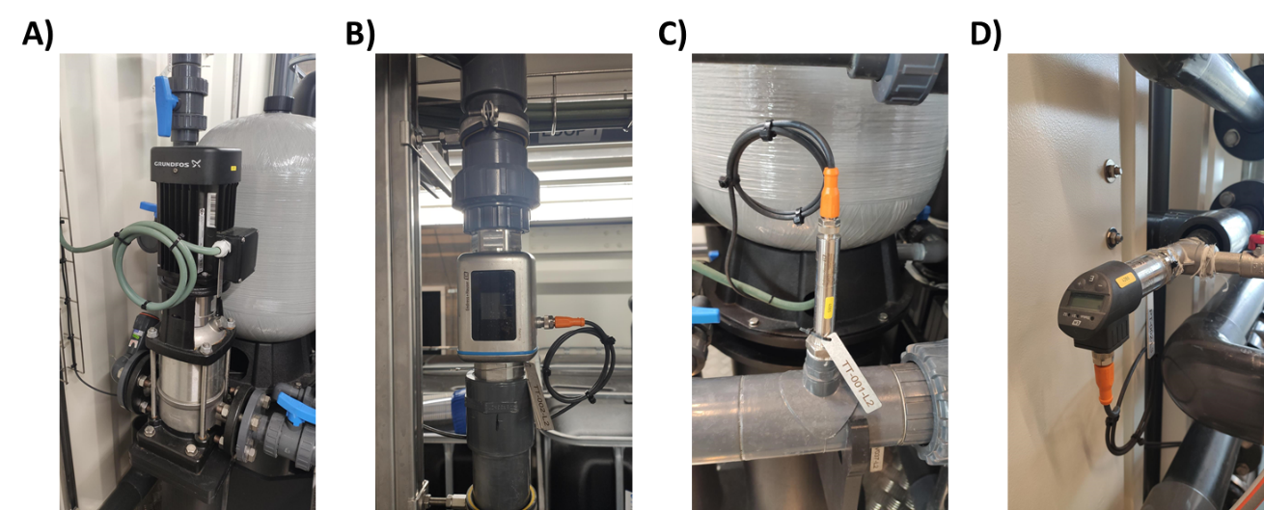
Fig S6: A) Vertical multistage centrifugal Grundfos pumps for recirculation of the water in each loop. The CRNE 3-4 and CRNE 5-4 look identical on the outside. B) The Picomag electromagnetic flow controller, which measures flow velocity, temperature and conductivity. C) E&H TMR31 temperature transmitters D) E&H Ceraphant PTP31B pressure switch.
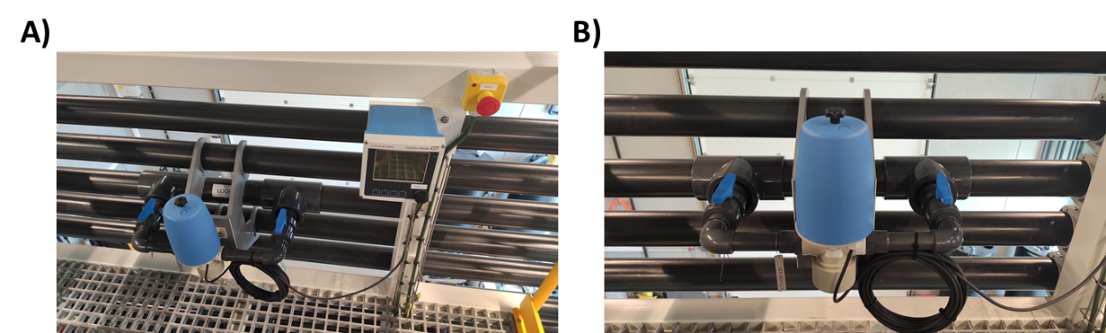
Fig S7: A) E&H Flowfit CPA250 and Liquiline CM442 cabinet controller. B) E&H Flowfit, housing the E&H Memosens pH sensor.
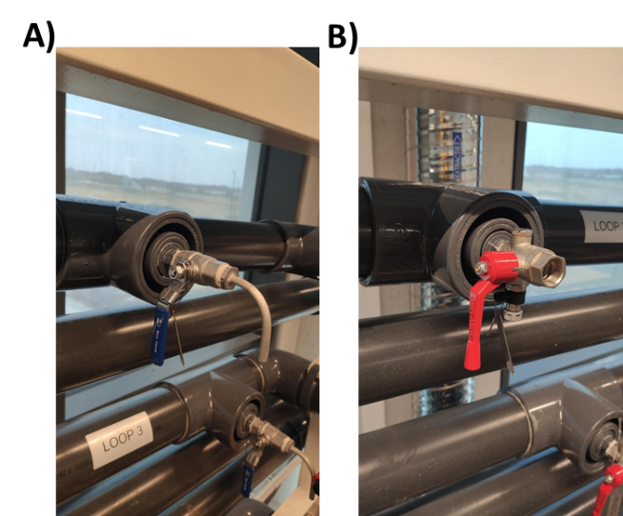
Fig S8: Sampling valves. A) Stainless steel (SS) ball valves (DN15) allow heat (flame) sterilization of the valve before sampling. B) SS ball valves with an extra drain cock for hose connections are used, to connect tubing to the flow cytometer for monitoring of the bacterial water quality.
Table S3: List of 32 taste and odor compounds investigated in the drinking water samples.
Compound | CAS-NR
β-ionone | 79-77-6
β-cyclocitral | 432-25-7
trichloromethane | 67-66-3
trans-2-cis-6-nonadienal | 557-48-2
nonanal | 124-19-6
Iodoform | 75-47-8
heptanal | 111-71-7
Geosmin | 19700-21-1
dimethyl trisulfide | 3658-80-8
dimethyl disulfide | 624-92-0
decanal | 112-31-2
cis-3-Hexen-1-ol | 928-96-1
anisole | 100-66-3
4-chloroanisole | 623-12-1
3-methyl-1-butanal | 590-86-3
2-methylisoborneol | 2371-42-8
2-methylbutyraldehyde | 96-17-3
2-isopropyl-3-methoxypyrazine | 25773-40-4
2-isobutyl-3-methoxypyrazine | 24683-00-9
2-chlorophenol | 95-57-8
2,6-di-tert-butyl-4-methylphenol (BHT) | 128-37-0
2,6-dibromophenol | 608-33-3
2,6-dibromo-4-methylphenol | 2432-14-6
2,4-heptadienal (trans, trans) | 4313-03-5
2,4-dichloroanisole | 553-82-2
2,4-decadienal (trans, cis) | 25152-83-4
2,4,6-trichlorophenol | 88-06-2
2,4,6-trichloroanisole (TCA) | 87-40-1
2,4,6-tribromoanisole | 607-99-8
2,4,5-trichloroanisole | 6130-75-2
2,3,6-trichloroanisole | 50375-10-5
2,3,4-trichloroanisole | 54135-80-7

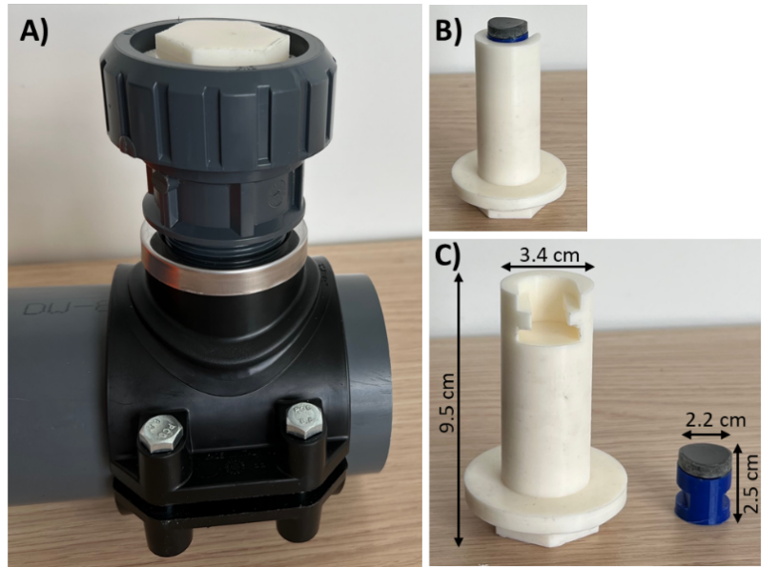
Fig S9: Biofilm sampling coupon to examine the biofilm undisruptive. The part of the insert that is in contact with the water is made out of PVC-U, same material as the pipes. A) The coupon installed on a pipe using a system to resist pressure. B) The coupon when removed from the pipe. C) The coupon consists of a white holder (3.4 cm of diameter, 9.5 cm long) made out of thermoplastic polyurethane (TPU), where a small insert, also made out of TPU, (2.2 cm of diameter, 2.5 cm long) can be placed. The top of this insert is made using a section of a PCV-U pipe and can be removed for further analysis.
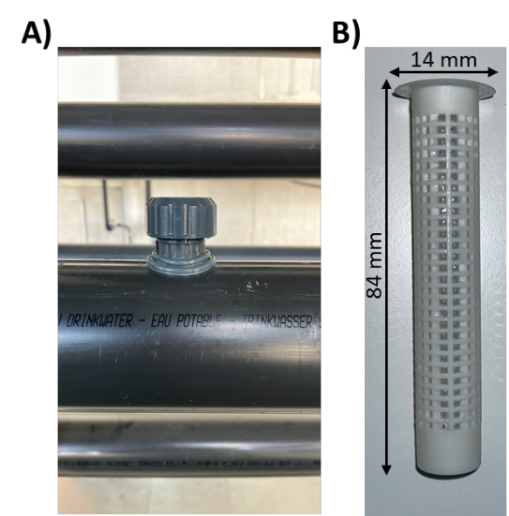
Fig S10: Sections to passively sample volatile organic compounds (VOCs) using stir bar sorptive extraction (SBSE). A) Section with screw threaded holes and corresponding closable caps. B) PP mesh container is placed, which can contain stir bars for SBSE.

