Supplement dataset 1

Evaluation of housekeeping genes for normalizing RT-qPCR and analysis of the expression patterns of WRKY1 transcription factor and rhynchophylline biosynthetic-related genes in Uncaria rhynchophylla

Additional files
Supplementary Table 1. Expression stability values of 10 candidate genes calculated using the RefFinder in U. rhynchophylla
Rank | MeJA | ETH | Low temperature | Total
1 | PP2A  1.189 | SAM  1.495 | SAM  1.50 | SAM  1
2 | ACT6  2 | cdc73  2.213 | cdc 73  2.632 | cdc 73  2.213
3 | cdc73  3.464 | ACT6  3 | PP2A  2.931 | ACT6  2.632
4 | SAM  3.464 | CYP  4.356 | CYP  3.13 | PP2A  4.356
5 | 18S  5 | PP2A  4.427 | 18S  4.141 | CYP  4.356
6 | CYP  6 | PAL  4.472 | PAL  4.606 | PAL  5.958
7 | GAPDH  7.483 | EF-1β  5.292 | GAPDH  6.402 | EF-1β  6.435
8 | PAL  7.969 | GAPDH  7.483 | ACT6  7.737 | DAPDH  8.239
9 | EF-1β  8.452 | TUA  9 | TUA  9 | 18S  8.739
10 | TUA  10 | 18S  10 | EF-1β  10 | TUA  10

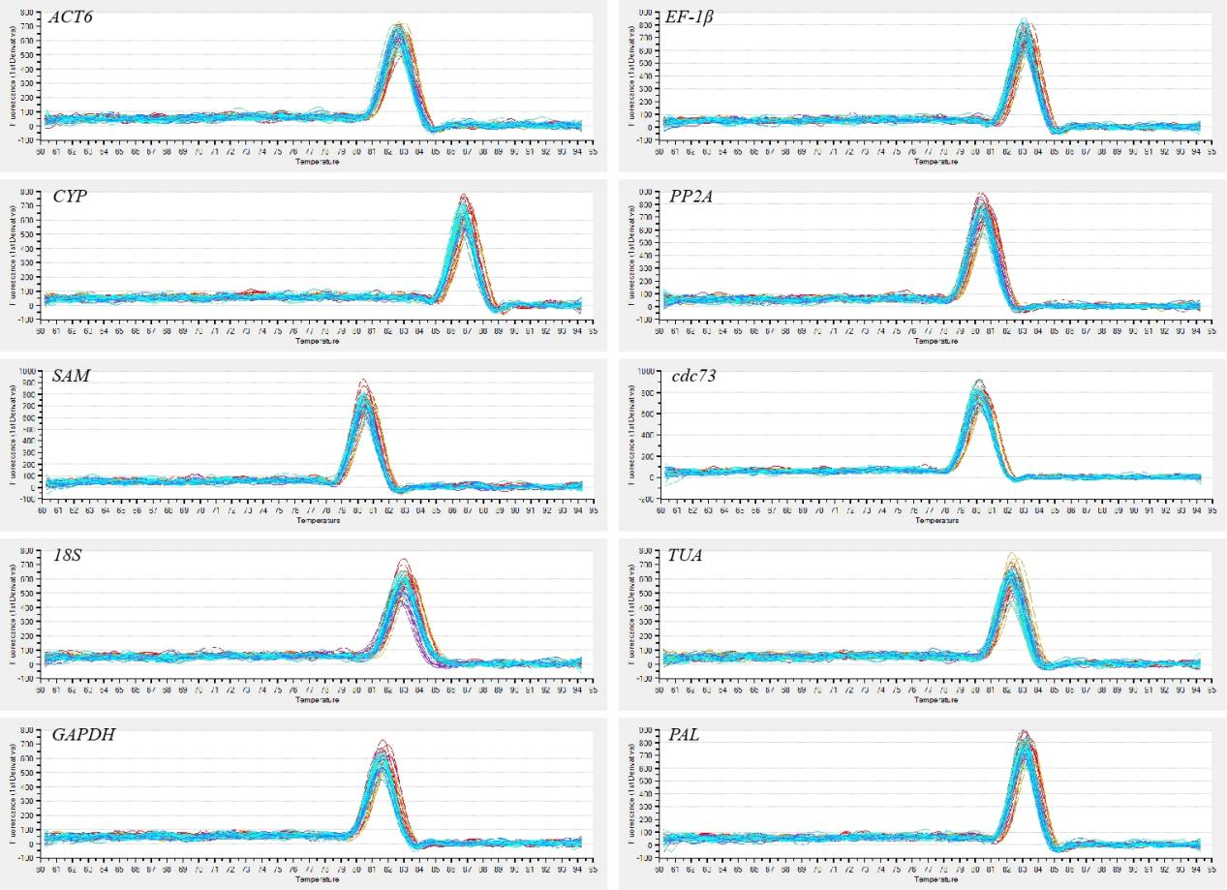
Supplementary Figure 1. RT- qPCR melting curves of ten housekeeping genes.

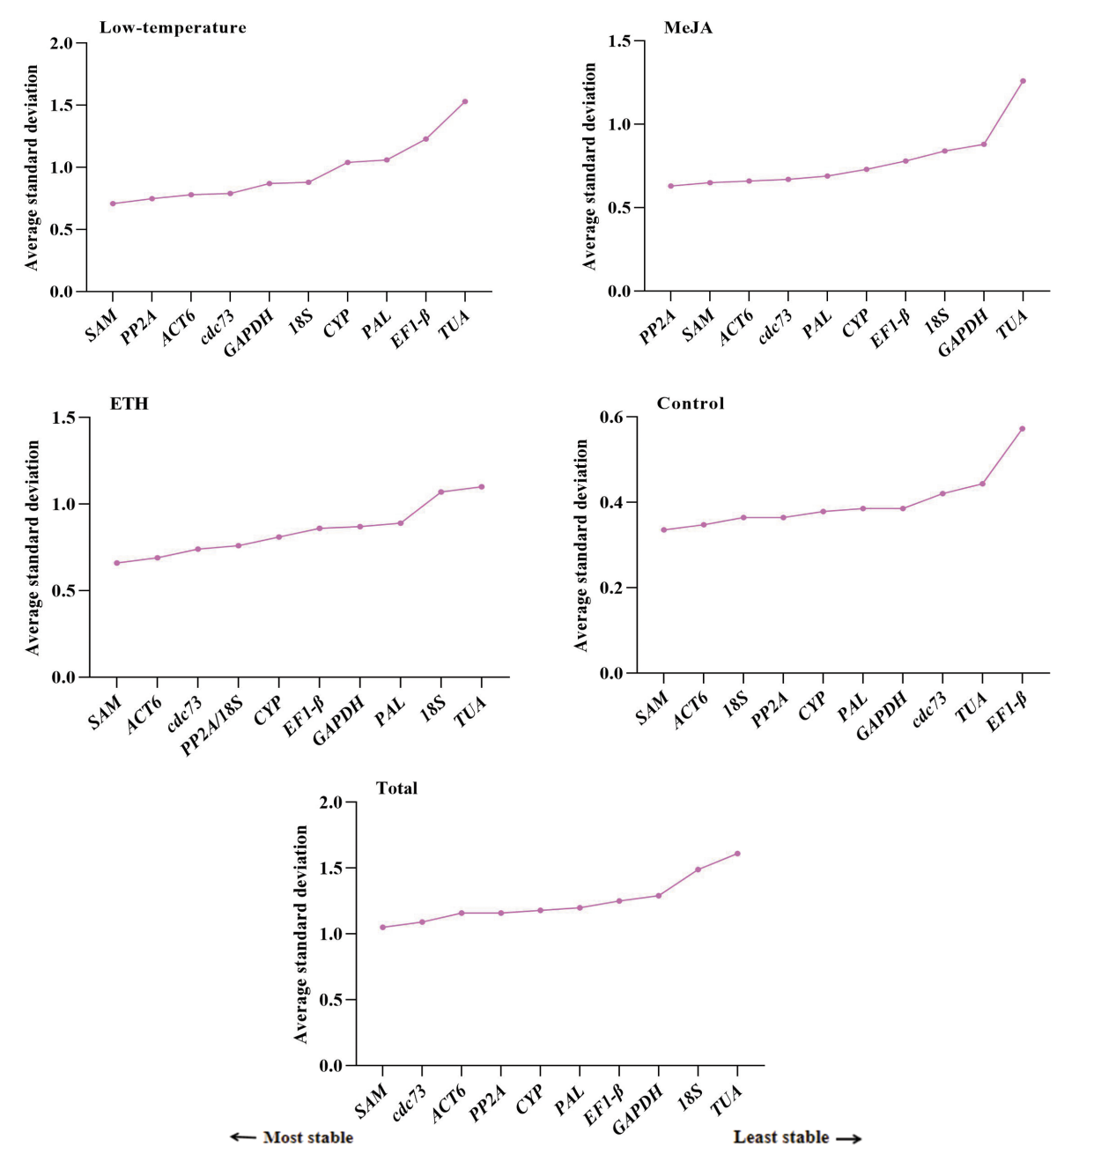
Supplementary Figure 2. Average standard stability deviation (SD) of the ten candidate housekeeping gene using Delta Ct algorithm.

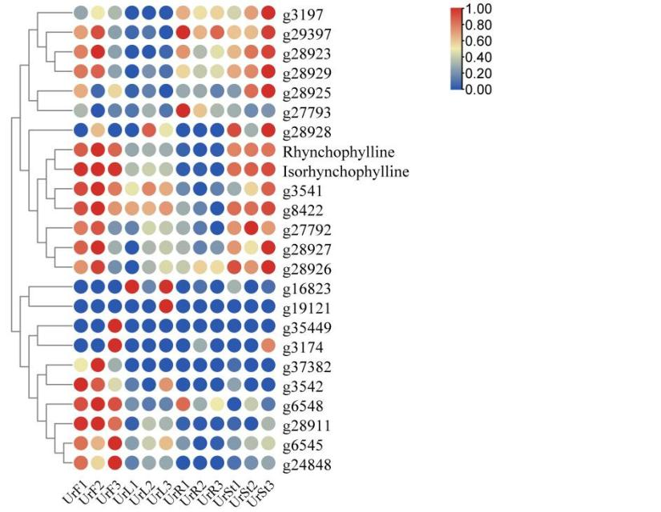
Supplementary Figure 3. Screening of strictosidine synthase genes heatmap. Rhynchophylline (RIN) and isorhynchophylline (IRN) are the content.

Additional files list
Supplementary Table 1. Expression stability values of 10 candidate genes calculated using the RefFinder in U. rhynchophylla
Supplementary Figure 1. RT- qPCR melting curves of ten housekeeping genes.
Supplementary Figure 2. Average standard stability deviation (SD) of the ten candidate housekeeping gene using Delta Ct algorithm.
Supplementary Figure 3. Screening of strictosidine synthase genes heatmap. Rhynchophylline (RIN) and isorhynchophylline (IRN) are the content.

