SUPPORTING INFORMATION
Bonding of isovalent homologous actinide and lanthanide pairs with chalcogenide donors: Effect of metal f-orbital participation and donor softness
Saparya Chattaraj^{a,c}, Arunasis Bhattacharyya^{b,c*}
ªHealth Physics Division, Health, Safety and Environment Group, Bhabha Atomic Research Centre, Mumbai – 400 085, India
^{b}Radiochemistry Division, Radiochemistry and Isotope Group, Bhabha Atomic Research Centre, Mumbai – 400 085, India,
^{c}Homi Bhabha National Institute, Anushaktinagar, Mumbai-400 094, India

*Corresponding Author: Tel.: +91 22 25596335, E-mail: arun12@barc.gov.in

Table S1 Frontier MO data for all the systems
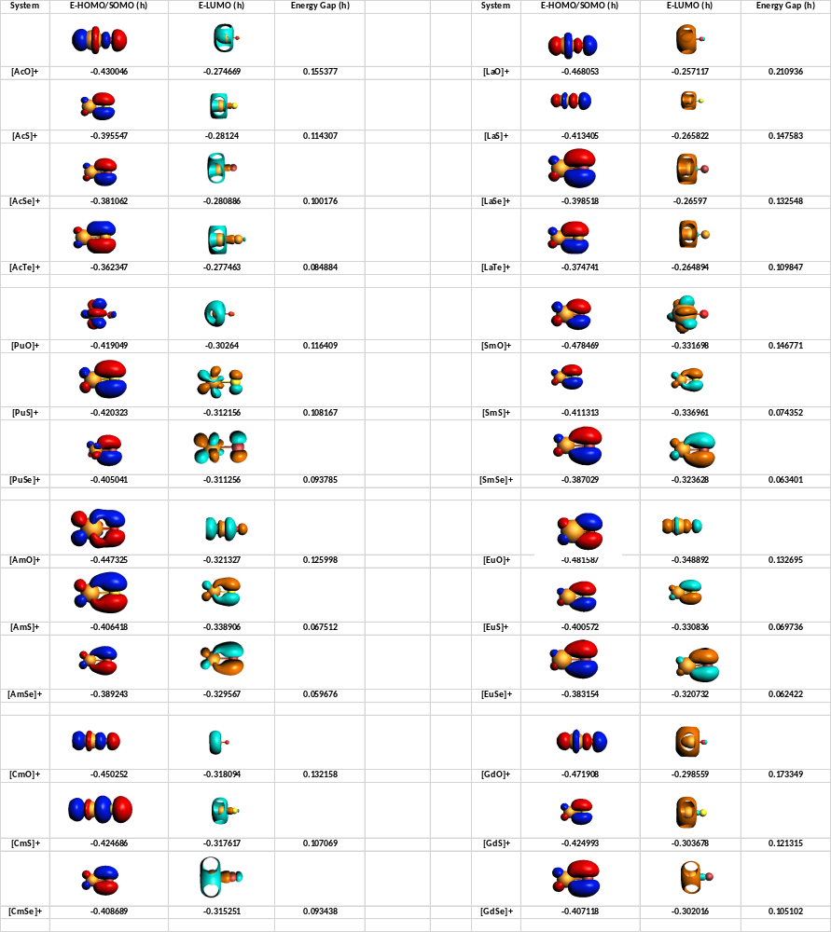

Table S2 Data from Energy Decomposition Analysis
 | ∆E_{bond} (kcal/mol) |  | ∆E_{Pauli} (kcal/mol) |  | ∆E_{elstat} (kcal/mol) |  | ∆E_{orb} (kcal/mol)
System | [AnX]⁺ | [LnX]⁺ | [AnX]⁺ | [LnX]⁺ | [AnX]⁺ | [LnX]⁺ | [AnX]⁺ | [LnX]⁺
0-O | -1024.06 | -1085.53 | 577.6 | 650.87 | -1272.9 | -1333.7 | -328.76 | -402.71
5-O | -1126.47 | -1133.25 | 690.52 | 589.62 | -1396.23 | -1329.22 | -420.76 | -393.64
6-O | -1124.07 | -1147.02 | 667.08 | 545.67 | -1389.47 | -1305.91 | -401.68 | -386.78
7-O | -1105.38 | -1123.21 | 626.04 | 570.96 | -1369.95 | -1328.96 | -361.48 | -365.21
0-S | -849.28 | -902.16 | 380.77 | 413.53 | -948.37 | -976.34 | -281.68 | -339.35
5-S | -952.08 | -956.78 | 412.93 | 324.5 | -1012.05 | -943.51 | -352.96 | -337.77
6-S | -950.55 | -986.37 | 357.05 | 242.84 | -974.31 | -881.64 | -333.29 | -347.58
7-S | -934.89 | -948.6 | 425.81 | 375.29 | -1033.53 | -990.53 | -327.17 | -333.36
0-Se | -825.23 | -876.52 | 336.6 | 359.1 | -884.67 | -905.6 | -277.17 | -330.01
5-Se | -925.81 | -939.61 | 340.82 | 245.86 | -924.15 | -847.87 | -342.47 | -337.59
6-Se | -931.79 | -970.9 | 287.76 | 208.22 | -886.1 | -819.21 | -333.45 | -359.91
7-Se | -910.64 | -924.76 | 366.3 | 323.5 | -954.63 | -917.51 | -322.31 | -330.75

Table S3 An/Ln-X bond lengths for all the systems
 | Bond Length (Å)
System | AnX | LnX
0-O | 1.897 | 1.791
5-O | 1.791 | 1.773
6-O | 1.792 | 1.787
7-O | 1.804 | 1.763
0-S | 2.422 | 2.303
5-S | 2.316 | 2.337
6-S | 2.367 | 2.450
7-S | 2.279 | 2.248
0-Se | 2.565 | 2.447
5-Se | 2.483 | 2.547
6-Se | 2.548 | 2.610
7-Se | 2.424 | 2.391

Table S4 AIM charges on An/Ln and X centres
 |  | AIM Charges
System | An | X | Ln | X
0-O | 2.18 | -1.18 | 2.01 | -1.01
5-O | 1.93 | -0.93 | 1.90 | -0.90
6-O | 1.91 | -0.91 | 1.84 | -0.84
7-O | 1.94 | -0.94 | 1.94 | -0.94
0-S | 1.91 | -0.91 | 1.74 | -0.74
5-S | 1.64 | -0.64 | 1.57 | -0.57
6-S | 1.61 | -0.61 | 1.53 | -0.53
7-S | 1.66 | -0.66 | 1.71 | -0.71
0-Se | 1.84 | -0.84 | 1.67 | -0.67
5-Se | 1.57 | -0.57 | 1.53 | -0.53
6-Se | 1.54 | -0.54 | 1.50 | -0.50
7-Se | 1.58 | -0.58 | 1.65 | -0.65

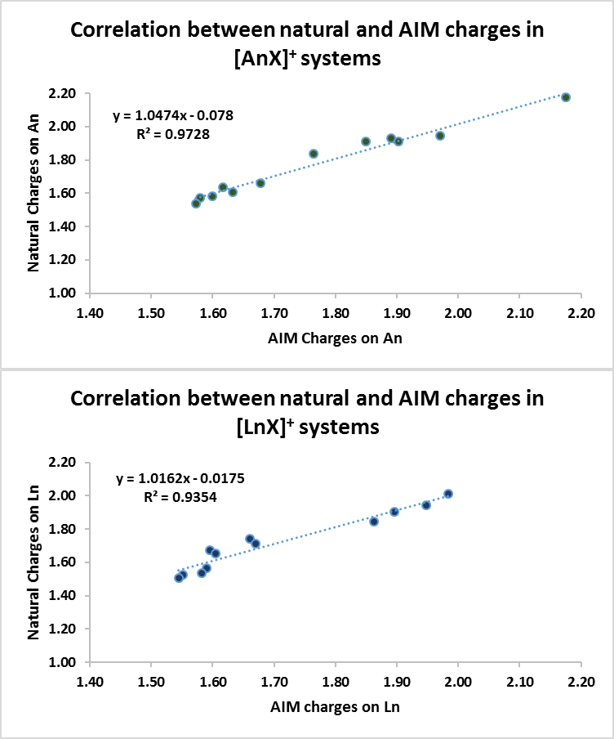
Figure S1 Correlation plots between natural and AIM charges

Table S5 QTAIM metrics for An/Ln-X bonds
QTAIM metrices at (3,-1) BCP | Electron Density |  | Laplacian of Electron Density |  | Total Energy Density
Bond | An-X | Ln-X | An-X | Ln-X | An-X | Ln-X
0-O | 0.213 | 0.257 | 0.414 | 0.280 | -0.184 | -0.275
5-O | 0.277  (0.285) | 0.259 | 0.499 | 0.440 | -0.296 | -0.265
6-O | 0.275  (0.283) | 0.242 | 0.496 | 0.500 | -0.293 | -0.228
7-O | 0.265  (0.269) | 0.257 | 0.708 | 0.664 | -0.255 | -0.243
0-S | 0.112 | 0.134 | 0.123 | 0.107 | -0.064 | -0.092
5-S | 0.131 | 0.110 | 0.149 | 0.199 | -0.084 | -0.056
6-S | 0.115 | 0.086 | 0.121 | 0.173 | -0.068 | -0.034
7-S | 0.135 | 0.130 | 0.182 | 0.182 | -0.086 | -0.081
0-Se | 0.093 | 0.111 | 0.103 | 0.098 | -0.046 | -0.065
5-Se | 0.103 | 0.081 | 0.135 | 0.143 | -0.054 | -0.031
6-Se | 0.085 | 0.070 | 0.109 | 0.129 | -0.038 | -0.024
7-Se | 0.108 | 0.106 | 0.156 | 0.153 | -0.057 | -0.055
Values in parenthesis are taken from Q.-R. Huang, J. R. Kingham and N. Kaltsoyannis, Dalton Transactions, 2015, 44, 2554–2566.

Table S6 Wiberg bond indices and delocalisation indices for An/Ln-X bonds
 | Wiberg Bond Indices |  | Delocalisation Indices
Bond | An-X | Ln-X | An-X | Ln-X
0-O | 1.423 | 1.678 | 1.756 | 1.946
5-O | 1.739 | 1.745 | 1.940  (2.097) | 2.000
6-O | 1.742 | 1.644 | 2.050  (2.079) | 1.926
7-O | 1.710 | 1.733 | 2.046  (2.081) | 1.984
0-S | 1.860 | 2.079 | 1.956 | 2.142
5-S | 1.796 | 1.246 | 1.642 | 1.154
6-S | 1.798 | 0.870 | 1.970 | 1.041
7-S | 2.066 | 2.063 | 2.248 | 2.154
0-Se | 1.961 | 2.151 | 2.013 | 2.188
5-Se | 2.042 | 1.024 | 2.206 | 1.072
6-Se | 1.674 | 0.818 | 1.825 | 1.048
7-Se | 2.143 | 2.125 | 2.283 | 2.184
Values in parenthesis are taken from Q.-R. Huang, J. R. Kingham and N. Kaltsoyannis, Dalton Transactions, 2015, 44, 2554–2566.

Table S7 Energetic contribution from second order perturbation analysis for donor acceptor delocalisation
 | Delocalisation Energy (kcal/mol)
System | An to An-X | X to An-X | Ln to Ln- X | X to Ln-X
0-O | 42.85 | 11.26 | 54.4 | 9.88
5-O | 17.45 | 5.01 | 19.32 | 4.18
6-O | 16.74 | 4.96 | 15.27 | 3.44
7-O | 19.42 | 6.32 | 17.76 | 4.75
0-S | 26.17 | 3.49 | 25.46 | 3.66
5-S | 9.23 | 1.75 | 6.69 | 1.78
6-S | 7.56 | 1.72 | 4.29 | 1.6
7-S | 11.26 | 3.61 | 3.73 | 2.65
0-Se | 22.61 | 4.55 | 20.71 | 3.77
5-Se | 8.16 | 2.36 | 4.48 | 1.53
6-Se | 5.81 | 2.18 | 3.45 | 1.17
7-Se | 10.19 | 4.01 | 8.06 | 2.54

