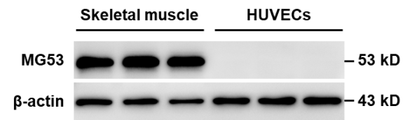

Supplementary Figure S1. MG53 is not expressed in endothelial cells. Proteins from mouse skeletal muscle and HUVECs were prepared and the expression of MG53 was detected with western blotting.

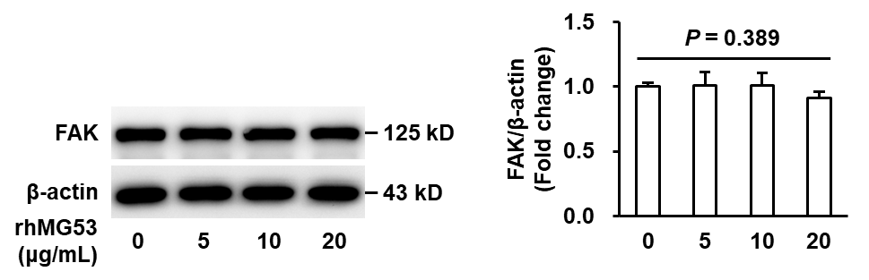

Supplementary Figure S2. rhMG53 has on effect on total FAK expression in HUVECs. HUVECs were stimulated with rhMG53 (0, 5, 10 and 20 μg/mL) for 24 h. Cell lysates were prepared and the expression of total FAK were measured with western blotting. Representative images of 3 independent experiments are shown and densitometric analysis of FAK normalized to β-actin was performed.

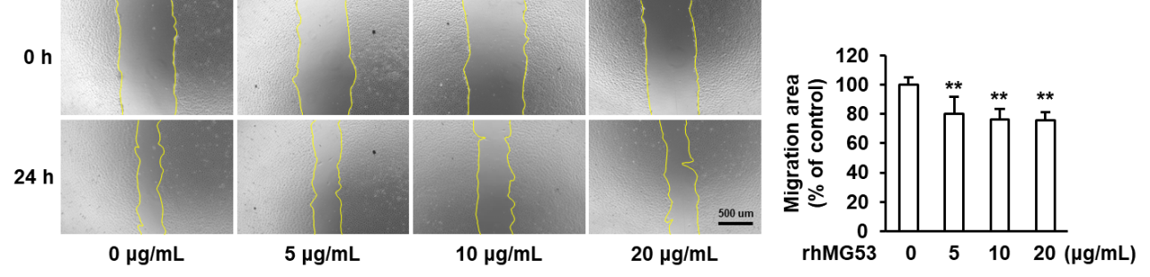

Supplementary Figure S3. rhMG53 decreases endothelial cell migration area. HUVECs were seeded onto 24-well plates and grown to 90% confluence. Then the cells were scratched with a 200 μL pipette tip, followed by stimulating with rhMG53 (0, 5, 10 and 20 μg/mL) for 24 h. Photomicrographs were taken immediately after the scratch and after rhMG53 treatment. Representative images of 3 independent experiments are shown. The cell migration area was calculated and quantitative assessment of 3 independent experiments was performed. **p < 0.01 vs. vehicle control.

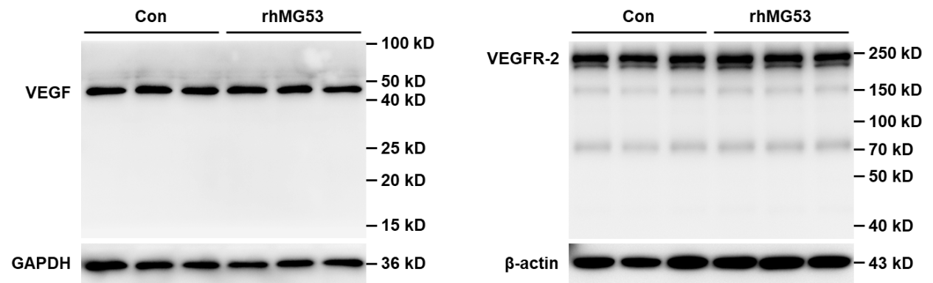

Supplementary Figure S4. rhMG53 has no effect on VEGF and VEGFR-2 expression in endothelial cells. HUVECs were stimulated with rhMG53 (10 μg/mL) for 24 h. Cell lysates were prepared and the expression of VEGF and VEGFR-2 were measured with western blotting.

