Supplementary information (Fig. S1-S6)

Enhancement of acarbose production by genetic engineering and process optimization in Actinoplanes sp. SIPI12-34

Zhenxin Li¹, Songbai Yang¹, Zhengyu Zhang^{1,2}, Yuanjie Wu¹, Jiawei Tang¹, Luoju Wang³ and Shaoxin Chen^{1*}

¹ State Key Laboratory of New Drug and Pharmaceutical Process, China State Institute of Pharmaceutical Industry, Shanghai Institute of Pharmaceutical Industry, Shanghai 201203, China
² Department of Biological Medicines & Shanghai Engineering Research Center of Immunotherapeutics, School of Pharmacy, Fudan University, Shanghai 201203, China
³ Shandong Qilu King-Pharmaceutical Co., Ltd. No.21 Qinglong Road, Pingyin County, Jinan, China

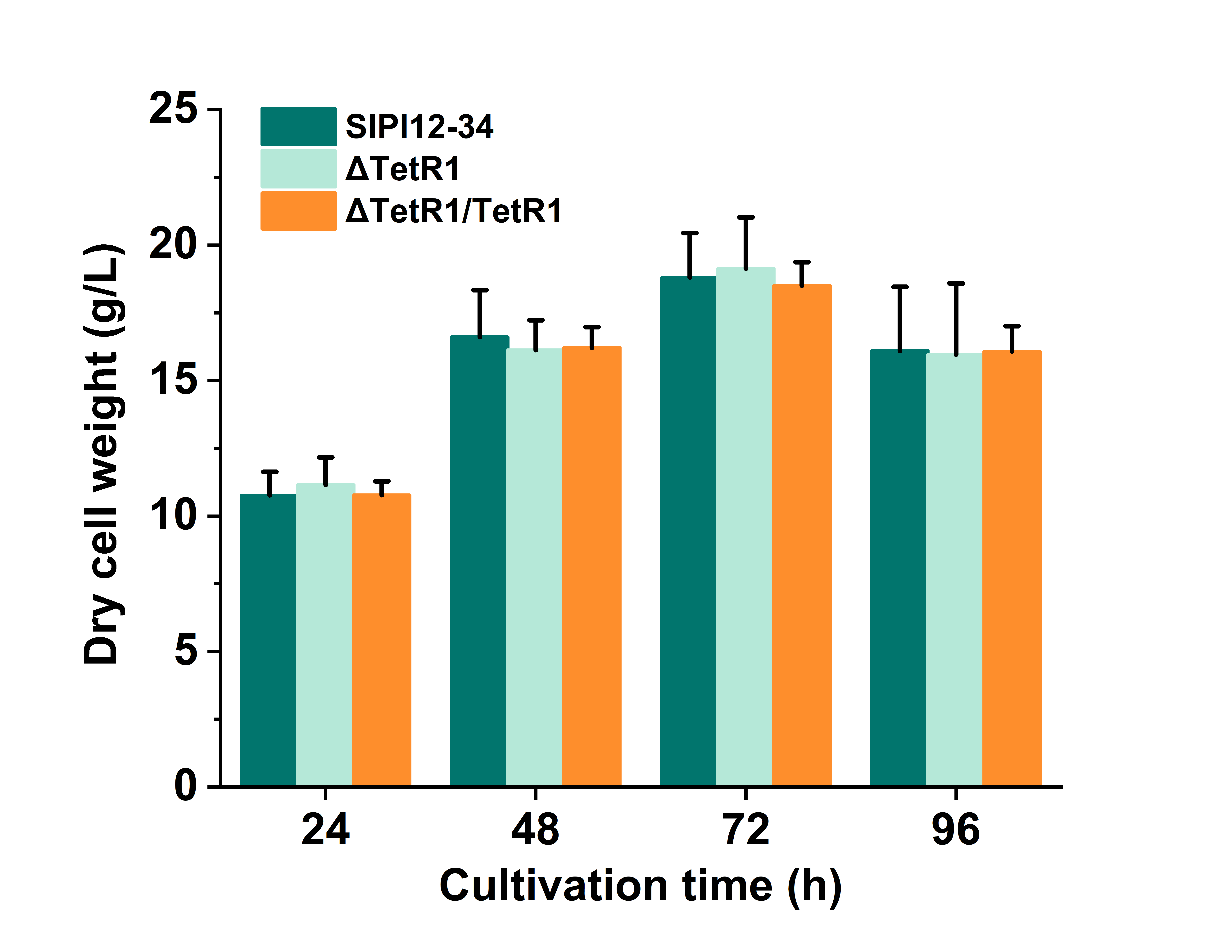
Fig. S1 Dry cell weights of SIPI12-34, ΔTetR1 and ΔTetR1/TetR1 at different times during the fermentation stage. Error bars show standard deviations, three replicates for each strain at each time point.

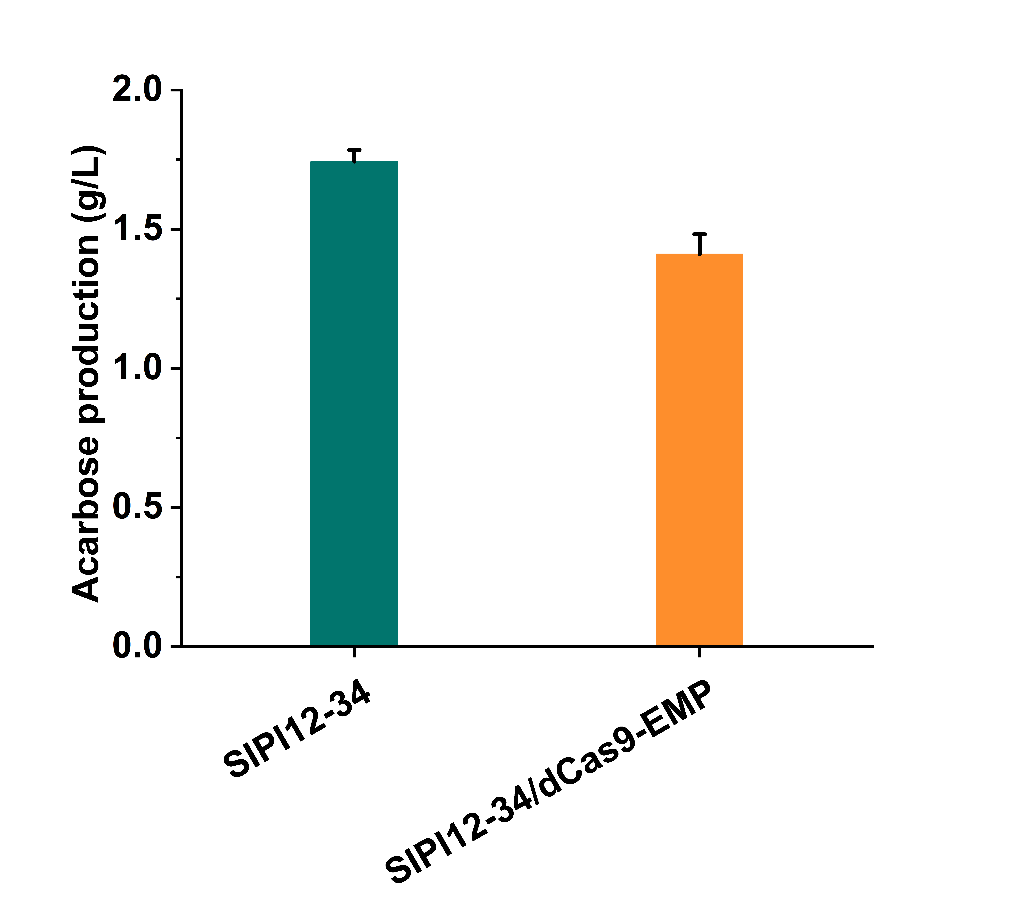
Fig. S2 Acarbose production profiles of SIPI12-34 and SIPI12-34/dCas9-EMP were analyzed by HPLC. SIPI12-34/dCas9-EMP: Mutant strain in which the expression of key enzyme gene (6-phosphofructokinase) in the glycolytic pathway was inhibited by the CRISPR-dCas9 system.

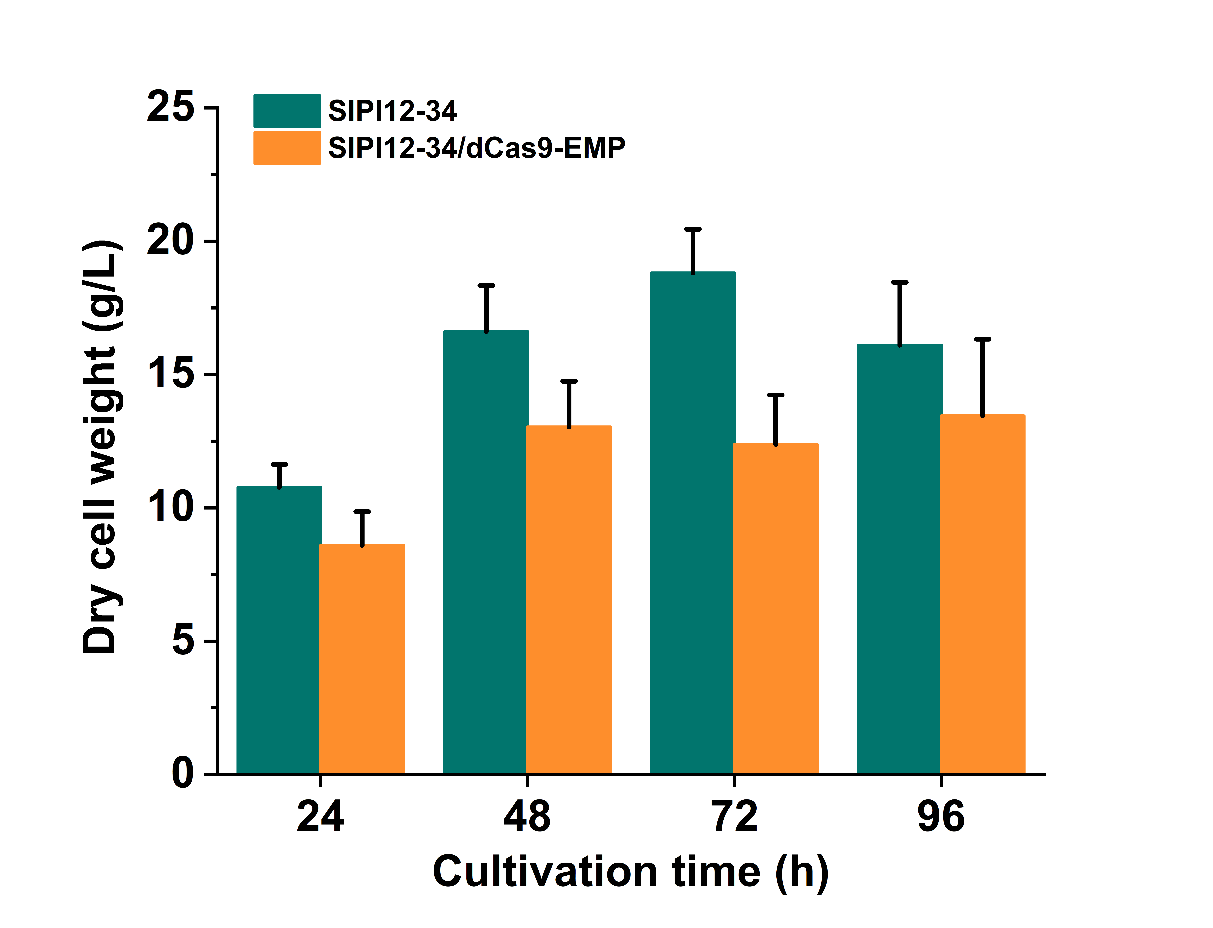

Fig. S3 Dry cell weights of SIPI12-34 and SIPI12-34/dCas9-EMP at different times during the fermentation stage. Three replicates for each strain at each time point.

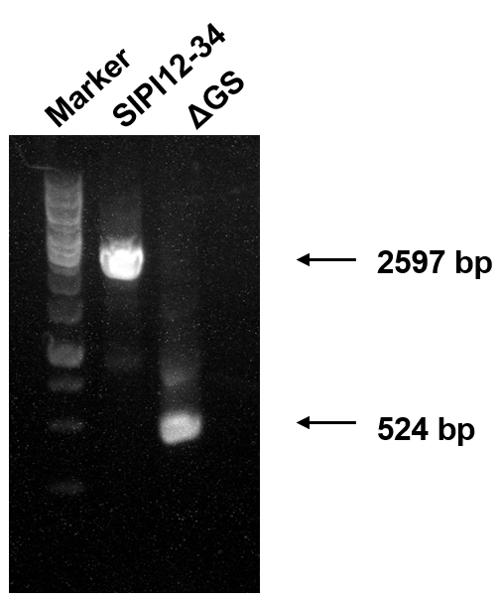
Fig. S4 PCR validation of ΔGS and SIPI12-34. ΔGS: mutant strain with complete deletion of glycogen synthase gene (2073 bp) in the chromosome of SIPI12-34.
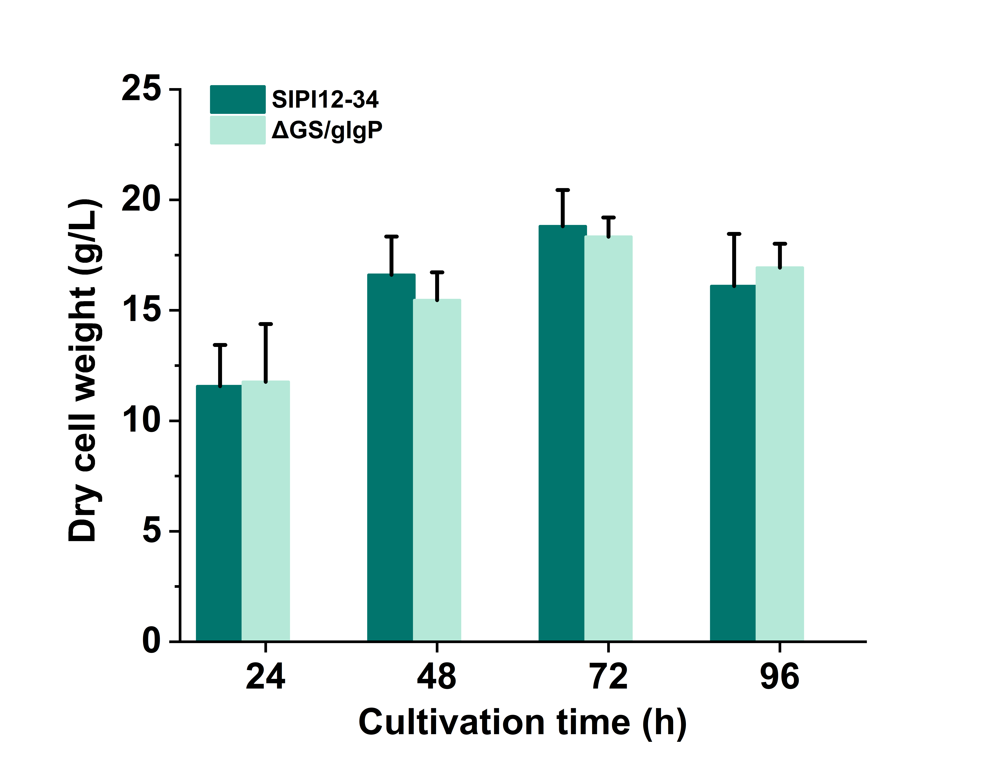
Fig. S5 Dry cell weights of SIPI12-34 and ΔGS/glgP at different times during the fermentation stage.

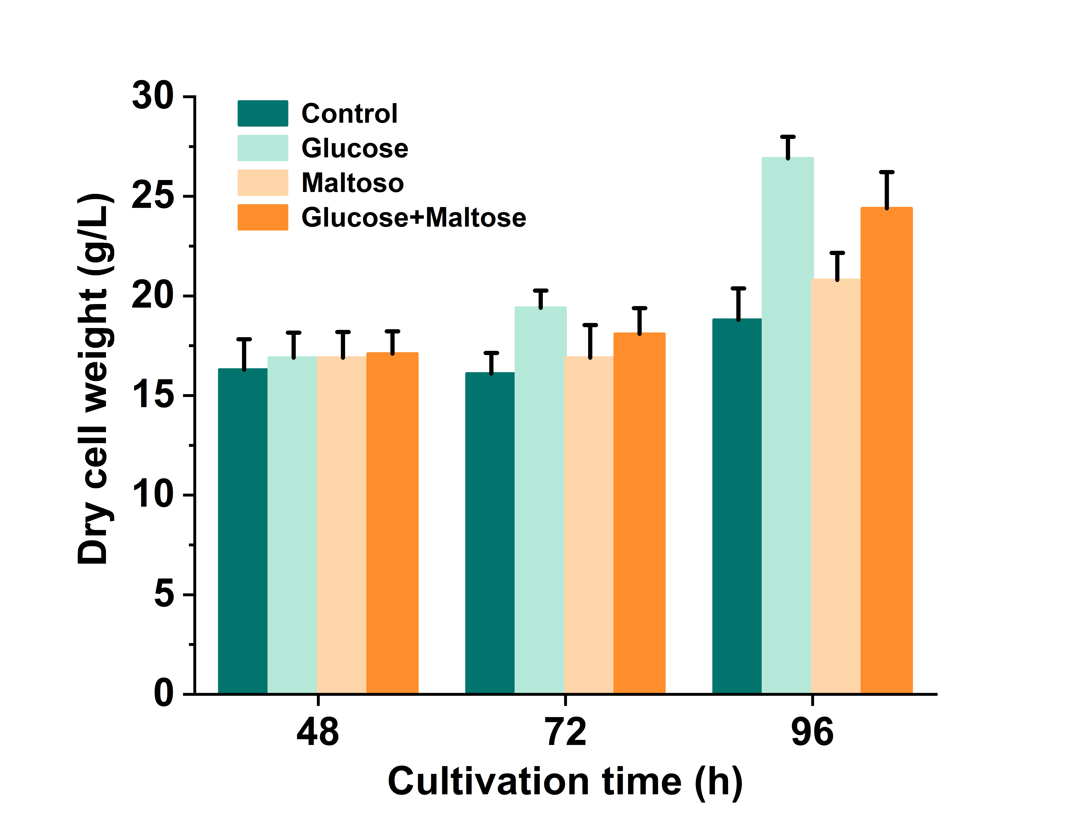
Fig. S6 Dry cell weights of SIPI2207 with addition of different sugars during the fermentation stage. Control represents no supplementation for SIPI2207. Glucose represents supplementation of 20 g/L glucose for SIPI2207 at 48 h. Maltose represents supplementation of 20 g/L maltose for SIPI2207 at 48 h. Glucose+Maltose represents supplementation of a 10 g/L mixture of glucose and maltose for SIPI2207 at 48 h.

