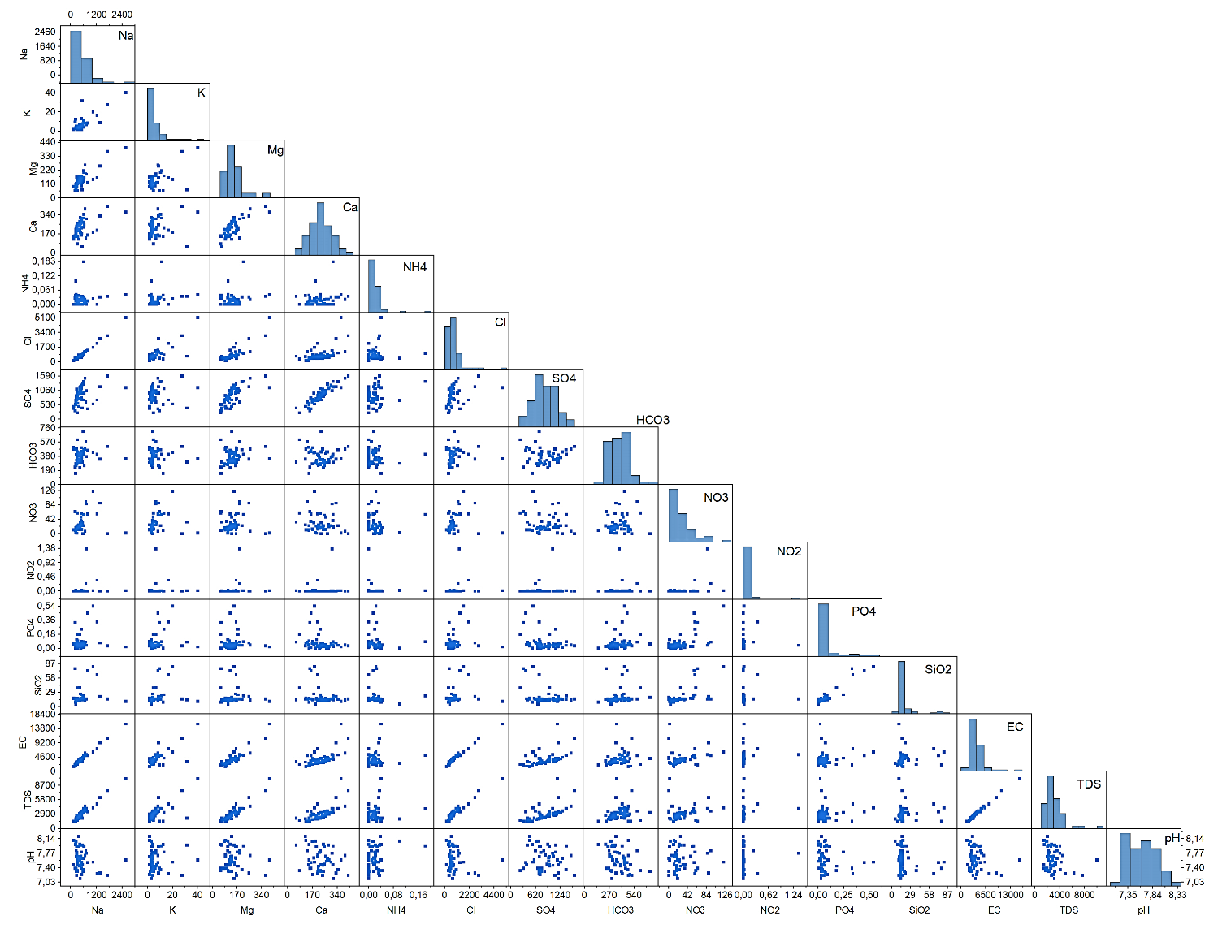
Fig. Scatterplot of the correlation matrix with histograms that depict how each numerical variable is distributed.

