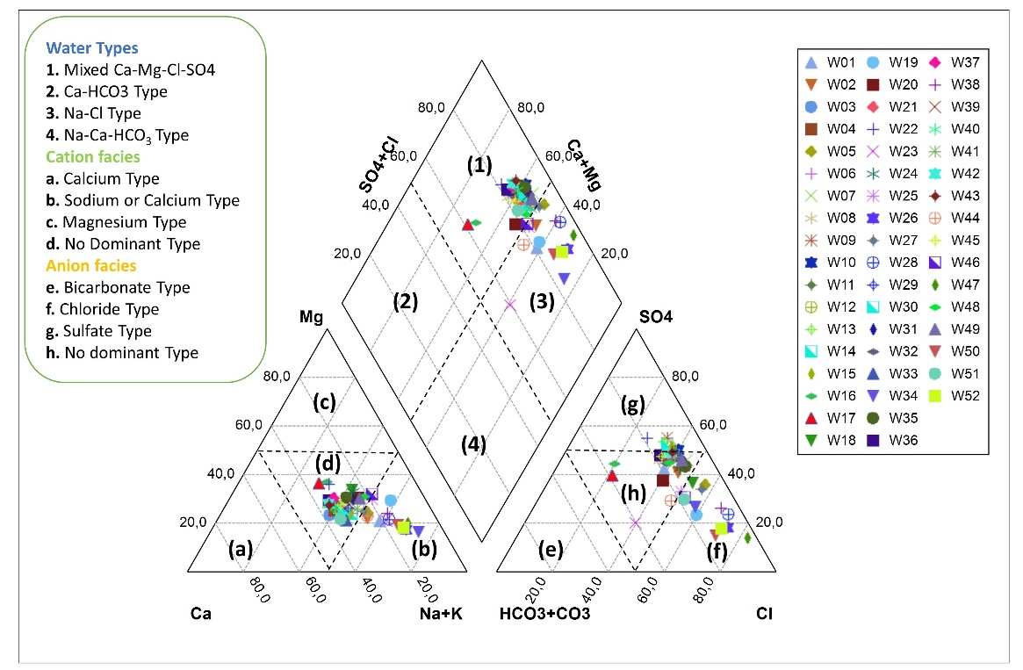
Fig. Piper diagram of the sampled groundwaters

