Embryo Genotypes and Lethality Mapping
Embryonic Day | +/+ | +/− | −/− | Total N | p-value | p-value
10.5 | 1 (5%) | 10 (56%) | 7 (39%) | 18 | 0.12 | E10.5-E12.5 p=0.38
11.5 | 2 (13%) | 7 (47%) | 6 (40%) | 15 | 0.33 | E10.5-E12.5 p=0.38
12.5 | 26 (23%) | 61 (54%) | 25 (22%) | 112 | 0.63 | E10.5-E12.5 p=0.38
14.5 | 27 (30) | 53 (55) | 16 (17) | 98 | 0.13 | E14.5-E18.5 p=0.049
16.5 | 2 (11%) | 10 (56%) | 6 (33%) | 18 | 0.36 | E14.5-E18.5 p=0.049
18.5 | 16 (46%) | 15 (43%) | 4 (11%) | 35 | 0.011 | E14.5-E18.5 p=0.049
Expected Mendelian ratio | 1 (25%) | 2 (50%) | 1 (25%)
Supplementary Table S1: Embryonic genotyping.
Embryos were genotyped between E10.5 and E18.5. The decreased total number of KO embryos from E14.5 to E18.5 (p<0.049) suggests embryonic lethality between E12.5 and E14.5. Chi-square calculated p-values (1:2:1 expected ratio) are shown for each embryonic day, for E10.5-E12.5 combined, and for E14.5-E18.5 combined.

Embryo Lethality Mapping when Crossing: Samd1^{+/−} x Samd1^{+/−}
Sex | +/+ | +/− | −/− | Total N | p-value  KO Mortality  (1:2:1 ratio) | p-value  HET Mortality  (1:2 ratio)
Male (55.2%) | 35 (47%) | 39 (53%) | 0 | 74 | 5.8 x 10⁻⁸ | 0.01
Female (44.8%) | 26 (43%) | 34 (57%) | 0 | 60 | 7.5 x 10⁻⁶ | 0.01
Total M+F | 61 (45.5%) | 73 (54.5%) | 0 | 134 | 5.1 x 10⁻¹³ | 0.003
Expected  Mendelian ratios | 1 (25%) | 2 (50%) | 1 (25%)
Supplementary Table S2: Samd1^{+/−} x Samd1^{+/−} crossings.
Genotyping of Samd1^{+/−} x Samd1^{+/−} crossings at P21. P-values for KO lethality were calculated using Chi-square and the 1:2:1 Mendelian ratio. P-values for HET lethality were calculated using Chi-square for a 1:2 Mendelian ratio.

Embryo Lethality Mapping when Crossing: Samd1^{+/+} x Samd1^{+/−}
Sex | +/+ | +/− | Total N | p-value HET Mortality  (1:1 ratio)
Male (50.9%) | 69 (56%) | 55 (44%) | 124 | 0.21
Female (49.1%) | 76 (63%) | 44 (37%) | 120 | 0.003
Total M+F | 145 (59.5%) | 99 (40.6%) | 244 | 0.003
Expected  Mendelian ratios | 1(50%) | 1 (50%)
Supplementary Table S3: Samd1^{+/−} x Samd1^{+/−} crossings
Genotyping of Samd1^{+/−} x Samd1^{+/−} crossings at P21. P-values for HET lethality were calculated using Chi-square for the 1:1 Mendelian ratio.

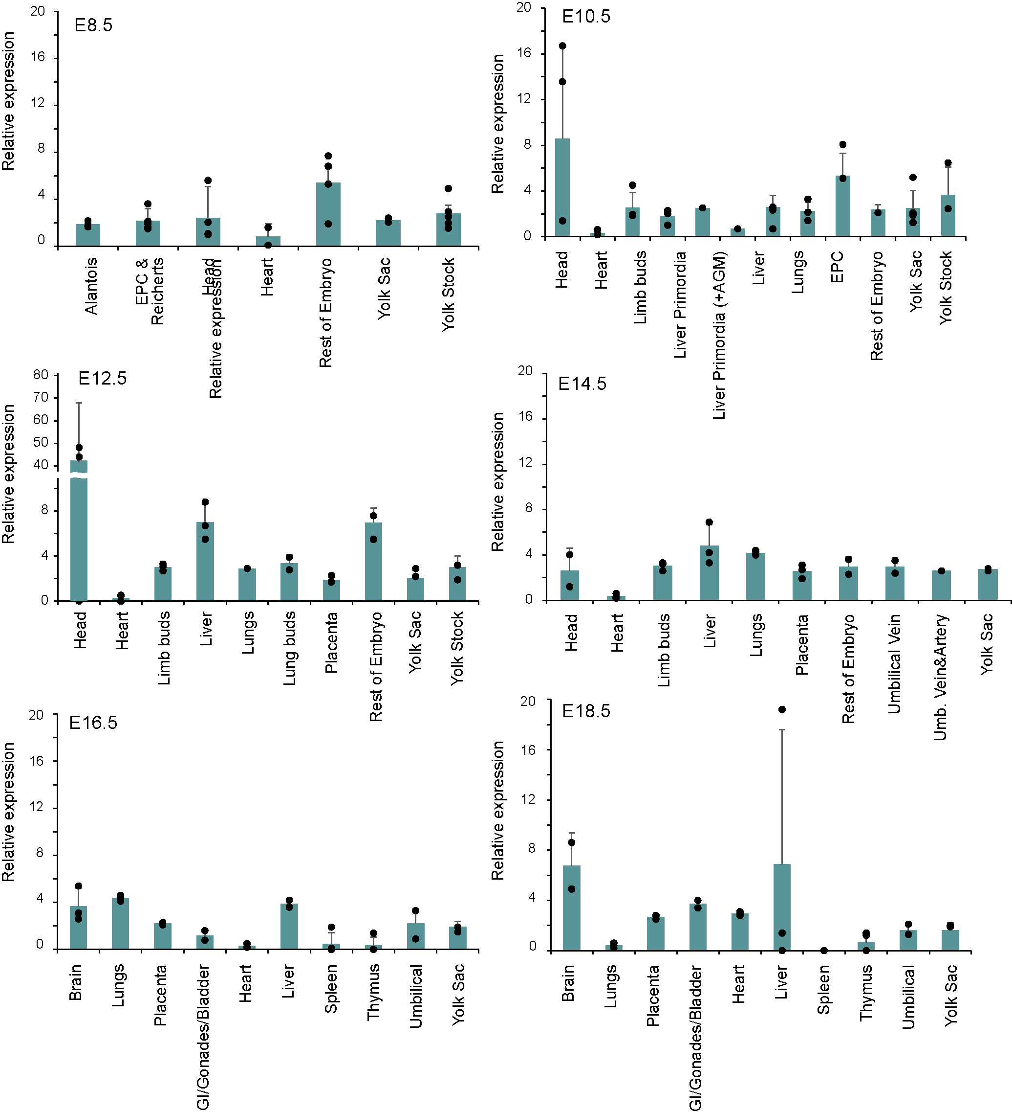
Supplementary Figure S1: Gene expression of SAMD1 during embryogenesis
RT-qPCR analysis of gene expression of SAMD1 using samples from wild-type embryos at various stages. Data are presented as mean ± SD.

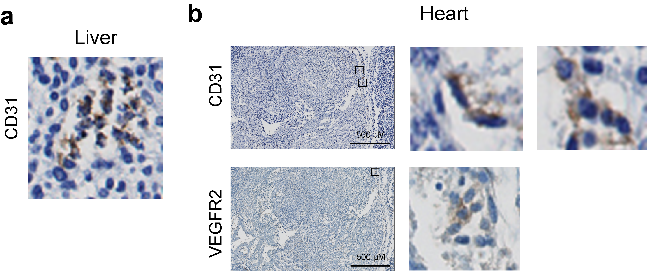
Supplementary Figure S2: Cell fragments in liver and heart
CD31 and VEGFR2 (brown) staining (counterstained with hematoxylin (blue)) in liver (a) and heart (b), showing examples for cell fragments and phagocytosis of ECs in SAMD1 KO mice.

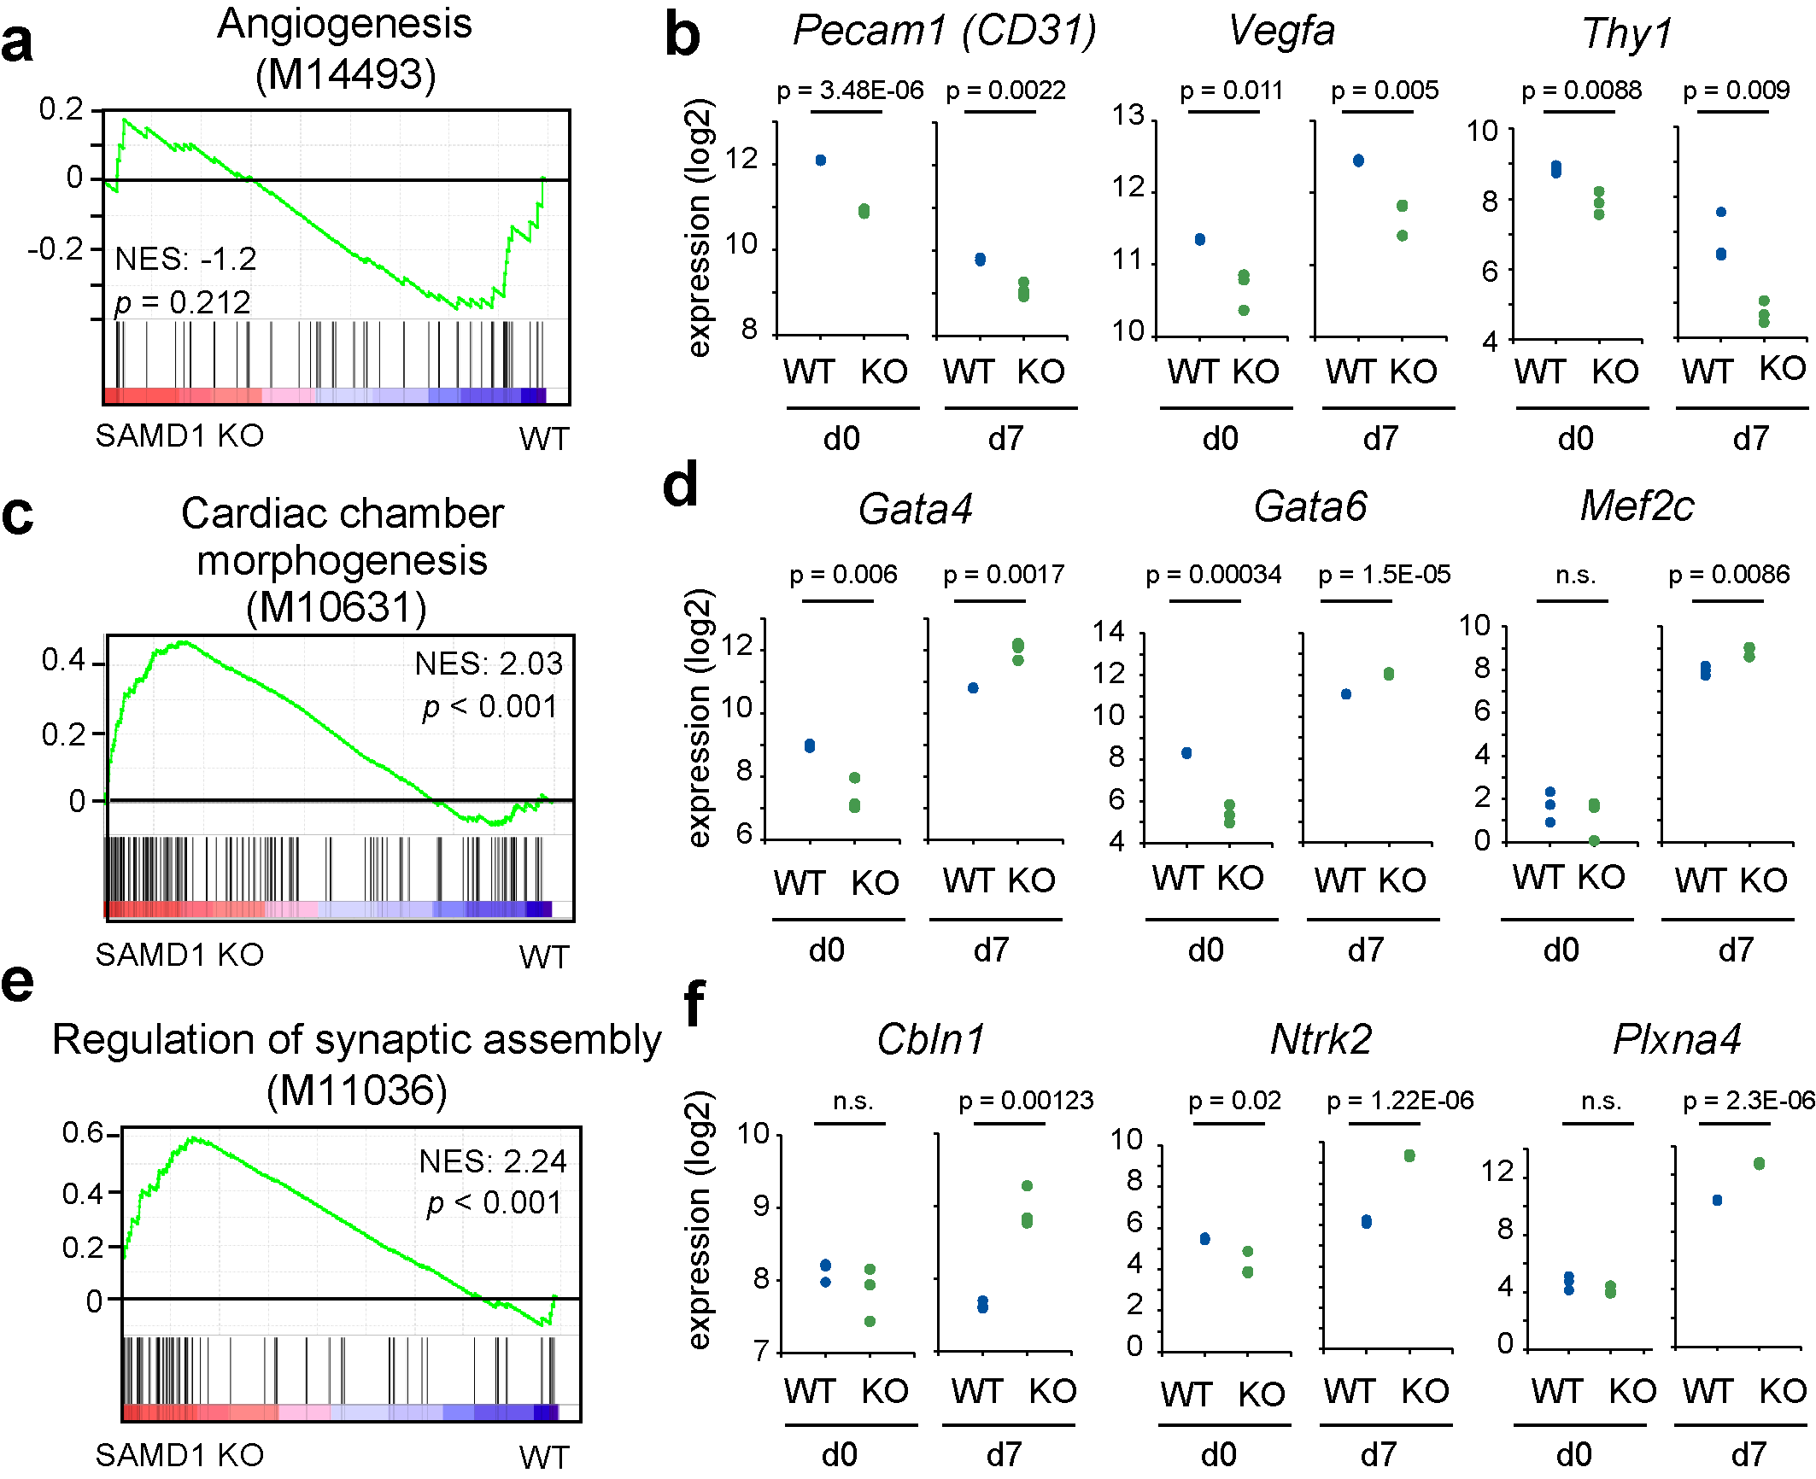
Supplementary Figure S3: SAMD1 deletion impairs multiple cellular pathways during undirected ES cell differentiation.
(a) GSEA (gene set enrichment analysis) of RNA-Seq data after 7 days of undirected ES cell differentiation⁴, showing the downregulation of angiogenesis pathways. (b) Examples of genes related to angiogenesis and arteriogenesis affected upon SAMD1 deletion in undifferentiated (d0) and differentiated (d7) ES cells. (c) GSEA of the cardiac chamber morphogenesis pathway. (d) Example dysregulated genes in SAMD1 KO cells related to heart development. Data from RNA-Seq. P-values two-tailed unpaired student’s t-test. (e) GSEA of the synaptic assembly pathway. (f) Example dysregulated genes in differentiated SAMD1 KO cells⁴. n.s. = not significant.

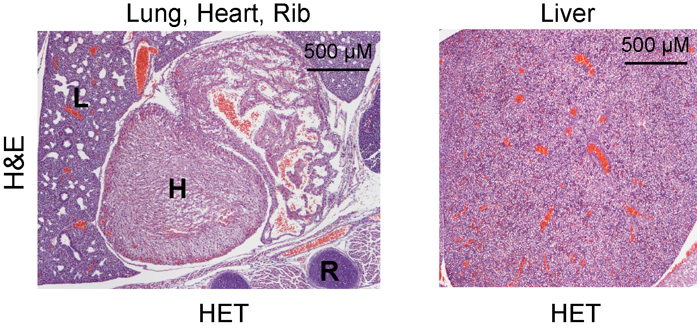
Supplementary Figure S4: Internal organs of SAMD1 HET mice are normal
H&E staining of lung (L), heart (H), rib (R) and liver from HET mice at E14.5. These tissues are indistinguishable from the WT tissues shown in Figures 2 and 3.

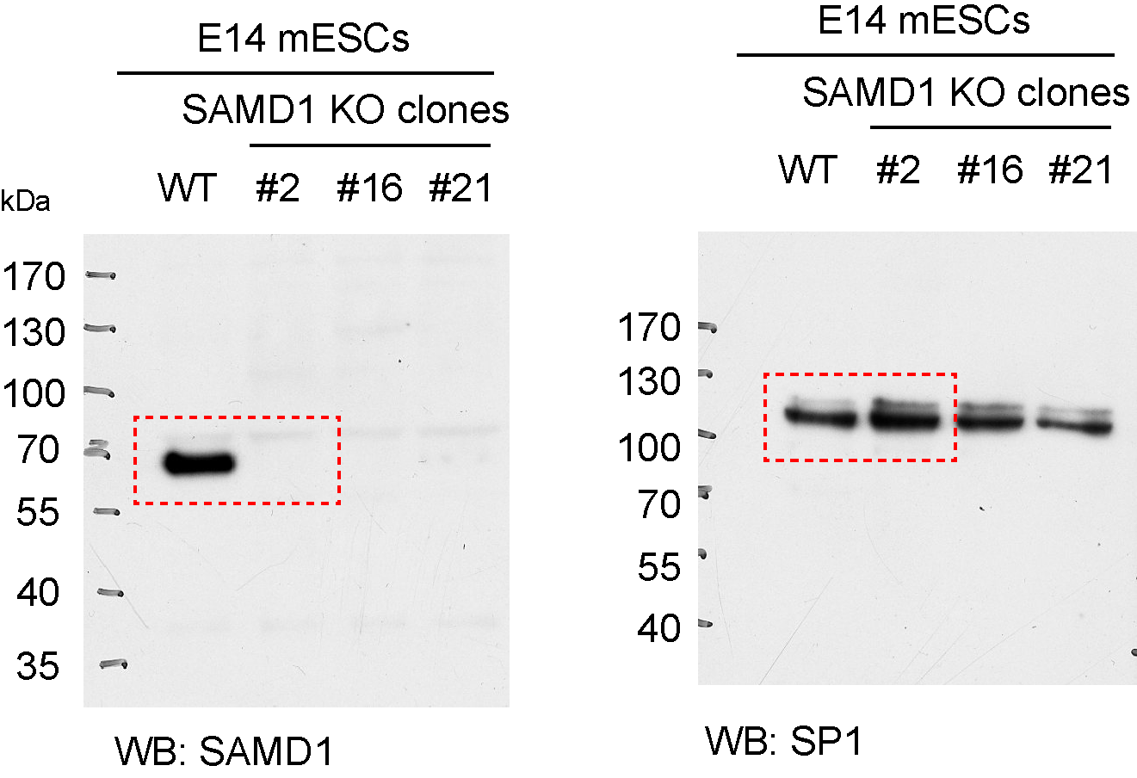
Supplementary Figure S5: Full Western blots.

Supplementary Table S4: RT-qPCR primers
Housekeeping genes
RT_mActb_fw | GTA-CCC-AGG-CAT-TGC-TGA-CA
RT_mActb_rv | AGG-GTG-TAA-AAC-GCA-GCT-CAG
RT_mGapdh_fw | AGA-CGG-CCG-CAT-CTT-CTT-GT
RT_mGapdh_rv | GCC-TTG-ACT-GTG-CCG-TTG-AA
Target genes
RT_mActn1_fw | GAT-ATT-GGC-AAC-GAC-CCC-CA
RT_mActn1_rv | TAA-TGA-ACC-CAG-CCA-GCC-AG
RT_mCbln1_fw | GAG-CCG-TCC-GAG-ATG-AGT-AA
RT_mCbln1_rv | CAC-CCG-TTC-AAC-ATG-AGG-CT
RT_mCdh2_fw | TGG-GAA-TCA-GAC-GGC-TAG-AC
RT_mCdh2_rv | GGT-AGT-CAT-AGT-CCT-GGT-CC
RT_mChd7_fw | CAG-ACG-TGC-TGT-TTT-CCT-CG
RT_mChd7_rv | CAG-TGA-GGA-GAC-GGT-CAA-AC
RT_mCldn11_fw | TTG-ACA-GTT-CTC-CCC-TGC-AT
RT_mCldn11_rv | GTA-GCC-AAA-GCT-CAC-GAT-GG
RT_mFoxa2_fw | GAT-GGA-AGG-GCA-CGA-GCC
RT_mFoxa2_rv | GTA-TGT-GTT-CAT-GCC-ATT-CAT-CCC
RT_mGalnt9_fw | CTC-TAC-CCC-TGT-CAT-GGC-AT
RT_mGalnt9_rv | TCT-CTA-CCT-CCA-GAC-ACC-GA
RT_mGfap_fw | AAG-GTT-GAA-TCG-CTG-GAG-GA
RT_mGfap_rv | CAC-TGC-CTC-GTA-TTG-AGT-GC
RT_mIsl1_fw | CCC-TCT-CAG-TCC-CTT-GCA-TC
RT_mIsl1_rv | GCG-TTT-CTT-GTC-CTT-GCA-CC
RT_mKlf4_fw | AAG-AGG-GGA-AGA-AGG-TCG-TG
RT_mKlf4_rv | CTG-TCA-CAC-TTC-TGG-CAC-TG
RT_mL3mbtl3_fw | CTT-GCC-TGG-GTG-TGA-AGA-AC
RT_mL3mbtl3_rv | TCC-GCA-GCT-TTG-AAC-ATC-AG
RT_mMyh6_fw | CAC-AGA-TGC-CGC-AAT-GAT-GG
RT_mMyh6_rv | GTC-GTG-CAT-CTT-CTT-GGC-AC
RT_mMyl2_fw | TTA-TTG-TTC-CAC-AGC-AGG-GGC
RT_mMyl2_rv | TGC-CCT-CGG-GAT-CAA-ACA-C
RT_mNanog_fw | CAC-AGT-TTG-CCT-AGT-TCT-GAG-G
RT_mNanog_rv | GCA-AGA-ATA-GTT-CTC-GGG-ATG-AA
RT_mNanos1_fw | GCC-TAG-TTT-AGG-TGC-GCA-AC
RT_mNanos1_rv | ACG-AGG-AAG-AAC-ACC-CTC-TC
RT_mNes_fw | GCC-TAT-AGT-TCA-ACG-CCC-CC
RT_mNes_rv | AGA-CAG-GCA-GGG-CTA-GCA-AG
RT_mNkx2-5_fw | ATT-TTA-CCC-GGG-AGC-CTA-CG
RT_mNkx2-5_rv | GCT-GTC-GCT-TGC-ACT-TGT-AG
RT_mNppa_fw | GCT-TCG-GGG-GTA-GGA-TTG-AC
RT_mNppa_rv | GAG-GCA-AGA-CCC-CAC-TAG-AC
RT_mNrp1_fw | AGC-TTC-GGA-CGT-TTT-CAC-CT
RT_mNrp1_rv | GGA-AGT-CAT-CAC-CTG-TGC-CA
RT_mNrp2_fw | TGC-AGG-TGA-GGA-TTT-TAA-AGA-TGA
RT_mNrp2_rv | CAG-GTG-CAG-TAA-AGG-AGG-AGG
RT_mOct4_fw | TGG-AAA-GGT-GTT-CAG-CCA-GA
RT_mOct4_rv | CCT-CAC-ACG-GTT-CTC-AAT-GC
RT_mOlig1_fw | TGA-ATC-CCA-CCT-GTT-TAG-AGC-C
RT_mOlig1_rv | CGA-TGC-TCA-CGG-ATA-CGA-GAA-TAG
RT_mPax3_fw | TCC-CAT-GGT-TGC-GTC-TCT-AAG
RT_mPax3_rv | CTC-CAC-GTC-AGG-CGT-TGT-C
RT_mPax7_fw | TGG-GGT-CTT-CAT-CAA-CGG-TC
RT_mPax7_rv | ATC-GGC-ACA-GAA-TCT-TGG-AGA
RT_mPth2_fw | GAG-ACC-TGC-CAG-ATG-TCC-AG
RT_mPth2_rv | CTG-CAT-GTA-AGA-GTC-CAG-CC
RT_mSamd1_fw | CTG-ATG-GGA-CAC-CTT-TTG-GC
RT_mSamd1_rv | GTG-AGC-ACA-TCT-GTC-CGT-TG
RT_mSfmbt1_fw | CCA-ACA-AGA-GAG-ATG-CCC-AG
RT_mSfmbt1_rv | GTG-GGA-AGG-GTA-AGG-AGC-AA
RT_mSox2_fw | AGG-AGA-GAA-GTT-TGG-AGC-CC
RT_mSox2_rv | TCT-GGC-GGA-GAA-TAG-TTG-GG
RT_mTbx5_fw_2 | CCC-CCT-GTA-CAG-AGC-GAG-AAT-A
RT_mTbx5_rv_2 | GGT-CGT-CTG-CGG-GAA-CAA-TA
RT_mTnnt2_fw | GTG-TGC-AGT-CCC-TGT-TCA-GA
RT_mTnnt2_rv | GCA-CCA-AGT-TGG-GCA-TGA-AG
RT_mTtn_fw | ACC-CTT-TTT-GGG-CAC-TCC-TG
RT_mTtn_rv | CTG-TTG-GCT-TTA-GTC-ACG-GC
RT_mTubb3_fw | TAG-ACC-CCA-GCG-GCA-ACT-AT
RT_mTubb3_rv | GTT-CCA-GGT-TCC-AAG-TCC-ACC

