Table 1 Molecular dynamics simulations concerning the effects of electric field on the morphology of the membrane with respect to the electroporation threshold, surface tension of the membrane and cholesterol content in the membrane patch.
 | 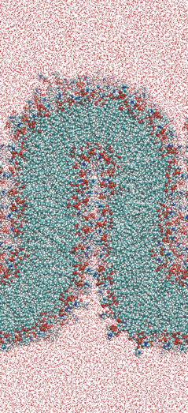 | 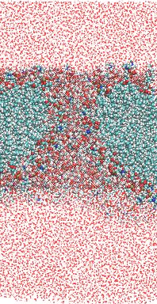 | 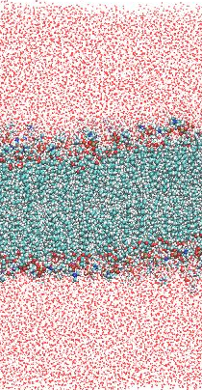 | 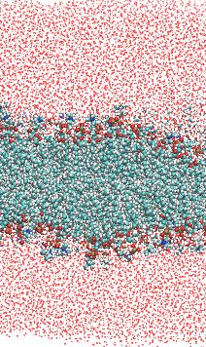
Relation to the electroporation threshold | Just below | Just over | Just below | Just below
Surface tension of the membrane | Low (-30 mN/m) | Low (-30 mN/m) | Low (-30 mN/m) | Normal (0 mN/m)
Cholesterol content in the membrane patch | 10% | 10% | 50% | 10%

Table 2 Summary of the molecular effects of nsPEF on pancreatic cancer cells (+ slight effect, ++ moderate effect, +++ high effect).
 | EPP85-181RDB | EPP85-181RNOV | EPP85-181P
Permeabilization | No | Yes | No
Membrane response | Release of microvesicles | No morphological change | Cell shrinkage
Actin response | Lack in the periphery | No visible effect | Reorganization
CD91 and CD243 colocalization | Most variable | Colocalized | Colocalized
Effect of nsPEF on chemotherapy resistance | Yes | No | No
Long lasting attenuation of cancer growth | No | Yes | No
Induction of cells adherence | + | ++ | +
Loss of Cadherin | +++ | +++ | ++

