Heat-light soaking treatments for high-performance CIGS solar cells on flexible substrates

Supplementary information

Romain Carron, Shiro Nishiwaki, Shih-Chi Yang, Mario Ochoa, Xiaoxiao Sun, Thomas Feurer, Ayodhya N. Tiwari

Laboratory for thin films and Photovoltaics, Empa–Swiss Federal Laboratories for Materials Science and Technology, Überlandstrasse 129, 8600, Dübendorf, Switzerland

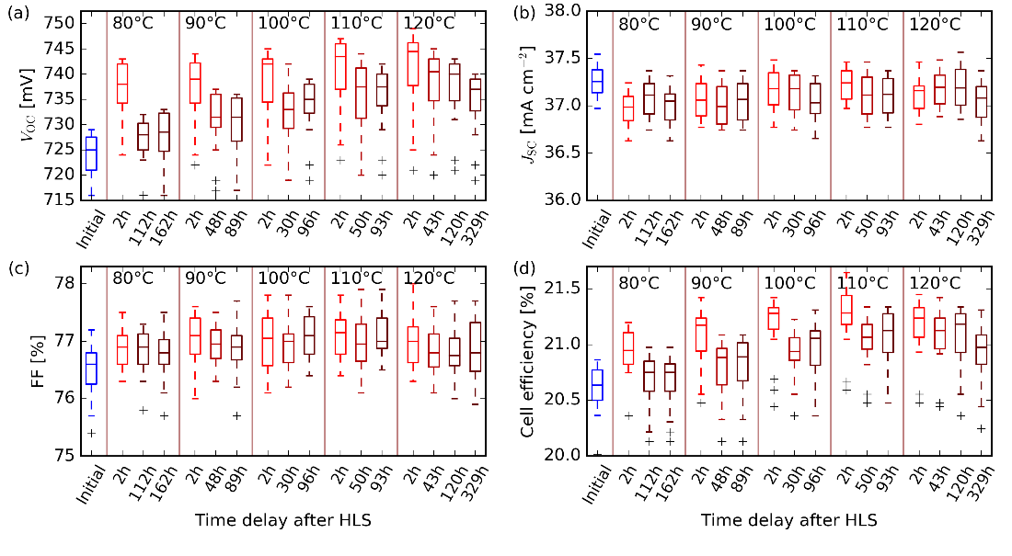
Figure SI.1: JV parameters cells (n=15) of a sample subjected to subsequent heat-light soaking treatments at progressively increased temperature. The cells are measured 2h after being taken out of the oven, as well as after various time delays afterwards, before the next HLS treatment take place. The V_{OC} plot is shown in the main manuscript and reported here for convenience.

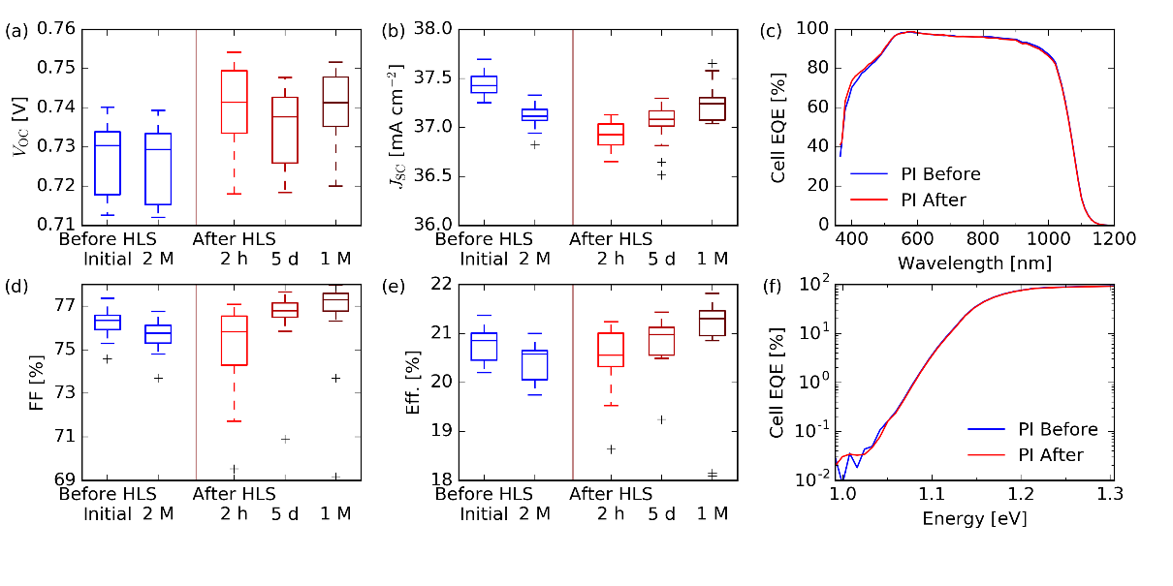
Figure SI.2; (a,b,d,e): Evolution of the PV parameters of solar cells of a sample on PI substrate over time (n=18). Measurements were acquired several times before and after HLS treatment: initial, and after 2 months; as well as 2 hours, 5 days, 1 month after treatment. The V_{OC} plot is shown in the main manuscript and reported here for convenience. (c): EQE of a cell of the same sample on PI, and on SLG substrate, before and after HLS. (f) Close-up to the EQE data on the sub-bandgap optical absorption. The optical absorption by tail states appear unchanged upon HLS.

 | Laser fluence | A₁ | τ₁ | A₂ | τ₂ | A₁+A₂ = ΣA | τ_{eff} | ΣA * τ_{eff} | Integration
 | photon cm⁻² pulse⁻¹ | a.u. | ns | a.u. | ns | a.u. | ns | a.u. | a.u.
Before HLS | 1.7E+11 | 6.96E+04 | 232 | 4.02E+04 | 579 | 1.10E+05 | 359 | 3.94E+07 | 3.96E+07
Before HLS | 3.7E+11 | 1.75E+05 | 176 | 1.50E+05 | 450 | 3.25E+05 | 303 | 9.84E+07 | 9.97E+07
Before HLS | 8.1E+11 | 8.71E+05 | 156 | 5.61E+05 | 386 | 1.43E+06 | 246 | 3.53E+08 | 3.59E+08
Before HLS | 1.4E+12 | 2.35E+06 | 143 | 1.28E+06 | 345 | 3.63E+06 | 215 | 7.80E+08 | 7.94E+08
Before HLS | 2.3E+12 | 5.60E+06 | 131 | 2.87E+06 | 305 | 8.47E+06 | 190 | 1.61E+09 | 1.64E+09
After HLS | 1.7E+11 | 3.14E+05 | 111 | 1.12E+05 | 365 | 4.26E+05 | 177 | 7.55E+07 | 7.88E+07
After HLS | 3.7E+11 | 1.17E+06 | 102 | 3.11E+05 | 290 | 1.49E+06 | 141 | 2.10E+08 | 2.19E+08
After HLS | 8.1E+11 | 4.35E+06 | 86 | 1.70E+06 | 196 | 6.05E+06 | 117 | 7.07E+08 | 7.33E+08
After HLS | 1.4E+12 | 1.05E+07 | 90 | 3.19E+06 | 182 | 1.37E+07 | 111 | 1.52E+09 | 1.57E+09
After HLS | 2.3E+12 | 2.17E+07 | 95 | 4.90E+06 | 175 | 2.66E+07 | 110 | 2.92E+09 | 3.01E+09
Table SI.1: Parameters of the 2-exponential fits to the TRPL data shown in Figure 2(c). The straightforward numerical integration is also reported, with a good match to the ΣA * τ_{eff} quantity derived from the fitted data. Unit of intensity values (a.u.) correspond to counts normalized by acquisition time, laser repetition rate and temporal bin width.

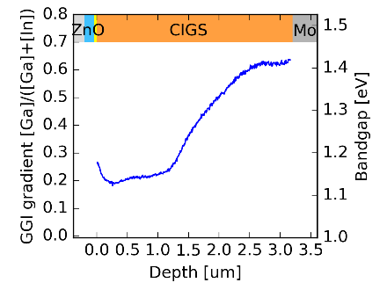
Figure SI 3: GGI gradient of the CIGS absorber on PI substrate. The estimated bandgap is shown on the right vertical axis using formula of Ref. [1]. The width of the region with bandgap minimum is about 1 µm. The bandgap at the front is about 1.18 eV, higher than the bandgap minimum about 1.13 eV.

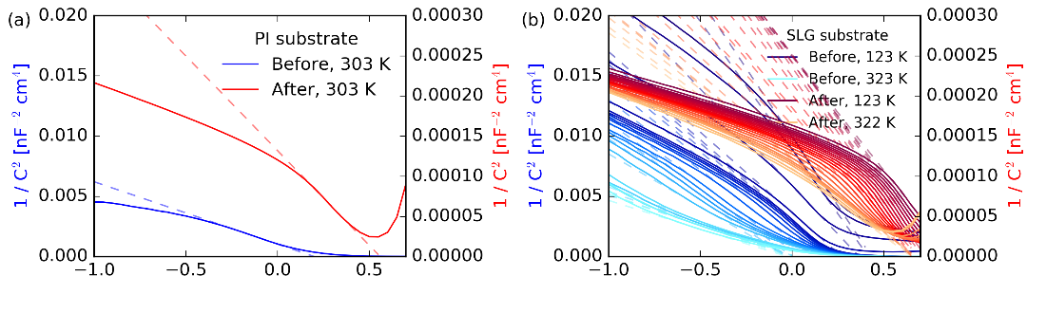
Figure SI.4: Base data to Figure 3b of main manuscript. Mott-Schottky visualization of C-V profiling of a cell on PI and on SLG substrates as function of the temperature, before (blue) and after (red) HLS treatment, in temperature range 123-323K. The dashed lines show the fits from which the built-in is extracted at the intercept y=0. Beware the different axis limits before and after treatment.

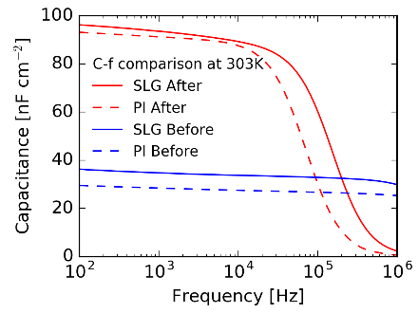
Figure SI.5: C-f admittance spectra of cells on PI and SLG substrate, near room temperature, before and after HLS. A very similar behavior is observed for cells on both substrate.

[1] Carron R, Avancini E, Feurer T, Bissig B, Losio P A, Figi R, Schreiner C, Bürki M, Bourgeois E, Remes Z, Nesladek M, Buecheler S and Tiwari A N 2018 Refractive indices of layers and optical simulations of Cu(In,Ga)Se 2 solar cells Sci. Technol. Adv. Mater. 19 396–410

