Table 1. Optimization of Reaction Conditions for the Synthesis of Substituted Quinolinesª
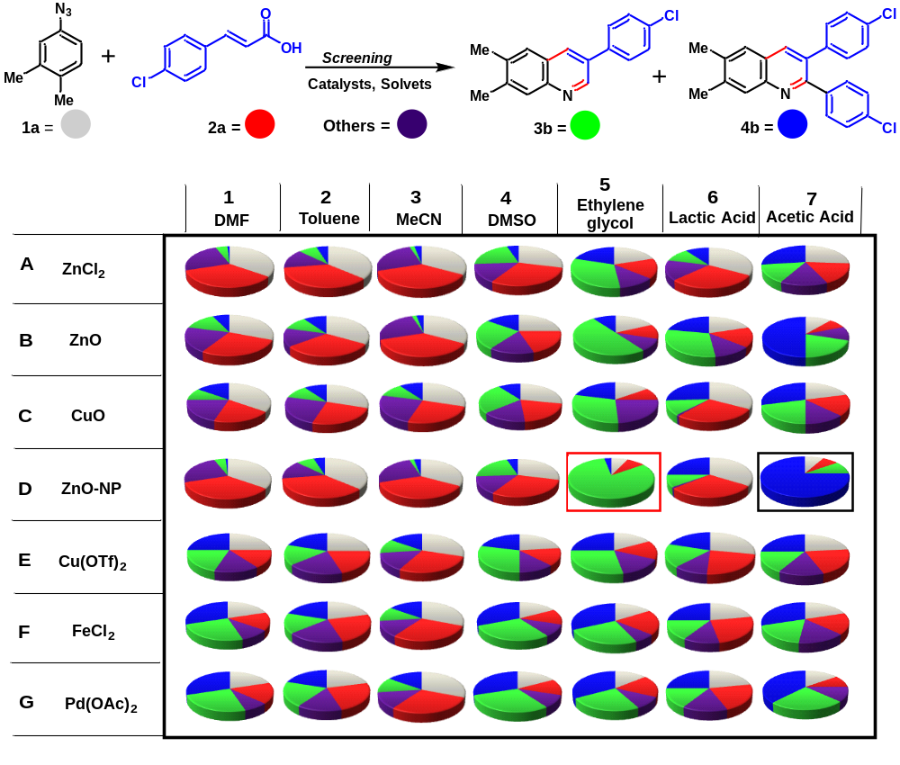
Reaction conditions: Unless otherwise specified, all reactions were carried out using 1a (1.0 mmol), 2a (1.2 mmol), and catalyst (3 mol %) under air (1 atm) in solvents (2 mL) at 120 ºC for 8-12h.

