Supporting Information

Regiodivergent ZnO-NP-Catalyzed Decarboxylative Synthesis of Substituted Quinolines and Application of N-Oxide via Late-Stage Diversification
Navaneet Kumar,† Deepak Bhadoria,†,‡ Rajesh Kumar,† and Atul Kumar*,†,‡
†Medicinal & Process Chemistry Division, CSIR-Central Drug Research Institute, Sector 10, Jankipuram extension, Sitapur Road, P.O. Box 173, Lucknow 226031, India.
‡Academy of Scientific and Innovative Research (AcSIR), Ghaziabad 201002, India.
Fax: 91-522-2771941; Tel:91-522-2612411
E-mail: dratulsax@gmail.com/atul_kumar@cdri.res.in
It consists of 89 pages, 123 figures (pages S6, S27-S87) and 3 tables (pages S3, S4, and S89).
Table of Contents:
- General Remarks …………………………………………………….....S2
- Optimization of Experiment Conditions………………………………..S3
- General Experimental Procedures ……………………………………...S5
- Recycling Study of the ZnO-NP Catalyst………………………………S5
- Characterization Data for Compounds ………………………………....S6
- Experimental Procedure and Characterization Data for Drug Compounds and Natural Products…………………………………………………..S23
- NMR-Spectra of Compounds (¹H and ¹³C )…….…………………......S27
- ¹⁹F-NMR-Spectra of Compound (3j) and (4a)………………………...S84
- DEPT-NMR-Spectra of Compound (3j) and (4a)……………………..S85
- ³¹P-NMR-Spectra of Compound (12)………………………………….S87
- X-Ray-data of Compound (3b) ……….………………………………S88
(1) General Remarks:
All the reactions were carried out in oven-dried glassware. All the chemicals and reagents were purchased from commercial sources (Sigma-Aldrich or Merck chemical Co. and Alfa Aesar) and were used without further purification. Progresses of reactions were monitored by Thin Layer Chromatography (TLC). TLC (Thin Layer Chromatography) was performed on Merck-percoated silica gel and 100-200 mesh silica gel was used for column chromatography. The chromatographic solvents are mentioned as v/v ratios. All the synthesized compounds were fully characterized by ¹H, ¹³C-NMR, IR, and further confirmed through ESI-MS and HRMS analyses. IR spectra were recorded on a Perkin-Elmer FT-IR RXI spectrophotometer and values reported in cm⁻¹. NMR spectra were recorded with 400 MHz spectrometers for ¹H-NMR, 100 MHz for ¹³C-NMR respectively. Chemical shifts are reported in δ (ppm) relative to TMS (¹H), CDCl₃ and DMSO-d₆ (¹³C) as internal standards. Integrals are in accordance with assignments; coupling constants are given in Hz. ESI-MS spectra were obtained on a LCQ Advantage Ion trap mass spectrometer (Finnigan thermo Fischer scientific). High resolution mass spectra (HRMS) were measured with a Waters Micromass GCT instrument and accurate masses were reported for the molecular ion ([M]⁺). All chemical shifts (δ) are reported in ppm and coupling constants (J) in Hz. All chemical shifts are reported relative to tetramethylsilane, and CDCl₃ (7.26 ppm for ¹H), and CDCl₃ (77.16 ppm for ¹³C), and DMSO-d₆ (2.50 ppm for ¹H) and DMSO-d₆ (39.52 ppm for ¹³C) respectively. The following abbreviations were used to explain the multiplicities: s = singlet, d = doublet, t = triplet, q = quartet, m = multiplet.
A good quality Yellow color single crystal of size 0.38 x 0.35 x 0.23 mm, was selected under a polarizing microscope and was mounted on a glass fiber for data collection. Single crystal X-ray data for compound (3b) were collected on the Rigaku Kappa 3 circle diffractometer equipped with the AFC12 goniometer and enhanced sensitivity (HG) Saturn724+ CCD detector in the 4x4 bin mode using the monochromated Mo-Kα radiation generated from the microfocus sealed tube MicroMax-003 X-ray generator equipped with specially designed confocal multilayer optics. Data collection was performed using ω-scans of 0.5º steps at 293(2) K. Cell determinations, data collection and data reduction was performed using the Rigaku CrystalClear-SM Expert 2.1 b24¹ software. Structure solution and refinement were performed by using SHELXTL-NT². Refinement of coordinates and anisotropic thermal parameters of non-hydrogen atoms were carried out by the full-matrix least-squares method. The hydrogen atoms attached to carbon atoms were generated with idealized geometries and isotropically refined using a riding model. Crystal data are summarized in Table S3.

(2) Optimization of Experiment Conditions
Table S1. Optimization of the Reaction conditions
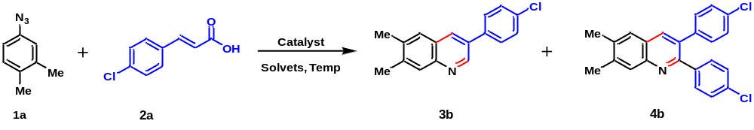
Entry | Catalyst (3 mol %) | Solvent | Temp (ºC) | Yield (%)^{(b)}
 |  |  |  | 3b | 4b
1 | ZnCl₂ | Ethylene glycol | 120 | 32 | 20
2 | ZnCl₂ | Acetic Acid | 120 | 15 | 27
3 | ZnO | Ethylene glycol | 120 | 50 | 22
4 | ZnO | Acetic Acid | 120 | 18 | 45
5 | CuO | Ethylene glycol | 120 | 30 | 21
6 | CuO | Acetic Acid | 120 | 25 | 35
7 | ZnO-NP | Ethylene glycol | 120 | 82 | trace
8 | ZnO-NP | Acetic Acid | 120 | 10 | 75
9 | ZnO-NP | Ethanol | reflux | trace | -
10 | ZnO-NP | Methanol | reflux | - | -
11 | ZnO-NP | DMF | 120 | <5 | -
12 | ZnO-NP | Toluene | 120 | 8 | <5
13 | ZnO-NP | DMSO | 120 | 21 | <5
14 | ZnO-NP | DMA | 120 | - | -
15 | ZnO-NP | MeCN | reflux | trace | trace
16 | ZnO-NP | H₂O | reflux | trace | trace
17 | ZnO-NP | Lactic Acid | 120 | 10 | 25
18 | ZnO-NP | Glycerol | 120 | 30 | -
19 | ZnO-NP | Gluconic Acid | 120 | 20 | 11
20 | ZnO-NP | PPA | 120 | 15 | 8
21^{c} | ZnO-NP | Acetic Acid | 100 | 29 | 57
22^{c} | ZnO-NP | Ethylene glycol | 100 | 69 | trace
23 | CuI | Ethylene glycol | 120 | 32 | 11
24 | CuCl | Ethylene glycol | 120 | 29 | 8
25 | CuBr | Ethylene glycol | 120 | 25 | 10
26 | Cu(OTf)₂ | Ethylene glycol | 120 | 28 | 25
27 | Cu(OTf)₂ | Acetic Acid | 120 | 20 | 30
28 | Fe(OAc)₂ | Ethylene glycol | 120 | 31 | -
29 | FeCl₂ | Acetic Acid | 120 | 18 | 30
30 | FeCl₃ | Acetic Acid | 120 | 10 | 33
31 | Pd(OAc)₂ | Acetic Acid | 120 | 25 | 33
32 | ZnO-NP | Acetic Acid | 140 | 20 | 67
33 | ZnO-NP | Ethylene glycol | 140 | 75 | trace
ªReaction conditions: Unless otherwise specified, all reactions were carried out using 1a (1.0 mmol), 2a (1.2 mmol) and catalyst (3 mol %) under open air (1 atm) in solvent (2 mL) at a specified temperature for 12-16h. ^{b}Yields of isolated products. ^{c}At 100 ºC.

Table S2. Optimization of the Reaction conditions

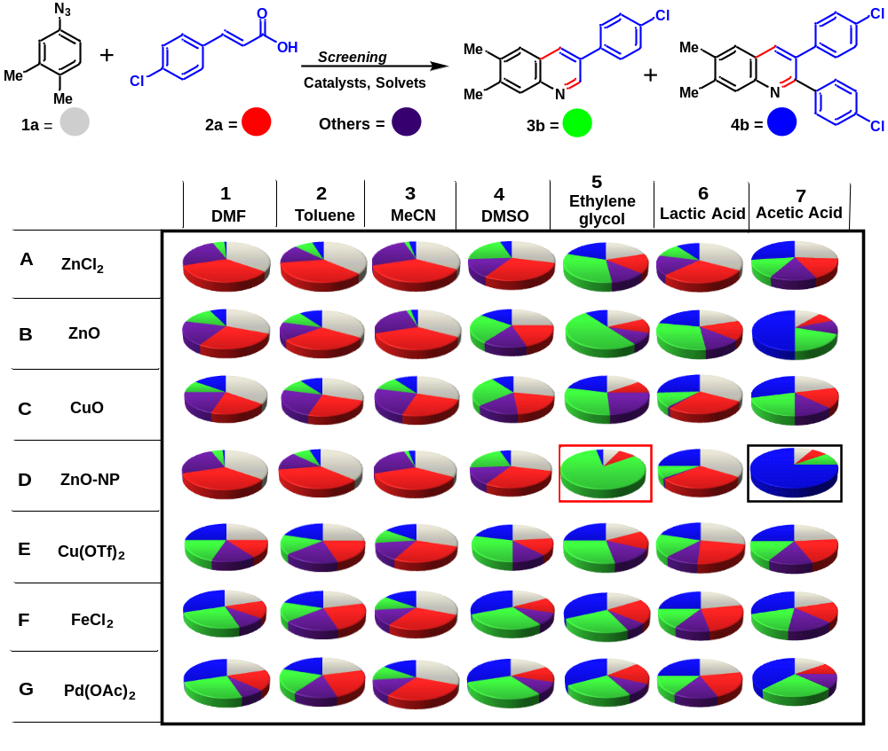
Reaction conditions: Unless otherwise specified, all reactions were carried out using 1a (1.0 mmol), 2a (1.2 mmol), and catalyst (3 mol %) under air (1 atm) in solvents (2 mL) at 120 ºC for 8-12h.

(3) General Experimental Procedures
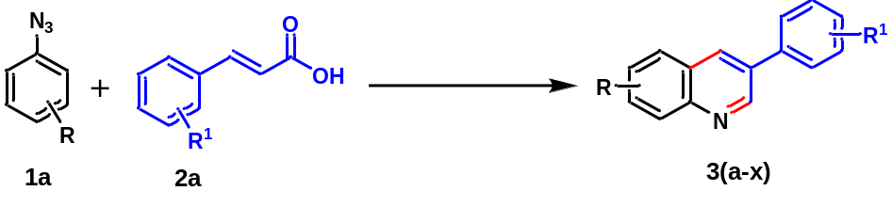(A) Representative Experimental Procedure for the Synthesis of 3-Substituted Quinolines 3(a-x):

Arylazides 1a (1.0 mmol), and arylcinnamic acids 2a (1.2 mmol) and ZnO-NP catalyst (3 mol %) were taken in a 25 mL round bottom flask containing ethylene glycol (2 mL) as a solvent under open air atmosphere condition, the reaction mixture was stirred at 120 °C. The completion of reaction was monitored by TLC; the reaction mixture was allowed to cool at room temperature. Then reaction mixture was diluted with ethyl acetate and water. The extracted layer was dried over anhydrous sodium sulphate and solvent was evaporated under vacuum. The crude product was purified by 100-200 mesh silica gel by column chromatography with hexane/ethyl acetate (96:4) to afford 3-substituted quinolines.
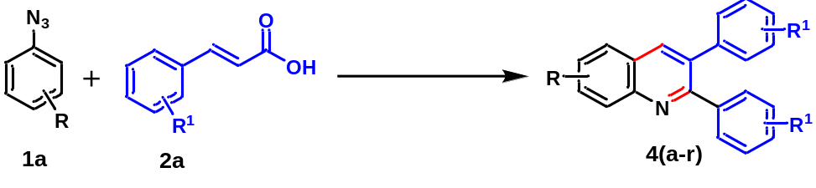(B) Representative Experimental Procedure for the Synthesis of 2,3-Disubstituted Quinolines 4(a-r):

Arylazides 1a (1.0 mmol), and arylcinnamic acids 2a (1.2 mmol) and ZnO-NP catalyst (3 mol %) were taken in a 25 mL round bottom flask containing AcOH (2 mL) as a solvent under open air atmosphere condition, the reaction mixture was stirred at 120 °C. The completion of reaction was monitored by TLC; the reaction mixture was allowed to cool at room temperature. Then reaction mixture was diluted with ethyl acetate and water. The extracted layer was dried over anhydrous sodium sulphate and solvent was evaporated under vacuum. The crude product was purified by 100-200 mesh silica gel by column chromatography with hexane/ethyl acetate (98:2) to afford 2,3-disubstituted quinolines.
(4) Recycling Study of the ZnO-NP Catalyst:
The reusability of the catalyst is a significant factor from economic and sustainable synthetic points of view. Thus, the reusability of the ZnO-NP was investigated for five cycles (including the fresh catalyst) for the regiodivergent decarboxylative synthesis of both 3-substituted quinolines and 2,3-disubstituted quinolines under the optimized reaction conditions. At the end of each reaction cycle, the ZnO-NP catalyst was isolated from the mixture reaction by simple filtration. The reused four times after simple washing with ethanol and drying, and both starting materials were freshly added for the next cycle. The results of the recycling of the ZnO-NP catalyst for (3a) and (4a) were shown in Figure S1.
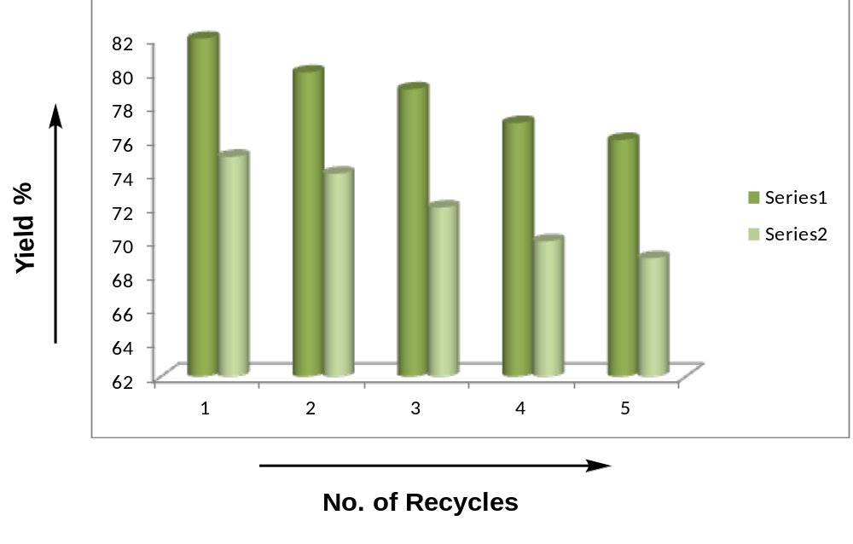

Figure S1. Recycling Study of the ZnO-NP Catalyst

(5) Characterization Data of all the Synthesized Compounds:
6,7-dimethyl-3-phenylquinoline (3a):
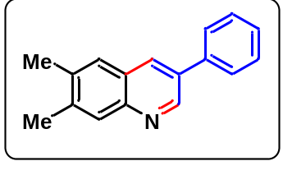White solid; yield 80%; mp: 128-130 °C; ¹H NMR (400 MHz;CDCl₃): δ 9.10 (s, 1H), 8.21 (s, 1H), 7.91 (s, 1H), 7.73-7.70 (m, 2H), 7.63 (s, 1H), 7.55-7.51 (m, 2H), 7.46-7.42 (m, 1H), 2.52 (s, 3H), 2.49 (s, 3H); ¹³C NMR (100 MHz; CDCl₃) δ 148.9, 146.5, 139.7, 138.2, 136.9, 132.2, 129.1, 128.5, 127.8, 127.3, 127.1, 126.6, 20.4, 20.0; IR (KBr) max 3841, 3739, 3395, 2922, 1446, 1096, 820; ESI-MS (m/z) = 234 (M+H); ESI-HRMS for cald. C₁₇H₁₅N; (M+H), 234.1282; found: m/z 234.1258.

3-(4-chlorophenyl)-6,7-dimethylquinoline (3b):
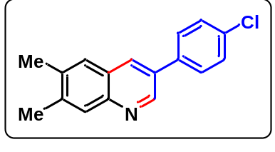Light yellow solid; yield 82%; mp: 145-147 °C. ¹H NMR (400 MHz, CDCl₃) δ 9.04 (s, 1H), 8.16 (s, 1H), 7.90 (s, 1H), 7.65-7.62 (m, 3H), 7.51-7.48 (m, 2H), 2.51 (s, 3H), 2.48 (s, 3H); ¹³C NMR (100 MHz, CDCl₃) δ 148.5, 146.6, 140.0, 137.1, 136.7, 134.0, 132.1, 131.8, 129.2, 128.5, 127.1, 126.5, 20.4, 20.0; IR (KBr) max 3842, 3740, 3395, 2922, 1446, 1096, 825; ESI-MS (m/z) = 268 (M+H); ESI-HRMS for cald. C₁₇H₁₄ClN; (M+H), 268.0895; found: m/z 268.0877.
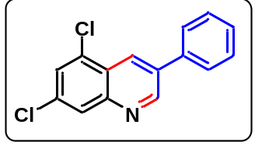5,7-dichloro-3-phenylquinoline (3c):
Light brown solid; yield 79%; mp: 164-166 °C. ¹H NMR (400 MHz, CDCl₃) δ 9.22 (s, 1H), 8.65 (s, 1H), 8.07 (s, 1H), 7.73 (d, J = 7.2 Hz, 2H), 7.66 (s, 1H), 7.55 (t, J = 7.7 Hz, 2H), 7.47 (t, J = 7.3 Hz, 1H); ¹³C NMR (100 MHz, CDCl₃) δ 151.6, 147.8, 137.1, 134.9, 134.4, 132.3, 129.9, 129.3, 128.6, 127.8, 127.6, 127.5, 124.8; IR (KBr) max 3842, 3739, 3416, 2920, 1634, 1074, 756; ESI-MS (m/z) = 274 (M+H); ESI-HRMS for cald. C₁₅H₉Cl₂N; (M+H), 274.0190; found: m/z 274.0185.
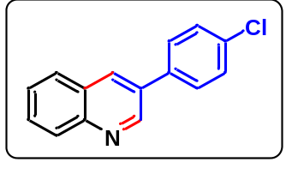3-(4-chlorophenyl)quinoline (3d):
Yellow oil; yield 75%; ¹H NMR (400 MHz, CDCl₃) δ 9.15 (s, 1H), 8.28 (s, 1H), 8.14 (d, J = 8.2 Hz, 1H), 7.88 (d, J = 8.0 Hz, 1H), 7.74 (t, J = 7.2 Hz, 1H), 7.65 (d, J = 8.4 Hz, 2H), 7.59 (t, J = 7.6 Hz, 1H), 7.51-7.49 (m, 2H); ¹³C NMR (100 MHz, CDCl₃) δ 149.5, 147.4, 136.3, 134.4, 133.1, 129.6, 129.4, 129.3, 128.6, 128.0, 127.2; IR (KBr) max 3839, 3740, 3391, 2923, 2855, 1596, 1490, 1394, 1093, 912, 828; ESI-MS (m/z) = 240 (M+H); ESI-HRMS for cald. C₁₅H₁₀ClN; (M+H), 240.0580; found: m/z 240.0570.
6,7-dichloro-3-phenylquinoline (3e):
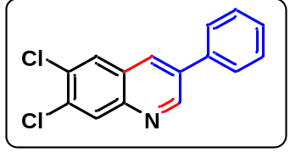Brown solid; yield 78%; mp: 125-127 °C; ¹H NMR (400 MHz, CDCl₃) δ 9.17 (s, 1H), 8.26 (s, 1H), 8.20 (s, 1H), 7.99 (s, 1H), 7.69 (d, J = 7.2 Hz, 2H), 7.54-7.52 (m, 2H), 7.47 (d, J = 6.6 Hz, 1H); ¹³C NMR (100 MHz, CDCl₃) δ 151.1, 145.8, 137.1, 134.8, 133.7, 131.8, 131.6, 130.3, 129.3, 128.6, 128.4, 127.4, 127.1; IR (KBr) max 3021, 2922, 1597, 1500, 1333, 1266, 1155, 1080, 816, 763, 666, 595; ESI-MS (m/z) = 274 (M+H); ESI-HRMS for cald. C₁₅H₉Cl₂N; (M+H), 274.0191; found: m/z 274.0185.

6,7-dimethyl-3-(p-tolyl)quinoline (3f):
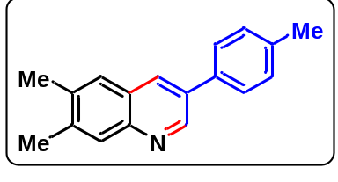Yellow oil; yield 80%; ¹H NMR (400 MHz, CDCl₃) δ 9.06 (s, 1H), 8.15 (s, 1H), 7.87 (s, 1H), 7.60-7.58 (m, 3H), 7.31 (d, J = 7.8 Hz, 2H), 2.48 (s, 3H), 2.45 (s, 3H), 2.42 (s, 3H); ¹³C NMR (100 MHz, CDCl₃) δ 148.9, 146.4, 139.5, 137.7, 136.8, 135.3, 132.9, 131.8, 129.8, 128.4, 127.1, 126.7, 21.1, 20.4, 20.0; IR (KBr) max 2928, 2874, 1624, 1414, 1084, 832; ESI-MS (m/z) = 248 (M+H); ESI-HRMS for cald. C₁₈H₁₇N; (M+H), 248.1439; found: m/z 248.1431
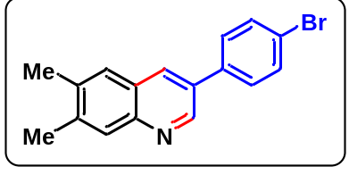3-(4-bromophenyl)-6,7-dimethylquinoline (3g):
Brown solid; yield 81%; mp:138-140 °C; ¹H NMR (400 MHz, CDCl₃) δ 9.02 (s, 1H), 8.14 (s, 1H), 7.88 (s, 1H), 7.64 (t, J = 1.9 Hz, 1H), 7.62 (t, J = 2.2 Hz, 1H), 7.60 (s, 1H), 7.56 (t, J = 2.2 Hz, 1H), 7.54 (t, J = 2.3 Hz, 1H), 2.49 (s, 3H), 2.46 (s, 3H); ¹³C NMR (100 MHz, CDCl₃) δ 148.4, 146.7, 140.0, 137.1, 132.2, 132.1, 131.8, 128.8, 128.5, 127.1, 126.5, 122.2, 20.4, 20.0; IR (KBr) max 3838, 3741, 3394, 2921, 2854, 1631, 1449, 1073, 820; ESI-MS (m/z) = 312 (M+H); ESI-HRMS for cald. C₁₇H₁₄BrN; (M+H), 312.0388; found: m/z 312.0383.
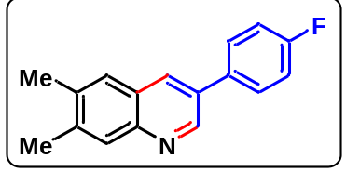3-(4-fluorophenyl)-6,7-dimethylquinoline (3h):
Brown oil; yield 80 %; ¹H NMR (400 MHz, CDCl₃) δ 9.02 (s, 1H), 8.12 (s, 1H), 7.88 (s, 1H), 7.67-7.62 (m, 2H), 7.59 (s, 1H), 7.22-7.16 (m, 2H), 2.49 (s, 3H), 2.46 (s, 3H); ¹³C NMR (100 MHz, CDCl₃) δ 164.0, 161.5, 148.6, 146.4, 139.8, 137.1, 134.3, 132.1, 129.0, 128.9, 128.5, 127.1, 126.5, 116.1, 115.9, 20.4, 20.0; IR (KBr) max 3838, 3741, 3394, 2921, 2854, 1606, 1453, 1232, 1029, 829; ESI-MS (m/z) = 252 (M+H); ESI-HRMS for cald. C₁₇H₁₄FN; (M+H), 252.1188; found: m/z 252.1181.
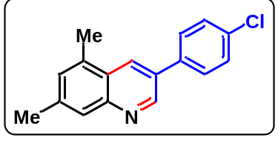3-(4-chlorophenyl)-5,7-dimethylquinoline (3i):
Brown solid; yield 81%; mp: 102-104 °C; ¹H NMR (400 MHz, CDCl₃) δ 9.09 (s, 1H), 8.36 (s, 1H), 7.77 (s, 1H), 7.63 (d, J = 8.5 Hz, 2H), 7.48 (d, J = 8.5 Hz, 2H), 7.25 (s, 1H), 2.69 (s, 3H), 2.53 (s, 3H); ¹³C NMR (100 MHz, CDCl₃) δ 148.7, 147.8, 143.4, 139.7, 136.8, 134.3, 134.1, 131.5, 130.1, 129.8, 129.3, 128.6, 126.2, 125.3, 21.8, 18.5; IR (KBr) max 3840, 3740, 3395, 2921, 1446, 1096, 820; ESI-MS (m/z) = 268 (M+H); ESI-HRMS for cald. C₁₇H₁₄ClN; (M+H), 268.0893; found: m/z 268.0886.
3-(4-fluorophenyl)-5,7-dimethylquinoline (3j):
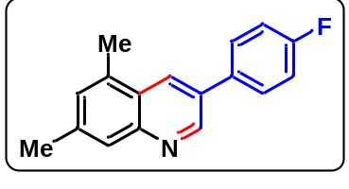Brown oil; yield 80%; ¹H NMR (400 MHz, CDCl₃) δ 9.07 (s, 1H), 8.33 (s, 1H), 7.76 (s, 1H), 7.67-7.64 (m, 2H), 7.24 (s, 1H), 7.20 (t, J = 8.6 Hz, 2H), 2.69 (s, 3H), 2.53 (s, 3H); ¹³C NMR (100 MHz, CDCl₃) δ 164.0, 161.6, 149.0, 147.8, 139.4, 134.5, 134.2, 131.7, 129.9, 129.5, 129.1, 129.0, 126.3, 125.3, 116.2, 115.9, 21.8, 18.5; ¹⁹F NMR (376 MHz, CDCl₃) δ -114.5; IR (KBr) max 3838, 3741, 3391, 2922, 2854, 1604, 1453, 1232, 1029, 825; ESI-MS (m/z) = 252 (M+H); ESI-HRMS for cald. C₁₇H₁₄FN; (M+H), 252.1188; found: m/z 252.1178.
3-(4-bromophenyl)-5,7-dimethylquinoline (3k):
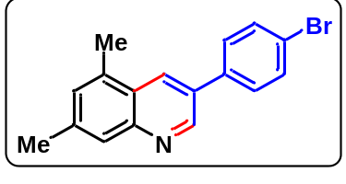Brown solid; yield 79%; mp: 154-156 °C. ¹H NMR (400 MHz, CDCl₃) δ 9.06 (s, 1H), 8.34-8.33 (m, 1H), 7.76 (s, 1H), 7.64-7.61 (m, 2H), 7.56-7.54 (m, 2H), 7.24 (s, 1H), 2.68 (s, 3H), 2.52 (s, 3H); ¹³C NMR (100 MHz, CDCl₃) δ 148.7, 148.0, 139.6, 137.3, 134.3, 132.2, 131.5, 130.0, 129.6, 128.9, 126.4, 125.3, 122.2, 21.8, 18.5; IR (KBr) max 3838, 3741, 3394, 2921, 2857, 1631, 1448, 1073, 823; ESI-MS (m/z) = 312 (M+H); ESI-HRMS for cald. C₁₇H₁₄BrN; (M+H), 312.0388; found: m/z 312.383.
5,7-dimethyl-3-(p-tolyl)quinoline (3l):
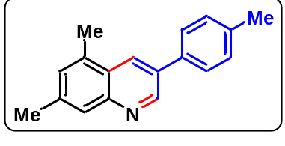Brown solid; yield 80%; mp: 115-117 °C; ¹H NMR (400 MHz, CDCl₃) δ 9.11 (s, 1H), 8.37 (s, 1H), 7.76 (s, 1H), 7.61 (d, J = 8.0 Hz, 2H), 7.32 (d, J = 7.8 Hz, 2H), 7.24 (s, 1H), 2.69 (s, 3H), 2.53 (s, 3H), 2.43 (s, 3H); ¹³C NMR (100 MHz, CDCl₃) δ 149.3, 147.7, 139.1, 137.8, 135.5, 134.2, 132.6, 130.6, 129.8, 129.3, 127.2, 126.3, 125.4, 21.8, 21.1, 18.5; IR (KBr) max 3837, 3740, 3393, 2921, 1450, 1373, 1034, 905, 816; ESI-MS (m/z) = 248 (M+H); ESI-HRMS for cald. C₁₈H₁₇N; (M+H), 248.1449; found: m/z 248.1431.
3-(4-bromophenyl)quinoline (3m):
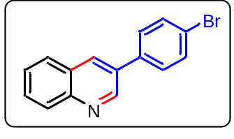Yellow oil; yield 78%; ¹H NMR (400 MHz, CDCl₃) δ 9.14 (s, 1H), 8.28 (s, 1H), 8.15 (d, J = 6.7 Hz, 1H), 7.91-7.87 (m, 1H), 7.75-7.72 (m, 1H), 7.66-7.64 (m, 2H), 7.61-7.57 (m, 3H); ¹³C NMR (100 MHz, CDCl₃) δ 149.3, 147.3, 139.7, 133.3, 132.3, 129.7, 129.1, 128.9, 128.0, 127.9, 127.2, 122.6, 114.0; IR (KBr) max 3840, 3740, 3395, 2921, 1446, 1096, 821; ESI-MS (m/z) = 284 (M+H); ESI-HRMS for cald. C₁₅H₁₀BrN; (M+H), 284.0075; found: m/z 284.0074.
3-(4-fluorophenyl)quinoline (3n):
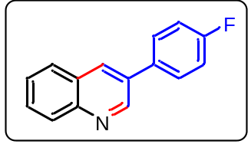White solid; yield 79%; mp:104-106 °C; ¹H NMR (400 MHz, CDCl₃) δ 9.15 (s, 1H), 8.26 (s, 1H), 8.15 (d, J = 6.6 Hz, 1H), 7.87 (d, J = 6.7 Hz, 1H), 7.74-7.71 (m, 1H), 7.69-7.65 (m, 2H), 7.60-7.57 (m, 1H), 7.23-7.19 (m, 2H); ¹³C NMR (100 MHz, CDCl₃) δ 163.9, 161.9, 156.3, 149.5, 147.1, 133.9, 133.2, 132.9, 129.5, 129.1, 129.0, 127.9, 127.7, 127.2, 116.2, 116.1, 114.0; IR (KBr) max 3839, 3741, 3394, 2922, 2854, 1608, 1453, 1232, 1029, 829; ESI-MS (m/z) = 224 (M+H); ESI-HRMS for cald. C₁₅H₁₀FN; (M+H), 224.0875; found: m/z 224.0873.
5,7-dimethyl-3-phenylquinoline (3o):
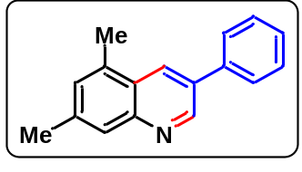White solid; yield 75%; mp:84-86 °C; ¹H NMR (400 MHz, CDCl₃) δ 9.12 (s, 1H), 8.38 (s, 1H), 7.76 (s, 1H), 7.71 (d, J = 5.7 Hz, 2H), 7.52 (t, J = 6.0 Hz, 2H), 7.42 (t, J = 5.8 Hz, 1H), 7.24 (s, 1H), 2.69 (s, 3H), 2.53 (s, 3H); ¹³C NMR (100 MHz, CDCl₃) δ 149.3, 147.8, 139.3, 138.4, 134.3, 132.7, 129.8, 129.7, 129.1, 127.8, 127.4, 126.3, 125.4, 114.0, 21.8, 18.5; IR (KBr) max 3840, 3741, 3393, 2921, 1450, 1373, 1034, 816; ESI-MS (m/z) = 234 (M+H); ESI-HRMS for cald. C₁₇H₁₅N; (M+H), 234.1282; found: m/z 234.1271.
3-phenylquinoline (3p):
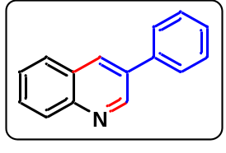Yellow oil; yield 74%; ¹H NMR (400 MHz, CDCl₃) δ 9.19 (s, 1H), 8.30 (s, 1H), 8.14 (d, J = 8.4 Hz, 1H), 7.88 (d, J = 7.7 Hz, 1H), 7.74-7.70 (m, 3H), 7.59-7.55 (m, 1H), 7.54-7.50 (m, 2H), 7.45-7.43 (m, 1H); ¹³C NMR (100 MHz, CDCl₃) δ 149.9, 147.3, 139.9, 133.8, 133.2, 129.4, 129.2, 129.1, 128.1, 128.0, 127.4, 127.0, 126.6, 116.6; IR (KBr) max 3392, 2921, 2857, 1596, 1511, 1339, 1104, 820; ESI-MS (m/z) = 206 (M+H); ESI-HRMS for cald. C₁₅H₁₁N; (M+H), 206.0969; found: m/z 206.0958.
3-(4-methoxyphenyl)-5,7-dimethylquinoline (3q):
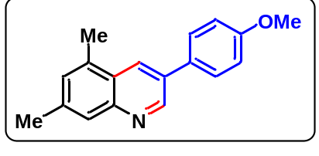Yellow oil; yield 75 %; ¹H NMR (400 MHz, CDCl₃) δ 9.09 (s, 1H), 8.32 (s, 1H), 7.74 (s, 1H), 7.65-7.62 (m, 2H), 7.22 (s, 1H), 7.06-7.03 (m, 2H), 3.87 (s, 3H), 2.68 (s, 3H), 2.52 (s, 3H); ¹³C NMR (100 MHz, CDCl₃) δ 159.6, 149.2, 147.6, 138.9, 134.1, 132.3, 130.9, 129.7, 128.8, 128.5, 126.4, 125.4, 114.6, 55.4, 21.8, 18.5; IR (KBr) max 3837, 3740, 3393, 2922, 1608, 1517, 1456, 1028, 802; ESI-MS (m/z) = 264 [M+H]; ESI-HRMS for cald. C₁₈H₁₇NO; (M+H), 264.1388; found: m/z 264.1376.
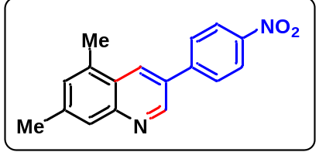5,7-dimethyl-3-(4-nitrophenyl)quinoline (3r):
White solid; yield 72 %; mp:197-199 °C; ¹H NMR (400 MHz, CDCl₃) δ 9.13 (s, 1H), 8.45 (s, 1H), 8.38-8.36 (m, 2H), 7.87-7.86 (m, 2H), 7.79 (s, 1H), 7.30 (s, 1H), 2.73 (s, 3H), 2.55 (s, 3H); ¹³C NMR (100 MHz, CDCl₃) δ 148.6, 148.5, 147.4, 144.9, 140.6, 134.6, 130.5, 130.4, 130.3, 128.1, 126.6, 125.1, 124.4, 21.9, 18.5; IR (KBr) max 3391, 2921, 2855, 1596, 1511, 1339, 1104, 857; ESI-MS (m/z) = 279 M+H]; ESI-HRMS for cald. C₁₇H₁₄N₂O₂; (M+H), 279.1143; found: m/z 279.1125.
6-chloro-3-phenylquinoline (3s): 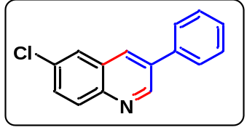
Yellow solid; yield 65 %; mp: 103-105 °C; ¹H NMR (400 MHz, CDCl₃) δ 9.19 (s, 1H), 8.23 (s, 1H), 8.10 (d, J = 7.1 Hz, 1H), 7.89 (s, 1H), 7.73-7.72 (m, 2H), 7.56 (t, J = 6.2 Hz, 2H), 7.48 (t, J = 6.0 Hz, 1H), 7.35-7.34 (m, 1H); ¹³C NMR (100 MHz, CDCl₃) δ 150.1, 145.6, 137.4, 134.7, 132.2, 130.8, 130.3, 129.2, 128.9, 128.7, 128.4, 127.4, 126.5; IR (KBr) max 3054, 2928, 2852, 1608, 1512, 1098, 820; ESI-MS (m/z) = 240 [M+H]; ESI-HRMS for cald. C₁₅H₁₀ClN; (M+H), 240.0580; found: m/z 240.0576.
3-(p-tolyl)quinoline (3t):
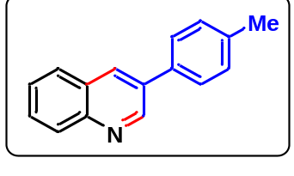White solid; yield 71 %; mp: 81-83 °C; ¹H NMR (400 MHz, CDCl₃) δ 9.16 (s, 1H), 8.26 (s, 1H), 8.12 (d, J = 8.4 Hz, 1H), 7.86-7.83 (m, 1H), 7.71-7.66 (m, 1H), 7.61-7.58 (m, 2H), 7.56-7.52 (m, 1H), 7.31 (d, J = 7.8 Hz, 2H), 2.41 (s, 3H); ¹³C NMR (100 MHz, CDCl₃) δ 150.1, 147.4, 138.2, 135.1, 133.9, 133.0, 130.1, 129.4, 129.0, 128.3, 128.1, 127.4, 127.1, 21.3; IR (KBr) max 2928, 2874, 1624, 1414, 1084, 832; ESI-MS (m/z) = 220 [M+H]; ESI-HRMS for cald. C₁₆H₁₃N; (M+H), 220.1126; found: m/z 220.1117.
6-chloro-3-(p-tolyl)quinoline (3u): 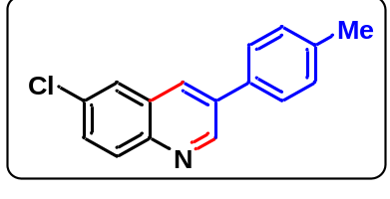
Brown oil; yield 72 %; ¹H NMR (400 MHz, CDCl₃) δ 9.15 (s, 1H), 8.17 (s, 1H), 8.07-8.04 (m, 1H), 7.84 (s, 1H), 7.64-7.61 (m, 1H), 7.59 (d, J = 8.1 Hz, 2H), 7.33 (d, J = 7.8 Hz, 2H), 2.43 (s, 3H); ¹³C NMR (100 MHz, CDCl₃) δ 149.1, 144.5, 137.4, 133.6, 133.4, 131.6, 130.7, 129.8, 129.0, 128.9, 127.7, 126.2, 125.5, 20.1; IR (KBr) max 3838, 3740, 3394, 2923, 2855, 1490, 1394, 1093, 825; ESI-MS (m/z) = 254 [M+H]; ESI-HRMS for cald. C₁₆H₁₂ClN; (M+H), 254.0736; found: m/z 254.032.
3-(4-methoxyphenyl)-6,7-dimethylquinoline (3v):
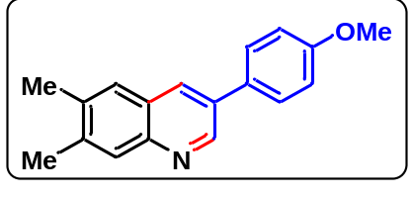Brown oil; yield 65 %; ¹H NMR (400 MHz, CDCl₃) δ 8.98 (s 1H), 8.05 (s, 1H), 7.79 (s, 1H), 7.57-7.54 (m, 2H), 7.51 (s, 1H), 6.99-6.95 (m, 2H), 3.80 (s, 3H), 2.41 (s, 3H), 2.38 (s, 3H); ¹³C NMR (100 MHz, CDCl₃) δ 158.6, 147.7, 145.1, 138.3, 135.8, 131.6, 130.4, 129.6, 127.3, 126.0, 125.7, 113.5, 54.3, 19.4, 19.0; IR (KBr) max 3836, 3740, 3393, 2921, 1608, 1517, 1456, 1259, 1028, 802; ESI-MS (m/z) = 264 [M+H]; ESI-HRMS for cald. C₁₈H₁₇NO; (M+H), 264.1388; found: m/z 264.1381.
6-chloro-3-(4-chlorophenyl)quinoline (3w):
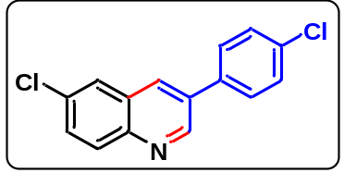Brown oil; yield 71 %; ¹H NMR (400 MHz, CDCl₃) δ 9.10 (s, 1H), 8.16 (s, 1H), 8.05 (d, J = 9.0 Hz, 1H), 7.84 (s, 1H), 7.65-7.62 (m, 1H), 7.62-7.61 (m, 1H), 7.60-7.59 (m, 1H), 7.50-7.49 (m, 1H), 7.48-7.47 (m, 1H); ¹³C NMR (100 MHz, CDCl₃) δ 149.9, 145.9, 136.0, 134.9, 133.7, 133.2, 132.3, 131.0, 130.7, 129.6, 128.8, 128.7, 126.7; IR (KBr) max 3839, 3740, 3391, 2923, 2855, 1596, 1490, 1394, 1093, 912, 828; ESI-MS (m/z) = 274 [M+H]; ESI-HRMS for cald. C₁₅H₉Cl₂N; (M+H), 274.0190; found: m/z 274.0183.
6-chloro-3-(4-methoxyphenyl)quinoline (3x): 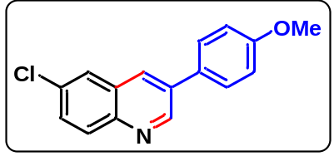
Yellow oil; yield 72 %; ¹H NMR (400 MHz, CDCl₃) δ 9.15 (s, 1H), 8.15 (s, 1H), 8.06 (d, J = 8.9 Hz, 1H), 7.84-7.83 (m, 1H), 7.65-7.60 (m, 3H), 7.07-7.04 (m, 2H), 3.88 (s, 3H); ¹³C NMR (100 MHz, CDCl₃) δ 160.0, 150.0, 145.1, 134.4, 132.7, 131.4, 130.6, 130.0, 129.7, 128.8, 128.5, 126.4, 114.7, 55.3; IR (KBr) max 3391, 2922, 2853, 1605, 1459, 1251, 1178, 1031, 832; ESI-MS (m/z) = 270 [M+H]; ESI-HRMS for cald. C₁₆H₁₂ClNO; (M+H), 270.0685; found: m/z 270.0676.
2,3-bis(4-fluorophenyl)-5,7-dimethylquinoline (4a):
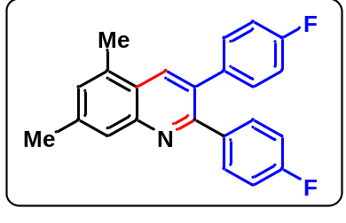White solid; yield 73 %; mp: 163-165 °C; ¹H NMR (400 MHz;CDCl₃): δ 8.20 (s, 1H), 7.81 (s, 1H), 7.43-7.38 (m, 2H), 7.24 (s, 1H), 7.22-7.17 (m, 2H), 7.03-6.94 (m, 4H), 2.67 (s, 3H), 2.53 (s, 3H); ¹³C NMR (100 MHz, CDCl₃) δ 163.6, 163.1, 161.7, 161.1, 156.5, 147.9, 139.8, 136.4, 136.3, 134.1, 133.9, 132.0, 131.8, 131.4, 131.3, 129.7, 126.5, 124.6, 115.4, 115.2, 115.0, 114.9, 21.8, 18.5; ¹⁹F NMR (376 MHz;CDCl₃): δ -113.8, -115.0; IR (KBr) max 3739, 3392, 2921, 1602, 1510, 1378, 1227, 1156, 1091, 839; ESI-MS (m/z) = 346 (M+H); ESI-HRMS for cald. C₂₃H₁₇F₂N; (M+H), 346.1407; found: m/z 346.1400.
2,3-bis(4-chlorophenyl)-6,7-dimethylquinoline (4b):
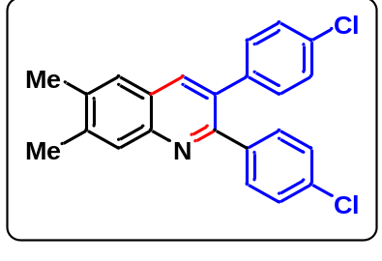Light brown solid; yield 75 %; mp: 136-138 °C. ¹H NMR (400 MHz, CDCl₃) δ 7.98 (s, 1H), 7.92 (s, 1H), 7.57 (s, 1H), 7.35 (d, J = 6.6 Hz, 2H), 7.27-7.24 (m, 4H), 7.13 (d, J = 6.6 Hz, 2H), 2.48 (s, 3H), 2.45 (s, 3H); ¹³C NMR (100 MHz, CDCl₃) δ 155.7, 146.6, 140.4, 138.8, 138.5, 137.2, 136.6, 134.1, 133.4, 132.2, 131.3, 131.0, 128.7, 128.6, 128.2, 126.6, 125.8, 20.5, 20.1; IR (KBr) max 3839, 3740, 3394, 2923, 1594, 1478, 1370, 1091, 1015, 831, 755; ESI-MS (m/z) = 378 (M+H); ESI-HRMS for cald. C₂₃H₁₇Cl₂N; (M+H), 378.0816; found: m/z 378.0813.
5,7-dimethyl-2,3-bis(4-nitrophenyl)quinoline (4c):
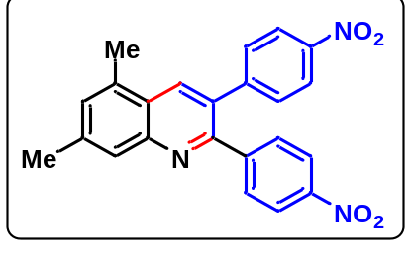Brown solid; yield 70 %; mp: >200 °C. ¹H NMR (400 MHz, CDCl₃) δ 8.32 (s, 1H), 8.20 (d, J = 6.7 Hz, 2H), 8.16 (d, J = 6.7 Hz, 2H), 7.85 (s, 1H), 7.61 (d, J = 6.7 Hz, 2H), 7.43 (d, J = 6.7 Hz, 2H), 7.34 (s, 1H), 2.72 (s, 3H), 2.57 (s, 3H); ¹³C NMR (100 MHz, CDCl₃) δ 154.4, 148.4, 147.6, 147.1, 146.4, 146.2, 141.3, 134.8, 134.3, 130.9, 130.7, 130.6, 126.7, 124.7, 123.8, 123.4, 21.9, 18.5; IR (KBr) max 3838, 3740, 3393, 2923, 1600, 1517, 1346, 1103, 857, 757; ESI-MS (m/z) = 400 (M+H); ESI-HRMS for cald. C₂₃H₁₇N₃O₄; (M+H), 400.1297; found: m/z 400.1292.
2,3-bis(4-methoxyphenyl)-5,7-dimethylquinoline (4d):
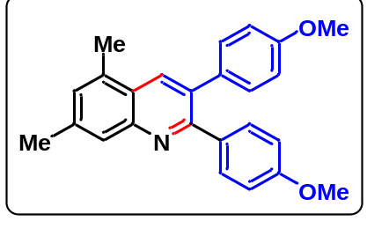Light yellow solid; yield 72 %; mp: 148-150 °C; ¹H NMR (400 MHz, CDCl₃) δ 8.16 (s, 1H), 7.80 (s, 1H), 7.40 (d, J = 8.7 Hz, 2H), 7.19-7.17 (m, 3H), 6.85 (d, J = 8.6 Hz, 2H), 6.80 (d, J = 8.6 Hz, 2H), 3.81 (s, 3H), 3.79 (s, 3H), 2.65 (s, 3H), 2.51 (s, 3H); ¹³C NMR (100 MHz, CDCl₃) δ 158.4, 157.7, 156.3, 146.7, 138.1, 132.8, 132.7, 132.2, 132.1, 131.7, 130.3, 129.8, 128.2, 126.7, 125.5, 123.5, 112.7, 112.3, 54.2, 20.8, 17.5; IR (KBr) max 3837, 3739, 3391, 2923, 2855, 1608, 1513, 1459, 1376, 1249, 1177, 1032, 916, 834, 756; ESI-MS (m/z) = 370 (M+H); ESI-HRMS for cald. C₂₅H₂₃NO₂; (M+H), 370.1807; found: m/z 370.1794.
2,3-bis(4-bromophenyl)-5,7-dimethylquinoline (4e):
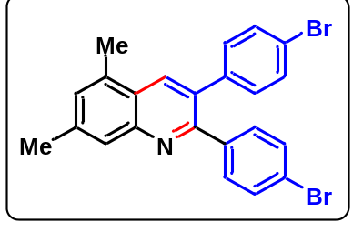Brown solid; yield 73 %; mp: 142-144 °C; ¹H NMR (400 MHz, CDCl₃) δ 8.19 (s, 1H), 7.80 (s, 1H), 7.45 (d, J = 6.7 Hz, 2H), 7.42 (d, J = 6.7 Hz, 2H), 7.31 (d, J = 6.7 Hz, 2H), 7.25 (s, 1H), 7.11 (d, J = 6.6 Hz, 2H), 2.67 (s, 3H), 2.53 (s, 3H); ¹³C NMR (100 MHz, CDCl₃) δ 156.0, 148.0, 140.1, 139.1, 134.2, 134.0, 131.7, 131.6, 131.4, 131.2, 129.9, 126.6, 124.6, 122.6, 121.6, 21.9, 18.5; IR (KBr) max 3837, 3739, 3391, 2921, 1619, 1380, 1074, 830; ESI-MS (m/z) = 465 (M+H); ESI-HRMS for cald. C₂₃H₁₇Br₂N; (M+H), 465.9806; found: m/z 465.9809.
5,7-dimethyl-2,3-diphenylquinoline (4f): 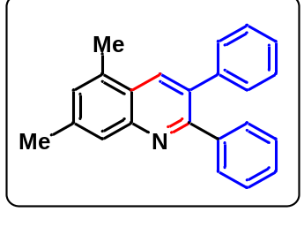
Light yellow solid; yield 71 %; mp: 136-138 °C; ¹H NMR (400 MHz, CDCl₃) δ 8.24 (s, 1H), 7.84 (s, 1H), 7.44-7.43 (m, 2H), 7.28-7.23 (m, 9H), 2.67 (s, 3H), 2.53 (s, 3H); ¹³C NMR (100 MHz, CDCl₃) δ 157.7, 147.9, 140.5, 139.5, 134.1, 134.0, 133.2, 130.0, 129.8, 129.5, 128.2, 127.8, 127.0, 126.6, 124.6, 21.9, 18.5; IR (KBr) max 3838, 3740, 3392, 2923, 2856, 1608, 1513, 1459, 1249, 1177, 1032, 834, 756; ESI-MS (m/z) = 310 (M+H); ESI-HRMS for cald. C₂₃H₁₉N; (M+H), 310.1595; found: m/z 310.1583.
2,3-bis(4-bromophenyl)quinoline (4g): 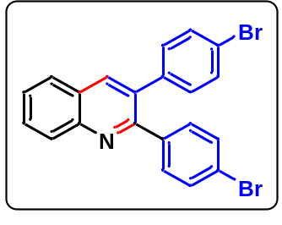
Light white solid; yield 74 %; mp: 180-182 °C; ¹H NMR (400 MHz, CDCl₃) δ 8.17 (d, J = 6.7 Hz, 1H), 8.14 (s, 1H), 7.87 (d, J = 6.4 Hz, 1H), 7.77-7.73 (m, 1H), 7.60-7.57 (m, 1H), 7.47-7.42 (m, 4H), 7.33-7.31 (m, 2H), 7.12-7.10 (m, 2H); ¹³C NMR (100 MHz, CDCl₃) δ 156.7, 147.4, 139.0, 138.6, 137.7, 133.0, 131.6, 131.3, 130.0, 129.4, 127.5, 127.1, 122.8, 121.8; IR (KBr) max 3837, 3739, 3391, 2923, 2855, 1608, 1513, 1459, 1249, 1177, 1032, 834; ESI-MS (m/z) = 437 (M+H); ESI-HRMS for cald. C₂₁H₁₃Br₂N; (M+H), 437.9493; found: m/z 437.9495.
2,3-bis(4-fluorophenyl)quinoline (4h):
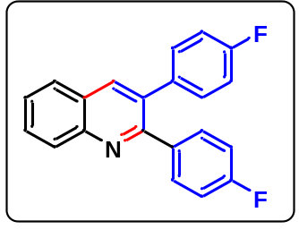White solid; yield 70 %; mp: 125-127 °C; ¹H NMR (400 MHz, CDCl₃) δ 8.18 (d, J = 6.8 Hz, 1H), 8.14 (s, 1H), 7.86 (d, J = 6.4 Hz, 1H), 7.74 (t, J = 6.5 Hz, 1H), 7.57 (t, J = 6.2 Hz, 1H), 7.43-7.40 (m, 2H), 7.21-7.18 (m, 2H), 7.03-6.97 (m, 4H); ¹³C NMR (100 MHz, CDCl₃) δ 163.7, 163.2, 161.7, 161.2, 157.1, 147.3, 137.6, 136.2, 135.8, 133.3, 131.9, 131.8, 131.3, 129.8, 129.3, 127.4, 127.1, 127.0, 115.5, 115.3, 115.1, 114.9; IR (KBr) max 3838, 3739, 3391, 2922, 2855, 1609, 1513, 1459, 1376, 1249, 1177, 1032, 916, 827; ESI-MS (m/z) = 318 (M+H); ESI-HRMS for cald. C₂₁H₁₃F₂N; (M+H), 318.1094; found: m/z 318.1089.
2,3-diphenylquinoline (4i):
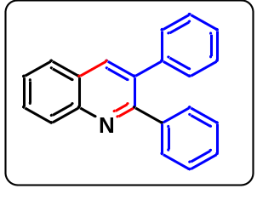Pale yellow solid; yield 68 %; mp: 90-92 °C; ¹H NMR (400 MHz, CDCl₃) δ 8.20 (d, J = 8.4 Hz, 1H), 8.16 (s, 1H), 7.87-7.85 (m, 1H), 7.75-7.70 (m, 1H), 7.57-7.53 (m, 1H), 7.46-7.43 (m, 2H), 7.29-7.25 (m, 4H), 7.25-7.22 (m, 4H); ¹³C NMR (100 MHz, CDCl₃) δ 158.4, 147.3, 140.4, 140.0, 137.5, 134.5, 130.0, 129.7, 129.6, 129.4, 128.2, 128.0, 127.9, 127.4, 127.2, 127.1, 126.7, 113.9; IR (KBr) max 3838, 3739, 3392, 2923, 2855, 1608, 1513, 1459, 1376, 1249, 1177, 1032, 916, 830; ESI-MS (m/z) = 282 (M+H); ESI-HRMS for cald. C₂₁H₁₅N; (M+H), 282.1282; found: m/z 282.1271.
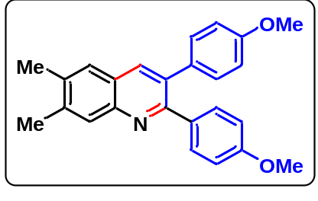2,3-bis(4-methoxyphenyl)-6,7-dimethylquinoline (4j):
Brown oil; yield 71 %; ¹H NMR (400 MHz, CDCl₃) δ 7.97 (s, 1H), 7.92 (s, 1H), 7.55 (s, 1H), 7.39-7.36 (m, 2H), 7.16-7.13 (m, 2H), 6.84-6.78 (m, 4H), 3.81 (s, 3H), 3.79 (s, 3H), 2.48 (s, 3H), 2.45 (s, 3H); ¹³C NMR (100 MHz, CDCl₃) δ 159.3, 158.6, 157.0, 146.3, 139.5, 136.2, 133.3, 133.1, 132.9, 131.3, 130.8, 128.6, 126.5, 125.8, 113.7, 113.3, 55.2, 20.4, 20.0; IR (KBr) max 3837, 3739, 3391, 2923, 2855, 1619, 1459, 1376, 1249, 1177, 1032, 916, 834; ESI-MS (m/z) = 370 (M+H); ESI-HRMS for cald. C₂₅H₂₃NO₂; (M+H), 370.1807; found: m/z 370.1803.
6-chloro-2,3-di-p-tolylquinoline (4k):
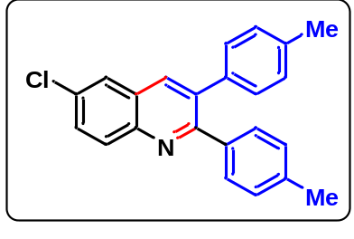Brown oil; yield 74 %; ¹H NMR (400 MHz, CDCl₃) δ 8.09 (d, J = 8.9 Hz, 1H), 8.01 (s, 1H), 7.81 (s, 1H), 7.64-7.61 (m, 1H), 7.54 (d, J = 8.4 Hz, 1H), 7.48 (s, 1H), 7.32-7.32 (m, 2H), 7.12-7.11 (m, 2H), 7.08 (d, J = 8.0 Hz, 2H), 2.35 (s, 3H), 2.33 (s, 3H); ¹³C NMR (100 MHz, CDCl₃) δ 164.5, 158.7, 151.1, 145.5, 140.2, 138.0, 137.1, 136.7, 136.4, 135.4, 132.1, 131.6, 131.1, 130.2, 129.8, 129.5, 129.0, 128.7, 125.9, 124.7, 121.1, 119.9, 110.9, 21.2, 21.1; IR (KBr) max 3371, 2923, 1711, 1600, 1491, 1387, 1277, 1176, 1074, 918, 823; ESI-MS (m/z) = 344 (M+H); ESI-HRMS for cald. C₂₃H₁₈ClN; (M+H), 344.1206; found: m/z 344.1202.
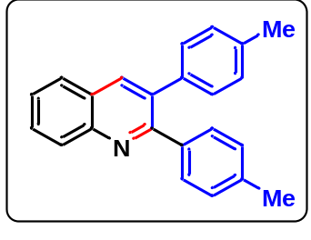2,3-di-p-tolylquinoline (4l):
Pale white oil; yield 75 %; ¹H NMR (400 MHz, CDCl₃) δ 8.17 (d, J = 8.4 Hz, 1H), 8.11 (s, 1H), 7.84-7.81 (m, 1H), 7.71-7.67 (m, 1H), 7.54-7.50 (m, 1H), 7.35 (d, J = 8.0 Hz, 2H), 7.20-7.15 (m, 1H), 7.13-7.10 (m, 3H), 7.08 (d, J = 7.7 Hz, 2H), 2.35 (s, 3H), 2.33 (s, 3H); ¹³C NMR (100 MHz, CDCl₃) δ 159.4, 158.4, 147.2, 137.7, 137.4, 137.2, 136.8, 134.5, 129.9, 129.5, 129.3, 128.9, 128.8, 128.7, 128.6, 127.4, 127.2, 126.5, 21.2, 21.1; IR (KBr) max 3837, 3739, 3391, 2923, 2855, 1608, 1513, 1459, 1377, 1249, 1177, 1032, 827; ESI-MS (m/z) = 310 (M+H); ESI-HRMS for cald. C₂₃H₁₉N; (M+H), 310.1595; found: m/z 310.1588.
6-chloro-2,3-diphenylquinoline (4m):
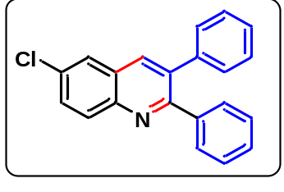Brown oil; yield 65 %; ¹H NMR (400 MHz, CDCl₃) δ 8.12 (d, J = 8.9 Hz, 1H), 8.06 (s, 1H), 7.84 (s, 1H), 7.67-7.64 (m, 1H), 7.44-7.41 (m, 2H), 7.30-7.26 (m, 6H), 7.23-7.20 (m, 2H); ¹³C NMR (100 MHz, CDCl₃) δ 158.7, 145.6, 140.0, 139.5, 135.4, 132.4, 131.0, 130.5, 129.9, 129.6, 128.2, 127.9, 127.4, 126.0, 124.7, 119.9, 110.9; IR (KBr) max 3739, 3391, 2922, 2855, 1619, 1513, 1459, 1376, 1249, 1177, 1030, 834; ESI-MS (m/z) = 316 (M+H); ESI-HRMS for cald. C₂₁H₁₄ClN; (M+H), 316.0893; found: m/z 316.0886.
5,7-dimethyl-2,3-di-p-tolylquinoline (4n):
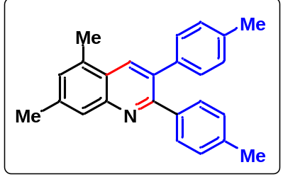Light yellow solid; yield 75 %; mp: 111-113 °C; ¹H NMR (400 MHz, CDCl₃) δ 8.23 (s, 1H), 7.86 (s, 1H), 7.40 (d, J = 6.4 Hz, 2H), 7.24 (s, 1H), 7.21-7.19 (m, 2H), 7.15 (d, J = 6.3 Hz, 2H), 7.13-7.11 (m, 2H), 2.69 (s, 3H), 2.56 (s, 3H), 2.40 (s, 3H), 2.37 (s, 3H); ¹³C NMR (100 MHz, CDCl₃) δ 158.0, 148.0, 139.4, 138.0, 137.8, 136.9, 134.2, 134.1, 133.3, 131.0, 130.1, 129.9, 129.5, 129.1, 128.8, 126.8, 124.8, 120.3, 116.5, 22.1, 21.5, 21.4, 20.0; IR (KBr) max 3389, 2921, 1619, 1380, 1029, 823; ESI-MS (m/z) = 338 (M+H); ESI-HRMS for cald. C₂₅H₂₃N; (M+H), 338.1908; found: m/z 338.1900.
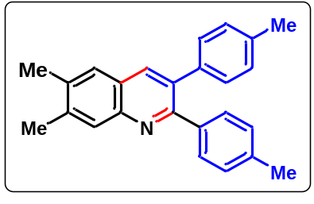6,7-dimethyl-2,3-di-p-tolylquinoline (4o):
Brown oil; yield 72 %; ¹H NMR (400 MHz, CDCl₃) δ 7.99 (s, 1H), 7.93 (s, 1H), 7.56 (s, 1H), 7.33 (d, J = 8.0 Hz, 2H), 7.13-7.05 (m, 6H), 2.48 (s, 3H), 2.45 (s, 3H), 2.35 (s, 3H), 2.32 (s, 3H); ¹³C NMR (100 MHz, CDCl₃) δ 156.4, 145.3, 138.6, 136.9, 136.5, 136.4, 135.5, 135.4, 132.5, 128.8, 128.5, 127.8, 127.6, 127.5, 125.5, 124.8, 20.2, 20.1, 19.4, 19.0; IR (KBr) max 3837, 3734, 3392, 2923, 2855, 1608, 1513, 1459, 1376, 1249, 1177, 1032, 834; ESI-MS (m/z) = 338 (M+H); ESI-HRMS for cald. C₂₅H₂₃N; (M+H), 338.1908; found: m/z 338.1897.
6-chloro-2,3-bis(4-chlorophenyl)quinoline (4p):
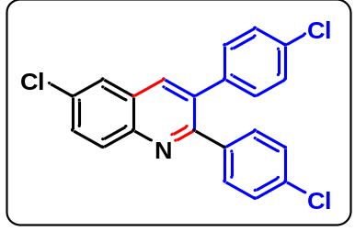Brown oil; yield 65 %; ¹H NMR (400 MHz, CDCl₃) δ 8.10 (d, J = 9.0 Hz, 1H), 8.04 (s, 1H), 7.84-7.83 (m, 1H), 7.69-7.66 (m, 1H), 7.38-7.37 (m, 1H), 7.36-7.35 (m, 1H), 7.31 (s, 1H), 7.30-7.28 (m, 2H), 7.27-7.26 (m, 1H), 7.17-7.16 (m, 1H), 7.15-7.14 (m, 1H); ¹³C NMR (100 MHz, CDCl₃) δ 157.2, 145.9, 138.3, 137.9, 136.9, 134.9, 134.2, 134.1, 133.0, 131.5, 131.2, 131.1, 129.0, 128.6, 127.9, 126.2; IR (KBr) max 3374, 2924, 2856, 1903, 1715, 1673, 1592, 1490, 1395, 1272, 1179, 1092, 919, 829, 758, 583; ESI-MS (m/z) = 384 (M+H); ESI-HRMS for cald. C₂₁H₁₂Cl₃N; (M+H), 384.0113; found: m/z 384.0107.
6-chloro-2,3-bis(4-methoxyphenyl)quinoline (4q):
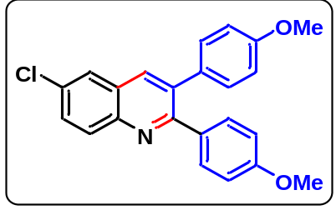Brown oil; yield 41 %; ¹H NMR (400 MHz, CDCl₃) δ 7.54-7.53 (m, 2H), 7.51-7.50 (m, 2H), 7.45-7.42 (m, 3H), 7.41-7.40 (m, 1H), 6.91-6.90 (m, 2H), 6.89-6.88 (m, 2H), 3.84 (s, 6H); ¹³C NMR (100 MHz, CDCl₃) δ 169.8, 160.9, 134.2, 133.2, 131.6, 131.3, 130.7, 129.1, 127.2, 120.9, 114.2, 113.8, 55.3; IR (KBr) max 3384, 2924, 2853, 1709, 1604, 1497, 1458, 1387, 1298, 1175, 1089, 830, 576; ESI-MS (m/z) = 376 [M+H]; ESI-HRMS for cald. C₂₃H₁₈ClNO₂; (M+H), 376.1104; found: m/z 376.1097.
2,3-bis(4-bromophenyl)-6,7-dimethylquinoline (4r): 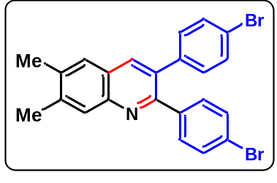
Light yellow solid; yield 74 %; mp: 163-165 °C; ¹H NMR (400 MHz, CDCl₃) δ 7.99 (s, 1H), 7.92 (s, 1H), 7.58 (s, 1H), 7.44-7.43 (m, 1H), 7.42-7.42 (m, 2H), 7.41-7.40 (m, 1H), 7.30-7.27 (m, 2H), 7.09-7.06 (m, 2H), 2.49 (s, 3H), 2.46 (s, 3H); ¹³C NMR (100 MHz, CDCl₃) δ 154.6, 145.6, 139.4, 138.2, 137.9, 136.2, 135.6, 131.1, 130.6, 130.5, 130.2, 130.1, 127.6, 125.5, 124.7, 121.4, 120.5, 19.5, 19.0; IR (KBr) max 3422, 2922, 1631, 1483, 1072, 827; ESI-MS (m/z) = 465 [M+H]; ESI-HRMS for cald. C₂₃H₁₇Br₂N; (M+H), 467.9806; found: m/z 467.9777.
2-(4-chlorobenzyl)-3-(4-chlorophenyl)-5,7-dimethylquinoline
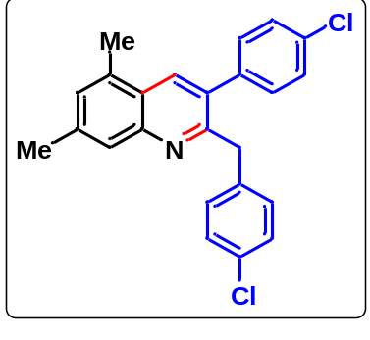White solid; yield 15 %; mp: 99-101 °C; ¹H NMR (400 MHz, CDCl₃) δ 8.03 (s, 1H), 7.80 (s, 1H), 7.38 (d, J = 6.7 Hz, 2H), 7.24 (s, 1H), 7.15-7.11 (m, 4H), 6.90 (d, J = 6.7 Hz, 2H), 4.26 (s, 2H), 2.63 (s, 3H), 2.56 (s, 3H); ¹³C NMR (100 MHz, CDCl₃) δ 157.7, 148.1, 139.9, 138.6, 138.0, 134.2, 133.9, 133.7, 132.0, 131.0, 130.3, 129.7, 128.6, 128.4, 126.4, 124.4, 120.2, 42.2, 22.1, 18.6; IR (KBr) max 3385, 2926, 1617, 1392, 1083, 756, 703; ESI-MS (m/z) = 392 (M+H); ESI-HRMS for cald. C₂₄H₁₉Cl₂N; (M+H), 392.0973; found: m/z 392.0961.
3-(4-chlorophenyl)-6,7-dimethylquinoline N-oxide (5):
All solid reactants, m-CPBA (2.0 mmol), and 3-substituted quinoline (3b) (1.0 mmol) were added in 25 mL round bottom flask, and dichloromethane (4 mL) was added at 0 °C. The reaction was allowed to stir at room temperature for 6 hours. On completion, the reaction mixture was extracted with ethyl acetate, and the organic layer was dried over Na₂SO₄ and concentrated under reduced pressure. The crude product was purified by column chromatography on silica gel with hexane/ethyl acetate to afford the desired 3-substituted 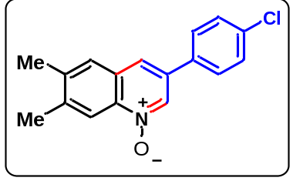quinoline N-oxide (5).
White solid; yield 90 %; mp: 210-212 °C; ¹H NMR (400 MHz, CDCl₃) δ 8.70 (s, 1H), 8.50 (s, 1H), 7.74 (s, 1H), 7.63 (s, 1H), 7.56 (d, J = 8.3 Hz, 2H), 7.47 (d, J = 8.1 Hz, 2H), 2.52 (s, 3H), 2.46 (s, 3H); ¹³C NMR (100 MHz, CDCl₃) δ 141.6, 139.5, 135.0, 134.7, 132.7, 129.5, 128.8, 128.2, 127.7, 122.8, 119.0, 20.6, 20.0; IR (KBr) max 3838, 3741, 3419, 2921, 1362, 1174, 818; ESI-MS (m/z) = 284 [M+H]; ESI-HRMS for cald. C₁₇H₁₄ClNO; (M+H), 284.0842; found: m/z 284.0829.
3-(4-chlorophenyl)-6,7-dimethyl-2-tosylquinoline (6):
Method (A): A solution of 3-substituted quinoline N-oxide (5) (1.0 mmol), sulfonyl hydrazide (2.0 mmol), NaI (4.0 mmol), and TBHP (70%, 3.0 mmol) in DMF/water (1:1) was stirred under an open air atmosphere at 100 °C for a desired time (monitored by TLC). After the reaction was finished, the mixture was added to 5 mL water and extracted with ethyl acetate (3 × 5 mL), and the organic phase was dried over Na₂SO₄, filtered, and concentrated under reduced pressure. The residue was separated on a silica gel column with petroleum ether/ethyl acetate as the eluent to get product (6).
Method (B): A 25 mL round bottom flask with a magnetic stirring bar was charged with a mixture of the 3-substituted quinoline N-oxide substrate (5) (1.00 mmol), the sodium sulfinate salt (2.0 mmol), I₂ (1.0 mmol), DMF (2 mL) and TBHP in water (3.00 mmol) and the reaction mixture was stirred at room temperature for 2 hours. Upon completion, saturated sodium thiosulfate (10 mL) and distilled deionized H₂O (10 mL) were added and the mixture was extracted with ethyl acetate (3 × 5 mL). The combined organic layers were washed with saturated NaCl, dried with anhydrous sodium sulphate and concentrated in vacuo. The crude product was purified by 100-200 mesh silica gel by column chromatography with hexane/ethyl acetate to afford product (6).
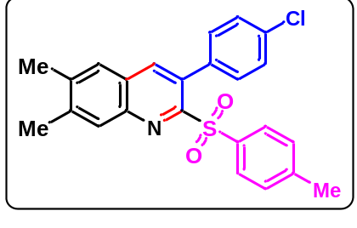Light yellow solid; yield (75, 80) %; mp: 154-156 °C; ¹H NMR (400 MHz, CDCl₃) δ 7.94 (s, 1H), 7.84 (s, 1H), 7.64 (d, J = 8.3 Hz, 2H), 7.56 (s, 1H), 7.38-7.32 (m, 4H), 7.22 (d, J = 8.0 Hz, 2H), 2.46 (s, 6H), 2.42 (s, 3H); ¹³C NMR (100 MHz, CDCl₃) δ 143.5, 143.1, 140.6, 139.1, 138.2, 134.4, 133.3, 130.4, 128.2, 128.1, 128.0, 126.9, 126.1, 125.3, 20.6, 19.3, 19.2; IR (KBr) max 3839, 3741, 3419, 2922, 1455, 1079, 771; ESI-MS (m/z) = 422 [M+H]; ESI-HRMS for cald. C₂₄H₂₀ClNO₂S; (M+H), 422.0981; found: m/z 422.0973.
3-(4-chlorophenyl)-6,7-dimethylquinolin-2(1H)-one (7):
A 25 mL round bottom flask with a magnetic stirring bar was charged with a mixture of the 3-substituted quinoline N-oxide substrate (5) (1.00 mmol), H₂O (2 mL) and MsCl (3.0 mmol), stirred under an open air atmosphere at room temperature for a desired time (monitored by TLC). After the reaction was finished, the mixture extracted with ethyl acetate (3 × 5 mL), and the organic phase was dried over Na₂SO₄, concentrated under reduced pressure. The residue was separated on a silica gel column with petroleum ether/ethyl acetate as the eluent to get product (7).
White solid; yield 85 %; mp: 216-218 °C; ¹H NMR (400 MHz, CDCl₃) δ 10.83 (s, 1H), 7.82 (s, 1H), 7.72 (d, J = 8.4 Hz, 2H), 7.41 (d, J = 8.3 Hz, 2H), 7.35 (s, 1H), 7.06 (s, 1H), 2.37 (s, 3H), 2.33 (s, 3H); ¹³C NMR (100 MHz, DMSO-d₆) δ 161.3, 140.4, 137.9, 137.4, 135.7, 132.7, 130.8, 129.3, 128.4, 128.3, 118.1, 115.5, 20.4, 19.3; IR (KBr) max 3838, 3740, 3419, 2919, 1656, 1564, 1493, 1020, 876, 833, 606; ESI-MS (m/z) = 284 [M+H]; ESI-HRMS for cald. C₁₇H₁₄ClNO; (M+H), 284.0842; found: m/z 284.0828.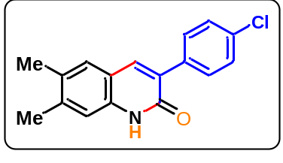
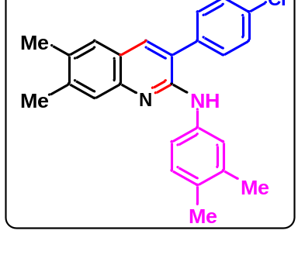3-(4-chlorophenyl)-N-(3,4-dimethylphenyl)-6,7-dimethylquinolin-2-amine (8): A 25 mL round bottom flask with a magnetic stirring bar was charged with a mixture of 3-substituted quinoline N-oxide 5 (1.0 mmol), diethylphosphite (0.8 mmol), CCl₄ (0.5 mL), K₂CO₃ (0.8 mmol) in DMF (3 mL) and 3,4-dimethylaniline (1.5 mmol) were stirred at room temperature for 3 hours. The mixture was quenched with water, extracted with CH₂Cl₂ (3 × 5 mL). The combined organic layers were washed with brine solution and dried over anhydrous Na₂SO₄. The solvent was evaporated in vacuo and the crude product was purified by silica gel chromatography (petroleum ether/ethyl acetate) to give the desired products (8).
Light yellow solid; yield 82 %; mp: 135-137 °C; ¹H NMR (400 MHz, CDCl₃) δ 7.57 (s, 2H), 7.49-7.47 (m, 1H), 7.42-7.40 (m, 2H), 7.38-7.36 (m, 2H), 7.30-7.29 (m, 2H), 6.99 (d, J = 6.5 Hz, 1H), 2.35 (s, 3H), 2.30 (s, 3H), 2.18 (s, 3H), 2.14 (s, 3H); ¹³C NMR (100 MHz, CDCl₃) δ 150.7, 145.8, 139.6, 138.1, 136.8, 136.3, 136.1, 134.3, 132.6, 130.7, 130.3, 129.8, 129.5, 128.8, 126.7, 126.6, 124.0, 122.3, 120.7, 116.9, 20.3, 19.9, 19.6, 19.0; IR (KBr) max 3839, 3741, 3429, 2923, 1607, 1518, 1090, 824; ESI-MS (m/z) = 387 [M+H]; ESI-HRMS for cald. C₂₅H₂₃ClN₂; (M+H), 387.1628; found: m/z 387.1610.
3-(4-chlorophenyl)-6,7-dimethyl-2-(phenylethynyl)quinoline (9):
A 25 mL round bottom flask with a magnetic stirring bar was charged with a mixture of 3-substituted quinoline N-oxide substrate (5) (1.00 mmol), phenylacetylene (1.5 mmol) and KOH (50% mol) in anhydrous toluene (3.0 mL) was stirred and refluxed for 12 hours. When the reaction was completed, the crude mixture was cooled to room temperature. The mixture was purified by column chromatography on silica gel (petroleum ether/ethyl acetate) to give the desired product (9).
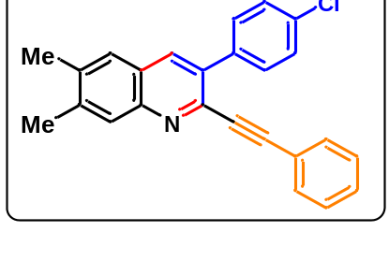White solid; yield 68 %; mp: 216-218 °C; ¹H NMR (400 MHz, CDCl₃) δ 8.00 (s, 1H), 7.92 (s, 1H), 7.67-7.64 (m, 2H), 7.56 (s, 1H), 7.49-7.47 (m, 2H), 7.43-7.40 (m, 2H), 7.35-7.32 (m, 3H), 2.49 (s, 3H), 2.46 (s, 3H); ¹³C NMR (100 MHz, CDCl₃) δ 141.0, 140.6, 137.9, 135.1, 134.7, 134.0, 131.9, 131.0, 129.0, 128.3, 126.7, 125.8, 122.2, 89.1, 20.5, 20.1; IR (KBr) max 3838, 3740, 3419, 2921, 1488, 1023, 824, 751; ESI-MS (m/z) = 368 [M+H]; ESI-HRMS for cald. C₂₅H₁₈ClN; (M+H), 368.1206; found: m/z 368.1198.
2-(4-bromophenoxy)-3-(4-chlorophenyl)-6,7-dimethylquinoline (10):
A 25 mL round bottom flask with a magnetic stirring bar was charged with a mixture of 3-substituted quinoline N-oxide 5 (1.0 mmol), diethylphosphite (0.8 mmol), CCl₄ (0.5 mL), K₂CO₃ (0.8 mmol) in DMF (2 mL) and 4-bromophenol (1.2 mmol) were stirred at room temperature for 3 hours. The mixture was quenched with water, extracted with CH₂Cl₂ (3 × 5 mL). The combined organic layers were washed with brine solution and dried over anhydrous Na₂SO₄. The solvent was evaporated in vacuo and the crude product was purified by silica gel chromatography (petroleum ether/ethyl acetate) to give the desired products.
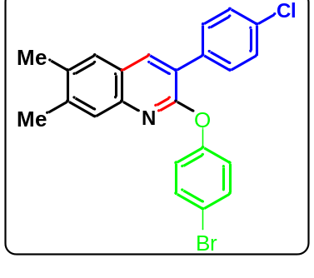White solid; yield 83 %; mp: 210-212 °C; ¹H NMR (400 MHz, CDCl₃) δ 8.00 (s, 1H), 7.61 (dt, J₁ = 8.5 Hz and J₂ = 2.5 Hz, 2H), 7.53 (s, 1H), 7.52 (s, 1H), 7.49 (dt, J₁ = 8.8 Hz and J₂ = 3.2 Hz, 2H), 7.42 (dt, J₁ = 8.5 Hz and J₂ = 2.5 Hz, 2H), 7.09 (dt, J₁ = 8.8 Hz and J₂ = 3.2 Hz, 2H), 2.40 (s, 3H), 2.39 (s, 3H); ¹³C NMR (100 MHz, CDCl₃) δ 157.7, 153.1, 144.4, 140.2, 138.3, 135.1, 135.0, 133.8, 130.6, 128.5, 127.1, 126.7, 124.7, 124.4, 123.2, 117.1, 20.3, 19.8; IR (KBr) max 3838, 3739, 3420, 2921, 1610, 1482, 1424, 1351, 1213, 1065, 1011, 885, 831; ESI-MS (m/z) = 440 [M+H]; ESI-HRMS for cald. C₂₃H₁₇BrClNO; (M+H), 440.0240; found: m/z 440.0216.
2-(3-(4-chlorophenyl)-6,7-dimethylquinolin-2-yl)-5,5-dimethylcyclohexane-1,3-dione (11):
A 25 mL round bottom flask with a magnetic stirring bar was charged with a mixture of 3-substituted quinoline N-oxide 5 (1.0 mmol), diethylphosphite (0.8 mmol), CCl₄ (0.5 mL), K₂CO₃ (0.8 mmol) in DMF (2 mL) and 5,5-dimethylcyclohexane-1,3-dione (1.2 mmol) were stirred at room temperature for 3 hours. The mixture was quenched with water, extracted with CH₂Cl₂ (3 × 5 mL). The combined organic layers were washed with brine solution and dried over anhydrous Na₂SO₄. The solvent was evaporated in vacuo and the crude product was purified by silica gel chromatography (petroleum ether/ethyl acetate) to give the desired products.
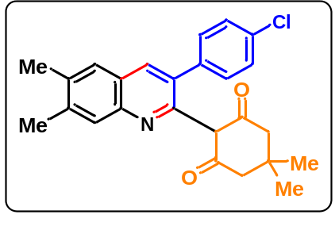Yellow solid; yield 70 %; mp: 202-204 °C; ¹H NMR (400 MHz, CDCl₃) δ 7.99 (s, 1H), 7.56 (s, 1H), 7.54 (s, 1H), 7.34 (s, 4H), 2.48 (s, 3H), 2.43 (s, 3H), 2.28 (s, 4H), 1.08 (s, 6H); ¹³C NMR (100 MHz, CDCl₃) δ 193.8, 153.9, 143.0, 140.9, 139.6, 136.7, 134.5, 133.7, 133.0, 128.7, 128.0, 127.4, 123.6, 119.2, 105.9, 50.9, 30.6, 29.7, 28.7, 20.7, 19.9; IR (KBr) max 3838, 3739, 3442, 2924, 1632, 1490, 1381, 1091, 756; ESI-MS (m/z) = 406 [M+H]; ESI-HRMS for cald. C₂₅H₂₄ClNO₂; (M+H), 406.1574; found: m/z 406.1560.
Diethyl (3-(4-chlorophenyl)-6,7-dimethylquinolin-2-yl)phosphonate (12):
A 25 mL round bottom flask with a magnetic stirring bar was charged with a mixture of 3-substituted quinoline N-oxide 5 (1.0 mmol), diethylphosphite (1.0 mmol), CCl₄ (0.3 mL), iPr₂EtN (0.8 mmol) in acetonitrile (2 mL) were stirred at 40 °C for 4 h. The mixture was quenched with water (5 mL), extracted with CH₂Cl₂ (3 × 5 mL). The combined organic layers were washed with brine solution and dried over anhydrous Na₂SO₄. The solvent was evaporated in vacuo and the crude product was purified by silica gel chromatography (petroleum ether/ethyl acetate) to give the desired products.
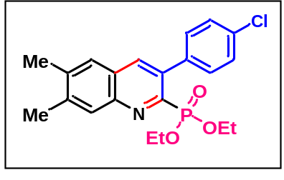Light yellow liquid; yield 65 %; ¹H NMR (400 MHz, CDCl₃) δ 7.98 (s, 1H), 7.93 (d, J = 6.7 Hz, 1H), 7.56 (s, 1H), 7.53-7.50 (m, 2H), 7.43-7.40 (m, 2H), 4.20-4.06 (m, 4H), 2.50 (s, 3H), 2.47 (s, 3H), 1.22 (t, J = 7.0 Hz, 6H); ¹³C NMR (100 MHz, CDCl₃) δ 151.1, 148.9, 145.9, 145.7, 140.6, 139.2, 137.8, 136.2, 136.1, 135.9, 133.9, 131.1, 129.3, 127.9, 126.5, 63.0, 62.9, 20.4, 20.2, 16.2, 16.1; ³¹P NMR (162 MHz, CDCl₃) δ 10.5; IR (KBr) max 3391, 2925, 1617, 1453, 1389, 1247, 1028, 757; ESI-MS (m/z) = 404 [M+H]; ESI-HRMS for cald. C₂₁H₂₃ClNO₃P; (M+H), 404.1182; found: m/z 404.1170.
5-(3-(4-chlorophenyl)-6,7-dimethylquinolin-2-yl)-2,2-dimethyl-1,3-dioxane-4,6-dione (13):
A 25 mL round bottom flask with a magnetic stirring bar was charged with a mixture of 3-substituted quinoline N-oxide 5 (1.0 mmol), diethylphosphite (0.8 mmol), CCl₄ (0.5 mL), K₂CO₃ (0.8 mmol) in DMF (2 mL) and 2,2-dimethyl-1,3-dioxane-4,6-dione (1.2 mmol) were stirred at room temperature for 3 hours. The mixture was quenched with water, extracted with CH₂Cl₂ (3 × 5 mL). The combined organic layers were washed with brine solution and dried over anhydrous Na₂SO₄. The solvent was evaporated in vacuo and the crude product was purified by silica gel chromatography (petroleum ether/ethyl acetate) to give the desired products.
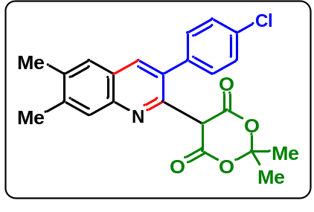Yellow solid; yield 75 %; mp: 166-168 °C; ¹H NMR (400 MHz, CDCl₃) δ 15.21 (s, 1H), 7.99 (s, 1H), 7.55 (s, 1H), 7.54 (s, 1H), 7.37 (s, 4H), 2.50 (s, 3H), 2.44 (s, 3H), 1.73 (s, 6H); ¹³C NMR (100 MHz, CDCl₃) δ 163.8, 153.2, 142.9, 141.0, 137.7, 135.8, 132.6, 132.5, 132.4, 127.8, 127.3, 126.6, 121.7, 117.1, 101.6, 78.1, 25.3, 19.7, 18.8; IR (KBr) max 3838, 3740, 3442, 2922, 1629, 1526, 1383, 1201, 1040, 769; ESI-MS (m/z) = 410 [M+H]; ESI-HRMS for cald. C₂₃H₂₀ClNO₄; (M+H), 410.1159; found: m/z 410.1149.
(6) Experimental Procedure and Characterization Data for Drug Compounds and Natural Products
N-(4-((3-(4-chlorophenyl)-6,7-dimethylquinolin-2-yl)oxy)phenyl)acetamide (14):
A 25 mL round bottom flask with a magnetic stirring bar was charged with a mixture of 3-substituted quinoline N-oxide 5 (1.0 mmol), diethylphosphite (0.8 mmol), CCl₄ (0.3 mL), iPr₂EtN (0.8 mmol) in acetonitrile (2 mL) and paracetamol (1.2 mmol) were stirred at 40 °C for 2 h. After completion, the reaction mixture was cool to room temperature and the product was precipitates, after filtration, washing with ethanol and drying, the product was obtained as a white solid.
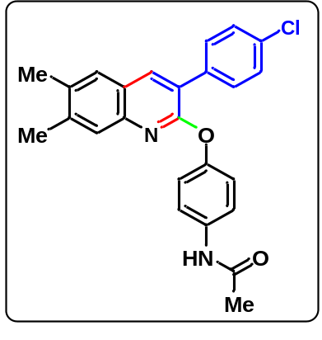White solid; yield 81 %; mp: 266-268 °C; ¹H NMR (400 MHz, DMSO-d₆) δ 9.97 (s, 1H), 8.29 (s, 1H), 7.78 (d, J = 8.4 Hz, 2H), 7.70 (s, 1H), 7.61 (d, J = 8.8 Hz, 2H), 7.56 (d, J = 8.4 Hz, 2H), 7.43 (s, 1H), 7.15 (d, J = 8.8 Hz, 2H), 2.37 (s, 3H), 2.36 (s, 3H), 2.06 (s, 3H); ¹³C NMR (100 MHz, DMSO-d₆) δ 168.6, 158.6, 149.2, 144.3, 140.6, 138.9, 136.5, 135.5, 134.9, 133.1, 131.6, 128.8, 127.5, 126.7, 124.7, 123.9, 122.5, 120.6, 24.4, 20.3, 19.8; IR (KBr) max 3312, 2919, 1655, 1526, 1396, 1249, 1017, 828; ESI-MS (m/z) = 417 [M+H]; ESI-HRMS for cald. C₂₅H₂₁ClN₂O₂; (M+H), 417.1370; found: m/z 417.1362.
3-(4-chlorophenyl)-6,7-dimethyl-2-(2-(2-methyl-5-nitro-1H-imidazol-1-yl)ethoxy)quinoline (15):
A 25 mL round bottom flask with a magnetic stirring bar was charged with a mixture of 3-substituted quinoline N-oxide 5 (1.0 mmol), diethylphosphite (0.8 mmol), CCl₄ (0.3 mL), iPr₂EtN (0.8 mmol) in acetonitrile (2 mL) and metronidazole (1.2 mmol) were stirred at room temperature for 2 h. The mixture was quenched with water (5 mL), extracted with CH₂Cl₂ (3 × 5 mL). The combined organic layers were washed with brine solution and dried over anhydrous Na₂SO₄. The solvent was evaporated in vacuo and the crude product was purified by silica gel chromatography (petroleum ether/ethyl acetate) to give the desired products.
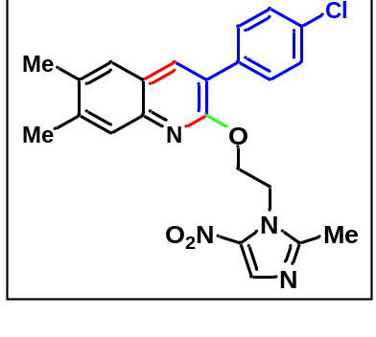Light brown solid; yield 68 %; mp: 170-172 °C; ¹H NMR (400 MHz, CDCl₃) δ 8.09 (s, 1H), 7.93 (s, 1H), 7.81 (s, 1H), 7.57 (s, 1H), 7.40 (d, J = 8.5 Hz, 2H), 7.29 (d, J = 8.4 Hz, 2H), 4.87 (t, J = 5.3 Hz, 2H), 4.70 (t, J = 5.2 Hz, 2H), 2.44 (s, 3H), 2.39 (s, 3H), 2.13 (s, 3H); ¹³C NMR (100 MHz, CDCl₃) δ 169.5, 157.5, 151.2, 144.3, 140.2, 137.8, 135.1, 134.6, 133.8, 133.4, 132.6, 130.5, 129.7, 128.6, 126.8, 126.2, 123.9,123.7, 63.9, 45.7, 20.4, 19.7, 13.9; IR (KBr) max; 3384, 2925, 1620, 1389, 1075, 756, 703; ESI-MS (m/z) = 437 [M+H]; ESI-HRMS for cald. C₂₃H₂₁ClN₄O₃; (M+H), 437.1380; found: m/z 437.1377.
3-(4-chlorophenyl)-6,7-dimethyl-2-((2,5,7,8-tetramethyl-2-(4,8,12-trimethyltridecyl)chroman-6-yl)oxy)quinoline (16):
A 25 mL round bottom flask with a magnetic stirring bar was charged with a mixture of 3-substituted quinoline N-oxide 5 (1.0 mmol), diethylphosphite (0.8 mmol), CCl₄ (0.3 mL), iPr₂EtN (0.8 mmol) in acetonitrile (2 mL) and alpha-tocopherol (1.2 mmol) were stirred at room temperature for 2 h. After completion, the reaction mixture was precipitate, after filtration, washing with ethanol and drying, the product was obtained as a white solid.
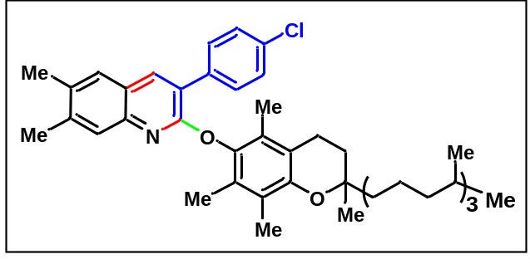White solid; yield 86 %; mp: 87-89 °C; ¹H NMR (400 MHz, CDCl₃) δ 7.97 (s, 1H), 7.70 (d, J = 8.4 Hz, 2H), 7.49 (s, 2H), 7.41 (d, J = 8.4 Hz, 2H), 2.61 (s, 2H), 2.38 (s, 3H), 2.35 (s, 3H), 2.12 (s, 3H), 1.96 (s, 3H), 1.92 (s, 3H), 1.87-1.81 (m, 2H), 1.55-1.47 (m, 4H), 1.37-1.36 (m, 4H), 1.28-1.25 (m, 9H), 1.16-1.08 (m, 7H), 0.87-0.83 (m, 12H); ¹³C NMR (100 MHz, CDCl₃) δ 158.0, 148.7, 145.0, 143.0, 139.5, 137.7, 135.6, 134.0, 133.5, 130.8, 128.3, 127.6, 127.2, 126.7, 125.7, 124.2, 123.7, 122.7, 117.2, 74.9, 39.3, 37.4, 37.3, 32.8, 32.7, 27.9, 24.8, 24.4, 22.7, 22.6, 21.0, 20.7, 20.2, 19.7, 13.5, 12.6, 11.9; IR (KBr) max; 3387, 2926, 1616, 1455, 1396, 1080, 756, 703; ESI-MS (m/z) = 696 [M+H]; ESI-HRMS for cald. C₄₆H₆₂ClNO₂; (M+H), 696.4547; found: m/z 696.4533.
(E)-3-(4-((3-(4-chlorophenyl)-6,7-dimethylquinolin-2-yl)oxy)-3-methoxyphenyl)acrylic acid (17):
A 25 mL round bottom flask with a magnetic stirring bar was charged with a mixture of 3-substituted quinoline N-oxide 5 (1.0 mmol), diethylphosphite (0.8 mmol), CCl₄ (0.3 mL), iPr₂EtN (0.8 mmol) in acetonitrile (2 mL) and ferulic acid (1.2 mmol) were stirred at 40 °C for 3 h. The mixture was quenched with water (5 mL), extracted with CH₂Cl₂ (3 × 5 mL). The combined organic layers were washed with brine solution and dried over anhydrous Na₂SO₄. The solvent was evaporated in vacuo and the crude product was purified by silica gel chromatography (petroleum ether/ethyl acetate) to give the desired products.
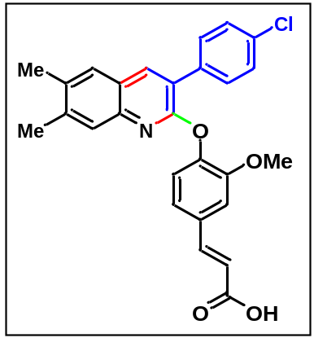White solid; yield 83 %; mp: 206-208 °C; ¹H NMR (400 MHz, CDCl₃) δ 12.37 (s, 1H), 8.29 (s, 1H), 7.82 (d, J = 8.5 Hz, 2H), 7.70 (s, 1H), 7.63 (d, J = 15.9 Hz, 1H), 7.57 (d, J = 8.5 Hz, 2H), 7.53 (s, 1H), 7.38 (s, 1H), 7.33-7.31 (m, 1H), 7.25 (d, J = 8.1 Hz, 1H), 6.62 (d, J = 15.9 Hz, 1H), 3.72 (s, 3H), 2.36 (s, 3H), 2.34 (s, 3H); ¹³C NMR (100 MHz, CDCl₃) δ 168.1, 158.1, 152.1, 144.3, 144.1, 140.6, 138.9, 135.5, 134.8, 133.1, 132.8, 131.5, 128.8, 127.5, 126.6, 124.8, 124.1, 123.3, 122.2, 119.4, 112.6, 56.5, 20.2, 19.8; IR (KBr) max; 3839, 3740, 3419, 2922, 1635, 1354, 1223, 995, 667; ESI-MS (m/z) = 460 [M+H]; ESI-HRMS for cald. C₂₇H₂₂ClNO₄; (M+H), 460.1315; found: m/z 460.1303.
(E)-3-(4-((3-(4-chlorophenyl)-6,7-dimethylquinolin-2-yl)oxy)phenyl)acrylic acid (18):
A 25 mL round bottom flask with a magnetic stirring bar was charged with a mixture of 3-substituted quinoline N-oxide 5 (1.0 mmol), diethylphosphite (0.8 mmol), CCl₄ (0.3 mL), iPr₂EtN (0.8 mmol) in acetonitrile (2 mL) and p-coumaric acid (1.2 mmol) were stirred at 40 °C for 3 h. The mixture was quenched with water (5 mL), extracted with CH₂Cl₂ (3 × 5 mL). The combined organic layers were washed with brine solution and dried over anhydrous Na₂SO₄. The solvent was evaporated in vacuo and the crude product was purified by silica gel chromatography (petroleum ether/ethyl acetate) to give the desired products.
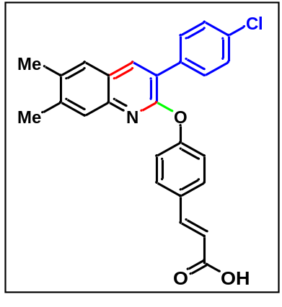White solid; yield 85 %; mp: 205-207 °C; ¹H NMR (400 MHz, CDCl₃) δ 12.39 (s, 1H), 8.33 (s, 1H), 7.79-7.76 (m, 3H), 7.73 (d, J = 9.8 Hz, 2H), 7.64 (d, J = 15.9 Hz, 1H), 7.57-7.54 (m, 2H), 7.45 (s, 1H), 7.27 (d, J = 8.6 Hz, 2H), 6.52 (d, J = 15.9 Hz, 1H), 2.38 (s, 3H), 2.36 (s, 3H); ¹³C NMR (100 MHz, CDCl₃) δ 168.1, 158.0, 155.8, 144.3, 143.7, 140.8, 139.2, 135.3, 135.2, 133.2, 131.6, 131.0, 130.0, 128.8, 127.5, 126.8, 124.9, 124.0, 122.5, 119.0, 20.2, 19.8; IR (KBr) max; 3838, 3739, 3420, 2922, 1689, 1634, 1497, 1423, 1354, 1223, 993, 829, 765; ESI-MS (m/z) = 430 [M+H]; ESI-HRMS for cald. C₂₆H₂₀ClNO₃; (M+H), 430.1210; found: m/z 430.1196.
4-((3-(4-chlorophenyl)-6,7-dimethylquinolin-2-yl)oxy)-2-methoxybenzaldehyde (19):
A 25 mL round bottom flask with a magnetic stirring bar was charged with a mixture of 3-substituted quinoline N-oxide 5 (1.0 mmol), diethylphosphite (0.8 mmol), CCl₄ (0.3 mL), iPr₂EtN (0.8 mmol) in acetonitrile (2 mL) and vanillin (1.2 mmol) were stirred at 40 °C for 3 h. The mixture was quenched with water (5 mL), extracted with CH₂Cl₂ (3 × 5 mL). The combined organic layers were washed with brine solution and dried over anhydrous Na₂SO₄. The solvent was evaporated in vacuo and the crude product was purified by silica gel chromatography (petroleum ether/ethyl acetate) to give the desired products.
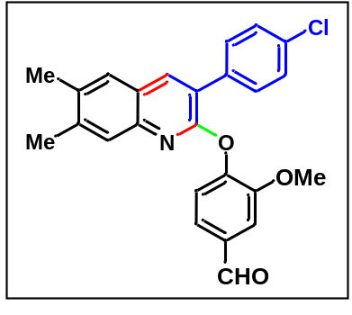White solid; yield 80 %; mp: 193-195 °C; ¹H NMR (400 MHz, CDCl₃) δ 9.97 (s, 1H), 8.00 (s, 1H), 7.71 (d, J = 6.2 Hz, 2H), 7.53 (s, 1H), 7.52 (s, 1H), 7.51 (s, 1H), 7.44 (d, J = 8.1 Hz, 2H), 7.42 (s, 1H), 7.35-7.34 (m, 1H), 3.77 (s, 3H), 2.39 (s, 3H), 2.36 (s, 3H); ¹³C NMR (100 MHz, CDCl₃) δ 191.3, 157.8, 152.5, 148.7, 144.5, 140.1, 138.1, 135.1, 134.9, 134.1, 133.9, 130.8, 128.5, 127.1, 126.8, 125.3, 124.9, 123.9, 123.6, 111.1, 56.1, 20.3, 19.8; IR (KBr) max; 3408, 2921, 1695, 1594, 1424, 1273, 1028; ESI-MS (m/z) = 418 [M+H]; ESI-HRMS for cald. C₂₅H₂₀ClNO₃; (M+H), 418.1210; found: m/z 418.1205.

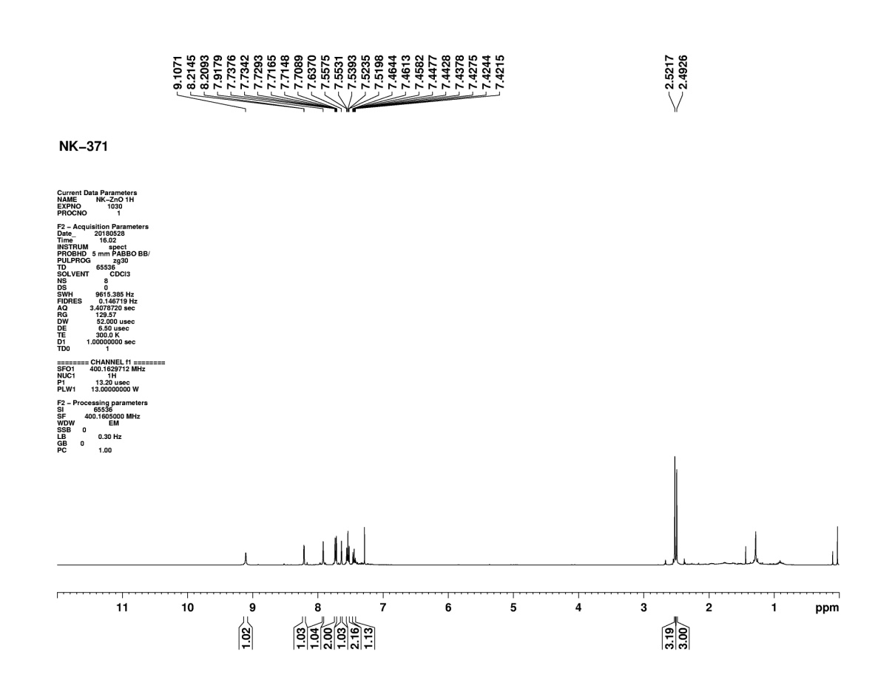
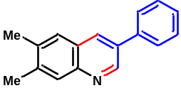(7) NMR-Spectra of Compounds
Figure S2: ¹H NMR of compound (3a)
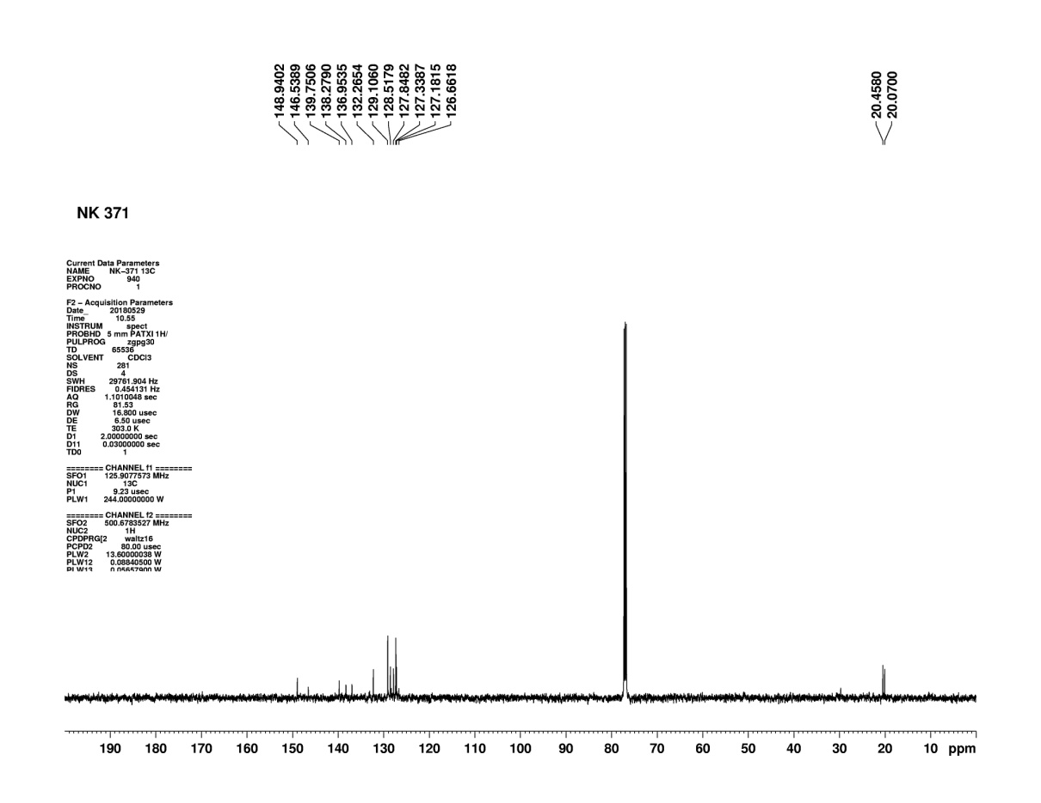
Figure S3: ¹³C NMR of compound (3a)
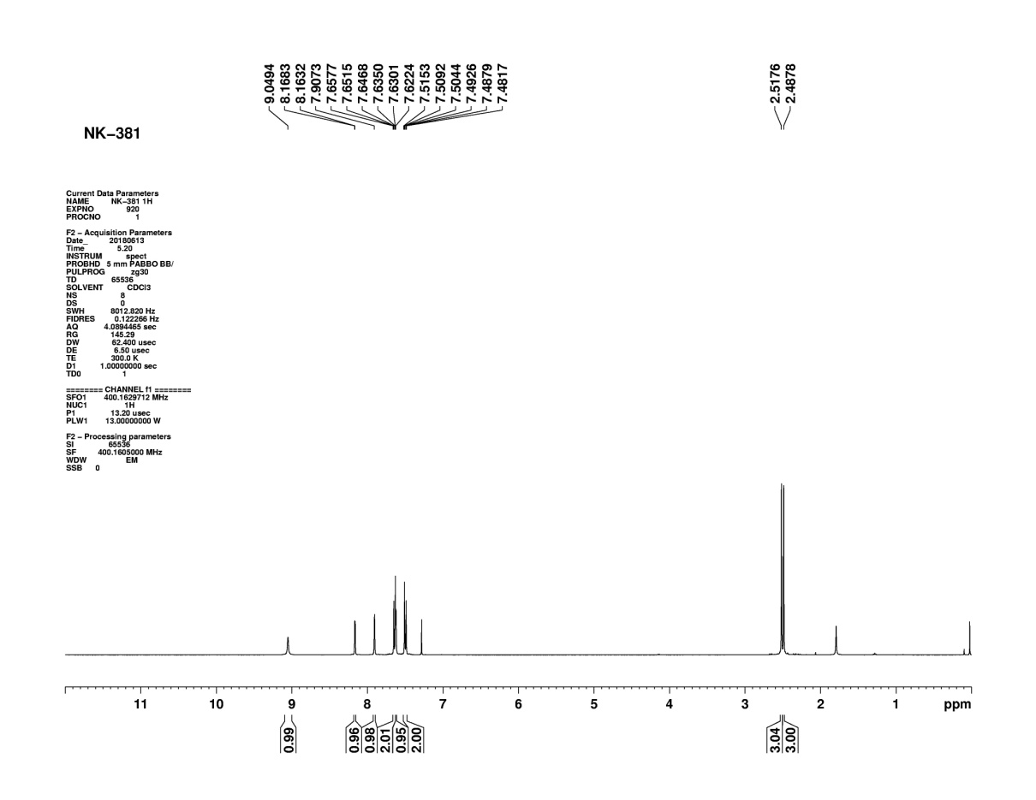
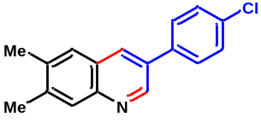
Figure S4: ¹H NMR of compound (3b)
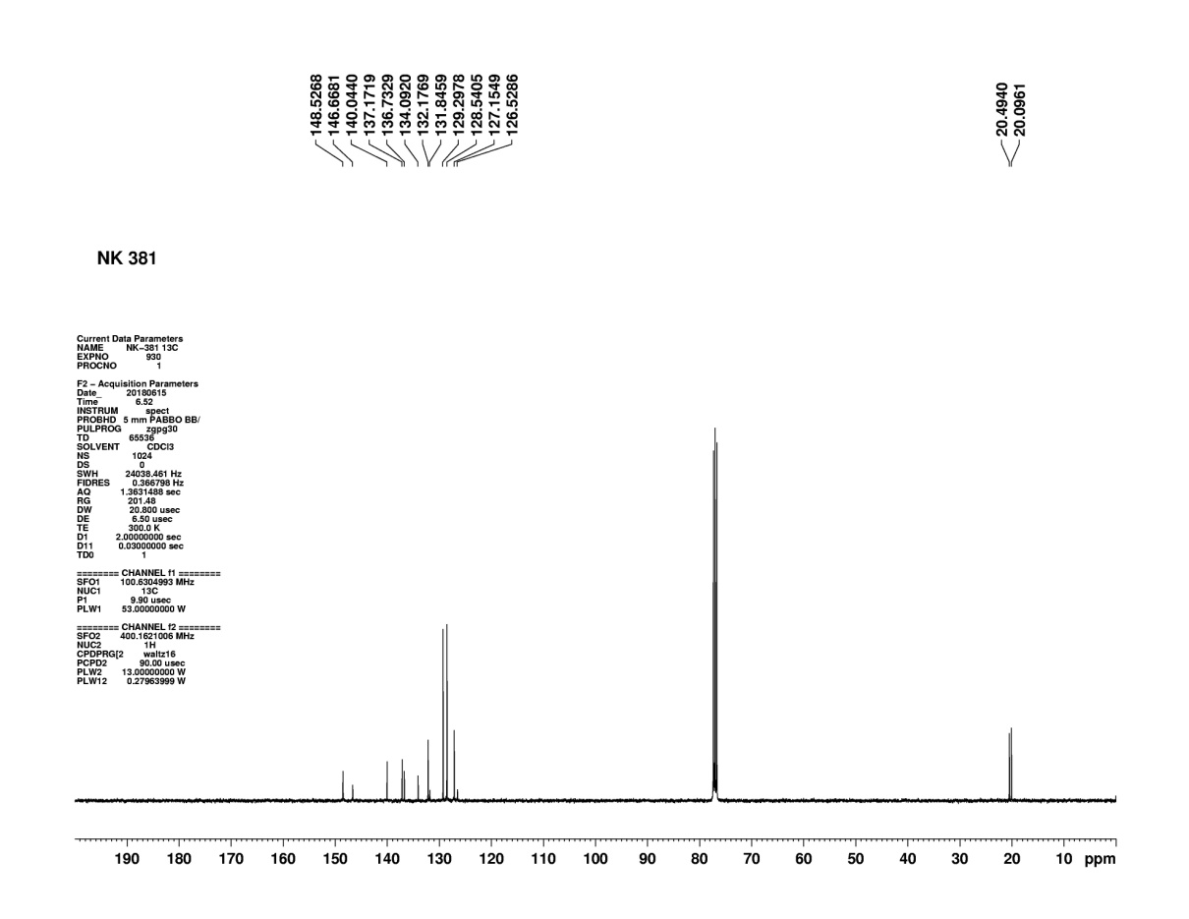

Figure S5: ¹³C NMR of compound (3b)

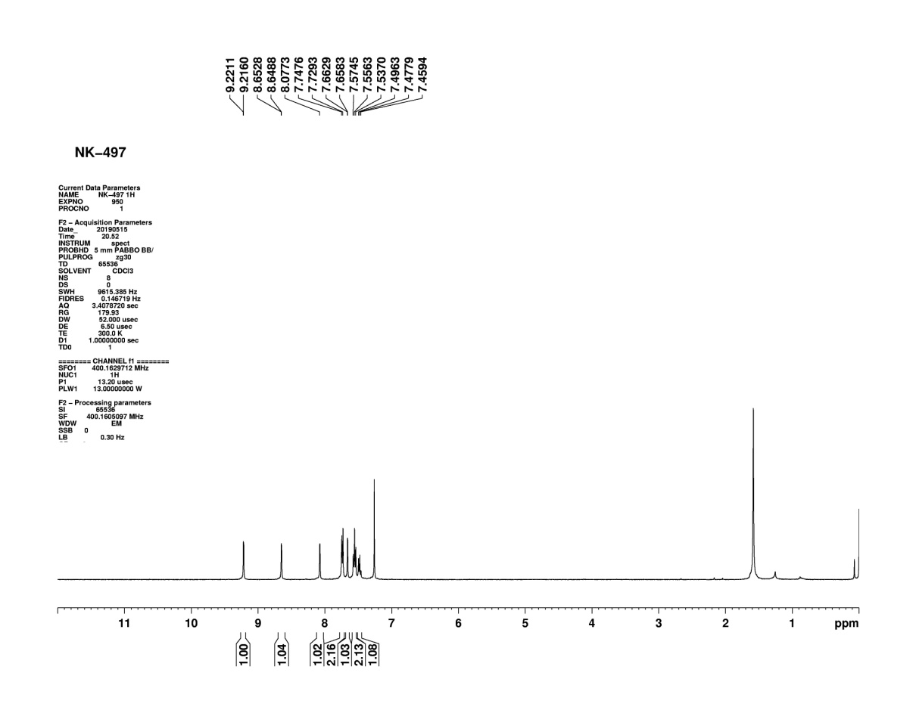

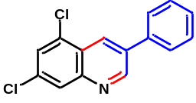

Figure S6: ¹H NMR of compound (3c)

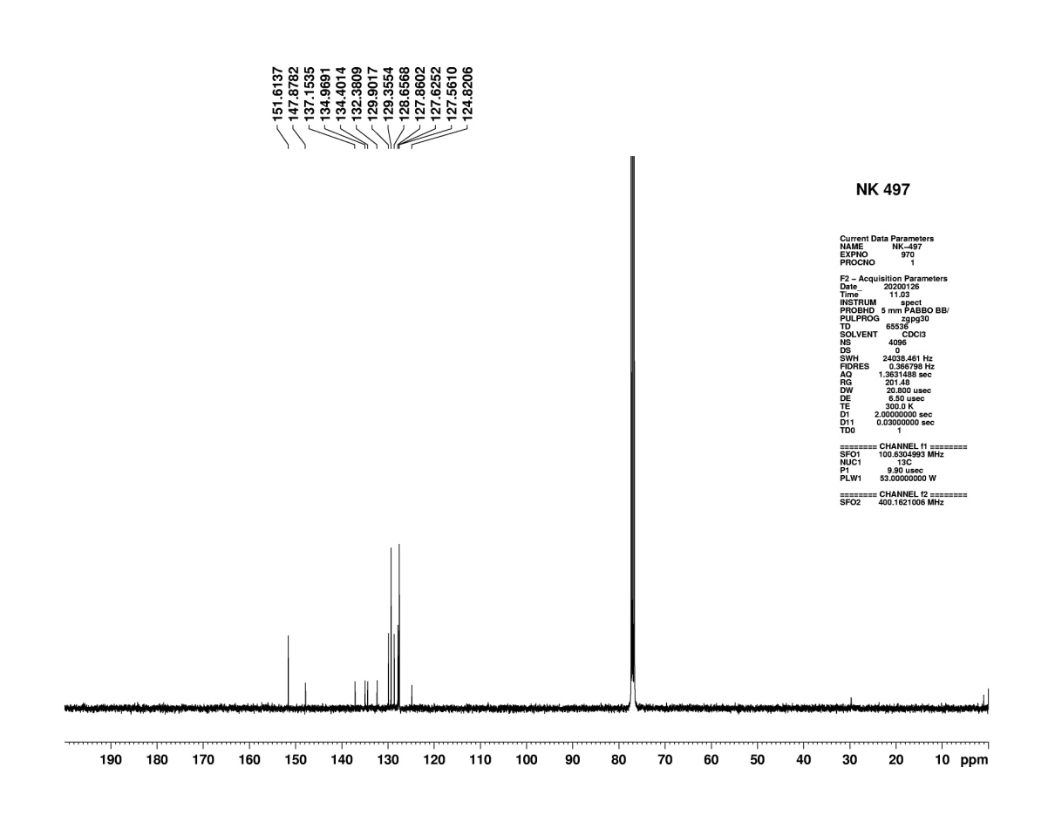

Figure S7: ¹³C NMR of compound (3c)
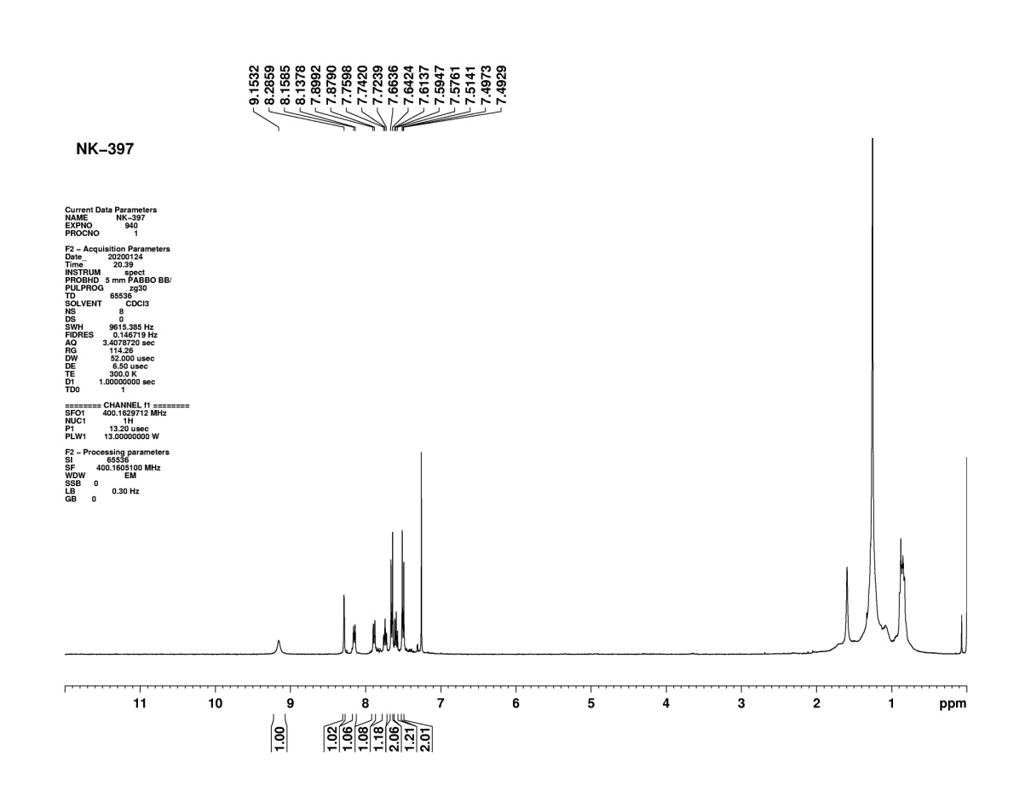

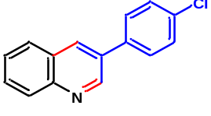
Figure S8: ¹H NMR of compound (3d)
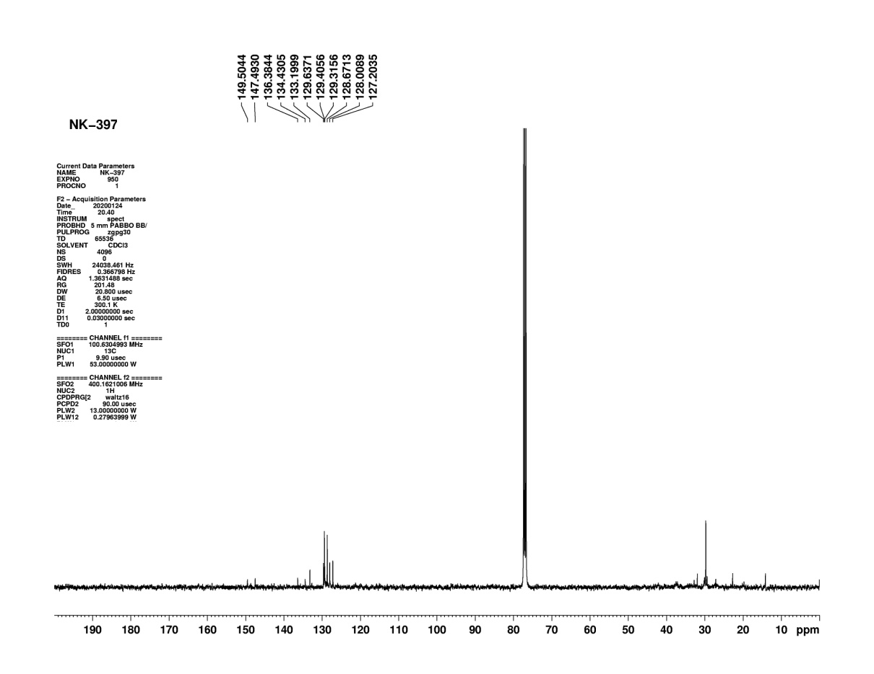
Figure S9: ¹³C NMR of compound (3d)

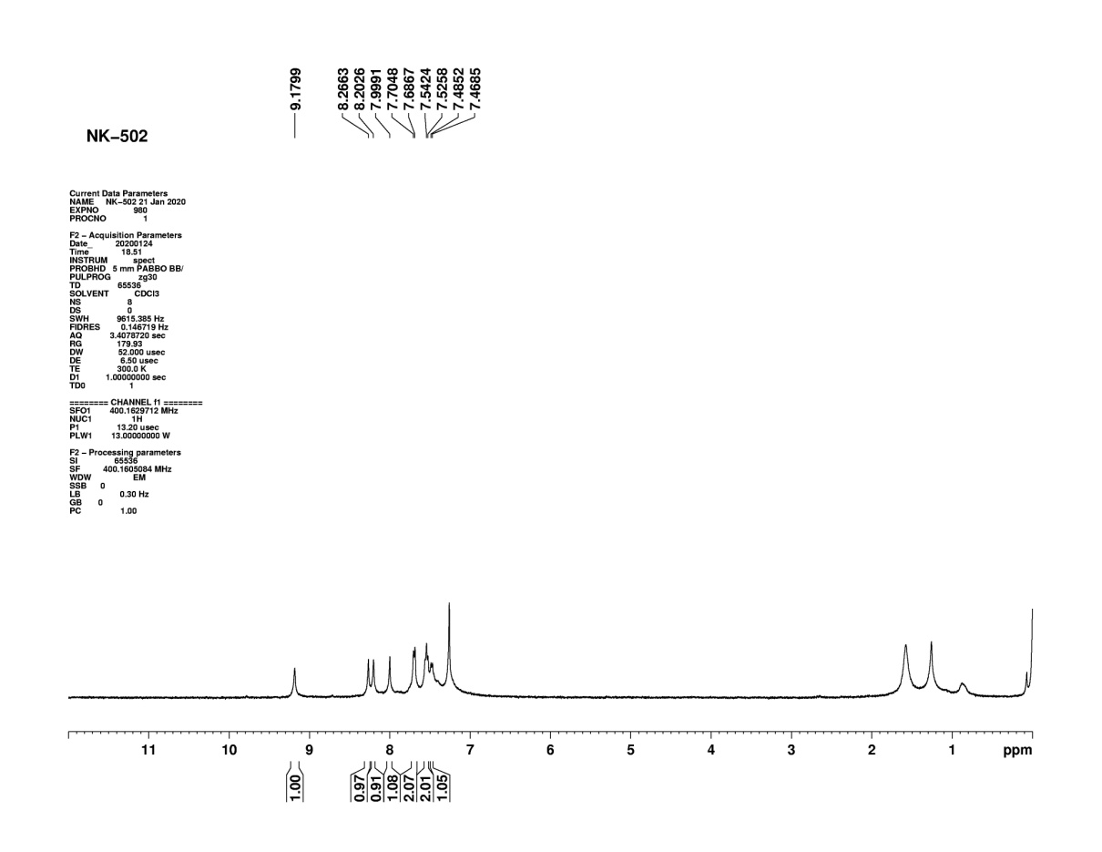
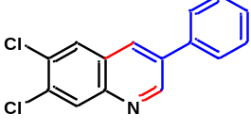
Figure S10: ¹H NMR of compound (3e)
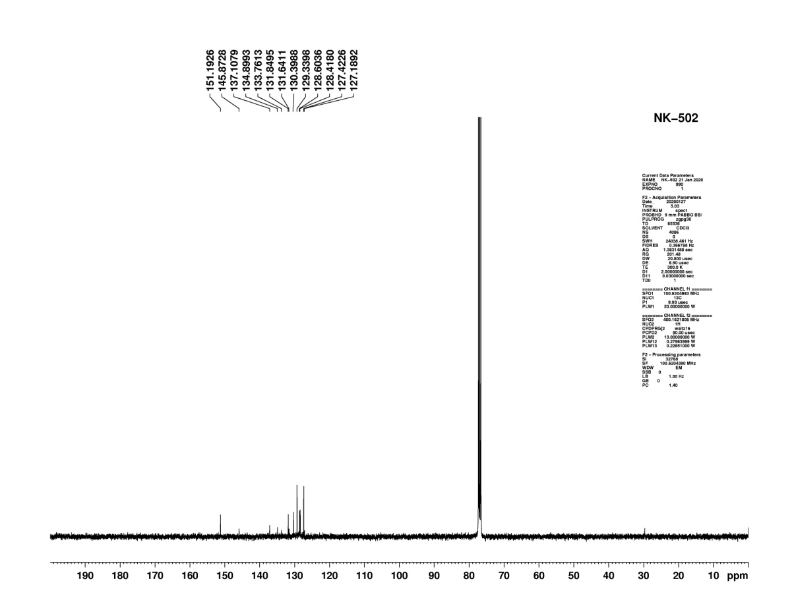
Figure S11:¹³C NMR of compound (3e)

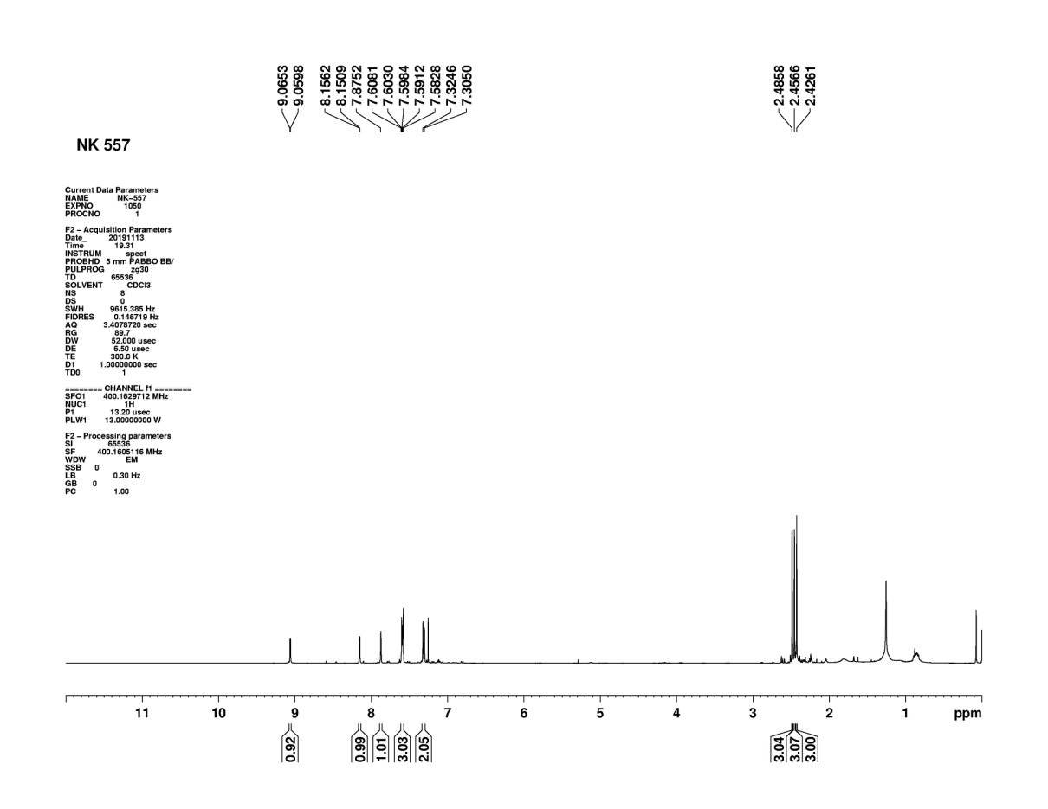
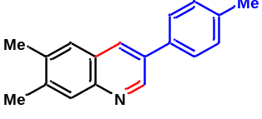
Figure S12: ¹H NMR of compound (3f)
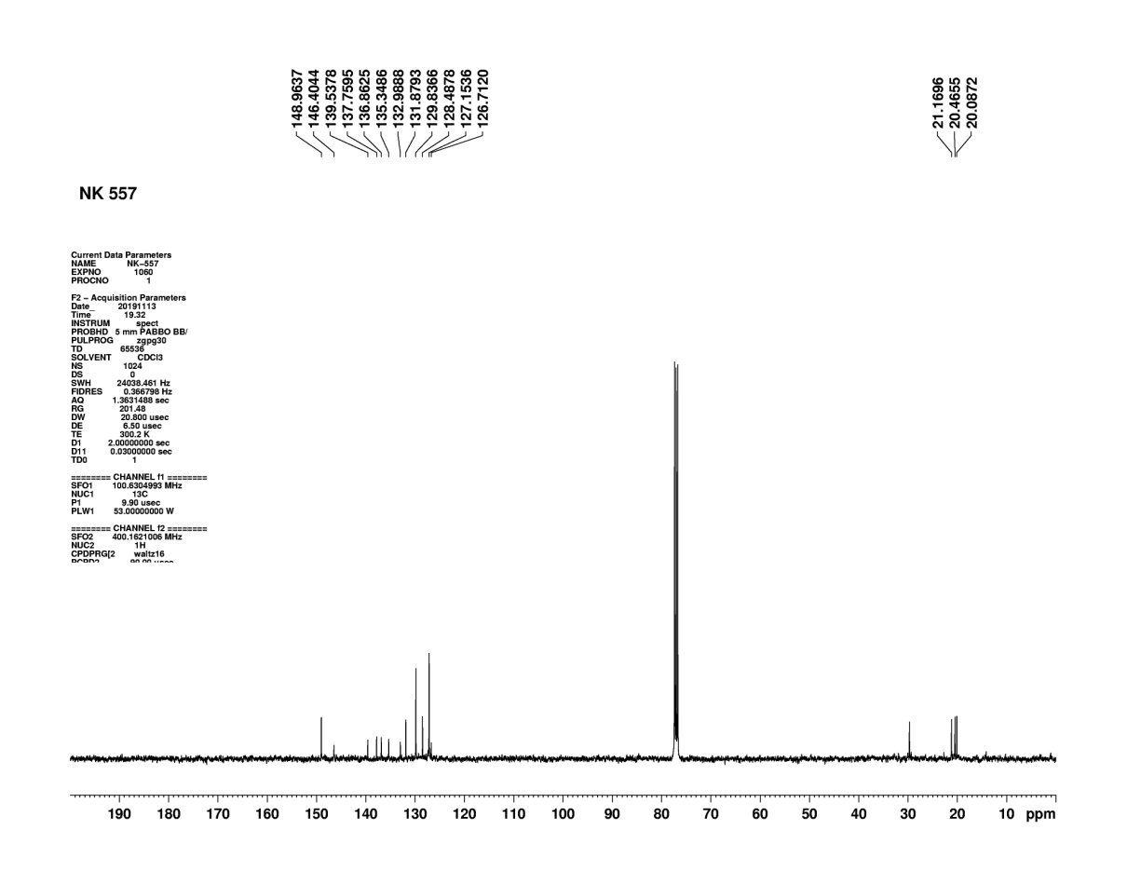
Figure S13: ¹³C NMR of compound (3f)

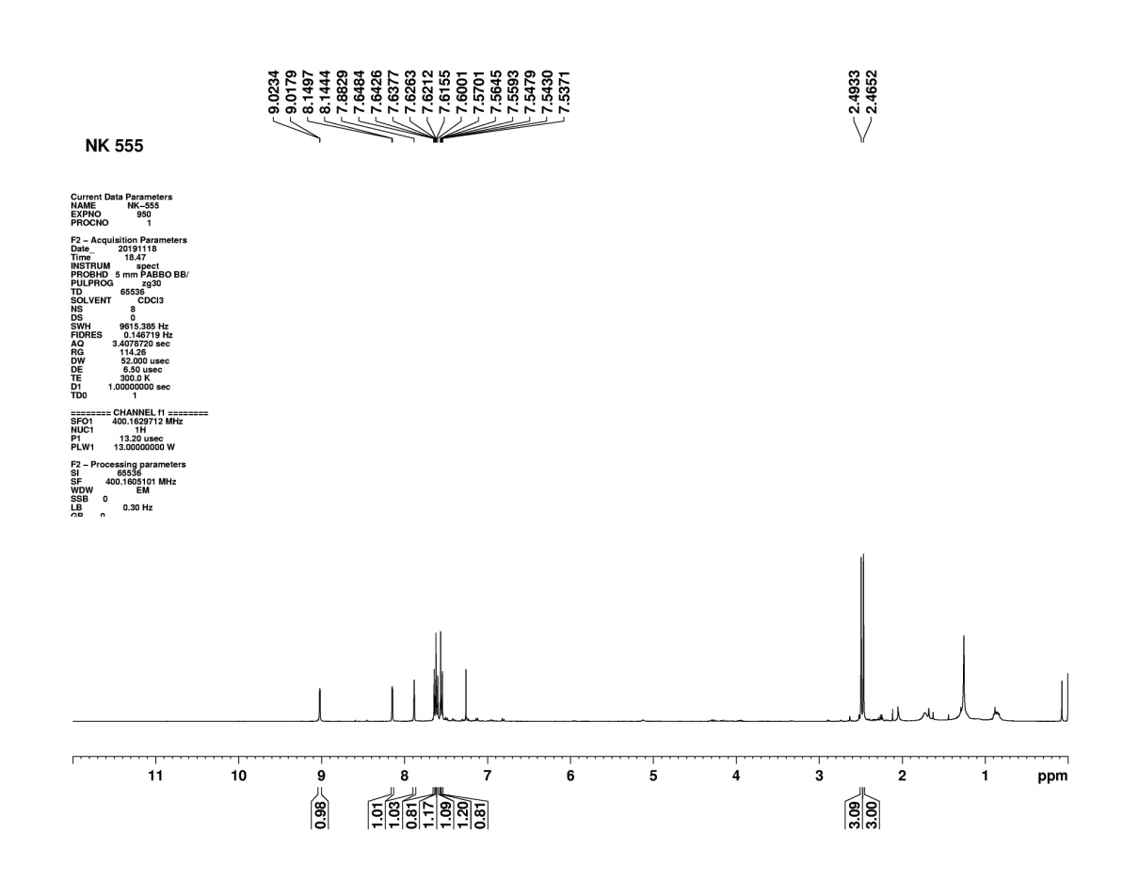
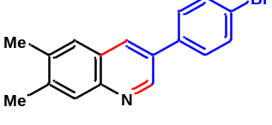
Figure S14: ¹H NMR of compound (3g)
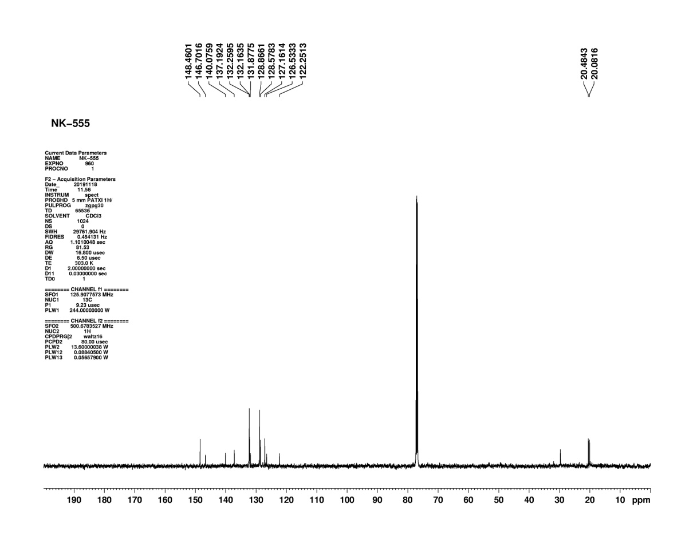
Figure S15: ¹³C NMR of compound (3g)

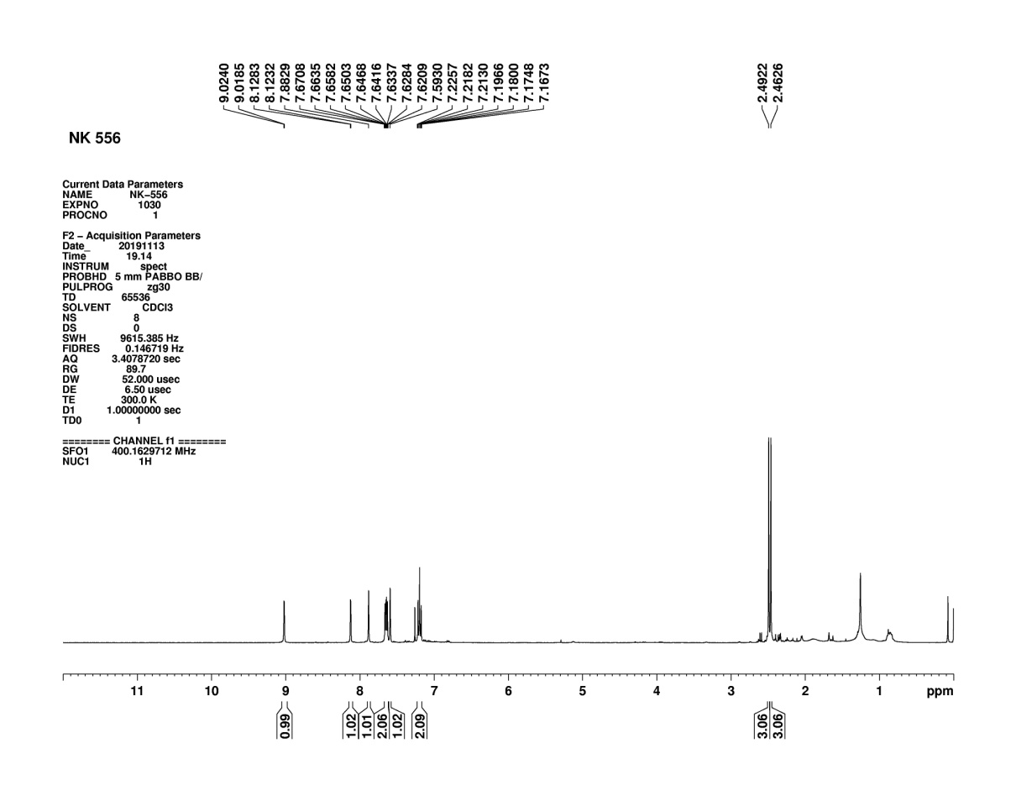
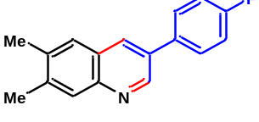
Figure S16: ¹H NMR of compound (3h)
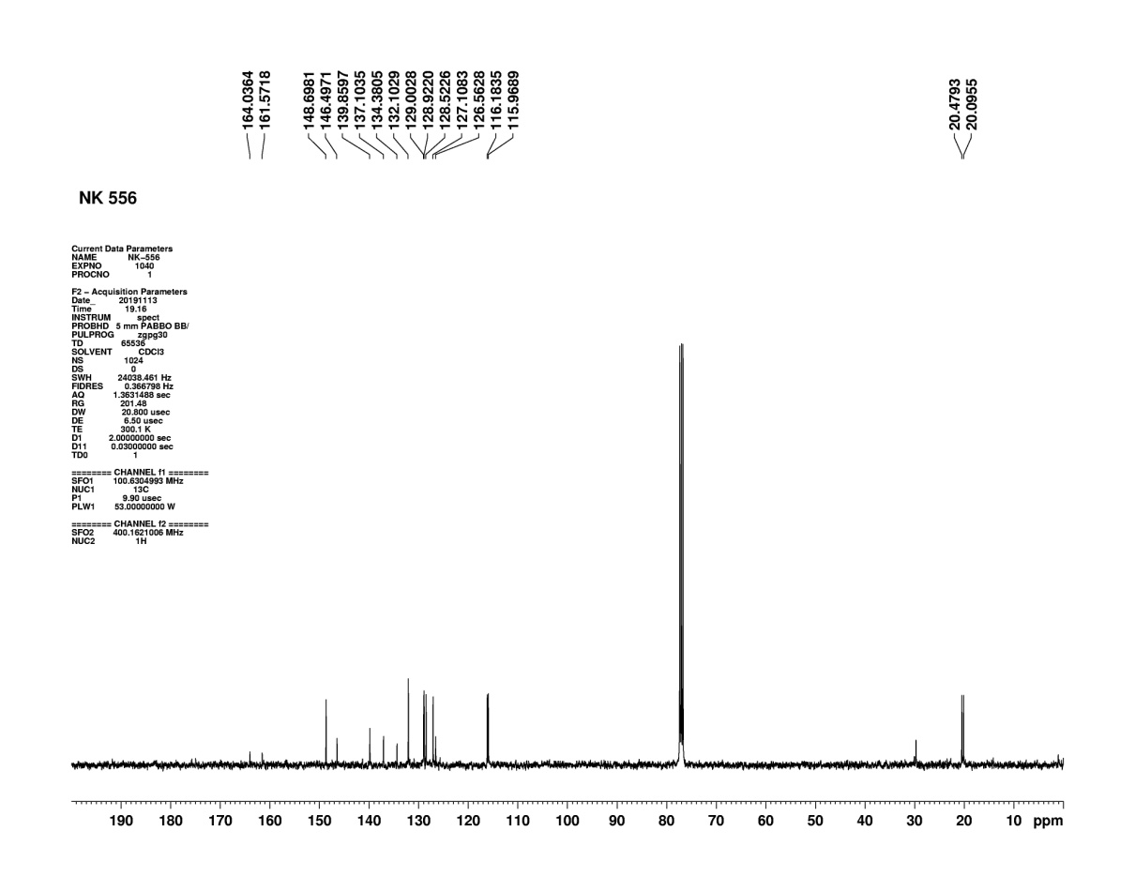
Figure S17: ¹³C NMR of compound (3h)

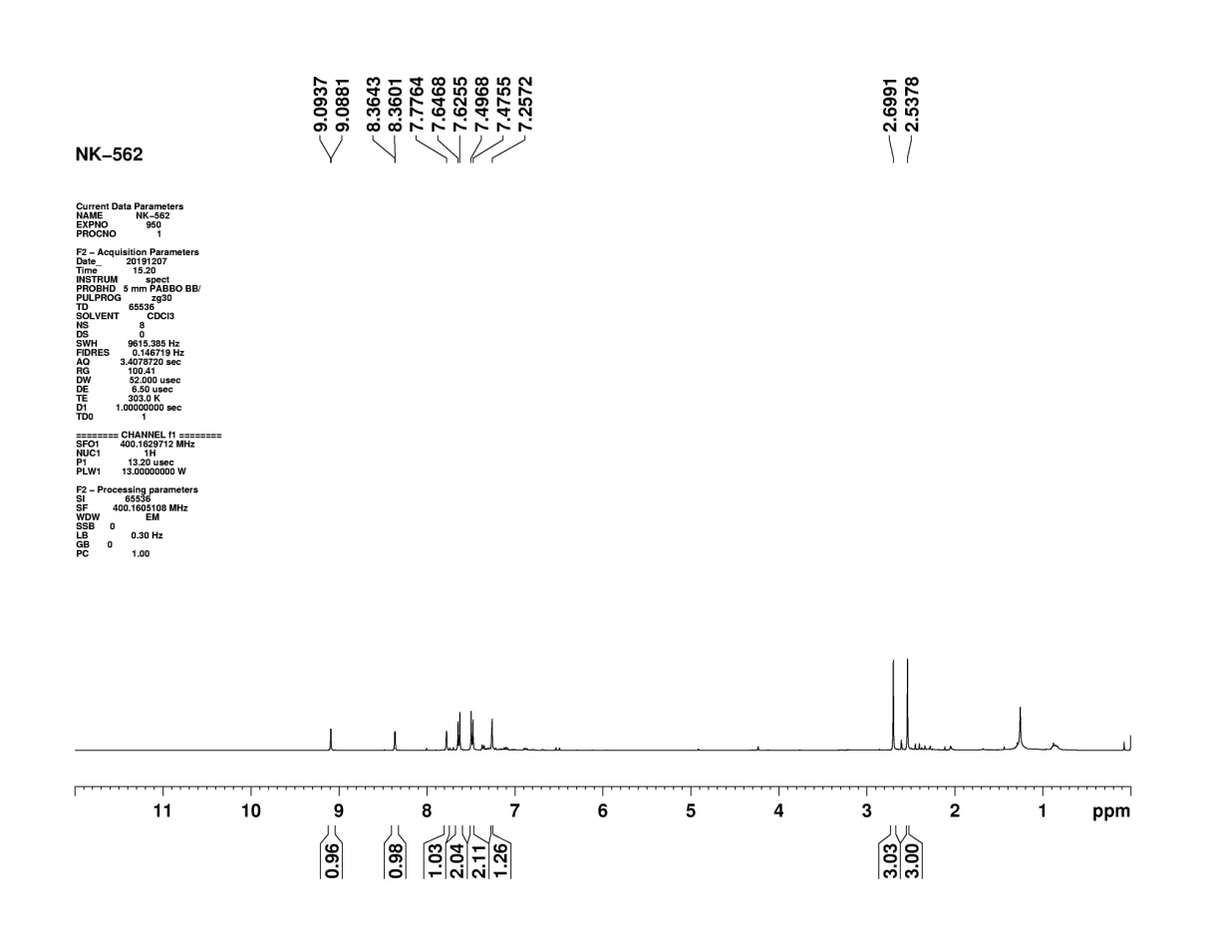
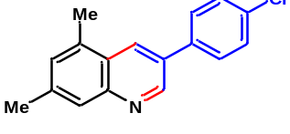
Figure S18: ¹H NMR of compound (3i)

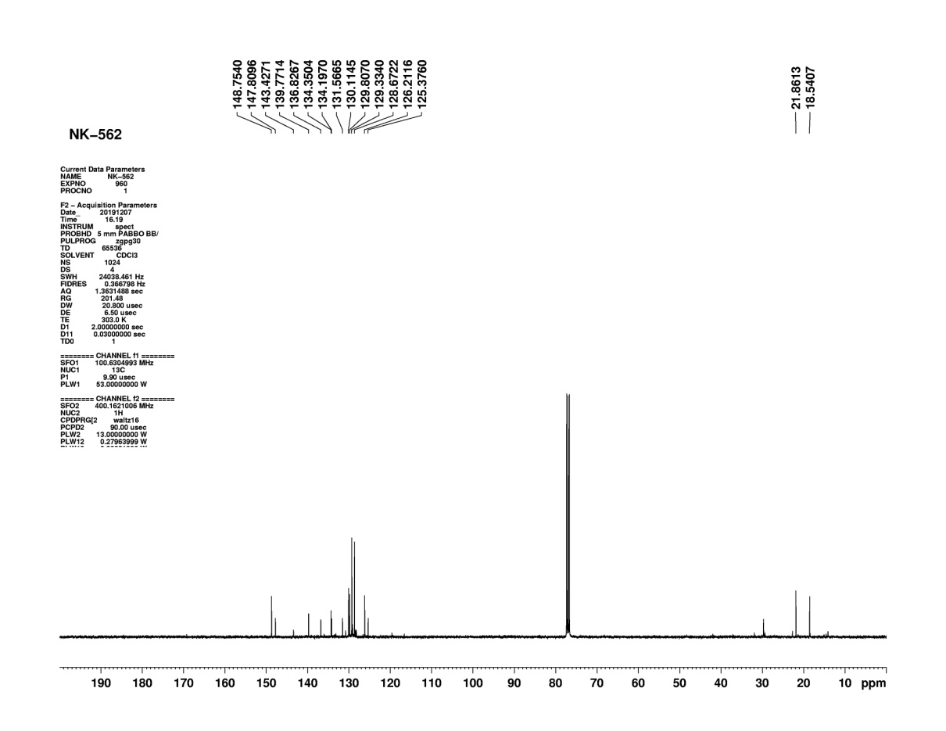
Figure S19: ¹³C NMR of compound (3i)
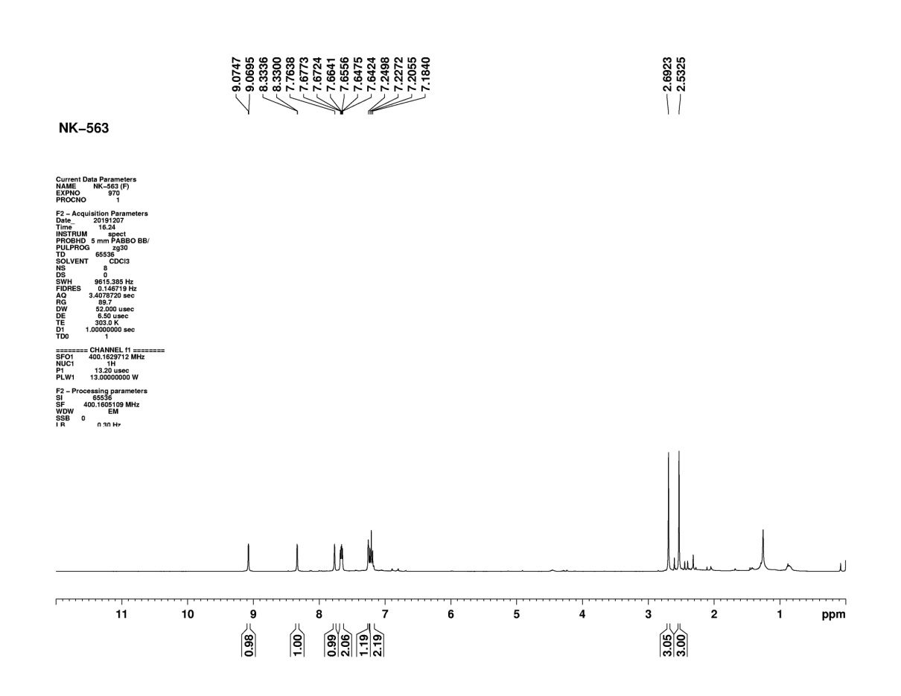
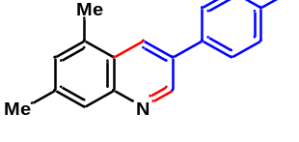 Figure S20: ¹H NMR of compound (3j)
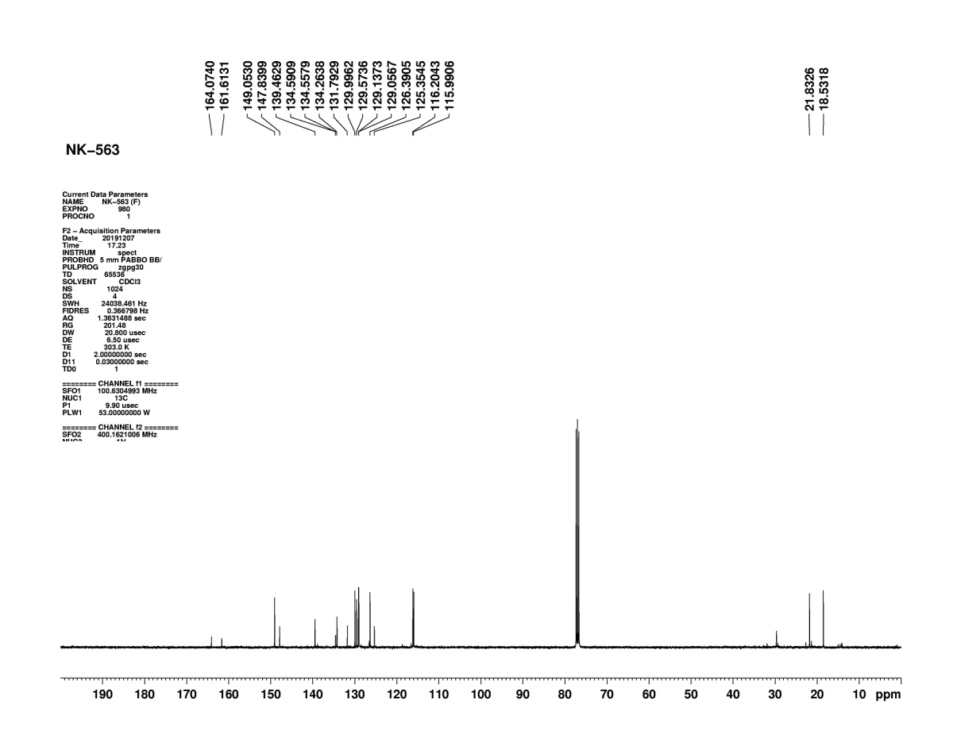
Figure S21: ¹³C NMR of compound (3j)

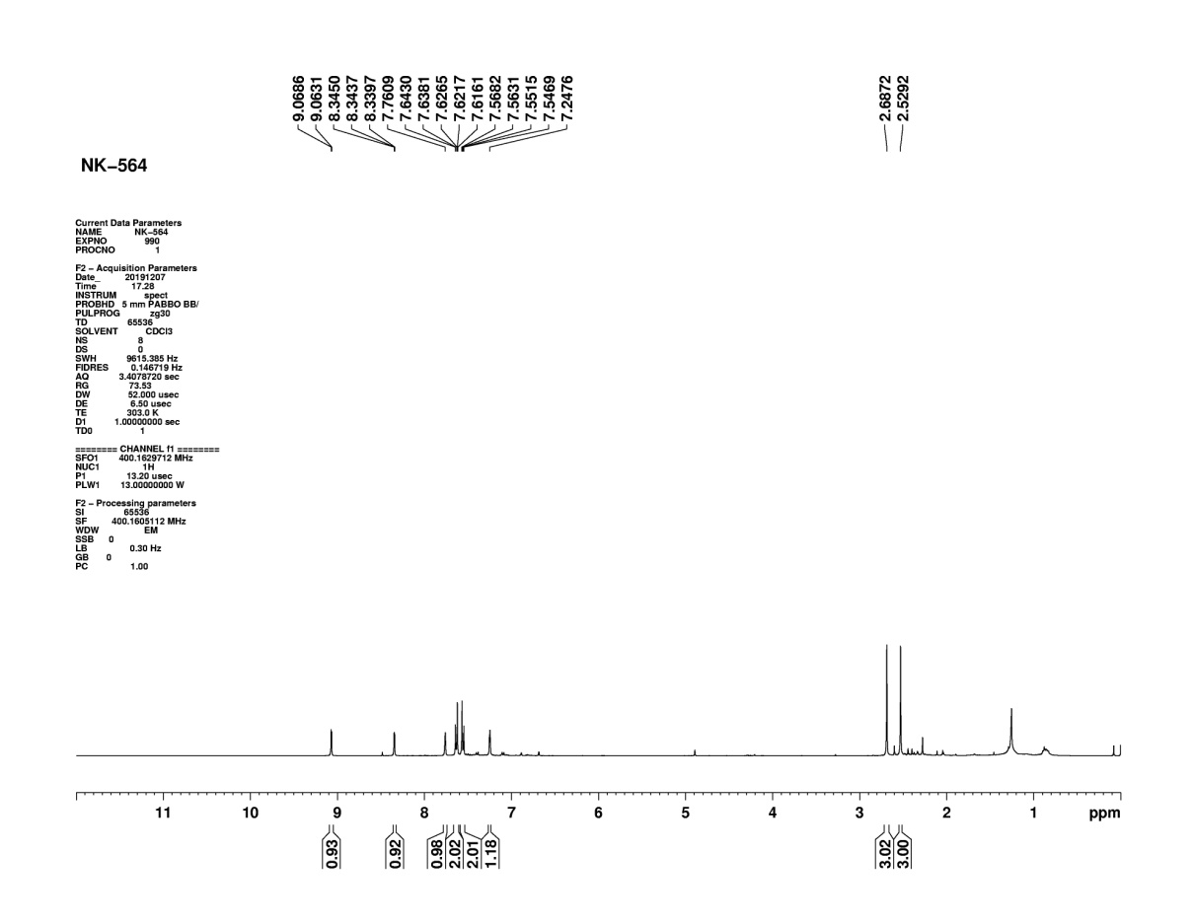
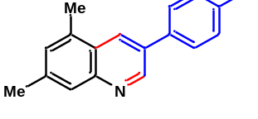
Figure S22: ¹H NMR of compound (3k)
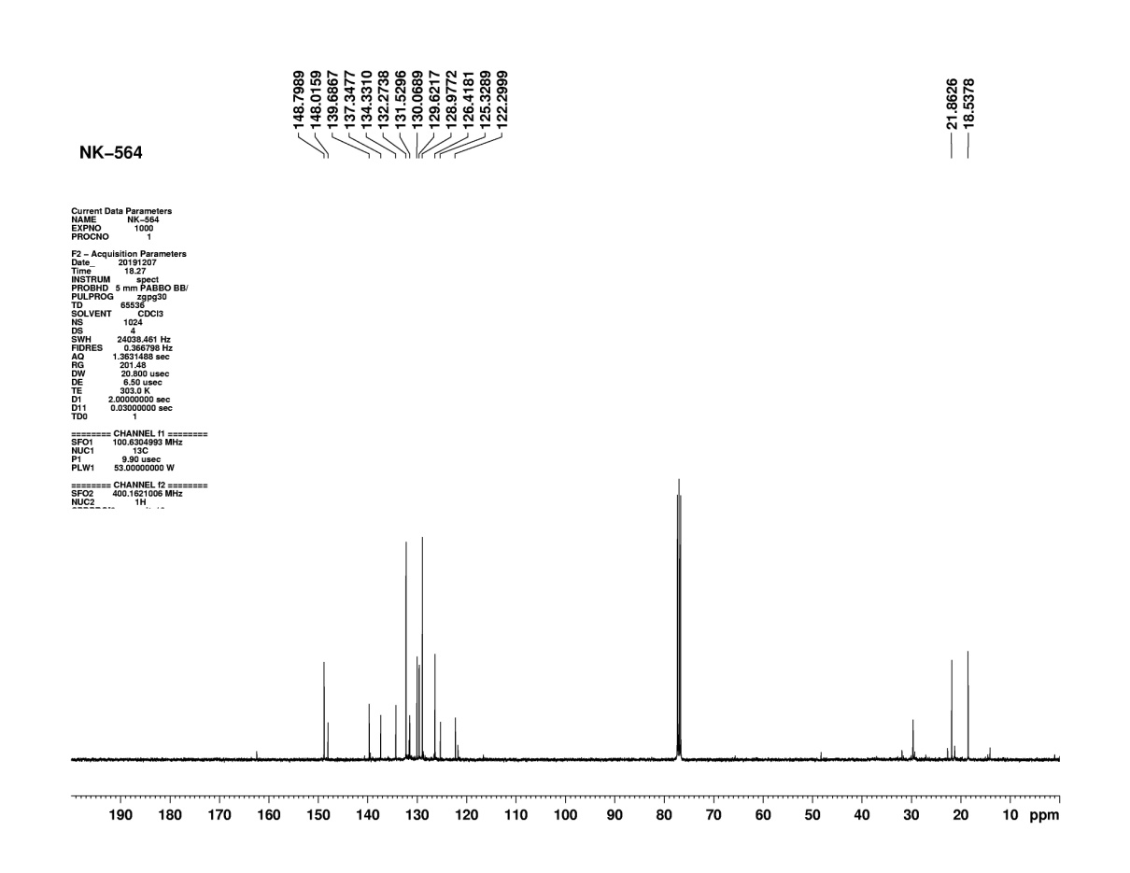

Figure S23: ¹³C NMR of compound (3k)

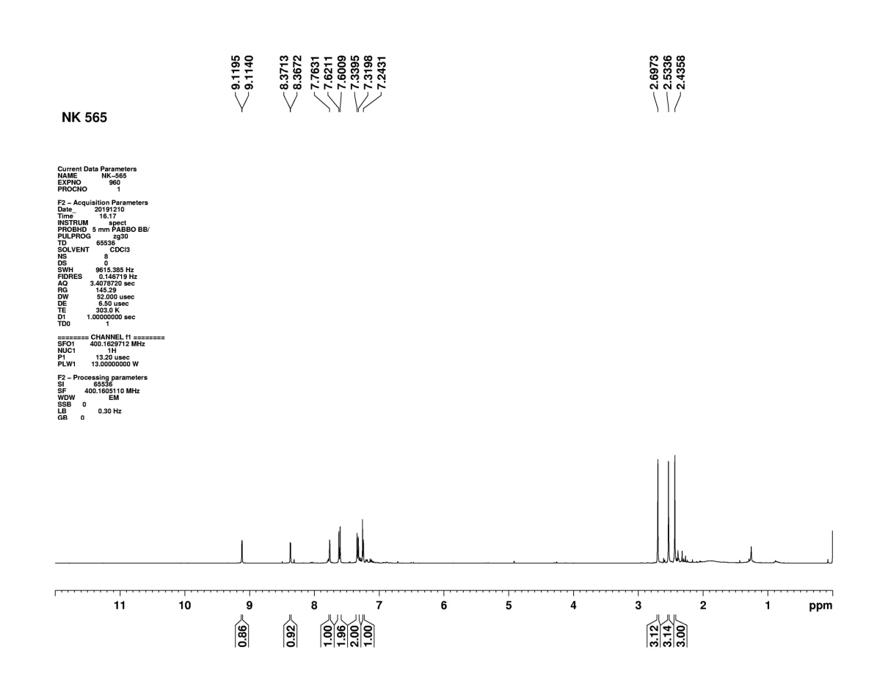
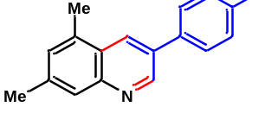 Figure S24: ¹H NMR of compound (3l)

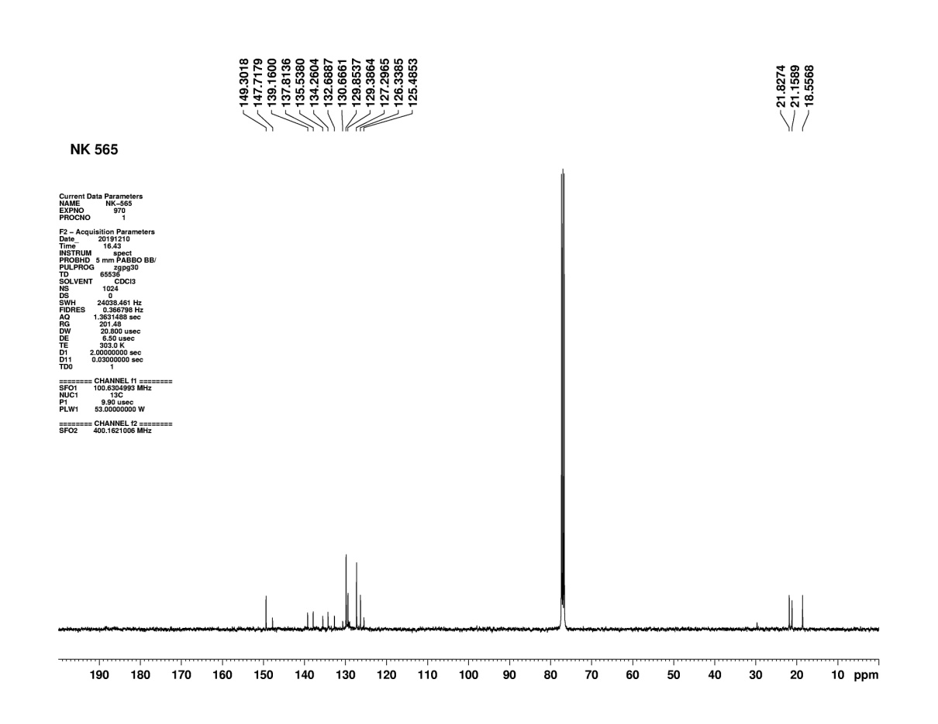

Figure S25: ¹³C NMR of compound (3l)
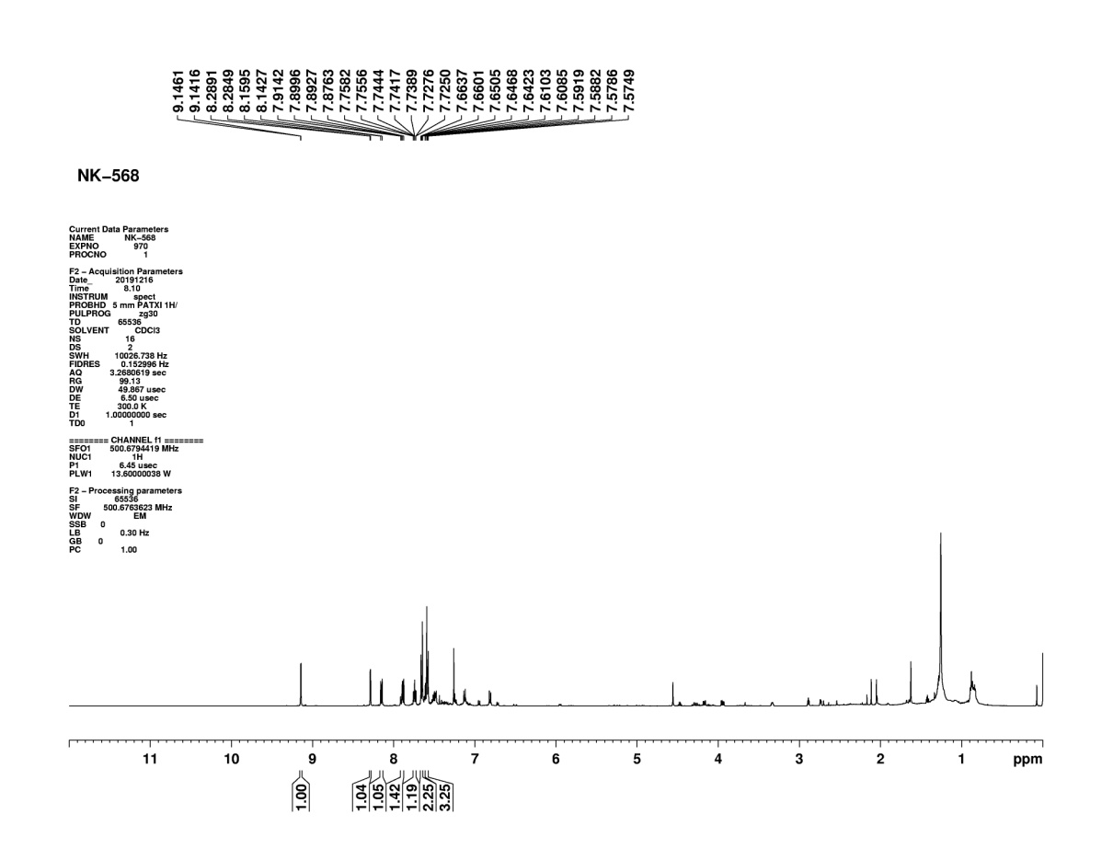
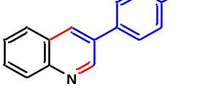
Figure S26: ¹H NMR of compound (3m)
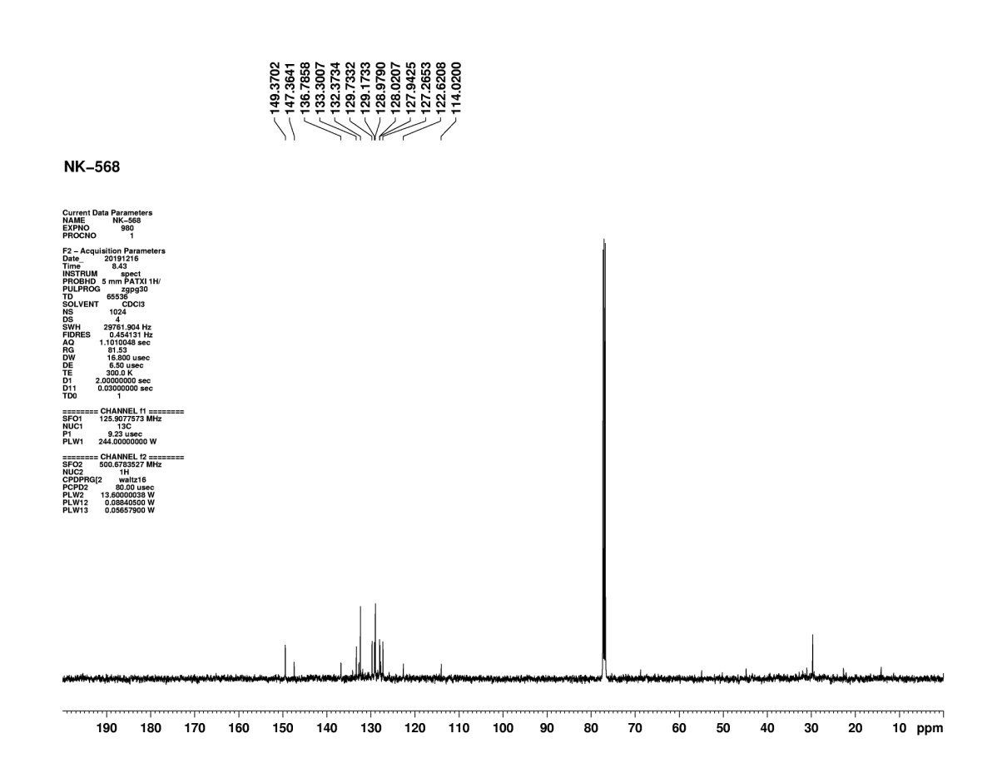
Figure S27: ¹³C NMR of compound (3m)

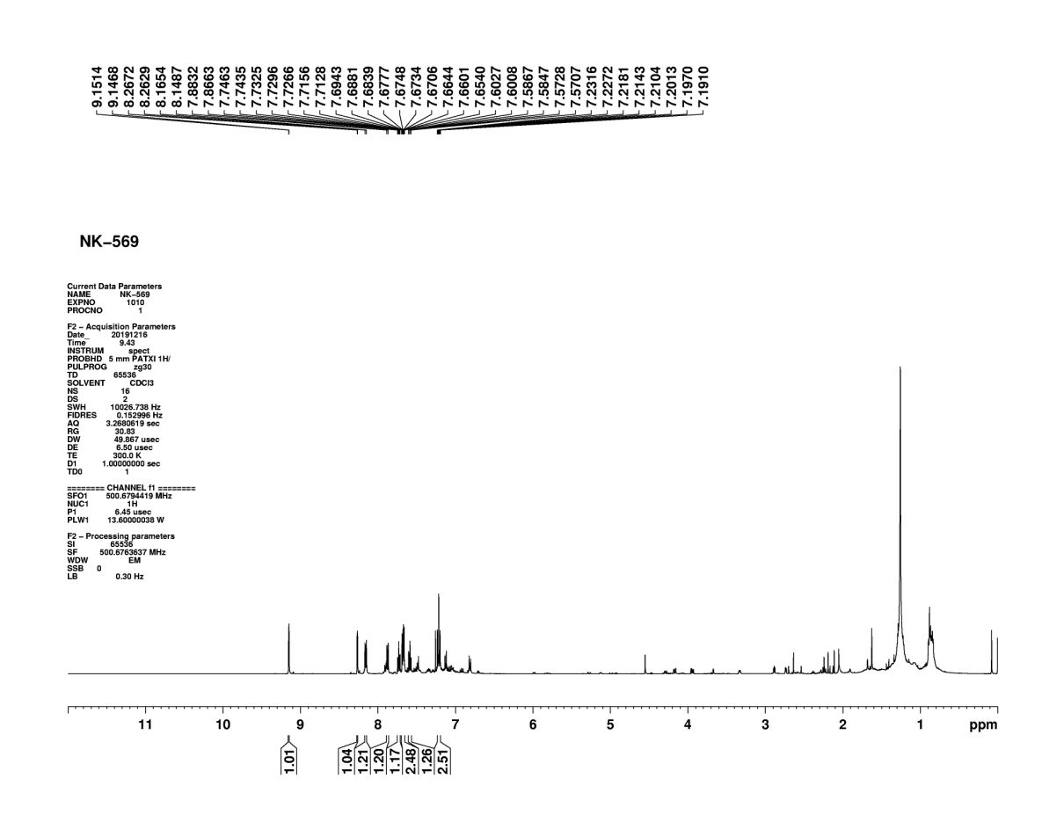

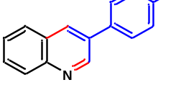

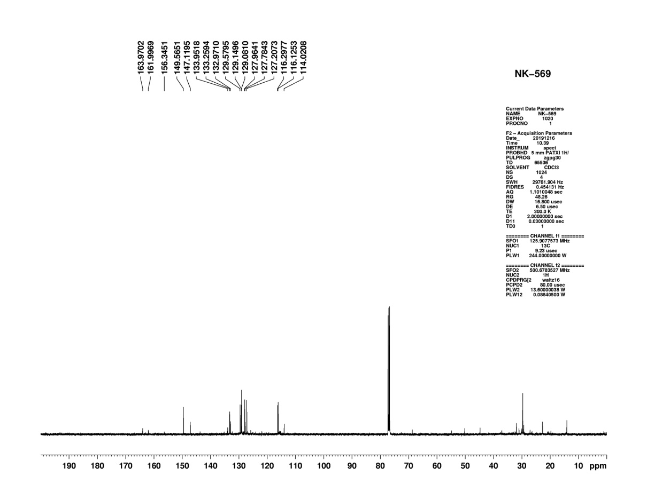
Figure S28: ¹H NMR of compound (3n)

Figure S29: ¹³C NMR of compound (3n)

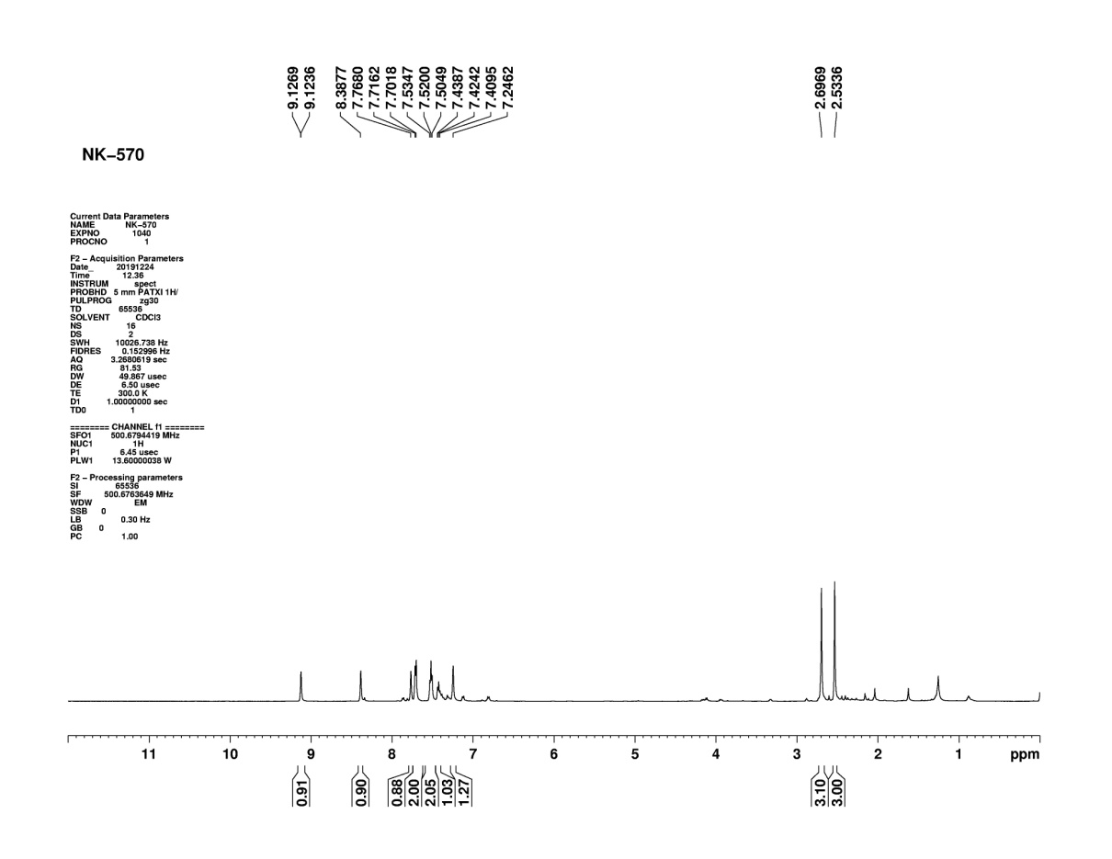
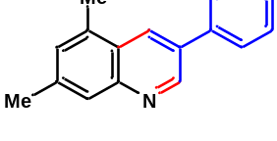
Figure S30: ¹H NMR of compound (3o)
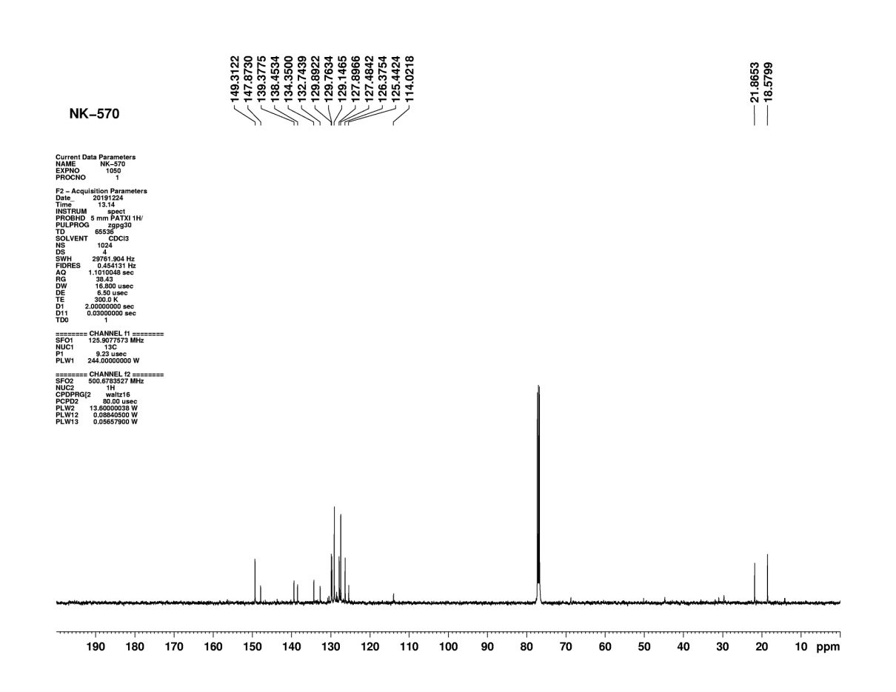
Figure S31: ¹³C NMR of compound (3o)

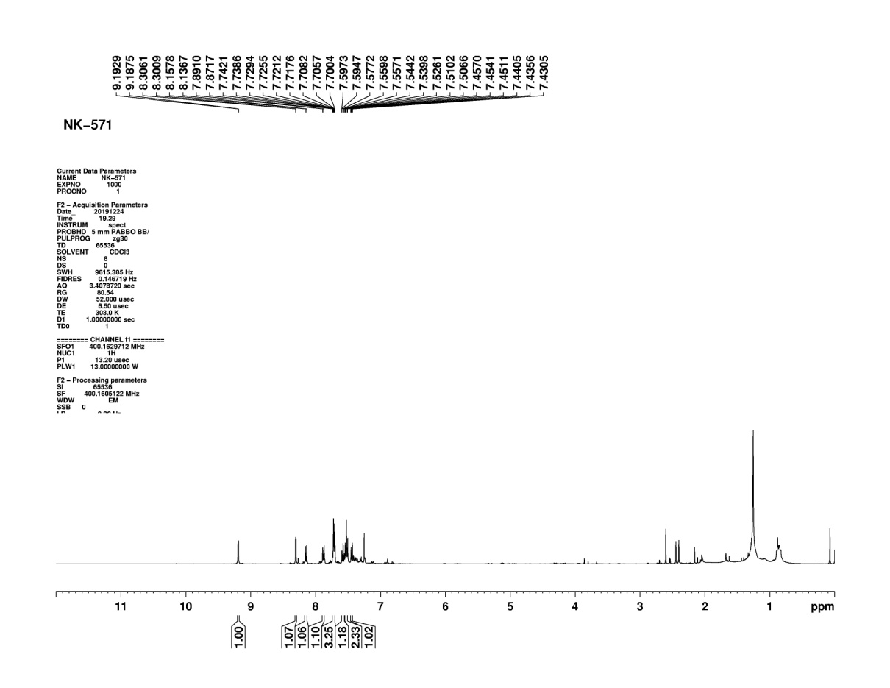
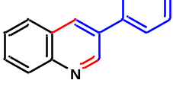
Figure S32: ¹H NMR of compound (3p)
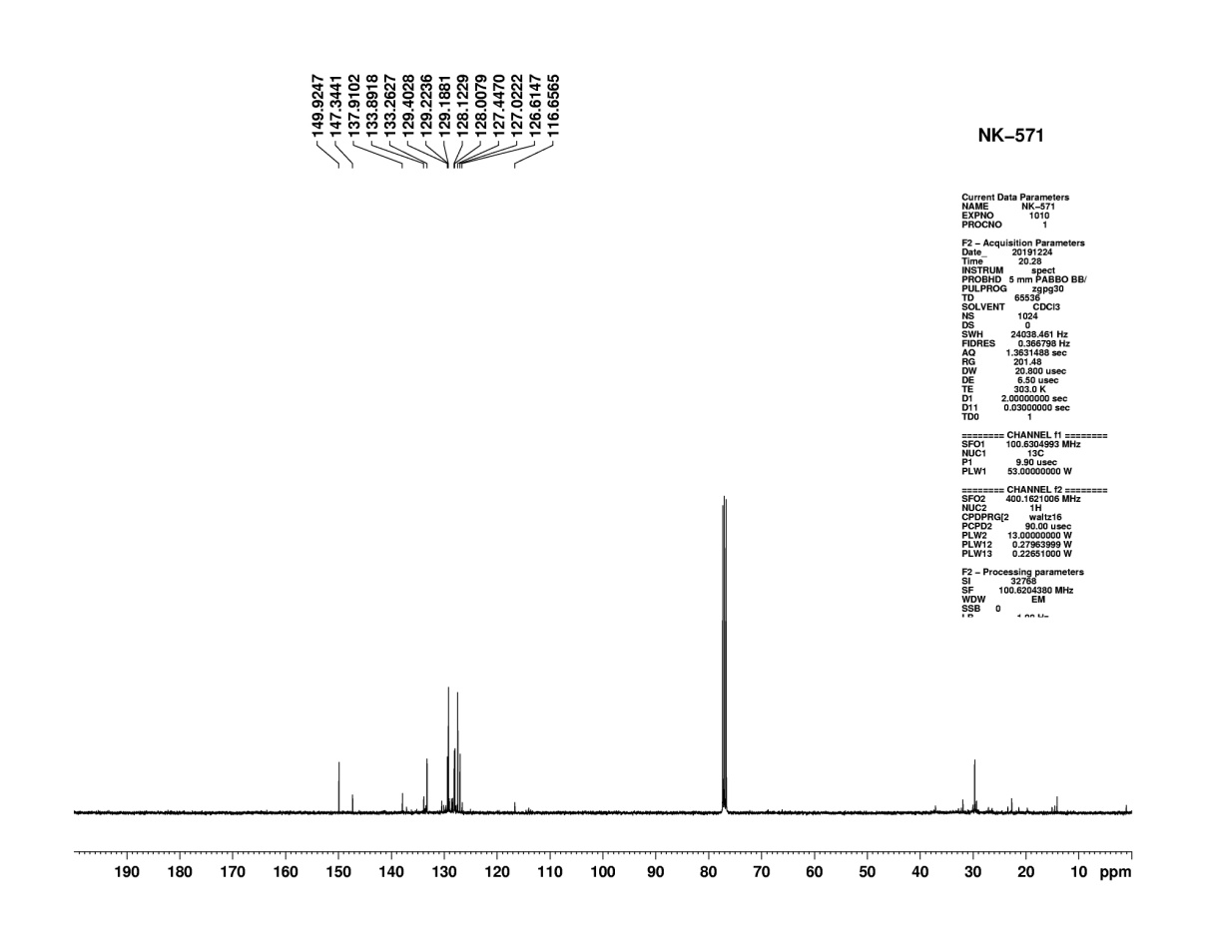
Figure S33: ¹³C NMR of compound (3p)
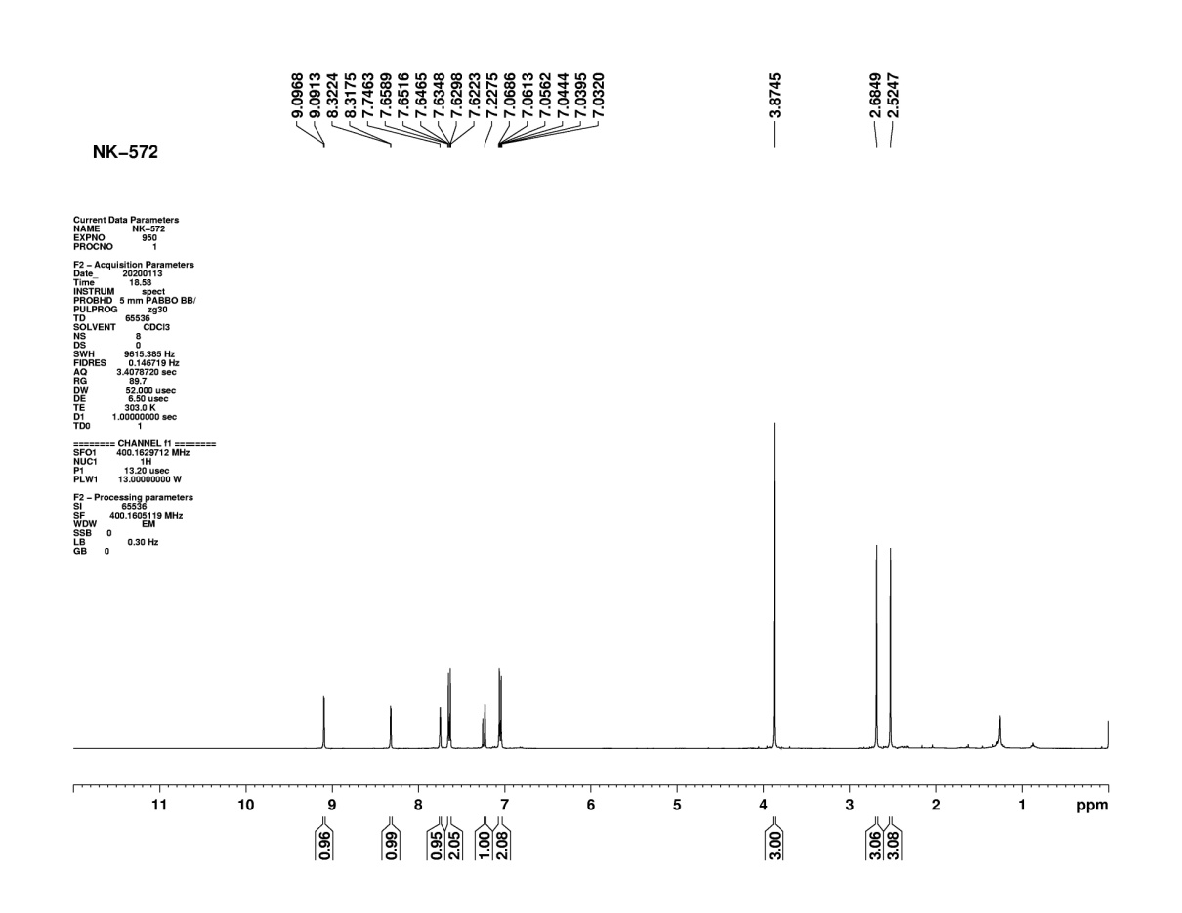

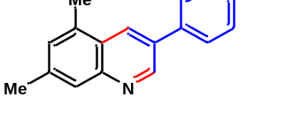

Figure S34: ¹H NMR of compound (3q)
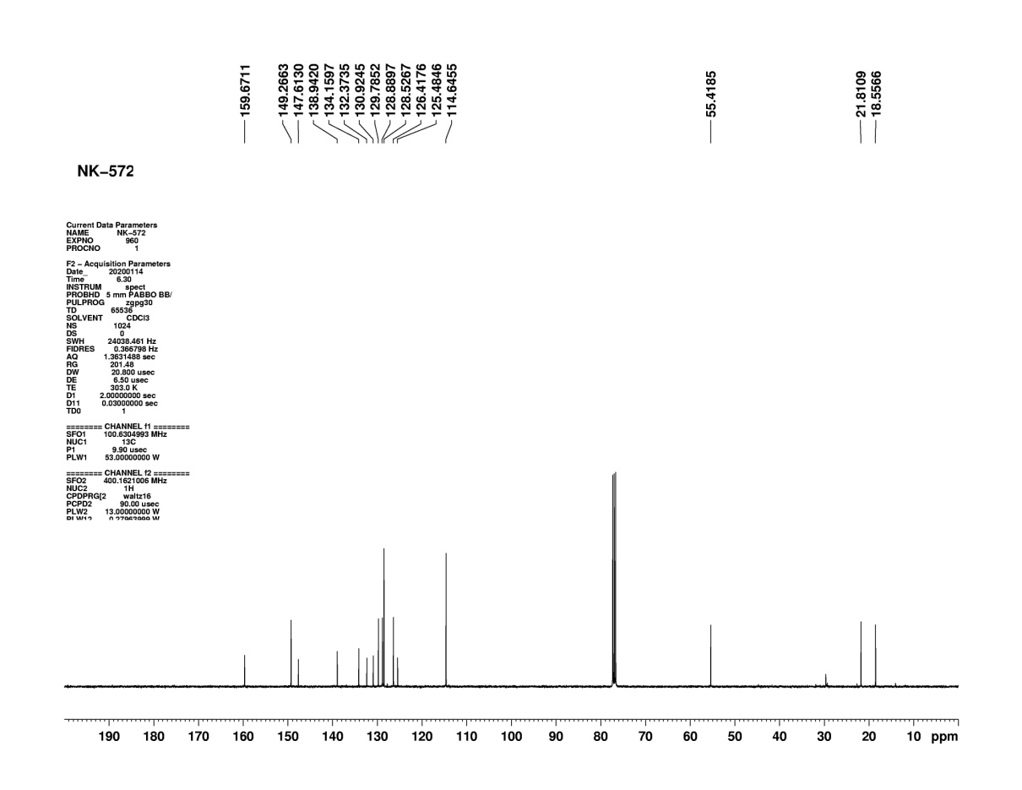
Figure S35: ¹³C NMR of compound (3q)

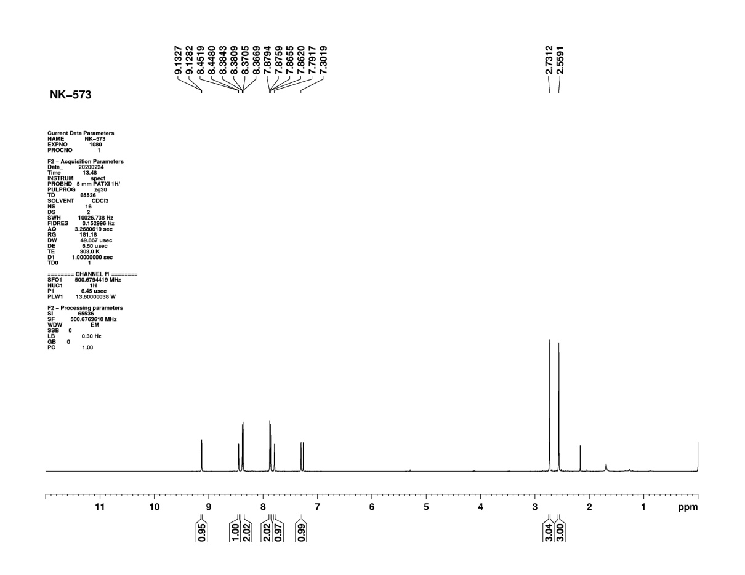
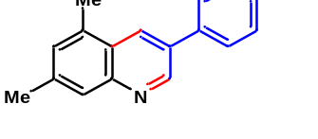
Figure S36: ¹H NMR of compound (3r)
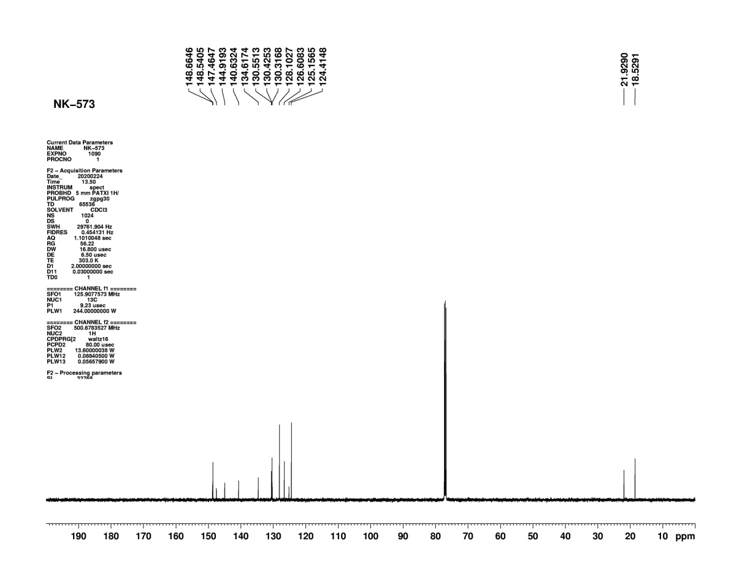
Figure S37: ¹³C NMR of compound (3r)

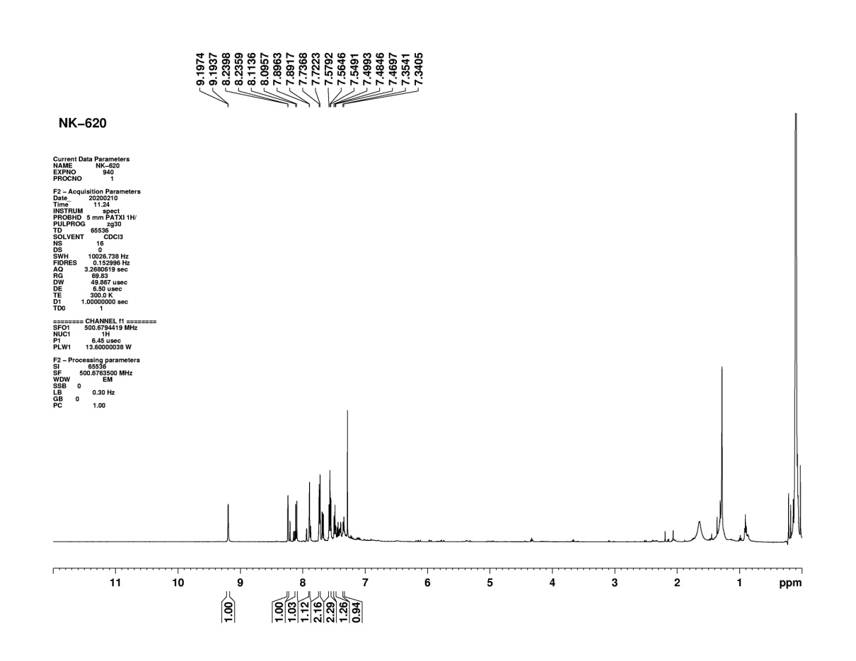
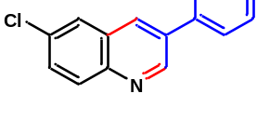
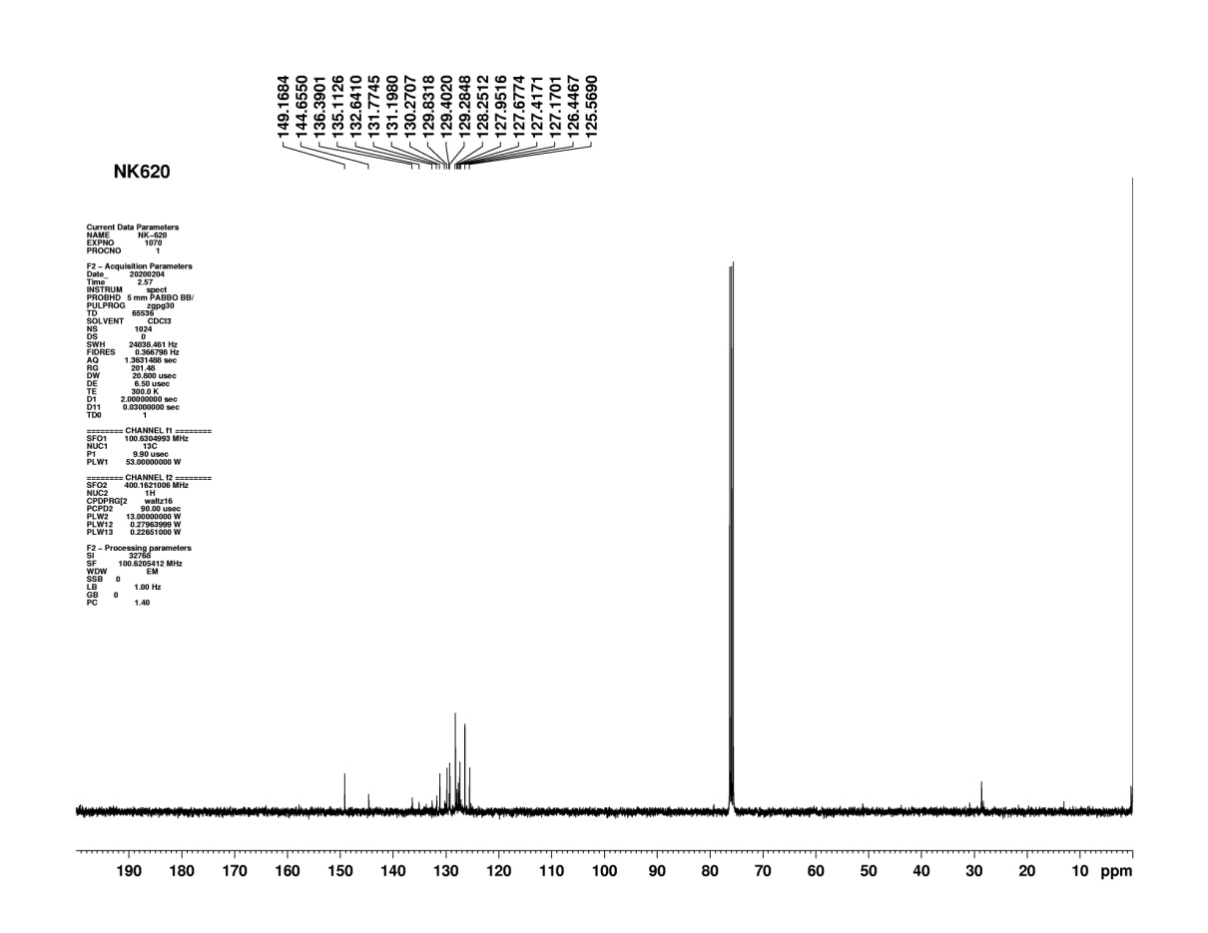
Figure S38: ¹H NMR of compound (3s)

Figure S39: ¹³C NMR of compound (3s)

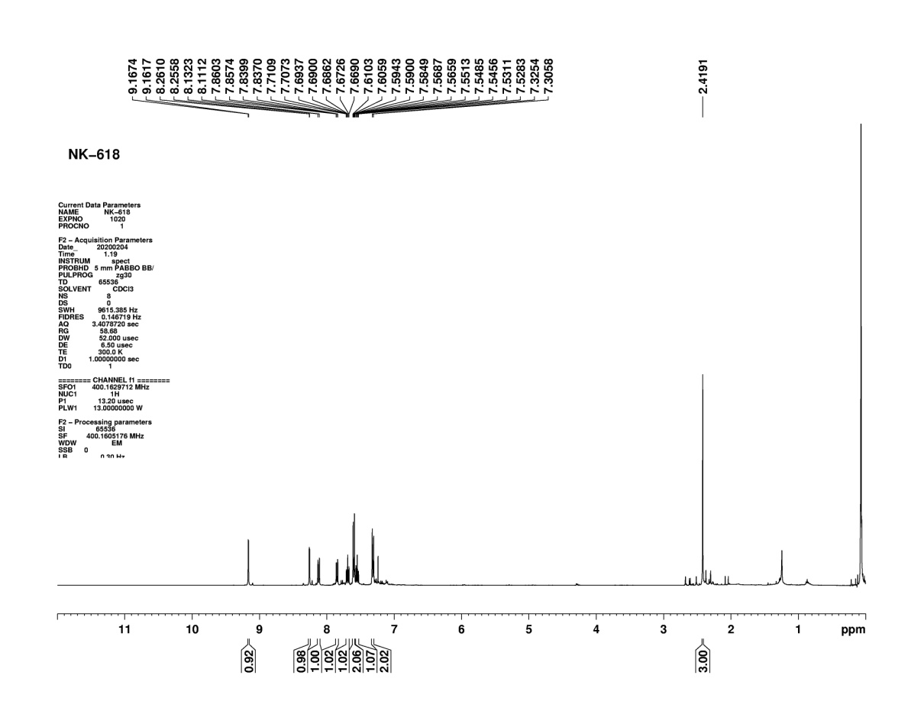
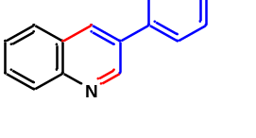
Figure S40: ¹H NMR of compound (3t)
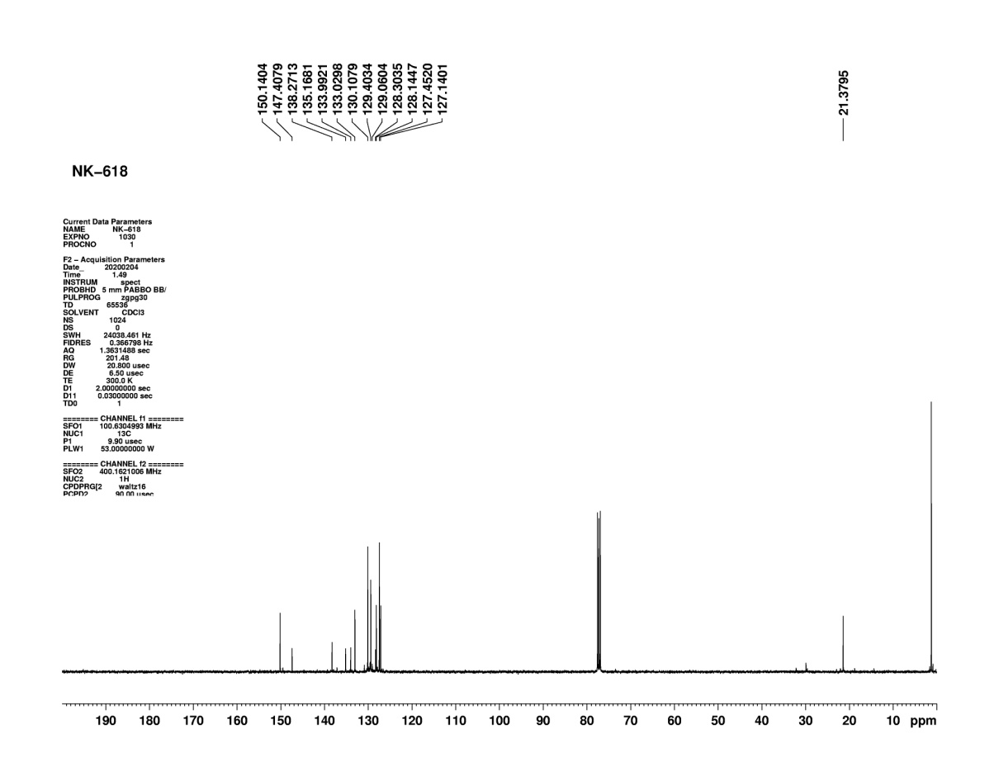
Figure S41: ¹³C NMR of compound (3t)

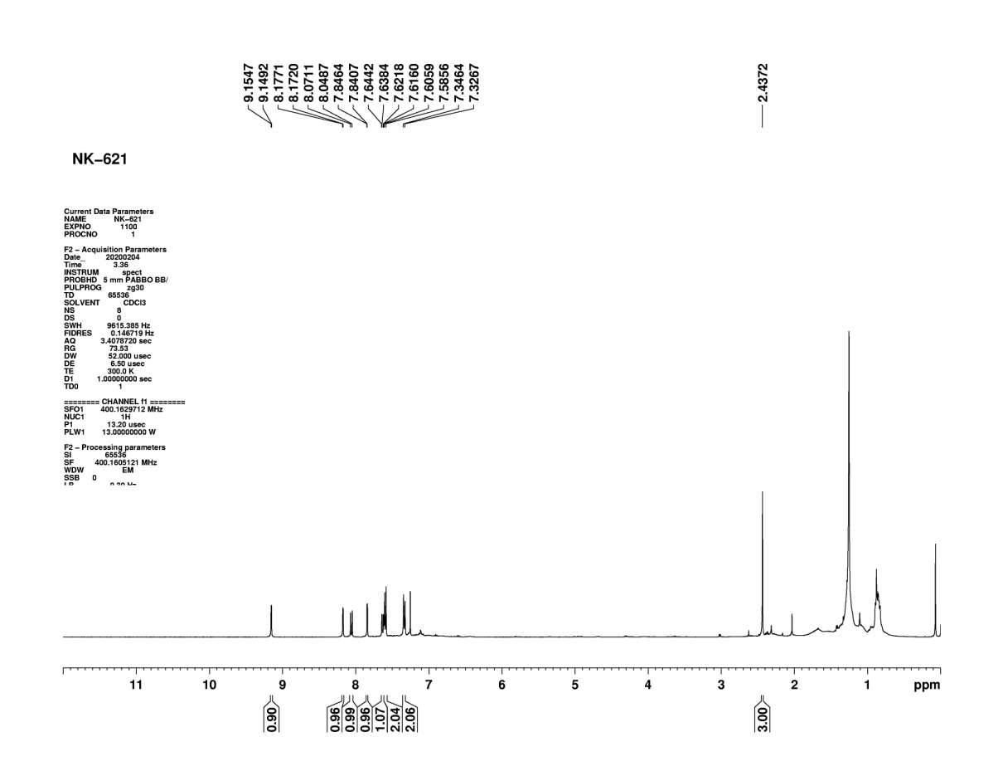
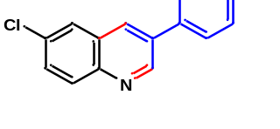
Figure S42: ¹H NMR of compound (3u)
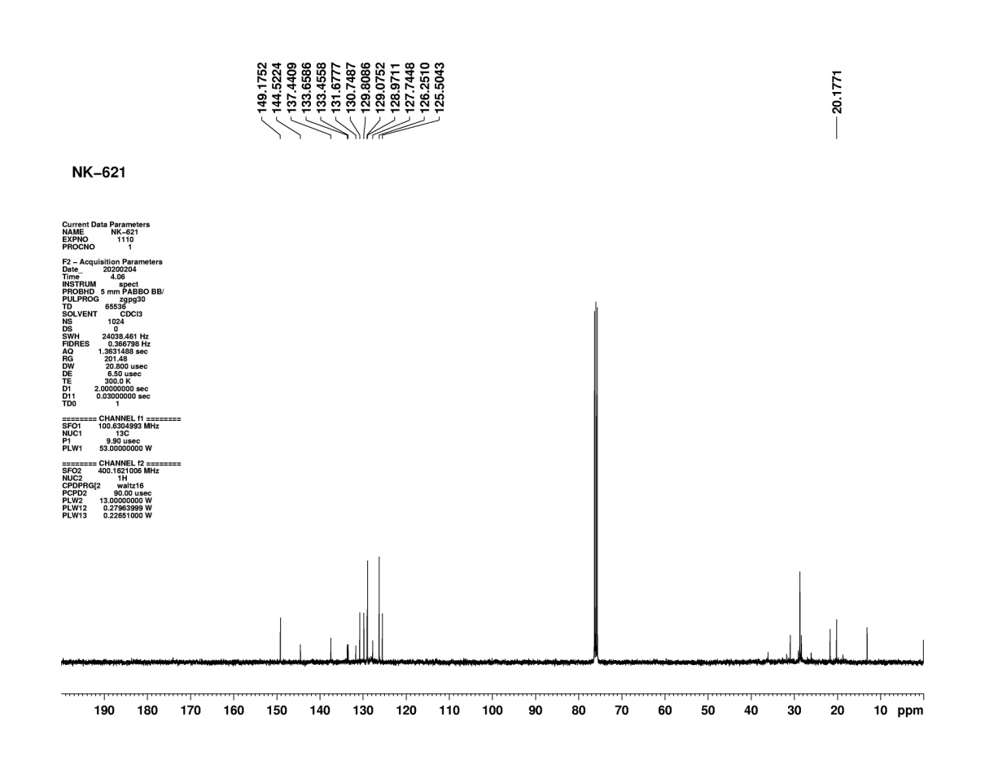
Figure S43: ¹³C NMR of compound (3u)

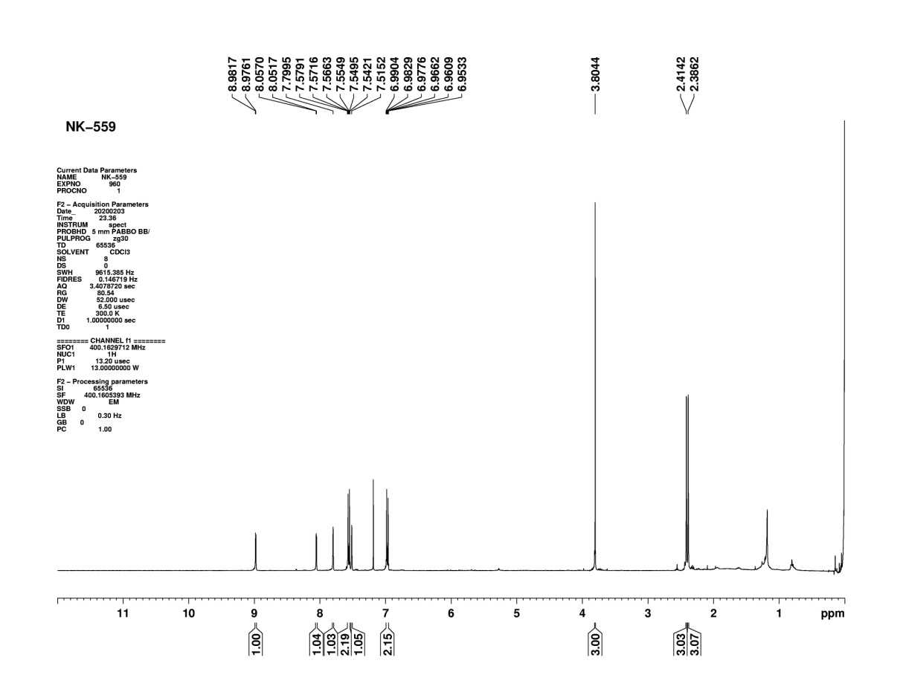
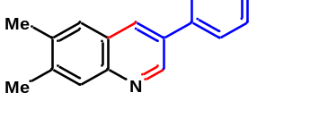
Figure S44: ¹H NMR of compound (3v)
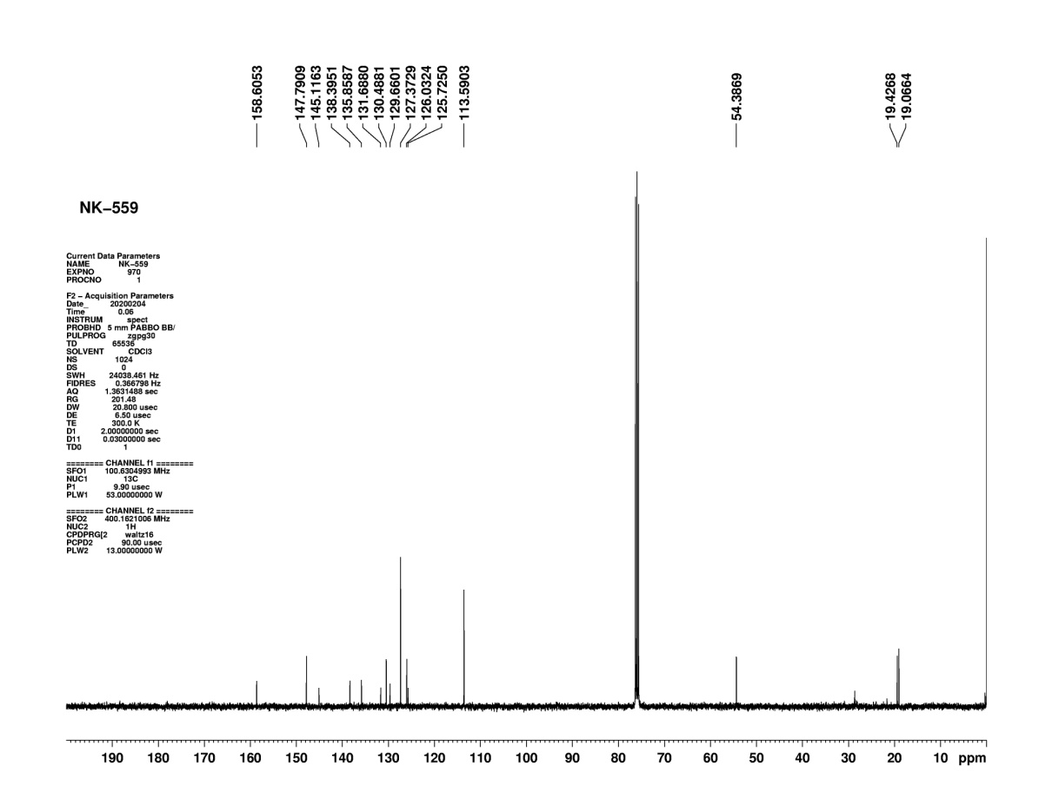
Figure S45: ¹³C NMR of compound (3v)

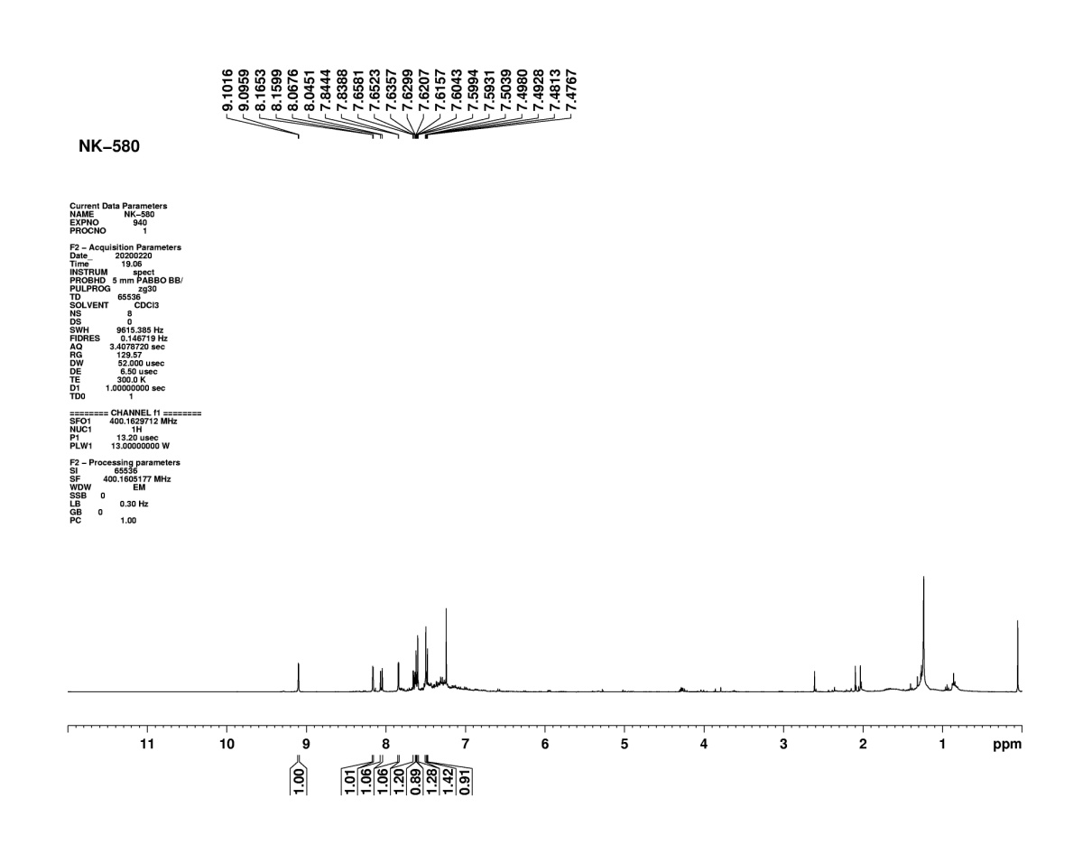
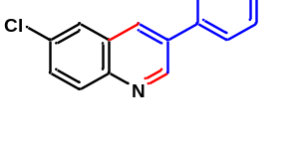
Figure S46: ¹H NMR of compound (3w)
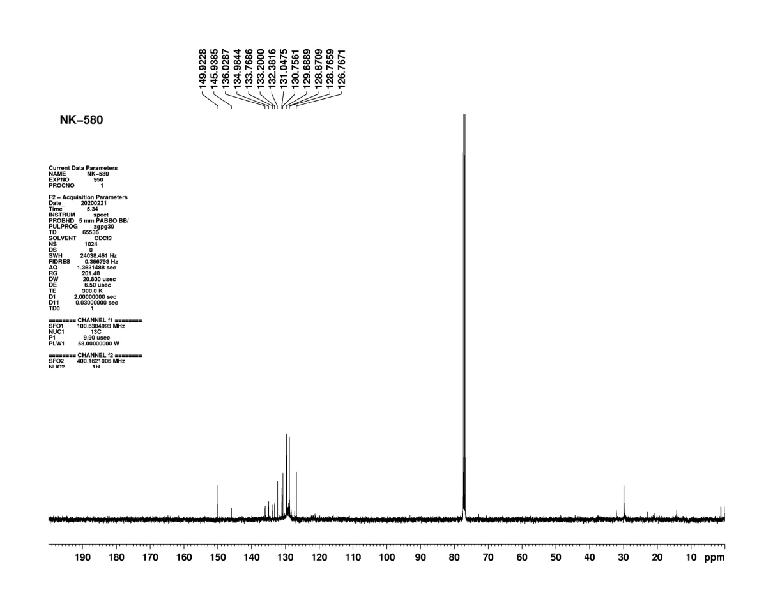
Figure S47: ¹³C NMR of compound (3w)

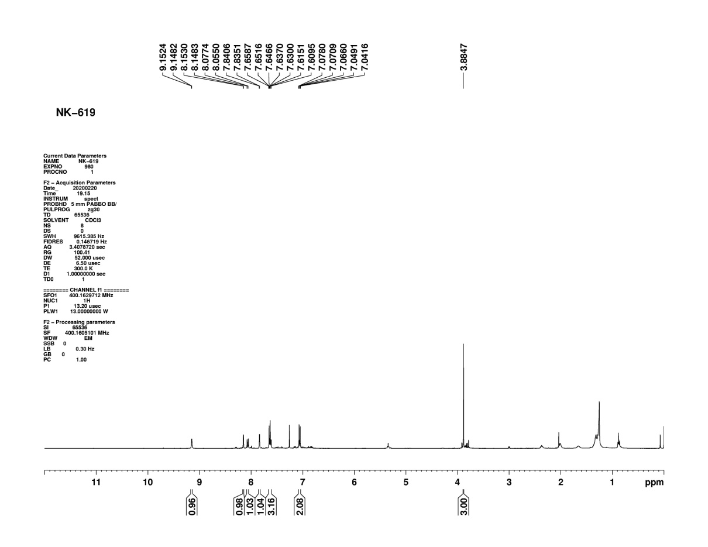
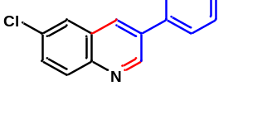
Figure S48: ¹H NMR of compound (3x)
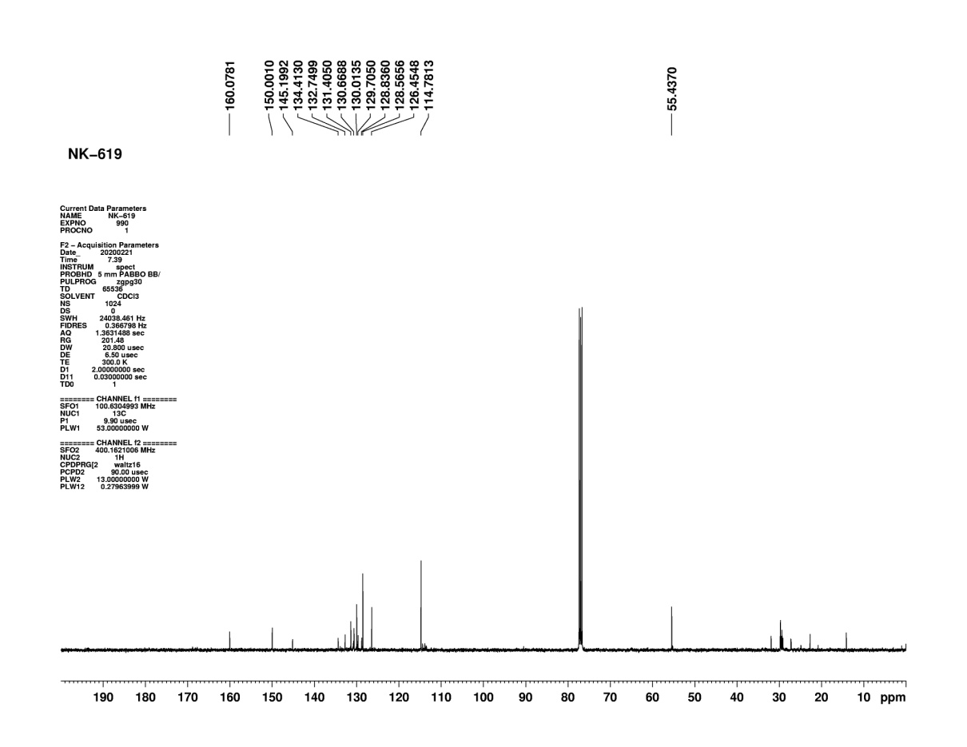
Figure S49: ¹³C NMR of compound (3x)

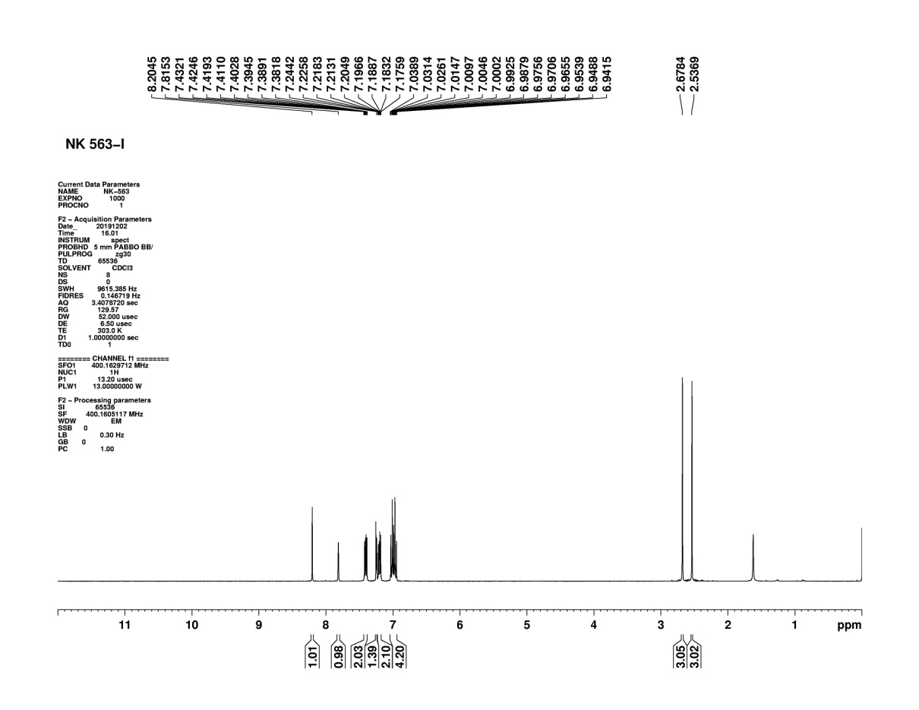
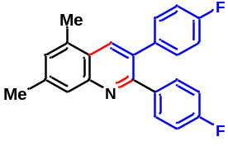
Figure S50: ¹H NMR of compound (4a)
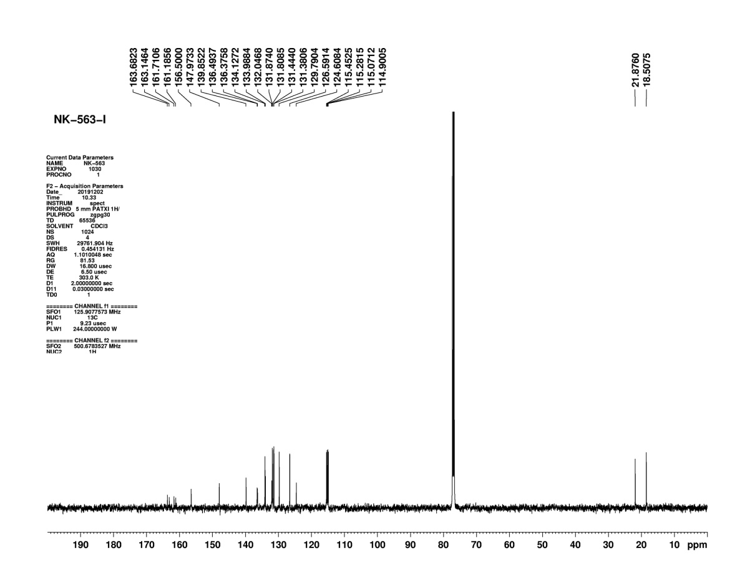
Figure S51: ¹³C NMR of compound (4a)

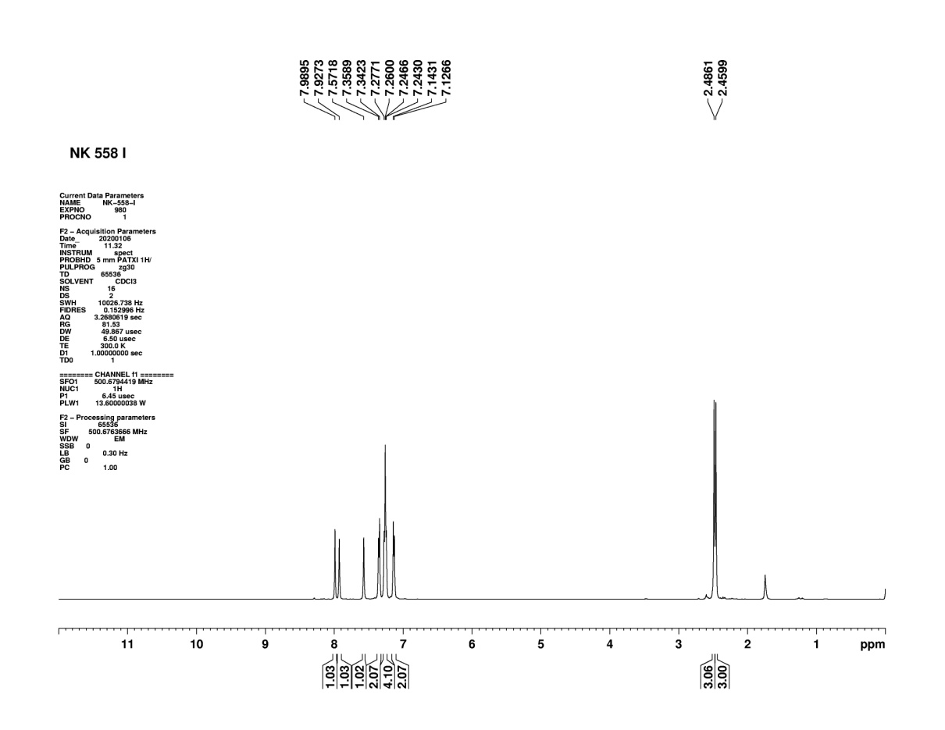
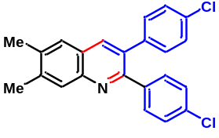
Figure S52: ¹H NMR of compound (4b)
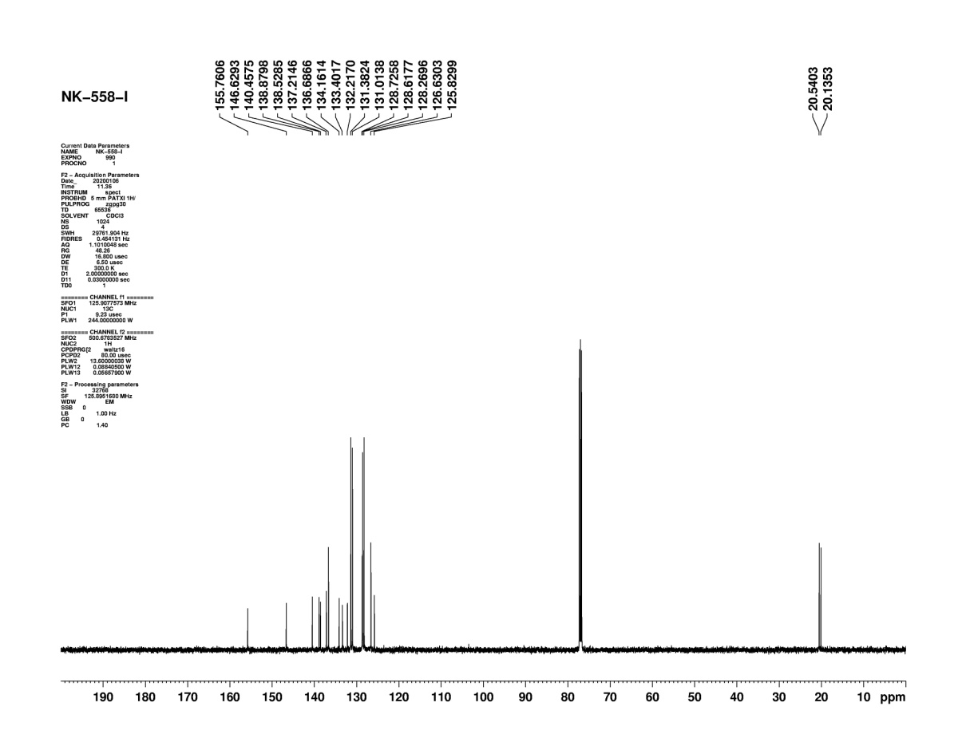
Figure S53: ¹³C NMR of compound (4b)

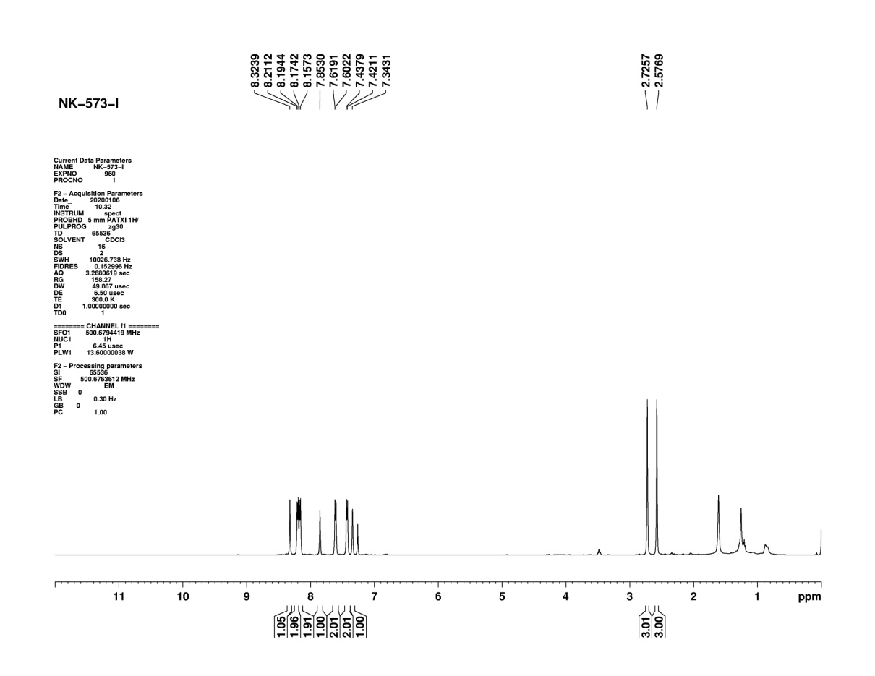
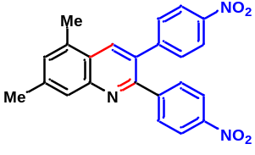
Figure S54: ¹H NMR of compound (4c)
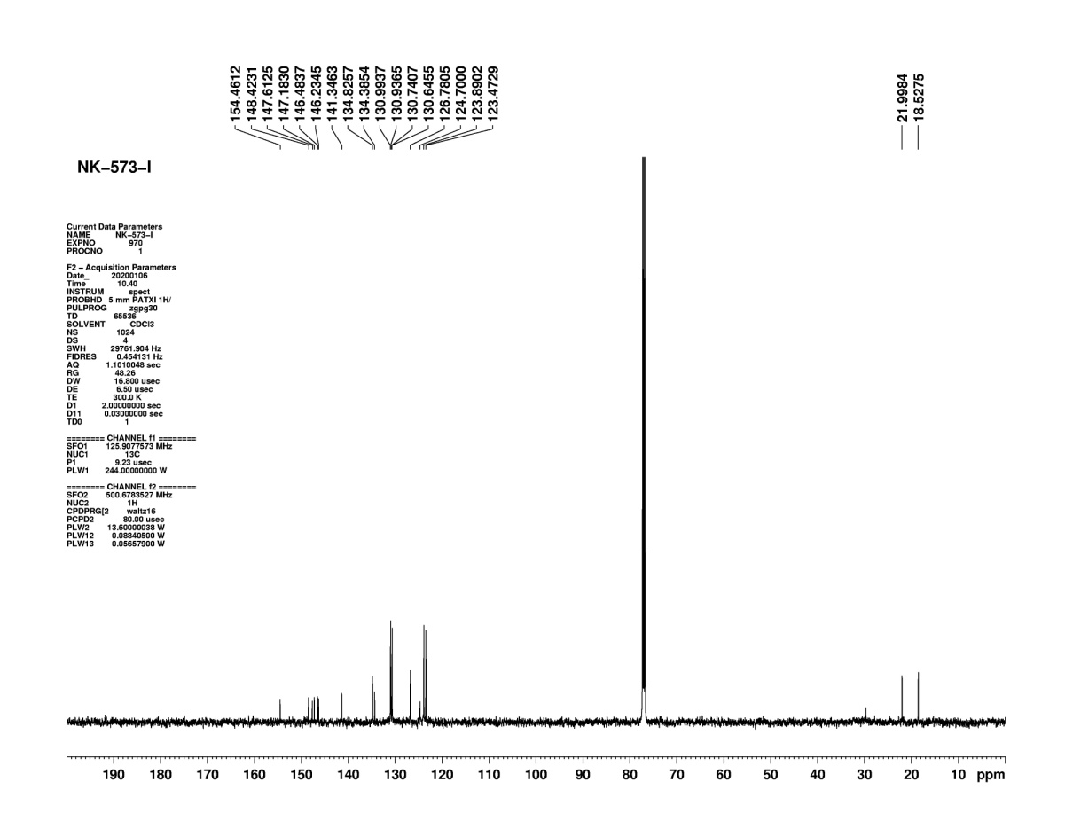
Figure S55: ¹³C NMR of compound (4c)

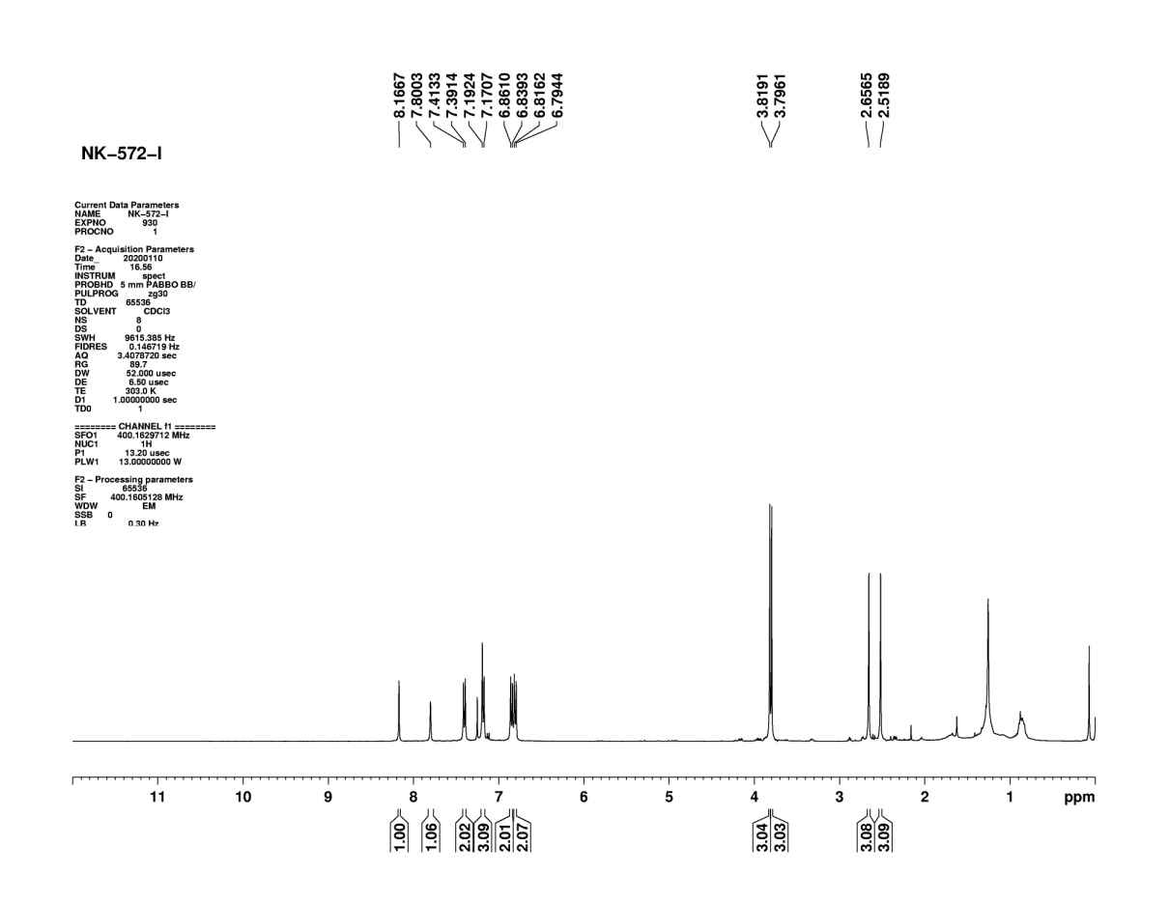
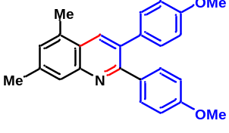 Figure S56: ¹H NMR of compound (4d)
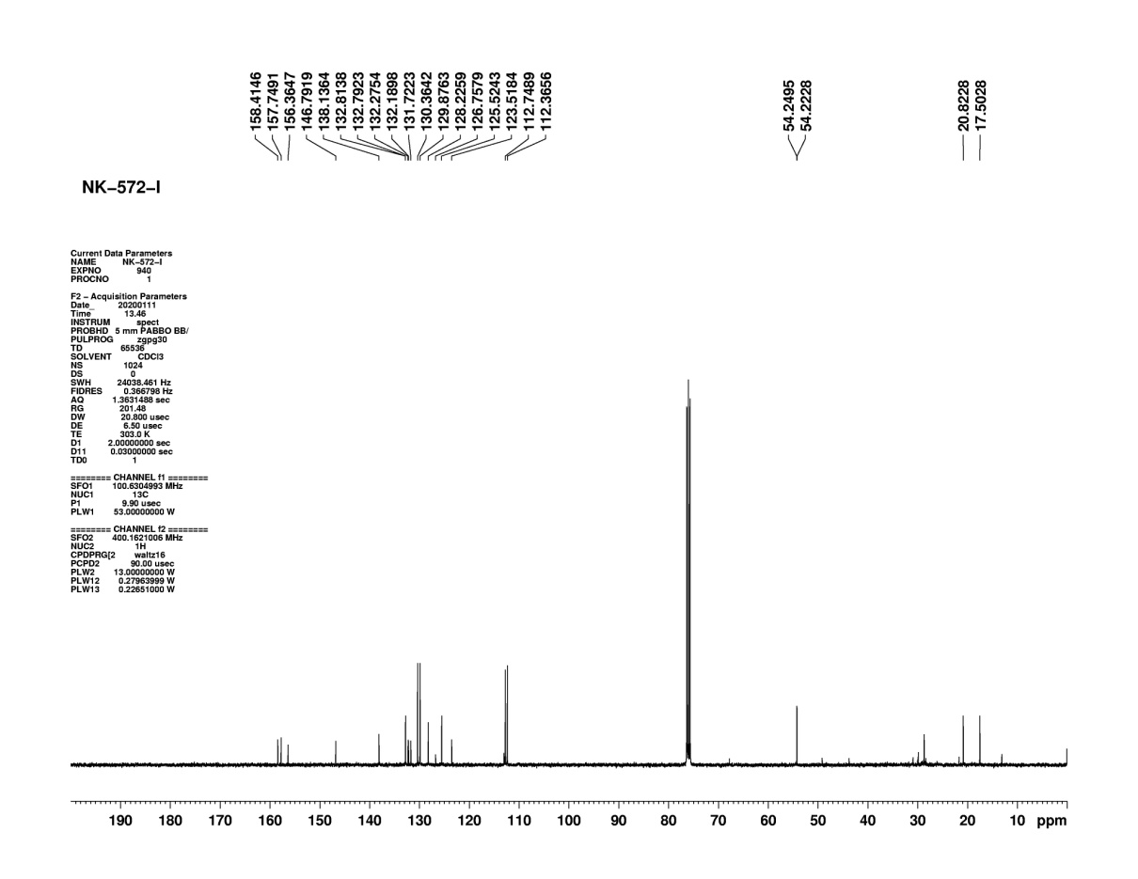
Figure S57: ¹³C NMR of compound (4d)

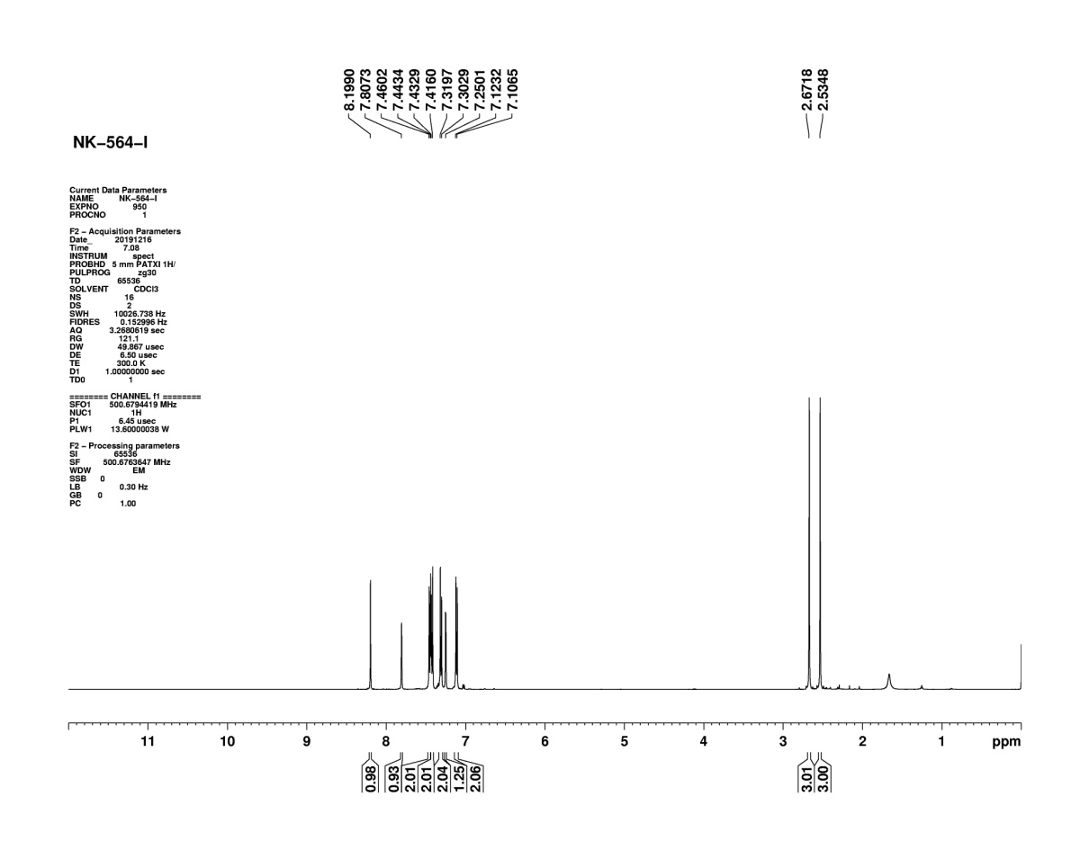
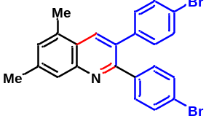
Figure S58: ¹H NMR of compound (4e)
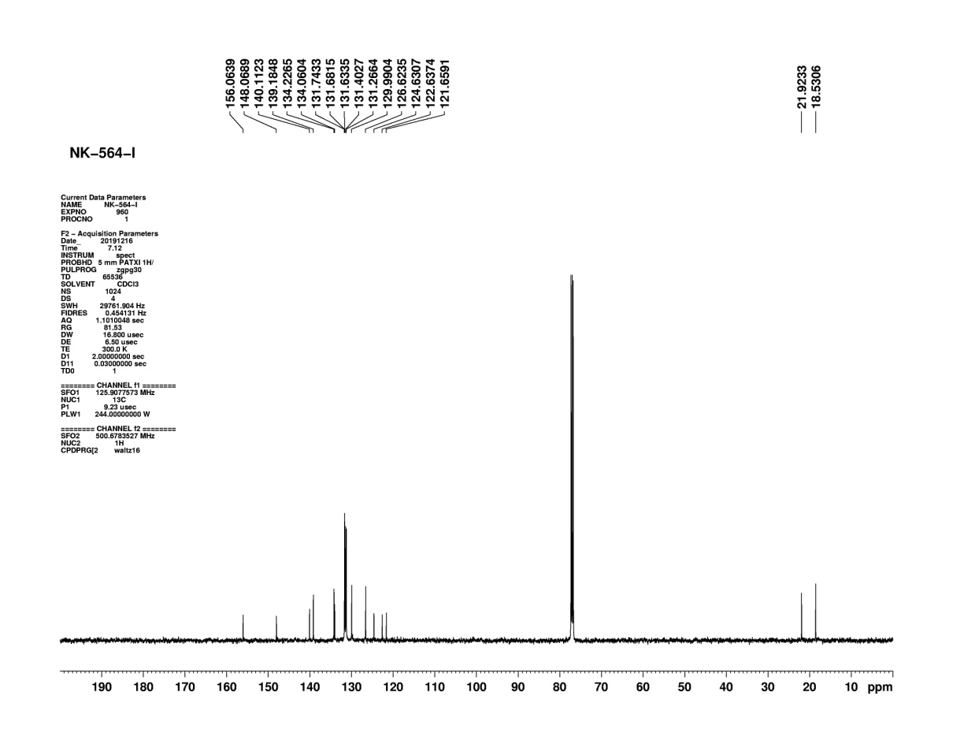
Figure S59: ¹³C NMR of compound (4e)

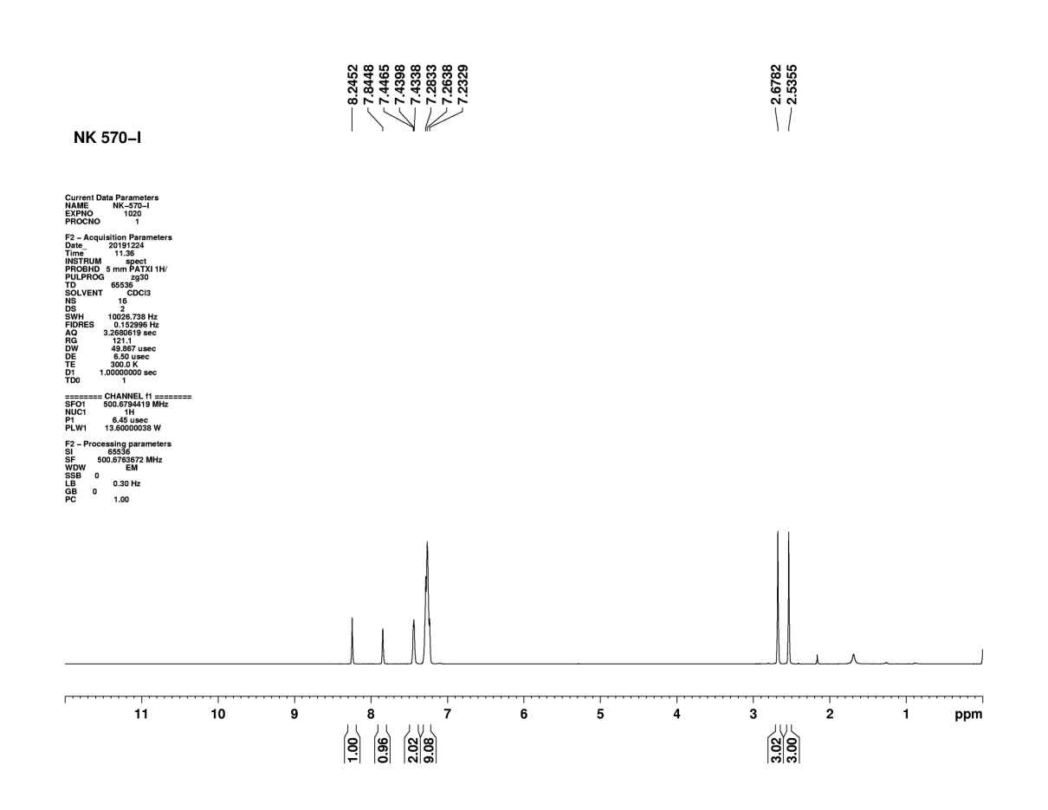
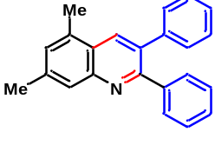 Figure S60: ¹H NMR of compound (4f)

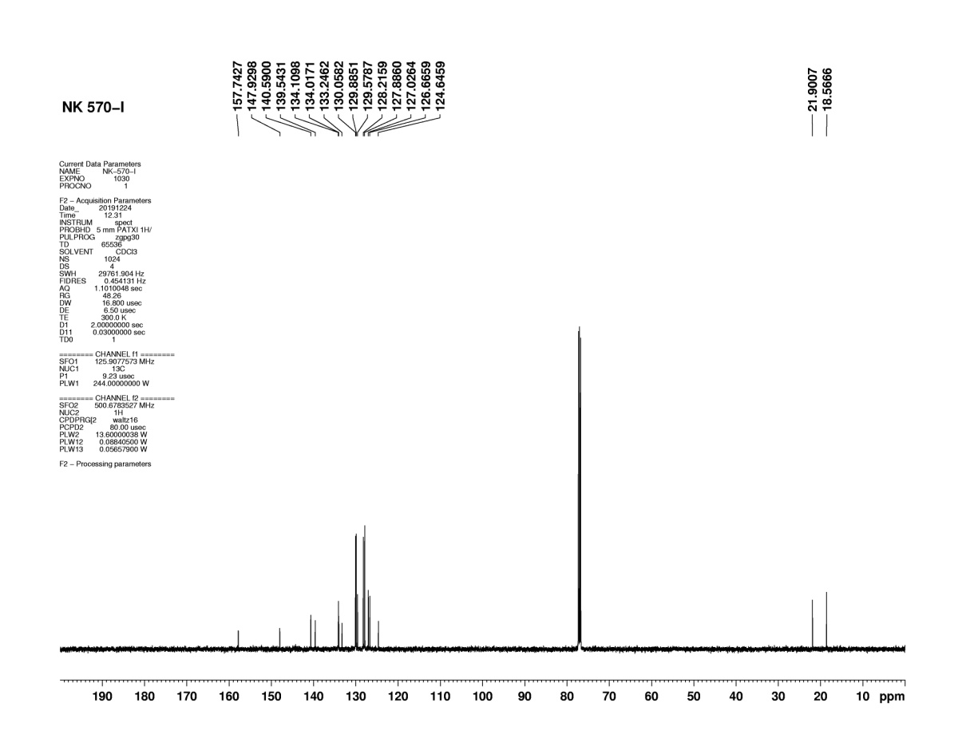
Figure S61: ¹³C NMR of compound (4f)
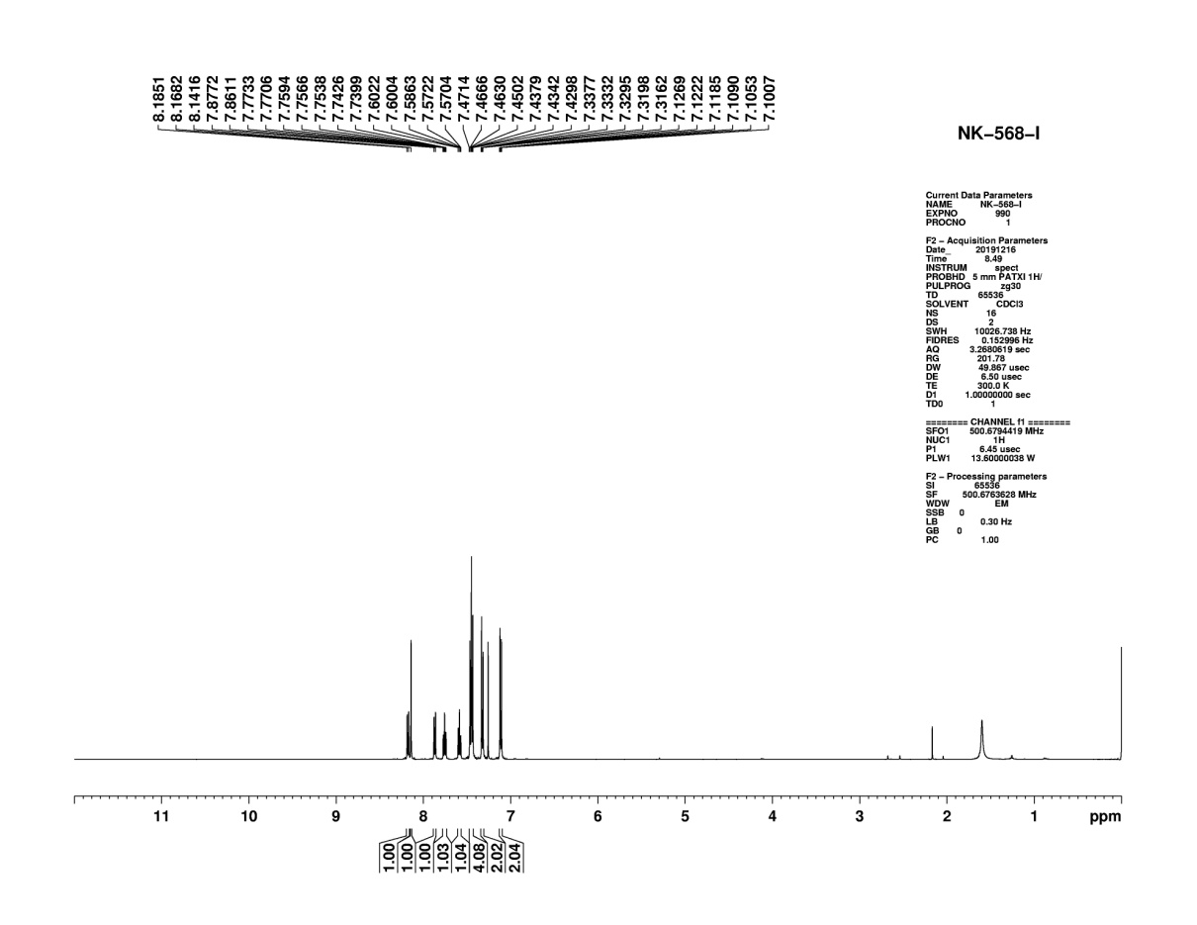
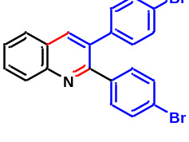Figure S62: ¹H NMR of compound (4g)
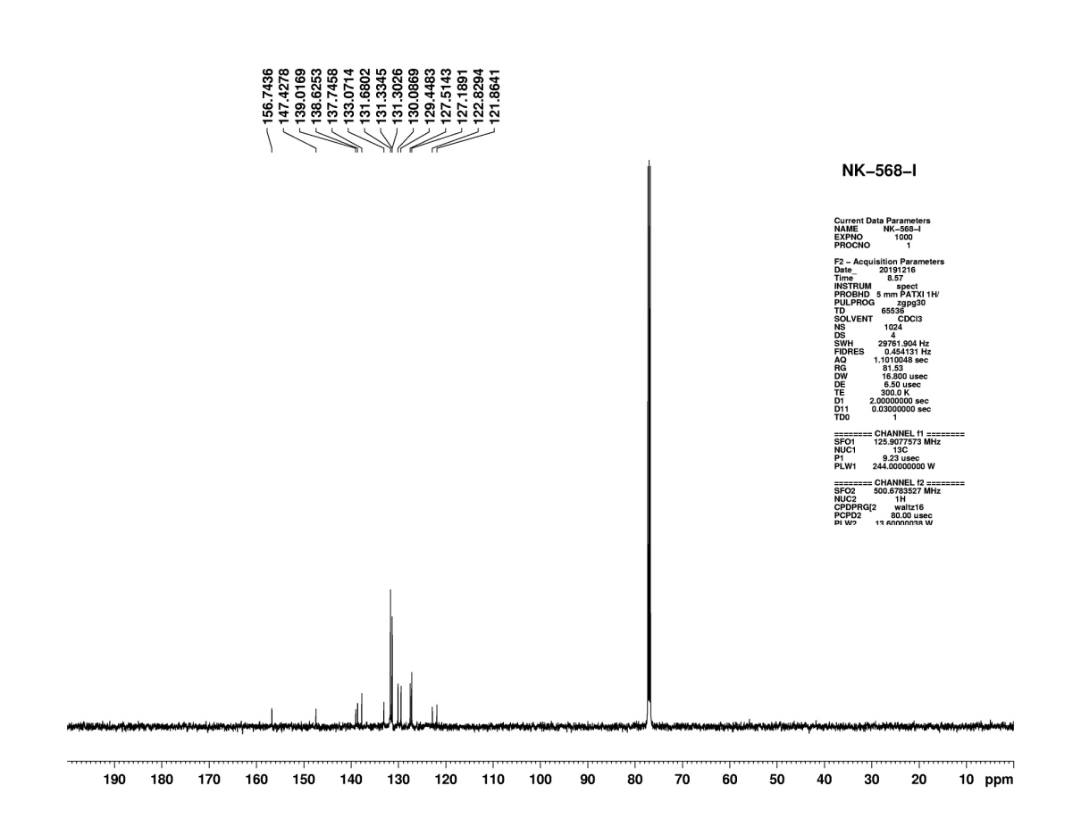
Figure S63: ¹³C NMR of compound (4g)

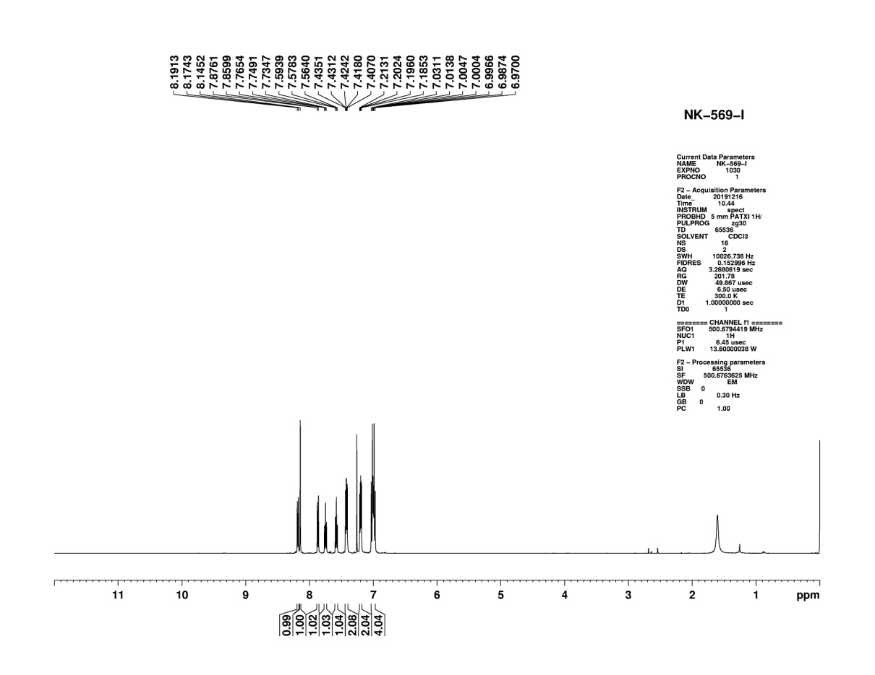
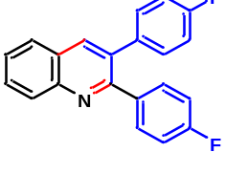
Figure S64: ¹H NMR of compound (4h)
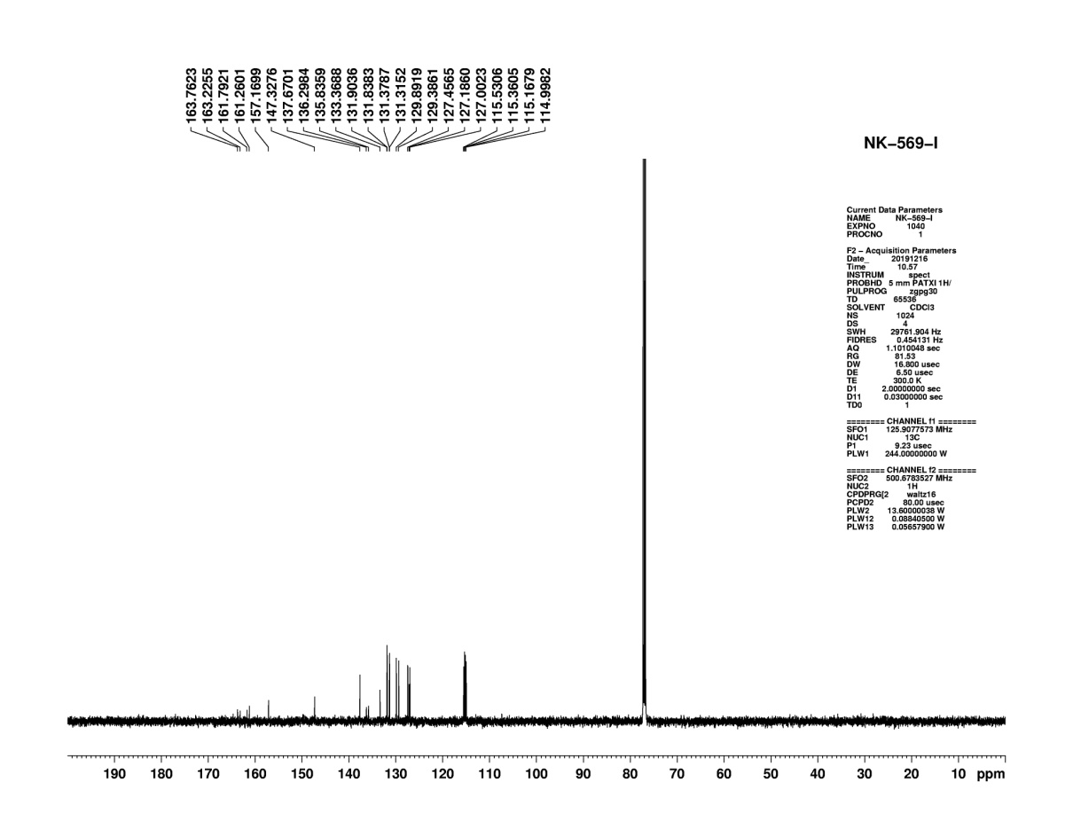
Figure S65: ¹³C NMR of compound (4h)

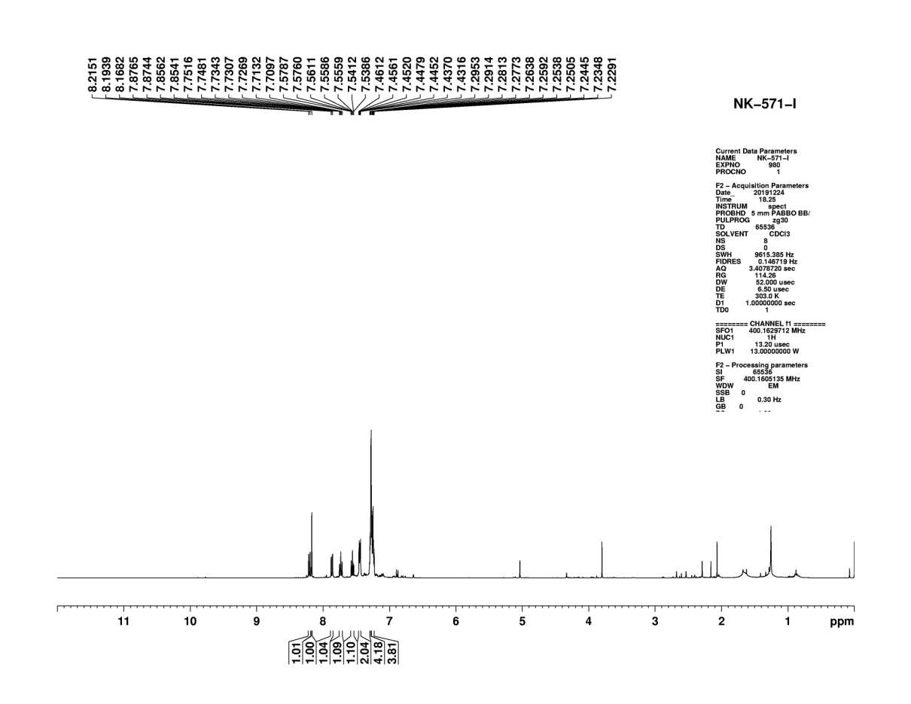
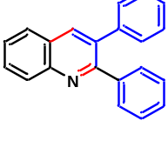
Figure S66: ¹H NMR of compound (4i)
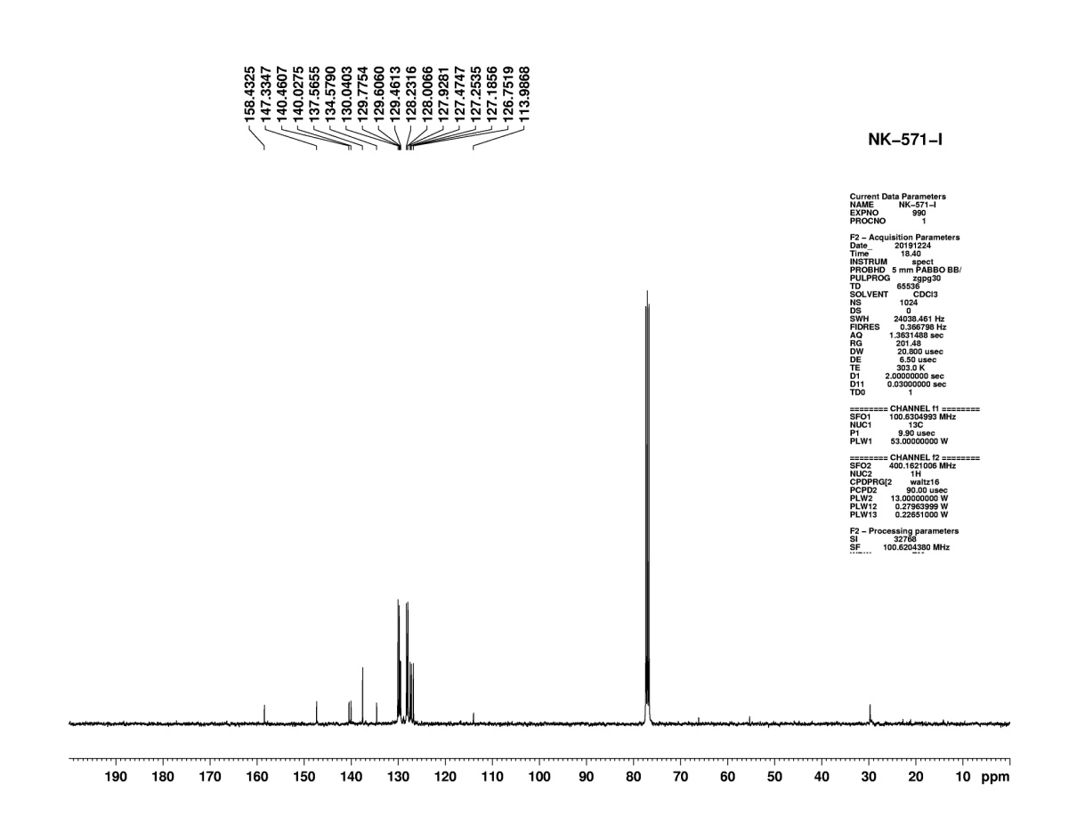
Figure S67: ¹³C NMR of compound (4i)

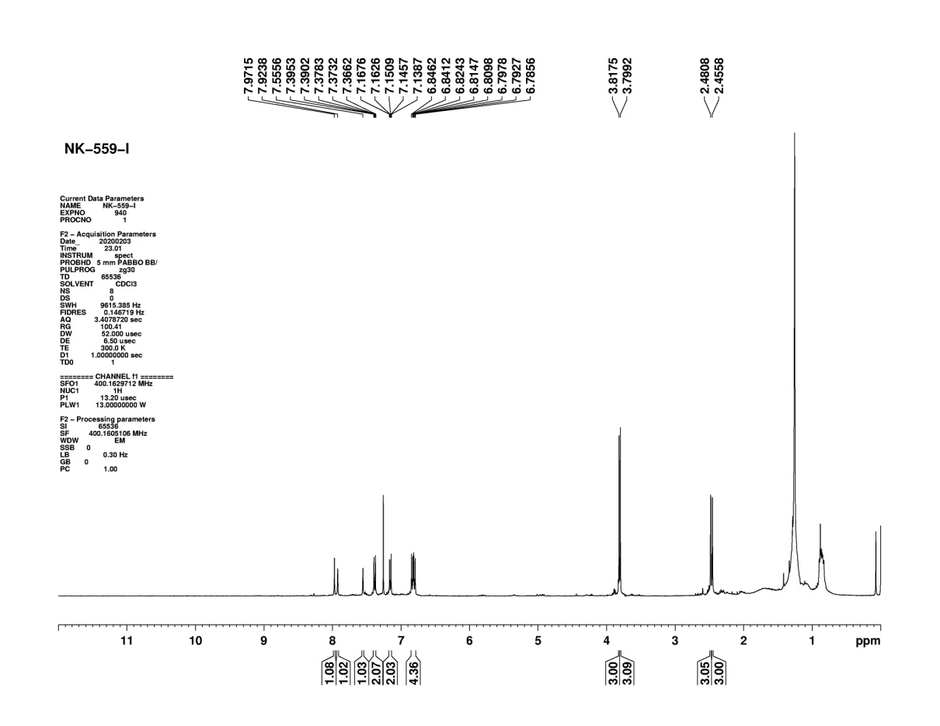
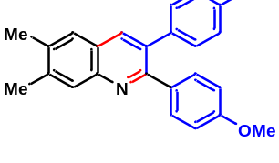
Figure S68: ¹H NMR of compound (4j)
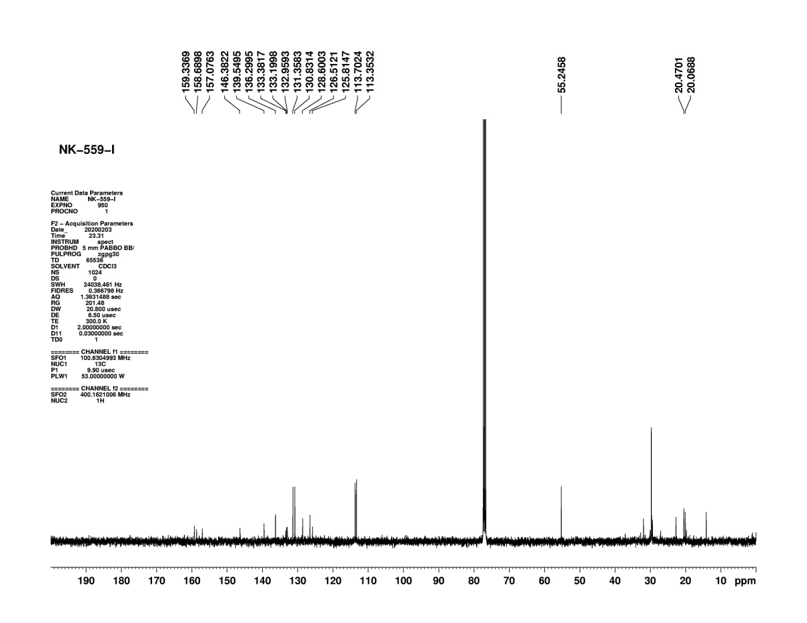
Figure S69: ¹³C NMR of compound (4j)

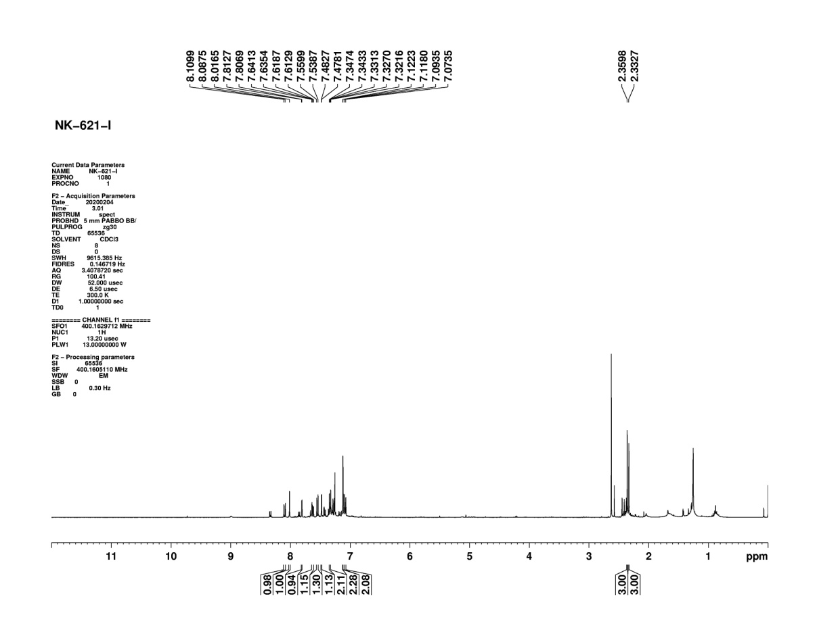
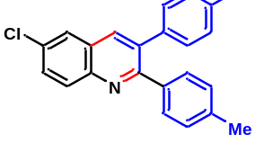
Figure S70: ¹H NMR of compound (4k)
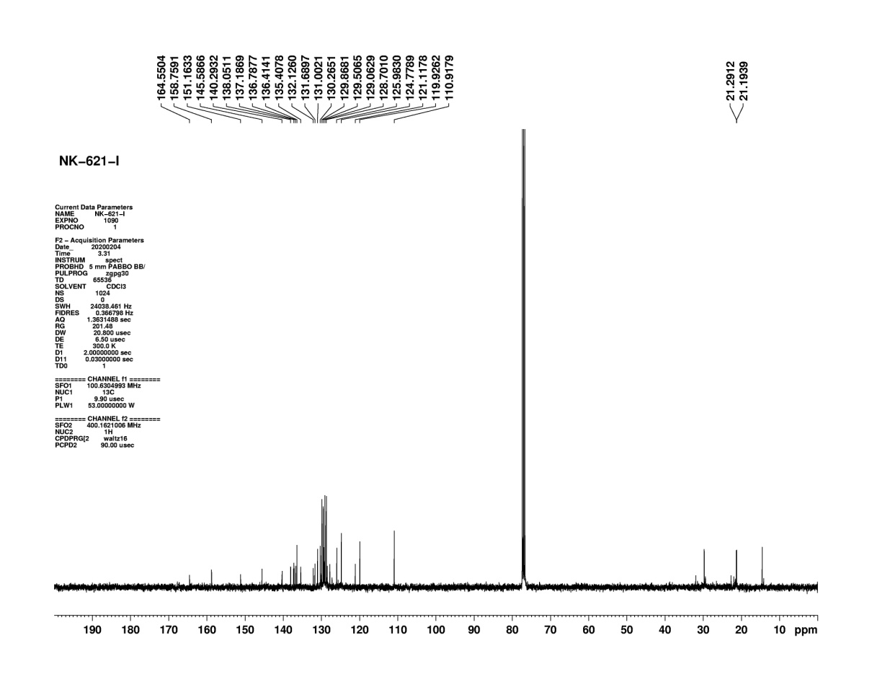
Figure S71: ¹³C NMR of compound (4k)

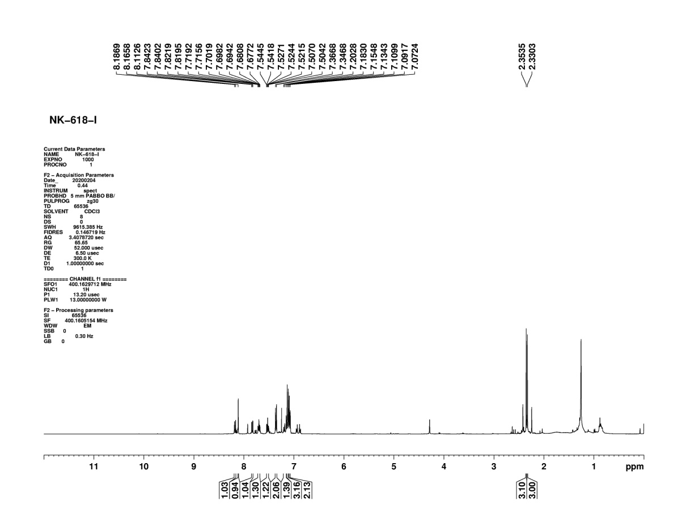
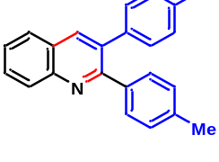
Figure S72: ¹H NMR of compound (4l)
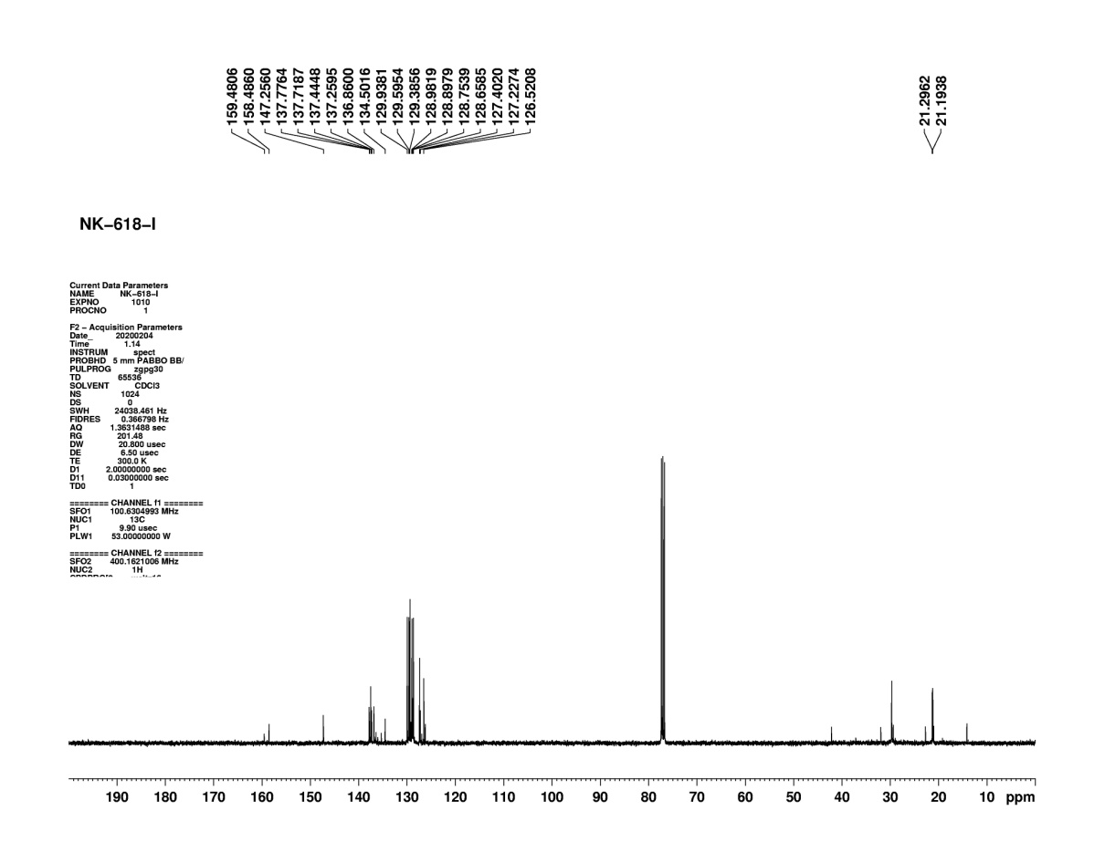
Figure S73: ¹³C NMR of compound (4l)

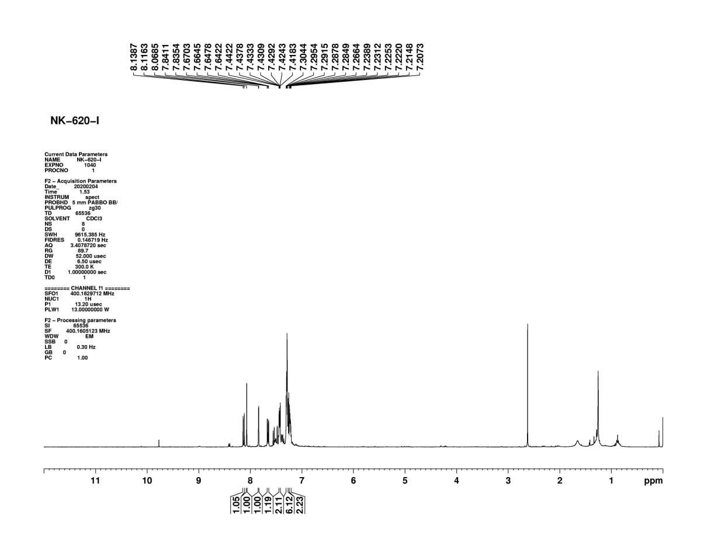
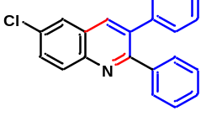
Figure S74: ¹H NMR of compound (4m)
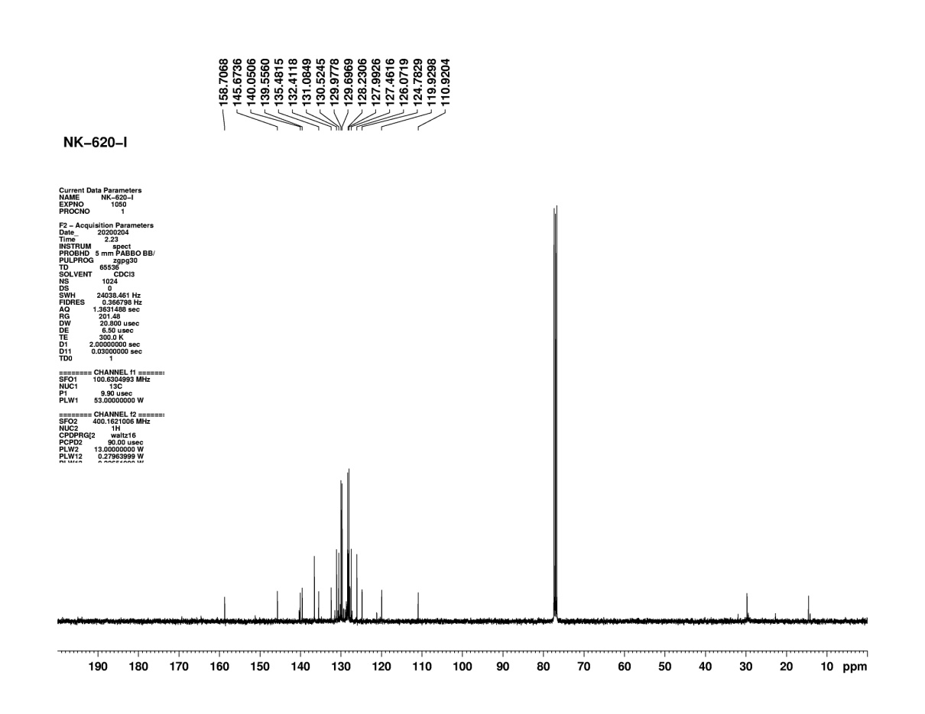
Figure S75: ¹³C NMR of compound (4m)

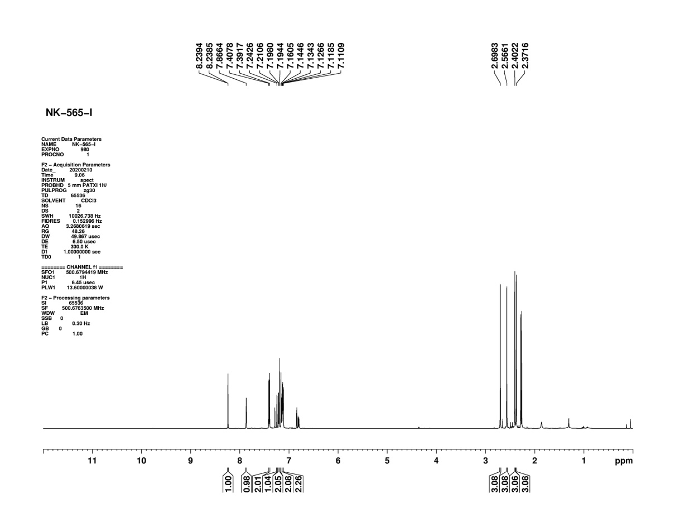
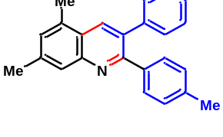
Figure S76: ¹H NMR of compound (4n)
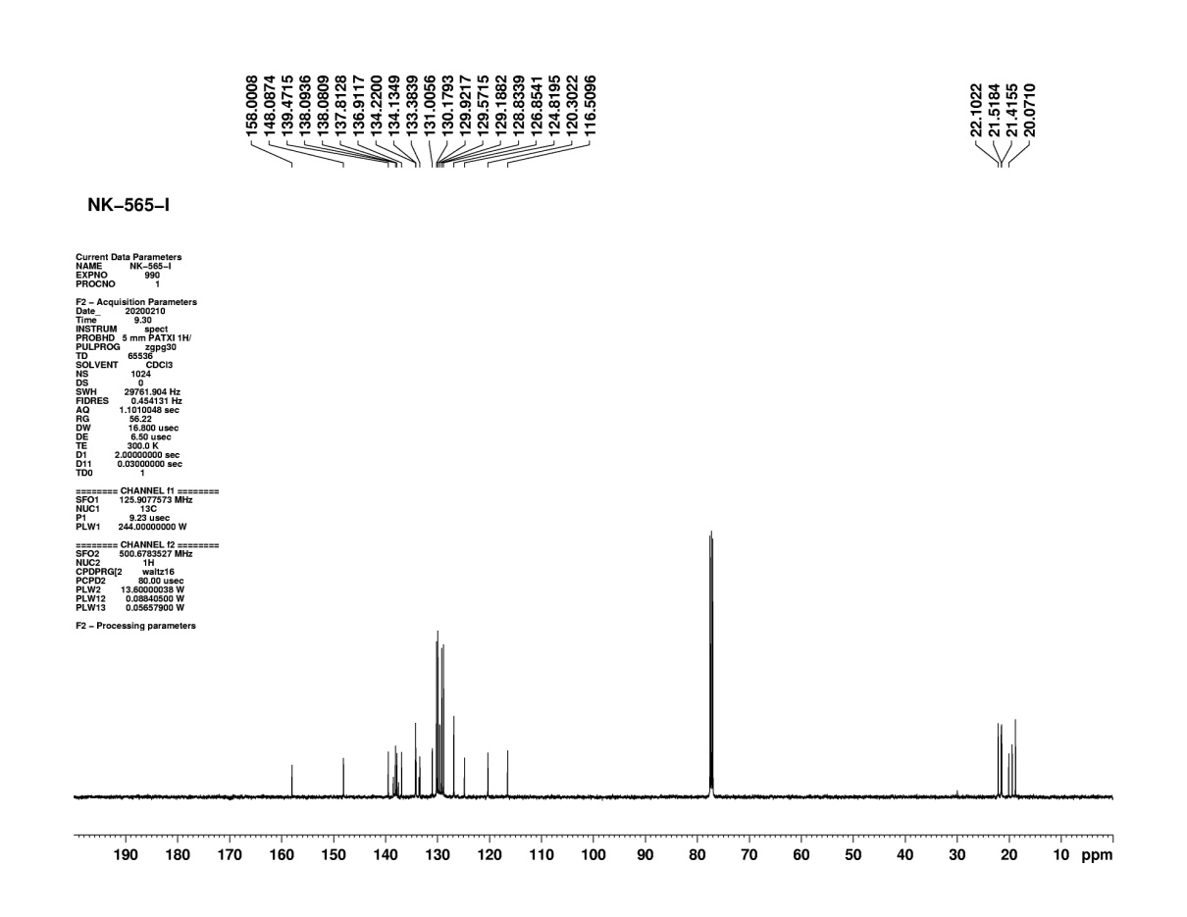
Figure S77: ¹³C NMR of compound (4n)
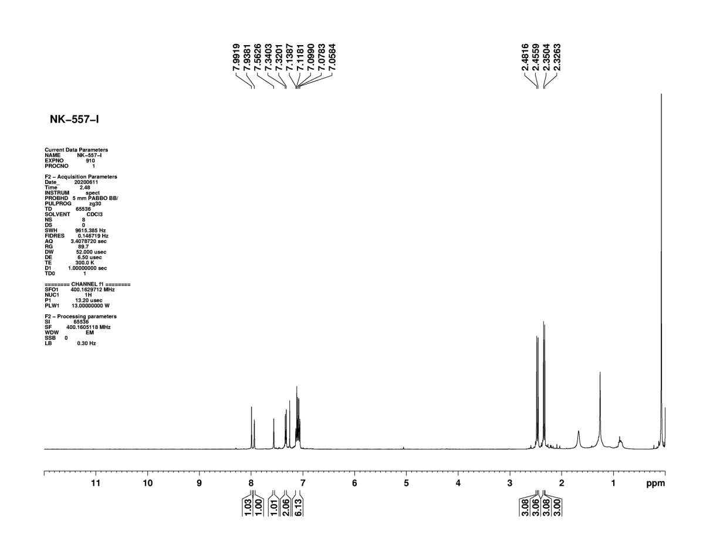

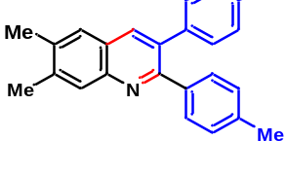

Figure S78: ¹H NMR of compound (4o)
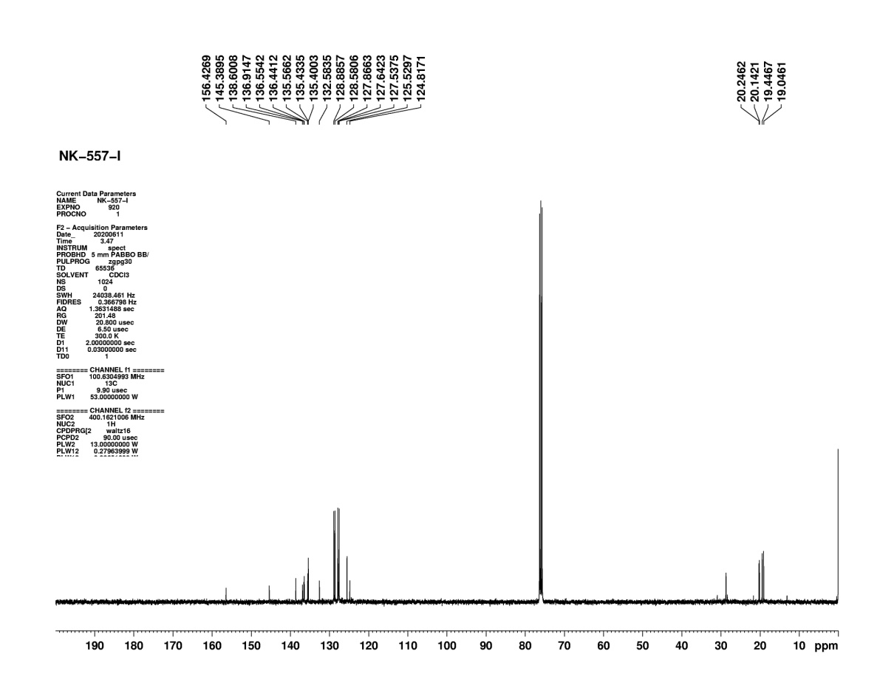

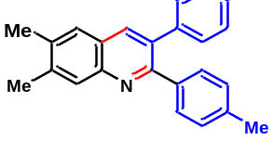
Figure S79: ¹³C NMR of compound (4o)

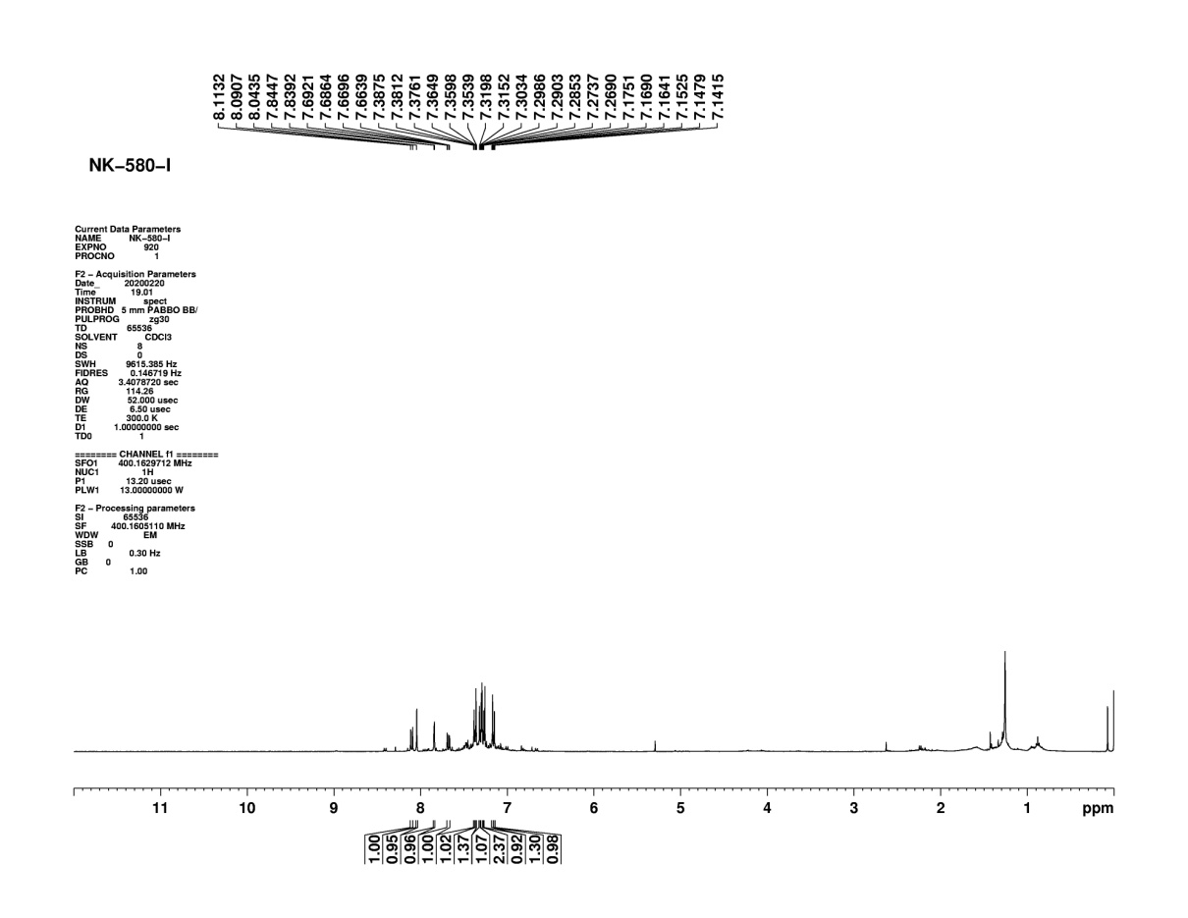
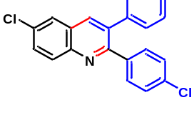
Figure S80: ¹H NMR of compound (4p)
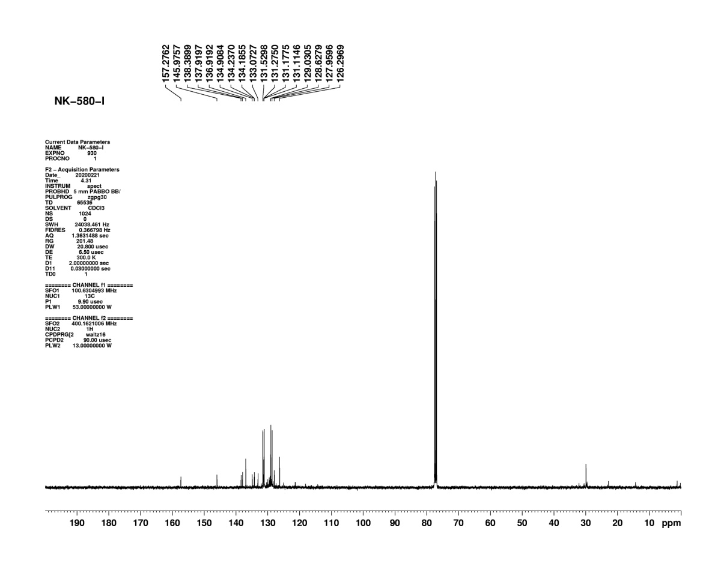
Figure S81: ¹³C NMR of compound (4p)

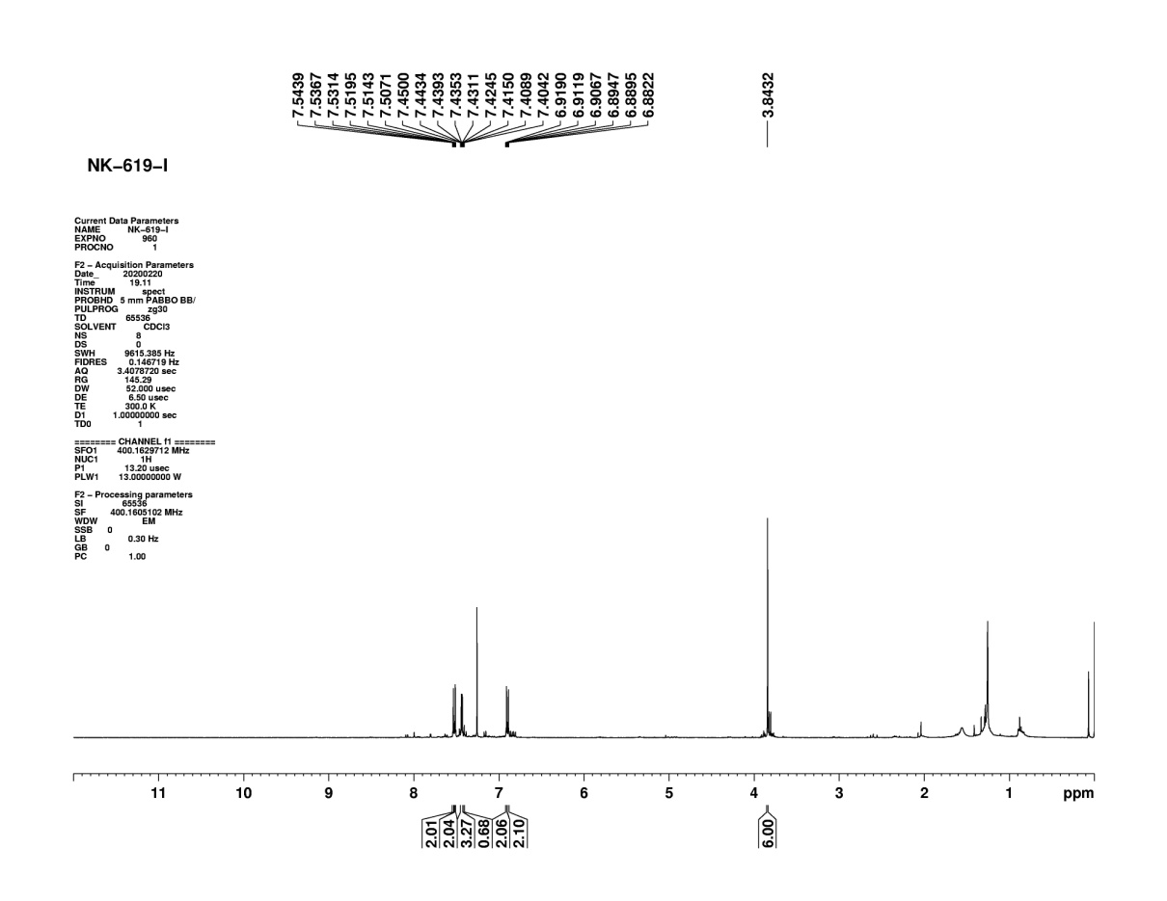
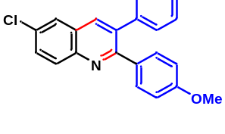
Figure S82: ¹H NMR of compound (4q)
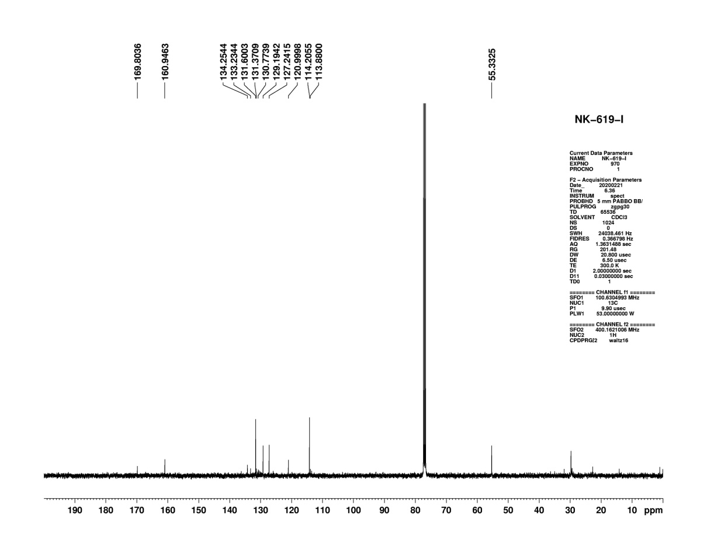
Figure S83: ¹³C NMR of compound (4q)
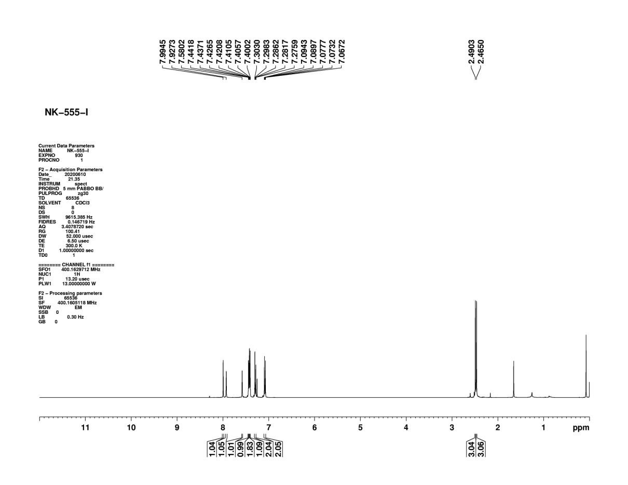

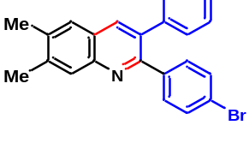

Figure S84: ¹H NMR of compound (4r)
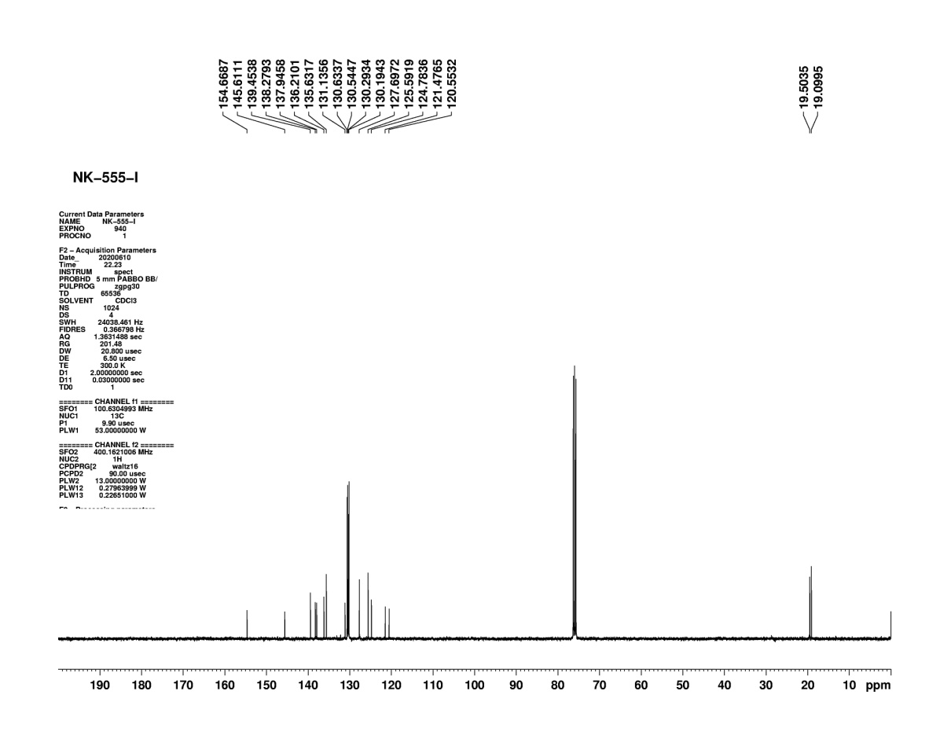

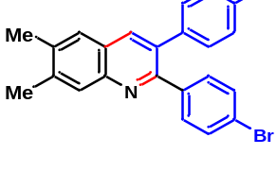

Figure S85: ¹³C NMR of compound (4r)
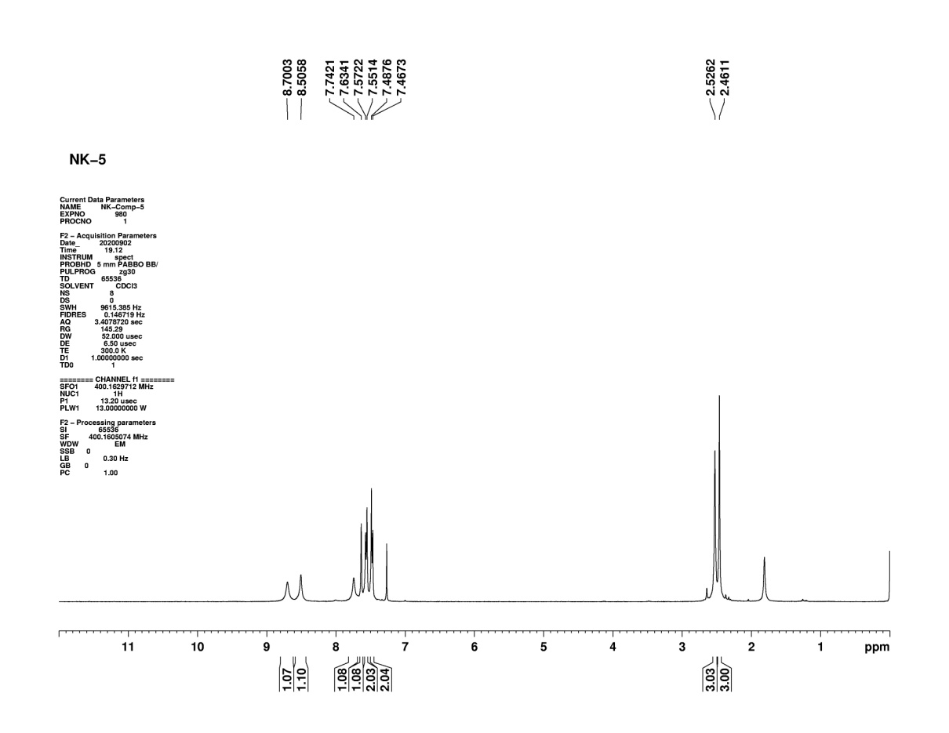
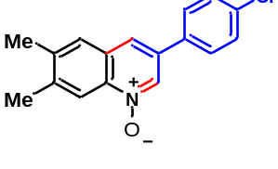Figure S86: ¹H NMR of compound (5)

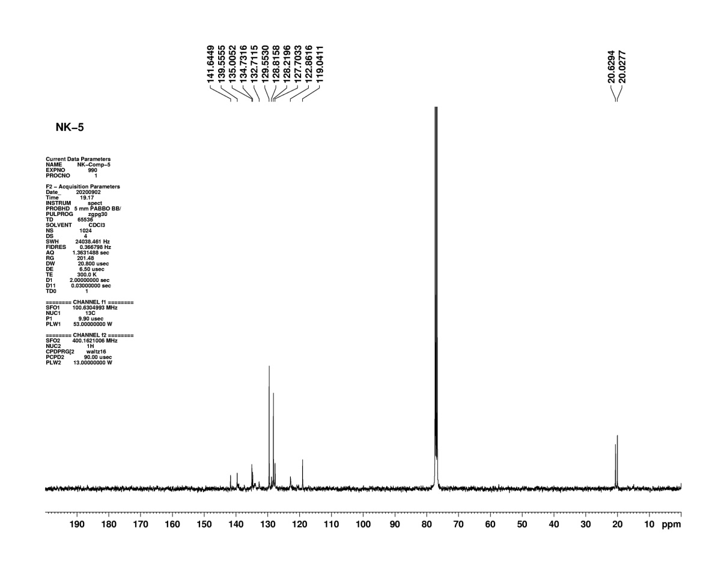

Figure S87: ¹³C NMR of compound (5)
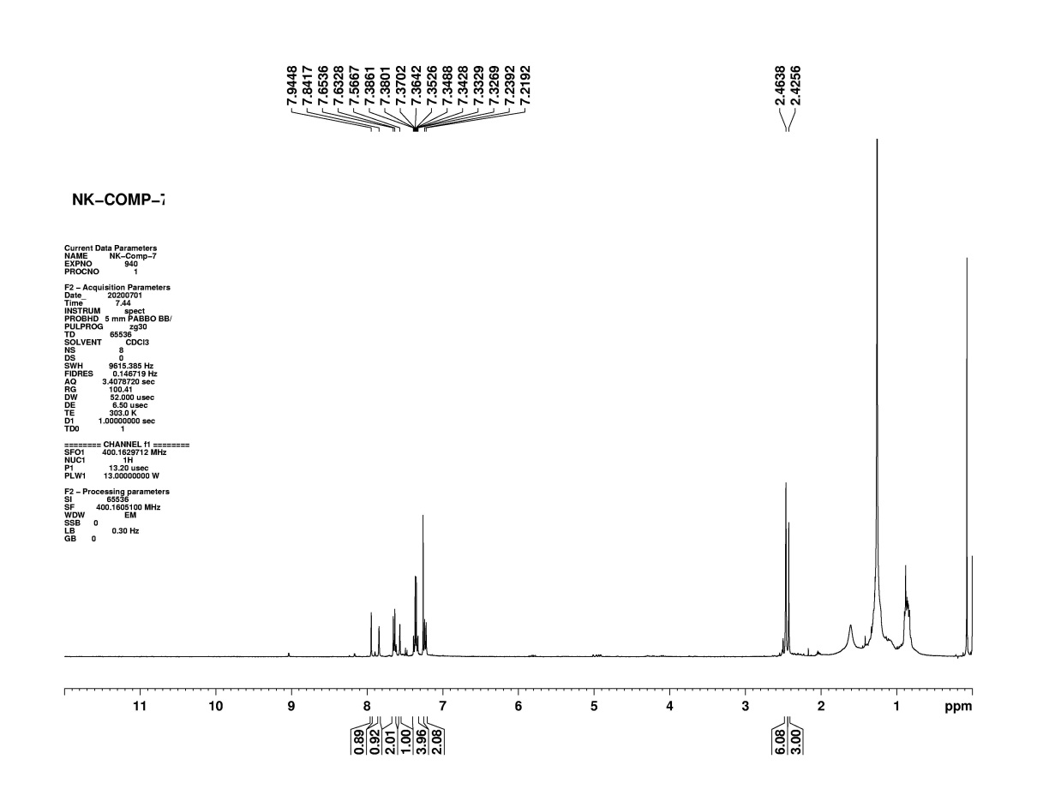
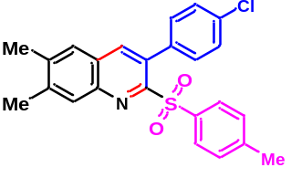
Figure S88: ¹H NMR of compound (6)
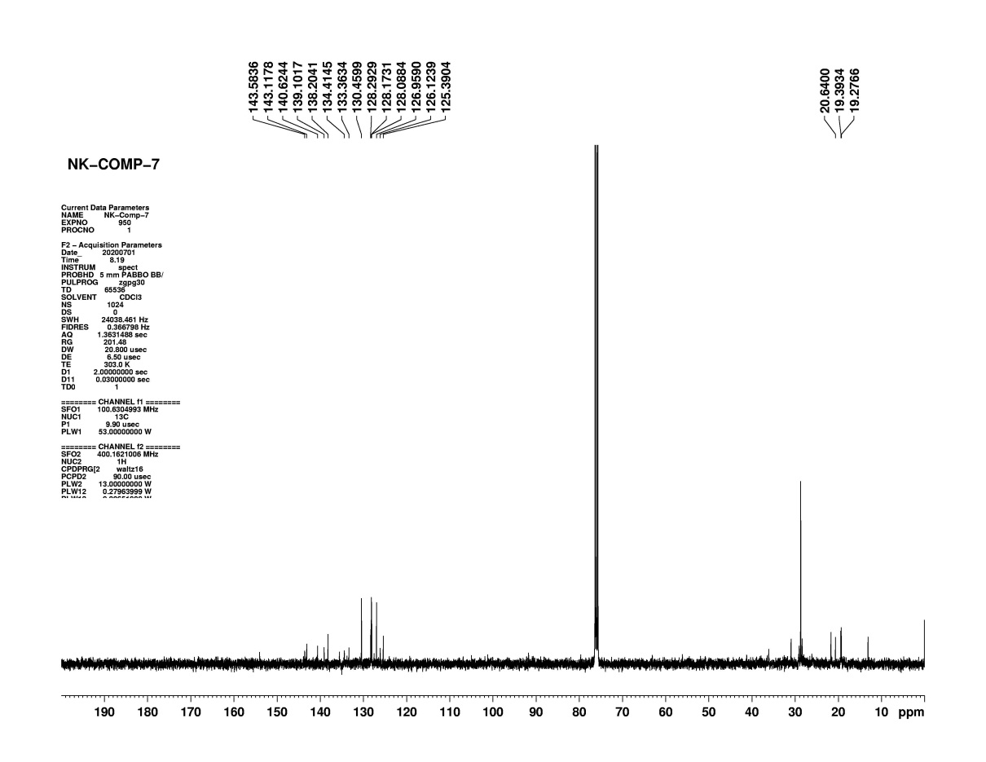

Figure S89: ¹³C NMR of compound (6)

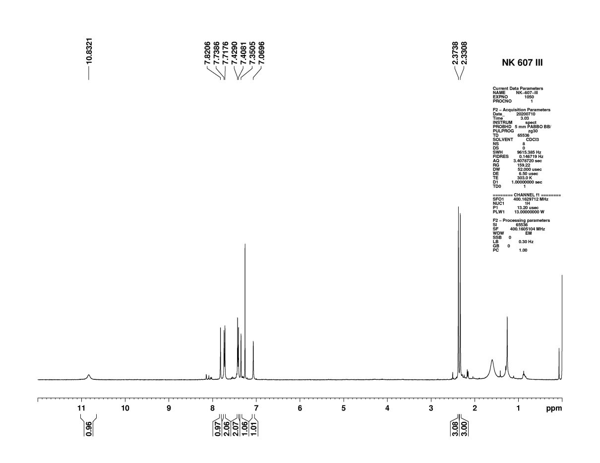

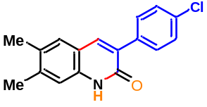

Figure S90: ¹H NMR of compound (7)
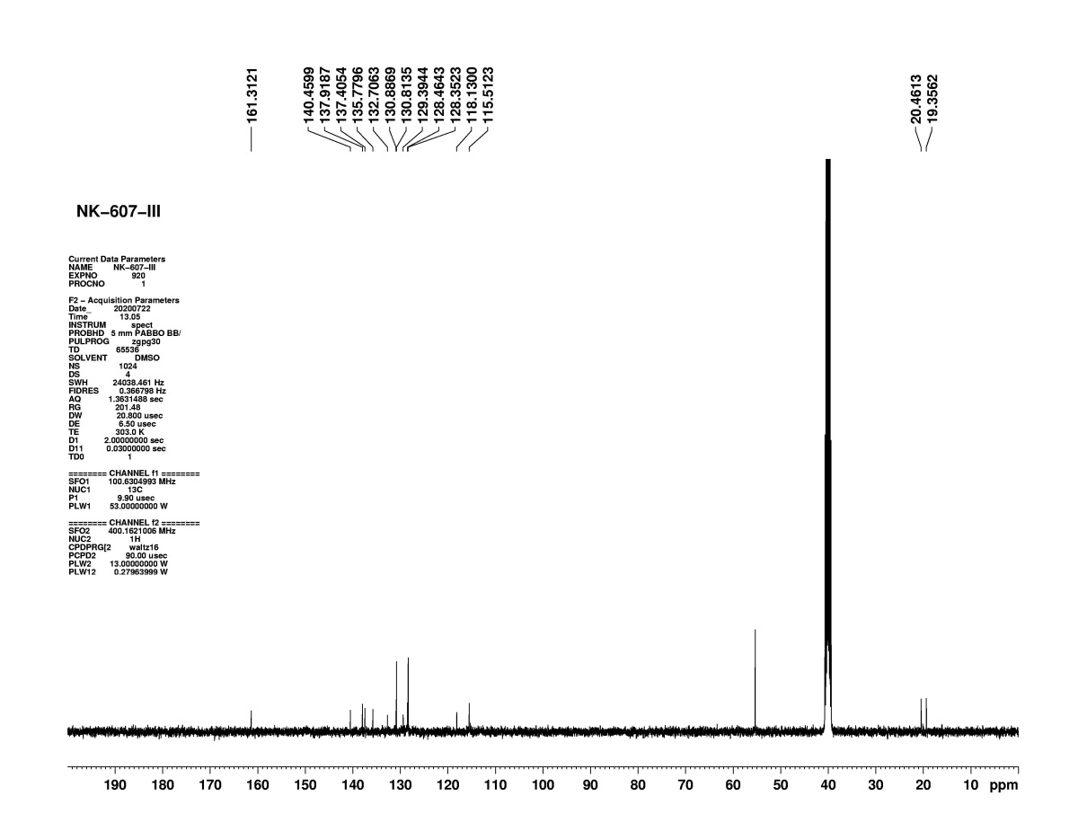

Figure S91: ¹³C NMR of compound (7)

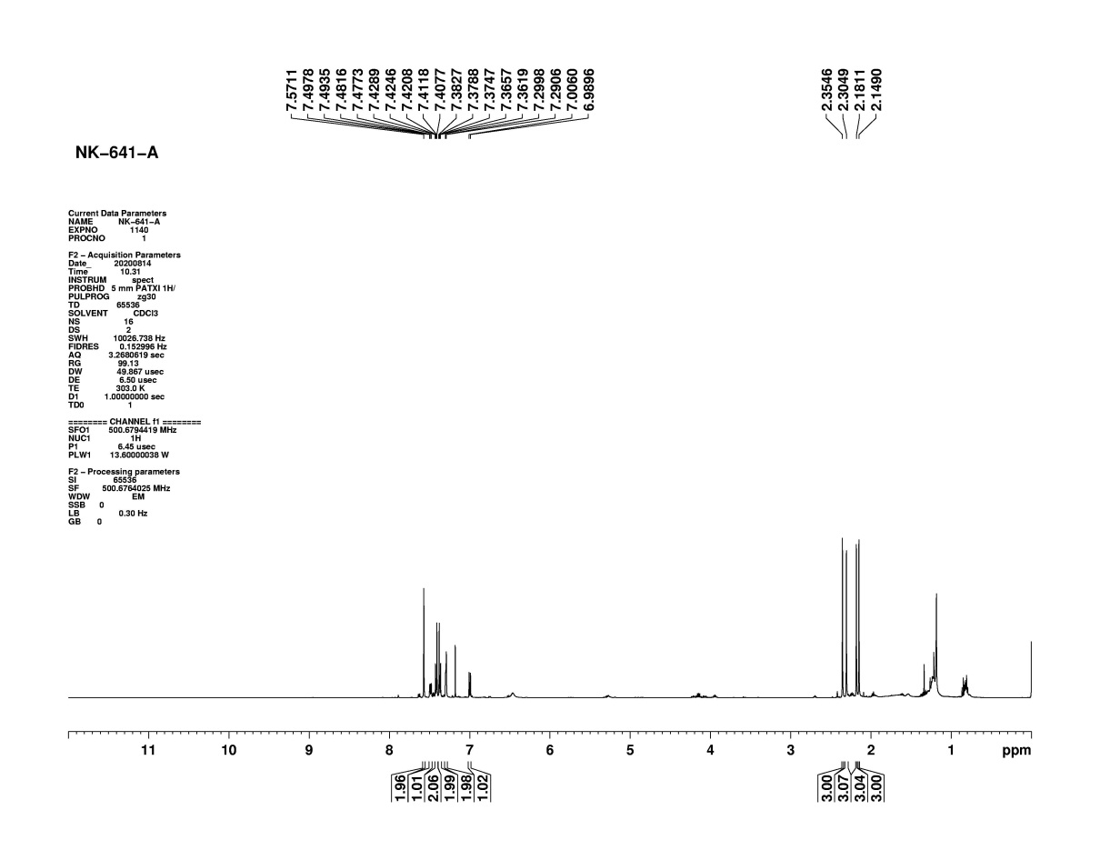

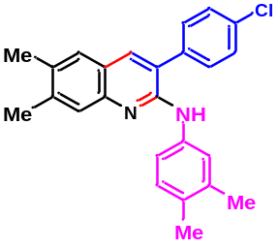

Figure S92: ¹H NMR of compound (8)

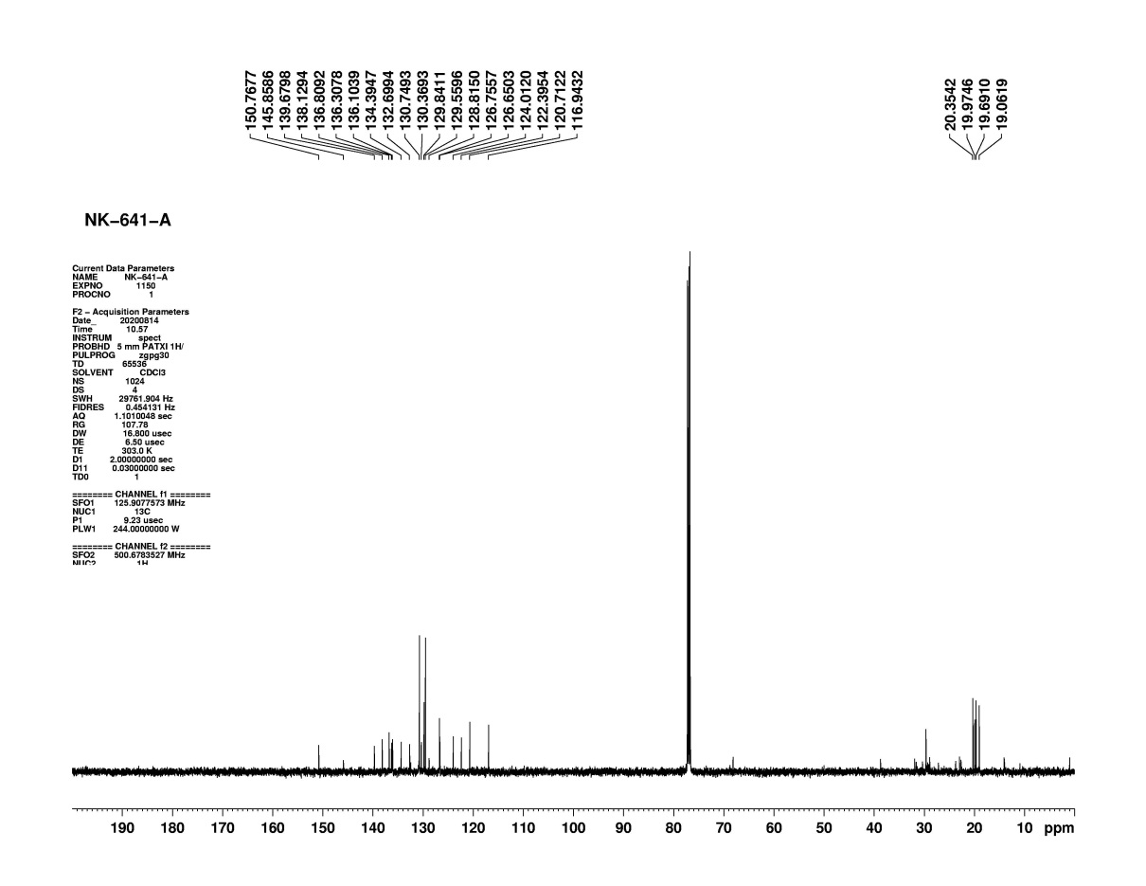

Figure S93: ¹³C NMR of compound (8)

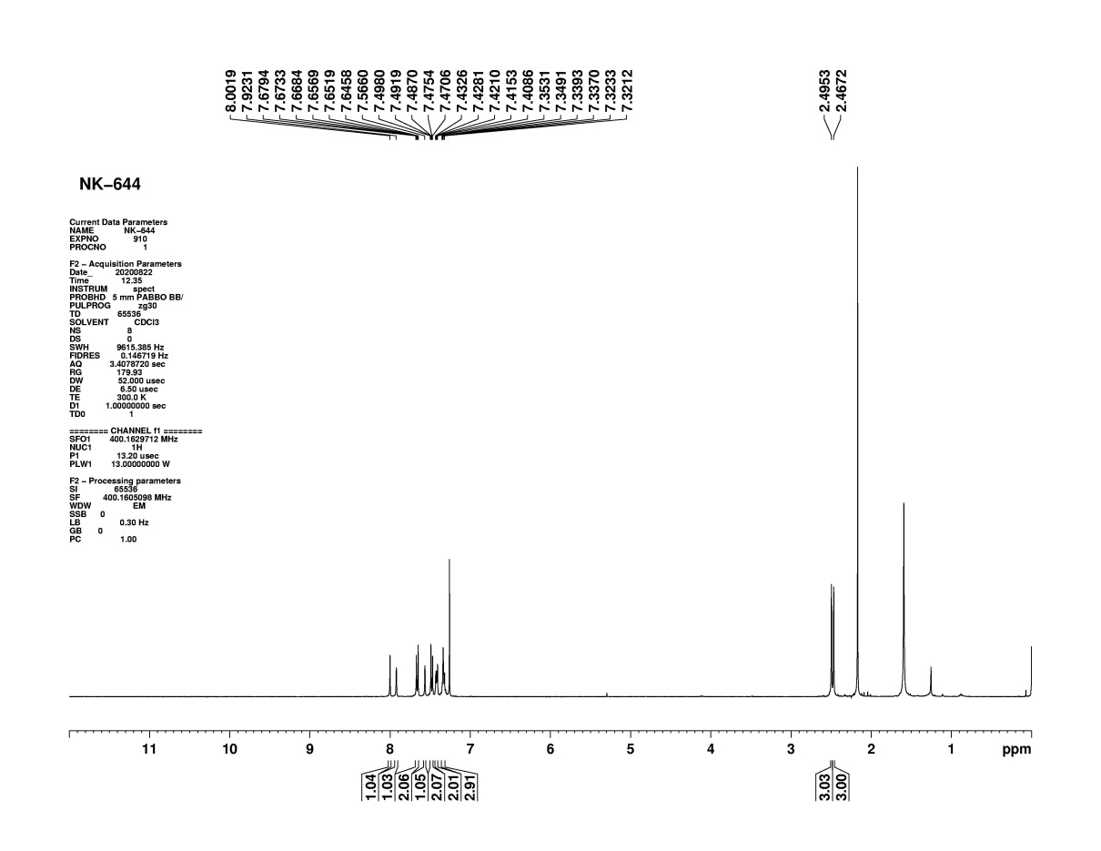

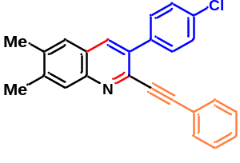

Figure S94: ¹H NMR of compound (9)
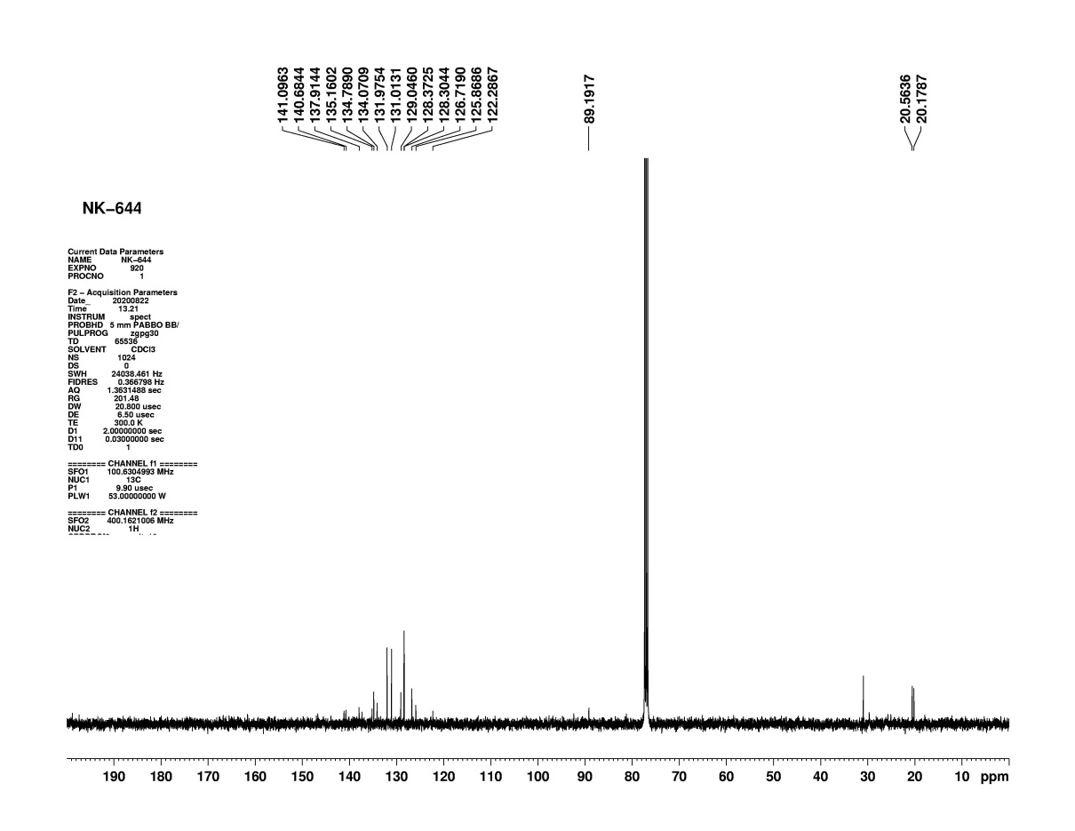

Figure S95: ¹³C NMR of compound (9)
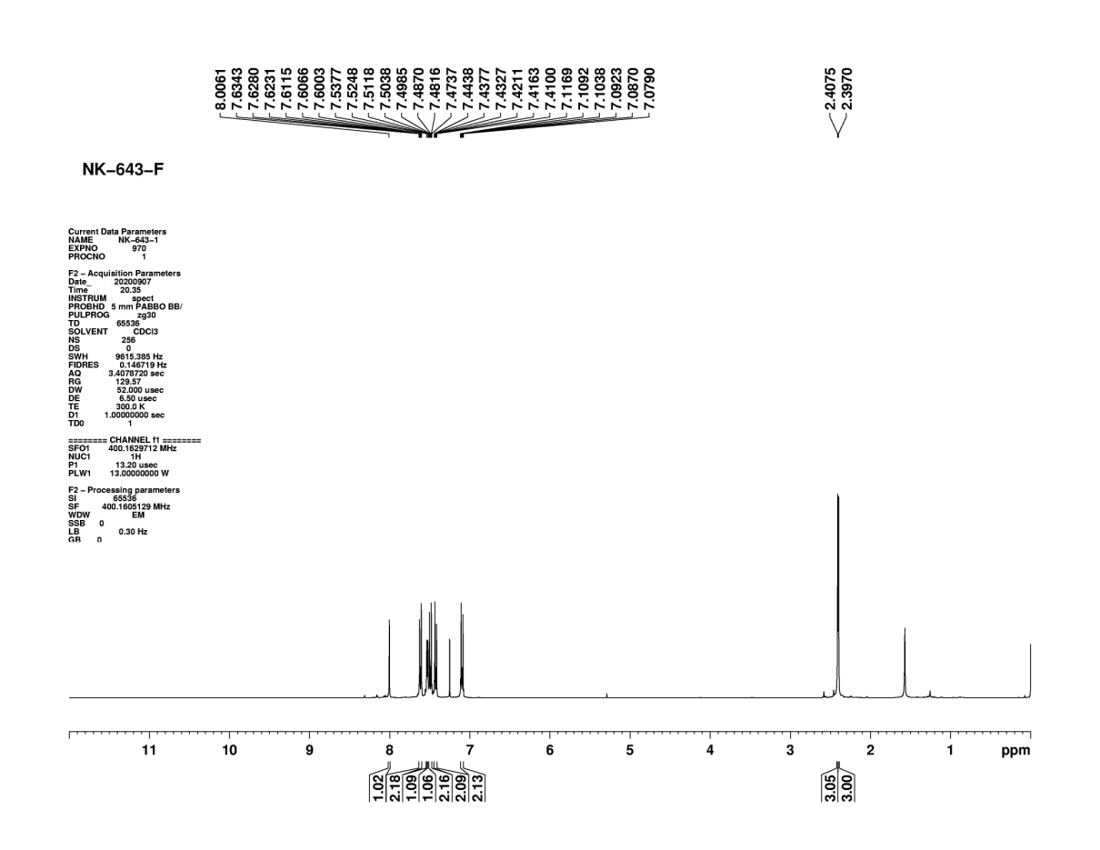

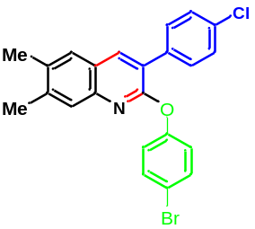

Figure S96: ¹H NMR of compound (10)
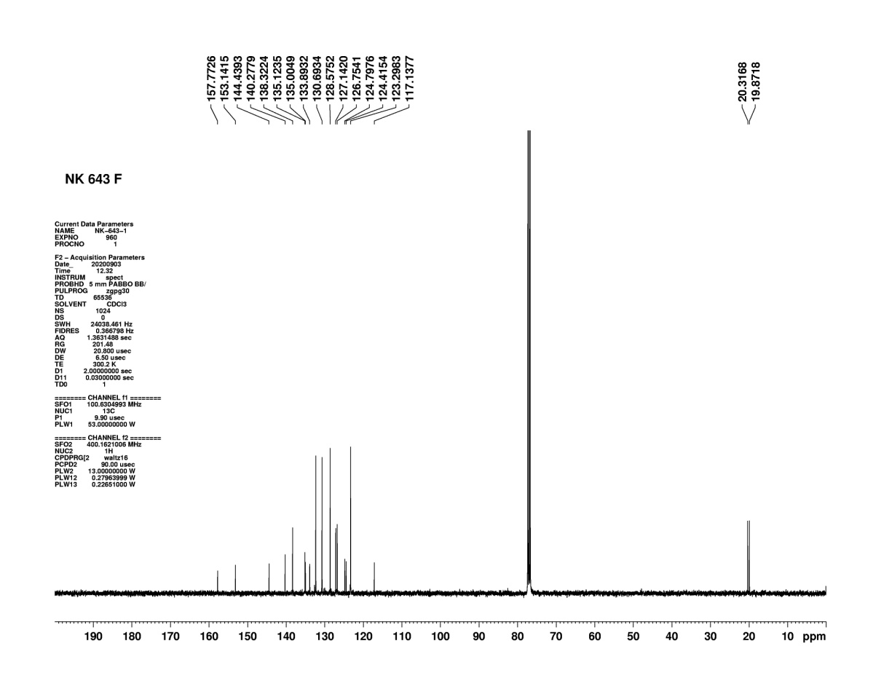

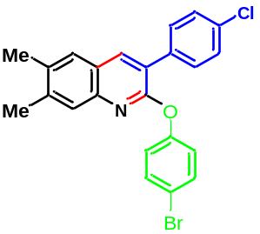

Figure S97: ¹³C NMR of compound (10)
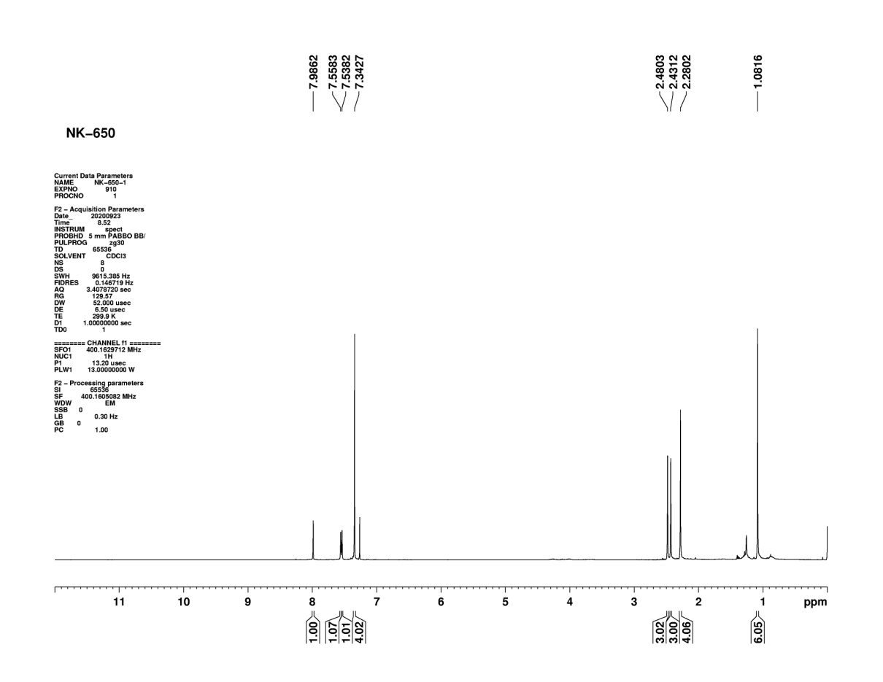

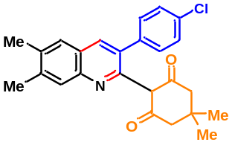

Figure S98: ¹H NMR of compound (11)
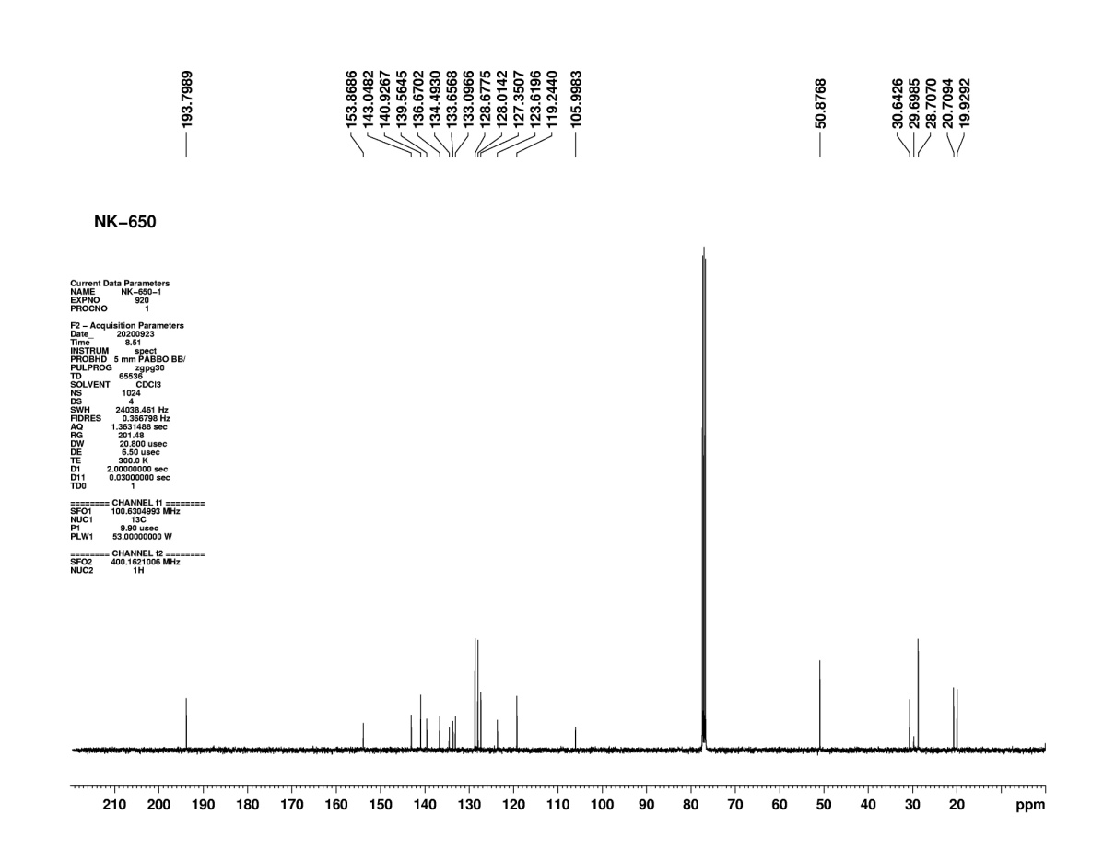
Figure S99: ¹³C NMR of compound (11)

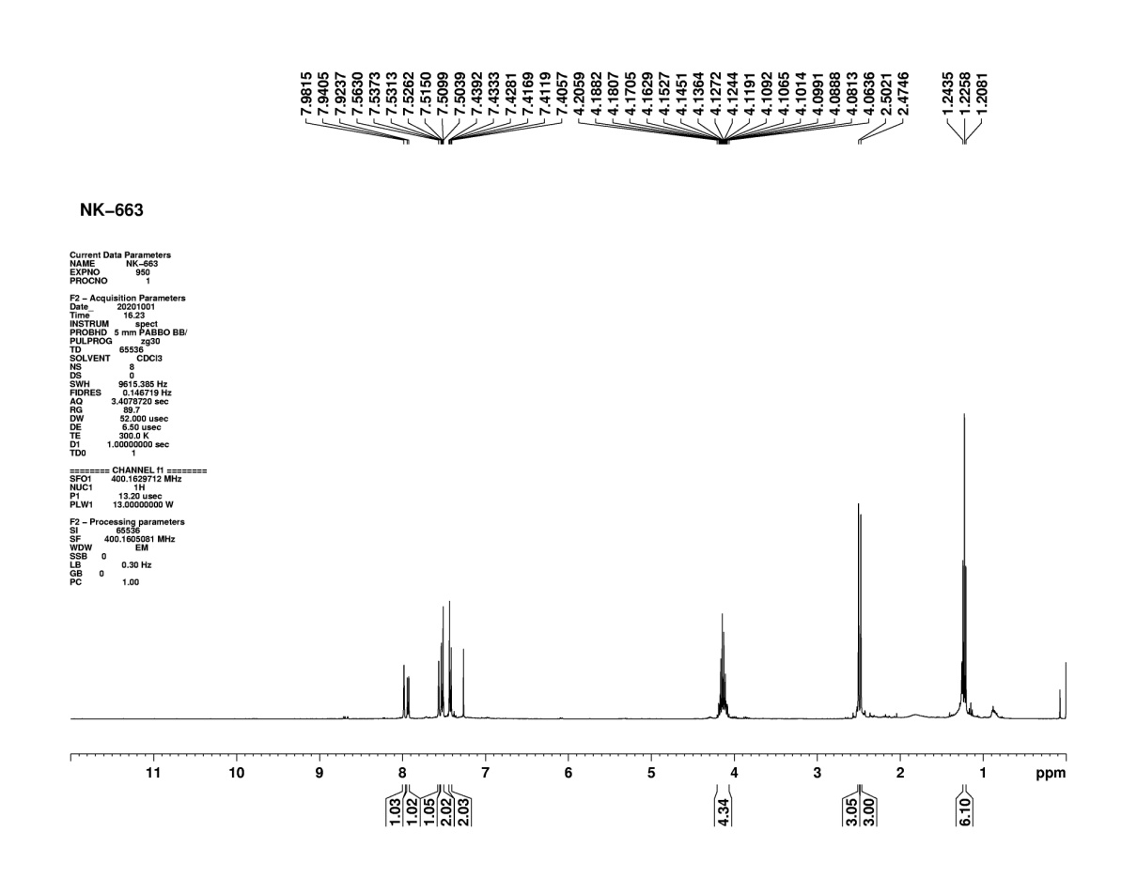

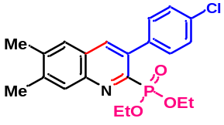

Figure S100: ¹H NMR of compound (12)
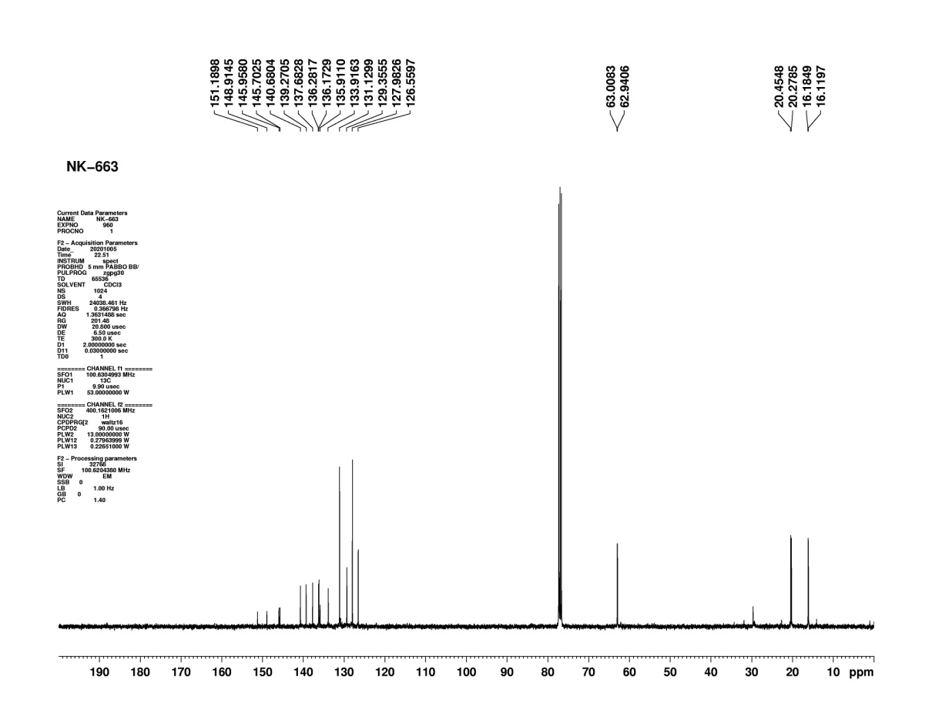

Figure S101: ¹³C NMR of compound (12)
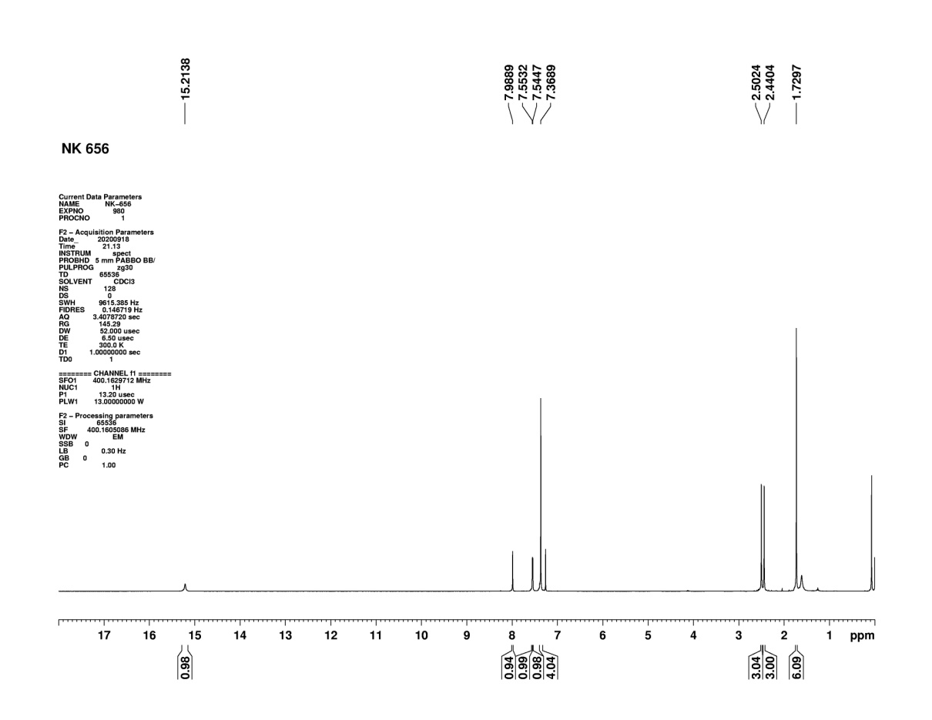

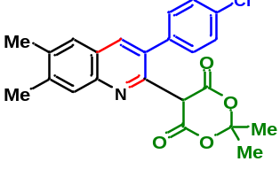

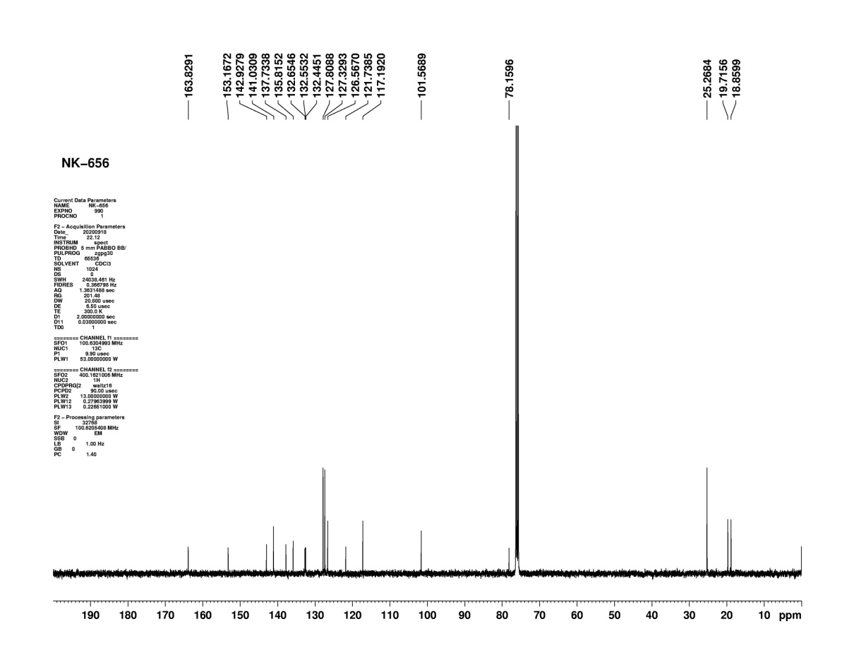
Figure S102: ¹H NMR of compound (13)

Figure S103: ¹³C NMR of compound (13)
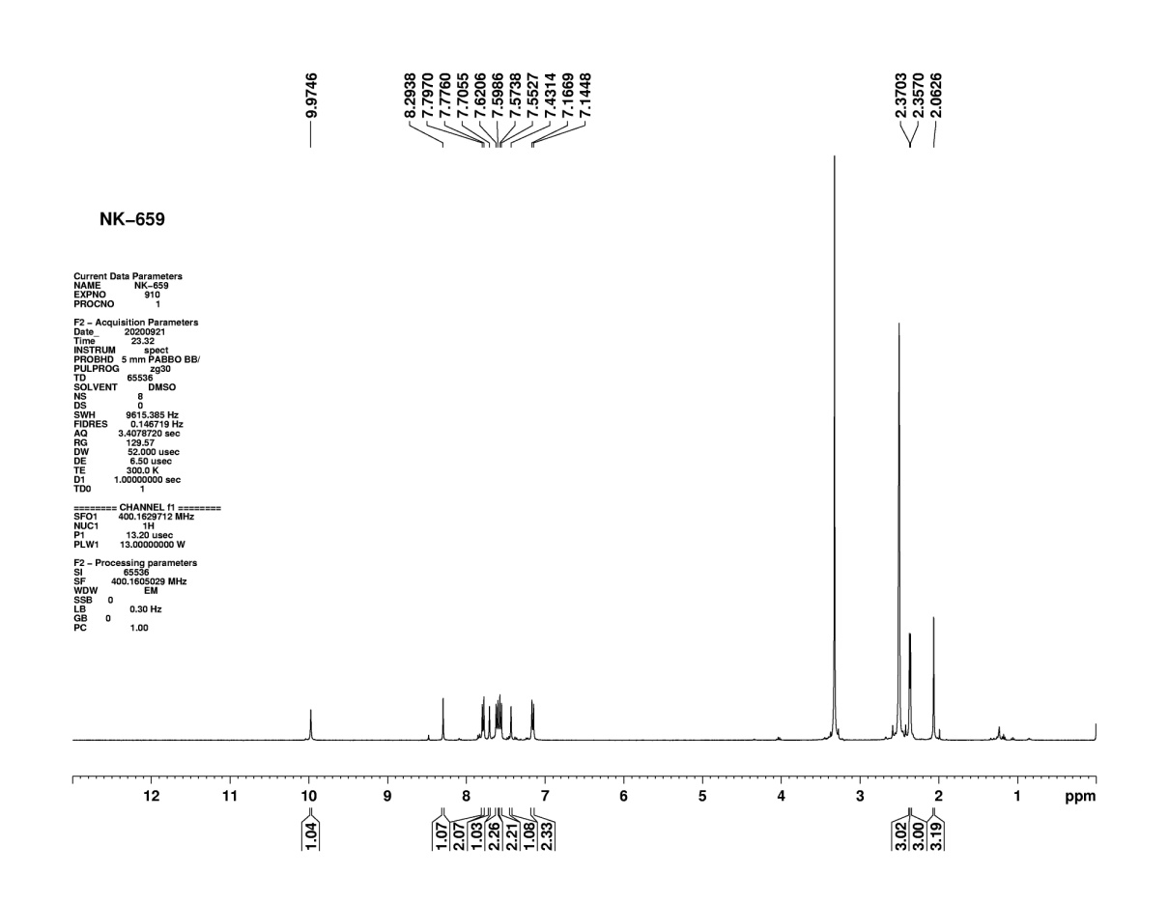

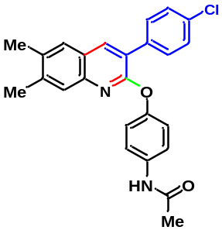

Figure S104: ¹H NMR of compound (14)
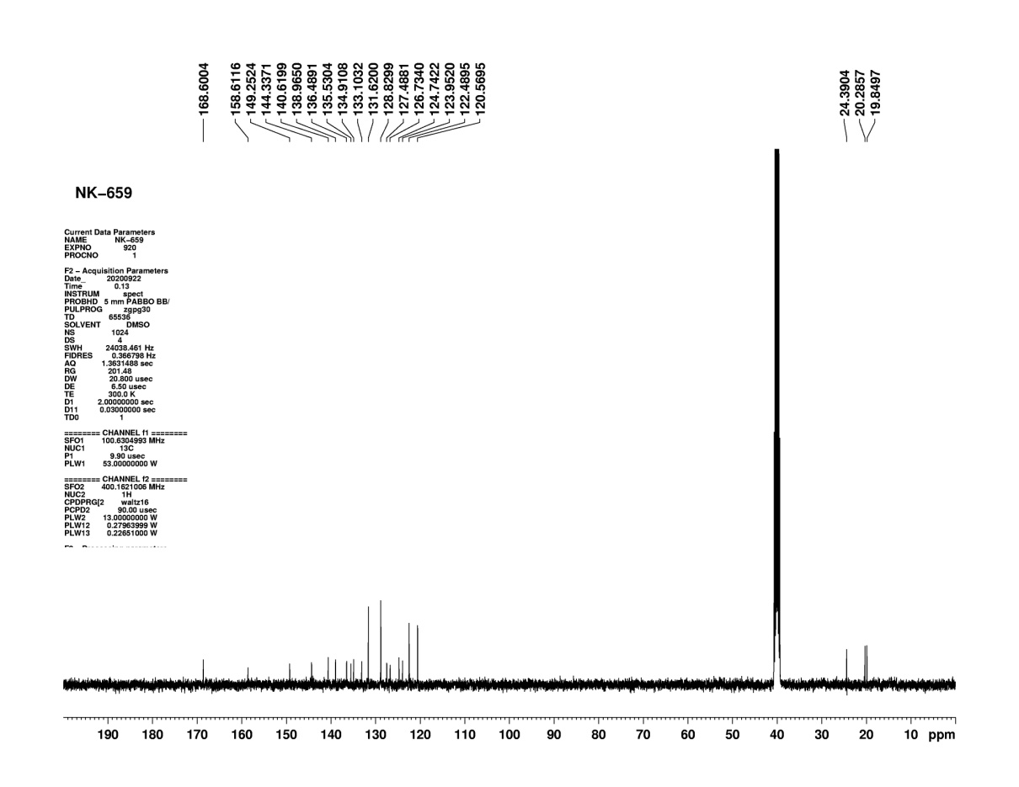

Figure S105: ¹³C NMR of compound (14)

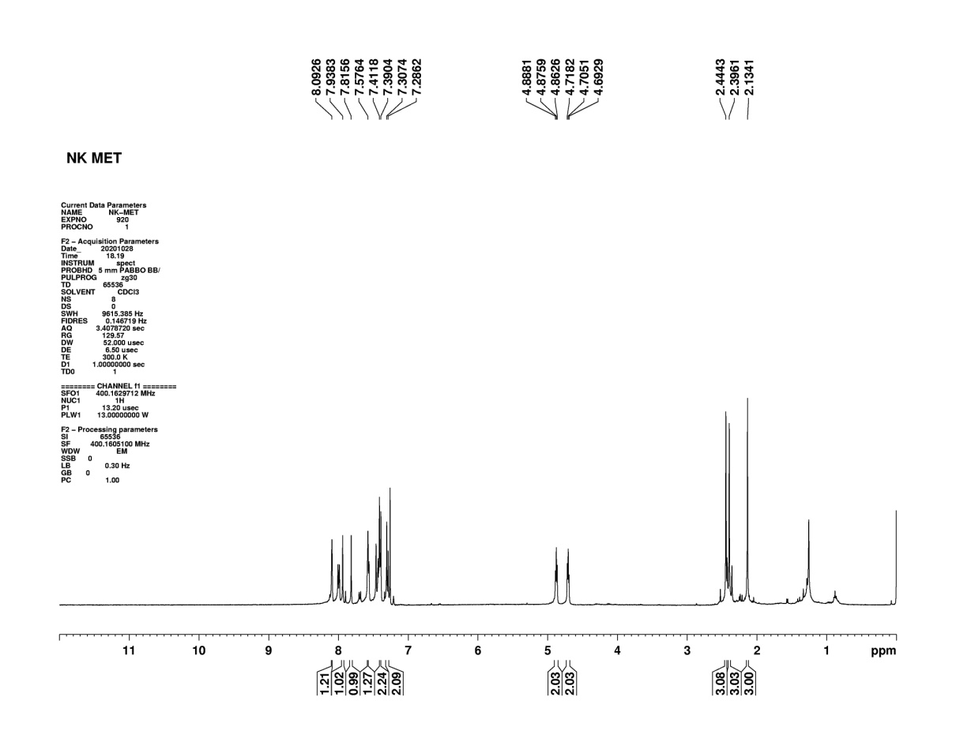

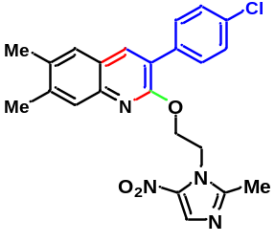

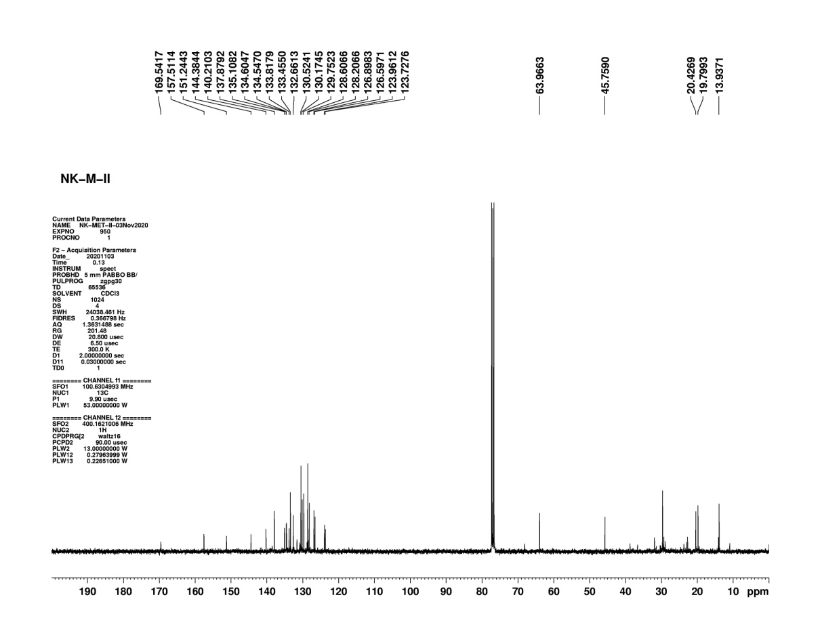
Figure S106: ¹H NMR of compound (15)

Figure S107: ¹³C NMR of compound (15)

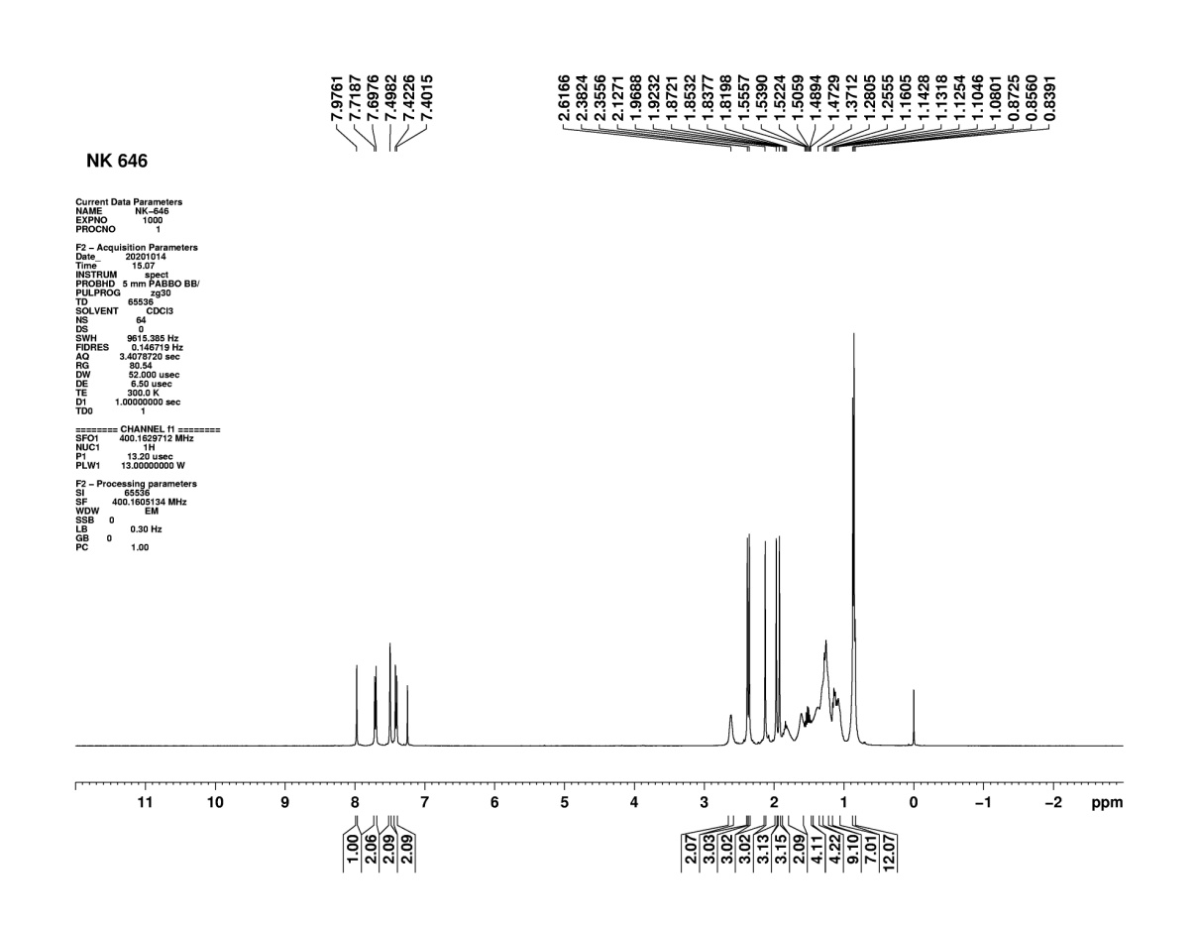

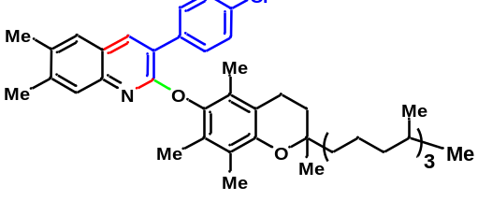

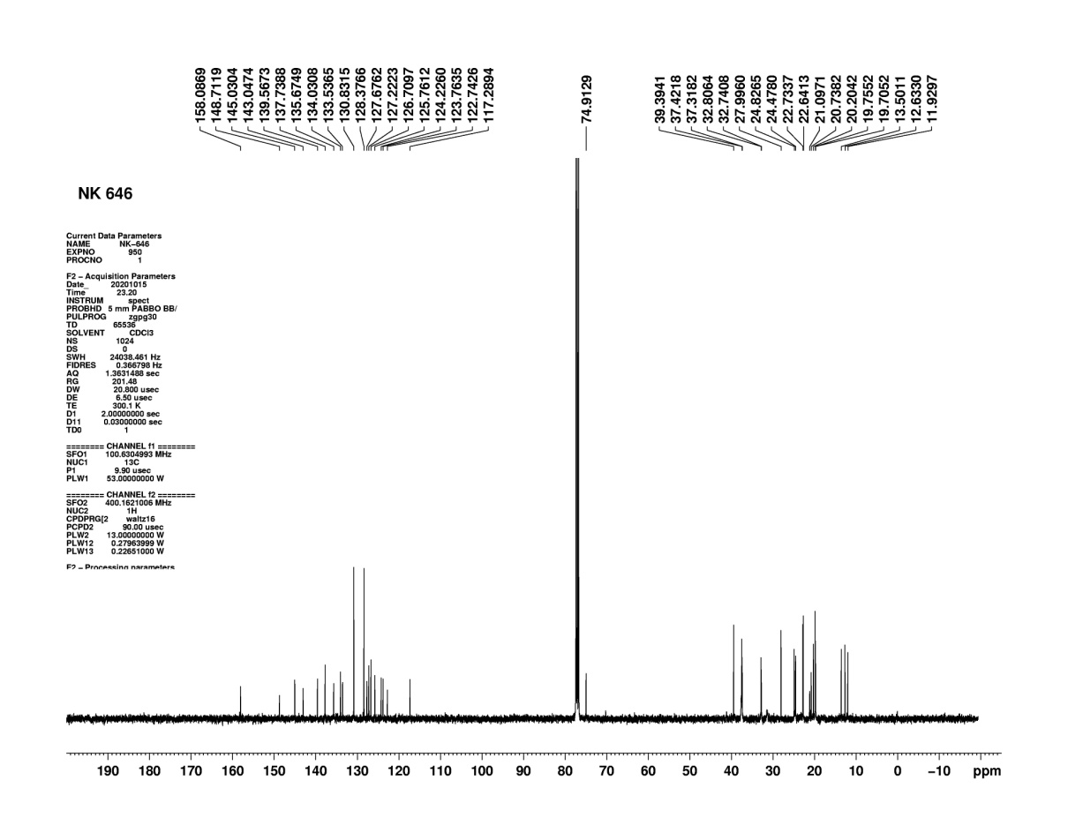
Figure S108: ¹H NMR of compound (16)

Figure S109: ¹³C NMR of compound (16)
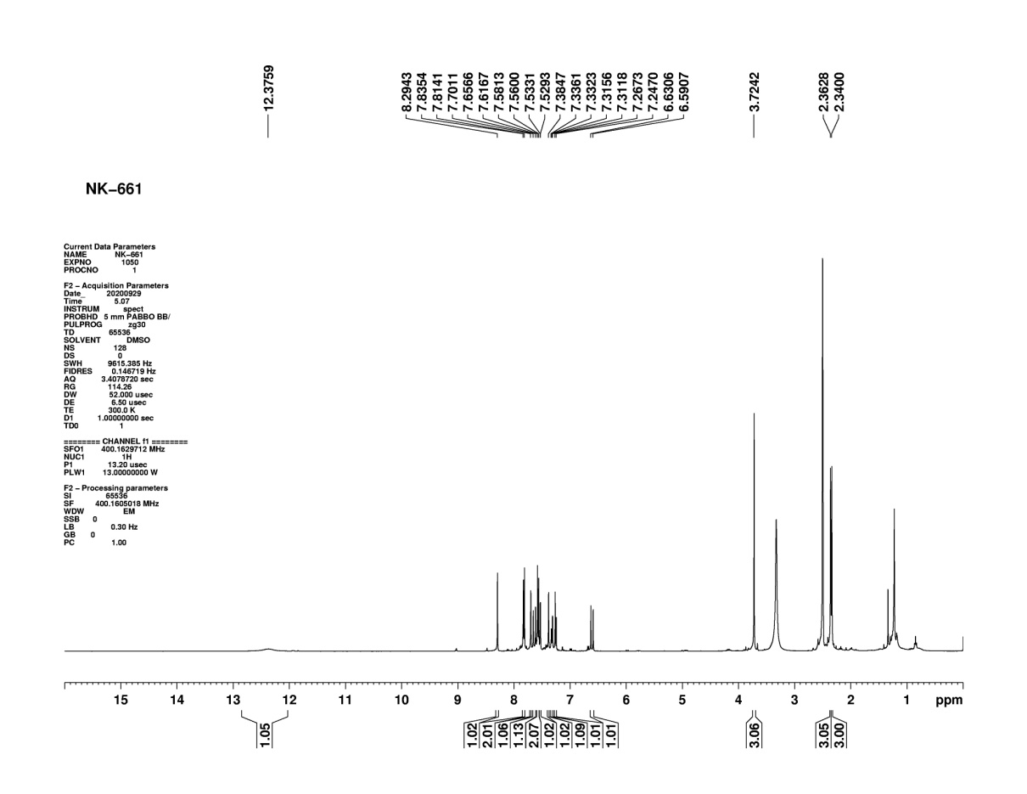

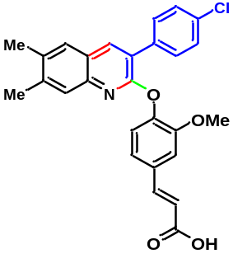

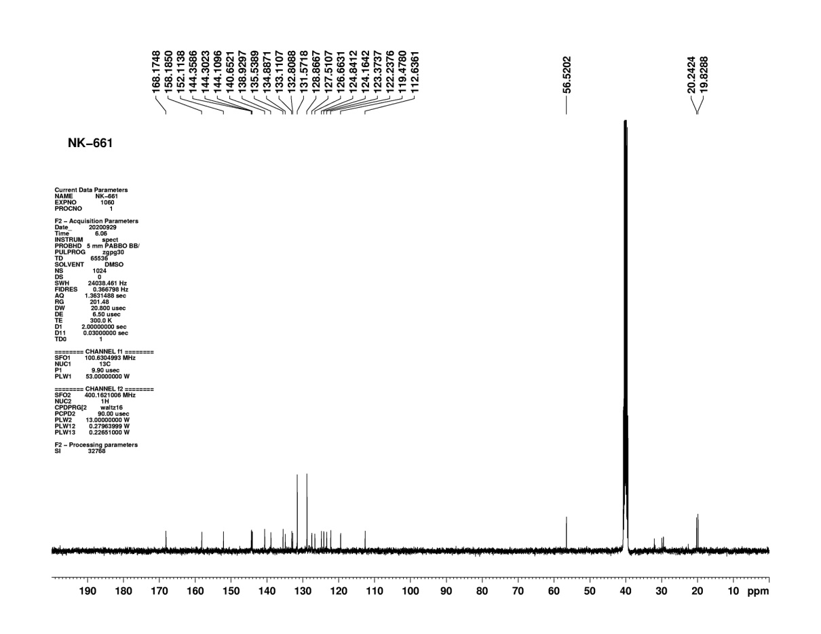
Figure S110: ¹H NMR of compound (17)

Figure S111: ¹³C NMR of compound (17)

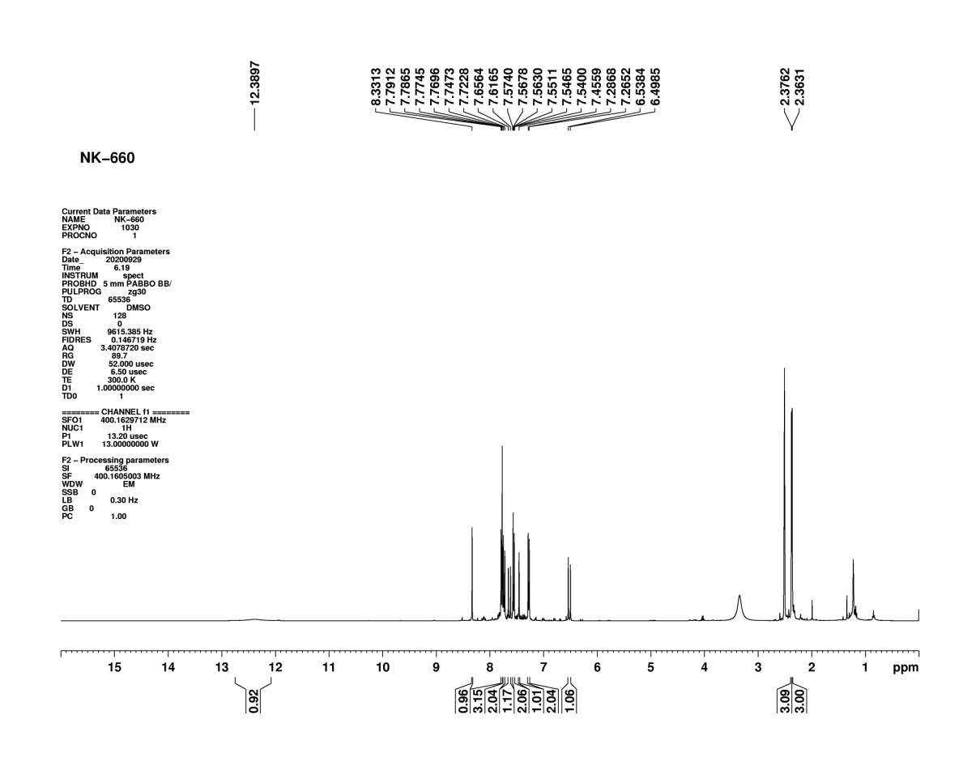
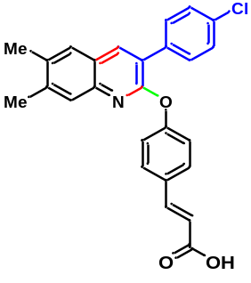

Figure S112: ¹H NMR of compound (18)
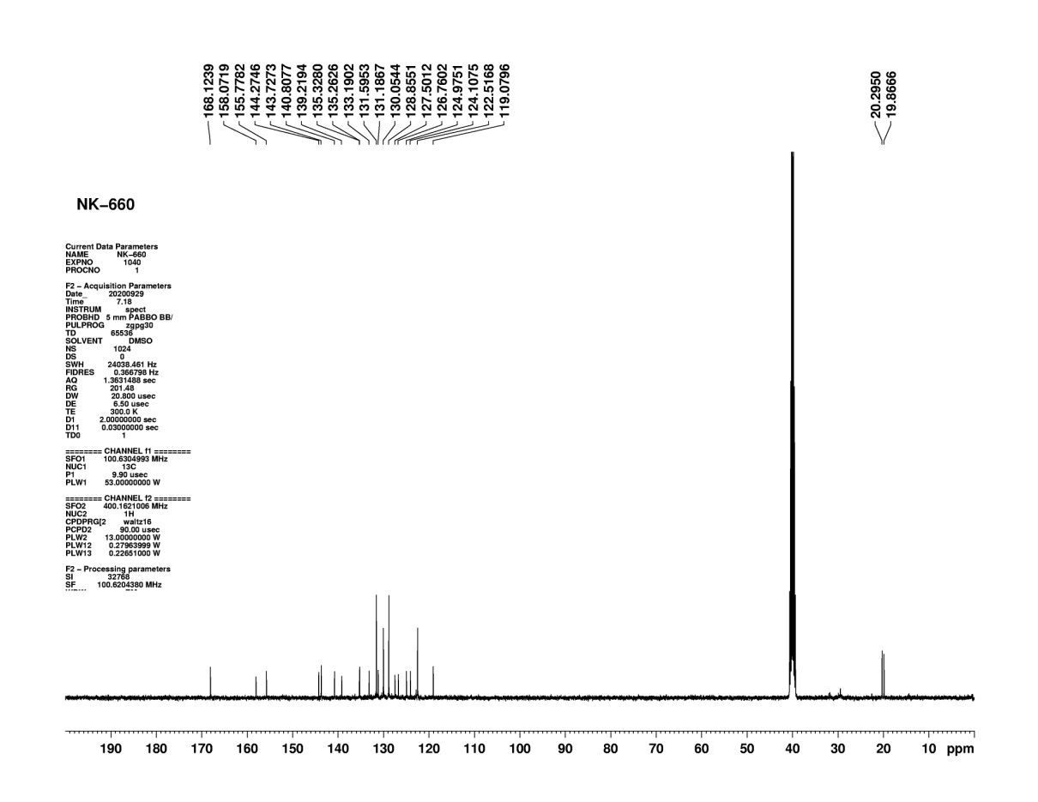
Figure S113: ¹³C NMR of compound (18)

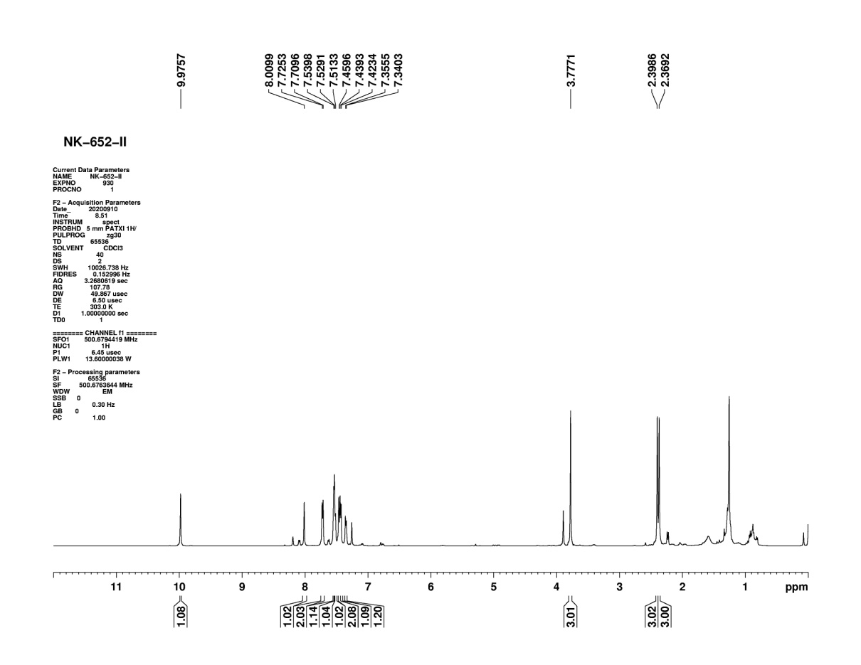
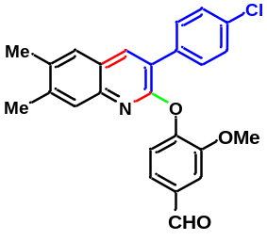

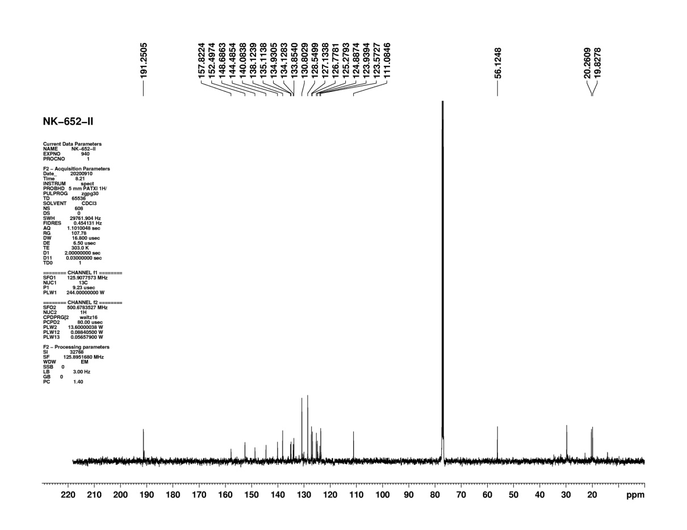
Figure S114: ¹H NMR of compound (19)

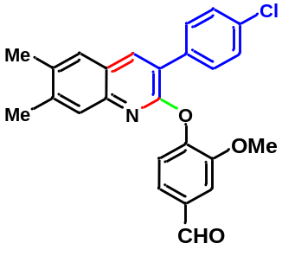

Figure S115: ¹³C NMR of compound (19)
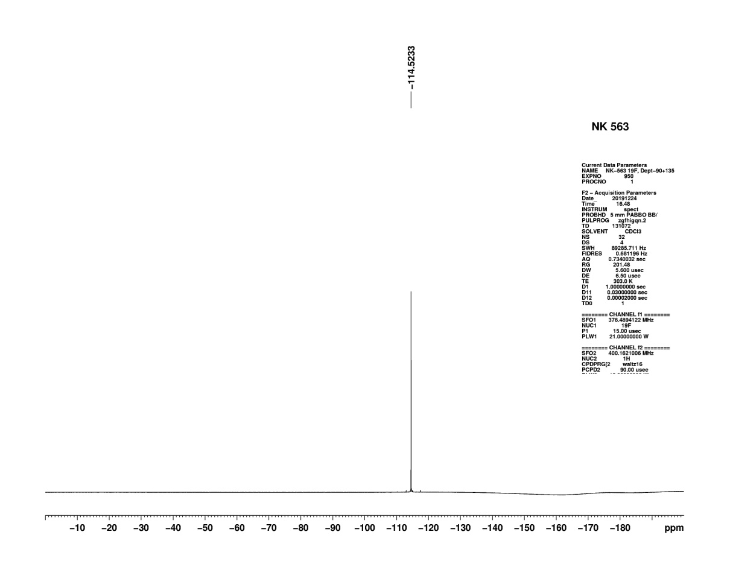
(8) ¹⁹F-NMR-Spectra of Compound (3j) and (4a)

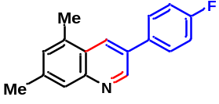

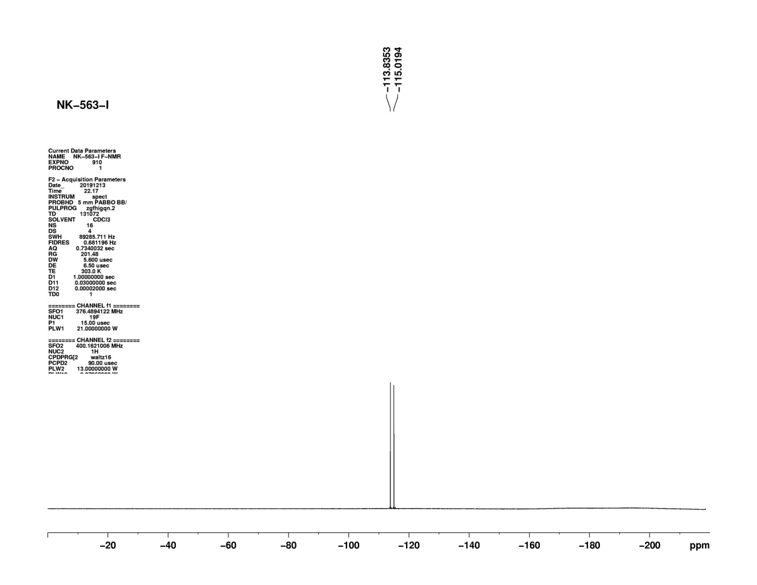
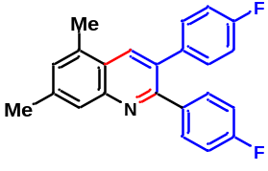Figure S116: F-NMR of compound (3j)

Figure S117: F-NMR of compound (4a)
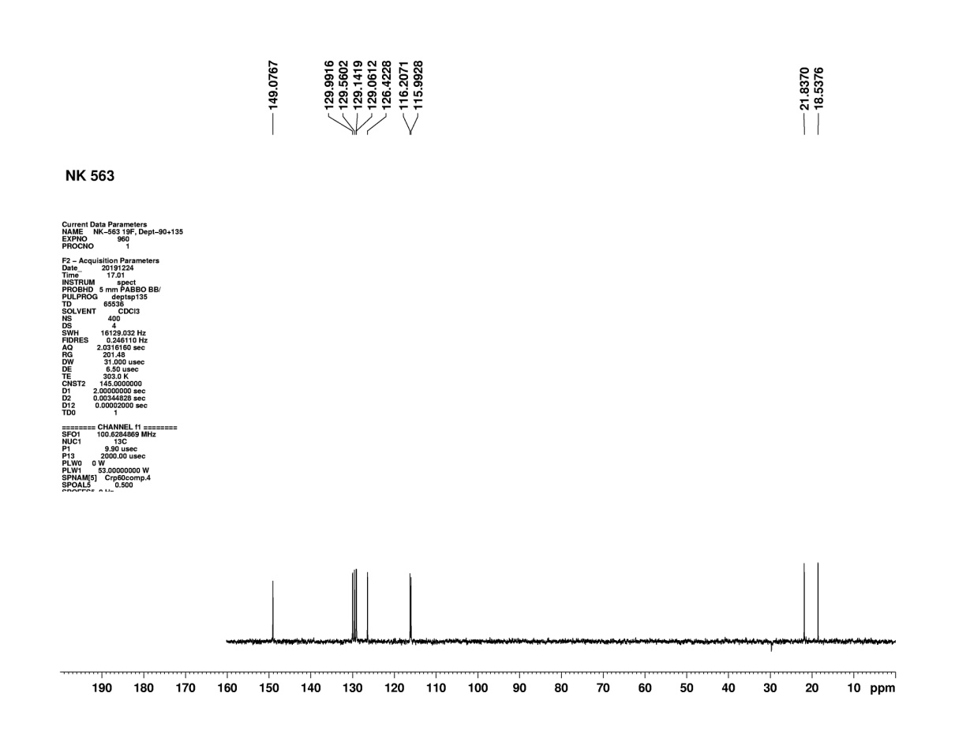
(9) DEPT-NMR-Spectra of Compound (3j) and (4a)
Figure S118: DEPT-135 NMR of compound (3j)
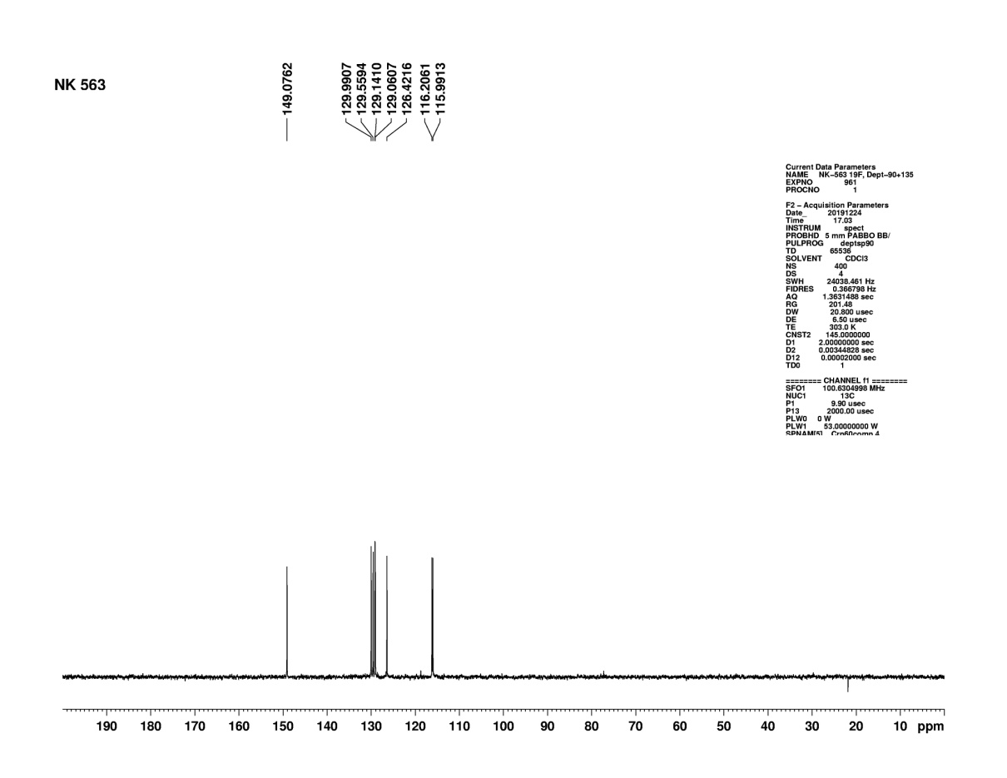
Figure S119: DEPT-90 NMR of compound (3j)
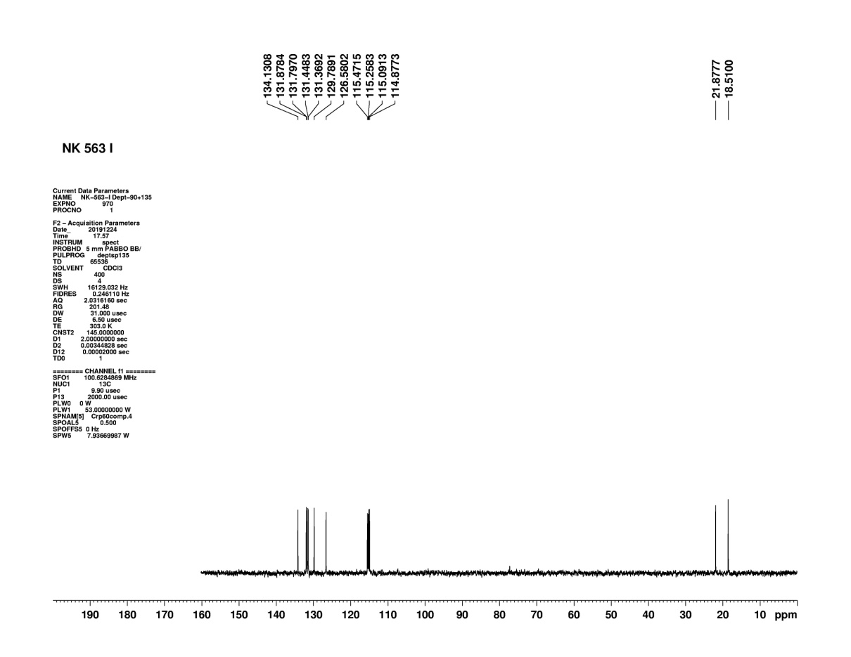
Figure S120: DEPT-135 NMR of compound (4a)
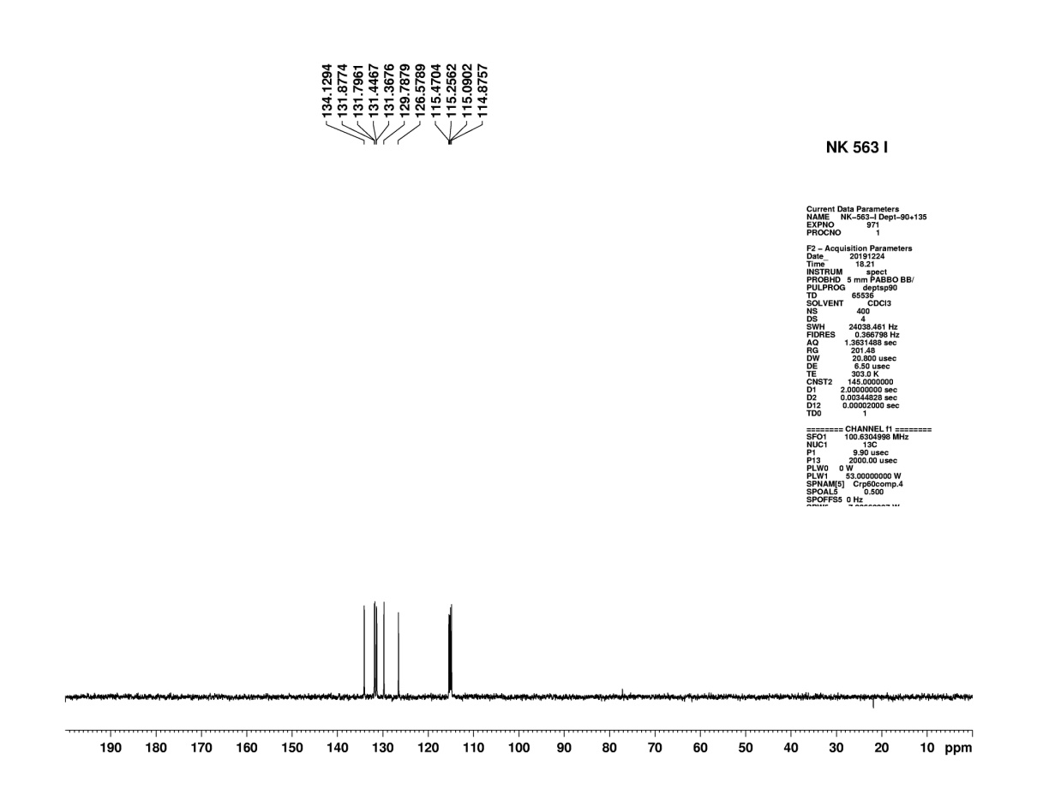

Figure S121: DEPT-90 NMR of compound (4a)

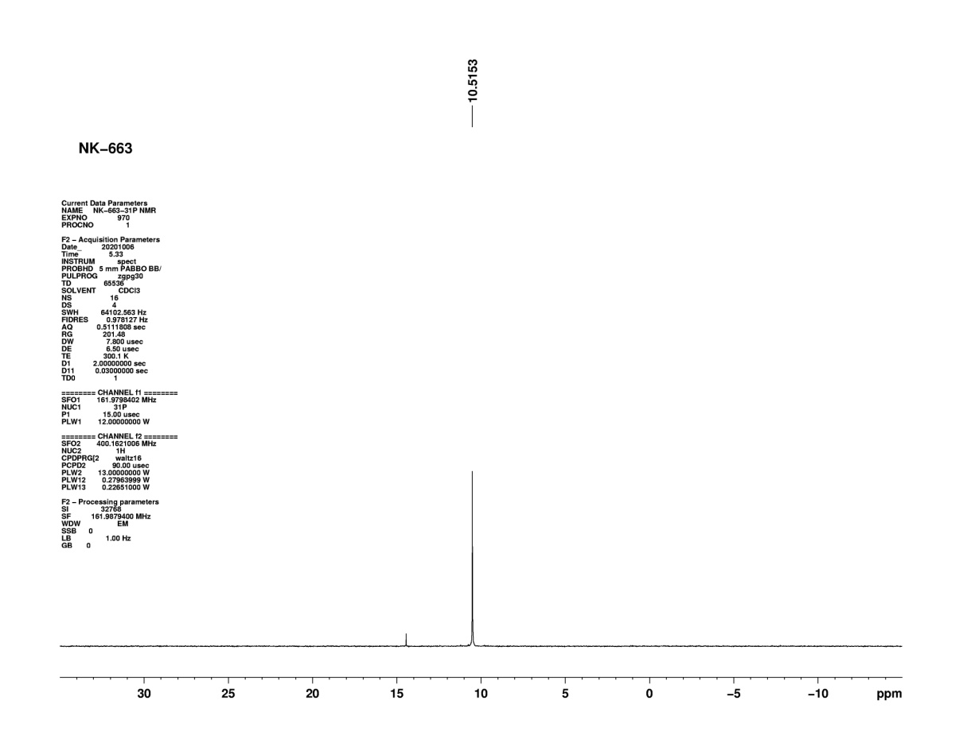
(10) ³¹P NMR-Spectra of compound (12)

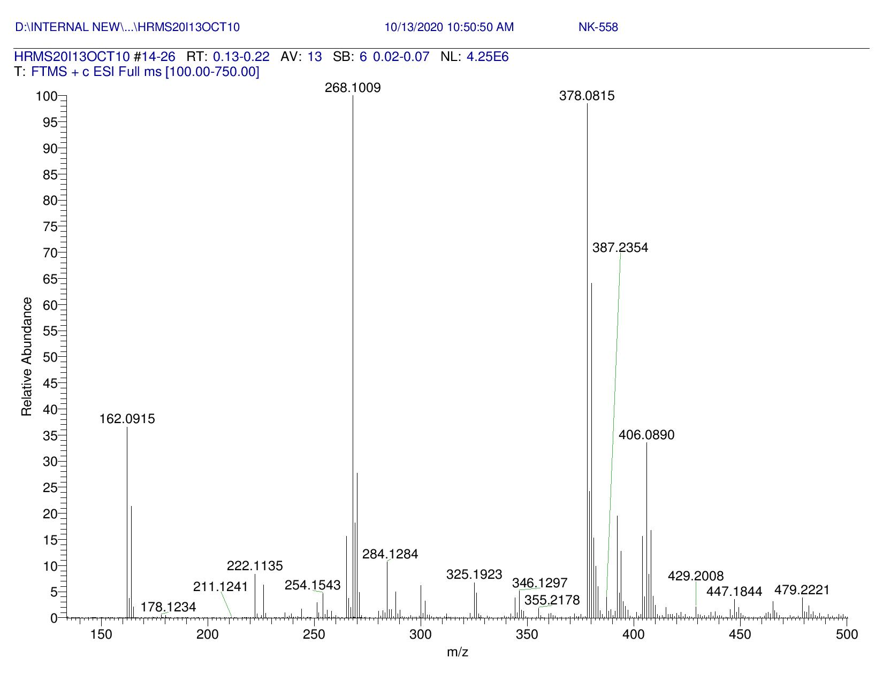
Figure S122: ³¹P NMR of compound (12)
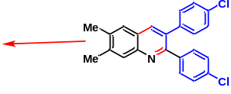
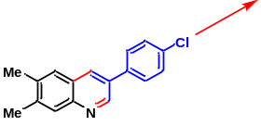

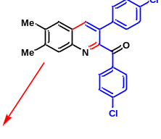

Figure S123: High Resolution Mass Spectrum of Reaction Mixture
(11) X-Ray data for compound (3b)
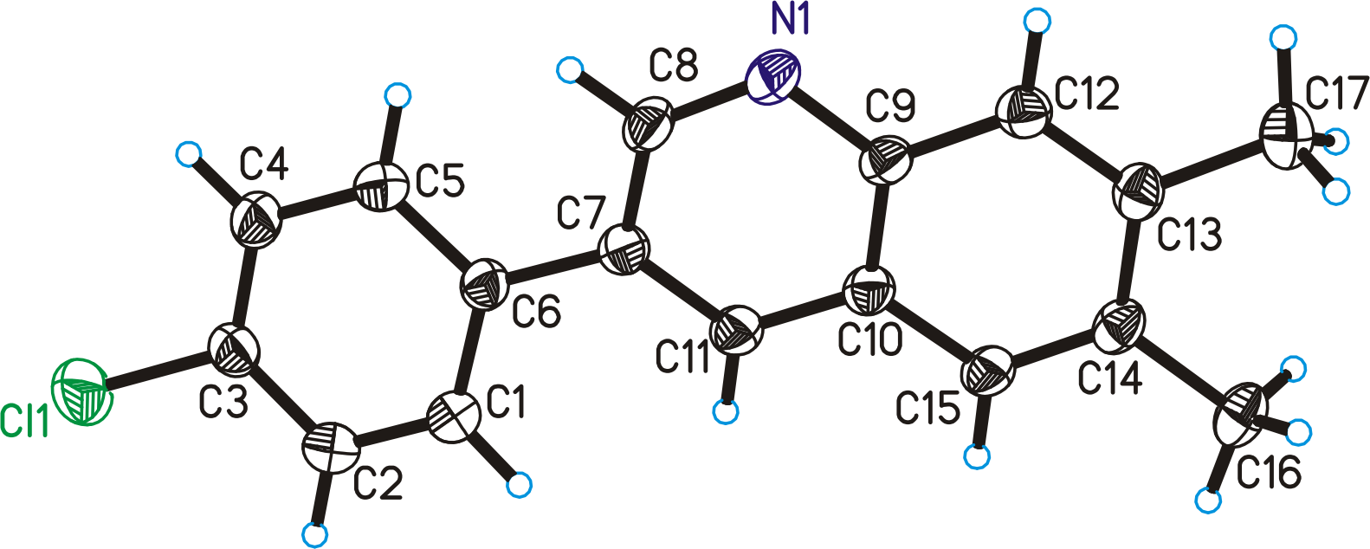

Figure S124. ORTEP diagram drawn with 30% ellipsoid probability for non-H atoms of the crystal structure of compound (3b) determined at 293 K.

X-Ray Data Collection and Structure Refinement Details:
A good quality Yellow color single crystal of size 0.38 x 0.35 x 0.23 mm, was selected under a polarizing microscope and was mounted on a glass fiber for data collection. Single crystal X-ray data for compound (3b) were collected on the Rigaku Kappa 3 circle diffractometer equipped with the AFC12 goniometer and enhanced sensitivity (HG) Saturn724+ CCD detector in the 4x4 bin mode using the monochromated Mo-Kα radiation generated from the microfocus sealed tube MicroMax-003 X-ray generator equipped with specially designed confocal multilayer optics. Data collection was performed using ω-scans of 0.5º steps at 293(2) K. Cell determinations, data collection and data reduction was performed using the Rigaku CrystalClear-SM Expert 2.1 b24¹ software. Structure solution and refinement were performed by using SHELXTL-NT². Refinement of coordinates and anisotropic thermal parameters of non-hydrogen atoms were carried out by the full-matrix least-squares method. The hydrogen atoms attached to carbon atoms were generated with idealized geometries and isotropically refined using a riding model.

- CrystalClear 2.1, Rigaku Corporation, Tokyo, Japan
- Sheldrick, G. M. Acta Crystallogr., Sect. A 2008, 64, 112–122.

Supplementary:

Table S3 Crystal data and structure refinement details for (3b).

Compound | 3b
Empirical formula | C₁₇ H₁₄ Cl N
Formula weight | 267.74
Crystal System | Triclinic
Space group | P -1
a (Å) | 6.317(2)
b (Å) | 14.516(4)
c (Å)  α (°) | 15.028(4)  105.514(9)
β (°)  γ (°) | 90.028(13)  90.068(12)
V (Å³) | 1327.8(7)
Z | 4
D_{c} (g/cm³) | 1.339
F₀₀₀ | 560
μ (mm⁻¹) | 0.272
θ_{max} (°) | 25.37
Total reflections | 8648
Unique reflections | 4468
Reflections [I > 2σ(I)] | 2252
Parameters | 348
R_{int} | 0.1586
Goodness-of-fit | 0.830
R [F² > 2σ(F²)] | 0.0935
wR (F², all data) | 0.2033
CCDC No. | 1876657

