Supplementary Information
Bioorganic Two-Photon Nanoprobes with a Photo-Oxidation Enhanced Emission Mechanism

Shukun Li^{1, 2}, Rui Chang¹, Luyang Zhao¹, Ruirui Xing^{1,3*}, Jan C. M. van Hest², Xuehai Yan^{1,3,4*}
¹ State Key Laboratory of Biochemical Engineering, Institute of Process Engineering, Beijing 100190, China
² Bio-Organic Chemistry, Institute for Complex Molecular Systems, Eindhoven University of Technology, P.O. Box 513, MB Eindhoven, The Netherlands
³ School of Chemical Engineering, University of Chinese Academy of Sciences, Beijing 100049, China
⁴ Center for Mesoscience, Institute of Process Engineering, Chinese Academy of Sciences, Beijing 100190, China

Supplementary figures

Figure S1. Chemical structure of ZHO.

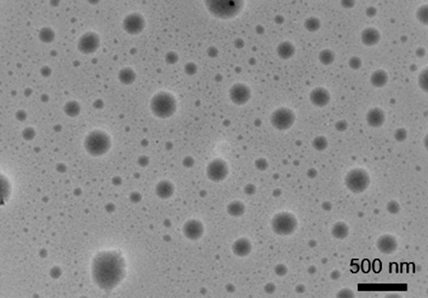
Figure S2. TEM image of ZHO/ICG nanodroplets.

Figure S3. Picture of ZHO/ICG nanodroplets and ZHO/ICG/Zn²⁺ nanoparticles (NPs) before and after aging for 24 h. The concentration of ICG was 129 µM.

Figure S4. UV-Vis absorption spectra of ICG nanodroplets and ICG NPs after aging for 24 h. The concentration of ICG was 129 µM.

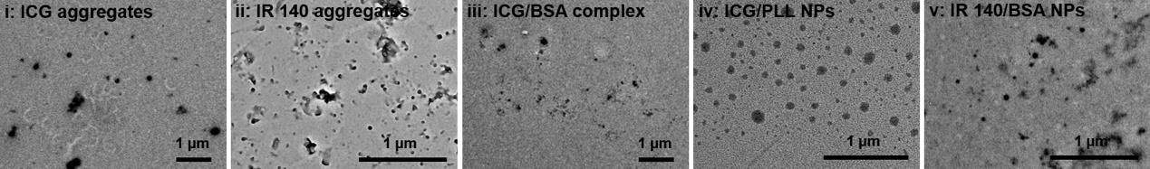
Figure S5. TEM images of (i) ICG self-aggregates at high concentration for one week; (ii) IR 140 self-aggregates; (iii) ICG/BSA complex; (iv) ICG/PLL NPs and (v) IR 140/BSA NPs.

Figure S6. CLSM images of (i) ICG self-aggregates at high concentration for one week, scale bar is 50 µm; (ii) IR 140 self-aggregates, scale bar is 10 µm; (iii) ICG/BSA complex, scale bar is 50 µm; (iv) ICG/PLL NPs, scale bar is 10 µm and (v) IR 140/BSA NPs, scale bar is 10 µm. All figures are obtained in the emission range of 495-540 nm

Figure S7. a) DLS measurements of RhB NPs. b) TEM image of RhB NPs. The insert shows a picture of the RhB NPs. c) UV-Vis absorption spectra of free RhB and RhB NPs. d) Fluorescence spectra of free RhB and RhB NPs. (e) TPA-based fluorescence spectra of free RhB and RhB NPs. f) CLSM image of RhB NPs. The emission range of red fluorescence covered the wavelength from 575 to 630 nm. The scale bar is 10 µm. The RhB concentration was 25.8 µM.

Figure S8. Computational simulation results of ICG NPs, where ZHO molecules were marked as yellow and ICG molecules were marked as blue. Dashed line and solid line indicated the geometric center distance and minimal distance between ICG molecules, respectively.

Figure S9. UV-Vis absorption spectra of a) free ICG and b) ICG NPs at different time intervals. The concentration of ICG was 129 µM.

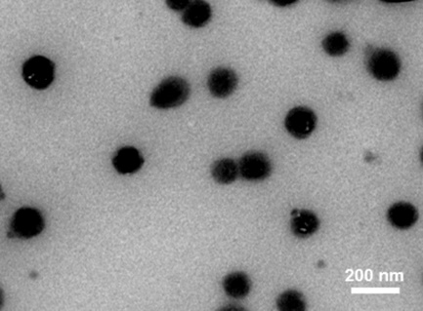
Figure S10. TEM image of the ICG NPs after incubation in 10% FBS at 37 ºC for 24 h. The scale bar is 200 nm.

Figure S11. Viability of MCF-7 cells treated with ICG NPs and RhB NPs. Error bars denote the standard deviation (n = 6).

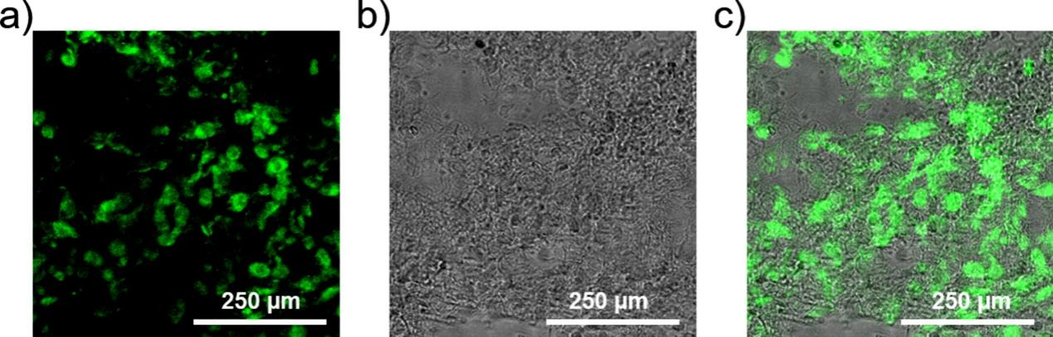
Figure S12. Images of biopsies of tumor tissue extracted from mice after intravenous injection of ICG NP at 24 h. The images show that the ICG NPs were uptaken by the tumor and evenly distributed in the cellular cytoplasm. The scale bar is 250 µm.

Supplementary tables

Table S1. Encapsulation of ICG in NPs at different concentrations with adding 2.64 mM ZHO.

Table S2. Size, polydispersity index (PDI) and zeta potential of nanoprobes.

Table S3. Slopes of fitted line from ICG-, IR 140- and IR 806-based probes.

Table S4. TPA cross section of free RhB, RhB NPs, free ICG and ICG NPs at 808 nm excited by a Ti: Sapphire oscillator laser. RhB dissolved in methanol is used as a reference.

Table S5. Size, polydispersity index (PDI) and zeta potential of ICG NPs before and after incubation in incubation in 10% FBS at 37 ºC for 24 h.

