Supplementary Information
For the journal of (Cellulose)
Hierarchical pores in degradable polymers-based aerogel for CO₂ adsorption
Lin Gan^{a,b,∗}, Shuyu Zheng^{a,b,∗}, Jin Huang^{a,b,∗∗}
a State Key Laboratory of Silkworm Genome Biology, and Chongqing Key Laboratory of Soft-Matter Material Chemistry and Function Manufacturing, School of Chemistry and Chemical Engineering, Southwest University, No.2, Tiansheng Road, Beibei Distinct, Chongqing 400715, China
b School of Chemistry and Chemical Engineering, and Engineering Research Center of Materials-Oriented Chemical Engineering of Xinjiang Bintuan, Shihezi University, Shihezi 832003, China
Corresponding Author: Prof. Jin Huang, Email: huangjin2015@swu.edu.cn

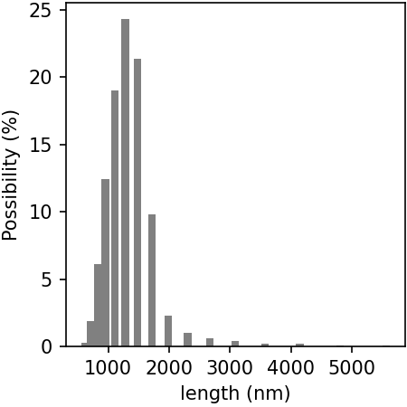
Figure S1 The size distribution of neat MIL-100(Fe) particles.

Figure S2. Typical SEM images of the aerogels for (a) PVA, (b) OCN/PVA, (c-f) MIL-100(Fe)@OCN/PVA. The ωMIL−100(Fe) of those MIL-100(Fe)@OCN/PVA is 5, and the y for (c), (d), (e), and (f) is 9.5, 9, 8, and 7, respectively.

