Supplementary Data for
The Effect of Metals on Zeolite Crystallization Kinetics with Relevance to Nuclear Waste Glass Corrosion
Adam J. Mallette¹, Joelle T. Reiser², Giannis Mpourmpakis³, Radha K. Motkuri², James J. Neeway^{2,}*, Jeffrey D. Rimer^{1,}*
¹Department of Chemical and Biomolecular Engineering, University of Houston, Houston, TX 77204, USA
²Pacific Northwest National Laboratory, Energy and Environment Directorate, Richland, WA 99354, USA
³Department of Chemical and Petroleum Engineering, University of Pittsburgh, Pittsburgh, PA 15213, USA
*Correspondence sent to: james.neeway@pnnl.gov and jrimer@central.uh.edu

Table of Contents
Supplementary Figures 2
Supplementary Tables 10
References 15

List of Figures and Tables
Figure S1: Crystallization kinetics of zeolite GIS in a conventional synthesis at 100°C
Figure S2: PXRD patterns of conventional GIS syntheses with elemental additives
Figure S3: PXRD patterns of products generated from glass-replicating syntheses
Figure S4: PXRD reference patterns of phases observed in glass-replicating syntheses
Figure S5: Correlations between GIS produced and elements besides calcium
Figure S6: Relationship between GIS product and calcium molar ratio by class
Figure S7: Correlations between burtite produced and elements besides tin
Figure S8: Periodic table comparisons of elemental effects in conventional and eLAW syntheses

Table S1: Compositions of eLAW glasses synthesized by Crum et al. [1]
Table S2: eLAW synthesis mixtures designed to replicate glass compositions
Table S3: Mass % of oxides in select representative eLAW glass formulations
Table S4: Molar ratio of oxides in select representative eLAW synthesis mixtures
Table S5: Crystal phase outcomes of glass-replicating syntheses

Supplementary Figures

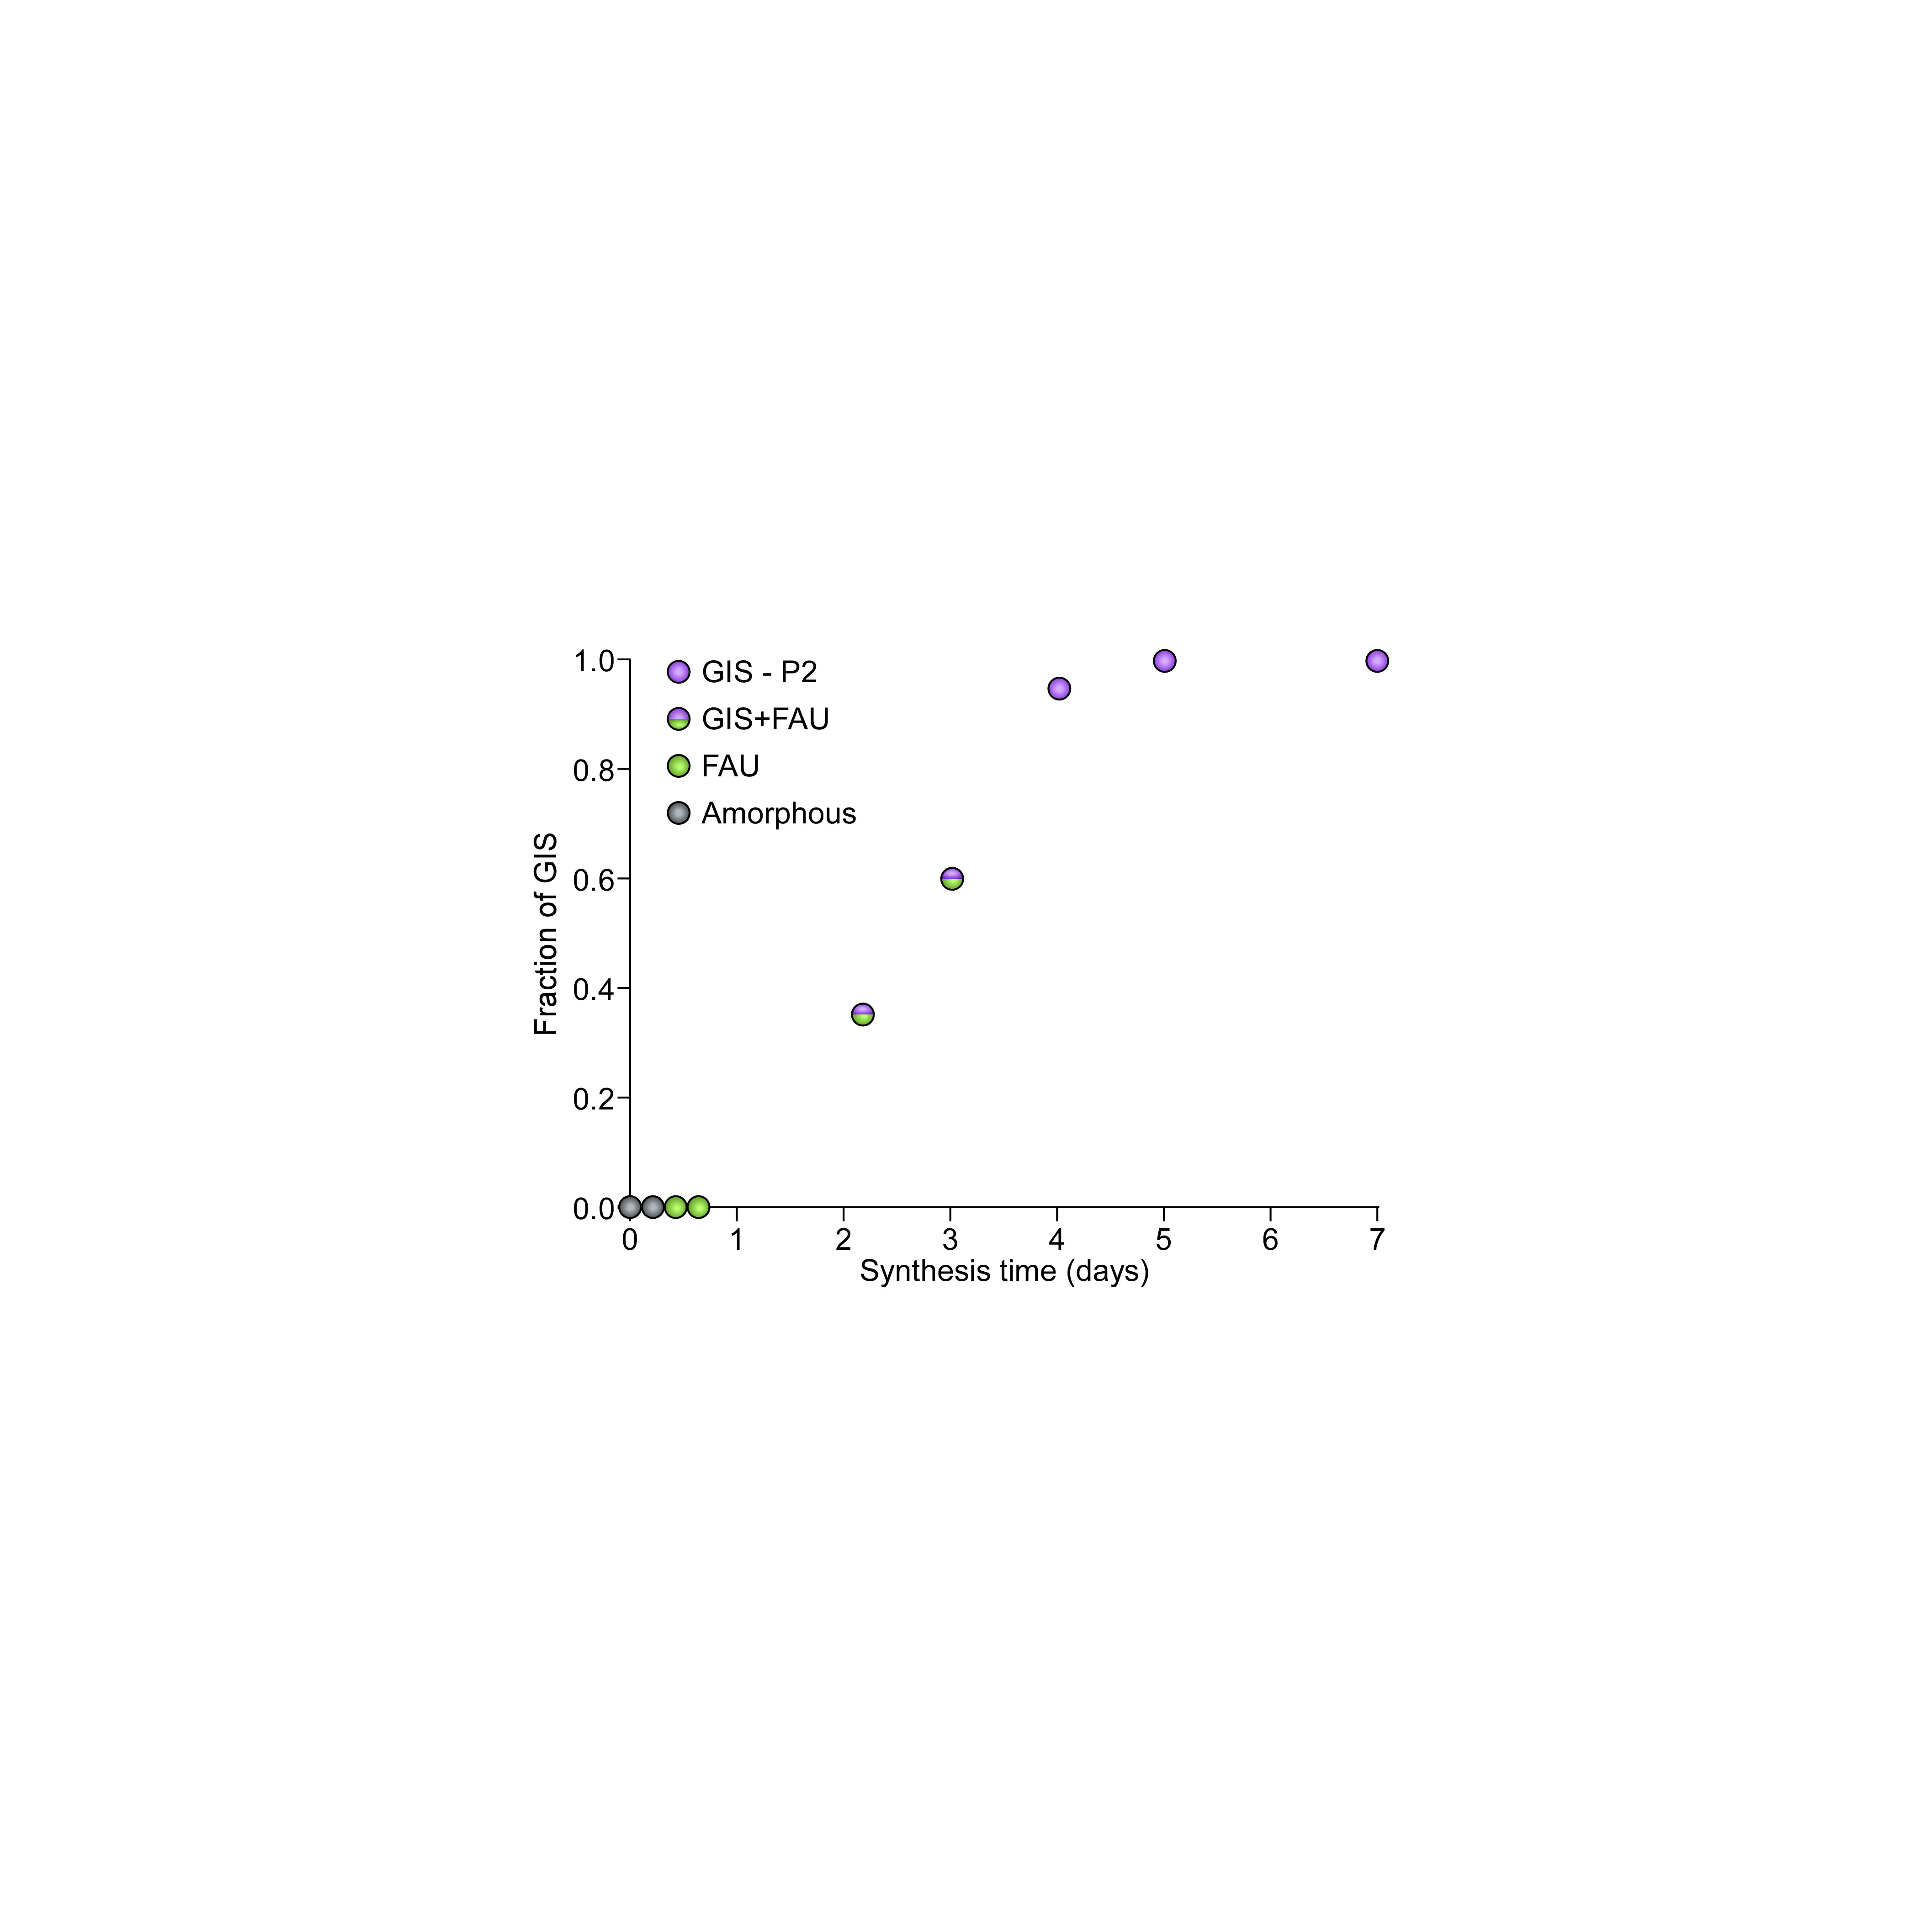
Figure S1. Time-resolved crystallization curve of zeolite GIS via the interzeolite transformation from FAU to GIS. A synthesis mixture with a molar composition of 9 SiO₂:0.5 Al₂O₃:5.5 Na₂O:190 H₂O was heated at 100°C for various times (0–7 days). Product phases were quantified from PXRD patterns as amorphous (grey), FAU (green), FAU + GIS (green/purple), and GIS with polymorph P2 (purple). Figure adapted using data from ref. [2]

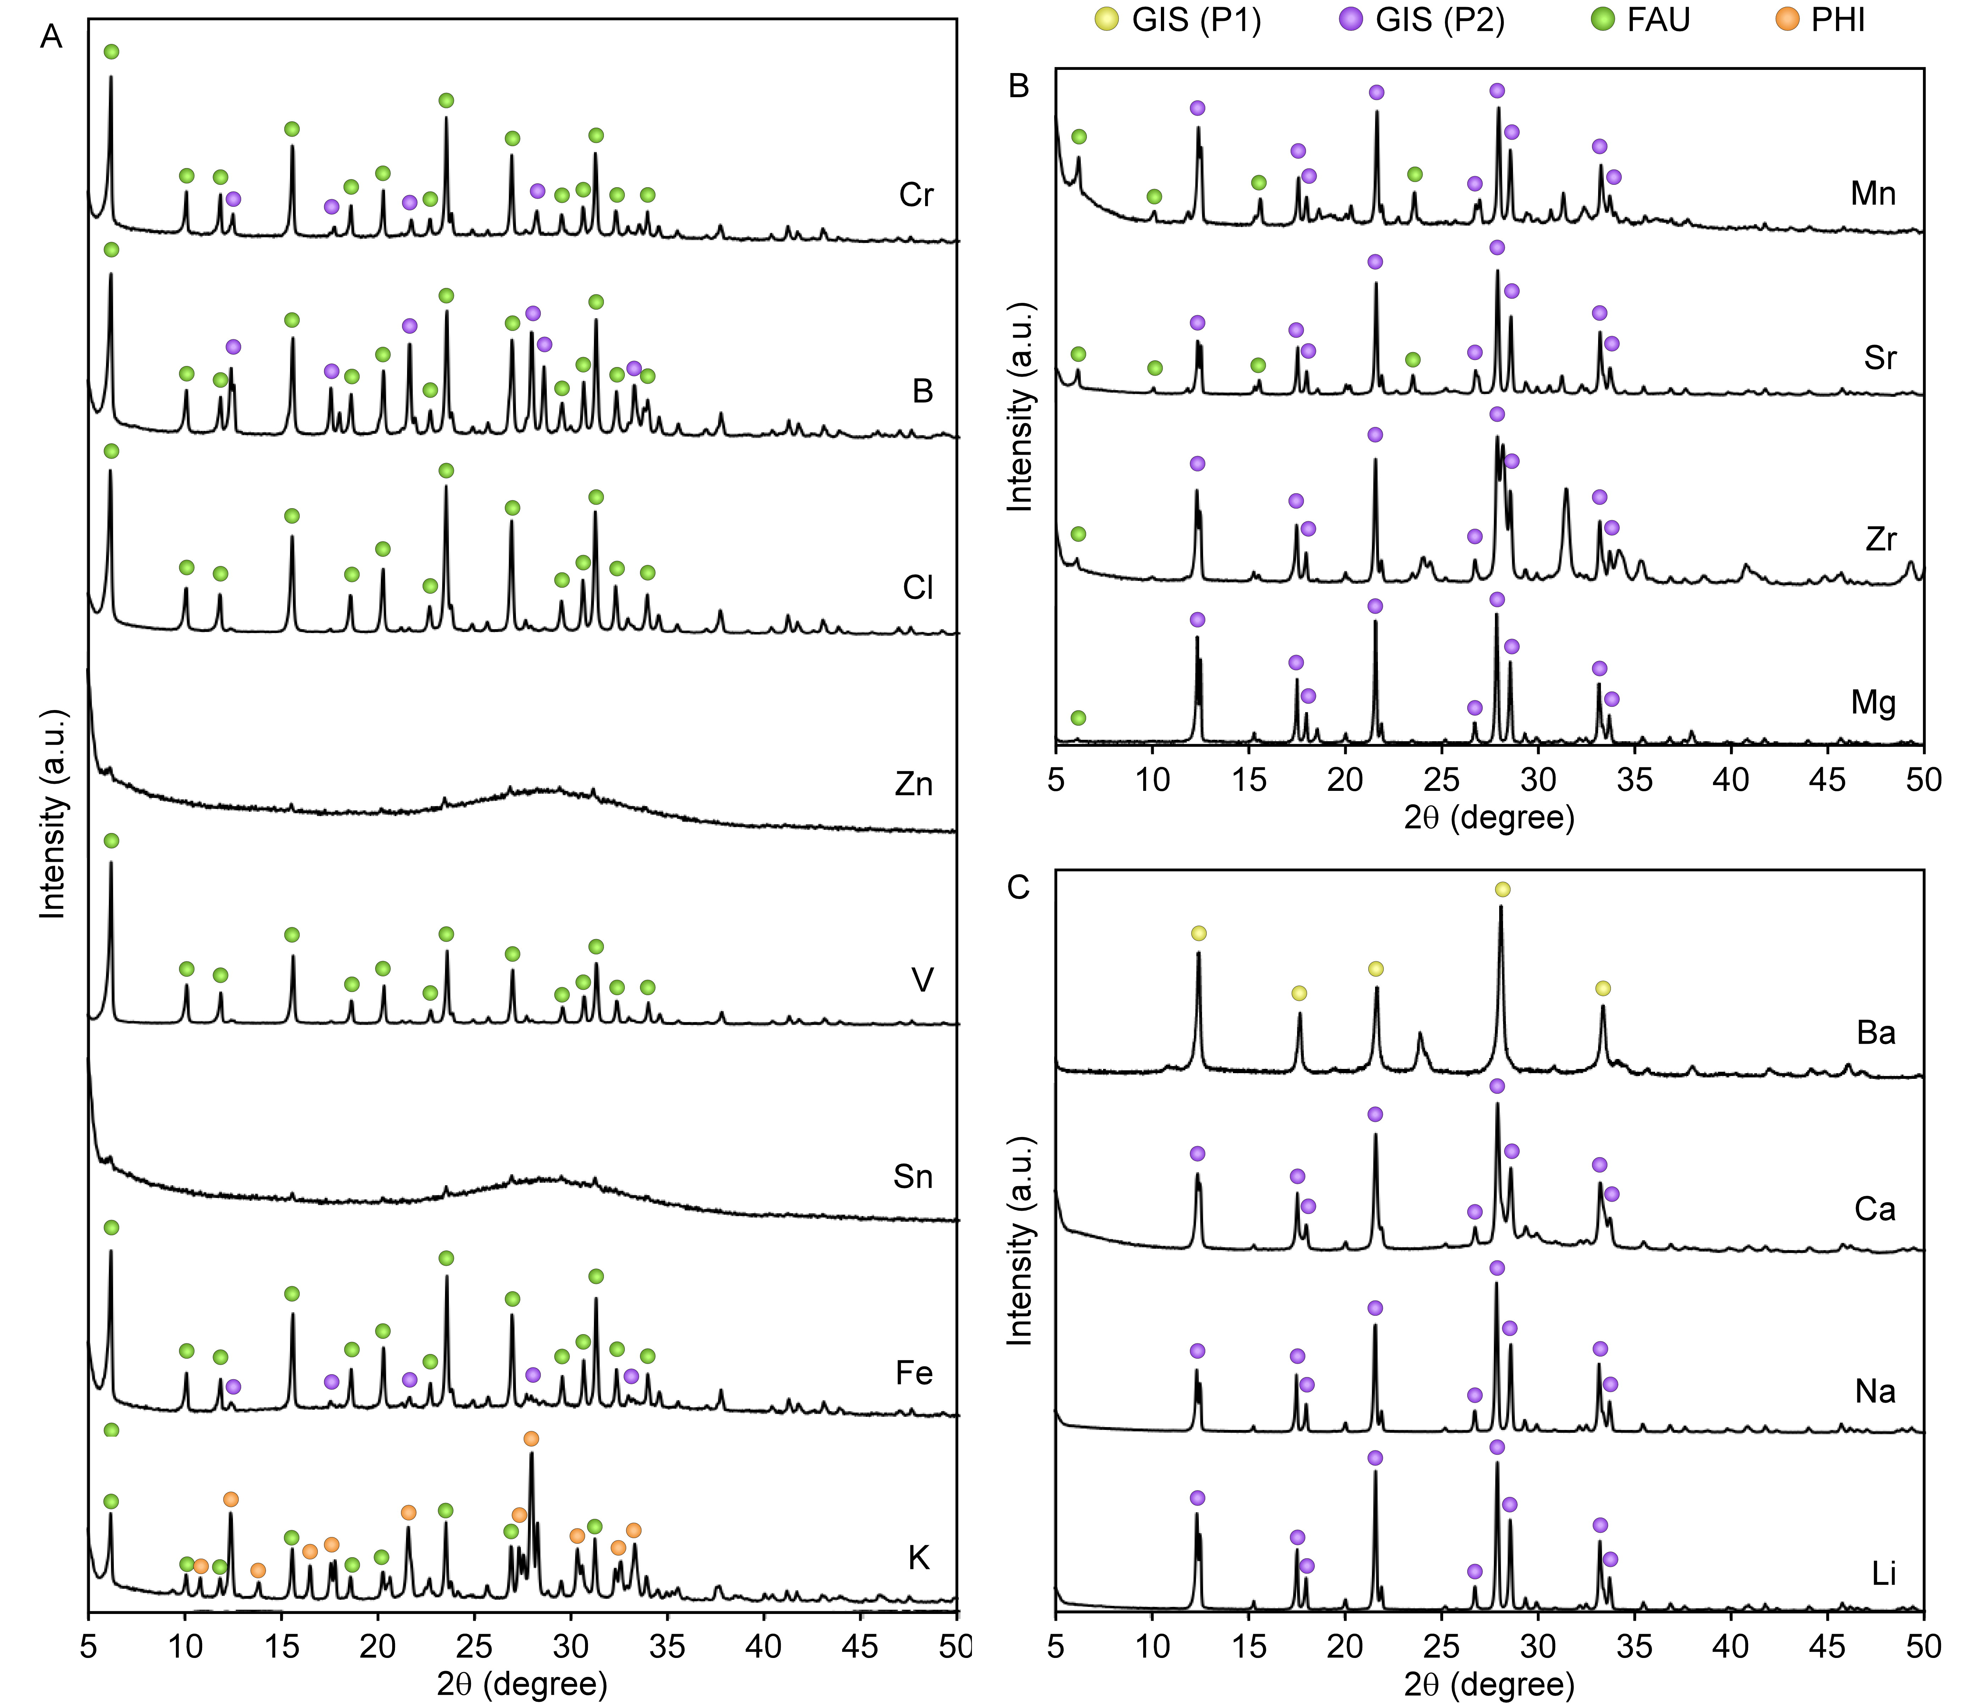
Figure S2. PXRD patterns of zeolite syntheses with elemental additives reveal the effect of each element on zeolite GIS crystallization kinetics as (A) a suppressor, (B) neutral, or (C) an accelerant. Syntheses possessing a molar composition of 9 Si:1 Al:11 Na:0.2 M:190 H₂O, where M corresponds to the element added, were carried out for 3 days at 100°C. Circles indicate select peaks from phases present: GIS (P1), yellow; GIS (P2), purple; FAU, green; and PHI, orange. Given that crystallization follows the Ostwald rule of stages and undergoes conversion from amorphous to FAU to GIS, suppression is indicated by an increase in the amount of either FAU or amorphous material relative to the control (Fig. S1, 3 days). Amorphous material is represented by a broad peak from ~25-35 degrees (2θ).

Figure S3. PXRD patterns of solids generated from 24 glass-mimicking syntheses. Synthesis number (corresponding to Table S1) is located at the right-hand side of each pattern, with “eLAW” omitted for brevity. Vertical dashed lines indicate peak positions for GIS (P1) (red), burtite (yellow), and MgO internal standard (blue). Additional peaks correspond to LTA (eLAW-1 and eLAW-23) and FAU (eLAW-20).

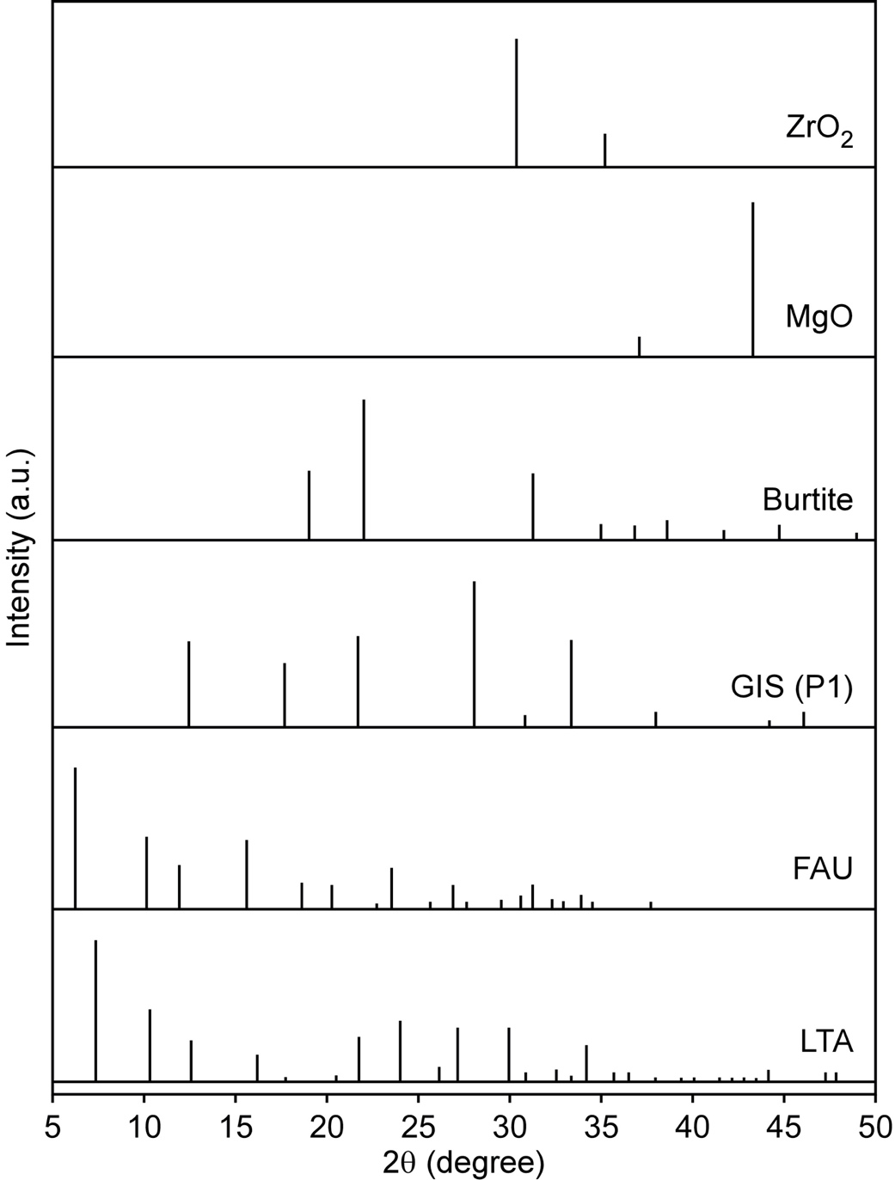
Figure S4. PXRD reference patterns for crystal phases observed as products of glass-mimicking syntheses: zeolites FAU, LTA, and GIS; burtite (calcium hexahydroxystannate – Ca[Sn(OH)₆]); MgO internal standard; and ZrO₂.

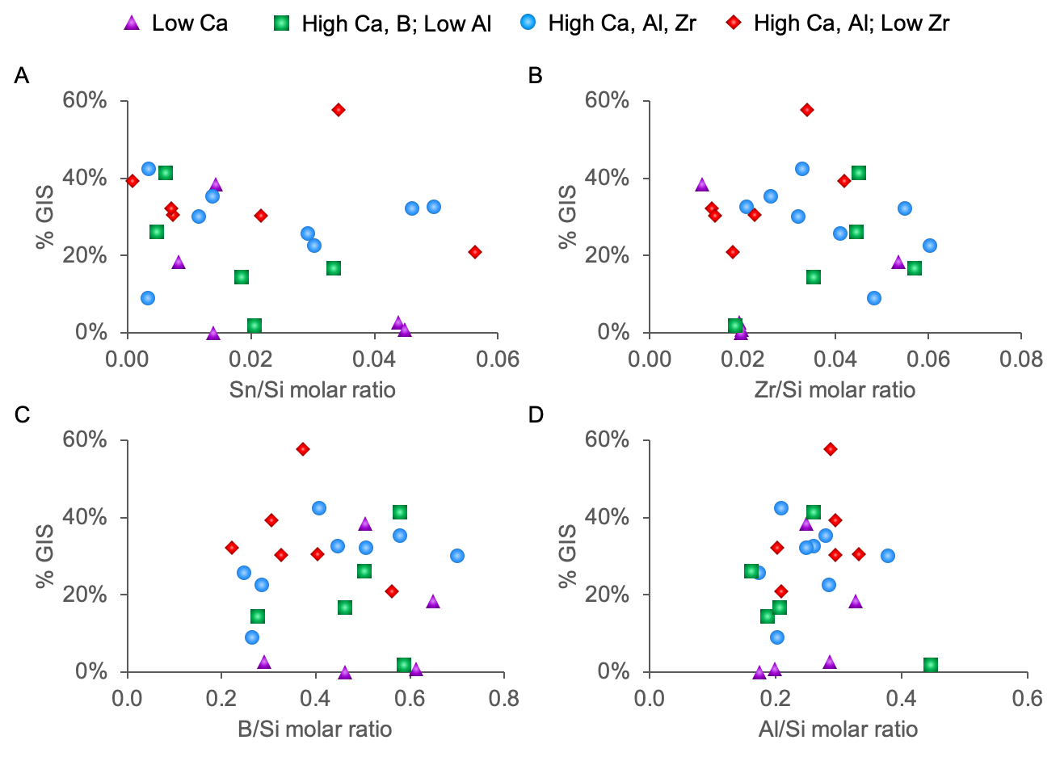
Figure S5. Zeolite GIS product yield as a function of molar ratios in the synthesis mixture besides calcium: (A) tin, (B) zirconium, (C) boron, and (D) aluminum. The absence of a clear trend in each graph suggests that Ca is the primary factor in determining the amount of GIS product, although tin may also be significant (Fig. 6). Color coding of data points is based on the classification of each glass according to Fig. 3A, which corresponds to alteration responses for glasses with low Ca (purple triangles); high Ca, Al, Zr (blue circles); high Ca, B, and low Al (green squares); and high Ca, Al, and low Zr (red diamonds).

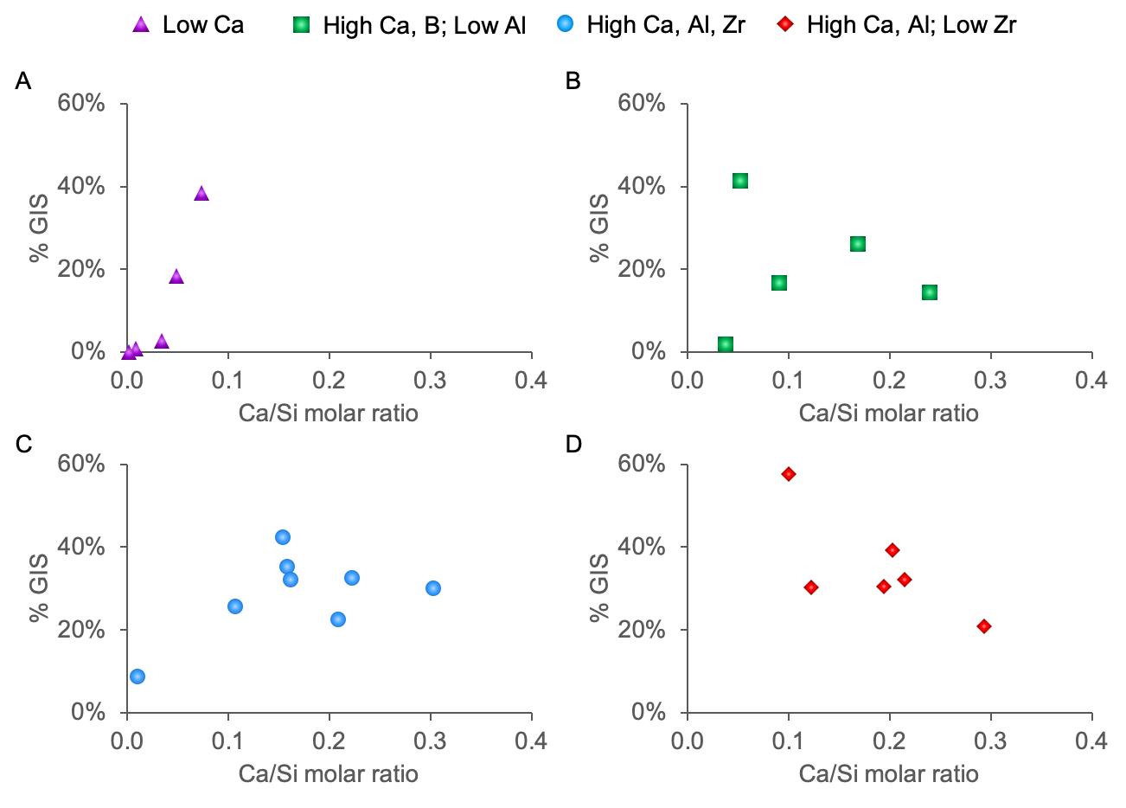
Figure S6. Zeolite GIS product yield as a function of the Ca/Si molar ratio in the synthesis mixture separated based on glass classification (as denoted by the color coding used in Fig. 3b), which corresponds to alteration responses for glasses with low Ca (purple triangles); high Ca, Al, Zr (blue circles); high Ca, B, and low Al (green squares); and high Ca, Al, and low Zr (red diamonds).

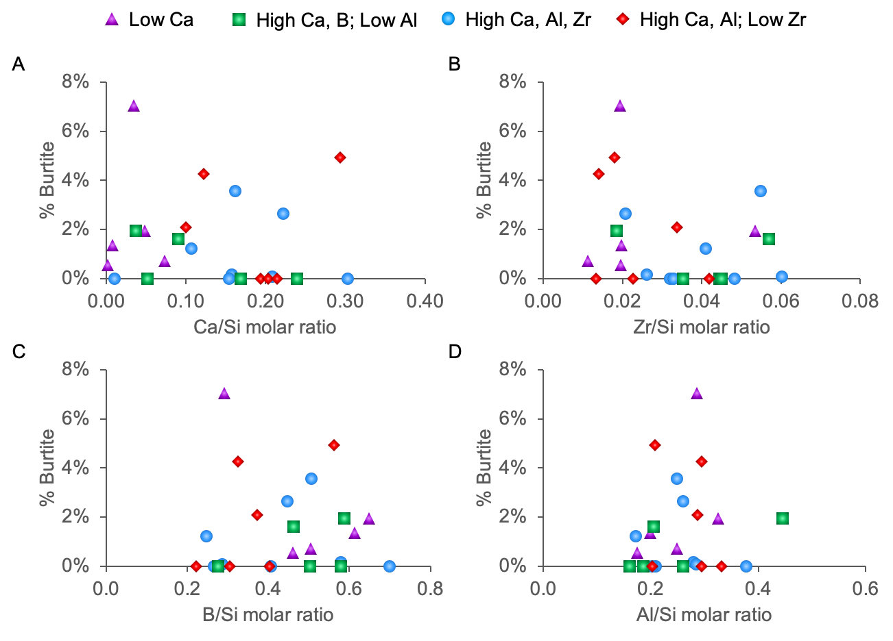
Figure S7. Burtite product yield as a function of molar ratios in synthesis mixtures besides tin: (A) calcium, (B) zirconium, (C) boron, and (D) aluminum. The absence of a clear trend in each graph indicates that the amount of tin is the predominant factor determining the quantity of burtite formed. Color coding of data points is based on the classification of each glass according to Fig. 3a, which corresponds to alteration responses for glasses with low Ca (purple triangles); high Ca, Al, Zr (blue circles); high Ca, B, and low Al (green squares); and high Ca, Al, and low Zr (red diamonds).

A
B
Figure S8. Comparison of elemental species’ effect on zeolite GIS crystallization rates using (A) conventional synthesis conditions and (B) synthesis conditions designed to replicate eLAW glass compositions.

Supplementary Tables

Table S1. eLAW glass compositions (mass %) [1]
Glass ID | Al₂O₃ | B₂O₃ | CaO | Na₂O | SiO₂ | ZrO₂ | SnO₂ | Others
eLAW01 | 0.0922 | 0.0659 | 0.0127 | 0.2350 | 0.3978 | 0.0159 | 0.0394 | 0.1411
eLAW02 | 0.0887 | 0.1467 | 0.0523 | 0.2441 | 0.3751 | 0.0232 | 0.0116 | 0.0585
eLAW03 | 0.0637 | 0.1484 | 0.0733 | 0.1501 | 0.4546 | 0.0489 | 0.0055 | 0.0555
eLAW04 | 0.0892 | 0.0628 | 0.0719 | 0.1924 | 0.3568 | 0.0452 | 0.0240 | 0.1577
eLAW05 | 0.0696 | 0.1697 | 0.0021 | 0.2042 | 0.4291 | 0.0179 | 0.0481 | 0.0593
eLAW06 | 0.1108 | 0.1571 | 0.0174 | 0.1829 | 0.3880 | 0.0463 | 0.0079 | 0.0894
eLAW07 | 0.0754 | 0.0755 | 0.0962 | 0.1541 | 0.4236 | 0.0312 | 0.0211 | 0.1228
eLAW08 | 0.0634 | 0.0617 | 0.0402 | 0.2498 | 0.4263 | 0.0420 | 0.0299 | 0.0867
eLAW09 | 0.1138 | 0.0994 | 0.0667 | 0.1670 | 0.3800 | 0.0163 | 0.0048 | 0.1521
eLAW10 | 0.1203 | 0.1701 | 0.0989 | 0.1567 | 0.3502 | 0.0262 | 0.0070 | 0.0706
eLAW11 | 0.0793 | 0.1171 | 0.0577 | 0.1928 | 0.4348 | 0.0251 | 0.0024 | 0.0909
eLAW12 | 0.0875 | 0.1404 | 0.0262 | 0.1778 | 0.4152 | 0.0108 | 0.0177 | 0.1244
eLAW13 | 0.0940 | 0.1215 | 0.0837 | 0.1549 | 0.4095 | 0.0195 | 0.0499 | 0.0671
eLAW14 | 0.0730 | 0.0977 | 0.0488 | 0.2162 | 0.3502 | 0.0427 | 0.0410 | 0.1305
eLAW15 | 0.1013 | 0.0777 | 0.0739 | 0.2338 | 0.3937 | 0.0383 | 0.0012 | 0.0802
eLAW16 | 0.0608 | 0.1370 | 0.0003 | 0.1662 | 0.4600 | 0.0207 | 0.0137 | 0.1414
eLAW17 | 0.0862 | 0.0655 | 0.0874 | 0.1962 | 0.4681 | 0.0136 | 0.0095 | 0.0735
eLAW18 | 0.0777 | 0.1312 | 0.0162 | 0.2239 | 0.3644 | 0.0326 | 0.0055 | 0.1485
eLAW19 | 0.0690 | 0.1136 | 0.0316 | 0.1591 | 0.3900 | 0.0482 | 0.0327 | 0.1558
eLAW20 | 0.0724 | 0.0686 | 0.0046 | 0.2412 | 0.4465 | 0.0496 | 0.0032 | 0.1140
eLAW21 | 0.0978 | 0.0959 | 0.0355 | 0.1980 | 0.4063 | 0.0329 | 0.0317 | 0.1019
eLAW22 | 0.1085 | 0.0880 | 0.0465 | 0.2262 | 0.4451 | 0.0152 | 0.0203 | 0.0503
eLAW23 | 0.1246 | 0.1280 | 0.0103 | 0.2472 | 0.3528 | 0.0140 | 0.0166 | 0.1065
eLAW24 | 0.0617 | 0.1301 | 0.0884 | 0.1801 | 0.3616 | 0.0152 | 0.0457 | 0.1172

Table S2. Molar ratios in growth mixtures of glass-mimicking syntheses
Glass ID | H₂O | Al₂O₃ | B₂O₃ | CaO | Na₂O | SiO₂ | ZrO₂ | SnO₂
eLAW01 | 1270 | 8.6 | 8.8 | 2.1 | 29.8 | 60.1 | 1.2 | 2.6
eLAW02 | 1270 | 8.4 | 17.4 | 9.5 | 29.8 | 60.1 | 1.6 | 0.8
eLAW03 | 1270 | 4.9 | 15.2 | 10.2 | 30.4 | 60.3 | 2.7 | 0.3
eLAW04 | 1270 | 8.6 | 8.6 | 12.5 | 29.7 | 60.2 | 3.6 | 1.8
eLAW05 | 1270 | 6.0 | 18.5 | 0.5 | 30.0 | 60.4 | 1.2 | 2.7
eLAW06 | 1270 | 9.8 | 19.5 | 2.9 | 29.7 | 60.2 | 3.2 | 0.5
eLAW07 | 1270 | 5.7 | 8.4 | 14.5 | 29.4 | 60.6 | 2.1 | 1.1
eLAW08 | 1270 | 5.4 | 7.7 | 6.6 | 30.5 | 62.2 | 2.6 | 1.8
eLAW09 | 1270 | 10.0 | 12.1 | 11.7 | 29.1 | 60.2 | 1.4 | 0.4
eLAW10 | 1270 | 11.3 | 21.0 | 18.1 | 30.5 | 60.0 | 1.9 | 0.7
eLAW11 | 1270 | 6.3 | 12.2 | 9.2 | 30.3 | 59.9 | 2.0 | 0.2
eLAW12 | 1270 | 7.4 | 15.0 | 4.4 | 30.1 | 59.5 | 0.7 | 0.8
eLAW13 | 1270 | 7.8 | 13.3 | 13.2 | 30.3 | 59.6 | 1.2 | 3.0
eLAW14 | 1270 | 7.5 | 15.2 | 9.7 | 30.7 | 59.8 | 3.3 | 2.8
eLAW15 | 1270 | 9.0 | 9.3 | 12.4 | 30.2 | 60.9 | 2.5 | 0.1
eLAW16 | 1270 | 5.3 | 13.9 | 0.1 | 31.2 | 60.1 | 1.2 | 0.8
eLAW17 | 1270 | 6.1 | 6.7 | 12.9 | 30.7 | 60.0 | 0.8 | 0.4
eLAW18 | 1270 | 7.9 | 17.5 | 3.2 | 30.8 | 60.4 | 2.7 | 0.4
eLAW19 | 1270 | 6.2 | 13.9 | 5.4 | 30.3 | 60.0 | 3.4 | 2.0
eLAW20 | 1270 | 6.1 | 8.0 | 0.6 | 29.6 | 59.9 | 2.9 | 0.2
eLAW21 | 1270 | 8.7 | 11.3 | 6.1 | 29.8 | 60.5 | 2.0 | 2.1
eLAW22 | 1270 | 9.0 | 9.9 | 7.4 | 29.7 | 60.6 | 0.8 | 1.3
eLAW23 | 1270 | 13.5 | 17.9 | 2.3 | 30.0 | 60.7 | 1.1 | 1.3
eLAW24 | 1270 | 6.3 | 17.0 | 17.8 | 30.2 | 60.5 | 1.1 | 3.4
Color coding of data points is based on the classification of each glass according to Fig. 3A, which corresponds to alteration responses for glasses with low CaO (Type 1, purple); high CaO, Al₂O₃, ZrO₂ (Type 2, blue); high CaO, B₂O₃, and low Al₂O₃ (Type 3, green); and high CaO, Al₂O₃, and low ZrO₂ (Type 4, red).

Table S3. Oxide percentage of the original glass compositions of 4 select eLAW glasses [1]
Oxide | eLAW-1 | eLAW-2 | eLAW-7 | eLAW-17
Al₂O₃ | 9.2% | 8.9% | 7.5% | 8.6%
B₂O₃ | 6.6% | 14.7% | 7.6% | 6.5%
CaO | 1.3% | 5.2% | 9.6% | 8.7%
Cl⁻ | 0.4% | 0.1% | 0.3% | 0.2%
Cr₂O₃ | 0.8% | 0.3% | 0.7% | 0.4%
F⁻ | 0.5% | 0.2% | 0.5% | 0.3%
Fe₂O₃ | 1.0% | 0.4% | 0.9% | 0.5%
K₂O | 1.7% | 0.7% | 1.5% | 0.9%
MgO | 1.1% | 0.5% | 1.0% | 0.6%
Na₂O | 23.5% | 24.4% | 15.4% | 19.6%
P₂O₅ | 1.2% | 0.5% | 1.0% | 0.6%
SiO₂ | 39.8% | 37.5% | 42.4% | 46.8%
SnO₂ | 3.9% | 1.2% | 2.1% | 0.9%
SO₃ | 0.9% | 0.4% | 0.7% | 0.4%
V₂O₅ | 1.7% | 0.7% | 1.5% | 0.9%
ZnO | 4.8% | 2.0% | 4.2% | 2.5%
ZrO₂ | 1.6% | 2.3% | 3.1% | 1.4%

Table S4. Oxide molar ratios of 4 select zeolite synthesis mixtures designed to replicate eLAW glass compositions.
Oxide | eLAW-1 | eLAW-2 | eLAW-7 | eLAW-17
Al₂O₃ | 8.2 | 8.4 | 6.3 | 6.5
B₂O₃ | 8.6 | 20.3 | 9.2 | 7.2
CaO | 2.1 | 9.0 | 14.7 | 12.1
Na₂O | 30.1 | 30.1 | 30.1 | 30.1
SiO₂ | 60.2 | 60.2 | 60.2 | 60.2
SnO₂ | 2.4 | 0.7 | 1.2 | 0.5
ZrO₂ | 1.2 | 1.8 | 2.2 | 0.9
H₂O | 1270 | 1270 | 1270 | 1270

The molar composition of H₂O, Na₂O, and SiO₂ are held constant across all synthesis mixtures to maintain consistency in Si concentration and pH.
Color coding of rows is based on the classification of each glass according to Fig. 3A, which corresponds to alteration responses for glasses with low CaO (purple); high CaO, Al₂O₃, ZrO₂ (blue); high CaO, B₂O₃, and low Al₂O₃ (green); and high CaO, Al₂O₃, and low ZrO₂ (red).

Table S5. Product phases (wt. %) in glass mimicking syntheses determined using TOPAS
Glass ID | GIS | burtite | ZrO₂ | FAU | LTA | amorphous
eLAW01 | 3% | 7% | 1% | - | 10% | 79%
eLAW02 | 35% | - | 2% | - | - | 63%
eLAW03 | 26% | - | 2% | - | - | 72%
eLAW04 | 22% | - | 1% | - | - | 76%
eLAW05 | 1% | 1% | 1% | - | - | 97%
eLAW06 | 18% | 2% | 3% | - | - | 77%
eLAW07 | 14% | - | - | - | - | 85%
eLAW08 | 26% | 1% | 2% | - | - | 71%
eLAW09 | 31% | - | 1% | - | - | 68%
eLAW10 | 30% | - | 1% | - | - | 69%
eLAW11 | 42% | - | 2% | - | - | 56%
eLAW12 | 38% | 1% | 2% | - | - | 59%
eLAW13 | 33% | 3% | 1% | - | - | 63%
eLAW14 | 32% | 4% | 2% | - | - | 62%
eLAW15 | 39% | - | 2% | - | - | 58%
eLAW16 | - | 1% | 1% | - | - | 99%
eLAW17 | 32% | - | 1% | - | - | 67%
eLAW18 | 41% | - | 3% | - | - | 56%
eLAW19 | 17% | 2% | 3% | - | - | 79%
eLAW20 | 9% | - | 5% | 8% | - | 78%
eLAW21 | 58% | - | 4% | - | - | 36%
eLAW22 | 30% | - | 1% | - | - | 64%
eLAW23 | 2% | 2% | 1% | - | 8% | 88%
eLAW24 | 21% | 5% | 1% | - | - | 73%
Color coding of rows is based on the classification of each glass according to Fig. 3A, which corresponds to alteration responses for glasses with low CaO (purple); high CaO, Al₂O₃, ZrO₂ (blue); high CaO, B₂O₃, and low Al₂O₃ (green); and high CaO, Al₂O₃, and low ZrO₂ (red).

References

[1] J. V. Crum, J. T. Reiser, B. P. Parruzot, J. J. Neeway, J. F. Bonnett, S. N. Kerisit, S. K. Cooley, J. V. Ryan, G. L. Smith and R. M. Asmussen, Journal of the American Ceramic Society, 2021, 104, 4145-4162.

[2] Mallette, A. J. et al. Heteroatom Manipulation of Zeolite Crystallization: Stabilizing Zn-FAU against Interzeolite Transformation. JACS Au, doi:10.1021/jacsau.2c00325 (2022).

