Supplementary Material

Results for the short protocol sub-cohort
Older age was associated with good response to treatment (median age, 81 vs 79 years, FDR adjusted p-value 0.048; Table S1). CST was positively associated with outcome (0.35 vs 0.4, p-value <2×10⁻³). Female sex was also significantly associated with good response to treatment (62% vs 54%, p-value <6×10⁻³). Baseline fovea dryness state was not associated with outcome (p-value >0.05).
To avoid overfitting due the short protocol sub-cohort’s size, we split it only into tuning (359 eyes, 65%) and held-out test sets (191 eyes, 35%). Applying the standard protocol sub-cohort’s ensemble model to the short protocol sub-cohort resulted in an AUROC of 0.62 (95% CI 0.61, 0.76). Transfer learning based on the standard protocol-based model on the tuning set of the short protocol sub-cohort resulted in an AUROC of 0.68 (95% CI 0.61, 0.76) (see Table 3 for breakdown). The clinical features that contributed the most to response prediction in the short protocol sub-cohort were TRV, sex, and CST (Figure S5).
When emulating a hypothetical candidate selection process based on the short protocol sub-cohort (each hypothetical trial size of 20–120 eyes drawn from the test data of each protocol), the AI-based selection method resulted in more suboptimal responders. It obtained a 16.2–75.7% increase in suboptimal responders compared with random and a 7.5–32.6% increase compared with the best performing alternative method (Table S2).

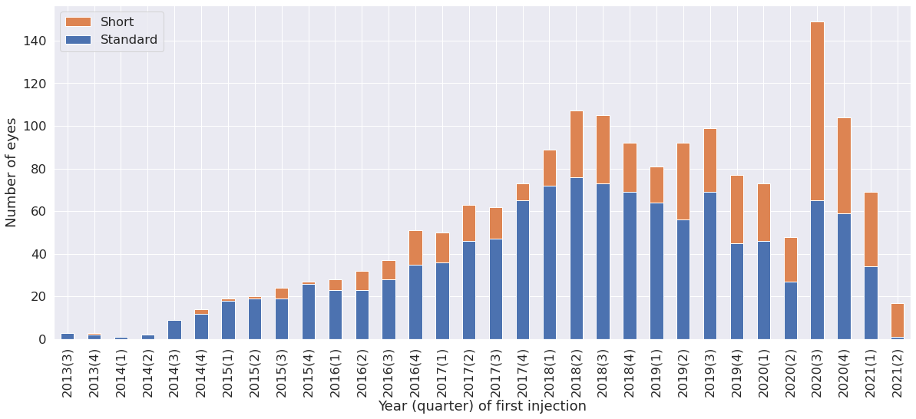
Supplementary figures
Figure S1. Use of the standard versus short protocol as a function of time

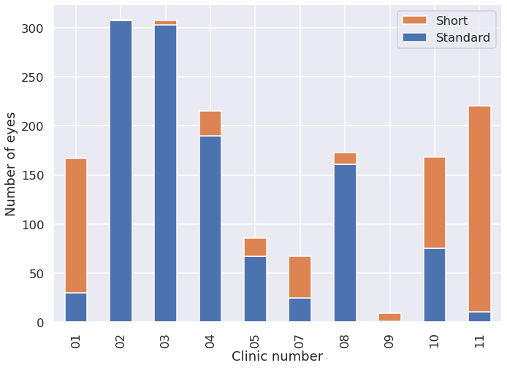
Figure S2. Use of the standard versus short protocol across different clinics

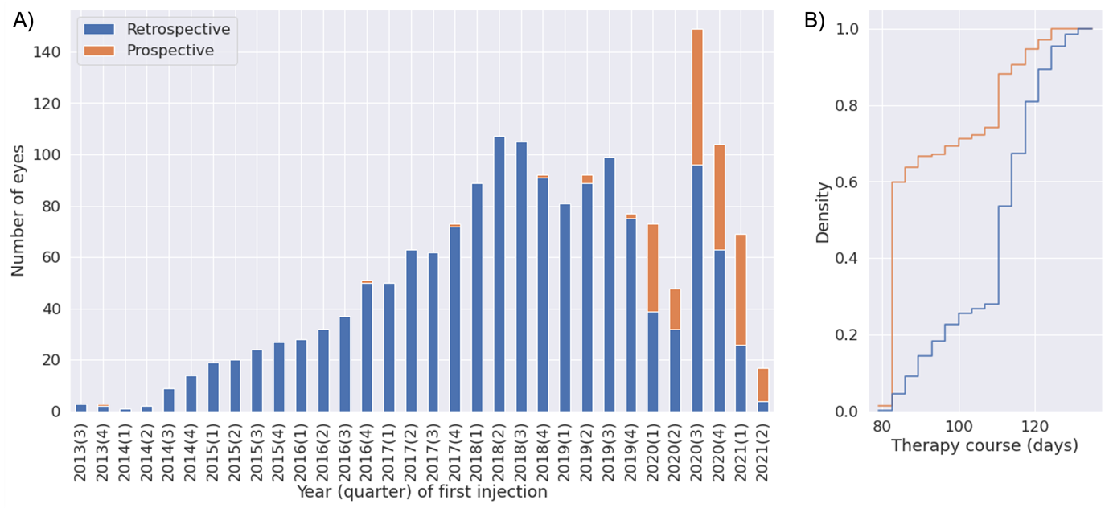
Figure S3. A) Number of prospective/retrospective cases as a function of time. B) Prospective cases tend to follow the short protocol rather than the standard protocol

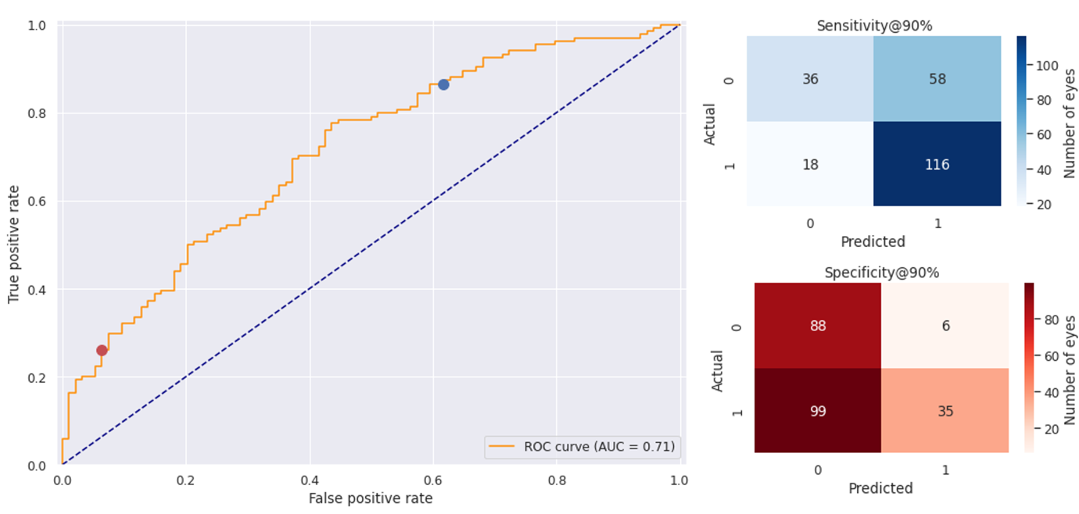
Figure S4. ROC curve and confusion matrices for the standard protocol sub-cohort
Blue dot represents 90% sensitivity. Red dot represents 90% specificity.
AUC, area under the curve; ROC, receiver operating curve.

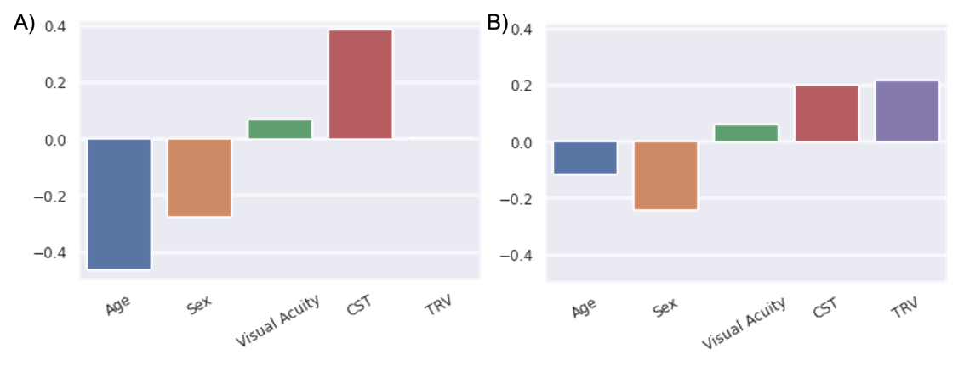
Figure S5. Feature contribution to the machine-learning model for the A) standard and B) short protocol sub-cohorts

Supplementary tables

Table S1. Association of features of interest with therapy response for the short protocol sub-cohort
 | No. of eyes | Eyes with no macular fluid | Eyes with macular fluid | Adjusted p-value
Age* | 548 (99.6) | 81 [75, 85] | 79 [74, 83 | 4.58×10⁻²
Sex | 550 (100) | 62% | 54% | 5.90×10⁻³
CST* | 550 (100) | 0.35 [0.29, 0.45] | 0.4 [0.32, 0.51] | 2.06×10⁻³
Visual acuity* | 536 (97.5) | 60 [49, 70] | 60 [47, 70] | 0.729
Data in parentheses are percentages.
CST, central retinal subfield thickness.
*Data are median [interquartile range]

Table S2. Fraction of suboptimal responders for the short protocol sub-cohort and selected sizes
Cohort size (no. of eyes) | AI | CST | Age | Random | % AI increase | % AI increase from random
20 | 0.65 | 0.53 | 0.51 | 0.37 | 22.64 | 75.68
50 | 0.57 | 0.38 | 0.43 | 0.37 | 32.56 | 54.05
70 | 0.52 | 0.40 | 0.41 | 0.37 | 26.83 | 40.54
100 | 0.47 | 0.43 | 0.40 | 0.37 | 9.30 | 27.03
120 | 0.45 | 0.43 | 0.40 | 0.37 | 4.65 | 21.62
150 | 0.43 | 0.40 | 0.38 | 0.37 | 7.50 | 16.22
Candidates were selected from the held-out set of the short protocol sub-cohort (191 patients).
CST, central retinal subfield thickness.

