Online Electronic Supplemental Material Oecologia
Title: Epidemics in native species influence the outcome of a species invasion
Paradyse E. Blackwood^{1*}, Kacie L. Jonasen¹, Brittany N. Heil^{1,2}, Catherine L. Searle¹
¹Department of Biological Sciences, Purdue University, West Lafayette, IN 47907
²Interdisciplinary Life Science Program (PULSe), Purdue University, West Lafayette, IN 47907

*Correspondence may be addressed to:
Paradyse Blackwood
Department of Biological Sciences
Purdue University
915 W. State Street
West Lafayette, IN 47907-2054
Phone: 765-494-9016
Fax: (765) 496-1495
pblackwo@purdue.edu
Clone line/Species | Origin | Year collected
Std/D. dentifera | Lake in Barry County, MI, USA | 2002-2003
Bd 16/D. dentifera | Bishop Lake, MI, USA | 2012
Wd 50/D. dentifera | Walsh Lake, MI, USA | 2012
FFSW 10/D. dentifera | Fairfield Lakes Southwest, IN USA | 2015
FFNE 6/D. dentifera | Fairfield Lakes Northeast, IN, USA | 2015
West 108/D. lumholtzi | West Point Lake, GA, USA | 2011

Table S1. Daphnia dentifera and D. lumholtzi clones used in the experiment.

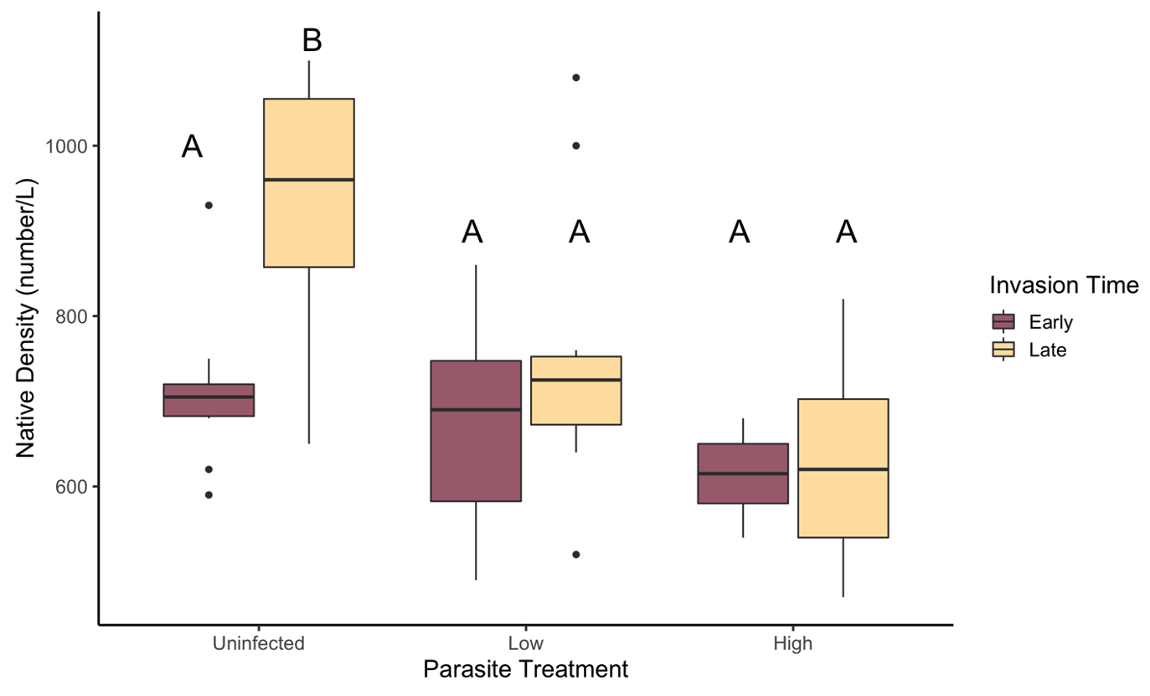
Figure S1. Density of the native species (Daphnia dentifera) on the day of the invasion was higher in the uninfected, late treatment than in any other treatment. Maroon indicates early invasion treatments and yellow indicates late invasion treatments. Treatments that share letters are not statistically different from each other.

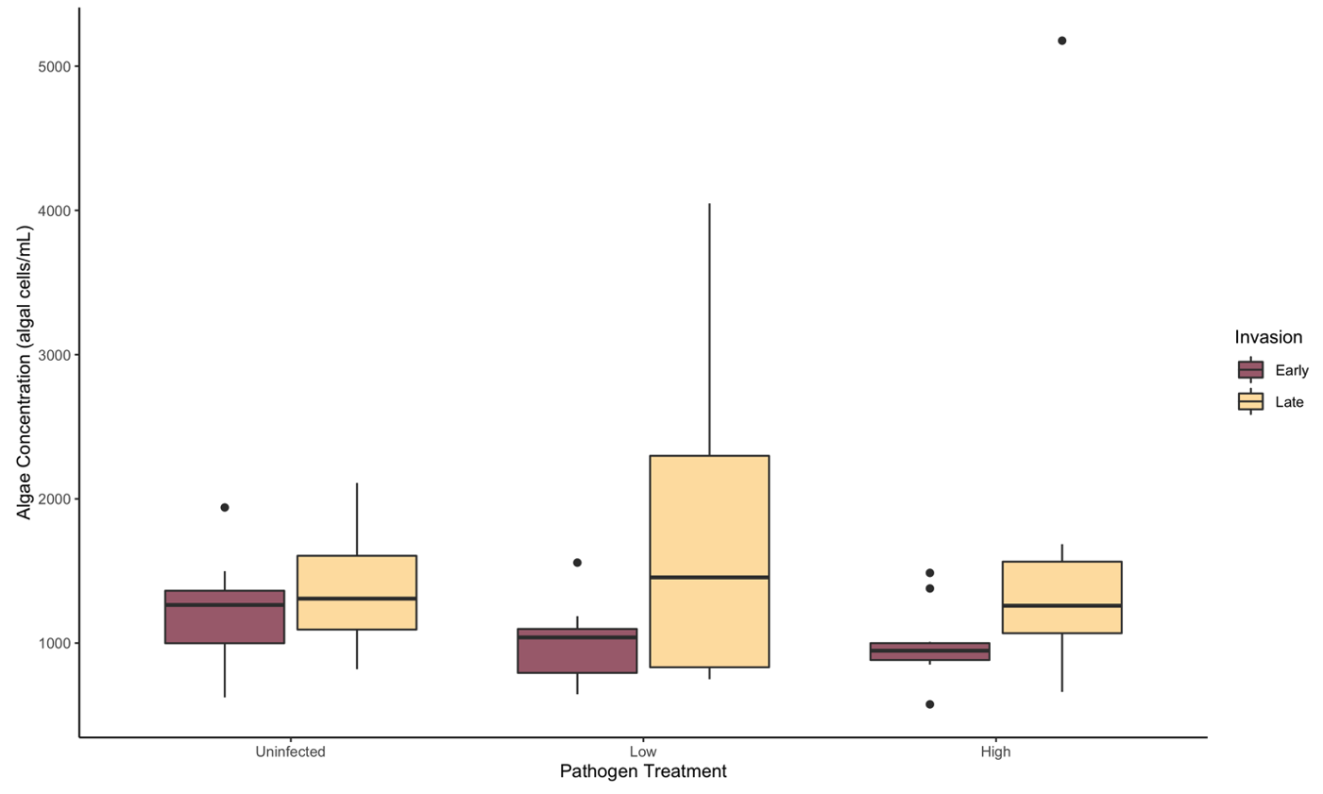
Figure S2. The concentration of algae at the time of the early invasion did not differ across treatments. Maroon indicates early invasion treatments and yellow indicates late invasion treatments.

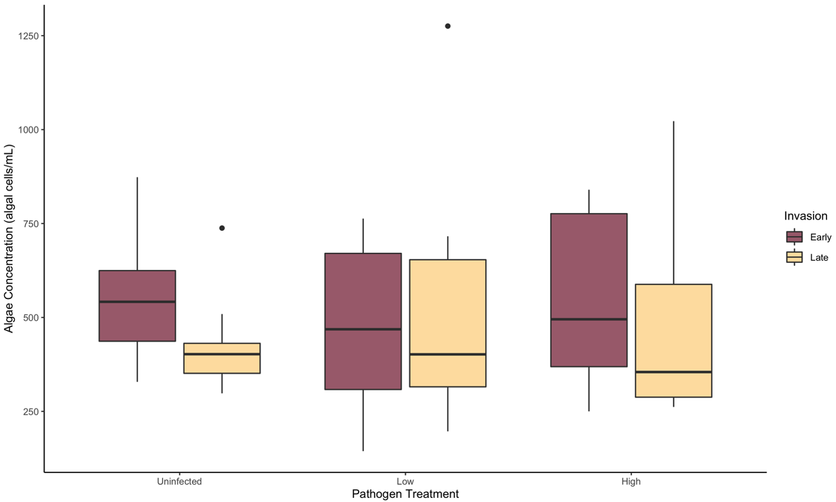
Figure S3. The concentration of algae at the time of the late invasion did not differ across treatments. Maroon indicates early invasion treatments and yellow indicates late invasion treatments.

