Supporting Information

Contents of this file

Figures S1 to S10

Tables S1 to S4

Introduction
Figure S1 shows the Taylor diagrams mentioned in section 2. Figures S2 and S3 show the spatial patterns of extreme precipitation 95th threshold of six selected climate models under SSP245 and SSP585 scenarios. Spatial distributions of mean precipitation, extreme precipitation events (EPEs) threshold, and the proportion of the amount of extreme precipitation (AEP) in total precipitation in the extended summer during 1979–2019 are revealed in Figure S4. Figure S5 shows the spatial patterns of two future heatwave metrics over 2021–2100. Figure S6 displays the time series of the total person-times affected by EPEs and HWs under SSP245 and SSP585 scenarios in eastern China over 2021–2100. Figure S7 shows the time variations of heatwave metrics under SSP245 and SSP585 scenarios over 2021–2100. Figure S8 shows the temporal variations and spatial patterns of the total summer 1-day EPEs in eastern China. Figure S9 shows the changes in magnitudes of near-surface maximum temperature warming relative to 1850-1900. The correlation maps between summer precipitation and 500-hPa geopotential height (GPH) anomalies, frequency of EPEs and GPH anomalies, Tasmax and GPH anomalies, and frequency of HWs and GPH anomalies during 1979–2019 are shown in Figure S10.
Table S1 presents the observational and reanalysis data sets used in this study. Tables S2 and S3 describe precipitation and near-surface maximum temperature outputs from CMIP6, which are utilized to evaluate observational data in this study. Table S4 shows the definitions of heatwave metrics.

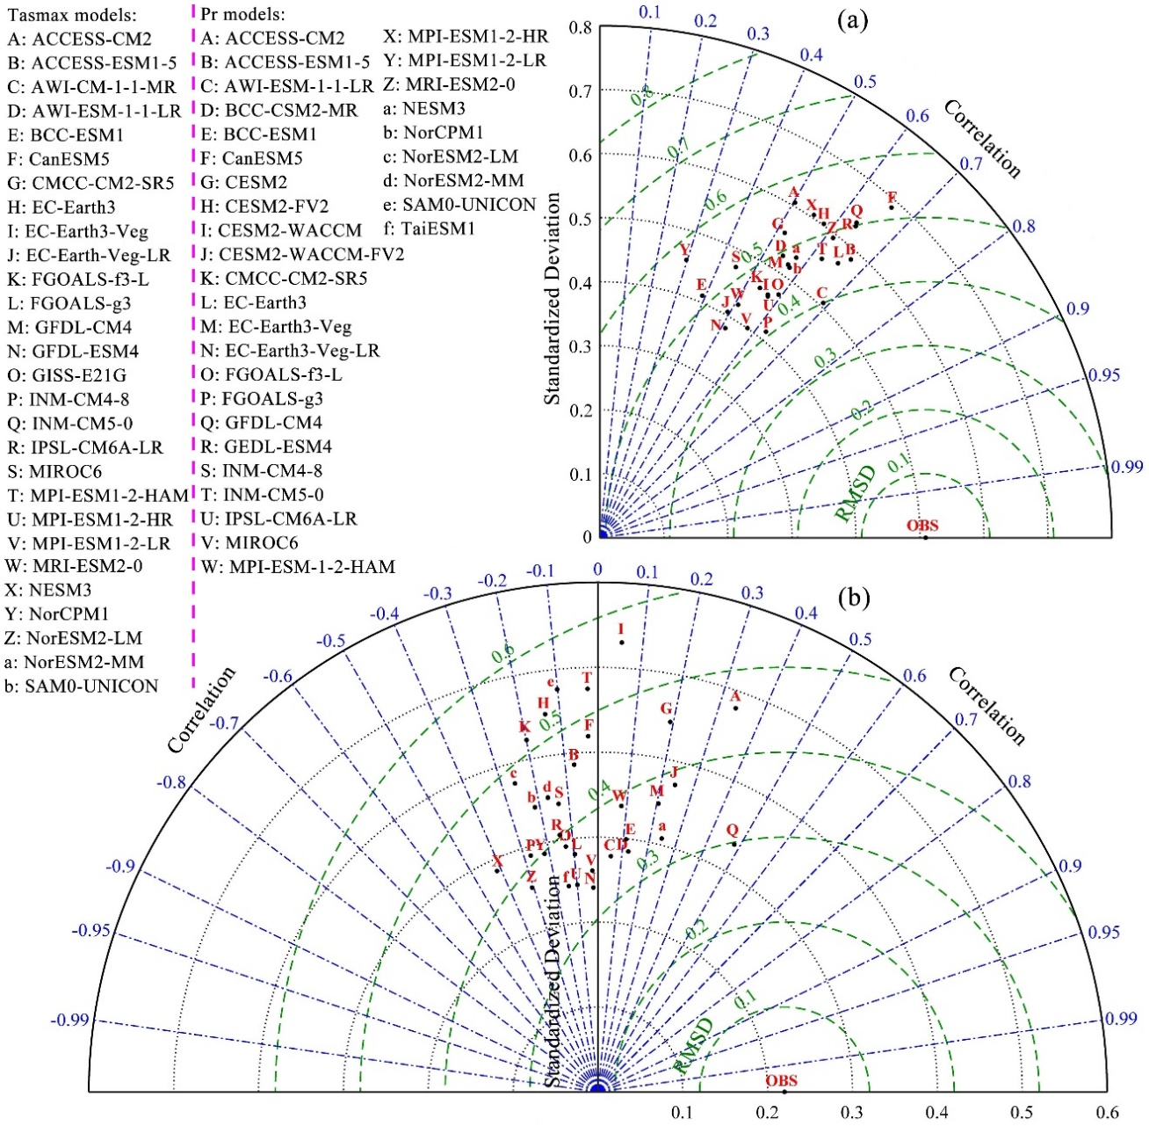Fig. S1 Taylor diagrams for displaying a statistical comparison between observations and the CMIP6 model in terms of (a) summer mean near-surface maximum temperature and (b) precipitation.

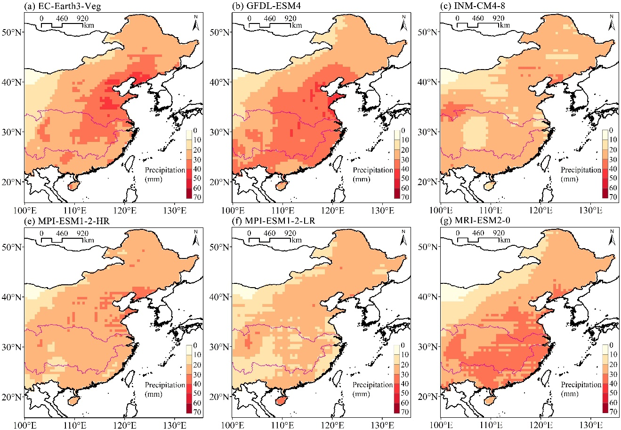
Fig. S2 Spatial patterns of the 95th threshold for extreme precipitation events based on six climate models under the SSP245 scenario. The threshold for each model is calculated using 41-years mean precipitation from 1979 to 2019. The purple line corresponds to the boundary of the Yangtze River Basin.

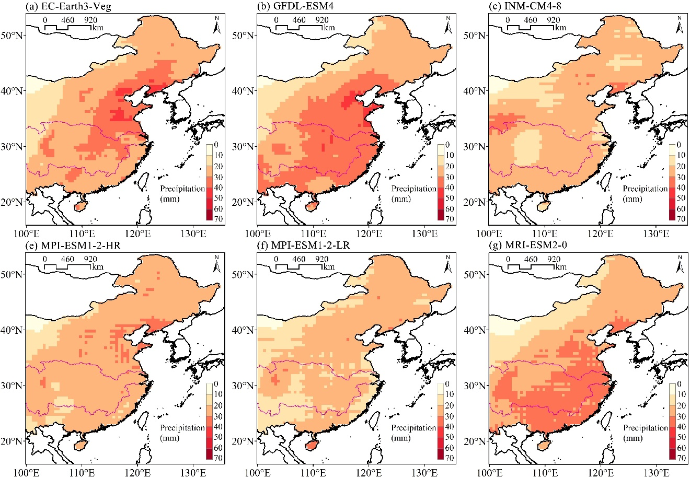
Fig. S3 The same as Figure S3, but for the SSP585 scenario.

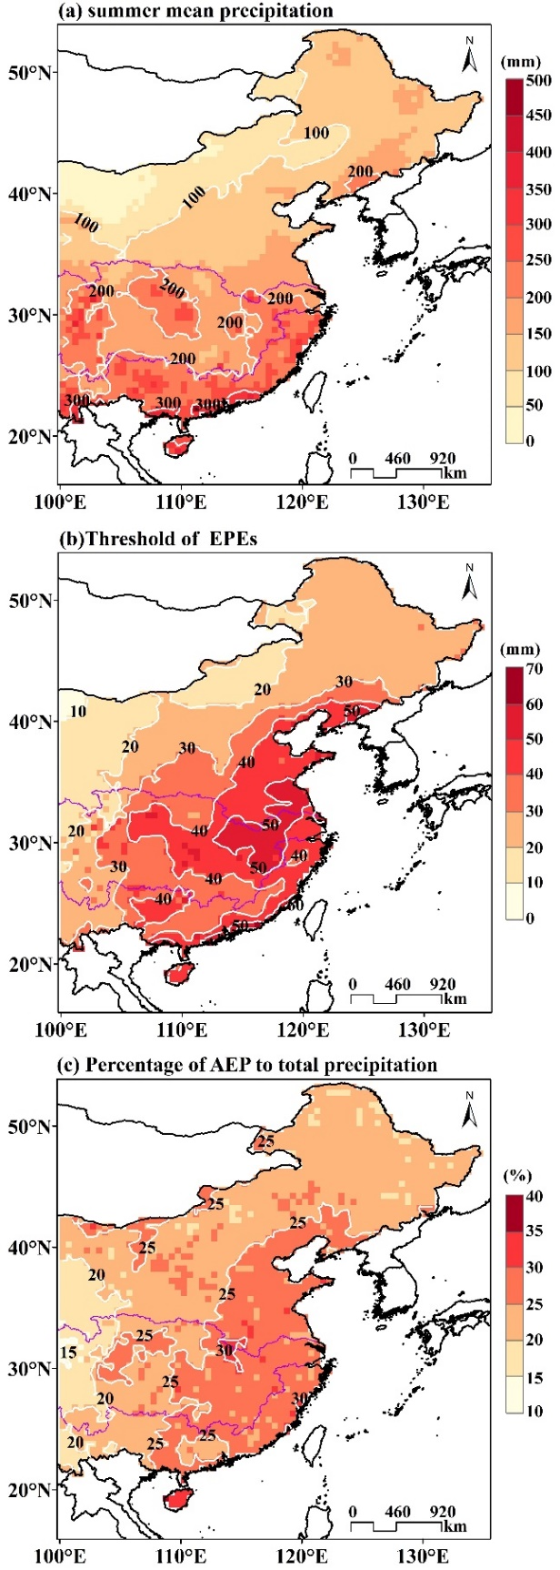
Fig. S4 Spatial distributions of (a) mean precipitation, (b) extreme precipitation events (EPEs) threshold, and (c) the proportion of the amount of extreme precipitation (AEP) in total precipitation in the extended summer during 1979–2019. The purple lines represent the Yangtze River Basin.
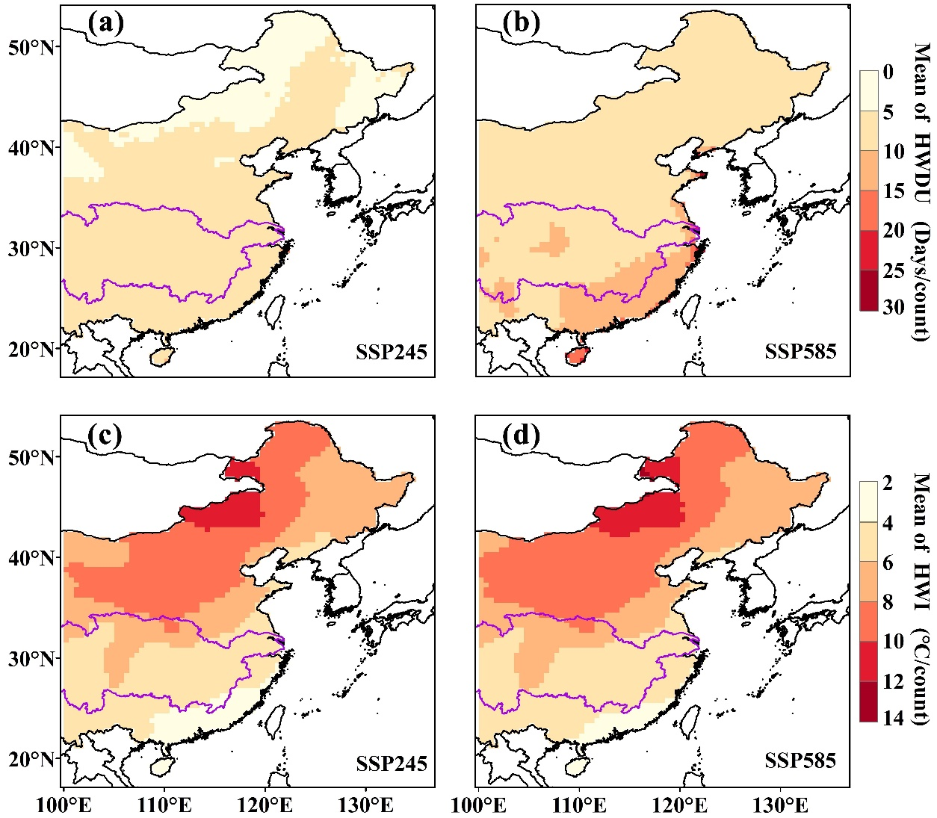
Fig. S5 Projected multi-year averaged (a, b) HWDU and (c, d) HWI for HWs in eastern China over 2021–2100 under the SSP245 (left column) and SSP585 scenarios (right column) based on the multi-model ensemble mean method. The purple lines delimit the Yangtze River Basin.

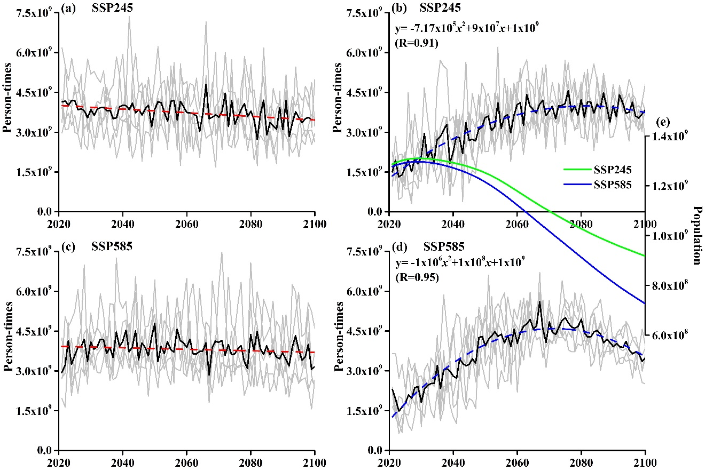
Fig. S6 Time series of the total person-times affected by (a, c) EPEs and (b, d) HWs under (a, b) SSP245 and (c, d) SSP585 scenarios in eastern China over 2021–2100. (e) Green and blue lines represent the annual average total population in eastern China under SSP245 and SSP585 scenarios, respectively. The dashed red and blue lines represent the linear trend and quadratic fit, respectively.

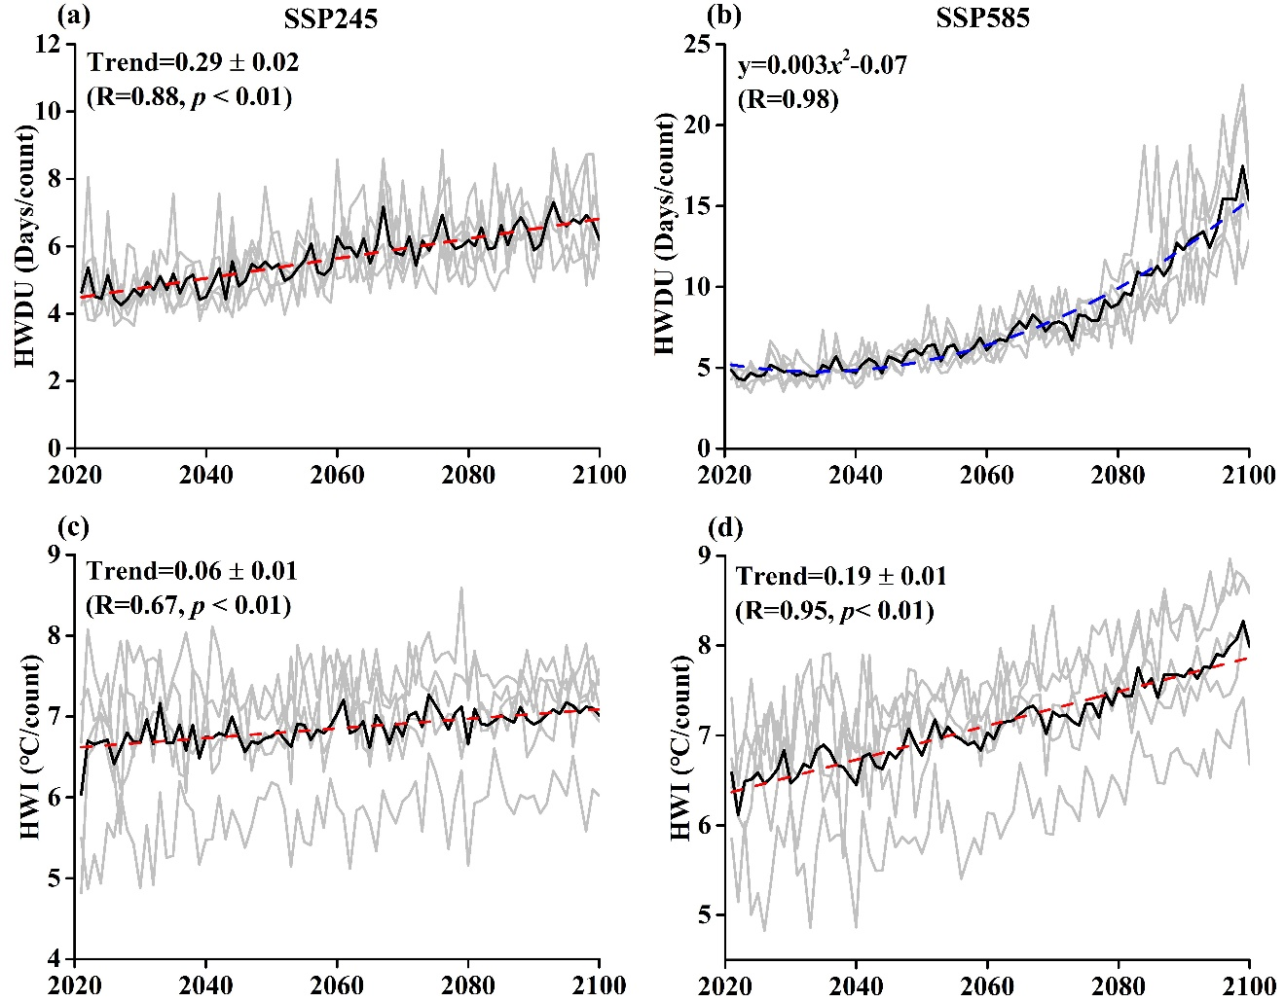
Fig. S7 Temporal variations of the regionally averaged HWDU and HWI in eastern China under SSP245 (a-c) and SSP585 (b-d) scenarios over 2021-2100. The dashed red and blue lines represent the linear trends and quadratic fits, respectively. Trends in the figures indicate the variation rates of heatwave metrics per decade.

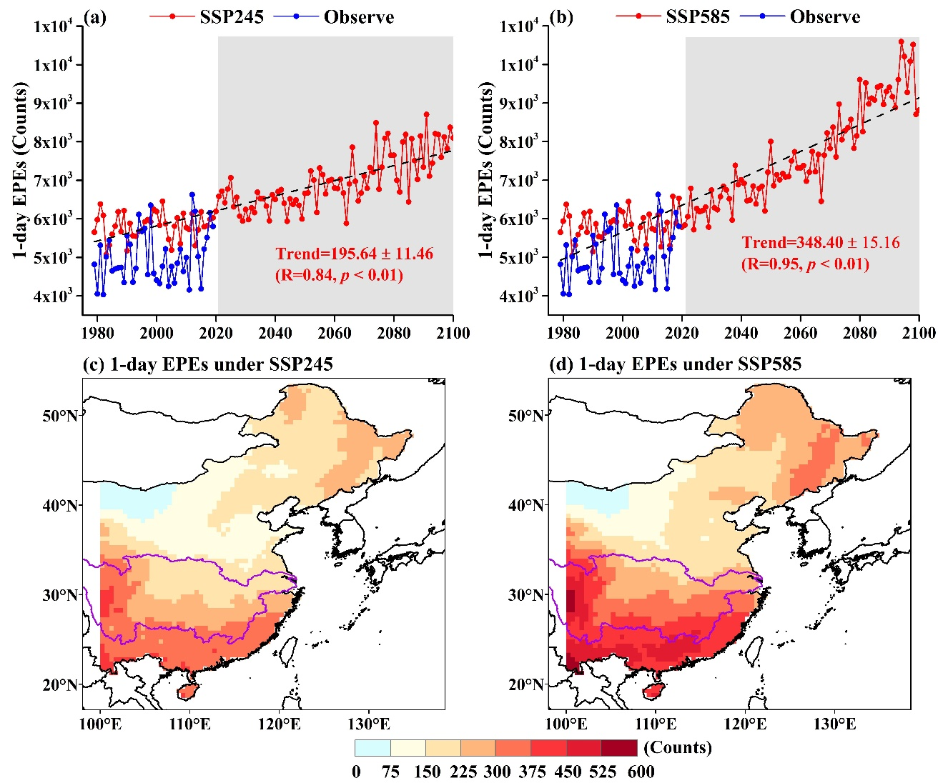
Fig. S8 Temporal variations and spatial patterns of the total summer 1-day EPEs in eastern China. (a) 1-day EPEs combined with historical period and SSP245 scenario, (b) 1-day EPEs combined with the historical period and SSP585 scenario, (c) 1-day EPEs under SSP245 scenario, and (d) 1-day EPEs under SSP585 scenario. The blue points represent the EPEs based on observational data. Shaded areas cover the period of 2021–2100. The purple lines present the Yangtze River Basin.

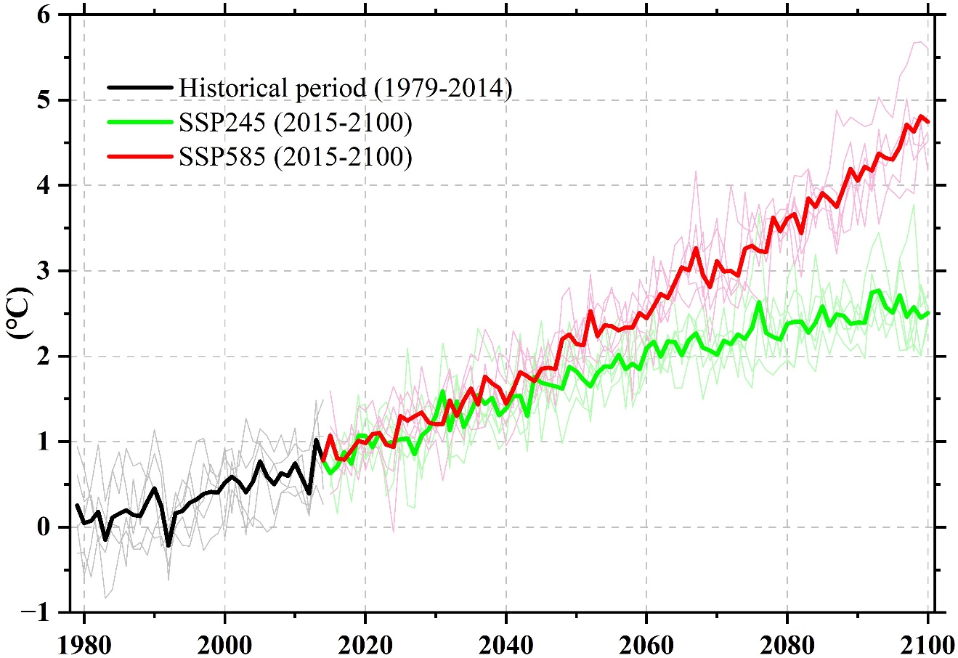
Fig. S9 Warming magnitudes of Tasmax relative to the period of 1850-1900. Data are from the CMIP6 outputs.

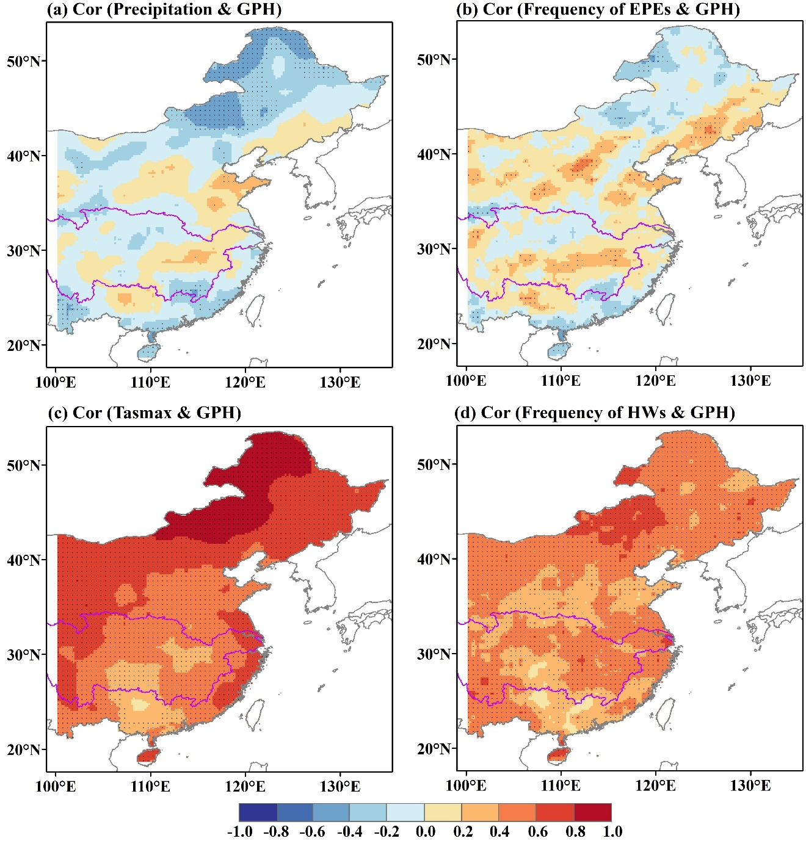
Fig. S10 The correlation maps between summer (a) precipitation and 500-hPa geopotential height (GPH) anomalies, (b) frequency of EPEs and GPH anomalies, (c) Tasmax and GPH anomalies, and (d) frequency of HWs and GPH anomalies during 1979–2019. The areas significant at the 95% confidence level are dotted. The purple lines delimit the Yangtze River Basin.

Table S1 The observational and reanalysis data sets used in this study
 | Dataset | Institute | Resolution | Period | Reference | Website
Tasmax/Pr | China Daily Surface Dataset (V2.0) | CMDC | 0.5°× 0.5° | 1979–2019 | (Chen et al. 2017) | http://data.cma.cn/en
SST | OISST | NOAA ESRL | 0.25°× 0.25° | 1982–2019 | (Huang et al. 2021) | https://psl.noaa.gov/data/gridded/data.noaa.oisst.v2.highres.html
Z500/Z850 | ERA5 | ECMWF | 0.25°× 0.25° | 1979–2019 | (Hersbach et al. 2018) | https://www.ecmwf.int/en/forecasts/datasets/reanalysis-datasets/era5
Population Density |  | RESDC | 0.01°× 0.01° | 1990–2015 | (Xu, 2017) | http://www.resdc.cn/
 |  | Scientific data | 0.01°× 0.01° | 2010–2100 | (Chen et al. 2020) | https://doi.org/10.6084/m9.figshare.c.4605713.v1

Table S2 Horizontal resolution (longitude × latitude) of the CMIP6 atmospheric models used in the present study (Tasmax variable)
Model name | Institution (county) | Resolution (lon×lat)
ACCESS-CM2 | CSIRO-ARCCSS (Australia) | 192×144
ACCESS-ESM1-5 | CSIRO (Australia) | 192×145
AWI-CM-1-1-MR | AWI (Germany) | 384×192
AWI-ESM-1-1-LR | AWI (Germany) | 192×96
BCC-ESM1 | BCC (China) | 128×64
CanESM5 | CCCma (Canada) | 128×64
CMCC-CM2-SR5 | CMCC (Italy) | 288×192
EC-Earth3 | EC-Earth-Consortium (EU) | 512×256
EC-Earth3-Veg | EC-Earth-Consortium (EU) | 512×256
EC-Earth3-Veg-LR | EC-Earth-Consortium (EU) | 320×160
FGOALS-f3-L | CAS (China) | 288×180
FGOALS-g3 | CAS (China) | 180×80
GFDL-CM4 | NOAA-GFDL (USA) | 288×180
GFDL-ESM4 | NOAA-GFDL (USA) | 288×180
GISS-E21-G | NASA-GISS (USA) | 144×90
INM-CM4-8 | INM (Russia) | 180×120
INM-CM5-0 | INM (Russia) | 180×120
IPSL-CM6A-LR | IPSL (France) | 144×143
MIROC6 | MIROC (Japan) | 256×128
MPI-ESM-1-2-HAM | HAMMOZ-Consortium (Germany) | 192×96
MPI-ESM1-2-HR | MPI-M (Germany) | 384×192
MPI-ESM1-2-LR | MPI-M (Germany) | 192×96
MRI-ESM2-0 | MRI (Japan) | 320×160
NESM3 | NUIST (China) | 192×96
NorCPM1 | NCC (Norway) | 144×96
NorESM2-LM | NCC (Norway) | 144×96
NorESM2-MM | NCC (Norway) | 288×192
SAM0-UNICON | SNU (Korea) | 288×192

Table S3 Horizontal resolution (longitude × latitude) of the CMIP6 atmospheric models used in the present study (Pr variable)
Model name | Institution (county) | Resolution (lon×lat)
ACCESS-CM2 | CSIRO-ARCCSS (Australia) | 192×144
ACCESS-ESM1-5 | CSIRO (Australia) | 192×145
AWI-ESM-1-1-LR | AWI (Germany) | 192×96
BCC-CSM2-MR | BCC (China) | 320×160
BCC-ESM1 | BCC (China) | 128×64
CanESM5 | CCCma (Canada) | 128×64
CESM2 | NCAR (America) | 288×192
CESM2-FV2 | NCAR (America) | 144×96
CESM2-WACCM | NCAR (America) | 288×192
CESM2-WACCM-FV2 | NCAR (America) | 144×96
CMCC-CM2-SR5 | CMCC (Italy) | 288×192
EC-Earth3 | EC-Earth-Consortium (EU) | 512×256
EC-Earth3-Veg | EC-Earth-Consortium (EU) | 512×256
EC-Earth3-Veg-LR | EC-Earth-Consortium (EU) | 320×160
FGOALS-f3-L | CAS (China) | 288×180
FGOALS-g3 | CAS (China) | 180×80
GFDL-CM4 | NOAA-GFDL (USA) | 288×180
GFDL-ESM4 | NOAA-GFDL (USA) | 288×180
INM-CM4-8 | INM (Russia) | 180×120
INM-CM5-0 | INM (Russia) | 180×120
IPSL-CM6A-LR | IPSL (France) | 144×143
MIROC6 | MIROC (Japan) | 256×128
MPI-ESM-1-2-HAM | HAMMOZ-Consortium (Germany) | 192×96
MPI-ESM1-2-HR | MPI-M (Germany) | 384×192
MPI-ESM1-2-LR | MPI-M (Germany) | 192×96
MRI-ESM2-0 | MRI (Japan) | 320×160
NESM3 | NUIST (China) | 192×96
NorCPM1 | NCC (Norway) | 144×96
NorESM2-LM | NCC (Norway) | 144×96
NorESM2-MM | NCC (Norway) | 288×192
SAM0-UNICON | SNU (Korea) | 288×192
TaiESM1 | TaiESM (Taiwan, China) | 288×192

Table S4 Definitions of HW metrics
Index | Definition | Formulas | Unit
HWN | Summer number of HWs in each year | $$HWF=N$$ | Counts
HWT | summer total HW days in each year | $HWT=\sum_{i=1}^{N}{D_{i}}$ | Days
HWDU | Average duration of HWs in each year summer | $$HWDU={\sum_{i=1}^{N}{(D_{i})}}/N$$ | Days/count
HWI | Average intensity of HWs in each year summer | $$HWI={\sum_{i}^{N}{\sum_{j}^{D_{i}}{(T_{ij}-{\tilde{T}}_{ij})}}}/N$$ | ℃/count
Note: for a heatwave$i$, its intensity $\sum_{j}^{D_{i}}{(T_{i,j}-{\tilde{T}}_{i,j})}$ is calculated as the sum of the temperature deviation exceeding the threshold throughout its duration $D_{i}$. $T_{i,j}$ and ${\tilde{T}}_{i,j}$ are the Tasmax and corresponding threshold for day $j$ during heatwave $i$.

