Supporting information:

Acoustic metamaterials driven transdermal drug delivery for rapid and on-demand management of acute disease
Junhua Xu,¹# Hongwei Cai,¹# Zhuhao Wu,¹ Chunhui Tian,¹ Xiang Li, ¹ Zheng Ao,¹ Vivian C. Niu,^{1,2} Xiao Xiao,³ Lei Jiang,¹ Marat Khodoun,⁴ Marc Rothenberg,⁴ Ken Mackie,⁵ Jun Chen,³* Luke P. Lee, ^{6,7,8}* and Feng Guo¹*

- Department of Intelligent Systems Engineering, Indiana University, Bloomington, IN 47405, United States
- Bloomington High School South, Bloomington, IN 47401, United States
- Department of Bioengineering, University of California, Los Angeles, Los Angeles, CA 90095, United States
- Division of Allergy and Immunology, Cincinnati Children's Hospital Medical Center, University of Cincinnati, Cincinnati, OH 45229, United States
- Gill Center for Biomolecular Science, and Department of Psychological and Brain Sciences, Indiana University, Bloomington, IN 47405, United States
- Department of Medicine, Brigham and Women’s Hospital, Harvard Medical School, Boston, MA 02115, United States
- Department of Bioengineering, Department of Electrical Engineering and Computer Science, University of California at Berkeley, Berkeley, CA 94720, United States
- Institute of Quantum Biophysics, Department of Biophysics, Sungkyunkwan University, Suwon, Korea
# Contributed equally to this work
* Corresponding email address: fengguo@iu.edu (F.G.),or lplee@bwh.harvard.edu (L.P.L.)

List of Contents
Supplementary Discussion
Theoretical prediction of acoustic metamaterials mediated drug release.

Supplementary Figures
Fig.S1 Design and fabricated devices of the acoustic metamaterial patches.
Fig.S2 Simulated distribution of acoustic field, acoustic streaming, and dye release.
Fig.S3 In vivo dye distribution mediated by acoustic metamaterial patches and other methods.
Fig.S4 Controlled release of epinephrine via acoustic metamaterial patches.
Fig.S5 Characterization of a mouse model of anaphylaxis.
Fig.S6 Body temperature variation of anaphylactic mice with different treatments.

Supplementary Videos
Video S1. Simulated 3D acoustic streaming mediated by acoustic materials.
Video S2. Experimental 3D acoustic streaming mediated by acoustic materials.
Video S3. Simulated dye release process via acoustic materials.
Video S4. Experimental dye release process via acoustic materials.
Video S5. A free-moving mouse with an acoustic metamaterial patch device.

Supplementary Discussion

Theoretical prediction of drug release mediated by acoustic metamaterials: The governing perturbation equations for acoustic fields in the porous media consist of a balance of linear momentum and mass. Considering the effects of the 2-phase porous metamaterial structure, the standard equation of porous medium dynamics can be written as¹:
$$ρ\left(\frac{∂v}{∂t}+v∙∇v\right)=-∇p-γw$$
$$\frac{∂}{∂t}(ϕρ)+∇∙(ϕρv)=0$$
$$w≔ϕ(v-u)$$
The actual density of the fluid is $ρ$, the volume fraction of porous media is $ϕ$, the interstitial fluid velocity is $v$, $γ≡1/K$ is the inverse of the hydraulic conductivity $K$, $u$ is the velocity of the porous solid frame, and $w$ is the relative velocity of the fluid. Under a harmonic force, the motion of the fluid is generally not harmonic. It is generally composed of two components: (1) a first-order component of the same period as the activation force, and (2) a second-order stable component (acoustic streaming). Taking the first and second-order components into account, we can write²:
$$w=w_{1}+w_{2}$$
$$v=v_{1}+v_{2}$$
$$u=u_{1}+u_{2}$$
$$ρ=ρ_{0}+ρ_{1}+ρ_{2}$$
$$p=p_{0}+p_{1}+p_{2}$$
$$ϕ=ϕ_{0}+ϕ_{1}+ϕ_{2}$$
For the first-order equation, we assume that acoustic waves travel in a uniform media, and the fluid and porous frame move together with the same velocity. Thus, $w_{1}$ and $ϕ_{1}$ vanish in the first-order equation, and we get: $\frac{∂ρ_{1}}{∂t}+ρ_{0}(∇∙v_{1})=0$

$$ρ_{0}\left(\frac{∂v_{1}}{∂t}+v_{1}∙∇v_{1}\right)=-∇p_{1}$$

For the second-order equation, since there is no streaming in the porous frame, the second-order frame velocity $u_{2}$ is zero. Expanding the equation to the second order and averaging the equation over a cycle yields:
$$γw_{2}=-∇p_{2}-ρ_{0}∇∙〈v_{1}v_{1}〉$$
$$∇∙w_{2}=-ϕ_{0}\frac{∇∙〈ρ_{1}v_{1}〉}{ρ_{0}}$$
The second-order equation has a form of Darcy's law, supplemented with a streaming force term.
For the acoustically-enhanced convection-diffusion of dye and drug, the governing equation is the conventional diffusion equation³:
$$\frac{∂c}{∂t}=∇∙\left(D∇c\right)-∇\left(v^{c}c\right)+R$$
c is the species concentration, D is the diffusivity, $v^{c}$ is the velocity field that the species is moving with. R describes sources or sinks of the quantity c.

Combining the second-order equation, we can get:
$$∇^{2}p_{2}=∇∙(-ρ_{0}∇∙〈v_{1}v_{1}〉+\frac{γϕ_{0}}{ρ_{0}}〈ρ_{1}v_{1}〉)$$
Thus, the streaming speed in the porous media also has the estimated relation with acoustic pressure:
$$v_{porous}\sim ωP^{2}$$
This streaming results in an effective diffusivity:
$$D_{eff}\sim ωP^{2}$$

If we simplify the convection-diffusion to 1D diffusion from the patch to the porous media, with a constant concentration $c_{0}$ at the surface of the patch. We can get:
$$\frac{∂c}{∂t}=D\frac{∂^{2}c}{∂x^{2}}$$
$${D=D_{0}+D}_{eff}$$
$D_{0}$ is the diffusivity of dye in the porous media. The regulation of this estimation equation is:
$$c=0 at t=0$$
$$c= c_{0} at t=0$$
With a solution:
$$c(x,t)=c_{0}[1-erf⁡(\frac{x}{\sqrt{4Dt}})]$$
$${D=D_{0}+D}_{eff}$$
$$D_{eff}\sim ωP^{2}$$
Integrating along x to get $d$ (the total released dye mass) at time $t$:
$$d=c_{0}\sqrt{\frac{4Dt}{π}}$$
$${D=D_{0}+D}_{eff}$$
$$D_{eff}\sim ωP^{2}$$

To reduce the computational effort, we only solved for one pyramid in the periodic metamaterial structure in 3D, because the pyramidal structures’ vibrations are periodic in both the x- and y-directions. Based on the above-discussed theoretical derivation, the numerical procedure is divided into three steps: (1) solving the acoustic field (1st-order problem) in the porous media domain; (2) solving the 2nd-order problem in a porous domain based on the 1st-order result from the first step and obtaining the streaming field; (3) solving for the diffusion of dye in porous domain assisted by acoustic streaming. COMSOL 5.3a (the COMSOL Group) was employed for the calculations following the above steps. In step (1), the predefined “Pressure acoustics” modified with “Poroacoustics" physics was used to calculate the acoustic field distribution (1st-order problem) in porous media. A “Periodic” boundary condition, which confines periodic connection of pyramids in the array and fluidic domains, was applied to side the two boundaries of the porous domain. The top boundary was set as “normal impedance” equal to that of the porous media to eliminate wave reflection. An activation of defined periodicity was applied to the patch boundary to account for acoustic vibration. Based on these settings, a “Frequency Domain” solver was used to solve the abovementioned physics together at the driving frequency (1.01 MHz). In step (2), “Darcy’s law” physics was used to solve the 2nd-order problem (Acoustic streaming) in porous media. The mass and force source terms were imposed by adding “weak contribution” and “volume force” conditions, respectively. Similarly, the condition, which confines periodic connection of pyramids in the array and fluidic domain, was applied to two surrounding boundaries. And an “outlet” boundary condition, which indicates no pressure difference on the two sides of a boundary, was imposed at the media-media interfaces. This physics is solved via a “Stationary” solver using the 1st-order solution of the previously mentioned “Frequency Domain” solver. As the last step, the “Transport of Diluted Species” was used to solve the diffusion problem of the dye. A constant concentration of dye is set on the surface of the patch to account for diffusion. All the walls of porous media were set as no flux boundary conditions. These physics were then solved via a "Time-Dependent" solver in a total of 1020 seconds with an interval of 0.1s by using the 2nd-order solution of the previously mentioned “Stationary” solver.

Supplementary Figures

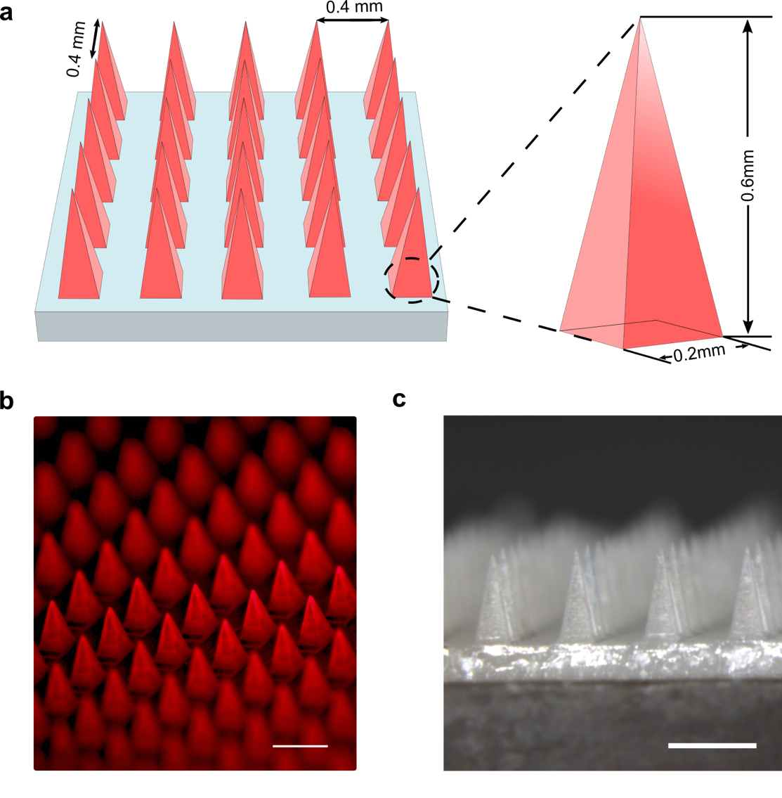
Fig.S1 Design and fabricated devices of the acoustic metamaterial patches. (a) The design of acoustic metamaterials as a plate with a layer of pyramidal structures (height:600 μm x length:200 μm x width:200 μm) in a square lattice distribution (pyramid center to pyramid center distance: 400 μm). (b) The fabricated acoustic metamaterial plate with only the pyramidal-shaped metamaterial structures loaded with RhB dye. (c) The fabricated acoustic metamaterial patch consists of a transducer and an acoustic metamaterial plate.

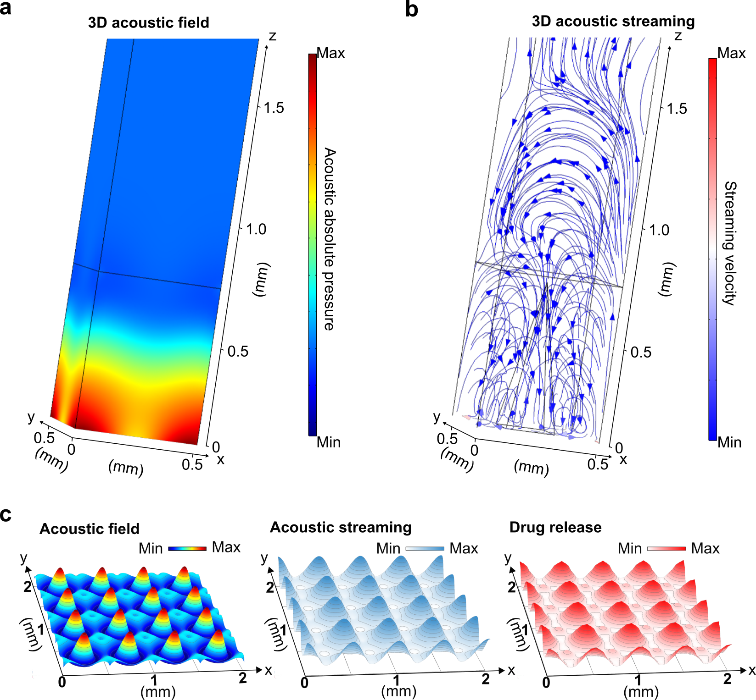

Fig.S2 Simulated distribution of the acoustic field, acoustic streaming, and dye release. (a) The 3D distribution of acoustic field mediated by acoustic metamaterial structures. (b) Acoustic metamaterial structures mediate the 3D distribution of the acoustic streaming field. (c) Acoustic metamaterial mediated 3D distributions of acoustic field acoustic streaming and released dye above the sharp metamaterial structures.

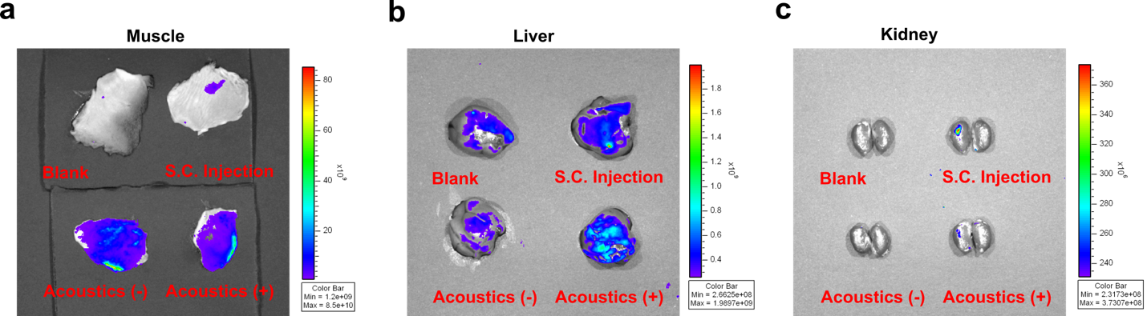

Fig.S3 In vivo dye distribution mediated by acoustic metamaterial patches and other methods. Representative images of harvested mouse muscle (a), liver (b), kidney (c) tissues after dye delivery mediated via an acoustic metamaterial patch with acoustic stimulation (Acoustics (+)), with acoustic stimulation (Acoustics (-)), via subcutaneous injection (S.C. injection), and without any treatment (Blank).

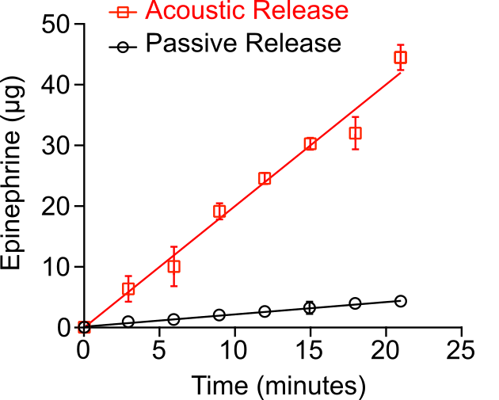
Fig.S4 Controlled release of epinephrine via acoustic metamaterial patches.

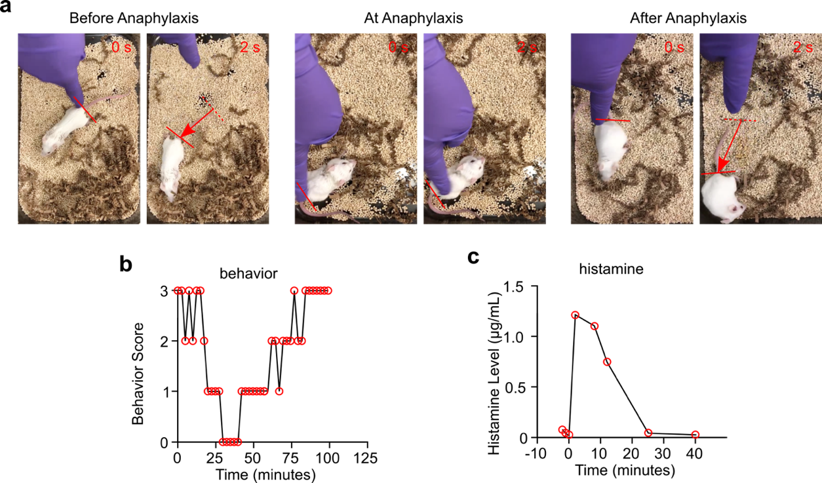

Fig.S5 Characterization of a mouse model of anaphylaxis. (a) Representative behaviors of mice before, during, and after anaphylaxis. (b) The behavior score of a mouse before, during, and after anaphylaxis. (c) Serum histamine elevation of a mouse during anaphylaxis.

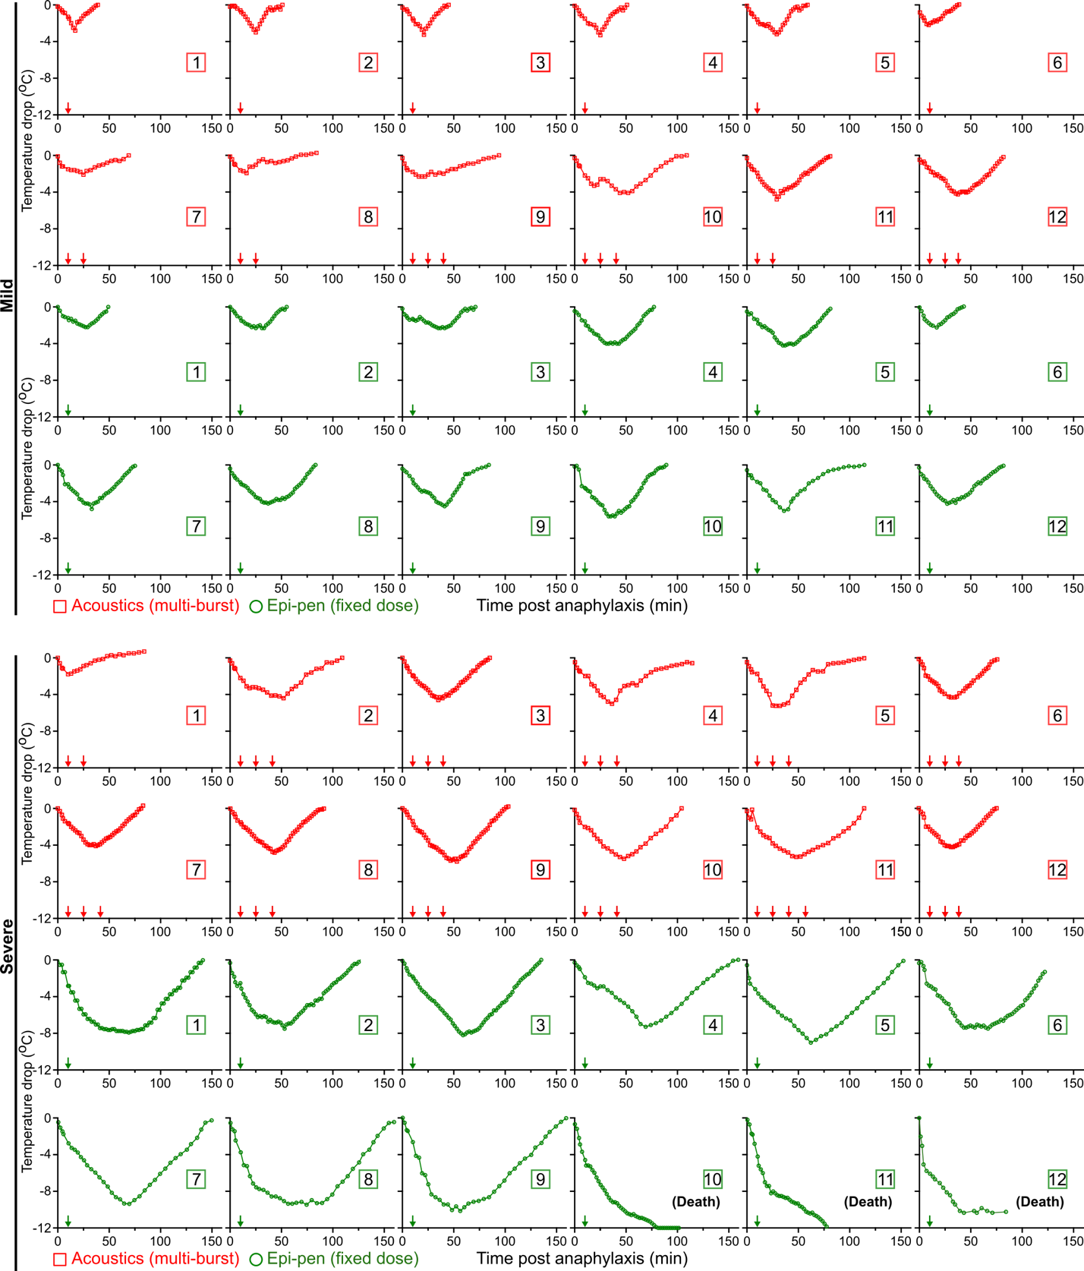

Fig.S6 Body temperature variation of anaphylactic mice subjected to different treatments. Dynamic body temperature change in mice with two levels (mild or severe) of anaphylaxis receiving a multi-burst delivery of epinephrine via acoustic metamaterial patches or the fixed dosage delivery of epinephrine via ‘epi-pen strategy’. The arrows indicate the injection of epinephrine (n= 12 mice per group, independent experiments).

Supplementary Videos

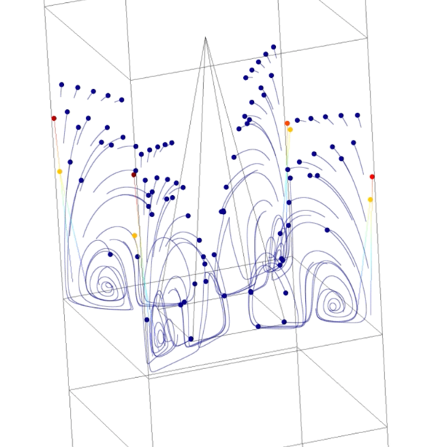

Video S1. Simulated 3D acoustic and streaming felids mediated by acoustic materials

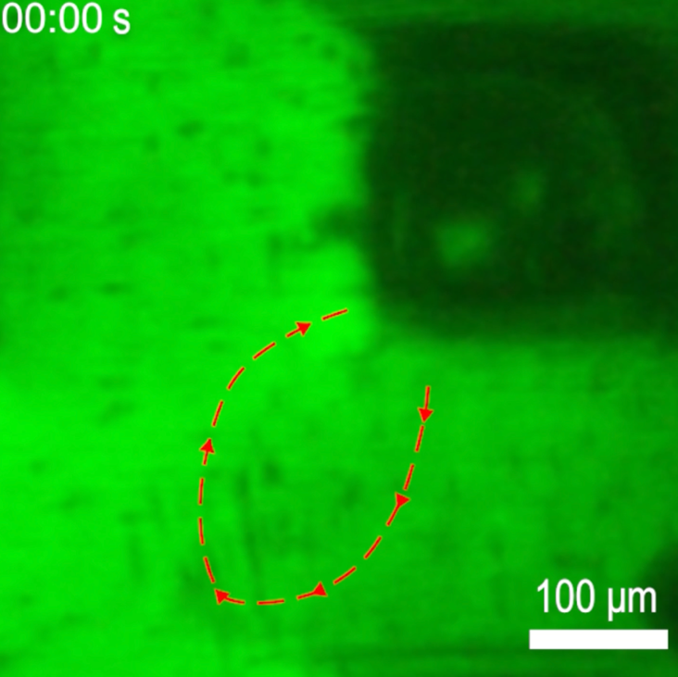

Video S2. Experimental 3D acoustic streaming mediated by acoustic materials

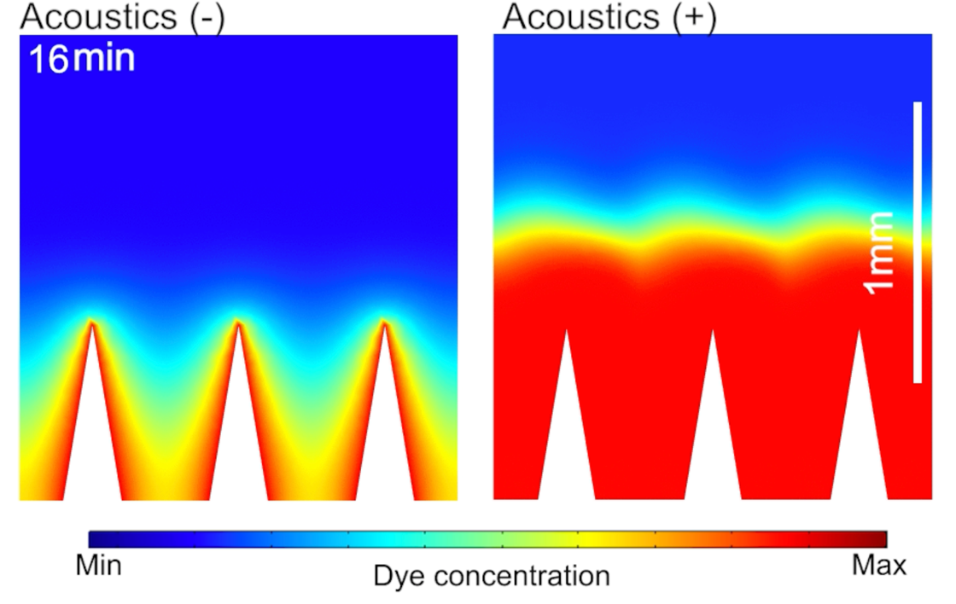

Video S3. Simulated 3D dye release process via acoustic materials with (Acoustics (+)) or without (Acoustics (-)) acoustic stimulation.

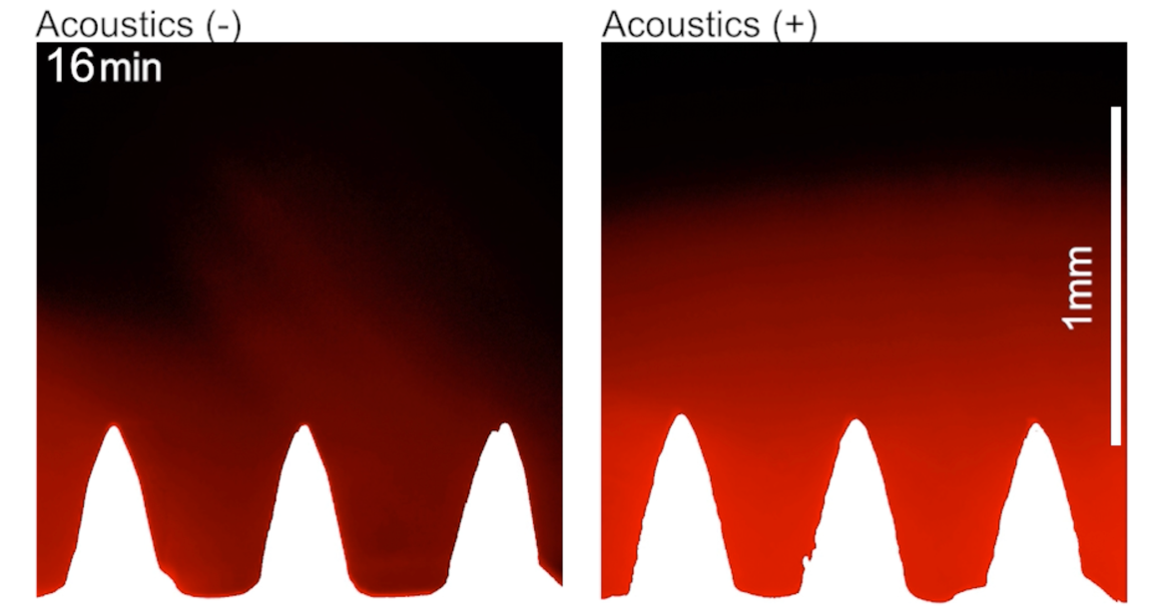

Video S4. Experimental dye release process via acoustic materials with (Acoustics (+)) or without (Acoustics (-)) acoustic stimulation.

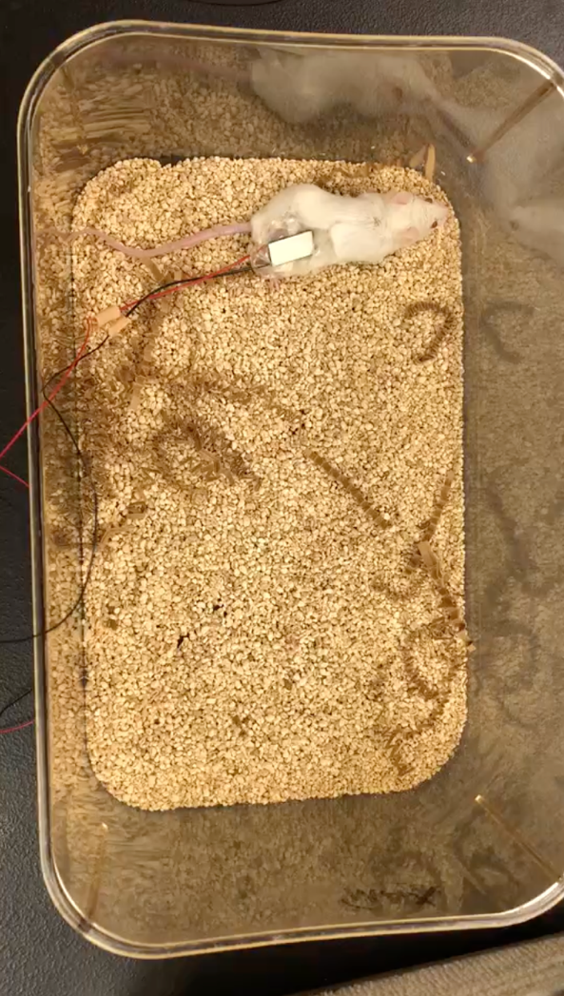

Video S5. A free-moving mouse with an acoustic metamaterial patch device.

References

1. Coussy O. Poromechanics. John Wiley & Sons Ltd: Chichester, 2004.

2. Hamilton MF, Blackstock DT. Nonlinear acoustics. Academic Press: San Diego, CA, 1998.

3. Dafermos CM, Dafermos CM, Dafermos CM, Mathématicien G, Dafermos CM, Mathematician G. Hyperbolic conservation laws in continuum physics, vol. 3. Springer, 2005.

