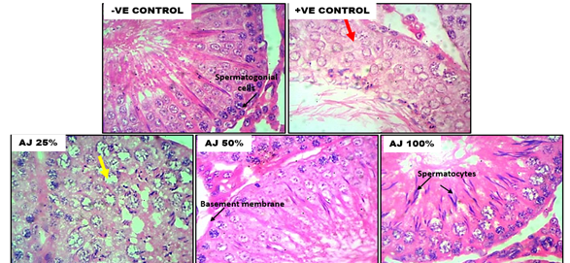

Plate 1: Histopathological effect of anti-hemorrhoid herbal recipe on the testis of rats
AJ means ‘Agbo Jedi’

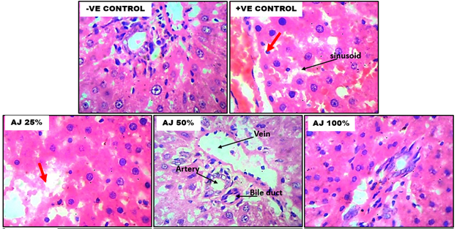

Plate 2: Histopathological effect of anti-hemorrhoid herbal recipe on the liver of rats
AJ means ‘Agbo Jedi’

Plate 3: Histopathological effect of anti-haemorrhoid herbal recipe on the kidney of rats
AJ means ‘Agbo Jedi’
