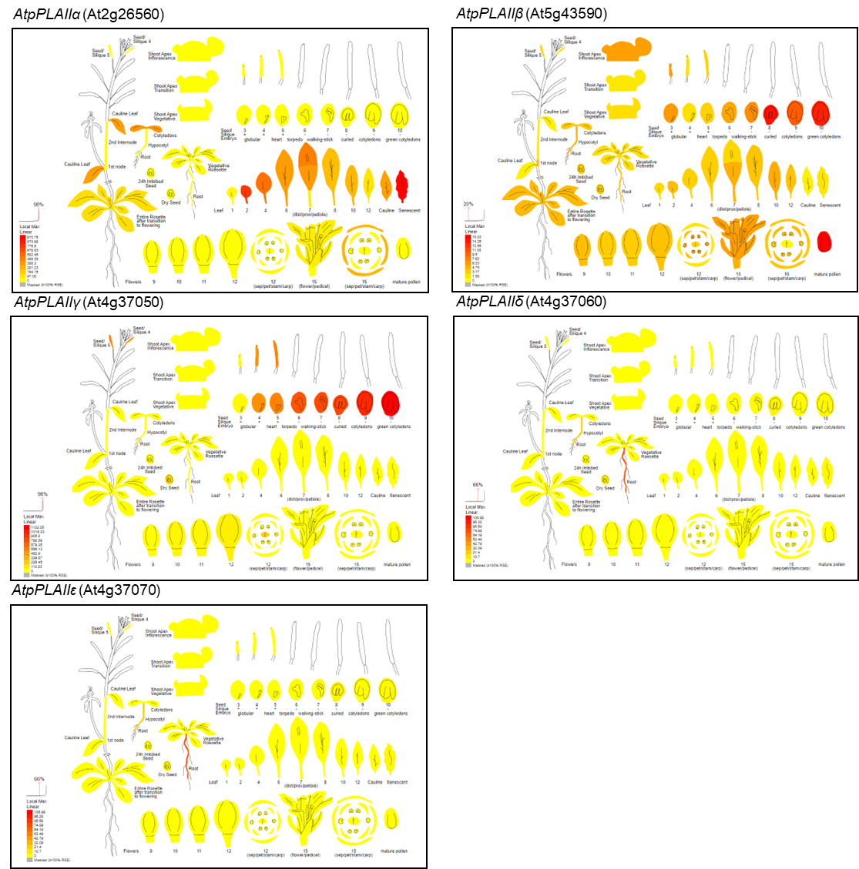

Extended Data Fig. 1 | Expression pattern of pPLAII genes (pPLAIIα, pPLAIIβ, pPLAIIγ, pPLAIIδ, and pPLAIIε) in Arabidopsis tissues. Data was collected from ePlant (http://bar.utoronto.ca/eplant). Values are means ± SD (n = 3 independent experiments).

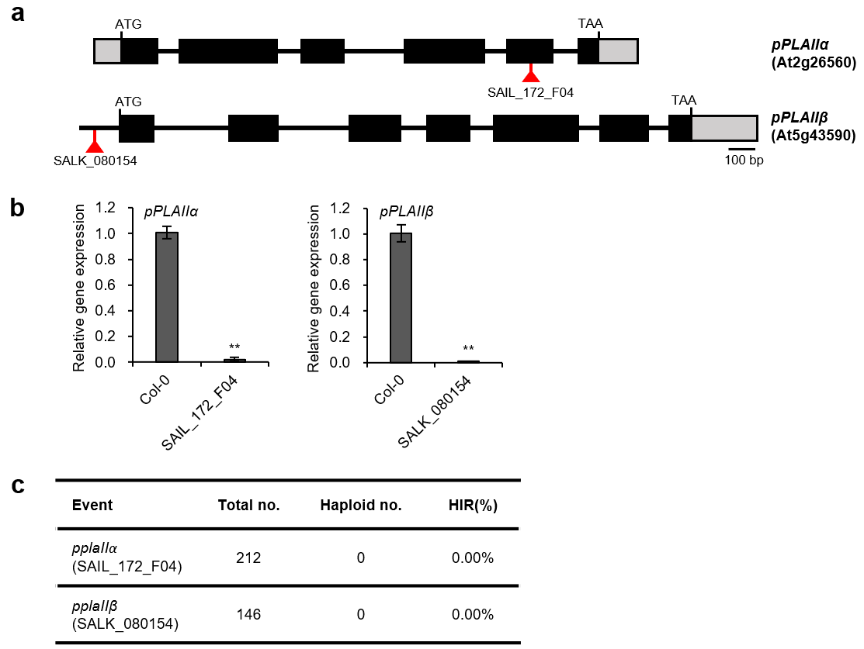

Extended Data Fig. 2 | The pplaIIα and pplaIIβ mutants did not induce haploid plant. a, Genomic structure of pPLAIIα (At2g26560) and pPLAIIβ (At5g43590). Red triangles indicate T-DNA insertion sites of pplaIIα (SAIL_172_F04) and pplaIIβ (SALK_080154). b, Transcripts level of pPLAIIα and pPLAIIβ in Col-0 and T-DNA insertion mutants. Data represents the average ± SE from three independent replicates at *P < 0.05, **P < 0.01 (Student’s t-test). c, Haploid induction rate (HIR) of pplaIIα and pplaIIβ by self-pollination.

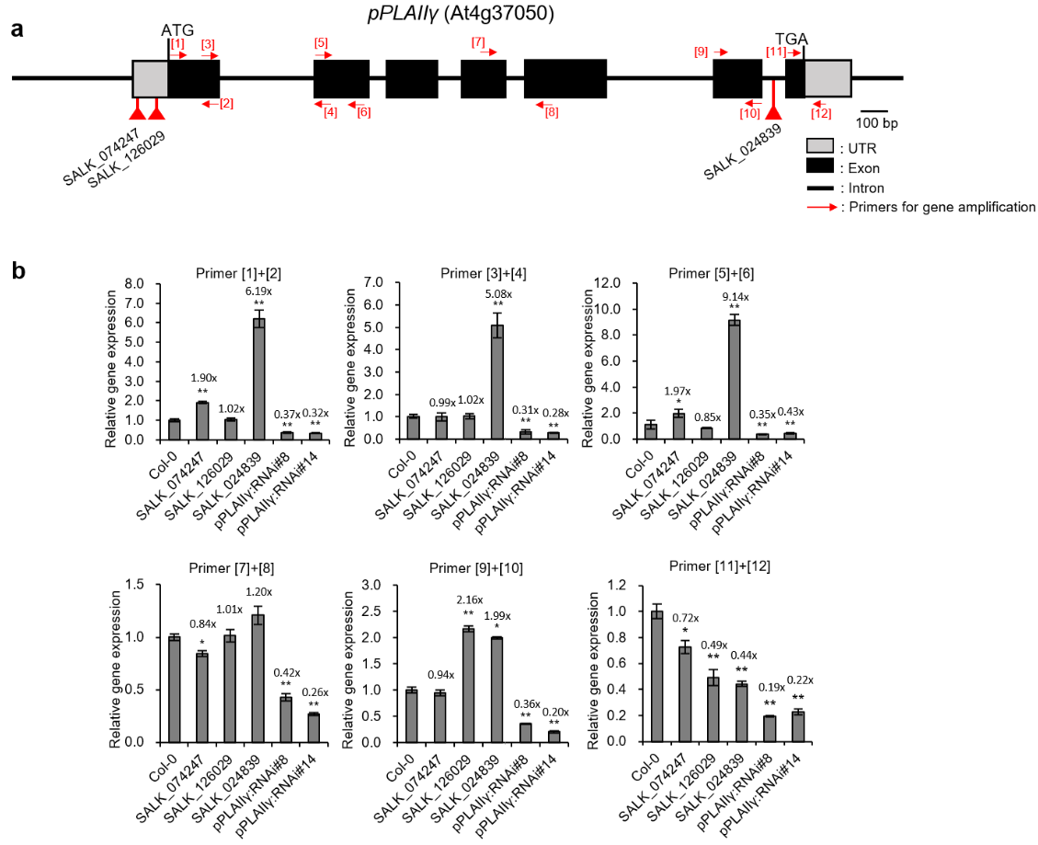

Extended Data Fig. 3 | Transcript level of pPLAIIγ in SALK mutants and pPLAIIγ:RNAi lines. a, Genomic structure of pPLAIIγ. Primer sites for qRT-PCR analysis (arrows) and T-DNA insertion sites (red triangles) of the SALK lines are indicated. b, Relative gene expression of pPLAIIγ in SALK mutants (SALK_074247, SALK_126029, and SALK_024839) and pPLAIIγ:RNAi lines. Data represents the average ± SE from three independent replicates at *P < 0.05, **P < 0.01 (Student’s t-test).

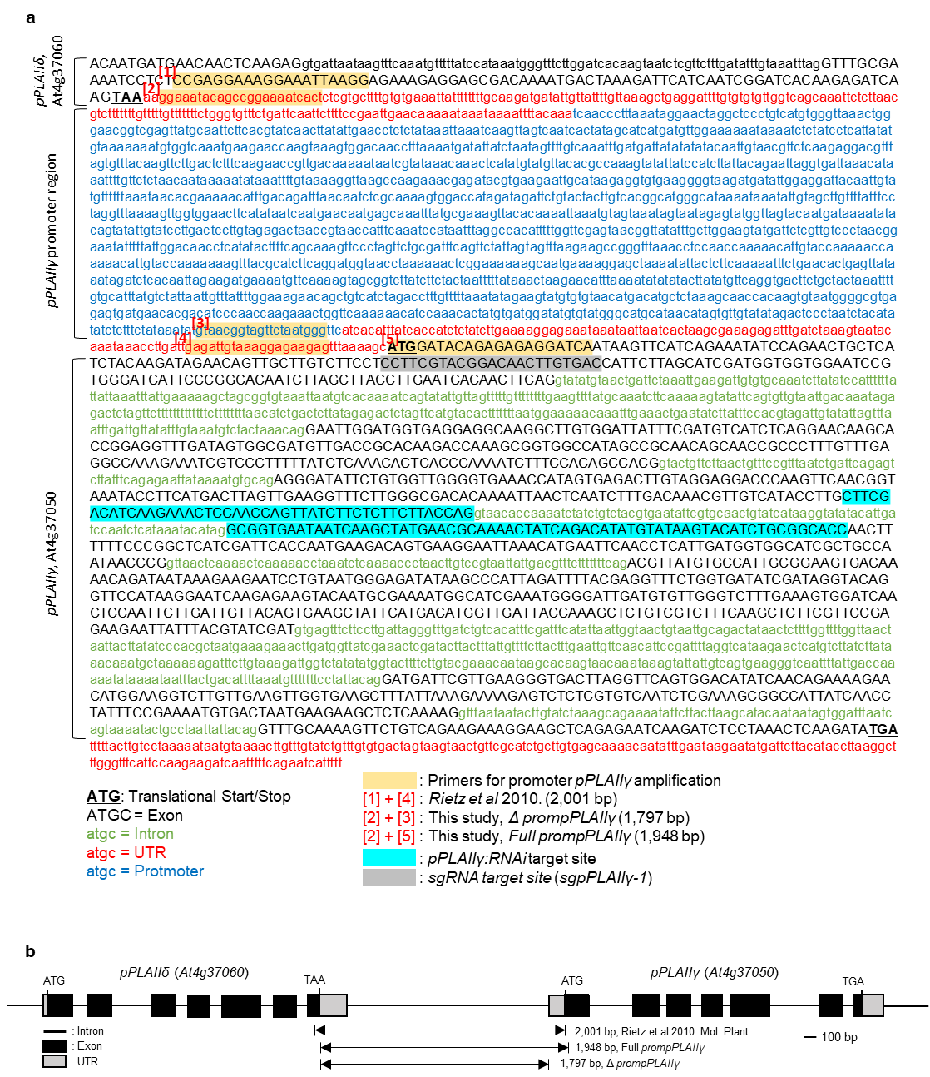

Extended Data Fig. 4 | Genomic sequence of pPLAIIγ, and the promoter regions used in prompPLAIIγ:GUS construct. a, Genomic sequence of pPLAIIγ and promoter region. Primer sites used for promoter amplification, pPLAIIγ:RNAi target site, and sgpPLAIIγ-1 target site are marked. b, Genomic structure of pPLAIIγ and pPLAIIδ. Double sided arrows indicate promoter region for prompPLAIIγ:GUS construction.

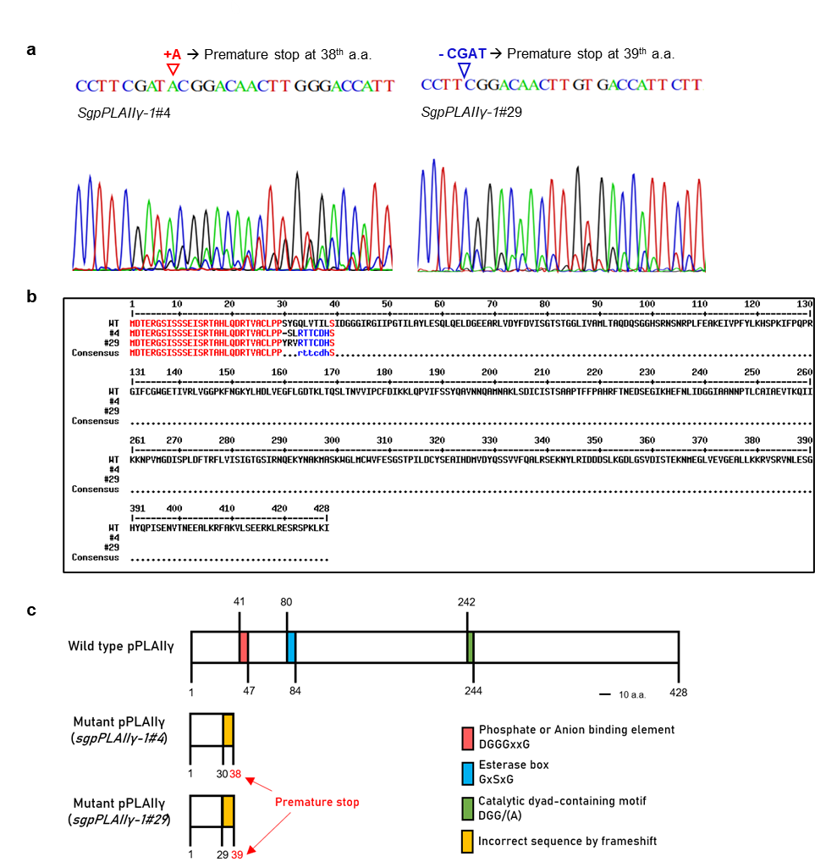

Extended Data Fig. 5 | Results of pPLAIIγ editing and protein changes resulting therefrom. a, Sanger sequencing chromatograms of sgpPLAIIγ-1 lines. b, Protein changes by editing of pPLAIIγ. c, Schematic images of predicted pPLAIIγ proteins from wild-type and sgpPLAIIγ-1 lines.

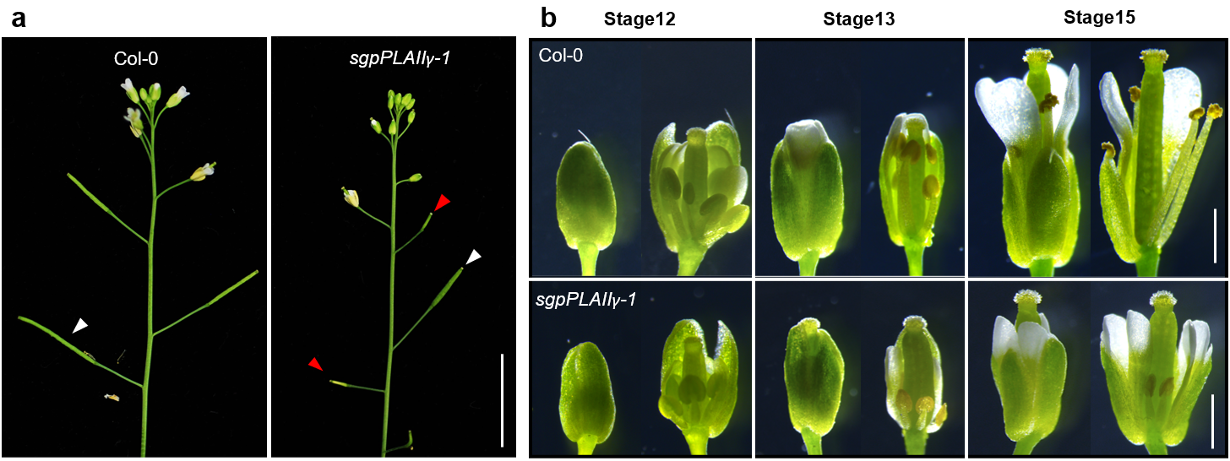

Extended Data Fig 6. | sgpPLAIIγ-1 is defective in stamen filament elongation and seed fertility. a, Representative image of inflorescence stem of Col-0 and sgpPLAIIγ-1. Red arrowheads indicate sterile silique. White arrowheads indicate fertile silique. b, Representative flower image of Col-0 and sgpPLAIIγ-1 at stage 12, 13, and 15. Stamen filament elongation is defective in sgpPLAIIγ-1. Scale bars = 1 cm (a), and 1 mm (b).

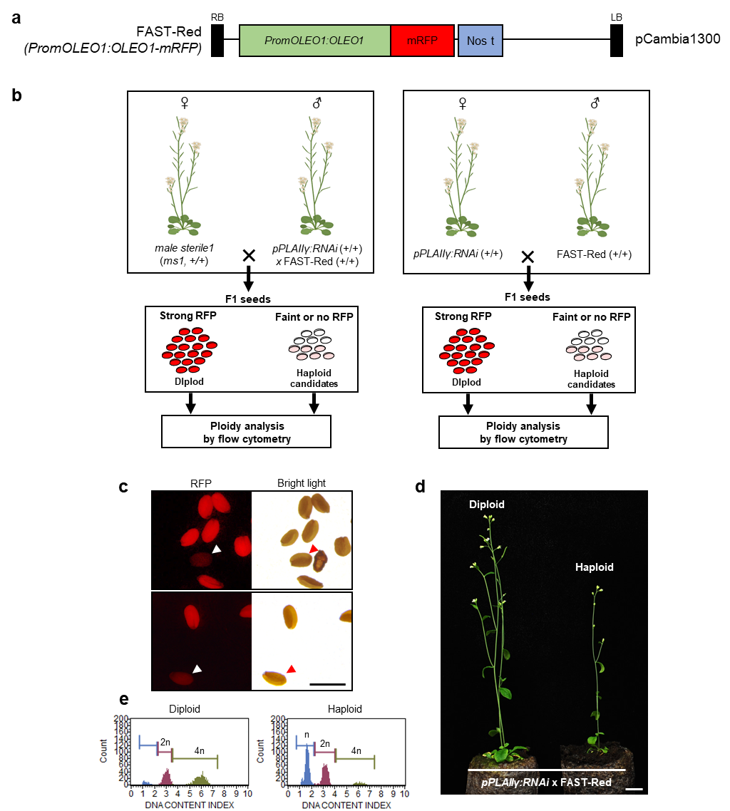
Extended Data Fig. 7 | Reciprocal cross test of pPLAIIγ:RNAi using FAST-Red. a, Construct map of FAST-Red (promOLEO1:OLEO1-mRFP). OLEO1 (Oleosin1, At4g25140). b, Haploid validation strategy using FAST-Red. After crossing (pPLAIIγ:RNAi used as maternal or paternal), seeds were sorted by RFP signal (strong, faint, and no signal) and ploidy was confirmed using flow cytometry. Images were created with BioRender.com (website: https://biorender.com/, accessed on 8 August 2022). c, Haploids were identified based on the faint RFP signal in the seeds. Seeds from pPLAIIγ:RNAi x FAST-Red cross were inspected under bright light and RFP light. Seeds containing putative haploid embryo have faint red fluorescence as indicated by arrowheads. d, Representative image and e, ploidy analysis of diploid and haploid from crossing (pPLAIIγ:RNAi x FAST-Red). Scale bars = 1 cm (d) and 1 mm (c).

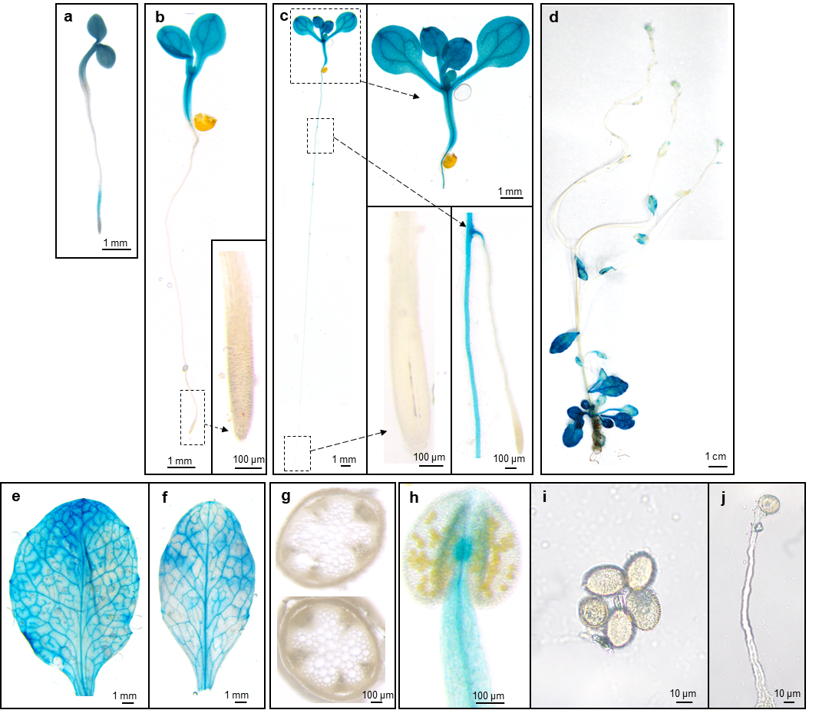

Extended Data Fig. 8 | Histochemical analysis of full prompPLAIIγ:GUS plants. a–j, Expression patterns of the full prompPLAIIγ:GUS of a, 2-, b, 4- and c, 7-day-old seedling, d, 5-week-old plant, e, rosette leaf, f, cauline leaf, g, stem section, h, anther, i, mature pollen grain, and j, germinated pollen.

Extended Data Table 1 | Transcriptional profiling of multiple pathways involved in auxin transport and response regulated by silencing of pPLAIIγ (pPLAIIγ:RNAi)
Gene ID | Gene name | Normalized expression levels |  | Log₂ fold change | Annotation
Gene ID | Gene name | Col-0 | pPLAIIγ:RNAi | pPLAIIγ:RNAi  vs Col-0 | Annotation
AT1G73590.1 | PIN1 | 275 | 157 | -0.81 | PIN-FORMED 1, auxin efflux carrier family protein
AT1G70940.1 | PIN3 | 2104 | 1188 | -0.82 | PIN-FORMED 3, auxin efflux carrier family protein
AT1G77110.1 | PIN6 | 5 | 2 | -1.45 | PIN-FORMED 6, auxin efflux carrier family protein
AT1G23080.1 | PIN7 | 367 | 259 | -0.51 | PIN-FORMED 7, auxin efflux carrier family protein
AT5G15100.1 | PIN8 | 15 | 7 | -1.13 | PIN-FORMED 8, auxin efflux carrier family protein
AT2G38120.1 | AUX1 | 340 | 297 | -0.19 | AUXIN RESISTANT 1, auxin influx transporter
AT2G21050.1 | LAX2 | 283 | 266 | -0.09 | Like auxin resistant2, auxin influx transporter
AT1G77690.1 | LAX3 | 554 | 319 | -0.8 | Like auxin resistant3, auxin influx transporter
AT5G60450.1 | ARF4 | 466 | 240 | -0.95 | Auxin response factor 4
AT1G30330.2 | ARF6 | 100 | 70 | -0.53 | Auxin response factor 6
AT2G28350.1 | ARF10 | 266 | 198 | -0.42 | Auxin response factor 10
AT2G46530.3 | ARF11 | 44 | 33 | -0.4 | Auxin response factor 11
AT4G30080.1 | ARF16 | 387 | 286 | -0.44 | Auxin response factor 16
AT1G19220.1 | ARF19 | 188 | 130 | -0.54 | Auxin response factor 19
AT5G47530.1 | SUBA4 | 339 | 232 | -0.55 | Auxin-responsive family protein
AT2G14960.1 | GH3.1 | 17 | 4 | -0.51 | Auxin-responsive GH3 family protein
AT5G13320.2 | PBS3 | 261 | 183 | -2.07 | Auxin-responsive GH3 family protein
AT4G27260.1 | GH3.5 | 851 | 316 | -1.43 | Auxin-responsive GH3 family protein
AT4G36110.1 | SAUR9 | 50 | 20 | -1.36 | Small auxin upregulated RNA 9
AT5G53590.1 | SAUR30 | 306 | 145 | -1.08 | Small auxin upregulated RNA 30
AT3G09870.1 | SAUR48 | 120 | 31 | -1.95 | Small auxin upregulated RNA 48
AT1G20470.1 | SAUR60 | 105 | 71 | -0.56 | Small auxin upregulated RNA 60
AT4G14560.1 | IAA1 | 120 | 58 | -1.04 | Indole-3-acetic acid inducible 1
AT1G04100.1 | IAA10 | 57 | 40 | -0.41 | Indole-3-acetic acid inducible 10
AT2G46990.1 | IAA20 | 28 | 18 | -0.66 | Indole-3-acetic acid inducible 20
AT2G36910.1 | ABCB1 | 6155 | 4050 | -0.6 | Arabidopsis P-glycoprotein 1
AT1G02530.1 | ABCB12 | 237 | 205 | -0.21 | Arabidopsis P-glycoprotein 12
AT3G28345.1 | ABCB15 | 322 | 205 | -0.65 | Arabidopsis P-glycoprotein 15
AT3G28360.1 | ABCB16 | 21 | 13 | -0.74 | Arabidopsis P-glycoprotein 26
AT3G28860.1 | ABCB19 | 2993 | 2613 | -0.2 | Arabidopsis P-glycoprotein 19
AT3G55320.1 | ABCB20 | 358 | 257 | -0.48 | Arabidopsis P-glycoprotein 20
AT5G58270.1 | ABCB25 | 565 | 488 | -0.21 | Arabidopsis P-glycoprotein 25
AT1G70610.1 | ABCB26 | 135 | 100 | -0.44 | Arabidopsis P-glycoprotein 26
AT4G25450.1 | ABCB28 | 138 | 110 | -0.32 | Arabidopsis P-glycoprotein 28
AT5G03910.1 | ABCB29 | 343 | 254 | -0.43 | Arabidopsis P-glycoprotein 29
AT1G10680.1 | PGP10 | 133 | 115 | -0.21 | Arabidopsis P-glycoprotein 15
