Extended Data
Extended Data Fig. 1| Characterization of CaCO₃ oligomer (CCO) and thioctic acid (TA). a, Snapshot of the CCO ethanol solution. b, Size distribution of CCO analysed by dynamic light scattering. The mean size of the CCO was 1.25 nm, which corresponded to a typical molecular formula (CaCO₃)₃ for CCO²². d, Snapshot of the TA ethanol solution. e, Mass spectrum of the TA ethanol solution. The main peaks were at m/z = 171 and 205, which were for the characteristic fragment ions of TA.

Extended Data Fig. 2| Additional characterization of TA-CCO hybrid molecules. a, Concentrations of S and Ca elements in a TA-CCO dissolved solution, which were measured by ICP‒OES, giving an approximate Ca/TA molar ratio of 1.5. b, c, Liquid-state ¹³C NMR spectra of CCO and TA in ethanol. The peaks at 160 ppm and 176 ppm were contributed to the carbonate (in CCO) and carboxyl groups (in TA), respectively. d, The peaks for carbonate and the carboxyl group in TA-CCO have almost similar symmetry to those of pure TA and CCO. The small shoulder (at 181.15 ppm) on the carboxyl group peak was attributed to byproducts generated during the reaction. e, TEM image of amorphous CaCO₃ nanoparticles (NP) with an average diameter of 41.3 nm. f, Snapshot of a TA-NP mixed ethanol solution. g, h, Liquid-state ¹³C NMR and mass spectra of the TA-NP mixed solution. The absence of a chemical shift for carbonate indicated unsuccessful construction of hybrid molecules from CaCO₃ nanoparticles.

Extended Data Fig. 3| Structures of the TA-CCO hybrid molecule and its polymerization. a, HRTEM images of partial single TA-CCO hybrid molecules with lengths of ≈3.2 nm. The variation in image contrast implied the coexistence of CaCO₃ (higher electron density) and TA (lower electron density) in the TA-CCO hybrid molecule. b, Size of a TA-CCO hybrid molecule calculated with the Multiwfn program⁶², which was consistent with the HRTEM results. c, Typical chemical shift of tertiary carbon on the carbon ring before and after polymerization indicates ring-opening polymerization of disulfide bonds^{63,64}.

Extended Data Fig. 4| Additional characterization of poly(TA-CCO) bulk. a, UV‒Vis spectra of poly(TA-CCO) and pTA-NP bulk with the same thicknesses of 2 mm. The poly(TA-CCO) bulk exhibited an average transmittance of 85% at 420-800 nm, while it was nontransparent at 200-420 nm. This was because the homogeneous structure of poly(TA-CCO) would not reflect or scatter light. Meanwhile, the TA absorbed lights between the wavelengths of 200-420 nm. In contrast, the pTA-NP bulk was completely opaque. The heterogeneous structure of pTA-NP caused by aggregation of nanoparticles scattered all of the light, leading to the nontransparency. This further confirmed the homogeneity of the poly(TA-CCO) bulk from the microscale to the macroscale, which differs from traditional nanocomposites. The inset shows snapshots of poly(TA-CCO) bulk with different shapes, demonstrating the mouldable construction of poly(TA-CCO). b, The enlarged spectra of (a) over the range 200-400 nm, exhibiting full absorption (over 99.9%) by the poly(TA-CCO) bulk in the ultraviolet region due to the characteristic UV absorptions of the organic segments in the TA-CCO hybrid molecule. The inset images demonstrated that fluorescence of the letters under ultraviolet irradiation was prohibited by covering the transparent poly(TA-CCO) bulk over the letters. This suggested that the optical features of the organic segments were preserved in the organic‒inorganic hybrid molecule. c, Snapshots of pTA showing the high viscosity, which was commonly used as an adhesive material⁶⁵. d, SEM image of pTA with a homogeneous structure. e, Snapshots of pTA-NP. f, SEM image of pTA-NP with apparent phase separation of the inorganic and organic phases. The yellow circles represent aggregated CaCO₃ nanoparticles.

Extended Data Fig. 5| Statistical widths of the inorganic and organic networks. The inset illustration represents a specific 2D projection acquired from the three-dimensional (3D) bulk. Due to tortuous linear-like distributions of inorganic and organic networks, the widths of the networks changed with the position of the slice and direction of the measurement. In a 2D image acquired with FIB and HAADF-STEM, we statistically measured the widths of inorganic and organic networks in a specific direction. The measured widths of the TA and CaCO₃ networks varied from 2.2 nm to 3.9 nm and from 1.1 nm to 1.8 nm, respectively. However, the minimum width was fixed, which corresponded to the periodic width of the TA and CaCO₃ networks in the 3D structure.

Extended Data Fig. 6| Mechanics of poly(TA-CCO) bulk. a, Hardness and modulus of pTA, pTA-NP, and poly(TA-CCO) bulk. b, Snapshots captured from a video of in situ nanoindentation corresponding to the maximum depth and residual impression remaining after unloading the flat indenter. The silicone rubber and poly(TA-CCO) exhibited similar deformation behaviour during loading and unloading. c, AFM height topology of residual Berkovich indentation for a maximum load of 50 mN on poly(TA-CCO). The cross-sectional profiles correspond to the two designated directions indicated by the red and blue lines. The maximum residual depth was 138 nm after 1813 nm deformation, indicating elastic recovery of the indented surface. d, Changes in apparent density for poly(TA-CCO) bulk and corresponding test temperatures for five measurements. The average density was 1.4987 g/cm³, which indicated lightweight characteristics similar to those of polymers⁶⁶.

Extended Data Fig. 7| Materials chosen for the Ashby diagrams in Figure 3. The error bars for each point were not displayed in order to make the figures easy to distinguish.

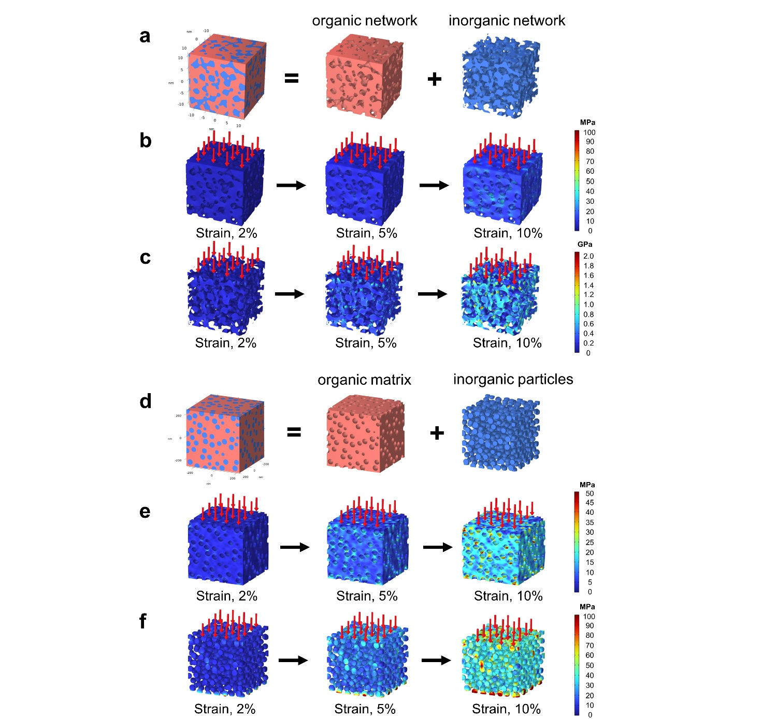

Extended Data Fig. 8| Finite element simulation of the mechanical response under uniaxial compression. a-c, Finite element model of the covalent-ionic bicontinuous network in poly(TA-CCO). The orange part represents the covalent (TA) network, and the blue part represents the ionic (CaCO₃) network. b, c, Calculated von Mises stress distributions of the covalent network (b) and ionic network (c) at strains of 2%, 5%, and 10%. This demonstrated the flexibility of the inorganic ionic network without accumulation of stresses. The average stress was 196 MPa for poly(TA-CCO) at a strain of 10%. d-f, Finite element model of the nanocomposite structure in pTA-NP. The orange part represents the TA matrix, and the blue represents CaCO₃ nanoparticles. d, e, Calculated von Mises stress distributions of the TA matrix (e) and CaCO₃ nanoparticles (f) at strains of 2%, 5%, and 10%. This showed accumulated stress at the organic‒inorganic interface, where the failure of organic‒inorganic nanocomposites commonly occurs. The average value of the stress was 22 MPa for pTA-NP.

Extended Data Fig. 9| Internal structure of poly(TA-CCO) bulk after recycling. a, HAADF-STEM image of the recycled poly(TA-CCO) bulk showing preservation of the covalent-ionic bicontinuous network. b, Pair distribution functions (denoted by G(r)) of the original poly(TA-CCO) bulk and recycled poly(TA-CCO) bulk. No obvious change was observed after recycling, which indicated the dynamic structural reversibility of the covalent-ionic bicontinuous network in poly(TA-CCO).

Supplementary Video| In situ nanoindentation test of silicone rubber and poly(TA-CCO).

