Online Appendix

Appendix A. Political leaders

Appendix B. Additional results

Appendix C. Heat maps

Appendix A. Political leaders

Table A1. Political leaders
Country | Leader | Function | Election date | E | A | C | Es | O
Afghanistan | Ashraf Ghani | President | 28-Sep-19 | 3.33 | 0.63 | 2.17 | 0.00 | 2.33
Albania | Edi Rama | PM | 25-Jun-17 | 2.83 | 1.83 | 2.00 | 1.33 | 2.83
Argentina | Alberto Fernández | President | 27-Oct-19 | 2.50 | 2.00 | 2.67 | 1.33 | 2.50
Australia | Scott Morrison | PM | 18-May-19 | 3.39 | 1.22 | 2.47 | 2.20 | 0.67
Austria | Sebastian Kurz | PM | 15-Oct-17 | 2.50 | 1.89 | 3.21 | 3.07 | 2.16
Bangladesh | Sheikh Hasina | PM | 30-Dec-18 | 2.38 | 2.00 | 3.50 | 3.25 | 2.63
Botswana | Mokgweetsi Masisi | PM | 23-Oct-19 | 2.94 | 3.04 | 3.00 | 2.81 | 2.56
Brazil | Jair Bolsonaro | President | 7-Oct-18 | 2.75 | 1.15 | 1.83 | 1.03 | 1.60
Bulgaria | Boyko Borisov | PM | 26-Mar-17 | 3.00 | 1.33 | 1.83 | 1.17 | 2.02
Cameroon | Paul Biya | President | 7-Oct-18 | 0.80 | 2.50 | 2.40 | 2.78 | 0.90
Canada | Justin Trudeau | PM | 21-Oct-19 | 3.69 | 2.69 | 1.63 | 2.69 | 3.33
Chile | Sebastián Piñera | President | 19-Nov-17 | 2.75 | 2.00 | 2.88 | 2.25 | 1.38
Colombia | Iván Duque Márquez | President | 27-May-18 | 2.22 | 1.95 | 3.19 | 3.02 | 1.26
Cyprus | Nicos Anastasiades | President | 28-Jan-18 | 2.00 | 0.78 | 2.03 | 1.48 | 1.75
Czech Republic | Andrej Babiš | PM | 20-Oct-17 | 2.86 | 1.14 | 2.86 | 1.82 | 2.50
Denmark | Mette Frederiksen | PM | 5-Jun-19 | 2.75 | 1.88 | 3.25 | 3.13 | 2.00
Ecuador | Lenín Moreno | President | 19-Feb-17 | 1.36 | 2.71 | 1.93 | 2.43 | 1.00
Estonia | Jüri Ratas | PM | 3-Mar-19 | 2.25 | 3.25 | 2.50 | 3.25 | 2.25
Fiji | Frank Bainimarama | PM | 14-Nov-18 | 3.50 | 1.67 | 2.85 | 1.10 | 1.67
France | Emmanuel Macron | President | 23-Apr-17 | 2.70 | 2.40 | 3.20 | 2.70 | 3.10
Germany | Angela Merkel | PM | 24-Sep-17 | 0.56 | 2.41 | 3.80 | 3.73 | 1.65
Ghana | Nana Akufo-Addo | President | 7-Dec-16 | 3.58 | 2.75 | 3.75 | 2.00 | 3.33
Greece | Kyriakos Mitsotakis | PM | 7-Jul-19 | 1.44 | 2.22 | 2.83 | 2.30 | 2.00
Guatemala | Alejandro Giammattei | President | 11-Aug-19 | 2.15 | 1.00 | 1.88 | 1.30 | 1.30
Hungary | Viktor Orbán | PM | 8-Apr-18 | 3.10 | 0.80 | 3.33 | 2.00 | 2.10
Iceland | Katrín Jakobsdóttir | PM | 29-Oct-16 | 3.13 | 2.88 | 3.42 | 3.50 | 3.25
India | Narendra Modi | PM | 19-May-19 | 2.69 | 1.25 | 2.88 | 2.50 | 2.35
Indonesia | Joko Widodo | President | 17-Apr-19 | 1.86 | 2.66 | 3.19 | 3.31 | 2.63
Iran | Hassan Rouhani | President | 19-May-17 | 2.42 | 1.88 | 3.54 | 3.42 | 2.38
Ireland | Leo Varadkar | PM | 8-Feb-20 | 2.00 | 2.30 | 3.60 | 3.10 | 2.50
Israel | Benjamin Netanyahu | PM | 9-Apr-19 | 3.09 | 0.97 | 2.54 | 1.97 | 2.50
Japan | Shinzō Abe | PM | 21-Jul-19 | 2.65 | 0.95 | 1.90 | 1.00 | 1.65
Kosovo | Albin Kurti | PM | 11-Jun-17 | 3.08 | 2.13 | 3.58 | 2.92 | 2.88
Lithuania | Gitanas Nausėda | President | 12-May-19 | 2.00 | 2.17 | 3.33 | 2.17 | 2.83
Madagascar | Andry Rajoelina | President | 7-Nov-18 | 3.50 | 2.38 | 1.25 | 2.13 | 2.13
Mexico | Andrés Manuel López Obrador | President | 1-Jul-18 | 2.54 | 1.43 | 2.14 | 1.75 | 1.96
Mozambique | Filipe Nyusi | President | 15-Oct-19 | 1.20 | 1.70 | 1.30 | 2.00 | 0.90
New Zealand | Jacinda Ardern | PM | 23-Sep-17 | 3.33 | 3.21 | 3.45 | 3.40 | 3.40
Nicaragua | Daniel Ortega | President | 6-Nov-16 | 0.83 | 0.33 | 2.17 | 0.67 | 0.67
Norway | Erna Solberg | PM | 11-Sep-17 | 2.14 | 2.43 | 3.14 | 3.57 | 1.64
Pakistan | Imran Khan | PM | 25-Jul-18 | 2.88 | 1.75 | 2.38 | 1.88 | 2.75
Philippines | Rodrigo Duterte | PM | 13-May-19 | 2.55 | 1.25 | 1.64 | 0.82 | 2.14
Portugal | António Costa | PM | 6-Oct-19 | 2.65 | 2.12 | 2.88 | 2.13 | 2.50
Romania | Klaus Iohannis | President | 10-Nov-19 | 0.75 | 1.50 | 3.42 | 3.38 | 1.25
Russia | Vladimir Putin | President | 18-Mar-18 | 2.24 | 2.00 | 2.92 | 2.92 | 1.93
Serbia | Aleksandar Vučić | President | 2-Apr-17 | 2.30 | 1.20 | 2.10 | 0.90 | 1.60
Slovenia | Janez Janša | PM | 3-Jun-18 | 2.20 | 0.70 | 2.70 | 1.50 | 1.10
South Africa | Cyril Ramaphosa | PM | 8-May-19 | 3.00 | 3.23 | 3.20 | 3.10 | 3.00
South Korea | Moon Jae-in | President | 9-May-17 | 1.60 | 3.00 | 3.00 | 3.00 | 1.80
Spain | Pedro Sánchez | PM | 28-Apr-19 | 2.31 | 2.74 | 2.53 | 2.83 | 2.06
Sweden | Stefan Löfven | PM | 9-Sep-18 | 0.75 | 2.63 | 3.25 | 2.75 | 1.13
Thailand | Prayut Chan-o-cha | PM | 24-Mar-19 | 2.76 | 0.89 | 2.11 | 0.65 | 1.05
The Netherlands | Mark Rutte | PM | 15-Mar-17 | 3.19 | 2.63 | 3.04 | 3.06 | 2.33
Timor Leste | Francisco 'Lú-Olo' Guterres | President | 20-Mar-17 | 1.67 | 2.50 | 2.67 | 3.00 | 2.33
Turkey | Recep Tayyip Erdoğan | President | 24-Jun-18 | 3.16 | 0.63 | 2.69 | 0.75 | 2.06
UK | Boris Johnson | PM | 12-Dec-19 | 3.69 | 1.24 | 0.88 | 1.42 | 2.81
Ukraine | Volodymyr Zelensky | President | 31-Mar-19 | 2.70 | 2.58 | 2.13 | 2.25 | 3.00
Uruguay | Luis Lacalle Pou | President | 27-Oct-19 | 3.29 | 1.93 | 3.39 | 2.57 | 2.67
USA | Donald Trump | President | 8-Nov-16 | 3.61 | 0.18 | 0.68 | 0.43 | 1.88
Uzbekistan | Shavkat Mirziyoyev | President | 4-Dec-16 | 2.38 | 1.50 | 3.35 | 2.05 | 2.33
Zimbabwe | Emmerson Mnangagwa | President | 30-Jul-18 | 0.83 | 1.33 | 2.17 | 2.50 | 0.67
Source: The Negative Campaigning Comparative Expert Study (NEGex). Format date dd-mmm-yy.

Appendix B. Additional results

Table B1. Factor loadings of personality traits
Component | Factor 1 | Factor 2 | Uniqueness
Agreeableness | 0.55 |  | 0.29
Conscientiousness | 0.50 |  | 0.49
Emotional Stability | 0.58 |  | 0.18
Extraversion |  | 0.74 | 0.40
Openness |  | 0.64 | 0.32
Eigenvalues | 2.43 | 1.58
Proportion | 0.49 | 0.32
Loadings smaller than 0.45 were omitted. N=61.

Table B2. Descriptive statistics
Variable | Coding | N | Mean | Std. Dev. | Min | Max
Travel restrictions (average) | 0-4 ordinal scale; average score | 61 | 2.17 | 0.62 | 0.00 | 3.08
Travel restrictions (days at min) | 0-4 ordinal scale; days at 0 | 61 | 54.66 | 31.59 | 6.00 | 182.00
Debt relief (average) | 0-2 ordinal scale; average score | 61 | 0.80 | 0.42 | 0.00 | 2.00
Debt relief (days at min) | 0-2 ordinal scale; days at 0 | 61 | 95.25 | 37.92 | 0.00 | 182.00
Gvt Response index (average) | 0-100 index; average score | 61 | 42.23 | 7.86 | 7.40 | 55.78
Gvt Response index (days at min) | 0-100 index; days at 0 | 61 | 32.03 | 19.11 | 0.00 | 74.00
Extraversion | 0 (very low) to 4 (very high) | 61 | 2.46 | 0.81 | 0.56 | 3.69
Agreeableness | 0 (very low) to 4 (very high) | 61 | 1.86 | 0.78 | 0.18 | 3.25
Conscientiousness | 0 (very low) to 4 (very high) | 61 | 2.65 | 0.73 | 0.68 | 3.80
Emotional stability | 0 (very low) to 4 (very high) | 61 | 2.22 | 0.92 | 0.00 | 3.73
Openness | 0 (very low) to 4 (very high) | 61 | 2.08 | 0.72 | 0.67 | 3.40
“Stability” | 0 (very low) to 4 (very high) | 61 | 2.24 | 0.70 | 0.43 | 3.35
“Plasticity” | 0 (very low) to 4 (very high) | 61 | 2.27 | 0.68 | 0.75 | 3.51
Populist | 0 (no), 1 (yes) | 61 | 0.43 | 0.50 | 0.00 | 1.00
Deaths per 10,000 people | Continuous | 61 | 1.03 | 1.58 | 0.00 | 6.59
Hospital beds per 1,000 people | Continuous | 57 | 3.70 | 2.85 | 0.20 | 13.40
Percent population over 65 | Percent | 59 | 12.48 | 6.80 | 2.58 | 27.58
Days first 100 cases | Continuous | 57 | 21993.7 | 17.9 | 21965 | 22063
Debt-GDP | Percent | 58 | 52.82 | 39.02 | 5.31 | 198.44
Regime Type | -10 (strongly autocratic) to 10 (strongly democratic) | 60 | 6.95 | 4.50 | -9.00 | 10.00
Individualism | 0-100 index | 38 | 43.08 | 22.48 | 6.00 | 90.00
Tourism | Percent | 60 | 10.98 | 11.84 | 0.81 | 64.00
Decentralisation | 0 (highly centralized) to 4 (highly decentralized) | 49 | 1.70 | 1.48 | 0 | 4.8
Political System | 0 (legislative), 1 (presidential) | 61 | 1.48 | 0.50 | 1.00 | 2.00

Table B3. Determinants of Average Policies (magnitude of response)
 | International Travel Controls | Financial Relief | Overall Government Response
Stability | -0.05 | 0.18* | 0.54
 | (0.14) | (0.09) | (1.83)
Plasticity | 0.05 | 0.12 | 4.03**
 | (0.13) | (0.08) | (1.64)
Populist | 0.05 | 0.07 | -0.13
 | (0.19) | (0.12) | (2.40)
Deaths/10000 | -0.10* | 0.03 | 0.58
 | (0.06) | (0.04) | (0.80)
Hospital Beds/1000 | 0.07 | <-0.00 | 0.68
 | (0.05) | (0.03) | (0.60)
Proportion of Population over 65 y.o. | -0.05** | 0.03* | -0.37
 | (0.03) | (0.02) | (0.35)
Days since First 100 Cases | 0.01* | <-0.01 | 0.07
 | (<0.01) | (<0.01) | (0.05)
Debt/GDP | <-0.01 | <0.01 | 0.01
 | (<0.01) | (<0.01) | (0.03)
Regime Type | 0.04* | -0.02 | 0.12
 | (0.02) | (0.01) | (0.30)
Individualism | <0.01 | <-0.01 | -0.04
 | (0.01) | (<0.01) | (0.07)
Tourism/GDP | 0.01 | - | -
 | (0.01)
Decentralization | - | - | 0.06
 |  |  | (1.02)
Constant | 1.45** | -0.02 | 26.69***
 | (0.54) | (0.32) | (6.28)
N | 61 | 61 | 61
R² | 0.26 | 0.26 | 0.20
Standard errors in parentheses. * p < 0.1, ** p < 0.05, *** p < 0.01.

Table B4. Determinants of Days at Minimum of Policies (promptness of response)
 | International Travel Controls | Financial Relief | Overall Government Response
Stability | 0.05 | -0.13* | -0.17
 | (0.12) | (0.07) | (0.15)
Plasticity | -0.15 | -0.11* | -0.21
 | (0.11) | (0.06) | (0.14)
Populist | 0.06 | 0.01 | -0.22
 | (0.15) | (0.10) | (0.18)
Deaths/10000 | 0.08* | -0.07** | -0.11*
 | (0.05) | (0.03) | (0.06)
Hospital Beds/1000 | -0.07** | -0.01 | -0.07
 | (0.04) | (0.02) | (0.05)
Proportion of Population over 65 y.o. | 0.03* | -0.03** | 0.02
 | (0.02) | (0.01) | (0.03)
Days since First 100 Cases | <0.01 | <0.01 | 0.01
 | (<0.01) | (<0.01) | (<0.01)
Debt/GDP | <0.01 | <-0.01 | <-0.01
 | (<0.01) | (<0.01) | (<0.01)
Regime Type | -0.04** | 0.02 | <-0.01
 | (0.02) | (0.01) | (0.02)
Individualism | <0.01 | <0.01 | <0.01
 | (<0.01) | (<0.01) | (<0.01)
Tourism/GDP | <0.01 | - | -
 | (0.01)
Decentralization | - | - | -0.15*
 |  |  | (0.08)
Constant | 4.03*** | 5.30*** | 4.22***
 | (0.44) | (0.24) | (0.50)
N | 61 | 61 | 61
R² | 0.03 | 0.05 | 0.03
Standard errors in parentheses. * p < 0.1, ** p < 0.05, *** p < 0.01.

Figure B1. Personality traits of political leaders
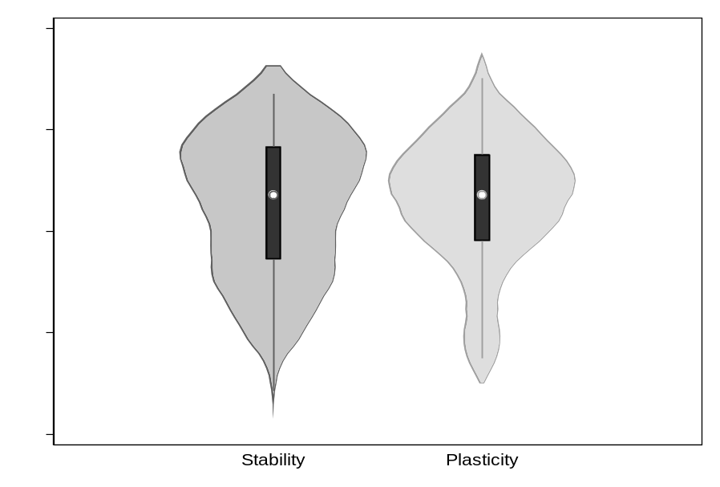
Source: The Negative Campaigning Comparative Expert Study (NEGex). N=61.

Figure B2. Substantive Impact of Stability on Financial Relief (Average)
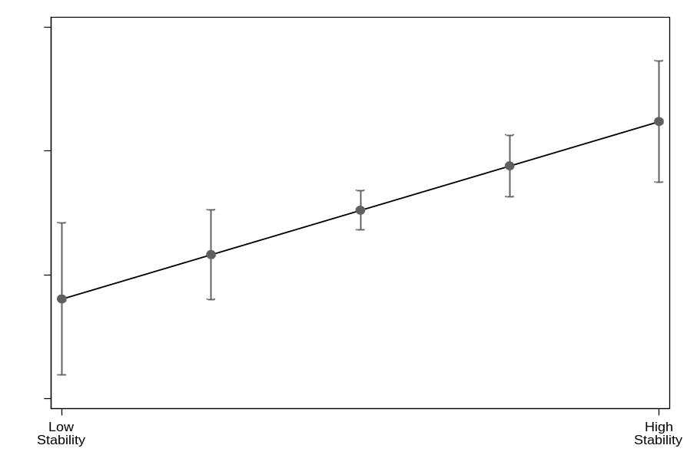
The markers represent predictive margins derived from the OLS regression in Figure 6 (top panel). Bars represent confidence intervals at the 84% level (corresponding to p < 0.05, see MacGregor-Fors & Payton, 2013).

Figure B3. Substantive Impact of Personality on Financial Relief (Days)
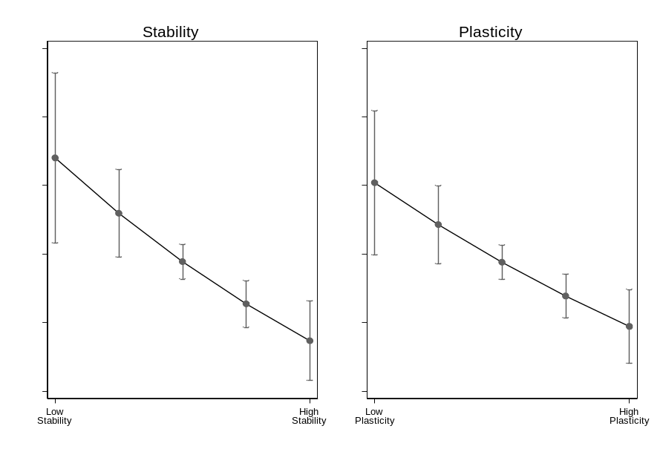
The markers represent predictive margins derived from the OLS regression in Figure 6 (bottom panel). Bars represent confidence intervals at the 76% level (corresponding to p < 0.1, see MacGregor-Fors & Payton, 2013).

Figure B4. Substantive Impact of Plasticity on Overall Government Response (Average)
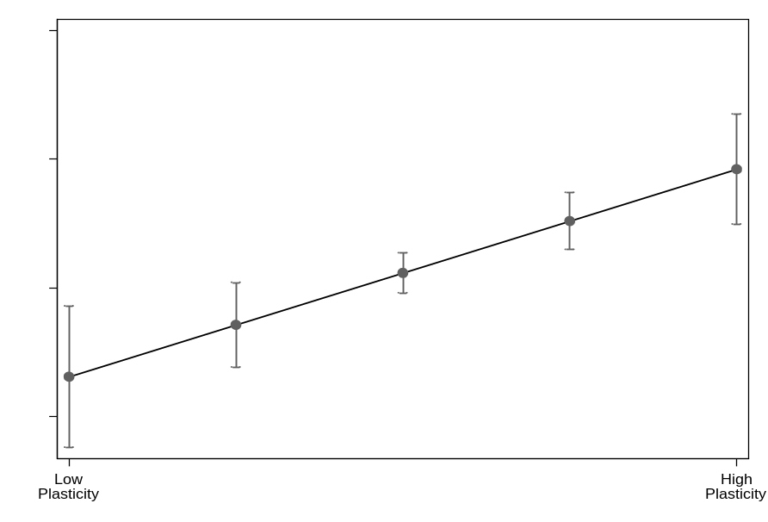
The markers represent predictive margins derived from the OLS regression in Figure 4 (top panel). Bars represent confidence intervals at the 84% level (corresponding to p < 0.05, see MacGregor-Fors & Payton 2013).

Figure B5. Moderation of Political System on the Impact of Stability on Financial Relief (Average)
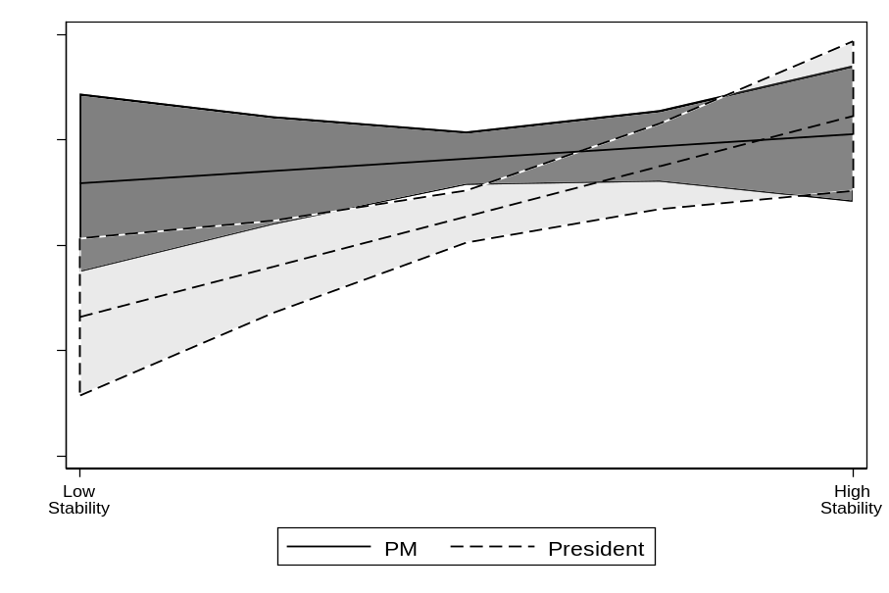
The mid-line represents predictive margins derived from an OLS regression. Bars represent confidence intervals at the 84% level (corresponding to p < 0.05, see MacGregor-Fors & Payton, 2013).

Appendix C. Heat maps for travel restrictions and debt relief

Figure C1. Heat map for weekly averages on travel restrictions

 | January |  |  |  | February |  |  |  | March |  |  |  |  | April |  |  |  | May |  |  |  | June
Week | 1 | 2 | 3 | 4 | 5 | 6 | 7 | 8 | 9 | 10 | 11 | 12 | 13 | 14 | 15 | 16 | 17 | 18 | 19 | 20 | 21 | 22 | 23 | 24 | 25 | 26
Afghanistan
Albania
Argentina
Australia
Austria
Bangladesh
Botswana
Brazil
Bulgaria
Cameroon
Canada
Chile
Colombia
Cyprus
Czech Rep.
Denmark
Ecuador
Estonia
Fiji
France
Germany
Ghana
Greece
Guatemala
Hungary
Iceland
India
Indonesia
Iran
Ireland
Israel
Japan
Kosovo
Lithuania
Madagascar
Mexico
Mozamb.
N. Zealand
Nicaragua
Norway
Pakistan
Philippines
Portugal
Romania
Russia
Serbia
Slovenia
South Africa
South Korea
Spain
Sweden
Thailand
The Netherl.
Timor Leste
Turkey
UK
Ukraine
Uruguay
USA
Uzbekistan
Zimbabwe
Source: Oxford COVID-19 Government Response Tracker initiative. Data for the period between January 1 and June 30, 2020. Weekly averages. Pale blue indicates lower scores (weaker response) and deep purple higher scores (stronger response) on travel restrictions. Original index varies between 0 and 4.

Figure C2. Heat map for weekly averages on debt relief

 | January |  |  |  | February |  |  |  | March |  |  |  |  | April |  |  |  | May |  |  |  | June
Week | 1 | 2 | 3 | 4 | 5 | 6 | 7 | 8 | 9 | 10 | 11 | 12 | 13 | 14 | 15 | 16 | 17 | 18 | 19 | 20 | 21 | 22 | 23 | 24 | 25 | 26
Afghanistan
Albania
Argentina
Australia
Austria
Bangladesh
Botswana
Brazil
Bulgaria
Cameroon
Canada
Chile
Colombia
Cyprus
Czech Rep.
Denmark
Ecuador
Estonia
Fiji
France
Germany
Ghana
Greece
Guatemala
Hungary
Iceland
India
Indonesia
Iran
Ireland
Israel
Japan
Kosovo
Lithuania
Madagascar
Mexico
Mozamb.
N. Zealand
Nicaragua
Norway
Pakistan
Philippines
Portugal
Romania
Russia
Serbia
Slovenia
South Africa
South Korea
Spain
Sweden
Thailand
The Netherl.
Timor Leste
Turkey
UK
Ukraine
Uruguay
USA
Uzbekistan
Zimbabwe
Source: Oxford COVID-19 Government Response Tracker initiative. Data for the period between January 1 and June 30, 2020. Weekly averages. Pale blue indicates lower scores (weaker response) and deep purple higher scores (stronger response) on debt relief. Original index varies between 0 and 2.

Figure C3. Heat map for weekly averages on government response index

 | January |  |  |  | February |  |  |  | March |  |  |  |  | April |  |  |  | May |  |  |  | June
Week | 1 | 2 | 3 | 4 | 5 | 6 | 7 | 8 | 9 | 10 | 11 | 12 | 13 | 14 | 15 | 16 | 17 | 18 | 19 | 20 | 21 | 22 | 23 | 24 | 25 | 26
Afghanistan
Albania
Argentina
Australia
Austria
Bangladesh
Botswana
Brazil
Bulgaria
Cameroon
Canada
Chile
Colombia
Cyprus
Czech Rep.
Denmark
Ecuador
Estonia
Fiji
France
Germany
Ghana
Greece
Guatemala
Hungary
Iceland
India
Indonesia
Iran
Ireland
Israel
Japan
Kosovo
Lithuania
Madagascar
Mexico
Mozamb.
N. Zealand
Nicaragua
Norway
Pakistan
Philippines
Portugal
Romania
Russia
Serbia
Slovenia
South Africa
South Korea
Spain
Sweden
Thailand
The Netherl.
Timor Leste
Turkey
UK
Ukraine
Uruguay
USA
Uzbekistan
Zimbabwe
Source: Oxford COVID-19 Government Response Tracker initiative. Data for the period between January 1 and June 30, 2020. Weekly averages. Pale blue indicates lower scores (weaker response) and deep purple higher scores (stronger response) on the government response index. Original index varies between 0 and 100.

