Supplementary Information
Different Zn loading in Urea-Formaldehyde influences the N controlled release by Structure Modification
Amanda S. Giroto ¹, Stella F. do Valle,^{1,2}, Gelton G. F. Guimaraes ³, Nicolai D. Jablonowski^{4*}, Caue Ribeiro^{1*}, Luiz Henrique C. Mattoso¹
¹Embrapa Instrumentação, National Nanotechnology Laboratory for Agribusiness (LNNA), XV Novembro Street, CP: 741, Zip Code: 13560-206 São Carlos, SP, Brazil
²Federal University of São Carlos, Department of Chemistry, Washington Luiz Highway, km 235, Zip Code: 13565-905 São Carlos, SP, Brazil
³Agricultural Research and Rural Extension Company of Santa Catarina, 6800 Highway, Antônio Heil, Itajaí, Santa Catarina, 88318112, Brazil
⁴Forschungszentrum Jülich GmbH, Institute of Bio- and Geosciences, IBG-2: Plant Science, 52425 Jülich, Germany
*Corresponding authors: n.d.jablonowski@fz-juelich.de; caue.ribeiro@embrapa.br

Table S1. FTIR bands related to bonds of the materials.
Bands |  |  | Wavenumber (cm⁻¹)
Bands | Urea | UF | UFZO |  |  | UFZS
Bands | Urea | UF | 0.5 | 1 | 0.2 | 0.5 | 1 | 2
ν-NH_{2 (free)} | 3425 | 3437 | 3437 | 3437 | 3437 | 3443 | 3443 | 3343
ν-NH _{(bonded)} | 3327 | 3327 | 3327 | 3327 | 3327 | 3327 | 3327 | 3327
νCO_{free} | 1676 | 1646 | 1646 | 1646 | 1646 | 1646 | 1646 | 1646
δN-H +νC-N | 1588 | 1599 | 1599 | 1599 | 1599 | 1599 | 1599 | 1599

Figure S1. EDX images of composites (a) UFZO 0.5, UFZO 1, UFZO 2, and (b) UFZS 0.5, UFZS 1 and UFZS 2.

Figure S2. Normalized FTIR spectra in (a) and (c) amplification to 3500-3000 cm⁻¹ and (b) and (d) 1800-1500cm⁻¹ for (i) urea, (ii) pure polymer UF, (iii) UFZO 0.5, (iv) UFZO 1, (v) UFZO 2 and (vi) ZnSO₄, (vii) UFZS 0.5, (viii) UFZS 1 and (ix) UFZS 2, (x) ZnO and (xi) ZnSO_{4.}
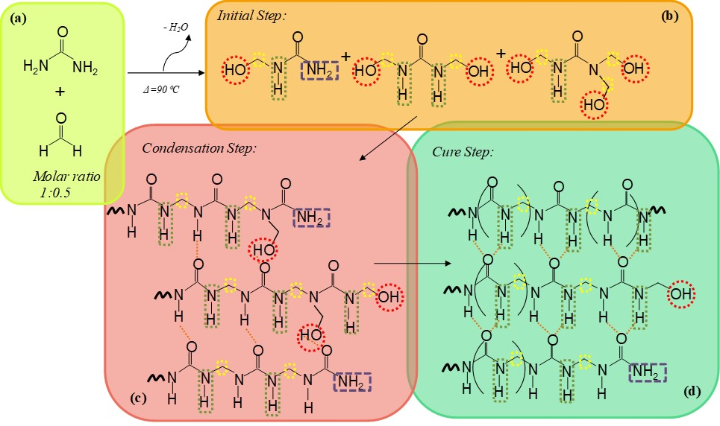
Figure S3. Schematic illustration of the possible chemical species corresponding to the ¹H NMR Spectra: (a) urea and formaldehyde, (b) small molecules formed: mono, di- and tri hydroxylureas, (c) condensation step with hydroxyl groups and (d) cure step and H-bond formation.

