Enhanced cancer starvation therapy via autophagy inhibition with a functional Dendritic Mesoporous Organosilicon Nanoagent

Graphical Abstract
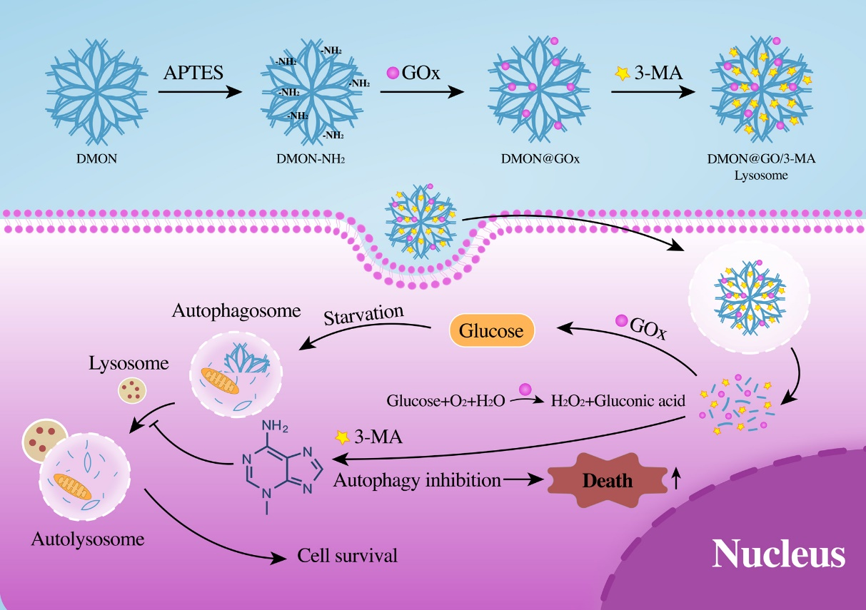
Scheme 1. Schematic representation of the functional pattern of DMON@GOx/3-MA. Autophagy inhibitor 3-MA released from DMON@GOx/3-MA enhances GOx-induced starvation therapy in tumor cells.

