Supplementary Material

Supplementary part I: Sample fabrication
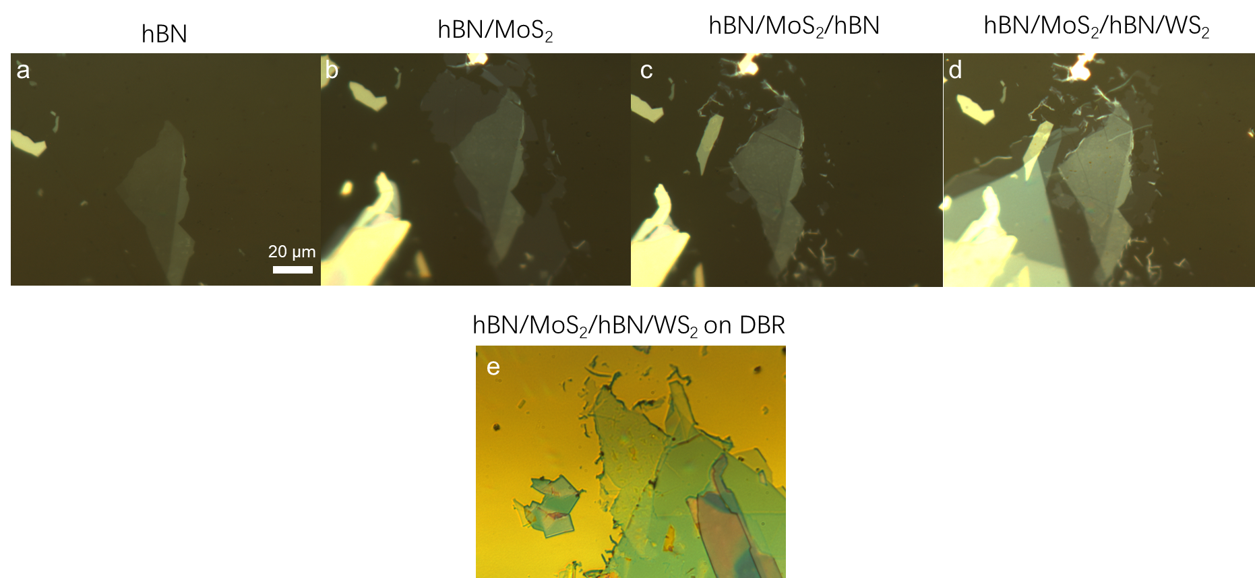
Supplementary Figure 1| Heterojunction fabrication process. (a-d) Optical image of the heterojunction made by the pick-up method. (e) Optical image of the heterojunction transferred onto the DBR substrate.

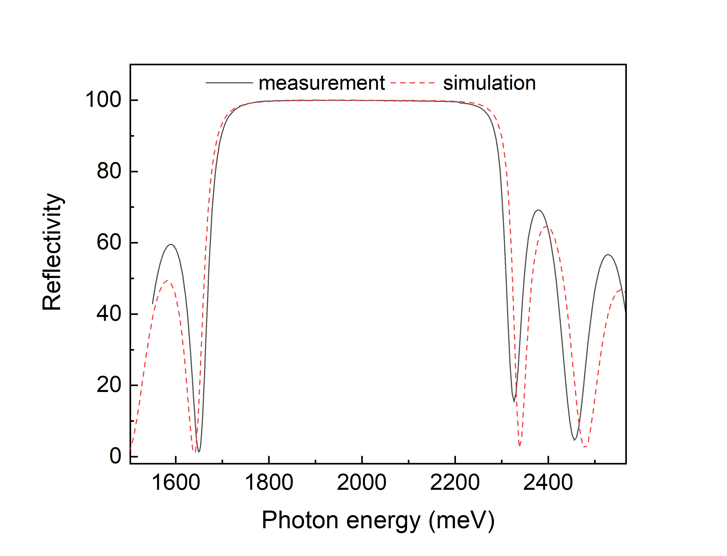
Supplementary Figure 2| Reflectivity spectrum of the DBR substrate.

Supplementary part II: Optical characterization
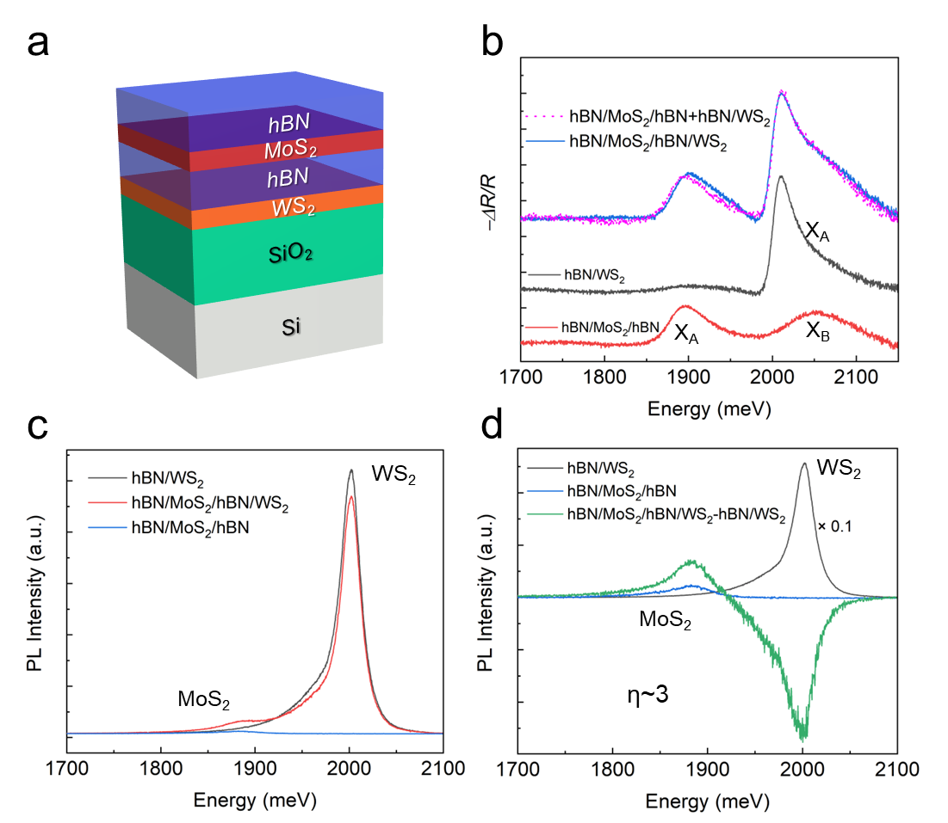
Supplementary Figure 3| FRET in het@SiO₂. (a) Schematic illustration of het@SiO₂. (b, c) Differential reflection (b) and PL (c) spectra in the different sample regions. (d) The comparison of PL spectra between hBN/WS₂ (black), hBN/MoS₂/hBN (blue) and hBN/MoS₂/hBN/WS₂ subtracting hBN/WS₂ (green). Note: PL spectra were obtained by the non-resonant excitation from a 532 nm continuous-wave (CW) laser of ~5 μW.

The intrinsic interlayer interaction in het@SiO₂ was learnt by comparing the differential reflection and PL spectra of hBN/MoS₂/hBN/WS₂, hBN/MoS₂/hBN, and hBN/WS₂ heterojunctions. The reflection spectrum of the hBN/MoS₂/hBN/WS₂ is almost the superposition of those of the hBN/MoS₂/hBN and hBN/WS₂, which indicates a weak interlayer coupling with a negligible transfer of dipole oscillator strength¹ (Supplementary Figure 3b). As known, for direct-bandgap semiconductor heterojunctions, the charge carrier transfer and exciton energy transfer are two dominant interlayer interactions. For the hBN/MoS₂/hBN/WS₂, the middle hBN layer of 2 nm almost entirely blocks the tunneling current^{2, 3}, while FRET still exists for the space thickness (d) of <10 nm^{2, 4}. Indeed, a FRET process is reflected by the weakened WS₂ PL intensity and strengthened MoS₂ PL intensity for the hBN/MoS₂/hBN/WS₂ in comparison with the corresponding intensity for hBN/MoS₂/hBN and hBN/WS₂ (Supplementary Figure 3c). By subtracting the spectrum of hBN/WS₂/hBN from that of hBN/MoS₂/hBN/WS₂, η is estimated to be ~3 (Supplementary Figure 3d), which is a typical value for FRET (Supplementary Table 2). Hence, without the cavity confinement, a typical FRET dominates the interlayer coupling in hBN/MoS₂/hBN/WS₂ heterojunction, which is also supported by the photoluminescence excitation (PLE) results (Supplementary Figure 6).
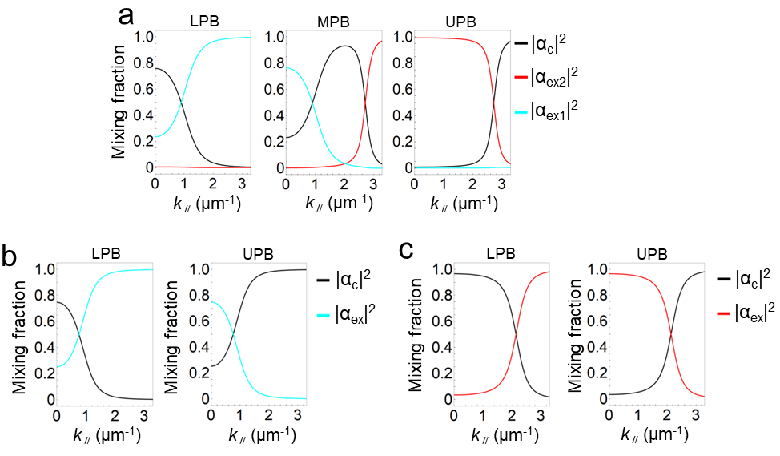
Supplementary Figure 4| Hopfield coefficient for het@cavity− (a), MoS₂@cavity (b) and WS₂@cavity (c).

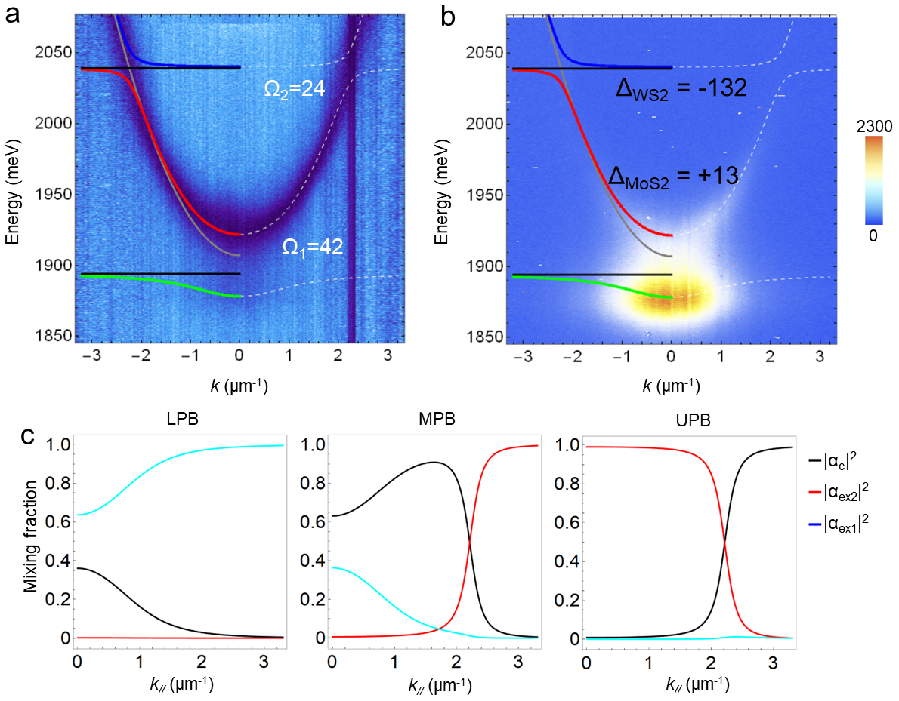
Supplementary Figure 5| Het@cavity+ with a positive detuning. (a, b) k-space energy-resolved reflectivity mapping (a), PL mapping (b). (c) Hopfield coefficient for LPB, MPB, and UPB, respectively.

The thickness of PMMA in het@cavity+ is slightly thinner than that in het@cavity−, leading to a blue-shift of the cavity photon mode.
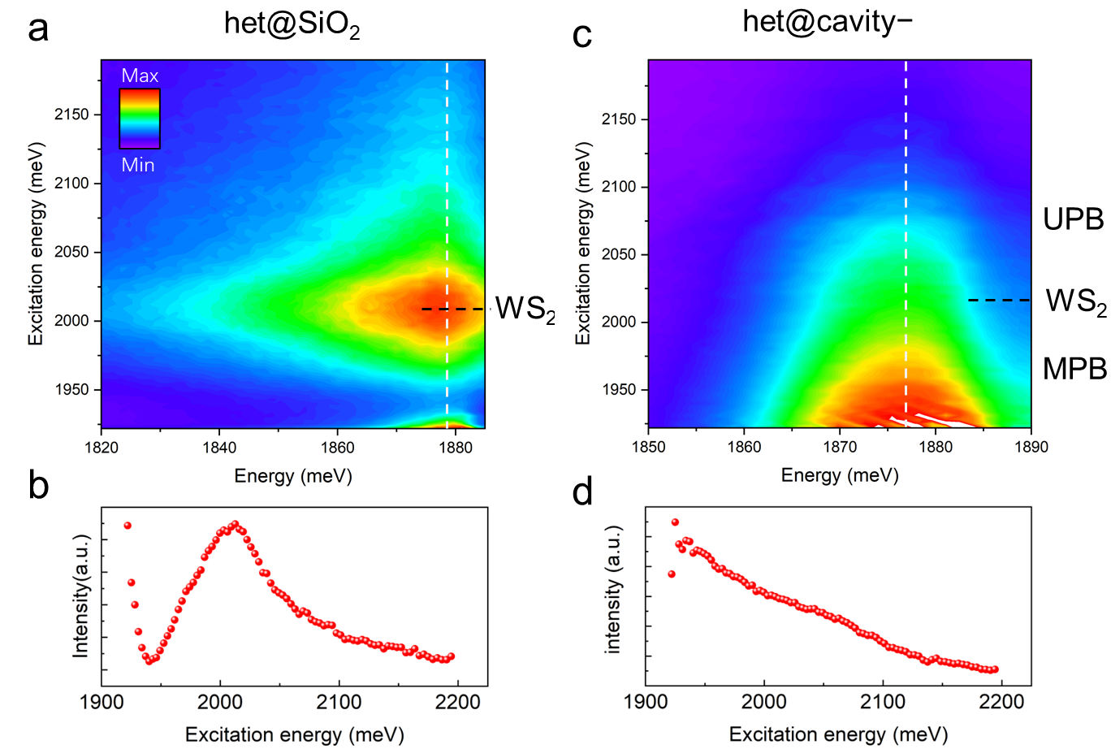
Supplementary Figure 6| Real-space PLE spectra. (a, b) PLE mapping (a), MoS₂ PL intensity with changing excitation energy (along the white dashed line in a) (b) of het@SiO₂. (c, d) PLE mapping (c), LPB PL intensity with changing excitation energy (along the white dashed line in c) (d) of het@cavity−.

In real-space PLE spectra, the MoS₂ emission of het@SiO₂ peaks at WS₂ exciton energy (Supplementary Figure 6a,b), demonstrating the FRET interaction, in agreement with the differential reflection and PL results in Supplementary Figure 3. On the contrary, the LPB emission of het@cavity− monotonously increases with decreasing the excitation energy to the LPB (Supplementary Figure 6c,d), which confirms the polariton relaxation mechanism.

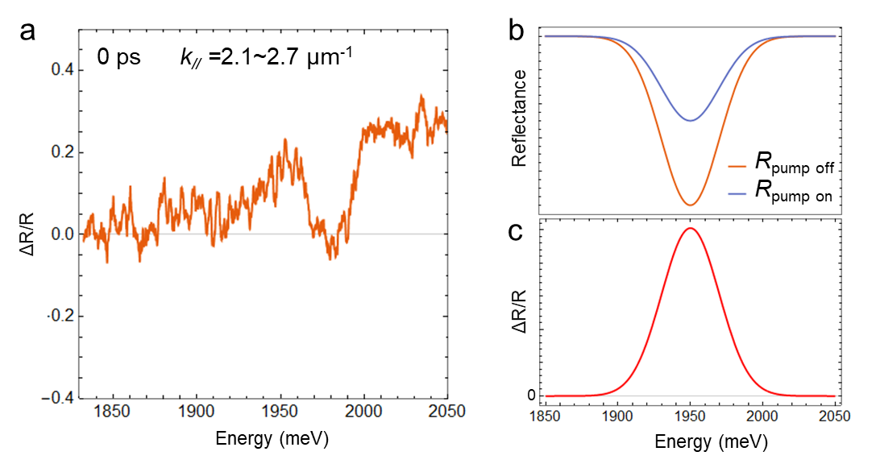
Supplementary Figure 7| (a) Integrated k-space transient-reflectivity spectrum of WS₂@cavity at 0 ps. (b,c) Schematic reflectance and corresponding $∆R/R$. Note: A simplified Gaussian function is used in (b), hence the simulated$∆R/R$ in (c) can only reflect the main feature of the polaritonic system.

The positive $∆R/R$ of WS₂@cavity at k//=2.1~2.7 μm⁻¹ in Supplementary Figure 7a indicates a pump-induced photobleaching process, as sketched in Supplementary Figure 7b,c. Specifically, the positive $∆R/R$ at 1950 and over 2000 meV corresponds to the photobleaching at LPB and UPB, respectively, while the dip at ~1970 meV to the negligible absorption at the Rabi splitting (Supplementary Figure 7a).

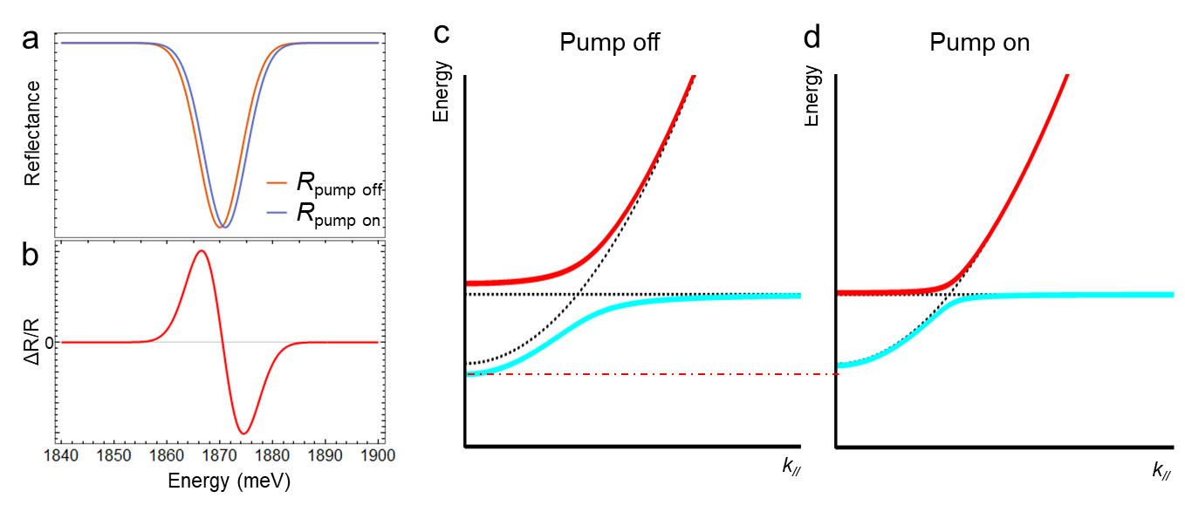
Supplementary Figure 8| The schematic illustration of a blue-shift in the k-space transient-reflectivity spectroscopy. (a, b) Blue-shift signal. (c, d) The dispersion with or without a pump.

The pump-induced blue shift shows a derivative signal in the integrated $∆R/R$ (Supplementary Figure 8a,b), which resembles the cases in Figure 3b,e. A blue shift in the polaritonic system represents a decrease of Rabi splitting energy (Ω), i.e., the decrease of dipole oscillator strength, as schematically drawn in Supplementary Figure 8c,d.

Supplementary part III: Theory
Transfer-matrix (t-martrix) method
Following the well-known formalism⁵⁻⁷, the T-matrix across a layer M in the TE polarization can be expressed as: $T_{M}=\left(\begin{matrix}cos⁡(α) & \frac{i}{q_{M}}sin⁡(α) \\ iq_{M}sin⁡(α) & cos⁡(α)\end{matrix}\right)$ where $α=n_{M}\left(ω\right)\frac{ω}{c}L_{M}cos⁡(θ_{M})$ and $q_{M}=n_{M}(ω)\frac{μ_{0}}{c}$. We consider the thickness of each layer as: $L_{Ag}=100 nm$, $L_{TiO2}=68.2 nm$, $L_{SiO2}=106.6 nm$, $L_{hBN1}=2 nm$, $L_{hBN2}=11 nm$, $L_{SiO2 Buffer}=11 nm$, $L_{PMMA}=85 nm$, $L_{MoS2}=1 nm$, $L_{WS2}=1 nm$. The slight difference between the theoretical and experimental values is due to the error in the measurement of the thicknesses. Since the thicknesses of the mirror layers in the sample are not exactly the same, the theoretical model reaches a much higher quality factor for the same number of layers. To compensate for this we only consider two pairs of layers in the simulations. The refractive indices are taken from the literature⁸⁻¹⁴.
The active layers (WS₂ and MoS₂ exciton states) are described in the framework of the T-matrix method, also following previously developed formalism^{5-7, 15}. The monolayers associated with the T-matrix can be expressed as: $T_{QW}=\left(\begin{matrix}1 & 0 \\ \frac{2q_{QW}r_{QW}}{1+r_{QW}} & 1\end{matrix}\right)$, where $q_{QW}$ is similar to $q_{M}$, although we assume the exciton resonance to be narrow enough such that the refractive index can be taken as a constant. The reflection coefficient can be derived as¹⁵ $r_{QW}=iΓ_{0}/(ω_{0}-ω-i(Γ_{0}+γ))$ where $Γ_{0}$ is the exciton radiative broadening and ${ℏω}_{0}$ is the resonance energy of the excitons. Considering these as fitting parameters, we get for the monolayers ${ℏΓ}_{0,MoS2}=0.05 meV$, ${ℏΓ}_{0,WS2}=0.15 meV$ and for the heterostructure ${ℏΓ}_{0,MoS2}=0.05 meV$ ${ℏΓ}_{0,WS2}=0.13 meV$. The exciton resonance energies are taken as: ${ℏω}_{0,MoS2}=1.885 eV$, ${ℏω}_{0,WS2}=1.980 eV$ for the monolayers and ${ℏω}_{0,MoS2}=1.885 eV$, ${ℏω}_{0,WS2}=2.020 eV$ for the heterostructure. The decay rate of the exciton is taken identical for all excitons : $γ=0.005 meV$. The differences between the parameters in the monolayer structures and the heterostructure can be explained by disorder and strain distributions that change between different samples. One may note some discrepancies between the coupled oscillator model and the T-matrix formalism at high energy. This difference is due to the non-validity of the effective mass approximation for the cavity photon used in the coupled oscillator model. Indeed this approximation requires working close to the lowest energy of the optical mode. Comparing directly the T-matrix simulations and the experimental data, we conclude to good agreement between the experiment and the theory.

The coupled rate equations
Here we construct the coupled rate equations for the polariton populations in different branches, leading to the theoretical model for the PL observed in experiments, as shown in Figure 2b,d,f in the main text. Rate equation is a tool that has been useful for describing the dynamics of the population of polaritons or excitons¹⁶⁻¹⁹. We will present the case for het@cavity− (involving three polariton branches) explicitly, while the ones for WS₂@cavity and MoS₂@cavity configurations follow as special cases. First, we consider the polariton population for all the branches (UPB, MPB, and LPB) in $k$-space and its evolution to the steady-state regime. The photonic part of these values corresponds to the observed PL, which with broadening in energy gives the simulated PL in the left half of Figure 2b (Also Figure 2d,f for the case of MoS₂@cavity and WS₂@cavity, respectively).

The coupled rate equations for the polariton populations read
$\frac{dN_{j}^{U}}{dt}=\left(P_{1}X_{1,j}^{U}+P_{2}X_{2,j}^{U}-γC_{j}^{U}\right)N_{j}^{U}+S^{UU}+S^{UM}+S^{UL}$,
$\frac{dN_{j}^{M}}{dt}=\left(P_{1}X_{1,j}^{M}+P_{2}X_{2,j}^{M}-γC_{j}^{M}\right)N_{j}^{M}+S^{MM}+S^{MU}+S^{ML}$,
$\frac{dN_{j}^{L}}{dt}=\left(P_{1}X_{1,j}^{L}+P_{2}X_{2,j}^{L}-γC_{j}^{L}\right)N_{j}^{L}+S^{LL}+S^{LU}+S^{LM}$, (1)
where the superscripts $\{U,M,L\}$ respectively denote the UPB, MPB, and LPB, while the subscript $j$ indicates the corresponding label for the point in $k$-space (uniform in $k$). The exciton fractions, denoted by $X_{\{1,2\},j}^{\{U,M,L\}}$, are obtained from the coupled oscillator model (Hopfield coefficients in Supplementary Figure 4), where $1 (2)$ indicates excitons in MoS₂ (WS₂). $C_{j}^{\left\{U,M,L\right\}}$ denotes the corresponding photonic fraction, $P_{1 (2)}$ the effective pump for the excitons in MoS₂ (WS₂), and $γ$ the decay rate for the photonic part of the polariton. The scattering terms originate from phonon-mediated exciton scattering^{20, 21}, giving rise to both intra-branch ($S^{UU}$, $S^{MM}$, and $S^{LL}$) and inter-branch ($S^{UM}$, $S^{UL}$, $S^{MU}$, $S^{ML}$, $S^{LU}$, and $S^{LM}$) scattering. The explicit expressions are written as
$S^{UU}=\sum_{k,{ E}_{j}^{U}<E_{k}^{U}}{ \left(W_{1}X_{1,j}^{U}X_{1,k}^{U}+W_{2}X_{2,j}^{U}X_{2,k}^{U}\right)\left|E_{j}^{U}-E_{k}^{U}\right|\left(\begin{aligned}N_{k}^{U}\left(N_{j}^{U}+1\right)\left(n_{ph}\left(\left|E_{j}^{U}-E_{k}^{U}\right|\right)+1\right) \\ -N_{j}^{U}\left(N_{k}^{U}+1\right)n_{ph}\left(\left|E_{j}^{U}-E_{k}^{U}\right|\right) \end{aligned}\right)}$
$+\sum_{k,{ E}_{j}^{U}>E_{k}^{U}}{ \left(W_{1}X_{1,j}^{U}X_{1,k}^{U}+W_{2}X_{2,j}^{U}X_{2,k}^{U}\right)\left|E_{j}^{U}-E_{k}^{U}\right|\left(\begin{aligned}N_{k}^{U}\left(N_{j}^{U}+1\right)n_{ph}\left(\left|E_{j}^{U}-E_{k}^{U}\right|\right) \\ -N_{j}^{U}\left(N_{k}^{U}+1\right)\left(n_{ph}\left(\left|E_{j}^{U}-E_{k}^{U}\right|\right)+1\right) \end{aligned}\right)}$,
$S^{UM}=\sum_{k,{ E}_{j}^{U}>E_{k}^{M}}{ \left(W_{1}X_{1,j}^{U}X_{1,k}^{M}+W_{2}X_{2,j}^{U}X_{2,k}^{M}\right)\left|E_{j}^{U}-E_{k}^{M}\right|\left(\begin{aligned}N_{k}^{M}\left(N_{j}^{U}+1\right)n_{ph}\left(\left|E_{j}^{U}-E_{k}^{M}\right|\right) \\ -N_{j}^{U}\left(N_{k}^{M}+1\right)\left(n_{ph}\left(\left|E_{j}^{U}-E_{k}^{M}\right|\right)+1\right) \end{aligned}\right)}$,
$S^{UL}=\sum_{k,{ E}_{j}^{U}>E_{k}^{L}}{ \left(W_{1}X_{1,j}^{U}X_{1,k}^{L}+W_{2}X_{2,j}^{U}X_{2,k}^{L}\right)\left|E_{j}^{U}-E_{k}^{L}\right|\left(\begin{aligned}N_{k}^{L}\left(N_{j}^{U}+1\right)n_{ph}\left(\left|E_{j}^{U}-E_{k}^{L}\right|\right) \\ -N_{j}^{U}\left(N_{k}^{L}+1\right)\left(n_{ph}\left(\left|E_{j}^{U}-E_{k}^{L}\right|\right)+1\right) \end{aligned}\right)}$,
$S^{MM}=\sum_{k,{ E}_{j}^{M}<E_{k}^{M}}{ \left(W_{1}X_{1,j}^{M}X_{1,k}^{M}+W_{2}X_{2,j}^{M}X_{2,k}^{M}\right)\left|E_{j}^{M}-E_{k}^{M}\right|\left(\begin{aligned}N_{k}^{M}\left(N_{j}^{M}+1\right)\left(n_{ph}\left(\left|E_{j}^{M}-E_{k}^{M}\right|\right)+1\right) \\ -N_{j}^{M}\left(N_{k}^{M}+1\right)n_{ph}\left(\left|E_{j}^{M}-E_{k}^{M}\right|\right) \end{aligned}\right)}$
$+\sum_{k,{ E}_{j}^{M}>E_{k}^{M}}{ \left(W_{1}X_{1,j}^{M}X_{1,k}^{M}+W_{2}X_{2,j}^{M}X_{2,k}^{M}\right)\left|E_{j}^{M}-E_{k}^{M}\right|\left(\begin{aligned}N_{k}^{M}\left(N_{j}^{M}+1\right)n_{ph}\left(\left|E_{j}^{M}-E_{k}^{M}\right|\right) \\ -N_{j}^{M}\left(N_{k}^{M}+1\right)\left(n_{ph}\left(\left|E_{j}^{M}-E_{k}^{M}\right|\right)+1\right) \end{aligned}\right)}$,
$S^{MU}=\sum_{k,{ E}_{j}^{M}<E_{k}^{U}}{ \left(W_{1}X_{1,j}^{M}X_{1,k}^{U}+W_{2}X_{2,j}^{M}X_{2,k}^{U}\right)\left|E_{j}^{M}-E_{k}^{U}\right|\left(\begin{aligned}N_{k}^{U}\left(N_{j}^{M}+1\right)\left(n_{ph}\left(\left|E_{j}^{M}-E_{k}^{U}\right|\right)+1\right) \\ -N_{j}^{M}\left(N_{k}^{U}+1\right)n_{ph}\left(\left|E_{j}^{M}-E_{k}^{U}\right|\right) \end{aligned}\right)}$,
$S^{ML}=\sum_{k,{ E}_{j}^{M}>E_{k}^{L}}{ \left(W_{1}X_{1,j}^{M}X_{1,k}^{L}+W_{2}X_{2,j}^{M}X_{2,k}^{L}\right)\left|E_{j}^{M}-E_{k}^{L}\right|\left(\begin{aligned}N_{k}^{L}\left(N_{j}^{M}+1\right)n_{ph}\left(\left|E_{j}^{M}-E_{k}^{L}\right|\right) \\ -N_{j}^{M}\left(N_{k}^{L}+1\right)\left(n_{ph}\left(\left|E_{j}^{M}-E_{k}^{L}\right|\right)+1\right) \end{aligned}\right)}$,
$S^{LL}=\sum_{k,{ E}_{j}^{L}<E_{k}^{L}}{ \left(W_{1}X_{1,j}^{L}X_{1,k}^{L}+W_{2}X_{2,j}^{L}X_{2,k}^{L}\right)\left|E_{j}^{L}-E_{k}^{L}\right|\left(\begin{aligned}N_{k}^{L}\left(N_{j}^{L}+1\right)\left(n_{ph}\left(\left|E_{j}^{L}-E_{k}^{L}\right|\right)+1\right) \\ -N_{j}^{L}\left(N_{k}^{L}+1\right)n_{ph}\left(\left|E_{j}^{L}-E_{k}^{L}\right|\right) \end{aligned}\right)}$
$+\sum_{k,{ E}_{j}^{L}>E_{k}^{L}}{ \left(W_{1}X_{1,j}^{L}X_{1,k}^{L}+W_{2}X_{2,j}^{L}X_{2,k}^{L}\right)\left|E_{j}^{L}-E_{k}^{L}\right|\left(\begin{aligned}N_{k}^{L}\left(N_{j}^{L}+1\right)n_{ph}\left(\left|E_{j}^{L}-E_{k}^{L}\right|\right) \\ -N_{j}^{L}\left(N_{k}^{L}+1\right)\left(n_{ph}\left(\left|E_{j}^{L}-E_{k}^{L}\right|\right)+1\right) \end{aligned}\right)}$,
$S^{LU}=\sum_{k,{ E}_{j}^{L}<E_{k}^{U}}{ \left(W_{1}X_{1,j}^{L}X_{1,k}^{U}+W_{2}X_{2,j}^{L}X_{2,k}^{U}\right)\left|E_{j}^{L}-E_{k}^{U}\right|\left(\begin{aligned}N_{k}^{U}\left(N_{j}^{L}+1\right)\left(n_{ph}\left(\left|E_{j}^{L}-E_{k}^{U}\right|\right)+1\right) \\ -N_{j}^{L}\left(N_{k}^{U}+1\right)n_{ph}\left(\left|E_{j}^{L}-E_{k}^{U}\right|\right) \end{aligned}\right)}$,
$S^{LM}=\sum_{k,{ E}_{j}^{L}<E_{k}^{M}}{ \left(W_{1}X_{1,j}^{L}X_{1,k}^{M}+W_{2}X_{2,j}^{L}X_{2,k}^{M}\right)\left|E_{j}^{L}-E_{k}^{M}\right|\left(\begin{aligned}N_{k}^{M}\left(N_{j}^{L}+1\right)\left(n_{ph}\left(\left|E_{j}^{L}-E_{k}^{M}\right|\right)+1\right) \\ -N_{j}^{L}\left(N_{k}^{M}+1\right)n_{ph}\left(\left|E_{j}^{L}-E_{k}^{M}\right|\right) \end{aligned}\right)}$, (2)
where $n_{ph}\left(x\right)$ stands for phonon distribution as detailed in the main text, $W_{1 (2)}$ is the exciton scattering coefficient. We note that a scattering process from a higher to lower energy emits a phonon and that of the reverse requires the absorption of one, hence the factor $n_{ph}\left(x\right)+1$ and $n_{ph}(x)$, respectively. This in turn guarantees that the whole system undergoes energy relaxation. The energy of the polariton $E_{j}^{\left\{U,M,L\right\}}$ (in meV) corresponds to the $j$th point in $k$-space, which is obtained from the coupled oscillator model.

In simulations, we take $(P_{1},P_{2},W_{1},W_{2})/γ$ as fitting parameters. The initial values for the population are taken as random, i.e., $N_{j}^{\left\{U,M,L\right\}}\left(0\right)∈[0,1]$. After the evolution, one gets the steady-state values (at $γt=τ$) for the population, $N_{j}^{\left\{U,M,L\right\}}\left(τ\right)$. The photonic part $n_{j}^{\left\{U,M,L\right\}}≡N_{j}^{\left\{U,M,L\right\}}\left(τ\right)C_{j}^{\left\{U,M,L\right\}}$ is responsible for the observed PL. The broadening in energy is incorporated as follows. For the $j$th point in the $k$-space, the energy dependence follows a Gaussian broadening:
$n_{j}^{\{U,M,L\}}\left(E\right)=n_{j}^{\{U,M,L\}}\frac{1}{σ_{j}^{\{U,M,L\}}\sqrt{2π}}exp\left(-\frac{{\left(E-E_{j}^{\{U,M,L\}}\right)}^{2}}{2{\left(σ_{j}^{\{U,M,L\}}\right)}^{2} }\right)$, (3)
where the width $σ_{j}^{\left\{U,M,L\right\}}=X_{1,j}^{\left\{U,M,L\right\}}Γ_{1}+X_{2,j}^{\{U,M,L\}}Γ_{2}+C_{j}^{\{U,M,L\}}Γ$ with $Γ_{1}$, $Γ_{2}$, and $Γ$ being the width of the MoS₂ excitons, WS₂ excitons, and cavity photons, respectively. The exciton widths are fixed at $Γ_{1}=Γ_{2}=1$ meV, while $Γ$ may vary for different configurations. The simulated PL for the $j$th point is given by $n_{PL,j}\left(E\right)=n_{j}^{U}\left(E\right)+n_{j}^{M}\left(E\right)+n_{j}^{L}\left(E\right)$. We have also taken into account a small shift and noises in measurements, i.e., $n_{PL,j}\left(E\right)→n_{PL,j}\left(E\right)+n_{0}+{[0,ϵ}_{j}\left(E\right)]$, where $n_{0}$ is a small constant and the last term is a random number between 0 and $ϵ_{j}\left(E\right)$ generated for every $j$ and $E$.

The configurations of MoS₂ and WS₂ are special cases of the method described above, where there are only two polariton branches and one type of excitons considered in each case. For the simulated PL in Figure 2d,f in the main text, the fitted parameters are summarized in Table 3. The total number of points in the $k$-space for each polariton branch is 50.

In the simulation of Figure 4, we fix the fitting parameters as used in the simulation of Figure 2b except for Ω₁ and Ω₂.

Supplementary Table 1| The detailed thickness information of all the constitutive layers.
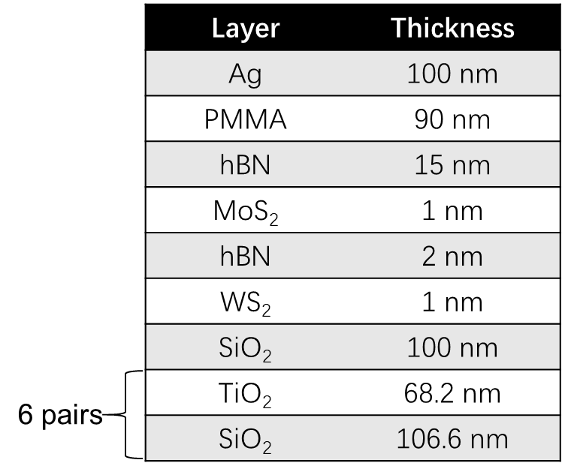
The same fabrication methods are used for MoS₂@cavity and WS₂@cavity. The hBN and PMMA thicknesses are finely tuned to ensure a similar cavity cut off energy to that in het@cavity−.

Supplementary Table 2| Summarized energy transfer time constant and enhancement factor.
Heterojunction | Donor-acceptor distance/mechanism | Energy transfer characteristic time | Enhancement factor (η) | Reference
WS₂/hBN/MoS₂ in FP cavity | 2 nm/Polariton relaxation | 1.3 ps | 440 | This study
WS₂/hBN/MoS₂ on SiO₂ | 2 nm/FRET | none | 3 | This study
Single-wall carbon nanotube bundles | 0.34 nm/FRET | 1.8 ps | none | ²²
CdSe quantum dot-MoS₂ | 6.3 nm/FRET | 4 ns | 3.3 | ²³
Molecules−graphene | 5 nm/FRET | 39 ps | none | ²⁴
WS₂/MoSe₂ | 1 nm/FRET | 1 ps | <1 | ⁴
WS₂/hBN/MoSe₂ | 3 nm/FRET | 38 ps | 2 | ²
WSe₂/MoTe₂ | 1 nm/DET | 0.2 ps | 2 | ²⁵
Pentancene/MoSe₂ | 1 nm/DET | none | 2 | ²⁶
2D perovskite/WS₂ | 1 nm/FRET | 3 ns | 8 | ²⁷
J-aggregates in FP cavity | <1 nm/Polariton relaxation | 1.5 ps | none | ²⁸
J-aggregates in FP cavity | 100 nm/Polariton relaxation | 25 ps | none | ²⁹

Supplementary Table 3| Summary of parameters used in simulations for Figure 2 b,d,f in the main text.
Configuration | $$P_{1}/γ$$ | $$P_{2}/γ$$ | $$W_{1}/γ$$ | $$W_{2}/γ$$ | $Γ$ [meV]
het@cavity− | $$0.64$$ | $$1.28$$ | $$0.030$$ | $$0.004$$ | $$11.5$$
MoS₂@cavity | $$0.59$$ | - | $$0.030$$ | - | $$14.0$$
WS₂cavity | - | $$2.2$$ | - | $$0.004$$ | $$10.0$$
References
1. Valeur, B. & Berberan-Santos, M.N. Molecular fluorescence: principles and applications. (John Wiley & Sons, 2012).
2. Hu, Z. et al. Trion-mediated Forster resonance energy transfer and optical gating effect in WS2/hBN/MoSe2 heterojunction. ACS Nano 14, 13470-13477 (2020).
3. Liu, X. et al. Manipulating charge and energy transfer between 2D Atomic layers via heterostructure engineering. Nano Lett. 20, 5359-5366 (2020).
4. Kozawa, D. et al. Evidence for fast interlayer energy transfer in MoSe₂/WS₂ heterostructures. Nano Lett. 16, 4087-4093 (2016).
5. Vladimirova, M., Kavokin, A. & Kaliteevski, M. Dispersion of bulk exciton polaritons in a semiconductor microcavity. Phys. Rev. B 54, 14566 (1996).
6. Kavokin, A.V., Baumberg, J.J., Malpuech, G. & Laussy, F.P. Microcavities, Vol. 21. (Oxford university press, 2017).
7. Krisnanda, T. et al. Room temperature light‐mediated long‐range coupling of excitons in perovskites. Adv. Opt. Mater. 9, 2001835 (2021).
8. DeVore, J.R. Refractive indices of rutile and sphalerite. J. Opt. Soc. Am. 41, 416-419 (1951).
9. Malitson, I.H. Interspecimen comparison of the refractive index of fused silica. J. Opt. Soc. Am. 55, 1205-1209 (1965).
10. Beadie, G., Brindza, M., Flynn, R.A., Rosenberg, A. & Shirk, J.S. Refractive index measurements of poly (methyl methacrylate)(PMMA) from 0.4–1.6 μm. Appl. Opt. 54, F139-F143 (2015).
11. Lee, S.Y., Jeong, T.Y., Jung, S. & Yee, K.J. Refractive index dispersion of hexagonal boron nitride in the visible and near‐Infrared. Phys. Status Solidi 256, 1800417 (2019).
12. Hsu, C. et al. Thickness‐dependent refractive index of 1L, 2L, and 3L MoS2, MoSe2, WS2, and WSe2. Adv. Opt. Mater. 7, 1900239 (2019).
13. Song, B. et al. Layer‐dependent dielectric function of wafer‐scale 2D MoS2. Adv. Optical Mater. 7, 1801250 (2019).
14. Jiang, Y., Pillai, S. & Green, M.A. Realistic silver optical constants for plasmonics. Sci. Rep. 6, 1-7 (2016).
15. Vladimirova, M., Ivchenko, E. & Kavokin, A. Exciton polaritons in long-period quantum-well structures. Semiconductors 32, 90-95 (1998).
16. Amthor, M. et al. Optical bistability in electrically driven polariton condensates. Phys. Rev. B 91, 081404 (2015).
17. Solnyshkov, D., Terças, H., Dini, K. & Malpuech, G. Hybrid Boltzmann–Gross-Pitaevskii theory of Bose-Einstein condensation and superfluidity in open driven-dissipative systems. Phys. Rev. A 89, 033626 (2014).
18. Lyons, T. et al. Giant effective Zeeman splitting in a monolayer semiconductor realized by spin-selective strong light-matter coupling. arXiv preprint arXiv:.05859 (2021).
19. Zhang, Q. et al. Electric Field Modulation of 2D Perovskite Excitonics. J. Phys. Chem. Lett. 13, 7161-7169 (2022).
20. Tassone, F., Piermarocchi, C., Savona, V., Quattropani, A. & Schwendimann, P. Bottleneck effects in the relaxation and photoluminescence of microcavity polaritons. Phys. Rev. B 56, 7554 (1997).
21. Tassone, F. & Yamamoto, Y. Exciton-exciton scattering dynamics in a semiconductor microcavity and stimulated scattering into polaritons. Phys. Rev. B 59, 10830 (1999).
22. Koyama, T. et al. Ultrafast exciton energy transfer in bundles of single-walled carbon nanotubes. J. Phys. Chem. Lett. 2, 127-132 (2011).
23. Prins, F., Goodman, A.J. & Tisdale, W.A. Reduced dielectric screening and enhanced energy transfer in single- and few-layer MoS₂. Nano. Lett. 14, 6087-6091 (2014).
24. Gaudreau, L. et al. Universal distance-scaling of nonradiative energy transfer to graphene. Nano Lett. 13, 2030-2035 (2013).
25. Wu, L., Chen, Y., Zhou, H. & Zhu, H. Ultrafast energy transfer of both bright and dark excitons in 2D van der Waals heterostructures beyond dipolar coupling. ACS Nano 13, 2341-2348 (2019).
26. Cheng, C.H., Li, Z., Hambarde, A. & Deotare, P.B. Efficient energy transfer across organic-2D inorganic heterointerfaces. ACS Appl. Mater. Interfaces 10, 39336-39342 (2018).
27. Zhang, Q., Linardy, E., Wang, X. & Eda, G. Excitonic energy transfer in heterostructures of quasi-2D perovskite and monolayer WS2. ACS Nano 14, 11482-11489 (2020).
28. Zhong, X. et al. Non-radiative energy transfer mediated by hybrid light-matter states. Angew. Chem. Int. Ed. 55, 6202-6206 (2016).
29. Zhong, X. et al. Energy transfer between spatially separated entangled molecules. Angew. Chem. Int. Ed. 56, 9034-9038 (2017).

