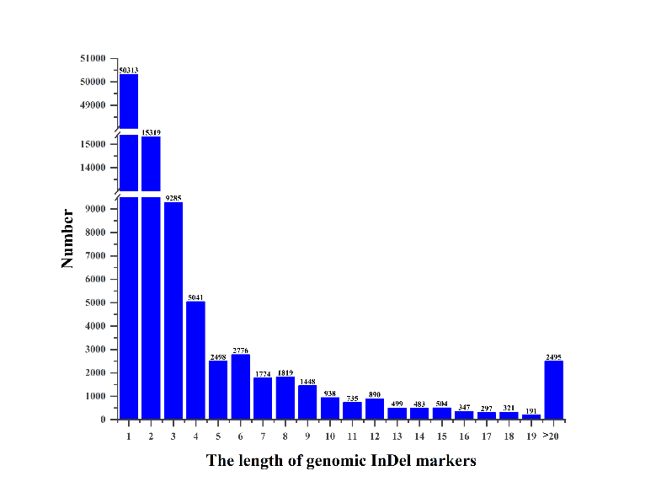

Fig. S1. The length of genomic InDel markers between two radish cultivars.

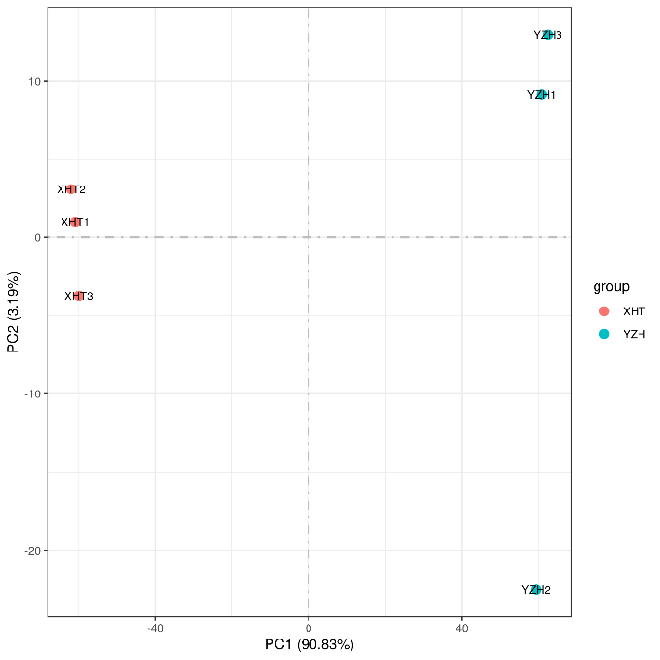

Fig. S2. Principal component analysis of the all samples base on the FKPM vales of all transcripts.

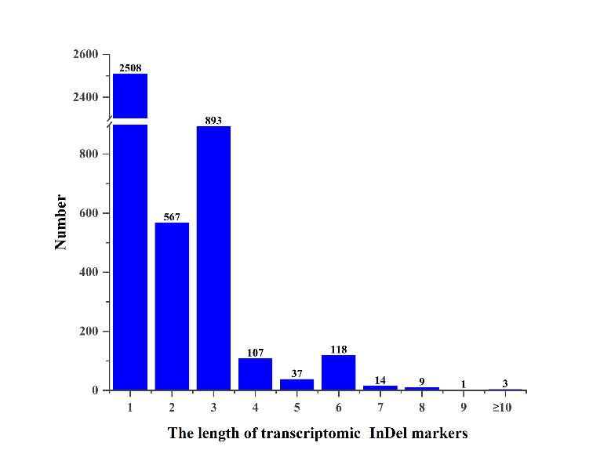

Fig. S3. The length of transcriptomic InDel markers between two radish cultivars.

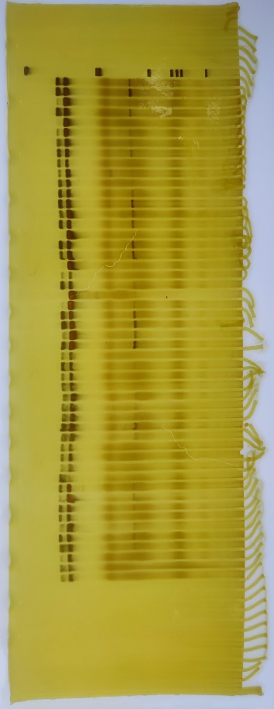

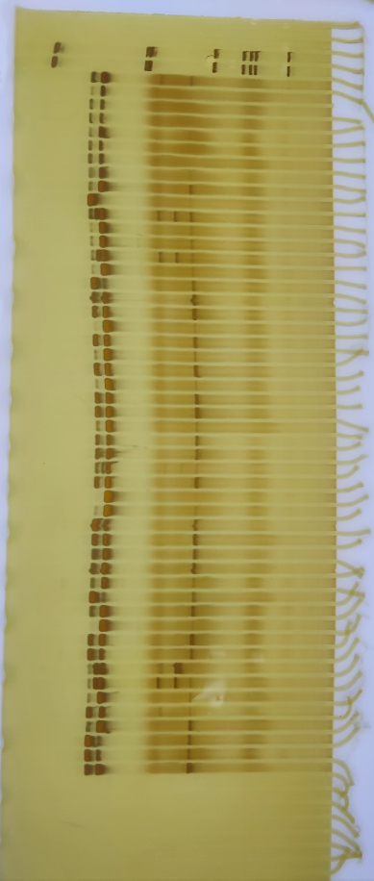
1-50

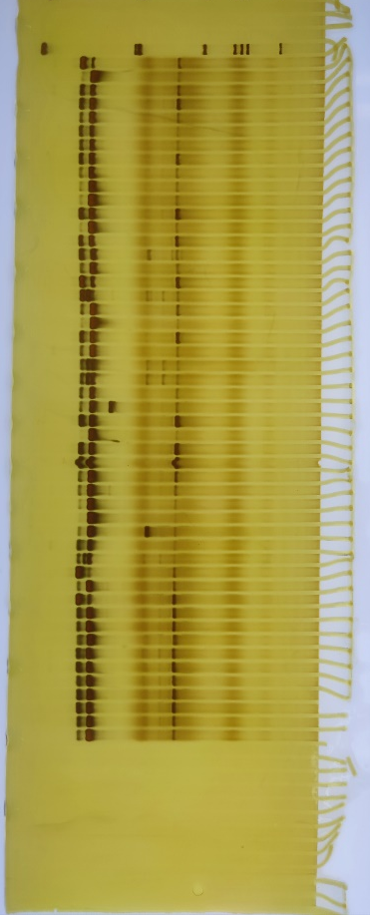
51-100

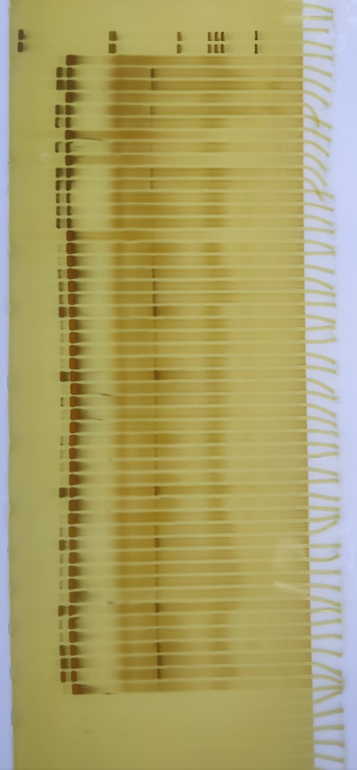

100-150

151-200

Fig. S4. The full-length gels of the RsInDelR4-18 in 200 accessions.

Table S1. Radish materials used in this study.
Code | Name | Origin | flowering time | Code | Name | Origin | flowering time
1 | Meilong123 | Beijing, China | 192 | 101 | Weining2 | Guizhou, China | 178
2 | AA534 | Beijing, China | 191 | 102 | Weining3 | Guizhou, China | 180
3 | AA173 | Beijing, China | 190 | 103 | Weining4 | Guizhou, China | 167
4 | Jiutianjinyu | Hubei, China | 180 | 104 | Chengdumanshenhong | Sichuan, China | 166
5 | Zhenbaiyu | Beijing, China | 180 | 105 | Ligenyihaoluobo | Yunnan, China | 193
6 | Dizengbao4 | Beijing, China | 192 | 106 | Yun9 | Yunnan, China | 183
7 | Yujiaolong | Beijing, China | 183 | 107 | Hongxinhongpiluobo | Sichuan, China | 167
8 | Shengyu806 | Beijing, China | 183 | 108 | Weining5 | Guizhou, China | 176
9 | Baigongbaoluo | Hubei, China | 183 | 109 | Zhengan1 | Guizhou, China | 176
10 | JintianhouR2008 | Beijing, China | 191 | 110 | Zhengan2 | Guizhou, China | 124
11 | Gaoyuanchunxue | Beijing, China | 176 | 111 | GD6 | Guizhou, China | 171
12 | Jiutianhaoyu | Hubei, China | 191 | 112 | GD7 | Guizhou, China | 174
13 | Dizengbao2 | Beijing, China | 191 | 113 | Weining6 | Guizhou, China | 173
14 | AA1084 | Beijing, China | 191 | 114 | Xishui | Guizhou, China | 179
15 | Junchuanyujie | Beijing, China | 186 | 115 | GD8 | Guizhou, China | 164
16 | Hongmei | Beijing, China | 173 | 116 | GD9 | Guizhou, China | 167
17 | Hanguodagen | Republic of Korea | 192 | 117 | Zhengan3 | Guizhou, China | 166
18 | Banyemanshenhong | Sichuan, China | 165 | 118 | Weining7 | Guizhou, China | 172
19 | Manshenhong | Sichuan, China | 165 | 119 | Daozhen1 | Guizhou, China | 167
20 | Hanjinbaiyu | Republic of Korea | 192 | 120 | Daozhen2 | Guizhou, China | 165
21 | Shangjiang9 | Beijing, China | 180 | 121 | Fenggang | Guizhou, China | 174
22 | Banyechunbulao | Sichuan, China | 161 | 122 | Daozhen3 | Guizhou, China | 176
23 | Ribendagen | Japan | 176 | 123 | GD9 | Guizhou, China | 186
24 | AA778 | Beijing, China | 173 | 124 | GD10 | Guizhou, China | 186
25 | Degaodongshan | Shandong, China | 180 | 125 | GD11 | Guizhou, China | 186
26 | Shaguandaqingtou | Shandong, China | 165 | 126 | GD12 | Guizhou, China | 186
27 | Hongmandi | Sichuan, China | 165 | 127 | Weining8 | Guizhou, China | 174
28 | Hongshuailuobo | Heilongjiang, China | 165 | 128 | Weining9 | Guizhou, China | 180
29 | Hongpiyouzhimanshenhong | Sichuan, China | 165 | 129 | Weining10 | Guizhou, China | 176
30 | Shouerxueyu | Republic of Korea | 192 | 130 | GD13 | Guizhou, China | 174
31 | Mutianhongfuerhao | Beijing, China | 173 | 131 | GD26 | Guizhou, China | 174
32 | Hongpichengdumanshenhong | Sichuan, China | 165 | 132 | Degaoqiuyu | Shandong, China | 180
33 | Heiyuluobo | Beijing, China | 173 | 133 | GD14 | Guizhou, China | 174
34 | Hanbaiyu | Republic of Korea | 192 | 134 | GD15 | Guizhou, China | 174
35 | Sijimanshenhong | Sichuan, China | 165 | 135 | GD16 | Guizhou, China | 193
36 | GD25 | Guizhou, China | 165 | 136 | GD17 | Guizhou, China | 193
37 | Degaoqingquan | Shandong, China | 180 | 137 | GDH4 | Guizhou, China | 186
38 | Degaoboluomi | Shandong, China | 180 | 138 | GDH2 | Guizhou, China | 165
39 | Shengcuierhao | Shandong, China | 184 | 139 | GDH3 | Guizhou, China | 186
40 | Qingguan107 | Yunnan, China | 173 | 140 | GDH1 | Guizhou, China | 165
41 | AA1092 | Beijing, China | 180 | 141 | GD18 | Guizhou, China | 173
42 | Guizu | Sichuan, China | 186 | 142 | Hanguobaiyuchunluobo | Republic of Korea | 193
43 | Yanzhimanshenhong | Sichuan, China | 165 | 143 | GD27 | Guizhou, China | 176
44 | AA544 | Beijing, China | 179 | 144 | GD19 | Guizhou, China | 178
45 | Shengcuiyihao | Shandong, China | 184 | 145 | GD20 | Guizhou, China | 167
46 | Yachunqingcui | Yunnan, China | 180 | 146 | GD21 | Guizhou, China | 170
47 | Shangjiang10 | Beijing, China | 180 | 147 | GD22 | Guizhou, China | 174
48 | Jieliya709 | Beijing, China | 180 | 148 | Liushizaoluobo | Sichuan, China | 174
49 | Hanxuebaiyu | Republic of Korea | 192 | 149 | Bantouhongyanzhiluobo | Sichuan, China | 174
50 | Baiwang | Beijing, China | 180 | 150 | Yidianhongluobo | Zhejiang, China | 173
51 | AA1054 | Beijing, China | 180 | 151 | Huasuzidaoxin | Shandong, China | 176
52 | Yachun2 | Yunnan, China | 192 | 152 | Yanzhihongluobo | Sichuan, China | 170
53 | AA1053 | Beijing, China | 192 | 153 | Gailiang791 | Hebei, China | 167
54 | AA251 | Beijing, China | 180 | 154 | Beijingxinlimei | Beijing, China | 177
55 | AA980 | Beijing, China | 184 | 155 | Banxialuobo | Jiangsu, China | 183
56 | Baishi | Beijing, China | 184 | 156 | Tianjingliwaiqing | Tianjin, China | 167
57 | XHT | Guizhou, China | 186 | 157 | Beijinggaotangcui | Beijing, China | 180
58 | Yanzhihong1 | Guizhou, China | 165 | 158 | Oulanbaiyu | Hebei, China | 186
59 | GDL | Guizhou, China | 186 | 159 | Sijiqingluobo | Anhui, China | 176
60 | DGE | Guizhou, China | 131 | 160 | Tiancuishuiguolaobo | Hebei, China | 178
61 | GD3 | Guizhou, China | 186 | 161 | Ribenfushiqing | Japan | 179
62 | GD4 | Guizhou, China | 186 | 162 | Weixianqingshuiguoluobo | Shandong, China | 178
63 | GD2 | Guizhou, China | 183 | 163 | Chunbulao | Sichuan, China | 174
64 | GD1 | Guizhou, China | 184 | 164 | Jintianhou132 | Beijing, China | 193
65 | GD5 | Guizhou, China | 182 | 165 | Jintianhou112 | Beijing, China | 193
66 | Hongfu | Sichuan, China | 167 | 166 | Jintianhou948 | Beijing, China | 193
67 | Yanzhicuihongxinluobo | Chongqing,China | 166 | 167 | Jintianhou906 | Beijing, China | 193
68 | Meihuachunbulaowanluobo | Guangxi, China | 180 | 168 | Jintianhou949 | Beijing, China | 193
69 | Xinxuanduanye13haokuaidaluobo | Guangxi, China | 121 | 169 | Jintianhou971 | Beijing, China | 193
70 | Tangjingluobo | Chongqing,China | 173 | 170 | 20ridagen | Jiangsu, China | 187
71 | Hongtaiyangluobo | Sichuan, China | 167 | 171 | Jinghong30 | Beijing, China | 180
72 | Quanhongluobo | Sichuan, China | 177 | 172 | Xiahongwrhao | Shandong, China | 180
73 | Hanjintiancuiluobo | Sichuan, China | 176 | 173 | Changfenghongyingtaoluobo | Jiangsu, China | 186
74 | Baiyutangtianweiluobo | Sichuan, China | 193 | 174 | Texuandaqingluobo | Hebei, China | 179
75 | Yuxingcuixue | Chongqing,China | 173 | 175 | Shadingyangzhouyuanbailuobo | Jiangsu, China | 183
76 | Xinlingmeiluobo | Sichuan, China | 176 | 176 | Xiaoluobo | Jiangsu, China | 176
77 | Yuxingyanzhihong | Chongqing, China | 166 | 177 | 791guanluobo | Jiangsu, China | 183
78 | Kunmingeryuehong | Yunnan, China | 186 | 178 | Yulu218 | Jiangsu, China | 180
79 | Pachixiaoluobo | Guangxi, China | 138 | 179 | Yangzhouyuanbai | Jiangsu, China | 183
80 | Tejiduanyehuochekuaidaluobo | Guangxi, China | 121 | 180 | Jingcui | Hebei, China | 186
81 | Xinxuanhongluobo | Sichuan, China | 167 | 181 | Mantanghong | Jiangsu, China | 177
82 | Yuhongsanhao萝卜 | Chongqing,China | 174 | 182 | Yingtaoluobo | Shandong, China | 188
83 | Tiancuitouxinhong | Sichuan, China | 167 | 183 | Hongxingyingtaoluobo | Gansu, China | 184
84 | Junxiu | Sichuan, China | 167 | 184 | GD23 | Guizhou, China | 184
85 | Chuanhongyihao | Sichuan, China | 165 | 185 | Tangbailuobo | Chongqing, China | 173
86 | Yun8 | Yunnan, China | 165 | 186 | Baitianshi | Beijing, China | 183
87 | Kunming | Yunnan, China | 167 | 187 | Qingcuishuiguoluobo | Shandong, China | 177
88 | Guanhongsanhao | Sichuan, China | 164 | 188 | Fenglishuiguoluobo | Hunan，China | 181
89 | Yuxingheiye | Chongqing,China | 186 | 189 | Zibaoluobo | Beijing, China | 192
90 | Ganshuiluobo | Sichuan, China | 184 | 190 | Qinglongliuhaoluobo | Hebei, China | 181
91 | GD24 | Guizhou, China | 172 | 191 | Qingguanzajiaoluobo | Heilongjiang, China | 181
92 | Sijiyanzhihong | Sichuan, China | 166 | 192 | Pingguocui | Shandong, China | 173
93 | Yun5 | Yunnan, China | 178 | 193 | Gaotangcuishuiguoluobo | Jilin，China | 181
94 | Yun4 | Yunnan, China | 180 | 194 | Jiaoshugailiangweixianluobo | Shandong, China | 180
95 | Yun3 | Yunnan, China | 174 | 195 | Tiancuishuiguoqing | Shandong, China | 176
96 | Yun2 | Yunnan, China | 173 | 196 | Qingcuiluobo | Heilongjiang, China | 177
97 | Yun1 | Yunnan, China | 180 | 197 | Weixianluobo | Shandong, China | 181
98 | Yun6 | Yunnan, China | 176 | 198 | Shouerzixingluobo | Republic of Korea | 193
99 | Yun7 | Yunnan, China | 183 | 199 | Xinuotiancuiqing | Shandong, China | 176
100 | Weining1 | Guizhou, China | 174 | 200 | Qingtianyihao | Shandong, China | 180

Table S3. Summary of genome resequencing dada in two radish cultivars.
Sample | Mapped reads | Total reads | Mapping rate(%) | Average depth(X) | Coverage at least 1X(%) | Coverage at least 4X(%)
XHT | 77,566,742 | 84,185,286 | 92.14 | 26 | 79.16 | 75.15
YZH | 72,440,232 | 79,949,206 | 90.61 | 23.74 | 80.15 | 75.55

Table S6. Summary of transcriptome dada in two radish cultivars.
Sample | Total_reads | Total_map | Unique_map | Multi_map | Read1_map | Read2_map | Positive_map | Negative_map
XHT1 | 42901466 | 37750627(87.99%) | 34364047(80.1%) | 3386580(7.89%) | 17202677(40.1%) | 17161370(40.0%) | 17192254(40.07%) | 17171793(40.03%)
XHT2 | 42586028 | 36817072(86.45%) | 33577355(78.85%) | 3239717(7.61%) | 16946662(39.79%) | 16630693(39.05%) | 16772881(39.39%) | 16804474(39.46%)
XHT3 | 42678722 | 36604338(85.77%) | 33390051(78.24%) | 3214287(7.53%) | 16868834(39.53%) | 16521217(38.71%) | 16676221(39.07%) | 16713830(39.16%)
YZH1 | 43358432 | 37254497(85.92%) | 33852866(78.08%) | 3401631(7.85%) | 17131437(39.51%) | 16721429(38.57%) | 16922783(39.03%) | 16930083(39.05%)
YZH2 | 43397142 | 37356308(86.08%) | 33950157(78.23%) | 3406151(7.85%) | 17152546(39.52%) | 16797611(38.71%) | 16966153(39.1%) | 16984004(39.14%)
YZH3 | 55214366 | 48399761(87.66%) | 44011347(79.71%) | 4388414(7.95%) | 22126561(40.07%) | 21884786(39.64%) | 22030398(39.9%) | 21980949(39.81%)

