Supporting Information

Grain-Growth Mediated Hydrogen Sorption Kinetics and Compensation Effect in Single Pd Nanoparticles

Svetlana Alekseeva¹, Michal Strach¹, Sara Nilsson¹, Joachim Fritzsche¹, Vladimir P. Zhdanov^{1,2}, Christoph Langhammer^{1, *}

¹Department of Physics, Chalmers University of Technology, 412 96 Göteborg, Sweden
²Boreskov Institute of Catalysis, Russian Academy of Sciences, Novosibirsk 630090, Russia

*Correspondence to: clangham@chalmers.se

Table of contents
1. Grazing Incidence X-ray Diffraction (GIXRD) of as-deposited Pd disks 3
2. Vacuum setup schematics 3
3. Extraction procedure for t₅₀ 4
4. Measurement scheme for mixed T-sweep 4
5. t₅₀ vs. T plots fitted with NLLS 5
6. Arrhenius plots fitted with LLS 5
7. Arrhenius parameters extracted with LLS and NLLS methods 7
10. Goodness-of-fit statistics for LLS and NLLS methods 7
11. Distribution of plateau pressures at absorption and desorption 8
12. Discussion of desorption mechanism 9
13. Average t₅₀ values as function of measurement number at each T 11
14. CQF analysis 11
15. Figure 5 analog for absorption 16
16. Simulated scenarios for E_{a} derived by Arrhenius analysis in a system with and without grain growth 17
17. Correlation of a kinetics slowing factor with E_{a} 18
18. Data set size and CQF values 19
References 20

1. Grazing Incidence X-ray Diffraction (GIXRD) of as-deposited Pd disks
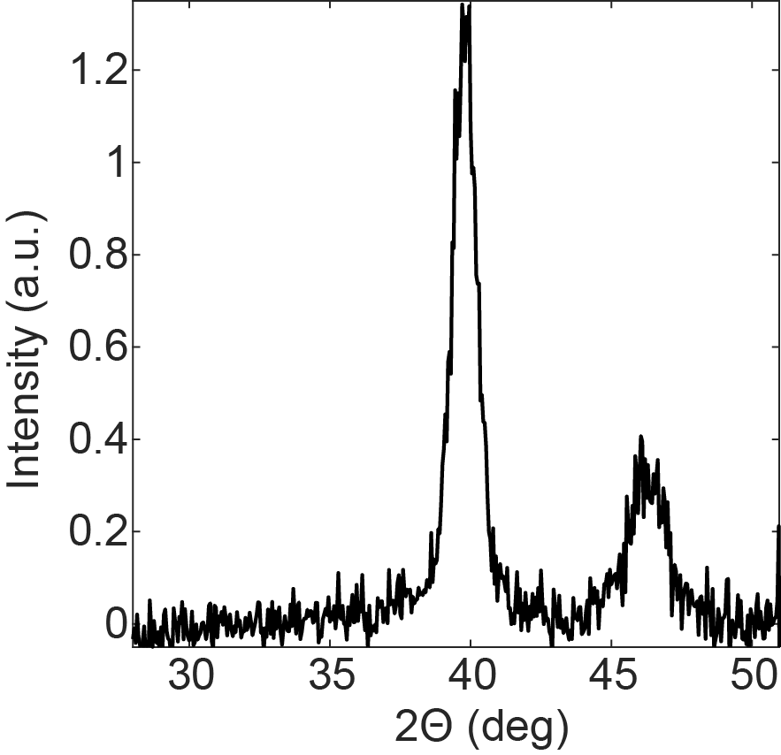

Supplementary Figure 1. XRD pattern of as-deposited Pd nanodisks, which reveals average crystallite size of 10 ± 2 nm.

2. Vacuum setup schematics

Supplementary Figure 2. Schematics of the vacuum setup used in the experiments. A customized Linkam temperature-controlled vacuum chamber was positioned on a motorized stage on the upright optical microscope.

3. Extraction procedure for t₅₀
In order to extract t₅₀ of the signal we used a function for mid-reference level crossing for bilevel waveform (SI Fig. 3).
Supplementary Figure 3. Example of a H₂ absorption trace, where the Matlab “midcross” function is used to extract t₅₀ (cross outlined with red circle). The vertical line indicates time stamp for introduction of H₂.

4. Measurement scheme for mixed T-sweep

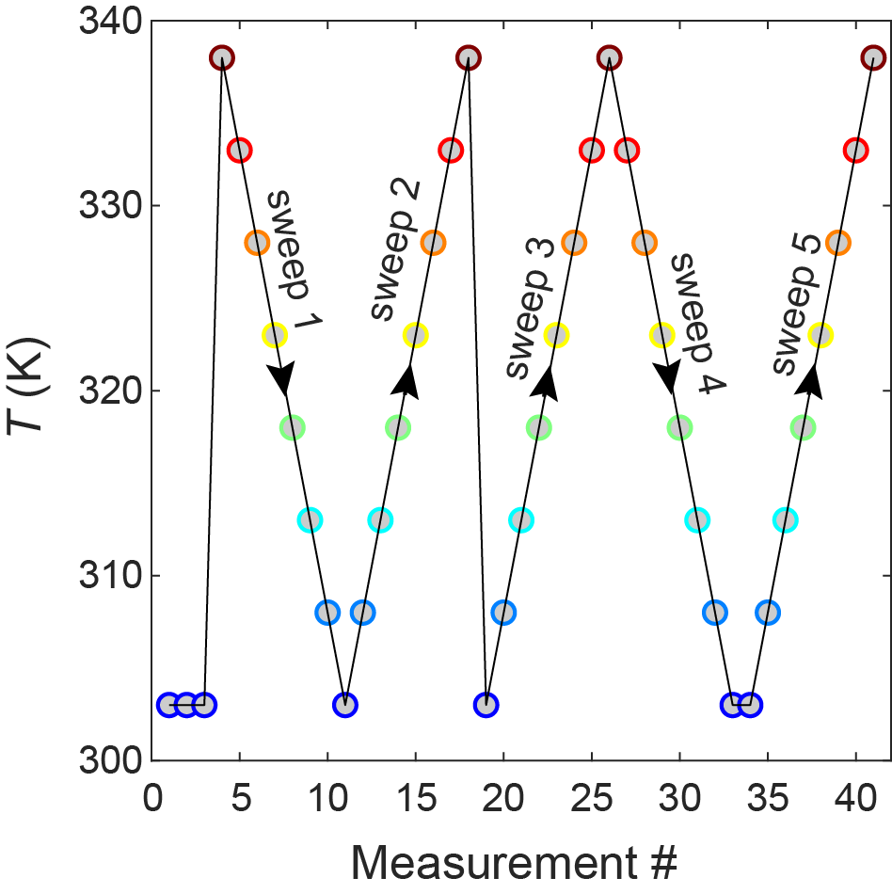

Supplementary Figure 4. Order in which measurements of t₅₀ both for H₂ absorption and desorption were performed for “mixed T-sweep” samples. The results of the first three subsequent measurement points at 303 K are shown in Figure 1 in the main text.

5. t₅₀ vs. T plots fitted with NLLS

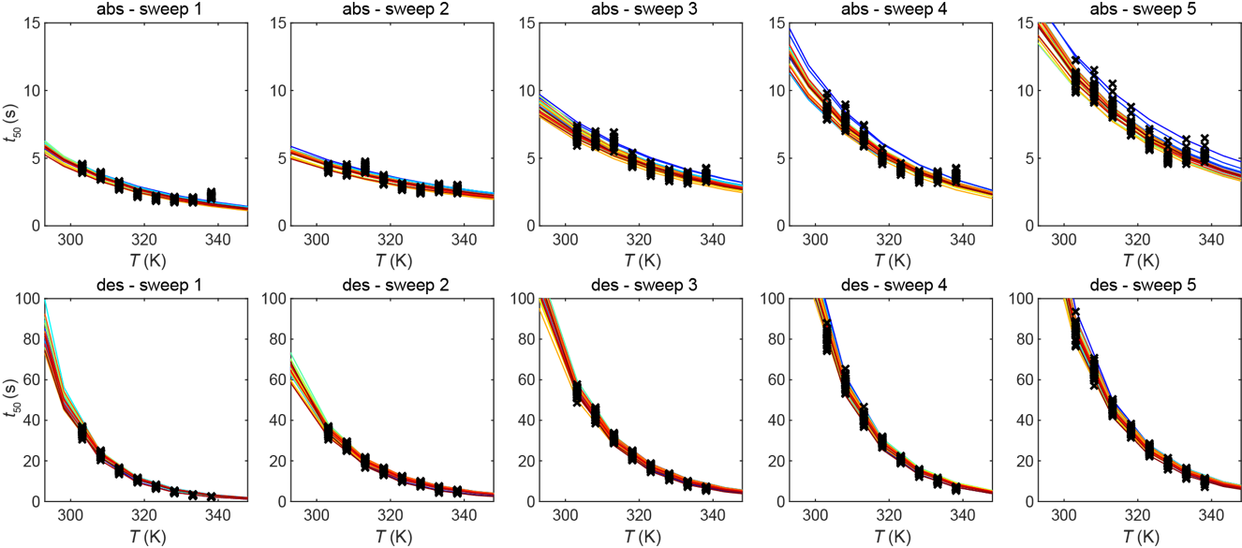

Supplementary Figure 5. t₅₀ vs. T plot (crosses) for 24 single Pd particles from 1st to 5th T-sweep (left to right, with mixed T-sweep according to SI Fig. 4) fitted with non-linear least squares regression (NLLS) for each individual particle (colored lines). The upper and lower panels correspond to absorption and desorption respectively.

6. Arrhenius plots fitted with LLS

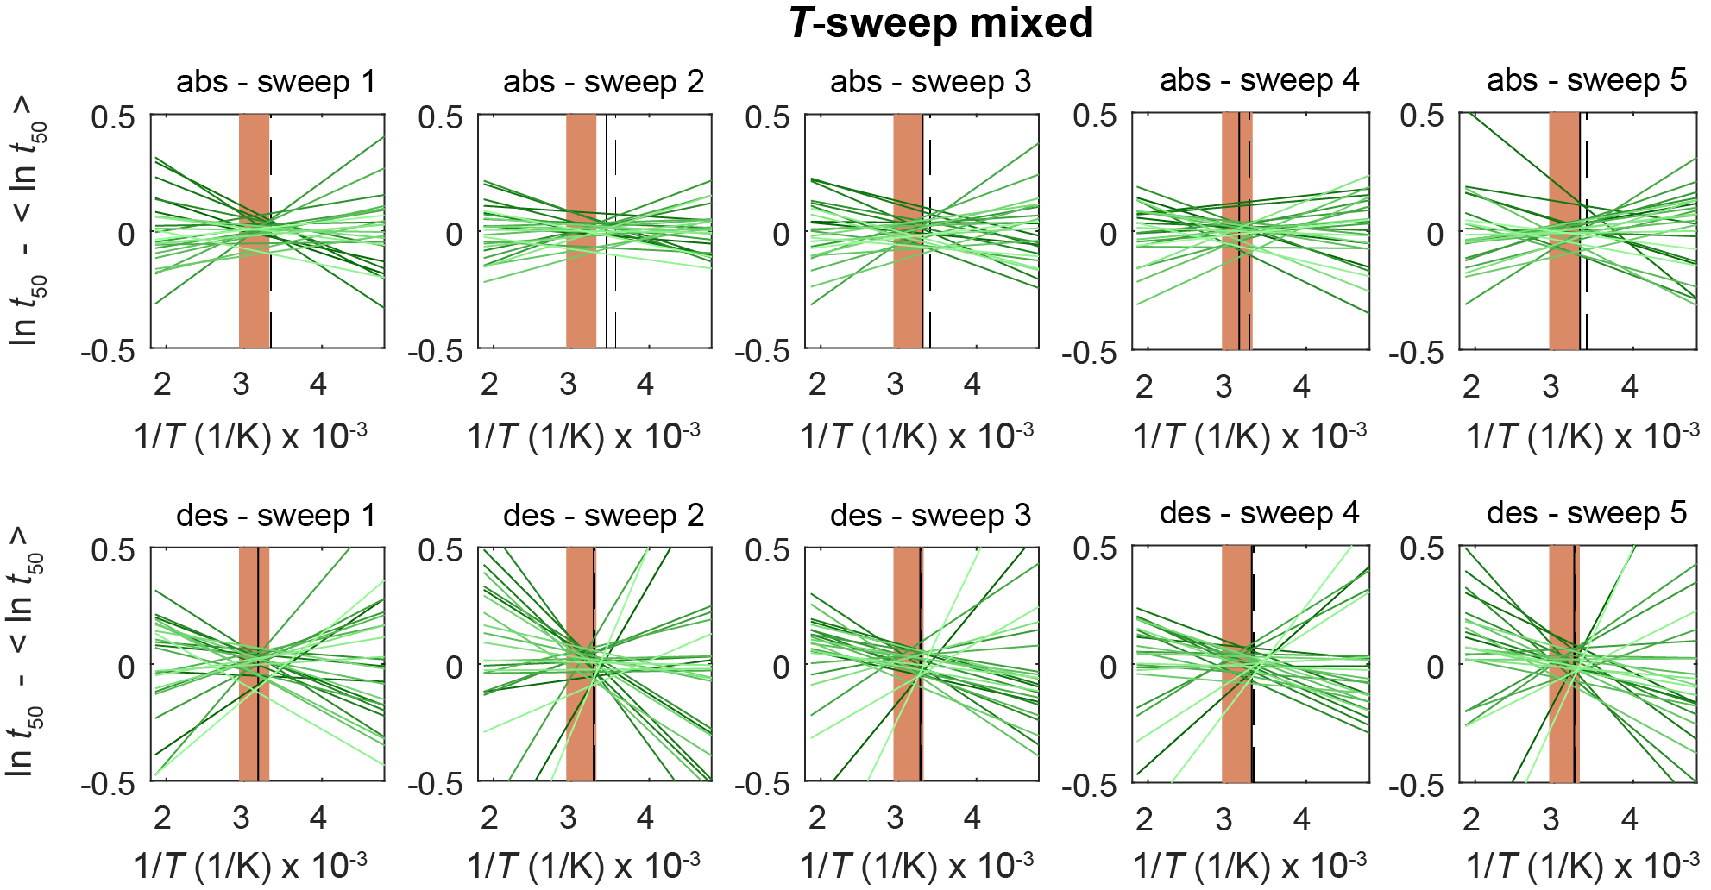

Supplementary Figure 6. Arrhenius plots for 24 particles (shades of green lines) from 1st to 5th T-sweep (left to right, with T-sweep direction according to SI Fig. 4) constructed from Arrhenius parameters by fitting least squares linear regression to experimental values of ln t₅₀ versus the inverse temperature. For clarity at each temperature the average < ln t₅₀ > taken over all measured 24 particles is subtracted from the individual ln t₅₀. The upper and lower panels correspond to absorption and desorption data respectively. The brown rectangle indicates the experimental T range. Vertical lines indicate T_{min} (solid) and T_{isokin} (dashed) according to analysis by Griessen et al.⁵

Supplementary Figure 7. Arrhenius plots for 180 particles (shades of red lines) from 1st to 7th T-sweep up (left to right) constructed from Arrhenius parameters by fitting least squares linear regression to experimental values of ln t₅₀ versus the inverse temperature. For clarity at each temperature the average < ln t₅₀ > taken over all measured 180 particles is subtracted from the individual ln t₅₀. The upper and lower panels correspond to absorption and desorption data respectively. The brown rectangle indicates the experimental T range. Vertical lines indicate T_{min} (solid) and T_{isokin} (dashed) according to analysis by Griessen et al.⁵

Supplementary Figure 8. Arrhenius plots for 180 particles (shades of blue lines) from 1st to 5th T-sweep down (left to right) constructed from Arrhenius parameters by fitting least squares linear regression to experimental values of ln t₅₀ versus the inverse temperature. For clarity at each temperature the average < ln t₅₀ > taken over all measured 180 particles is subtracted from the individual ln t₅₀. The upper and lower panels correspond to absorption and desorption data respectively. The brown rectangle indicates the experimental T range. Vertical lines indicate T_{min} (solid) and T_{isokin} (dashed) according to analysis by Griessen et al.⁵

7. Arrhenius parameters extracted with LLS and NLLS methods
Data were analysed with both linear (LLS) and nonlinear least squares regression (NLLS) methods in order to see whether there are significant differences between the results¹. In our case, both methods result in similar trends (SI Fig. 9), however the goodness-of-fit statistics are better for the LLS method (SI Fig. 10).

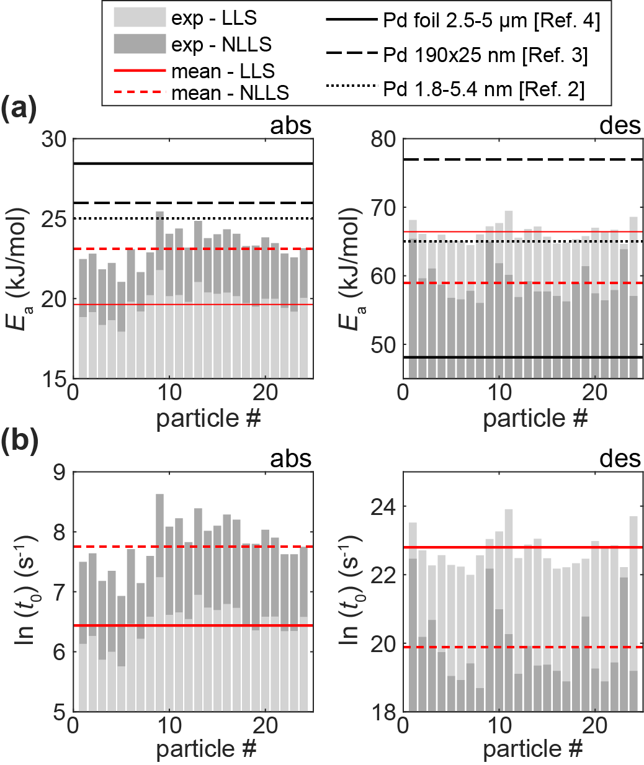
Supplementary Figure 9. (a) Apparent activation energy, E_{a}, and (b) pre-exponential factor, t₀, at absorption (left) and desorption (right) extracted for the 24 individual Pd disks (light grey and dark grey bars are data from LLS and NLLS fits respectively with their mean value indicated as red solid and dashed line). The data were extracted from the 1st T-sweep as shown in SI Fig. 4, which included a full set of consecutive measurements across the T range of the experiment from 338 to 303 K. Black lines in the upper panel denote E_{a} values for annealed Pd nanoparticles² of 2-5 nm in size (dotted), annealed Pd disks³ of 190 nm in diameter and 25 nm in height (dashed) and Pd foil⁴ of 2.5-5 µm in thickness (solid). The corresponding Arrhenius plots and nonlinear fits to data can be found in SI Fig. 5 & 6. See goodness-of-fit statistics for both methods in SI Fig. 10.

10. Goodness-of-fit statistics for LLS and NLLS methods
The goodness-of-fit of a model describes how well it fits the set of observations. The following are the plots with goodness-of-fit statistics for each T-sweep, which include sum of square errors (SSE), R-square, adjusted R-square and Root Mean Squared Error (RMSE). These values were extracted using the Matlab Curve Fitting Toolbox™ software. The statistics are presented for both methods that were used to extract Arrhenius parameters, i.e. least square linear regression (LLS – red circles for absorption, blue circles for desorption) and nonlinear least square regression (NLLS – black dots).

Supplementary Figure 10. Goodness-of-fit statistics for the 1st T-sweep as shown in SI Fig. 4.

11. Distribution of plateau pressures at absorption and desorption
In addition to the kinetic measurements, it is instructive to assess the evolution of the thermodynamics of hydrogen absorption and desorption in our samples. Following this line, we have measured sorption isotherms at 303 K (SI Fig. 11) for a sample comprised of an array of 24 single Pd nanodisks of the same size as in kinetic measurements, which before the measurement were not exposed to any (de)hydrogenation cycles. The obtained data we then compared with a corresponding isotherm measurement on a same sample that had been cycled 41 times in kinetic measurements prior to the isotherm measurement. We use separate samples for this purpose, since exposure to H₂ during an isotherm measurement of an as-deposited sample will inevitably change it, and therefore it cannot be used for comparison with a sample that was cycled. From the isotherm measurements we extracted the plateau pressures for absorption and desorption (P_{abs} and P_{des}) for each particle and observe sizable increase in hysteresis for the cycled sample, as well as a larger spread in P_{abs} and P_{des} values for the individual particles. This distinct increase in hysteresis further supports the idea of grain growth in the particles upon cycling⁶.
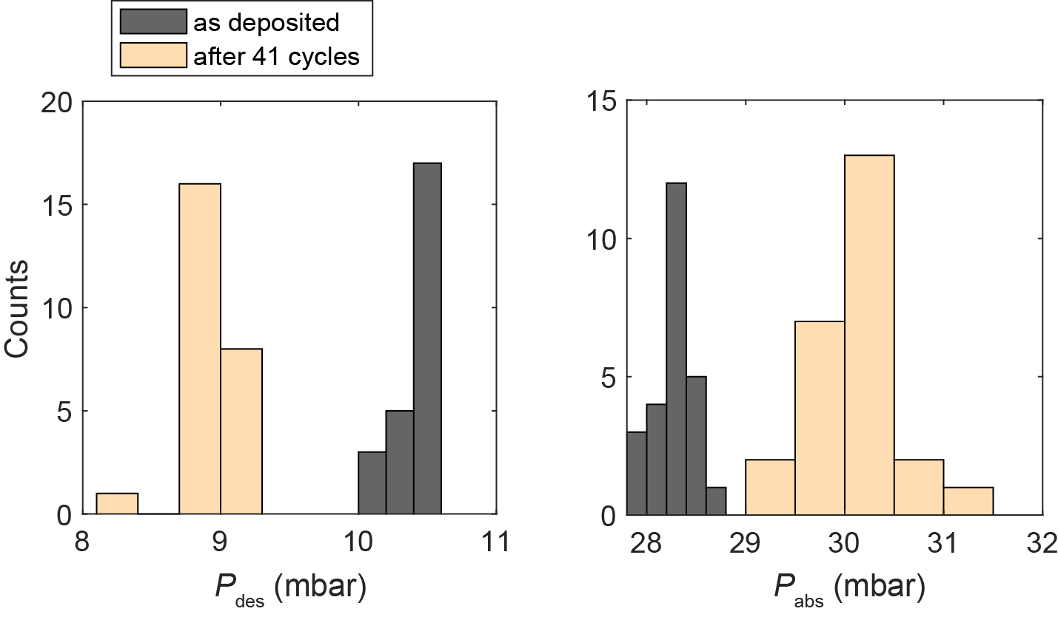

Supplementary Figure 11. Distribution of (a) desorption and (b) absorption plateau pressures measured at 303 K on a sample in as-deposited condition (dark-grey) and after 41 (de)hydrogenation cycles (light-orange). Cycling with hydrogen clearly increases the hysteresis and the spread in plateau pressure values, which confirms grain growth.

12. Discussion of grain-growth impact on desorption kinetics
This section is dedicated to discussion of the impact of grain-growth on the hydride decomposition and H₂ desorption kinetics summarized in Figure 4b,d-e in the main text. To this end, it is commonly accepted that Pd hydride decomposition kinetics are controlled by associative desorption from the metal-gas interface.⁷ In other words, the diffusion-mediated supply of H to this interface from the inside of the Pd particle is not rate limiting. For the case of our polycrystalline particles, this means that an additional grain-boundary diffusion channel is not expected to influence the kinetics. In fact, H₂ desorption takes place from the surface of the grains at the gas-nanoparticle interface. In analogy to small single crystalline particles², the desorption rate associated with a single grain at the surface of the polycrystalline particle can therefore be represented as w = r s exp(R*/R_{gr}), where s is the area of the grain gas-metal interface, r is the desorption rate per unit area in the limit when surface strain effects are negligible, and exp(R*/R_{gr}) is the factor taking surface strain into account (R_{gr} is the grain radius, and R* is a constant proportional to the surface strain). The desorption rate associated with a polycrystalline nanoparticle is accordingly given by W = r S exp(R*/R_{gr}), where S is the area of the gas-metal interface for the entire particle. If we now for a first approximation initially assume that the atomic surface structure does not depend on grain size, S becomes grain size independent, and the timescale of hydrogen desorption from a polycrystalline Pd nanoparticle can be represented as

$t_{50}=B\exp{(-R^{*}/R_{gr})}$ (1)

where B is a constant proportional to the V/S ratio (V is the nanoparticle volume). The corresponding fit to the experimental single particle data yields R* = 31.6 nm (Fig 4c). This value is significantly larger than R* = 3.9 obtained earlier for small single crystalline Pd nanoparticles². This significant difference between the two R* values may either indicate a stronger dependence of the desorption rate on R_{gr} in a polycrystalline particle, compared to a single crystalline one, or it may indicate that the atomic structure of the polycrystalline particle surface depends strongly on R_{gr}, and that our initial assumption of the grain size independence of S therefore is not correct. Physically, the second scenario is very likely because the extent of atomic-scale roughness is expected to decrease with increasing R_{gr}, since fewer grain boundaries characterized by an open atomic structure and by Pd atoms with low coordination will be present at the surface of the particle, where H₂ desorption occurs (SI Fig. 12).
Following this line, the faster desorption kinetics we observe in the small grain regime can be understood from an energetics point of view, where it is known that the activation energy for H₂ desorption from more open Pd(211) and Pd(100) faces is lower than from Pd(111), with a computed energy difference of about 0.1 eV^{8,9}. This concept can be further supported by XRD studies of thin Pd films, which show a weakening/disappearance of the (200) reflection and intensity increase of the (111) reflection upon repeated H₂-cycling.^{10,11} This indicates an energetically more favourable packing of Pd atoms and consequent reorientation in the out-of-plane (111) direction upon stress-strain cycling induced by (de)hydrogenation, which is also reasonable to expect for our polycrystalline particles.

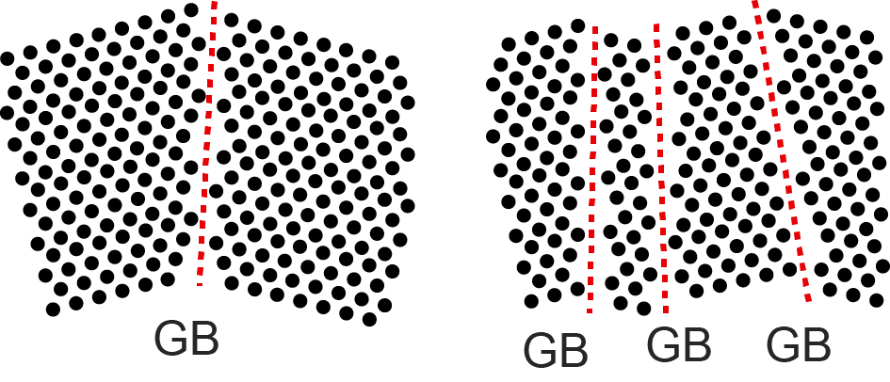
Supplementary Figure 12. Schematics of the atomic structure at the surface of a particle for the case with few (left) and many (right) grain boundaries (GB) indicated by red dashed lines, where the presence of many GBs leads to an atomically rougher surface with more low-coordinated atoms.

13. Average t₅₀ values as function of measurement number at each T
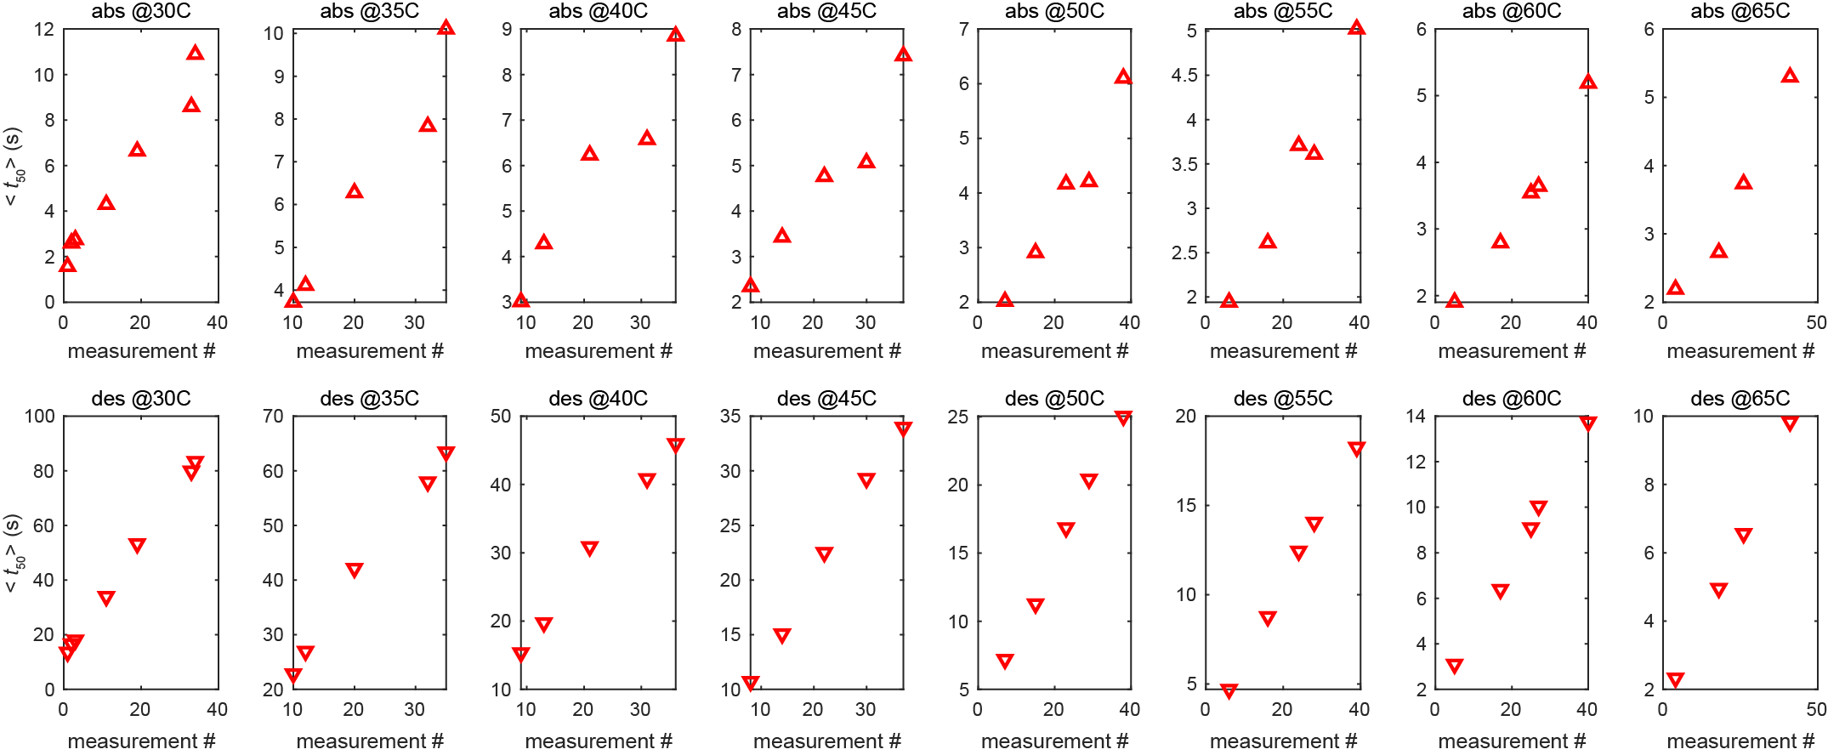

Supplementary Figure 13. Average t₅₀ values become higher with each measurement for all measured temperatures and both for absorption (top row) and desorption (bottom row). Measurement numbers are given according to the experiment scheme depicted in SI Fig. 4.

14. CQF analysis
This section describes the analysis developed by Griessen et al⁵ (Eq. 28-35 therein), which we applied to characterize the compensation effect observed between Arrhenius parameters in our data. The analysis requires calculation of parameters such as Compensation Quality Factor (CQF), which depends on the number of samples in the measurement (in our case, number of particles measured in one T-sweep (N = 24 or 180), coefficient of determination value (R_{square}), as well as variance in and covariance between Arrhenius parameters.
analytically calculated variance in ln(t₅₀) for the set of the N investigated particles allows to determine the temperature T_{min} at which the variance of ln(t₅₀) reaches a minimum. The variance of ln(t₅₀) at T_{min} is a direct measure of the degree of coalescence of the Arrhenius plots. The ratio of the variance of ln(t₅₀) at T_{min} normalized to the largest experimentally measured ln(t₅₀) variance defines a CQF that characterizes quantitatively the extent of the crossing region of Arrhenius lines. The CQF is by definition unity for perfect compensation (T_{min} = T_{isokin}, where T_{isokin} is the isokinetic temperature that corresponds to the slope of the Constable plot (i.e. the temperature at which all the particles in the specific measurement set have the same rate of reaction⁵) and tends towards zero when the Arrhenius lines do not come close to a single crossing. The calculated value of CQF is also compared to a threshold value 𝛾, which depends on N and the choice of the confidence level (i.e. level of certainty, %).
According to this analysis, if CQF < 𝛾 at the chosen confidence level, an observed compensation effect is a statistical artefact. This is the case for our absorption and desorption data if we analyse each T-sweep separately at a 99.5% confidence level (see SI Fig. 6-8 where there is no well-defined crossing of Arrhenius plots for each of the independent T-sweeps). Accordingly, when we apply this analysis to the data presented in Fig. 2 in the main text, i.e. the 1st decreasing T-sweep for 24 single particles, CQF is lower than 𝛾 (at 99.5 % confidence level) in both cases. This implies that if analysed for this specific data set, the observed compensation effect is of statistical origin, despite Cremer-Constable plots showing high level of correlation, with relatively high R_{square} ≥ 0.98, both for absorption and desorption data (SI Fig. 14). However, as we discuss in the main text by invoking a larger set of particles to increase N in this analysis (180 vs. 24), in fact, the compensation effect can be traced back to particle-specific grain structure prior to the very first hydrogenation and therefore has non-statistical origin (SI Section 18).

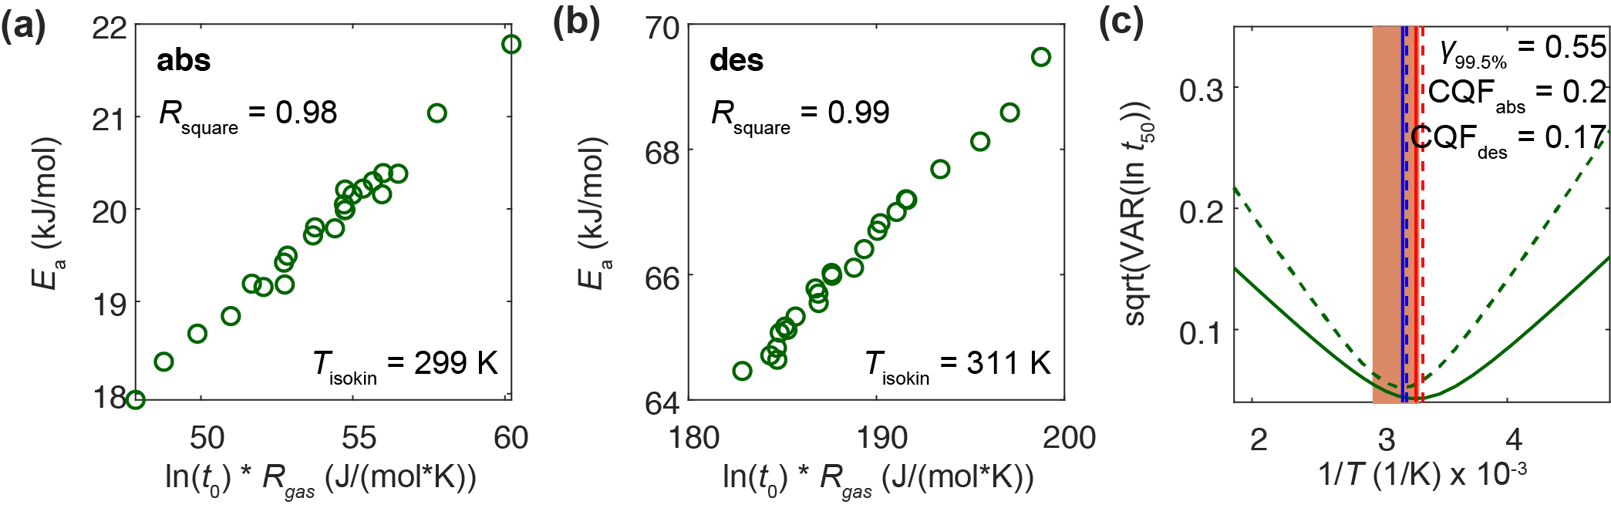
Supplementary Figure 14. Modified Cremer-Constable plots at (a) absorption and (b) desorption for the data presented in Fig. 2 in the main text (1st sweep with decreasing temperature in T-sweep mixed dataset). (c) Temperature dependence of the spread of ln(t₅₀) values calculated according to Griessen et al.⁵ (green lines, solid – absorption, dashed - desorption). Vertical lines indicate T_{isokin} (dashed) and T_{min} (solid) for absorption (red) and desorption (blue). T_{min} indicates where the minimum spread of ln(t₅₀) values occurs. The brown rectangle indicates T_{exp} (303-338 K), where the spread of ln(t₅₀) is little, and which leads to low CQF values of ~0.2, both for absorption and desorption, indicating statistical compensation effect.

Similarly, we have also applied this CQF analysis to the scenario where we include whole series of T-sweeps with specific T-sweep directions (i.e. not just a single T-sweep) to maximize the grain growth effect (see stars in SI Fig. 15-17 d, e). Also, this analysis then reveals a non-statistical origin of the compensation effect for desorption with 99.5% confidence level for “T-sweeps up and down”, as well as for absorption with “T-sweep down”, thereby identifying grain growth as the physical mechanism behind the observed compensation effect. We attribute the failure of the analysis to identify the compensation effect as non-statistical for the case of absorption for “T-sweep up” to the larger experimental error in absorption measurements, since the absorption process tends to be much faster than desorption, which leads to less accurate t₅₀ data. This is especially pronounced for measurements at higher T, where we are close to the time the resolution limit of our instrument. For the mixed T-sweep case, the CQF is low also for desorption because the Arrhenius parameters tend to oscillate between different T-sweep directions, which also implies a higher ratio between minimum and maximum of t₅₀ variance, and therefore by definition leads to a low CQF value.

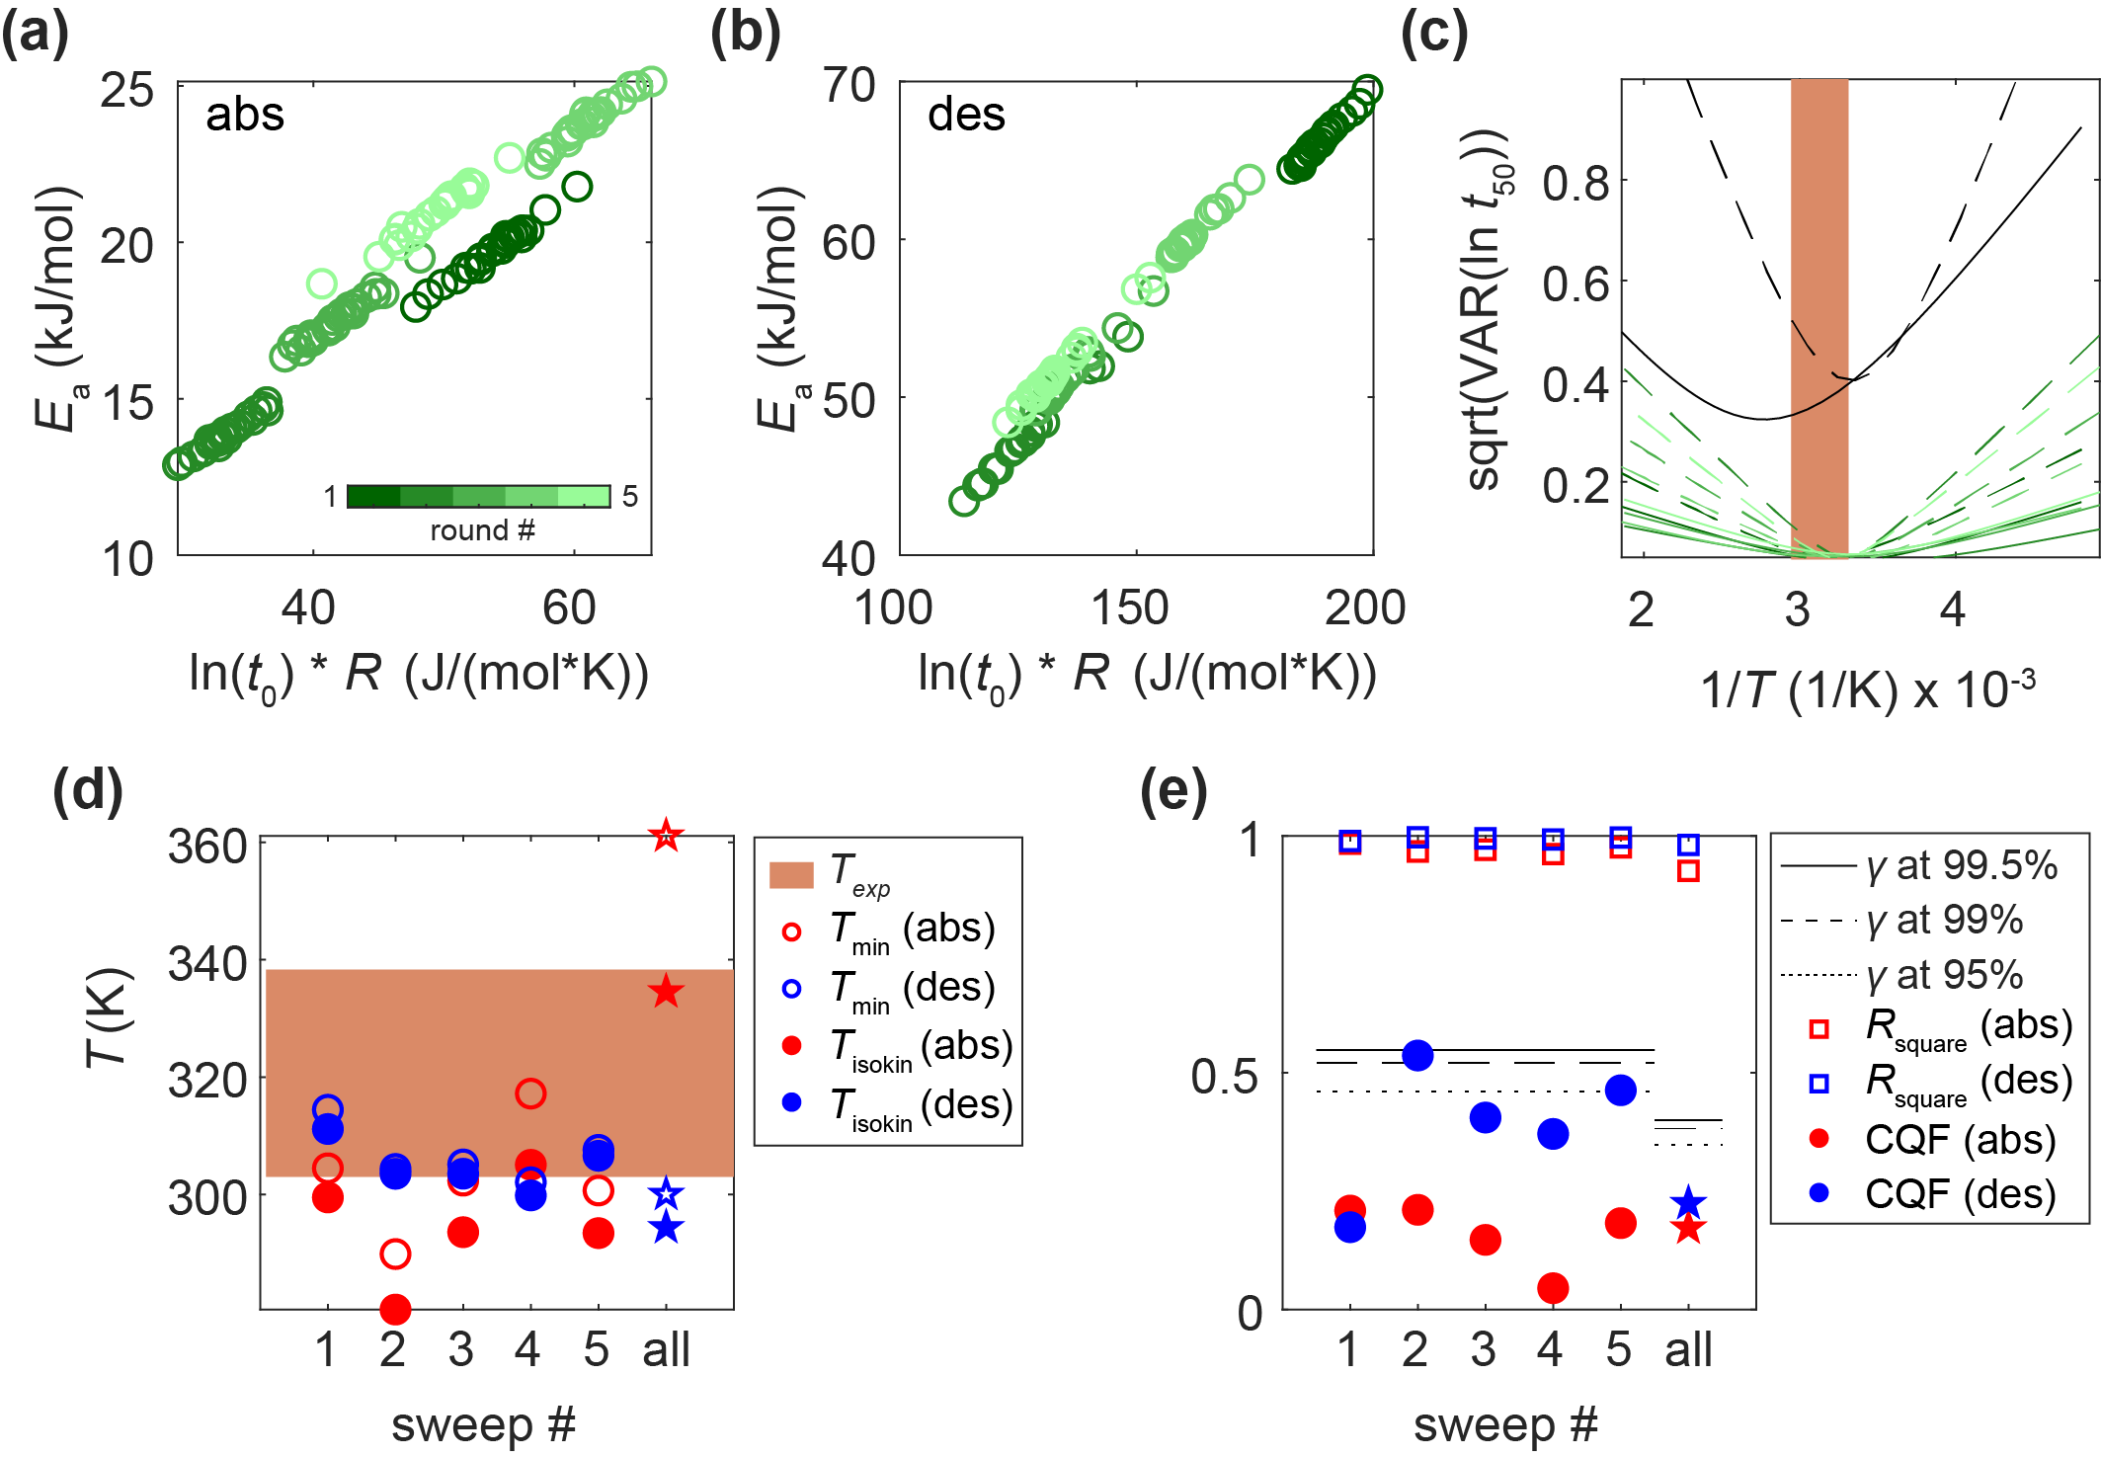

Supplementary Figure 15. Modified Cremer-Constable plot of the Arrhenius parameters (color bars) for 24 measured particles from 1st to 5th T-sweeps at (a) absorption and (b) desorption using mixed T-sweep (according to SI Fig. 4). (c) Temperature dependence of the spread of ln(t₅₀) values calculated according Ref.⁵ for each of the 5 sweeps (color code is the same as in (a,b)). The spread for all sweeps together is shown in black lines (solid and dashed lines indicate abs/des data respectively). (d) The slope of the modified Cremer-Constable plots is called isokinetic temperature T_{isokin} (full circles). The minimum spread of ln(t₅₀) values occurs at T_{min} (hollow circles). Brown rectangle in (c) and (d) indicates the temperature range of the experiment from 303 to 338 K (T_{exp}). (e) Within this range the spread of ln(t₅₀) values is small for each sweep separately, which leads to low CQF values (full circles) that are below the threshold value 𝛾 at confidence levels of 95% (dotted line), 99% (dashed line) and 99.5 % (solid line) for each separate sweep and for both absorption and desorption. R_{square} for each sweep is indicated as squares. Red and blue markers indicate absorption and desorption data respectively. The stars in (d, e) indicate values calculated for the entire set of 5 T-sweeps considered together. The CQF values for the entire set are low due to lower variance in the data caused by the mixed directions of the individual T-sweeps in the set.

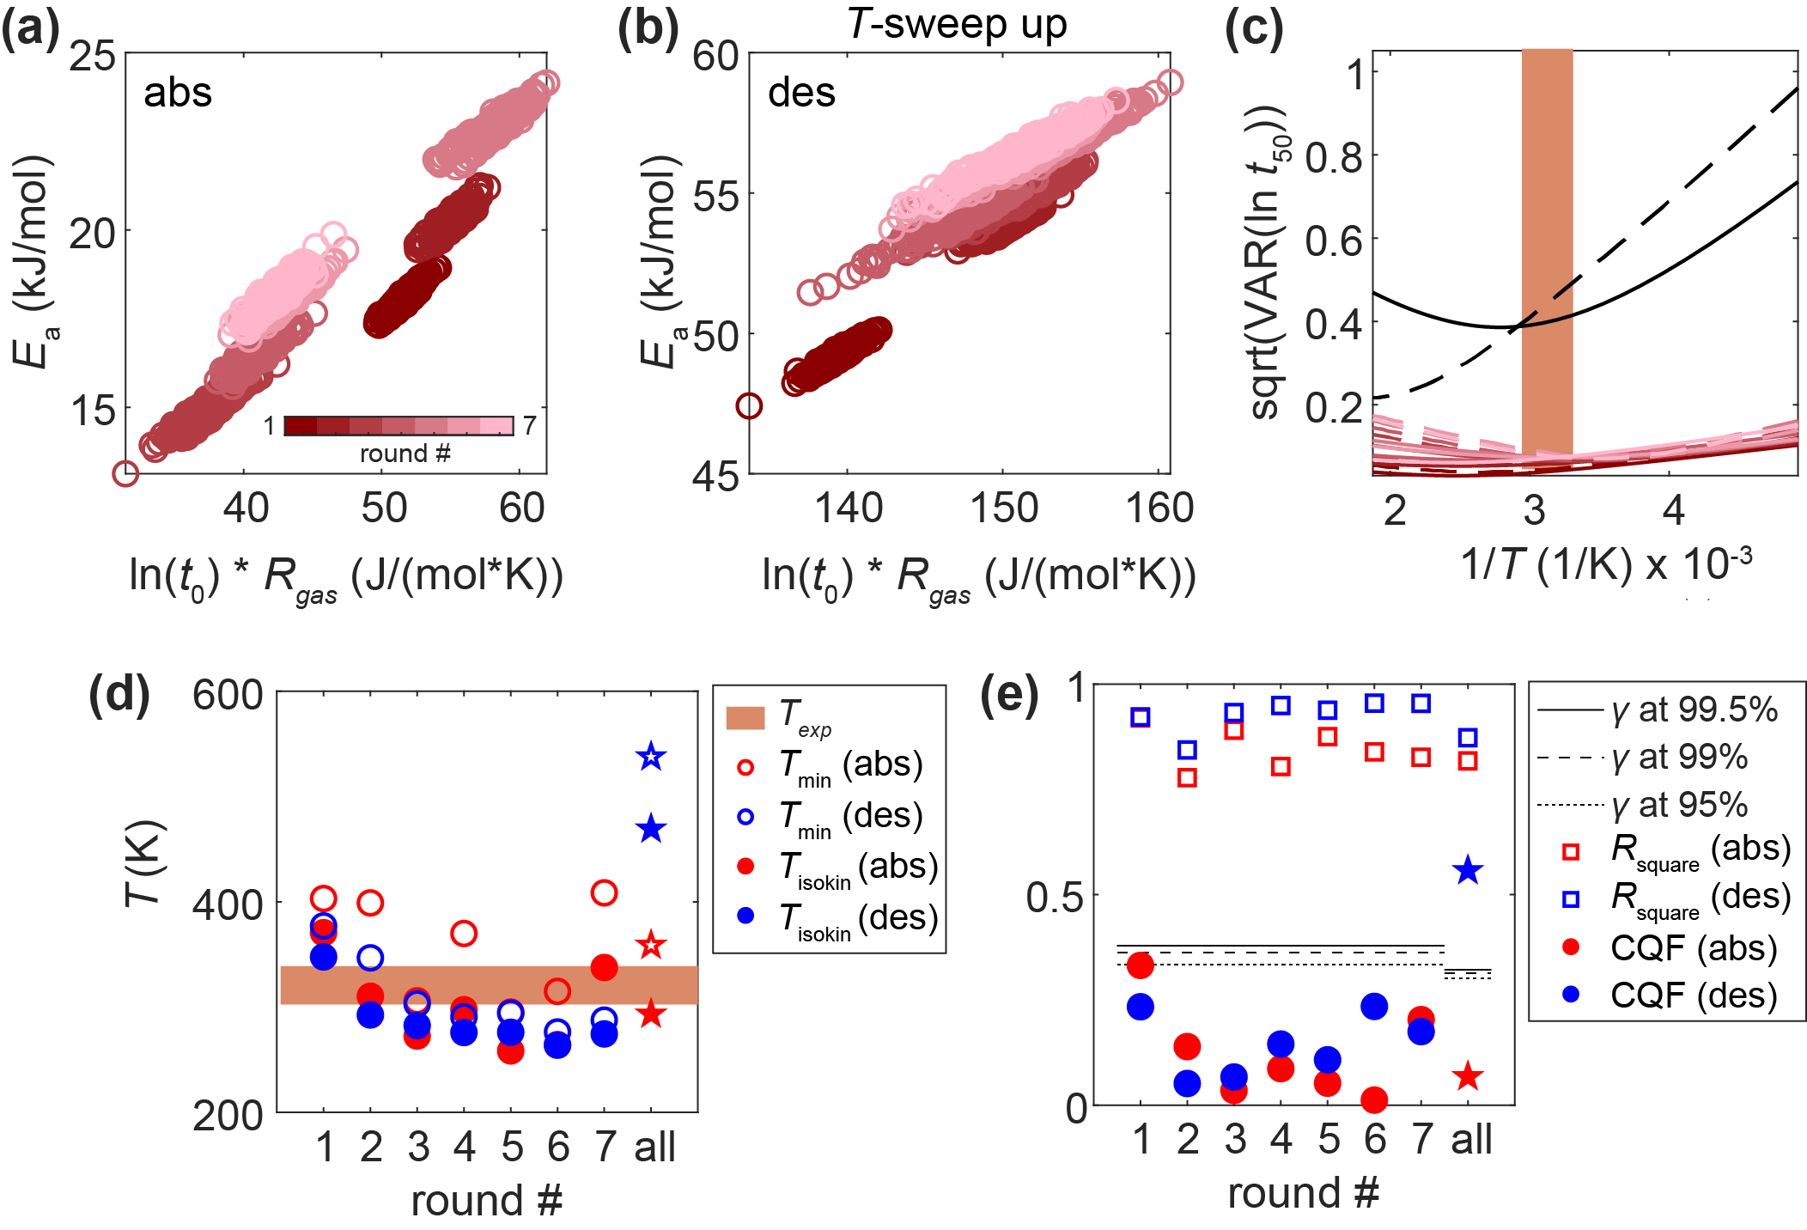

Supplementary Figure 16. Modified Cremer-Constable plot of the Arrhenius parameters (color bars) for 180 measured single particles from 1st to 7th T-sweep at (a) absorption and (b) desorption using T-sweep up. (c) Temperature dependence of the spread of ln(t₅₀) values calculated according to Ref.⁵ for each of the 7 sweeps (color code is the same as in (a,b)). The spread for all sweeps together is shown in black lines (solid and dashed lines indicate abs/des data respectively). (d) The slope of the modified Cremer-Constable plots is called isokinetic temperature T_{isokin} (full circles). The minimum spread of ln(t₅₀) values occurs at T_{min} (hollow circles). Brown rectangle in (c) and (d) indicates the temperature range of the experiment from 303 to 338 K (T_{exp}). (e) Within this range the spread of ln(t₅₀) values is small for each sweep separately, which leads to low CQF values (full circles) that are below the threshold value 𝛾 at confidence levels of 95% (dotted line), 99% (dashed line) and 99.5 % (solid line) for each separate sweep and for both absorption and desorption. R_{square} for each sweep is indicated as squares. Red and blue markers indicate absorption and desorption data, respectively. The stars in (d, e) indicate values calculated for entire set of 7 T-sweeps considered together. The CQF values for the entire set are high for desorption and low for absorption, which we attribute to higher experimental error in absorption measurements of t₅₀ in general.

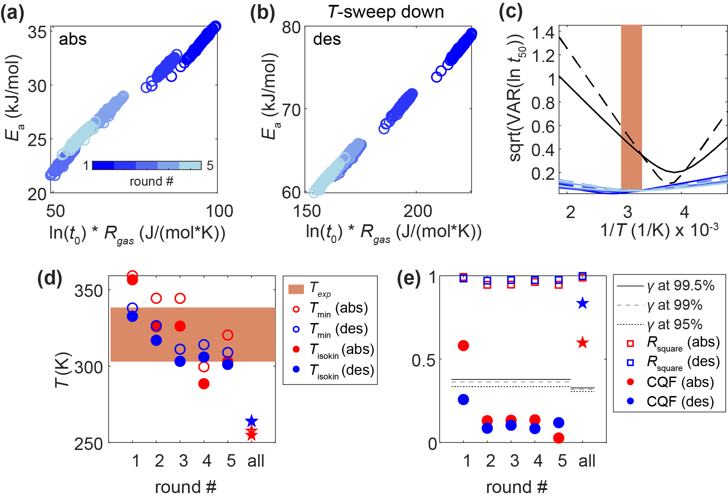

Supplementary Figure 17. Modified Cremer-Constable plot of the Arrhenius parameters (color bars) for 180 measured single particles from 1st to 5th T-sweeps at (a) absorption and (b) desorption using T-sweep down. (c) Temperature dependence of the spread of ln(t₅₀) values calculated according to Ref.⁵ for each of the 5 sweeps (color code is the same as in (a,b)). The spread for all sweeps together is shown in black lines (solid and dashed lines indicate abs/des data respectively). (d) The slope of the modified Cremer-Constable plots is called isokinetic temperature T_{isokin} (full circles). The minimum spread of ln t₅₀ values occurs at T_{min} (hollow circles). Brown rectangle in (c) and (d) indicates the temperature range of the experiment 303 to 338 K (T_{exp}). (e) Within this range the spread of ln(t₅₀) values is small for each sweep separately, which leads to low CQF values (full circles) that are below the threshold value 𝛾 at confidence levels of 95% (dotted line), 99% (dashed line) and 99.5 % (solid line) for each separate sweep and for both absorption and desorption. R_{square} for each sweep is indicated as squares. Red and blue markers indicate absorption and desorption data, respectively. The stars in (d, e) indicate values calculated for the entire set of 5 T-sweeps considered together. The CQF values for the entire set are high both for absorption and desorption.

15. Figure 5 analog for absorption

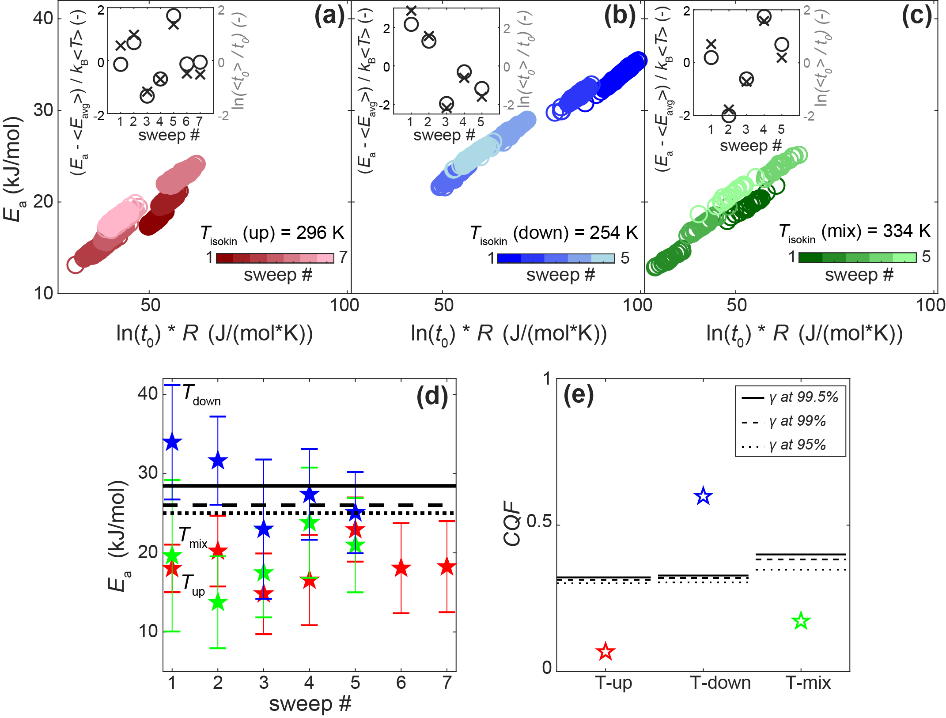

Supplementary Figure 18. Modified Cremer-Constable plots at absorption for three samples measured with different T-sweeps: (a) up – red; (b) down – blue and (c) mixed – green. Each subsequent T-sweep in a set is colored as a lighter shade of the main color (colorbar). Insets show normalized change in activation energy, E_{a} – <E_{avg}> / k_{B}T (where E_{a} is the average value for 180 (T_{up} and T_{down}) or 24 particles (T_{mix}) in each sweep, <E_{avg}> is the average of the entire set and k_{B} is Boltzmann constant, black stars), and logarithm of the pre-exponential factor (ln(<t₀ >/ t₀), where t₀ is the average value for the particles in each sweep and <t₀ > is average of the entire set, gray stars) as function of measured T-sweeps. T_{isokin} for each T-sweep was calculated according to Ref.⁵ (d) Average E_{a} of the particles for each of the measured sweep directions (colored stars). Black lines denote E_{a} values at absorption for annealed Pd nanoparticles² of 2-5 nm in size (dotted), annealed Pd disks³ of 190 nm in diameter and 25 nm in height (dashed) and Pd foil⁴ of 2.5-5 µm in thickness (solid). (e) Compensation Quality Factor (CQF) for each set of the T-sweep directions in relation to threshold level 𝛾 at 95, 99 and 99.5 % confidence levels (dotted, dashed and solid lines, respectively), which shows that it is significantly high for the T-sweep down set, indicating non-statistical origin of the compensation effect according to Ref.⁵

16. Simulated scenarios for E_{a} derived by Arrhenius analysis in a system with and without grain growth
To generate a better understanding of how an activation energy derived by Arrhenius analysis may be affected by a grain growth induced slowdown of sorption kinetics and how this effect depends on the direction of the T-sweep used, we present the following thought experiment. Let’s take the average E_{a} and t₀ values from the first set of measurements shown in Fig. 2 in the main text (for E_{a} – 20 and 66 kJ/mol, for t₀ – 6.25 and 22.5 for absorption and desorption, respectively) and assume that these parameters represent an ideal situation without grain growth (scenario 1). Based on these values, we can generate a set of t₅₀ values that perfectly fit these Arrhenius parameters within the temperature range of our experiments (Eq. 1 in main text, with R_{square} = 1). In SI Fig. 19a they are presented as black circles. From our experiments we know, however, that in reality the t₅₀ values increase with each H₂ cycle, and that the extent of slowing is different depending on the direction of the T-sweep. For T-sweep up (scenario 2), the slowing is less pronounced since in the beginning of the experiment everything is faster, and for measurements at higher temperatures it is faster as well (red triangles in SI Fig. 19a). For a T-sweep down (scenario 3), we see significant slowing of t₅₀ due to the fact that we move towards lower temperatures, where slowing of the process at lower T coincides with slowing due to grain growth upon cycling (blue triangles in SI Fig. 19a). This is correspondingly reflected in the Arrhenius plots of ln(t₅₀) versus 1/T (SI Fig. 19b) and results in lower E_{a} for T-sweep up (scenario 2) and higher E_{a} for T-sweep down (scenario 3) as compared to “ideal” scenario 1 without any grain growth as shown in SI Fig. 19c.

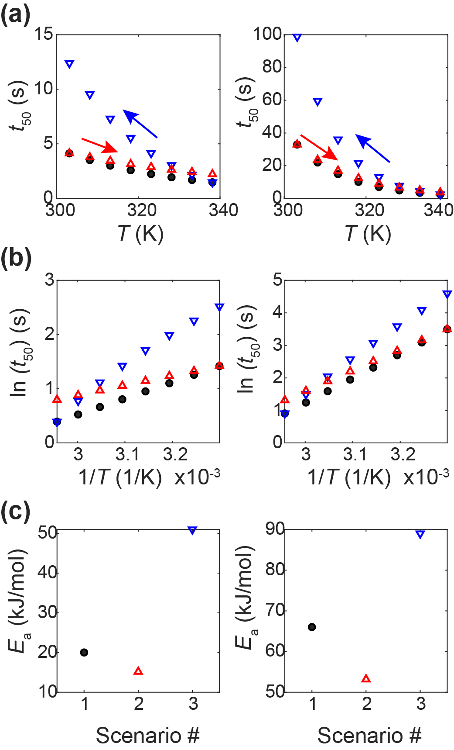
Supplementary Figure 19. Simulation of 3 scenarios for derivation of the activation energy at absorption (left) and desorption (right): ideal case without grain growth (black circles), grain growth with T-sweep up (red triangles) and grain growth with T-sweep down (blue triangles). (a) t₅₀ vs. T. (b) Arrhenius plots of ln(t₅₀) vs. 1/T. (c) Activation energy for each scenario.

17. Correlation of a kinetics slowing factor with E_{a}
The slowing factor (SF) is defined as the ratio of the latest t₅₀ measured at 303 K to the first t₅₀ measured at 303 K. All three samples used for sweeps T_{up}, T_{down} and T_{mix} were pre-cycled 3 times with H₂ at 303 K before sets of T-sweeps for extraction of Arrhenius parameters were performed. Similar to Fig. 6 in the main text, where SF versus E_{a} values at the first T-sweep is plotted, in SI Fig. 20 we plot SF vs. E_{a} for all the other corresponding sweeps not shown in the main text.

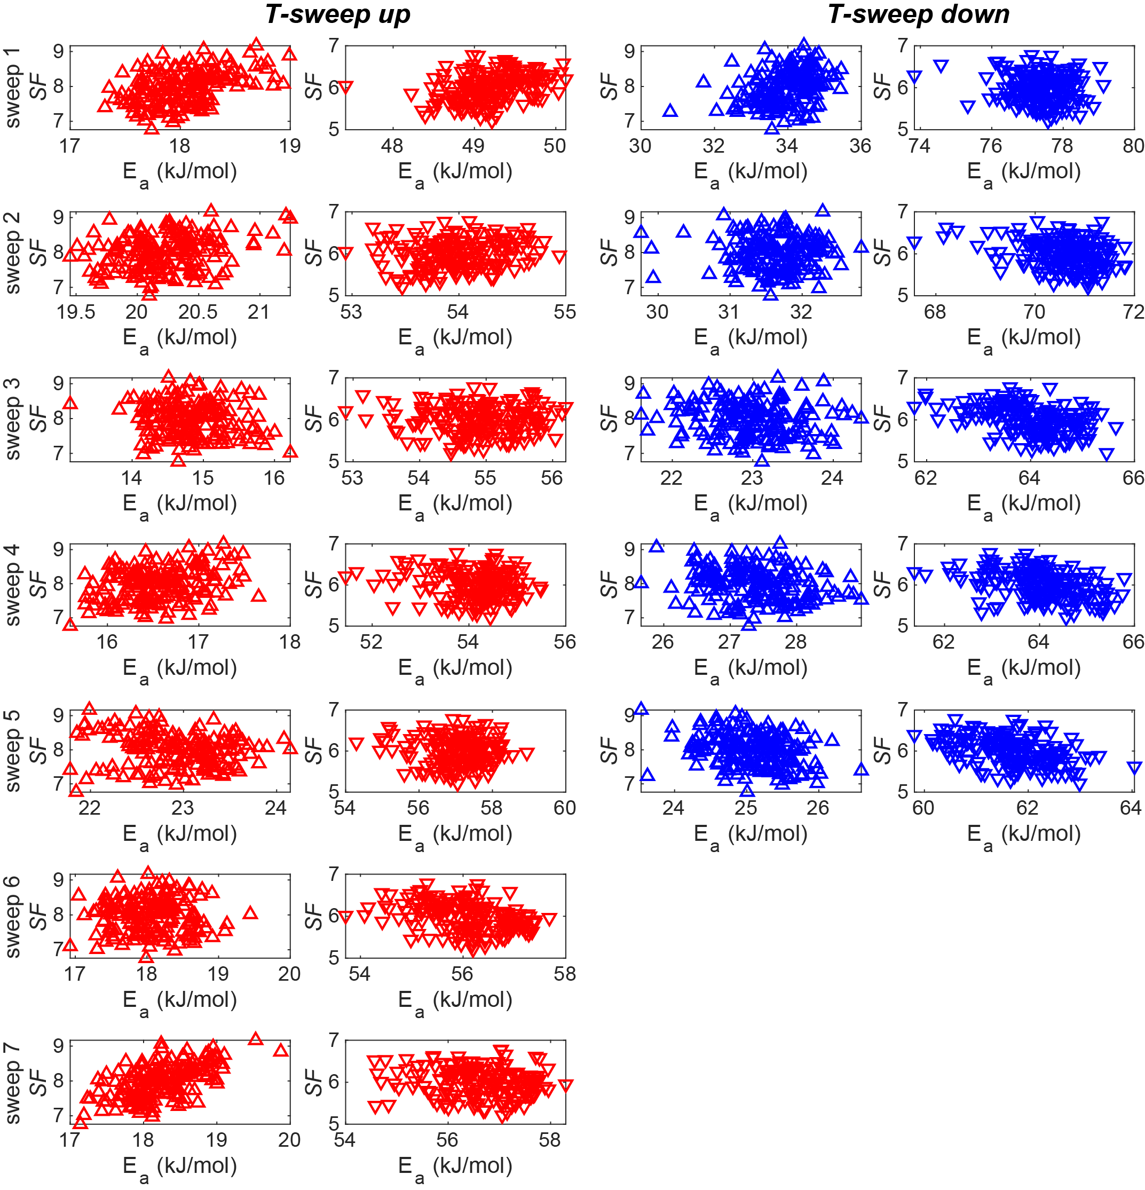
Supplementary Figure 20. Slowing factor (t₅₀ (last) / t₅₀ (first) at 303 K) versus activation energy at the 1st sweep for samples measured according to scheme T_{up} (left panel, red data) and T_{down} (right panel, blue data) at absorption (upward pointing triangles) and desorption (downward pointing triangles). For T_{up} SF = t₅₀ (53)/ t₅₀ (1) and T_{down} SF = t₅₀ (43)/ t₅₀ (1), where numbers in parentheses indicate the cycle number at which the corresponding last and first measurement at 303 K was performed for each sample.

18. Data set size and CQF values
In this section, we illustrate the influence of sample size on the calculated CQF value within a single T-sweep. As an example, we use the dataset with 180 particles measured using a T_{down} sweep, where the correlation between slowing factor (SF) and activation energy was the most pronounced (Fig. 6b in the main text). For this purpose, we randomly divide the dataset of 180 particles into 7 subsets each consisting of 25 particles, where the 1st set includes particles 1 to 25, the 2^{d} set – particles 26 to 50 and so on, while the 7th set includes particles 150 to 175. Particle numbers indicate their position on the sample. Then we plot corresponding SF vs. E_{a} (SI Fig. 21a, b) for each of the particle subsets. We see that with fewer particles included in the analysis it becomes difficult to see the correlation between the two parameters. We also calculate the CQF value for each of the 7 subsets and compare it to CQF value of the entire set of 180 particles (SI Fig. 21c). The comparison shows that depending on the constituent nanoparticles in the subset, the CQF value can be greatly different than the value of the entire 180-particle set both for absorption and desorption, highlighting the importance of large data sets (N-value) if this analysis is to be reliably applied.

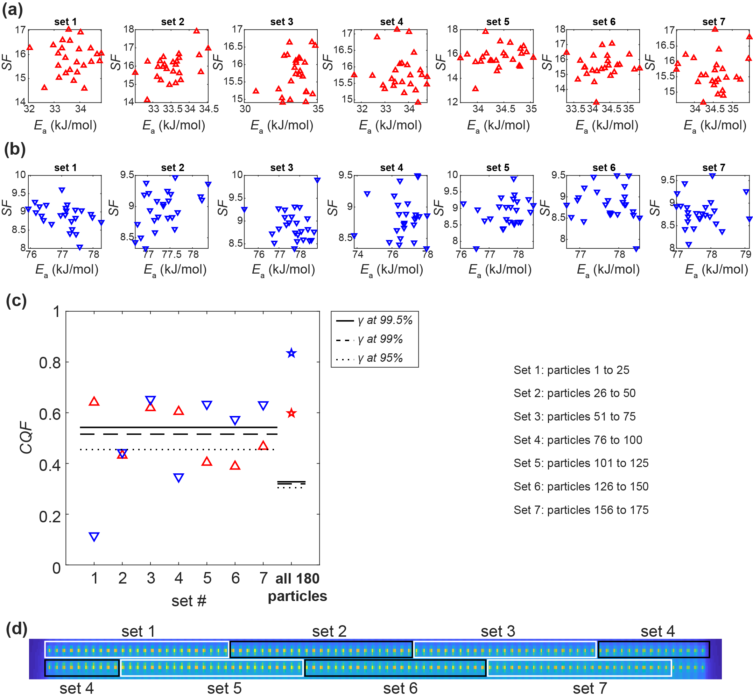
Supplementary Figure 21. Slowing factor, SF = (t₅₀ (43) / t₅₀ (1) at 303 K vs. E_{a}, obtained from the 1st T-sweep for a sample of 180 particles measured according to T_{down} scheme, divided into 7 sets of 25 particles, at (a) absorption and (b) desorption. Numbers in parentheses for SF indicate the cycle number at which the corresponding last and first measurement at 303 K was performed for each sample. (c) CQF value calculated for each of the 7 subsets (triangles) and for the entire 180-particle set (stars) in relation to the threshold level 𝛾 at 95, 99 and 99.5 % confidence levels (dotted, dashed and solid lines, respectively and according to number of particles in the set, i.e. 25 and 180) according to Ref.⁵ (d) CCD image of the sample with 180 particles with black and white boxes indicating corresponding particle subsets.

References

1 Barrie, P. J. The mathematical origins of the kinetic compensation effect: 1. the effect of random experimental errors. Physical Chemistry Chemical Physics 14, 318-326, doi:10.1039/C1CP22666E (2012).
2 Langhammer, C., Zhdanov, V. P., Zorić, I. & Kasemo, B. Size-Dependent Kinetics of Hydriding and Dehydriding of Pd Nanoparticles. Physical Review Letters 104, 135502 (2010).
3 Nugroho, F. A. A. et al. Metal–polymer hybrid nanomaterials for plasmonic ultrafast hydrogen detection. Nat. Mater. 18, 489-495, doi:10.1038/s41563-019-0325-4 (2019).
4 Auer, W. & Grabke, H. J. The Kinetics of Hydrogen Absorption in Palladium (α- and β-phase) and Palladium-Silver-Alloys. Berichte der Bunsengesellschaft für physikalische Chemie 78, 58-67, doi:10.1002/bbpc.19740780110 (1974).
5 Griessen, R. et al. Single Quality Factor for Enthalpy-Entropy Compensation, Isoequilibrium and Isokinetic Relationships. ChemPhysChem 21, 1618-1618, doi:10.1002/cphc.202000616 (2020).
6 Alekseeva, S. et al. Grain boundary mediated hydriding phase transformations in individual polycrystalline metal nanoparticles. Nature Communications 8, 1084, doi:10.1038/s41467-017-00879-9 (2017).
7 Zhdanov, V. P. & Kasemo, B. Effect of Lattice Strain on the Dehydriding Kinetics in Nanoparticles. The Journal of Physical Chemistry C 113, 6894-6897, doi:10.1021/jp901552n (2009).
8 Hong, S. & Rahman, T. S. Adsorption and diffusion of hydrogen on Pd(211) and Pd(111): Results from first-principles electronic structure calculations. Physical Review B 75, 155405, doi:10.1103/PhysRevB.75.155405 (2007).
9 Posada-Borbón, A., Heard, C. J. & Grönbeck, H. Cluster Size Effects in Ethylene Hydrogenation over Palladium. The Journal of Physical Chemistry C 121, 10870-10875, doi:10.1021/acs.jpcc.6b12072 (2017).
10 Gremaud, R. et al. Hydrogenography of PdHx thin films: Influence of H-induced stress relaxation processes. Acta Materialia 57, 1209-1219, doi:https://doi.org/10.1016/j.actamat.2008.11.016 (2009).
11 Harumoto, T., Suzuki, Y., Shi, J. & Nakamura, Y. X-ray diffraction study on a (111)-textured palladium thin film under hydrogen loading and unloading: film structure evolution and its mechanism. Journal of Applied Crystallography 50, 1478-1489, doi:doi:10.1107/S1600576717012638 (2017).

