Figure. 1B

Caspase-1 p20

Pro caspase-1

GSDMD FL

GSDMD NT

PARP
Cleaved PARP

β-actin

Figure. 1D

Caspase-1 p20

Pro caspase-1

GSDMD FL
GSDMD p43

GSDMD NT

PARP
Cleaved PARP

β-actin

Figure .2D

Caspase-1 p20

IL-1β p17

Caspase-4 p31

Pro caspase-4

GSDMD FL

GSDMD NT

PARP
Cleaved PARP

β-actin

Figure. 5A

GSDMD FL

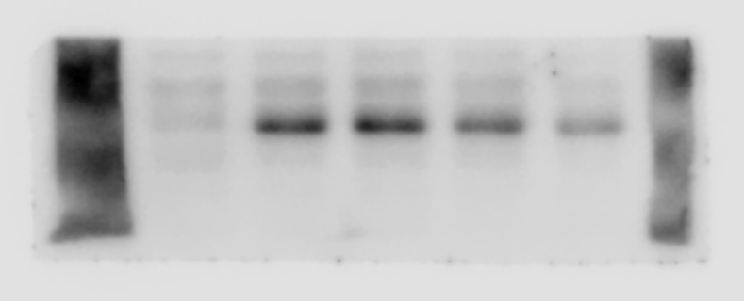

GSDMD NT

β-actin

Figure. 5B

GSDMD FL

GSDMD NT

β-actin

Figure. S1

NLRP3

Caspase-4

Caspase-1

AIM2

ASC

β-actin

