Supplementary Information

Detector-Grade Perovskite Single Crystal Wafers via Stress-Free Gel-Confined Solution Growth Targeting High-Resolution Ionizing Radiation Detection
Yilong Song^{1#}, Lixiang Wang^{2#}, Yongqiang Shi^{3,4#}, Weihui Bi¹, Jianwu Chen^{3,4}, Mingwei Hao¹, Anran Wang¹, Xueying Yang¹, Yuan Sun¹, Fan Yu¹, Liansheng Li^{3,4*}, Yanjun Fang^{2,5*}, Deren Yang² and Qingfeng Dong^{1*}

¹State Key Laboratory of Supramolecular Structure and Materials, College of Chemistry, Jilin University, Changchun, 130012, P. R. China.
²State Key Laboratory of Silicon Materials and School of Materials Science and Engineering, Zhejiang University, Hangzhou, 310027, P. R. China.
³Beijing Institute of Control Engineering, Beijing, 100190, P. R. China.
⁴Science and Technology on Space Intelligent Control Laboratory, Beijing, 100190, P. R. China.
⁵Shanxi-Zheda Institute of Advanced Materials and Chemical Engineering, Taiyuan, 030024, P. R. China.
*E-mail: qfdong@jlu.edu.cn; jkfang@zju.edu.cn; liliansheng502@163.com

#Y. S., L.W., Y. S. contribute equally to this work

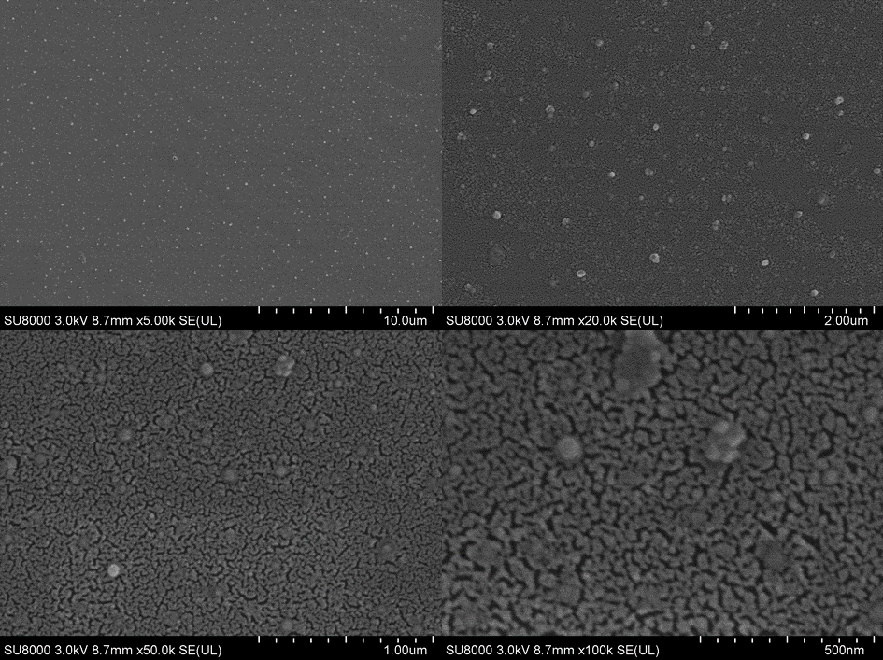
Figure S1. SEM images of F-gel treated substrates at different magnifications.

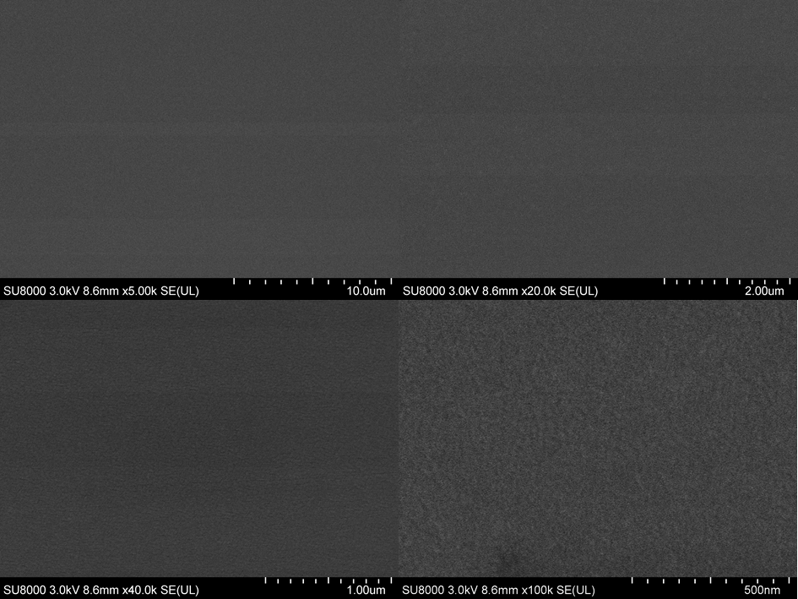
Figure S2. SEM images of SAM treated substrates at different magnifications.

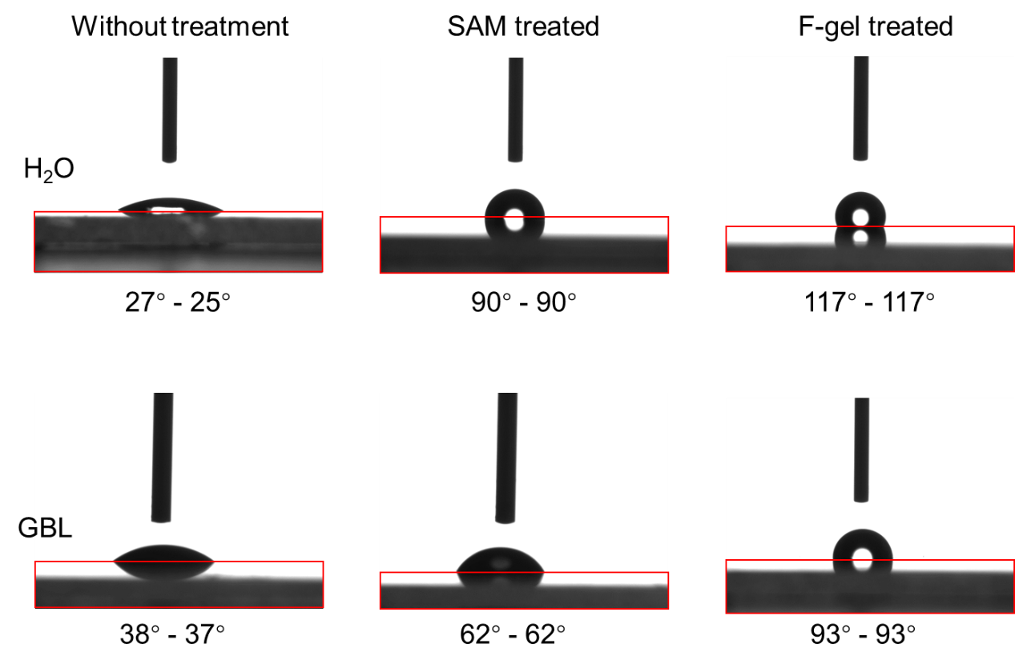
Figure S3. Contact angle measurement of water and GBL on substrates with different treatments.

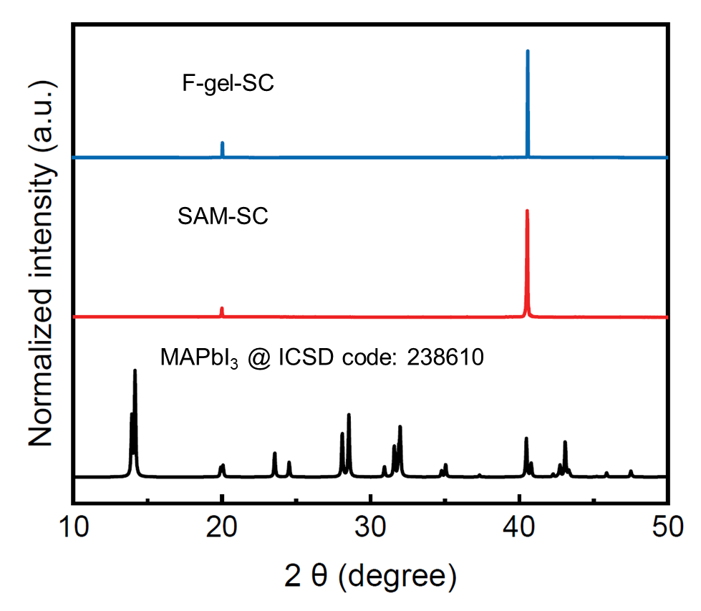
Figure S4. Comparison of single crystal XRD spectra with standard MAPbI₃ XRD spectra (indexed based on ICSD file No. 238610).

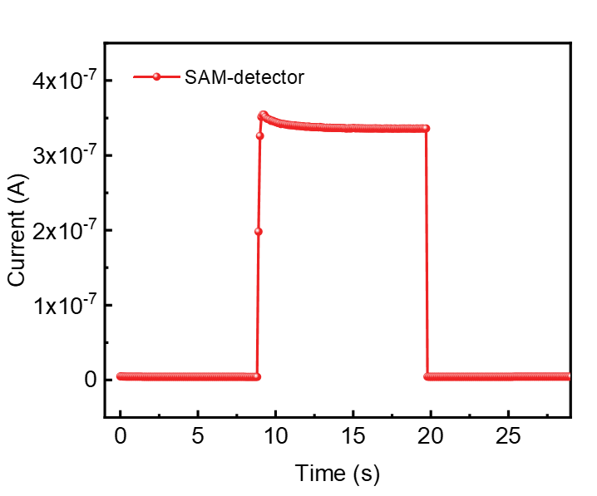
Figure S5. X-ray response curves of SAM-detector under the X-ray.

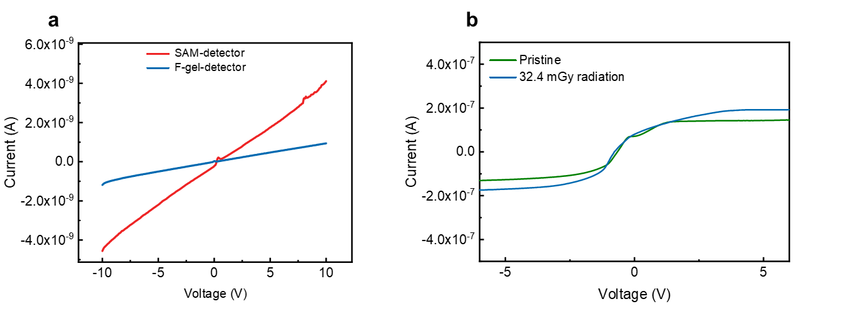
Figure S6. (a). Dark current curves of F-gel-detector and SAM-detector; (b). Photocurrent comparison of the F-gel-detector before / after X-ray radiation.

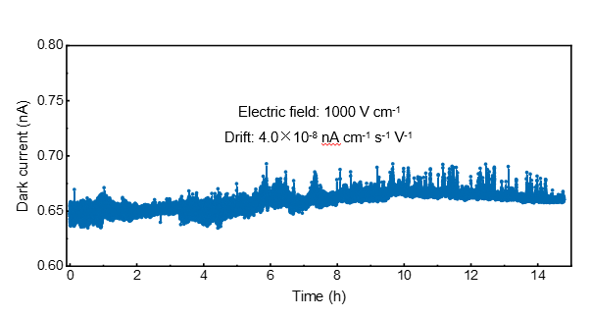
Figure S7. Dark current output as a function of time for the devices based on F-gel-SC under 1000 V cm⁻¹ electric field.

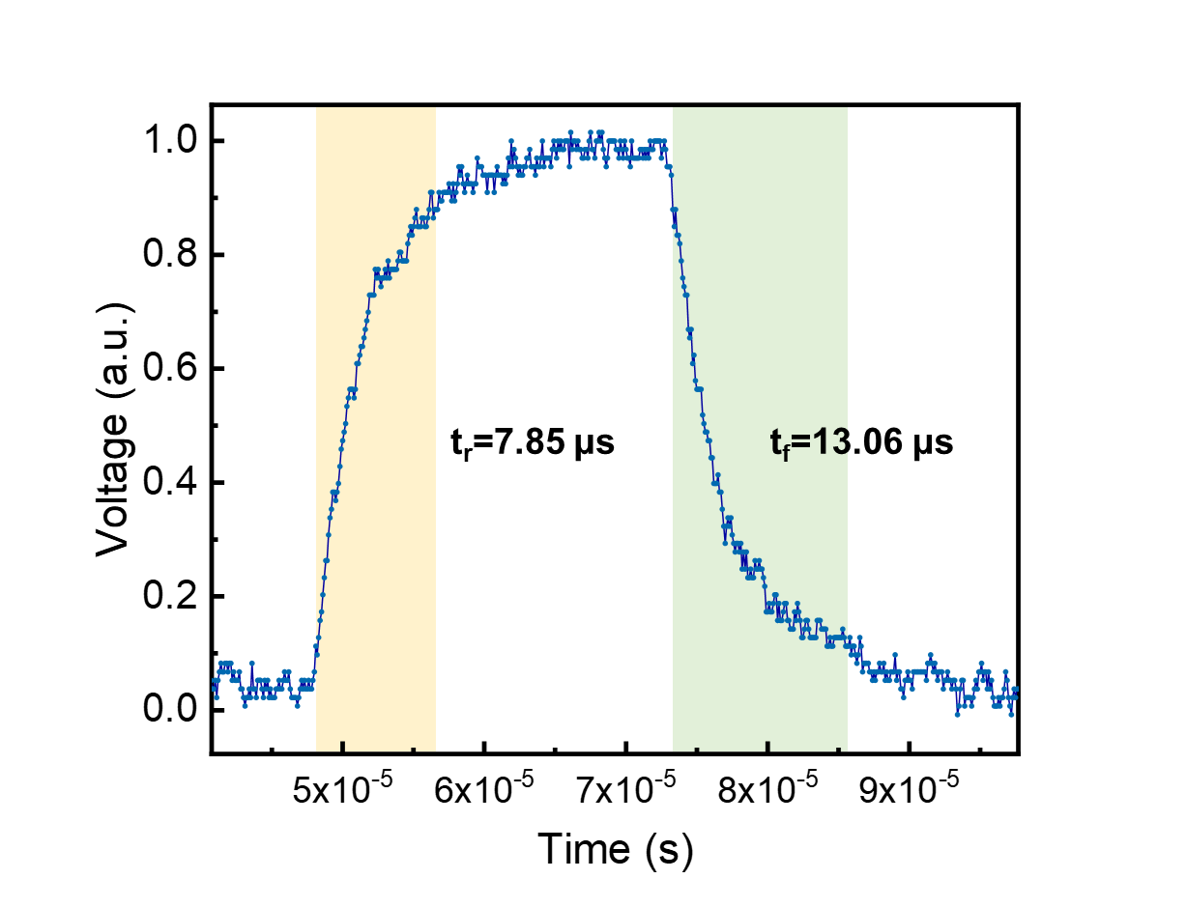
Figure S8. The response speed curve of F-gel-detector.

