Supporting Information
Sequential UV and chlorine disinfection induced change of biofilm-originated disinfection byproducts formation potential in drinking water distribution system: Effect of UV dose and influencing mechanism
Tuqiao Zhang¹ · Chengzhuo Li¹ · Xiaowei Liu^{1,2*}
¹ Zhejiang Key Laboratory of Drinking Water Safety and Distribution Technology, Zhejiang University, Hangzhou 310058, PR China
² Ocean College, Zhejiang University, Hangzhou 310058, PR China
*Correspondence: Xiaowei Liu (liuxiaowei@zju.edu.cn)

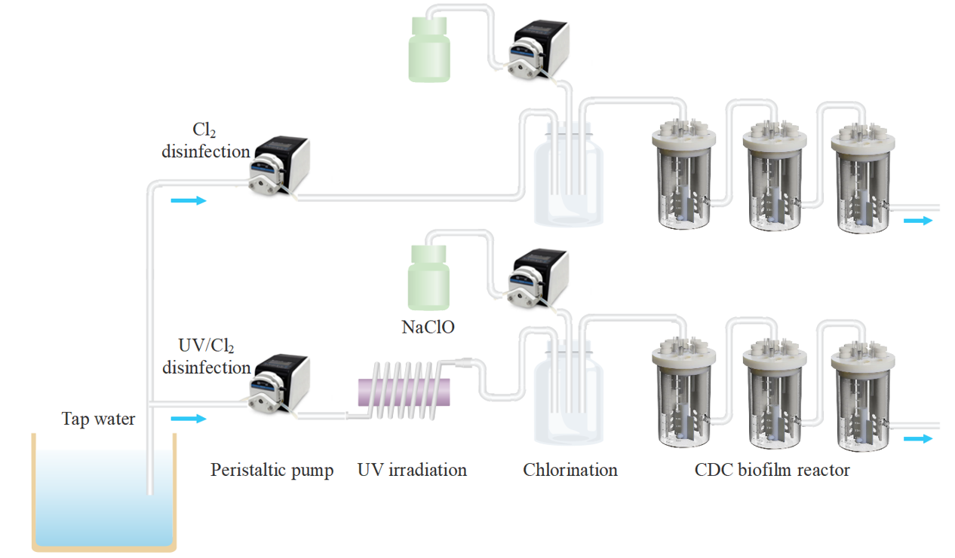
Fig. S1 Annular reactors used for simulating DWDS experiment

Text S1 The determination of total organic halogen (TOX) using the ultraviolet (ozone) oxidation method, take a 30mL water sample under the irradiation of a 185nm ultraviolet lamp (Heraeus GPH212T5VH/4) for 30min to oxidize organochlorine to inorganic ions. Then, the difference in inorganic halogen ion concentration before and after the reaction was calculated to obtain the TOX, and the recovery rate of the method was >85% by pre-experiment verification.

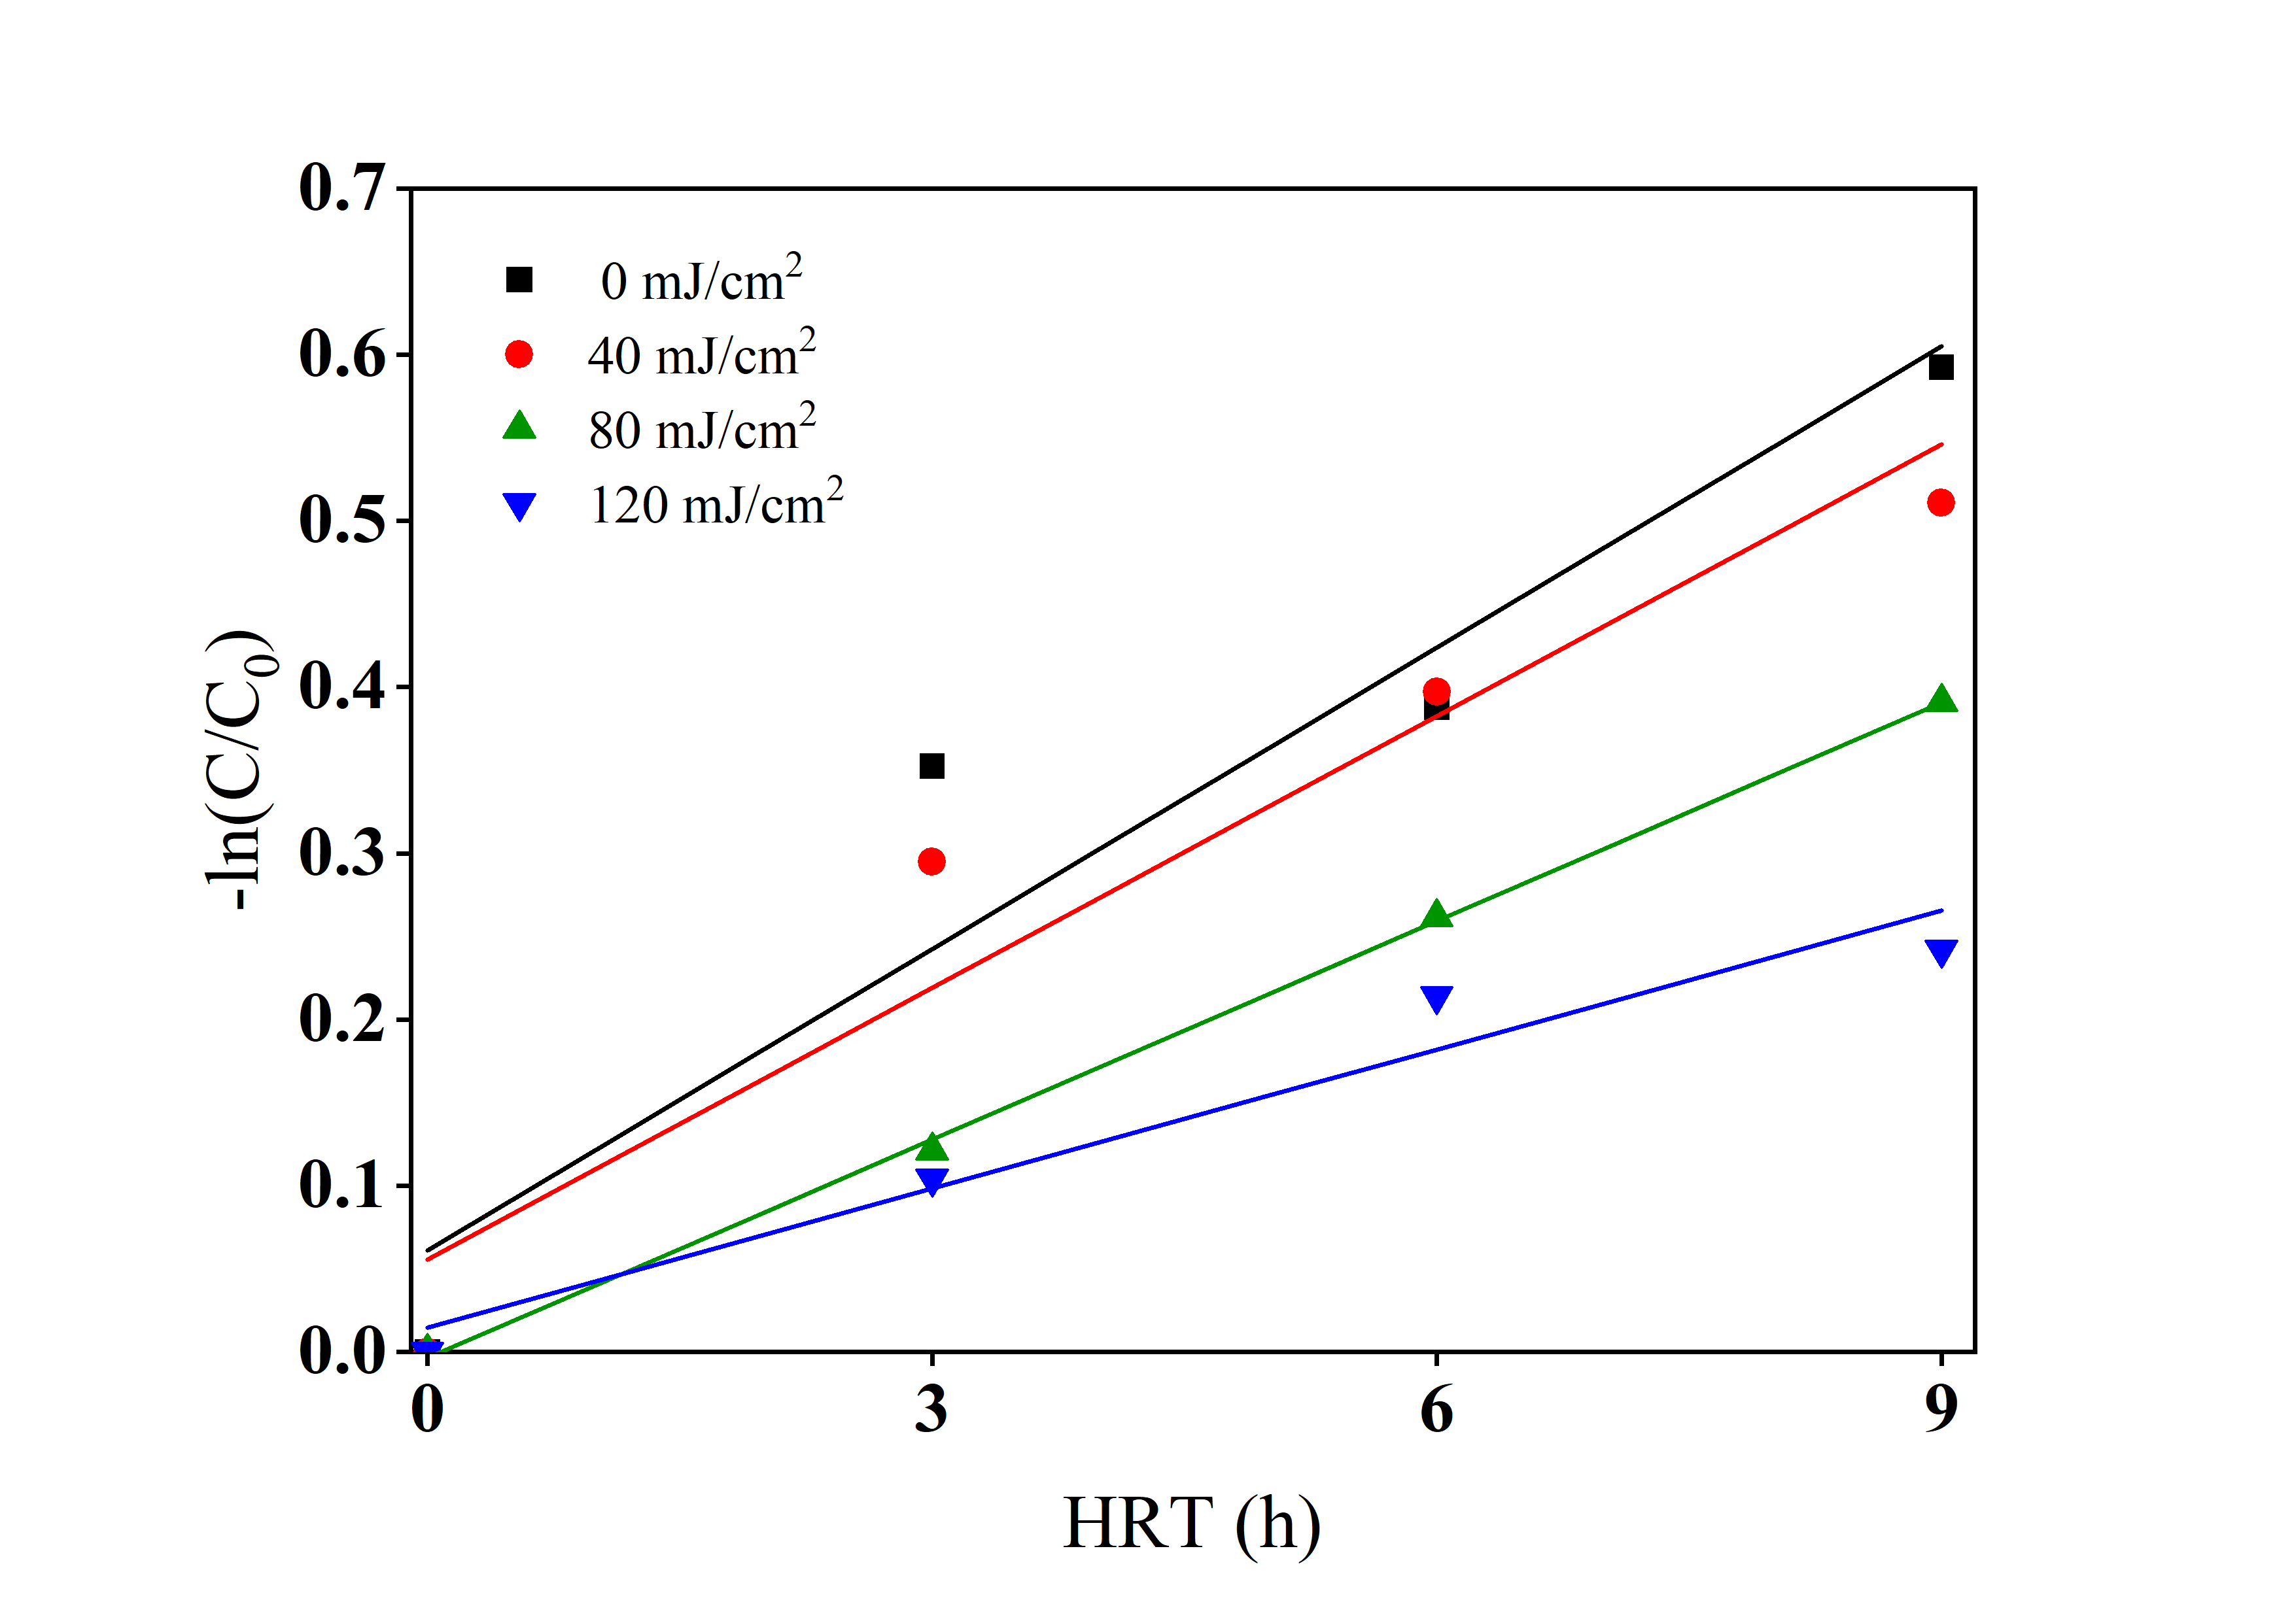
Fig. S2 Chlorine decay in the DWDS(-ln$\frac{C}{C0}$)

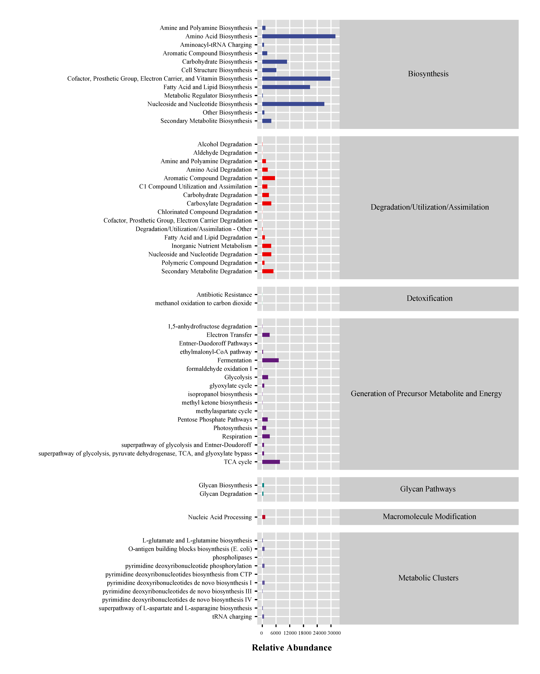
Fig. S3 Bacterial community functional relative abundance

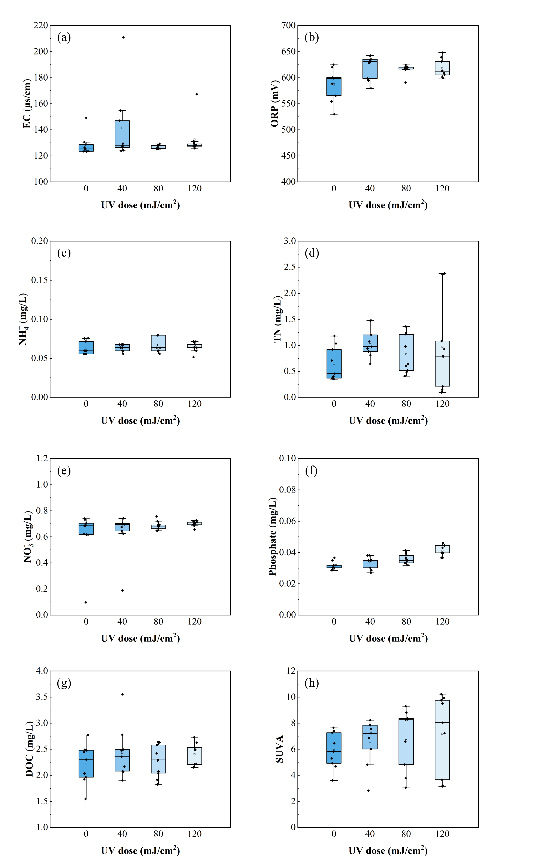
Fig. S4 Changes in the water quality parameters under different disinfection process operating conditions: (a) EC, (b) ORP, (c) NH+ 4, (d) TN, (e) NO- 3, (f) phosphate, (g) DOC and (h) SUVA

