Course schedule details
Day1
Content: General cardiac anatomy
Duration: 4 classes, 1 hour/class
Teaching material:
1)Wenlong Ding, Xuezheng Liu.(2018)Systematic Anatomy. Beijing: People's Medical Publishing House.
Note：Through AR technology, the plan in this textbook is stereoscopic, and the abstract knowledge is transformed into an easy to observe 3D learning scene.
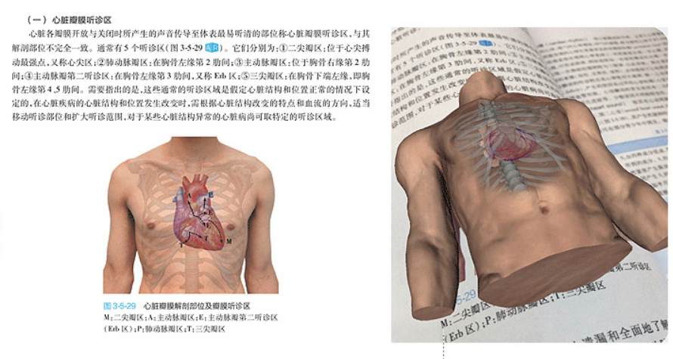
2)PVC Heart model
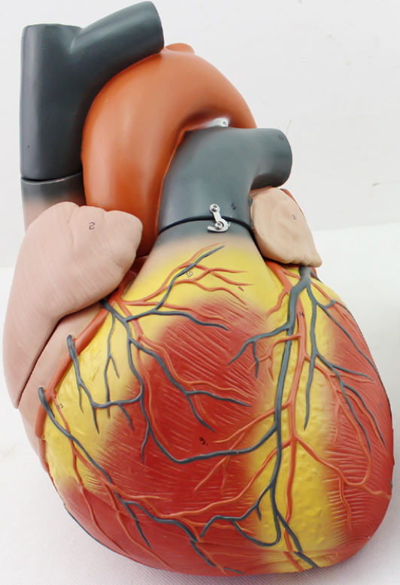

Day2
Content: literature study of General cardiac anatomy
Duration: 4 classes
Teaching material:
1)Mori S, Tretter JT, Spicer DE, Bolender DL, Anderson RH. What is the real cardiac anatomy? Clin Anat. 2019 Apr;32(3):288-309. Doi: 10.1002/ca.23340.
2) Mori, S. and K. Shivkumar(2021). "Stereoscopic three-dimensional anatomy of the heart: another legacy of Dr. Wallace A. McAlpine." Anat Sci Int 96(3): 485-488.

Day3
Content: Three-dimensional anatomical pictures
Duration: 2 classes
Teaching material: Anatomical 3D atlas and resource from the Internet

Day4
Content: Rest and review general cardiac anatomy
Day5
Content: The anatomy of the ventricular outflow tract
Duration：4 classes
Teaching material:
1)Asirvatham SJ. Correlative anatomy for the invasive electrophysiologist: Outflow tract and supravalvar arrhythmia. J Cardiovasc Electrophysiol 2010; 20:955-968. DOI: 10.1111/j.1540-8167.2009.01472.x
2)Chun KR, Satomi K, Kuck KH, Ouyang F, Antz M. Left ventricular outﬂow tract tachycardia including ventricular tachycardia from the aortic cusps and epicardial ventricular tachycardia. Herz 2007;32:226-232. DOI: 10.1007/s00059-007-2977-0
3) Li YG, Gronefeld G, Israel C, Hohnloser SH. Sustained monomorphic ventricular tachycardia ablation from the aortic sinus of valsalva. J Cardiovasc Electrophysiol 2002;13:130-134. DOI: 10.1046/j.1540-8167.2002.00130.x
4) Sidhu S, Calkins H. New insights on ablation of idiopathic ventricular arrhythmias arising from the right ventricular outflow tract. Heart Rhythm 2019;16:1521-1522. DOI: 10.1016/j.hrthm.2019.04.046
5) Katie AW, Gerard JF. Anatomy of the left main coronary artery of particular relevance to ablation of left atrial and outflow tract arrhythmias. Heart Rhythm 2014;11:2231-2238. DOI: 10.1016/j.hrthm.2014.08.006.
Note: We have integrated the knowledge points and related graphs in the above literature into our teaching plan.

Day6
Content: Porcine heart anatomy
Duration：2 classes
Teaching material: Porcine heart
Note: The goal is that every trainee can find all structures by themselves and
master adjacent relationships.

Day7
Content: Ventricular outflow tract anatomy and related electrophysiological knowledge
Duration：4 classes
Teaching material: Book:S. Yen Ho. Anatomy For Cardiac Electrophysiologists，Published August 2012,ISBN: 9780979016448
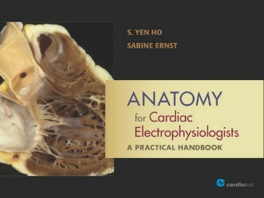
Note: We focused on the relationship between anatomy and intracardiac electrogram and its correlation with ablation.

