Supplementary Materials
for

Understanding information about COVID-19: how sources’ reliability and level of understanding influenced adherence to sanitary measures in Canada

Table of contents
Supplementary 1. Study Materials 2
Supplementary 1a. COVID-19: the end of the world as we know it? 2
Table 1. Descriptive statistics of the survey 2
Supplementary 1b. Variables 3
Adherence to sanitary measure 3
Table 2. Detailed description of the questions used as dependant variables 3
Figure 1. Correlations between social distancing measures 3
Figure 2. Correlations between contacts limitation measures 4
Figure 3. Correlations between mask wearing measures 4
Figure 4. Correlations between sanitary measures at the first measurement time 5
Reliability of sources 6
Figure 5. Results from the iCare Study on the importance of sources of information 6
Table 3. Percentages of sources selected in the top 3 7
Figure 6. Correlations between sources of information 8
Level of understanding 9
Table 4. Distribution of participants’ answers on true/false statements 9
Table 5. Distribution of participants’ answers on their perception of understanding of sanitary measures 9
Figure 7. Correlations between level of understanding statements 10
Control Variables 11
Table 6. Descriptive statistics for control variables 11
Figure 8. Correlations between control variables 12
Supplementary 2. Results 13
Supplementary 2A. Social distancing trajectories 13
Table 7. Bayesian information criterion for selection of a trajectory model 13
Table 8. Detailed results for trajectories of adherence to social distancing (model parameters) 14
Table 9. Associations with predictors and control variables 14
Table 10. Average group assignment probability to social distancing group, conditional on assignment by maximum probability 16
Figure 9. Individual trajectories of adherence to social distancing by group 16
Supplementary 2b. Contacts’ limitation trajectories 17
Table 11. Bayesian information criterion for selection of a trajectory model 17
Table 12. Detailed results for trajectories of adherence to contacts’ limitation (model parameters) 18
Table 13. Associations with predictors and control variables 18
Table 14. Average group assignment probability to contacts’ limitation group, conditional on assignment by maximum probability 20
Figure 10. Individual trajectories of adherence to contacts’ limitation by group 21
Supplementary 2c. Mask wearing trajectories 22
Table 15. Bayesian information criterion for selection of a trajectory model 22
Table 16. Detailed results for trajectories of adherence to social distancing (model parameters) 23
Table 17. Associations with predictors and control variables 23
Table 18. Average group assignment probability to mask wearing group, conditional on assignment by maximum probability 26
Figure 11. Individual trajectories of adherence to mask wearing by group 26

Supplementary 1. Study Materials

This project is part of a longitudinal study on the psychological impacts of COVID-19 on the Canadian population. This project, entitled "COVID-19 Canada: the end of the world as we know it?", was carried out with the collaboration of several researchers from different disciplines. The objective of this project is to understand the impacts on the Canadian population of a dramatic social change such as the COVID-19 pandemic through three themes: adherence to health measures, social cohesion, and well-being. The participants were questioned on more than a hundred variables covering concepts as diverse as emotions, behaviors, attitudes, and cognitions related to the COVID-19 pandemic.

Supplementary 1a. COVID-19: the end of the world as we know it?

Table 1. Descriptive statistics of the survey
Measurement times |  | Survey dates | Sample Size  (N) | Intervals between measurement times |  | Number of weeks elapsed since launch of survey
1 | April 6th – May 6th 2020 |  | 3617 | 2 weeks | 0
2 | April 21st – May 13th 2020 |  | 2282 | 2 weeks | 2
3 | May 4th – May 25th 2020 |  | 2369 | 2 weeks | 4
4 | May 18th – June 10th 2020 |  | 2296 | 2 weeks | 6
5 | June 1st – June 23rd 2020 |  | 2154 | 2 weeks | 8
6 | June 15th – July 13th 2020 |  | 2116 | 2 weeks | 10
7 | July 13th – August 8th 2020 |  | 2072 | 4 weeks | 14
8 | August 17th – September 13th2020 |  | 1871 | 5 weeks | 19
9 | September 21st – October 19th 2020 |  | 1821 | 5 weeks | 24
10 | November 26th –December 29th 2020 |  | 1883 | 9 weeks | 33
11 | April 13th – May 31st 2021 |  | 2002 | 20 weeks | 53
12 | Mars 2nd – April 19th 2022 |  | 1672 | 46 weeks | 99
Table 1 illustrates various elements of the survey: the number of measurement times, the timeline of the survey, and the sample size. Most importantly, this table indicates the coding scheme for this study, in which we only refer to the number of weeks elapsed since the launch of the survey as measurement time (from 0 to 53).

Supplementary 1b. Variables

Adherence to sanitary measure

Table 2. Detailed description of the questions used as dependant variables
Questions from the survey | Scale | Dates of entry in the survey
Currently, how often do you do the following?
Maintain a distance of at least two meters (about two arm's lengths) from others when I am not at home | 1-10 (Never to Always) | April 6th – May 6th 2020
Stay home as much as I can | 1-10 (Never to Always) | April 6th – May 6th 2020
Wear a mask in public | 1-10 (Never to Always) | June 1st – June 23rd 2020
Participants were questioned on their level of adherence to sanitary measures by reporting how often they would follow the public health recommendations. Table 2 shows that mask wearing was introduced later in the survey, which explains the time gap with other measures.

Figure 1. Correlations between social distancing measures
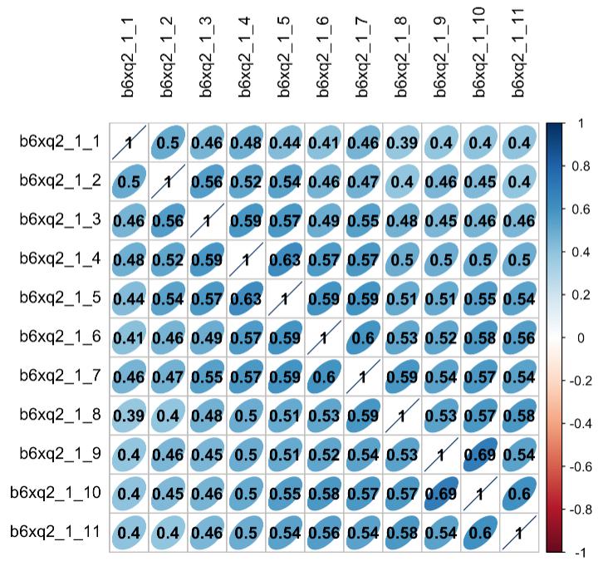
Figure 1 illustrates the Pearson correlations between social distancing measures at all 11 measurement times. Associations between different time measures of social distancing were evaluated to verify the validity of the question from the survey. Indeed, this allowed us to verify whether the answers from one measurement time to another were similar in pattern. In the case of social distancing measures, we can confirm that all measures are strongly associated with one another as correlations range between 0.39 and 0.63.

Figure 2. Correlations between contacts limitation measures
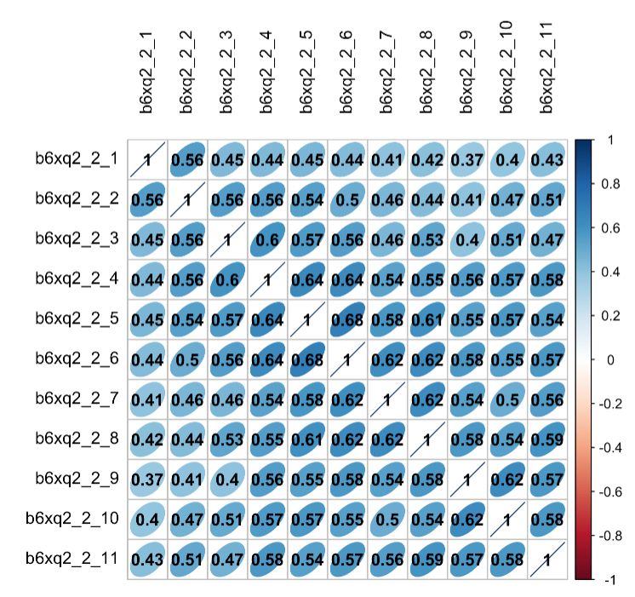
Figure 2 illustrates the Pearson correlations between contacts limitation measures at all 11 measurement times. The correlations vary between 0.37 and 0,68, which indicates the presence of strong associations between measures of contacts limitations.

Figure 3. Correlations between mask wearing measures
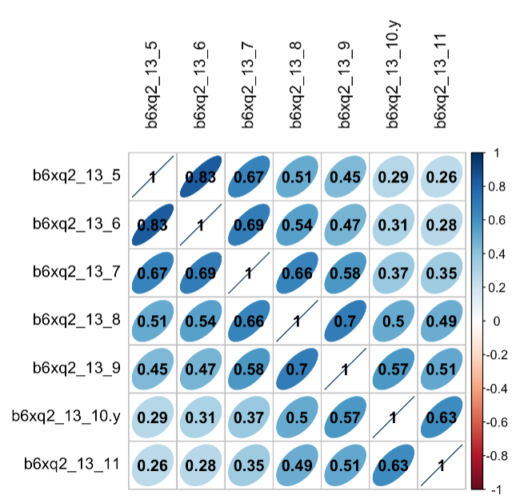
Figure 3 illustrates the Pearson correlations between mask wearing measures at all 6 measurement times. The correlations vary between 0.26 and 0,83, which indicates the presence of strong associations between measures of mask wearing.

Figure 4. Correlations between sanitary measures at the first measurement time
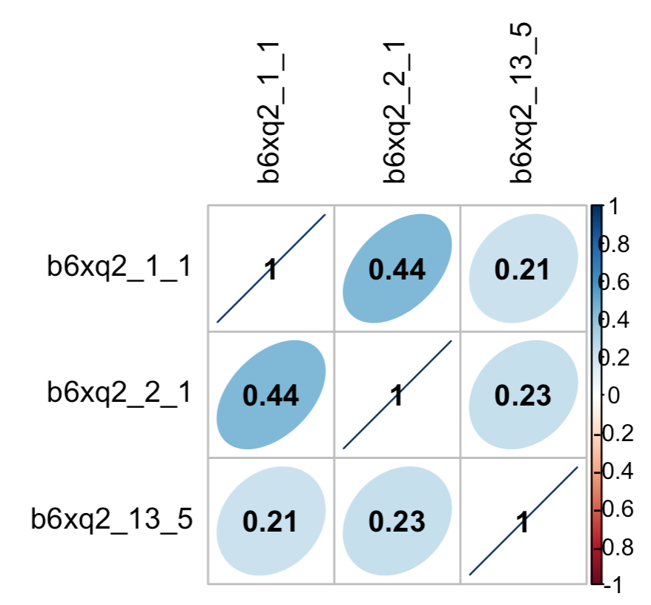
Figure 4 illustrates the Pearson correlations between sanitary measures at the first measurement time, except for mask wearing which is measured at the fifth measurement time. The correlations vary between 0.21 and 0,44, which indicates the presence of medium strong associations between sanitary measures. This demonstrates that sanitary measures share some similarities but not enough to be considered as a unique variable.

Reliability of sources

This question was derived from a larger study on COVID-19, the iCare Study (Bacon et al., 2021). In this study, participants were asked: “Among the following sources of information about COVID-19, please rank all the sources that you use, from most to least important.” In the longitudinal survey for the project “COVID-19 Canada: the end of the world as we know it”, we used the same source options, but participants were only asked to rank up to three sources that they “trusted the most to get information regarding COVID-19”.

Figure 5. Results from the iCare Study on the importance of sources of information
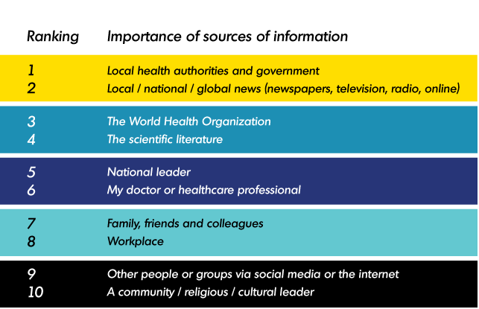
Source : iCARE Study – Results. (2021). MBMC. https://mbmc-cmcm.ca/covid19/research/stats/other/

Table 3. Percentages of sources selected in the top 3
Sources | 1  (%) | 2  (%) | 3  (%) | In the top 3
 |  |  |  | Yes  (%) | No  (%)
Family/friends | 2 | 3 | 5 | 10 | 90
Workplace | 2 | 2 | 3 | 7 | 93
News | 21 | 19 | 20 | 60 | 40
Doctor | 8 | 11 | 12 | 31 | 69
Health authorities | 35 | 30 | 15 | 80 | 20
Community | 0,8 | 0,8 | 1,3 | 3 | 97
WHO | 18 | 18 | 17 | 52 | 48
Scientific literature | 11 | 11 | 12 | 34 | 66
Others/internet | 1,5 | 1,5 | 3 | 6 | 94
In our preliminary analysis, we found that participants relied mostly on health authorities, news outlets and the WHO to obtain information on the COVID-19 pandemic. The table 3 presents the percentages of sources selected in the top 3, with 80% of participants reporting that health authorities are one the most used sources of information.

Figure 6. Correlations between sources of information
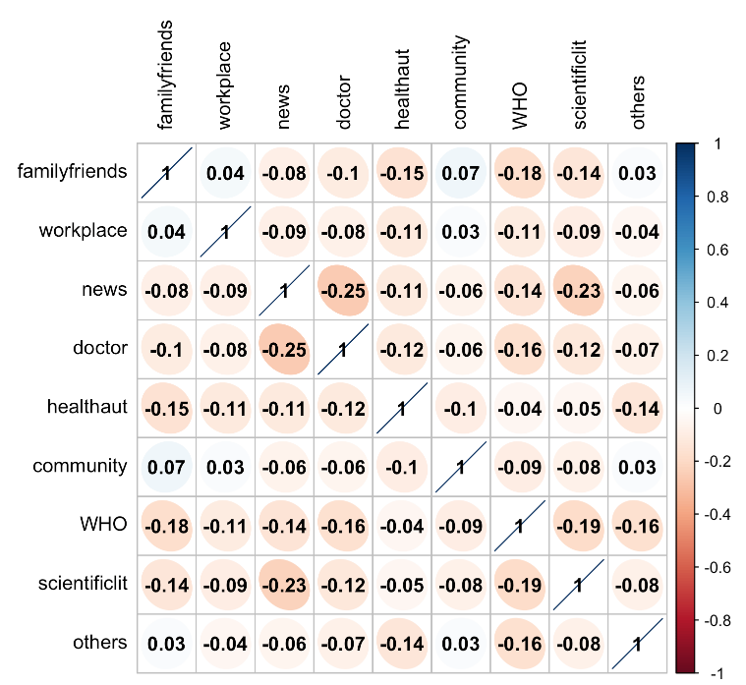
Following the identification of most used sources, we then proceeded to evaluate the correlations between the sources. Figure 6 introduces the various degrees of correlations between sources of information, it shows that participants who relied mostly on family and friends for information on COVID-19 tend to depend less on healthcare authorities and the WHO. Similar patterns were observed for other lesser used sources of information, such as community and workplace. From these preliminary results, we were able to distinguish reliable sources from unreliable ones. Indeed, we considered healthcare authorities, news organisations, the WHO, doctors as reliable sources. The remaining options, like family/friends, the workplace, the community, and others/Internet, were identified as unreliable sources.

Level of understanding

The participants’ level of understanding was evaluated in two parts: the first part being an objective evaluation of their understanding of sanitary measures through true/false questions, and the second part an introspective evaluation of their understanding of sanitary measures. The scores from each part were summed together to obtain a total score (0= high understanding; 1= medium understanding; 2= low understanding).

Table 4. Distribution of participants’ answers on true/false statements
Statements from the survey |  |  | Avoiding gatherings with large numbers of people helps prevent the spread of COVID-19.
I know what "maintaining a social distance" means. |  |  |  | True (0) | False (1)
 |  | True  (0) |  | 2657  (98.7%) | 11  (0.4%)
 |  | False  (1) |  | 19  (0.7%) | 5  (0.2%)
Table 4 shows the distribution of answers on questions evaluating the Canadians’ level of understanding of sanitary measures. 98.7% (N=2657) of participants indicated the right answer on both questions, which granted them the score 0. The 35 participants (1.3%) who answered incorrectly on at least one question were attributed the score 1.

Table 5. Distribution of participants’ answers on their perception of understanding of sanitary measures
Statements from the survey |  |  | In general, I have a clear understanding of the various measures established by my provincial public health agency.
In general, I have a clear understanding of the various measures established by Canada’s public health agency. |  |  |  | High understanding  (0) | Low understanding (1)
 | High understanding (0) |  |  | 2186  (83.1%) |  |  | 119  (4.5%)
 | Low understanding  (1) |  |  | 150  (5.7%) |  | 174  (6.6%)
Table 5 presents the distribution of Canadians’ level of perception of understanding of sanitary measures. 83.1 % (N= 2186) of participants perceived their understanding of sanitary measures as being high on both questions, meanwhile 16.8 % considered having a low understanding on at least one question. Those who reported a high understanding on both questions were attributed the score 0, and those who answered low on at least one question were given the score 1. Finally, the individuals who indicated a low understanding on both questions were given the score 2.

Figure 7. Correlations between level of understanding statements
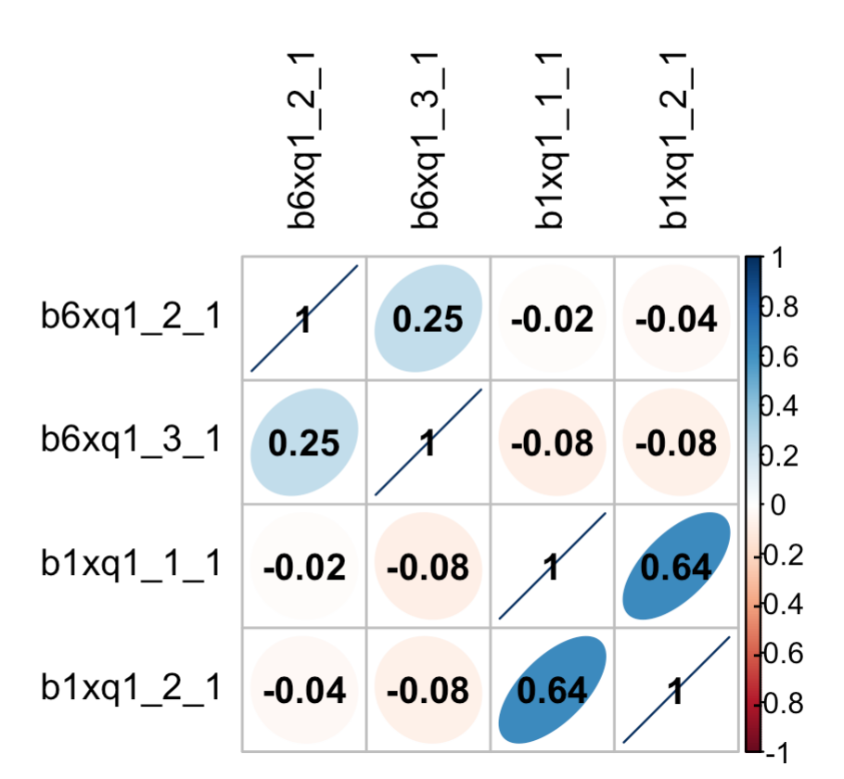
Figure 7 illustrates the correlations between the items used to create the level of understanding variable. The true/false statements correlate strongly between each other (r=0.25), and a similar pattern seems to emerge between the self-reported answers (r=0.64).

Control Variables

Table 6. Descriptive statistics for control variables
Variables | % (n)/  Mean (SD) | Weighted % /  Weighted mean (SD)
Age | 49.8 (16.6) | 45.4 (15.6)
Political identity  (1: left, 10: right) | 5.2 (1.9) | 5.3 (1.9)
Gender
Male | 50.1 (1316) | 50.2
Female | 49.9 (1313) | 49.2
Education level
No diploma | 2.1 (55) | 2.7
Secondary school diploma | 17.3 (454) | 16.0
College, CEGEP or other non-university diploma | 28.8 (756) | 29.5
Bachelor's degree | 32.5 (854) | 32.5
Master's degree | 12.4 (325) | 11.7
Earned doctorate | 7.0 (185) | 6.7
Canadian Regions
Ontario | 40.5 (1058) | 37.9
Atlantic | 6.8 (177) | 6.2
Quebec | 20.3 (532) | 23.6
Prairies | 18.0 (474) | 18.2
BC | 14.3 (374) | 13.1
Born in Canada
Yes | 79.5 (2077) | 76.9
No | 20.5 (526) | 21.8
Table 6 presents statistics concerning the subsample of participants who completed at least four measurements times of the longitudinal survey (n = 2629).

Figure 8. Correlations between control variables
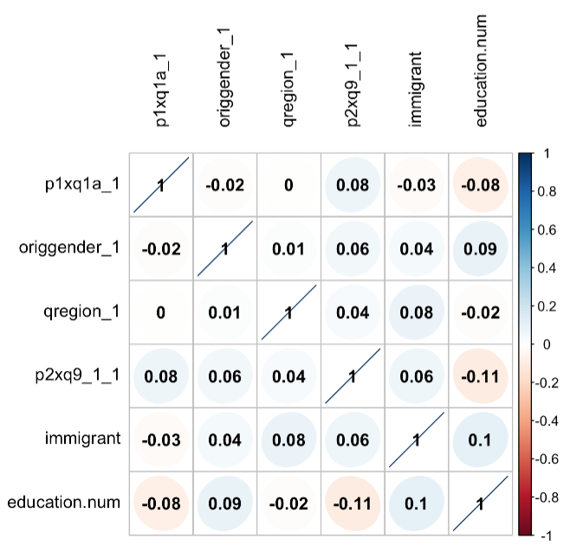
Figure 8 displays the various degrees of associations between control variables. The correlations range from 0 to |0.11|, which reveals that control variables are not strongly correlated.

Supplementary 2. Results

Supplementary 2A. Social distancing trajectories

Table 7. Bayesian information criterion for selection of a trajectory model
Model | K | Order | BIC
1 | 1 | 2 | -30 582.30*
2 | 2 | 2,2 | -27 971.27*
3 | 3 | 2,2,2 | -27 107.97*
4 | 4 | 2,2,2,2 | -26 932.43
5 | 5 | 2,2,2,2,2 | -26 787.36
6 | 6 | 2,2,2,2,2,2 | -26 761.38
7 | 4 | 1,2,2,2 | -26 937.26
8 | 4 | 1,2,2,1 | -26 934.17
9 | 4 | 1,2,2,0 | -26 931.25*
10 | 4 | 1,3,2,0 | -26 852.69*
11 | 4 | 1,3,3,0 | -26 826.81*
Table 7 shows the various attempts at obtaining the best model of social distancing trajectories. Only models with an * were retained for comparison, as the parameters’ estimates were significant (p < 0.05). The models were compared according to the Bayesian information criterion (BIC): indeed, the solution with the lowest absolute value of BIC was selected. In this case, we selected the model with 4 trajectories (1,3,3,0).

Table 8. Detailed results for trajectories of adherence to social distancing (model parameters)
Group | Parameter | β | SE | t | p-value
1 | Intercept | 5.899 | .293 | 20.167 | .000
1 | Linear | -.029 | .010 | -2.729 | .006
2 | Intercept | 8.799 | .245 | 35.920 | .000
2 | Linear | -.176 | .023 | -7.589 | .000
2 | Quadratic | .008 | .001 | 6.696 | .000
2 | Cubic | -.000 | .000 | -5.880 | .000
3 | Intercept | 10.855 | .523 | 20.755 | .000
3 | Linear | -.229 | .038 | -5.948 | .000
3 | Quadratic | .009 | .002 | 5.724 | .000
3 | Cubic | -.000 | .000 | -5.168 | .000
4 | Intercept | 12.433 | .272 | 45.793 | .000
Note. β: Standardized coefficients
SE: Standard Errors

Table 9. Associations with predictors and control variables

Variable | Group | β | SE | t | p-value
Constant | 2 | .027 | 1.127 | .024 | .981
Constant | 3 | -1.385 | 1.558 | -.889 | .374
Constant | 4 | -2.391 | 1.242 | -1.924 | .054
Level of understanding – medium | 2 | 1.808 | 0.431 | 4.196 | .000
Level of understanding – medium | 3 | 2.104 | .481 | 4.376 | .000
Level of understanding – medium | 4 | 2.522 | .615 | 4.103 | .000
Level of understanding – high | 2 | 1.894 | 0.312 | 6.070 | .000
Level of understanding – high | 3 | 2.788 | .378 | 7.375 | .000
Level of understanding – high | 4 | 3.530 | .486 | 7.268 | .000
Use of reliable sources | 2 | .487 | 0.381 | 1.278 | .201
Use of reliable sources | 3 | .577 | .392 | 1.474 | .141
Use of reliable sources | 4 | .833 | .428 | 1.949 | .051
Age | 2 | .031 | .010 | 3.078 | .002
Age | 3 | .071 | .009 | 8.380 | .000
Age | 4 | .072 | .009 | 7.580 | .000
Gender – Male | 2 | .053 | 0.324 | .163 | .871
Gender – Male | 3 | -.333 | .282 | -1.180 | .238
Gender – Male | 4 | -.618 | .293 | -2.108 | .035
Region of residence  – Atlantic | 2 | .397 | .719 | .552 | .581
Region of residence  – Atlantic | 3 | .888 | .605 | 1.470 | .142
Region of residence  – Atlantic | 4 | .746 | .635 | 1.174 | .240
Region of residence  – Quebec | 2 | -.340 | .403 | -.843 | .399
Region of residence  – Quebec | 3 | -.596 | .378 | -1.575 | .115
Region of residence  – Quebec | 4 | -.646 | .404 | -1.600 | .110
Region of residence  – Prairies | 2 | -.350 | .332 | -1.055 | .292
Region of residence  – Prairies | 3 | -.787 | .337 | -2.334 | .020
Region of residence  – Prairies | 4 | -1.386 | .367 | -3.771 | .000
Region of residence  – British Columbia | 2 | -.154 | .388 | -.396 | .692
Region of residence  – British Columbia | 3 | -.756 | .430 | -1.757 | .079
Region of residence  – British Columbia | 4 | -1.001 | .415 | -2.433 | .015
Immigrant | 2 | .107 | .352 | .304 | .761
Immigrant | 3 | .398 | .339 | 1.175 | .240
Immigrant | 4 | .609 | .330 | 1.845 | .065
Education level  – High school | 2 | .025 | 1.080 | .023 | .981
Education level  – High school | 3 | -.745 | 1.059 | -.704 | .482
Education level  – High school | 4 | -.444 | 1.042 | -.427 | .670
Education level  – College | 2 | .307 | 1.082 | .284 | .777
Education level  – College | 3 | -.893 | 1.038 | -.860 | .390
Education level  – College | 4 | -.728 | 1.006 | -.724 | .469
Education level  – Bachelor | 2 | .761 | 1.068 | .713 | .476
Education level  – Bachelor | 3 | -.263 | .982 | -.268 | .789
Education level  – Bachelor | 4 | -.344 | .978 | -.352 | .725
Education level  – Master | 2 | .279 | 1.117 | .250 | .803
Education level  – Master | 3 | -.554 | 1.086 | -.510 | .610
Education level  – Master | 4 | -.709 | 1.091 | -.649 | .516
Education level  – Doctorate | 2 | -.325 | 1.206 | -.269 | .788
Education level  – Doctorate | 3 | -.707 | 1.197 | -.591 | .555
Education level  – Doctorate | 4 | -.970 | 1.159 | -.837 | .403
Political identity | 2 | -.231 | .074 | -3.136 | .002
Political identity | 3 | -.215 | .088 | -2.434 | .015
Political identity | 4 | -.209 | .085 | -2.445 | .015
Note. β: Standardized coefficients of multinomial logistic regression
SE: Standard Errors

Table 10. Average group assignment probability to social distancing group, conditional on assignment by maximum probability

Group assignment | Probability (%)
Group assignment | 1 | 2 | 3 | 4
1 | 90.5 | 1.2 | .0 | .0
2 | 9.5 | 87.1 | 10.8 | .1
3 | .0 | 11.1 | 83.9 | 8.5
4 | .0 | .0 | 5.3 | 91.4
Overall average group assignment probability to assigned group: 88.2%

Figure 9. Individual trajectories of adherence to social distancing by group
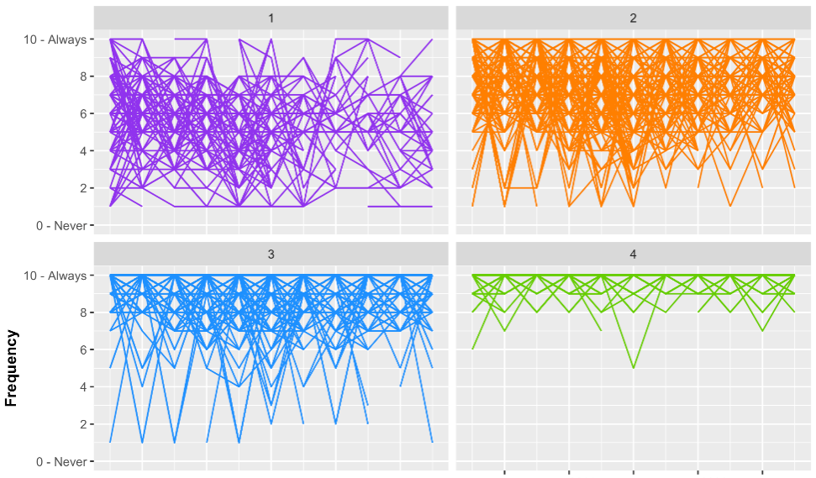

Supplementary 2b. Contacts’ limitation trajectories

Table 11. Bayesian information criterion for selection of a trajectory model
Model | K | Order | BIC
1 | 1 | 2 | -32 696.63*
2 | 2 | 2,2 | -29 917.64*
3 | 3 | 2,2,2 | -29 016.22*
4 | 4 | 2,2,2,2 | -28 721.53
5 | 5 | 2,2,2,2,2 | -28 548.56
6 | 6 | 2,2,2,2,2,2 | -28 524.75*
7 | 4 | 2,2,2,1 | -28 726.54
8 | 4 | 2,2,2,0 | -28 723.74*
9 | 4 | 3,2,2,0 | -28 647.11*
10 | 4 | 3,3,2,0 | -28 531.54*
11 | 4 | 3,3,3,0 | -28 437.49*
Table 11 shows the various attempts at obtaining the best model of contacts’ limitation trajectories. Only models with an * were retained for comparison, as the parameters’ estimates were significant (p < 0.05). The models were compared according to the Bayesian information criterion (BIC): indeed, the solution with the lowest absolute value of BIC was selected. In this case, we selected the model with 4 trajectories (3,3,3,0).

Table 12. Detailed results for trajectories of adherence to contacts’ limitation (model parameters)
Group | Parameter | β | SE | t | p-value
1 | Intercept | 7.013 | .374 | 18.774 | .000
1 | Linear | -.510 | .072 | -6.998 | .000
1 | Quadratic | .022 | .004 | 6.030 | .000
1 | Cubic | -.000 | .000 | -5.450 | .000
2 | Intercept | 9.050 | .250 | 36.266 | .000
2 | Linear | -.309 | .024 | -13.124 | .000
2 | Quadratic | .012 | .001 | 10.007 | .000
2 | Cubic | -.000 | .000 | -8.190 | .000
3 | Intercept | 11.393 | .257 | 44.299 | .000
3 | Linear | -.340 | .022 | -15.486 | .000
3 | Quadratic | .014 | .001 | 13.079 | .000
3 | Cubic | -.000 | .000 | -10.991 | .000
4 | Intercept | 13.043 | .194 | 67.331 | .000
Note. β: Standardized coefficients
SE: Standard Errors

Table 13. Associations with predictors and control variables
Variable | Group | β | SE | t | p-value
Constant | 2 | 1.049 | 1.171 | .896 | .370
Constant | 3 | 1.011 | 1.082 | .934 | .350
Constant | 4 | -.444 | 1.580 | -.281 | .779
Level of understanding – medium | 2 | 1.293 | .486 | 2.662 | .008
Level of understanding – medium | 3 | 1.409 | .421 | 3.345 | .001
Level of understanding – medium | 4 | 1.389 | .521 | 2.666 | .008
Level of understanding – high | 2 | 1.562 | .339 | 4.608 | .000
Level of understanding – high | 3 | 2.209 | .371 | 5.953 | .000
Level of understanding – high | 4 | 2.456 | .437 | 5.622 | .000
Use of reliable sources | 2 | .607 | .355 | 1.710 | .087
Use of reliable sources | 3 | .365 | .320 | 1.141 | .254
Use of reliable sources | 4 | .896 | .364 | 2.460 | .014
Age | 2 | .021 | .007 | 2.988 | -.003
Age | 3 | .030 | .007 | 4.310 | .000
Age | 4 | .027 | .008 | 3.320 | .001
Gender – Male | 2 | .003 | .254 | .013 | .990
Gender – Male | 3 | -.431 | .241 | -1.789 | .074
Gender – Male | 4 | -.841 | .257 | -3.268 | .001
Region of residence  – Atlantic | 2 | .159 | .672 | .237 | .813
Region of residence  – Atlantic | 3 | .320 | .637 | .502 | .615
Region of residence  – Atlantic | 4 | .445 | .655 | .679 | .497
Region of residence  – Quebec | 2 | -.326 | .341 | -.955 | .340
Region of residence  – Quebec | 3 | -.787 | .348 | -2.260 | .024
Region of residence  – Quebec | 4 | -.692 | .375 | -1.846 | .065
Region of residence  – Prairies | 2 | -.350 | .410 | -.853 | .394
Region of residence  – Prairies | 3 | -.698 | .352 | -1.984 | .047
Region of residence  – Prairies | 4 | -.805 | .371 | -2.173 | .030
Region of residence  – British Columbia | 2 | .138 | .416 | .332 | .740
Region of residence  – British Columbia | 3 | -.406 | .409 | -.992 | .321
Region of residence  – British Columbia | 4 | -.530 | .422 | -1.257 | .209
Immigrant | 2 | -.150 | .329 | -.455 | .649
Immigrant | 3 | .008 | .326 | .024 | .981
Immigrant | 4 | .580 | .331 | 1.752 | .080
Education level  – High school | 2 | -.359 | .863 | -.416 | .677
Education level  – High school | 3 | -.780 | .817 | -.955 | .340
Education level  – High school | 4 | .345 | 1.178 | .293 | .770
Education level  – College | 2 | -.582 | .956 | -.608 | .543
Education level  – College | 3 | -.613 | .873 | -.702 | .483
Education level  – College | 4 | .034 | 1.242 | .027 | .978
Education level  – Bachelor | 2 | .132 | .823 | .161 | .873
Education level  – Bachelor | 3 | -.188 | .785 | -.240 | .811
Education level  – Bachelor | 4 | .562 | 1.116 | .504 | .615
Education level  – Master | 2 | -.345 | .986 | -.350 | .726
Education level  – Master | 3 | -.645 | .866 | -.745 | .456
Education level  – Master | 4 | .409 | 1.266 | .323 | .747
Education level  – Doctorate | 2 | -.251 | 1.048 | -.240 | .811
Education level  – Doctorate | 3 | -.871 | .959 | --.908 | .364
Education level  – Doctorate | 4 | .378 | 1.375 | .276 | .782
Political identity | 2 | -.203 | .069 | -2.946 | .003
Political identity | 3 | -.251 | .071 | -3.531 | .000
Political identity | 4 | -.251 | .079 | -3.213 | .001
Note. Β: Standardized coefficients of multinomial logistic regression
SE : Standard Errors

Table 14. Average group assignment probability to contacts’ limitation group, conditional on assignment by maximum probability
Group assignment | Probability (%)
Group assignment | 1 | 2 | 3 | 4
1 | 88.6 | 2.7 | .0 | .0
2 | 11.4 | 88.0 | 8.8 | .1
3 | .0 | 9.3 | 86.4 | 9.3
4 | .0 | .0 | 4.8 | 90.6
Overall average group assignment probability to assigned group: 88.4%

Figure 10. Individual trajectories of adherence to contacts’ limitation by group
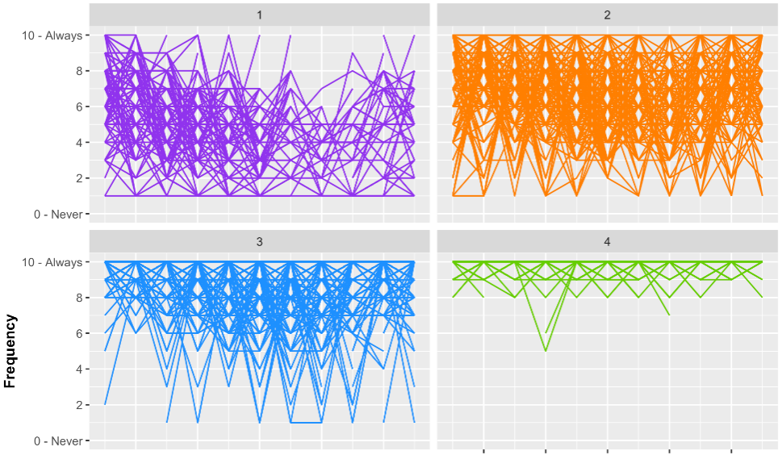

Supplementary 2c. Mask wearing trajectories

Table 15. Bayesian information criterion for selection of a trajectory model
Model | K | Order | BIC
1 | 1 | 2 | -18 157.69*
2 | 2 | 2,2 | -16 763.31*
3 | 3 | 2,2,2 | -16 233.62*
4 | 4 | 2,2,2,2 | -16 022.90*
5 | 5 | 2,2,2,2,2 | -15 834.63
6 | 6 | 2,2,2,2,2,2 | -15 760.27
7 | 5 | 1,2,2,2,2 | -15 838.81
8 | 5 | 1,2,1,2,2 | -15 942.46
9 | 5 | 1,2,0,2,2 | -15 944.47*

Table 15 shows the various attempts at obtaining the best model of mask wearing trajectories. Only models with an * were retained for comparison, as the parameters’ estimates were significant (p < 0.05). The models were compared according to the Bayesian information criterion (BIC): indeed, the solution with the lowest absolute value of BIC was selected. In this case, we selected the model with 5 trajectories (1,2,0,2,2).

Table 16. Detailed results for trajectories of adherence to social distancing (model parameters)
Group | Parameter | β | SE | t | p-value
1 | Intercept | -2.051 | .823 | -2.483 | .013
1 | Linear | 0.158 | .036 | 4.334 | .000
2 | Intercept | -5.506 | .810 | -6.799 | .000
2 | Linear | .830 | .057 | 14.650 | .000
2 | Quadratic | -.010 | .000 | -12.997 | .000
3 | Intercept | 7.459 | .414 | 18.009 | .000
4 | Intercept | 2.316 | .949 | 2.440 | .015
4 | Linear | .510 | .063 | 8.110 | .000
4 | Quadratic | -.006 | .000 | -7.962 | .000
5 | Intercept | 7.256 | .590 | 12.295 | .000
5 | Linear | .500 | .065 | 7.705 | .000
5 | Quadratic | -.007 | .001 | -6.818 | .000
Note. Β: Standardized coefficients
SE : Standard Errors

Table 17. Associations with predictors and control variables

Variable | Group | β | SE | t | p-value
Constant | 2 | 2.694 | 1.225 | 2.200 | .028
Constant | 3 | 1.381 | 1.914 | .721 | .471
Constant | 4 | 3.032 | 1.229 | 2.467 | .014
Constant | 5 | 1.292 | 1.297 | .996 | .319
Level of understanding – medium | 2 | 2.232 | 1.318 | 1.694 | .090
Level of understanding – medium | 3 | .999 | 1.914 | .749 | .454
Level of understanding – medium | 4 | 2.424 | 1.305 | 1.858 | .063
Level of understanding – medium | 5 | 2.055 | 1.307 | 1.572 | .116
Level of understanding – high | 2 | 1.664 | .649 | 2.565 | .010
Level of understanding – high | 3 | .650 | .752 | .864 | .388
Level of understanding – high | 4 | 2.381 | .622 | 3.829 | .000
Level of understanding – high | 5 | 2.334 | .666 | 3.503 | .001
Use of reliable sources | 2 | .612 | 1.530 | .400 | .689
Use of reliable sources | 3 | 1.041 | 1.296 | .803 | .422
Use of reliable sources | 4 | .540 | 1.299 | .415 | .678
Use of reliable sources | 5 | .086 | 1.247 | .069 | .945
Age | 2 | .004 | .015 | .307 | .759
Age | 3 | -.005 | .020 | -.277 | .782
Age | 4 | .020 | .015 | 1.338 | .181
Age | 5 | .037 | .014 | 2.727 | .006
Gender – Male | 2 | .679 | .829 | .819 | .413
Gender – Male | 3 | 1.858 | .763 | 2.436 | .015
Gender – Male | 4 | .304 | .678 | .449 | .654
Gender – Male | 5 | -.021 | .728 | -.029 | .977
Region of residence  – Atlantic | 2 | 9.288 | .798 | 11.637 | .000
Region of residence  – Atlantic | 3 | 7.715 | 1.131 | 6.824 | .000
Region of residence  – Atlantic | 4 | 8.437 | .739 | 11.418 | .000
Region of residence  – Atlantic | 5 | 7.755 | .728 | 10.657 | .000
Region of residence  – Quebec | 2 | -.489 | .596 | -.821 | .412
Region of residence  – Quebec | 3 | -1.340 | .637 | -2.104 | .035
Region of residence  – Quebec | 4 | -1.232 | .532 | -2.316 | .021
Region of residence  – Quebec | 5 | -1.159 | .533 | -2.175 | .030
Region of residence  – Prairies | 2 | -.111 | .636 | -.175 | .861
Region of residence  – Prairies | 3 | -4.190 | 1.396 | -3.002 | .003
Region of residence  – Prairies | 4 | -1.357 | .634 | -2.141 | .032
Region of residence  – Prairies | 5 | -2.549 | .576 | -4.428 | .000
Region of residence  – British Columbia | 2 | .569 | .924 | .615 | .538
Region of residence  – British Columbia | 3 | -.673 | .942 | -.715 | .475
Region of residence  – British Columbia | 4 | -.773 | .938 | -.823 | .410
Region of residence  – British Columbia | 5 | -1.536 | .871 | -1.764 | .078
Immigrant | 2 | -1.300 | .661 | -1.967 | .049
Immigrant | 3 | -.315 | .631 | -.499 | .618
Immigrant | 4 | -.576 | .640 | -.900 | .368
Immigrant | 5 | -.063 | .577 | -.109 | .913
Education level  – High school | 2 | -.576 | 1.218 | -.473 | 0.637
Education level  – High school | 3 | -.178 | 1.949 | -.091 | .927
Education level  – High school | 4 | -.527 | 1.174 | -.449 | .653
Education level  – High school | 5 | .174 | 1.234 | .142 | .887
Education level  – College | 2 | -.729 | 1.279 | -.570 | .569
Education level  – College | 3 | .280 | 1.895 | .148 | .883
Education level  – College | 4 | -.460 | 1.189 | -.387 | .699
Education level  – College | 5 | .083 | 1.261 | .066 | .948
Education level  – Bachelor | 2 | .223 | 1.228 | .181 | .856
Education level  – Bachelor | 3 | 1.929 | 1.927 | 1.001 | .317
Education level  – Bachelor | 4 | .575 | 1.183 | .486 | .627
Education level  – Bachelor | 5 | 1.283 | 1.232 | 1.041 | .298
Education level  – Master | 2 | -.447 | 1.306 | -.343 | .732
Education level  – Master | 3 | 1.005 | 2.007 | .501 | .616
Education level  – Master | 4 | .270 | 1.244 | .216 | .829
Education level  – Master | 5 | .814 | 1.290 | .631 | .528
Education level  – Doctorate | 2 | -1.126 | 1.372 | -.821 | .412
Education level  – Doctorate | 3 | .306 | 2.086 | .147 | .883
Education level  – Doctorate | 4 | -.973 | 1.332 | -.731 | .465
Education level  – Doctorate | 5 | -.065 | 1.362 | -.048 | .962
Political identity | 2 | -.369 | .157 | -2.323 | 0.019
Political identity | 3 | -.255 | .171 | -1.493 | .136
Political identity | 4 | -.451 | .150 | -2.999 | .003
Political identity | 5 | -.380 | .149 | -2.557 | .011
Note. β: Standardized coefficients of multinomial logistic regression
SE: Standard Errors

Table 18. Average group assignment probability to mask wearing group, conditional on assignment by maximum probability
Group assignment | Probability (%)
Group assignment | 1 | 2 | 3 | 4 | 5
1 | 90.0 | 1.7 | .1 | .0 | .0
2 | 9.9 | 87.5 | 4.0 | 4.0 | .0
3 | .1 | 1.9 | 79.8 | 4.8 | .5
4 | .0 | 8.9 | 15.1 | 84.7 | 8.2
5 | .0 | .0 | .9 | 6.4 | 91.3
Overall average group assignment probability to assigned group: 87%

Figure 11. Individual trajectories of adherence to mask wearing by group

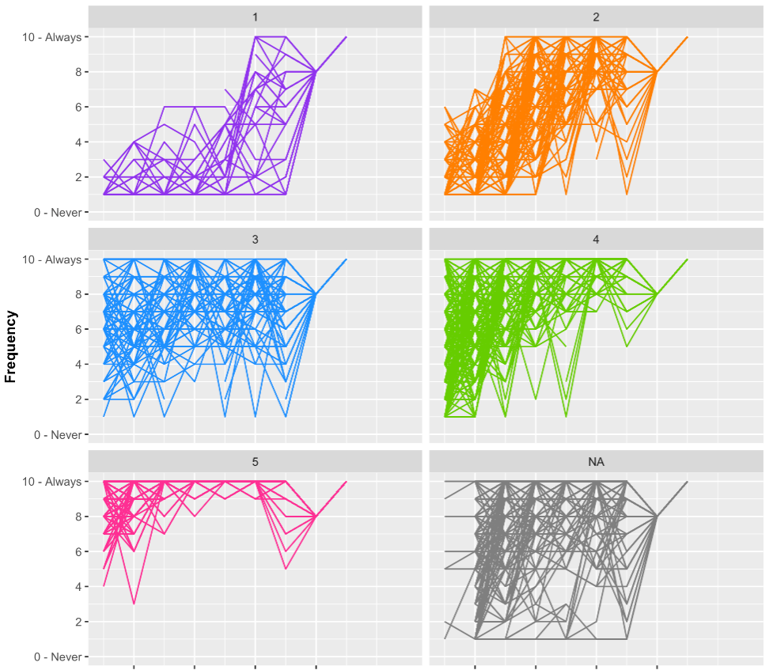

References

Bacon, S. L., Lavoie, K. L., Boyle, J., Stojanovic, J., & Joyal-Desmarais, K. (2021). International assessment of the link between COVID-19 related attitudes, concerns and behaviours in relation to public health policies: optimising policy strategies to improve health, economic and quality of life outcomes (the iCARE Study). BMJ Open, 11(3), e046127. https://doi.org/10.1136/bmjopen-2020-046127

de la Sablonnière, R., Dorfman, A., Pelletier-Dumas, M., Lacourse, É., Lina, J. M., Stolle, D., Taylor, D. M., Benoit, Z., Boulanger, A., Caron-Diotte, M., Mérineau, S., & Nadeau, A. (2020). COVID-19 Canada: The end of the world as we know it? (Technical report No. 1). Presenting the COVID-19 Survey. Université de Montréal.

