Supplementary Material

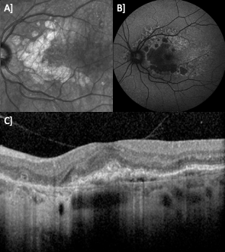
Supplementary Figure 1: Example of the three modalities commonly used to examine the retinas of patients with inherited retinal disease. A] Infrared (IR) fundus acquired at 30 degrees B] Fundus autofluorescence (FAF) acquired at 55 degrees C] Spectral-domain Optical Coherence Tomography (SD-OCT).

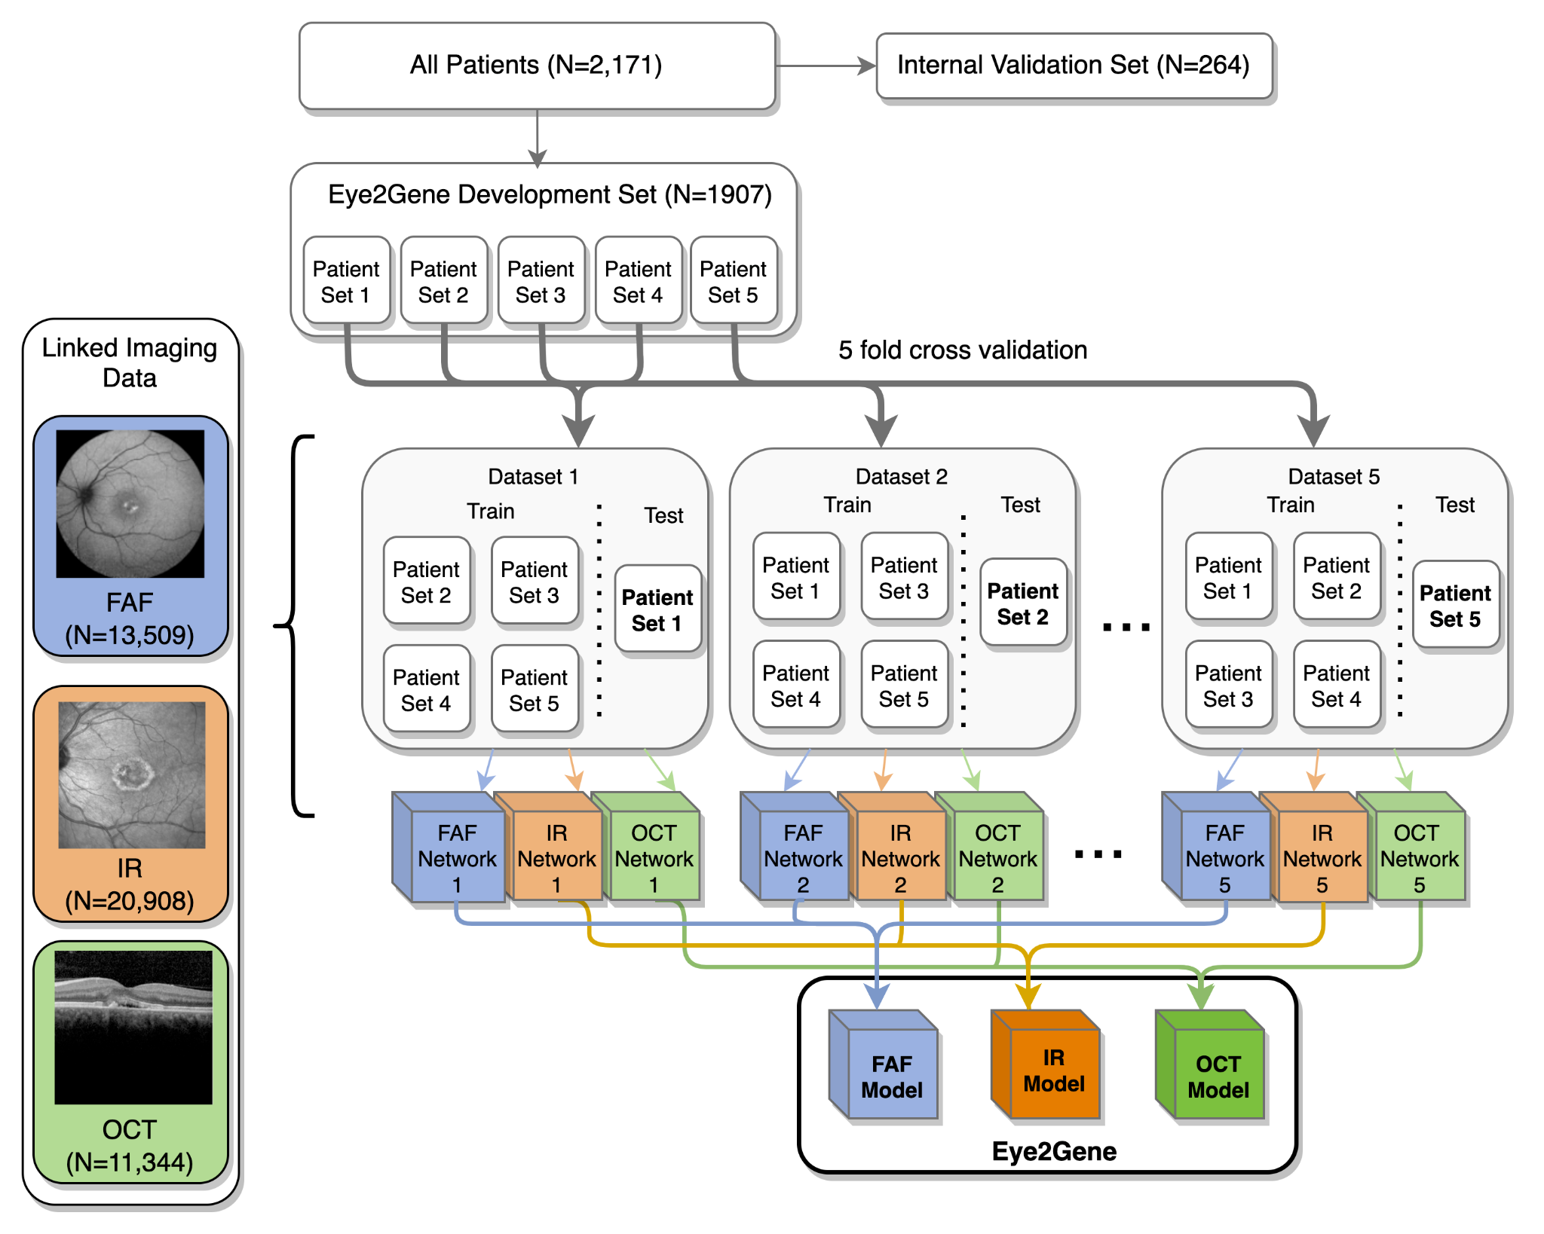

Supplementary Figure 2: Dataset splitting used to train the individual networks for each modality. All patients are assigned either to the development dataset or the internal test dataset which is held-out. The development dataset is split into 5 patient subsets, which are used to create 5 different train/test datasets. After linking the imaging data to these patient datasets they are used to train the 15 networks. The 5 networks from each modality are then assembled to produce the 3 modality-specific networks of Eye2Gene: the FAF model, the IR model and the OCT model. The Eye2Gene model is the ensemble output of these 3 models.

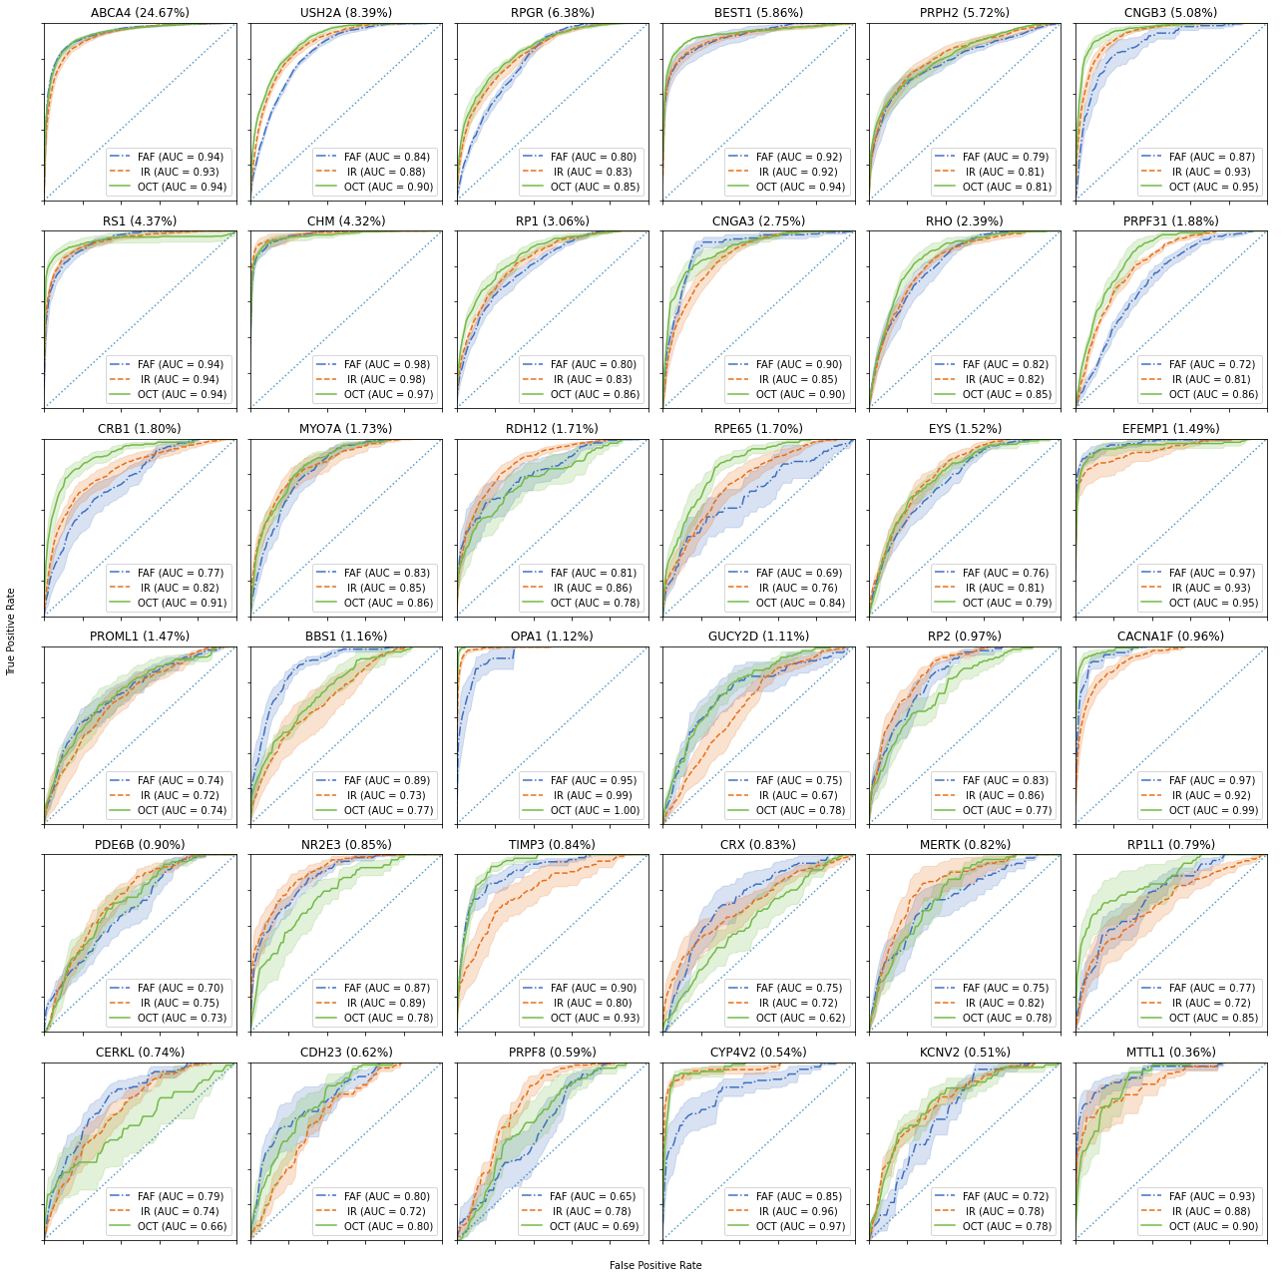
Supplementary Figure 3: Per-gene Receiver Operating Characteristic (ROC) curves from cross-validation on the development data for the three different imaging modalities across the 36 predicted genes, taking the mean ROC curve across the 5 models per modality. Percentages next to gene name denote the percentage of total images (across all three modalities) of the given gene. Shaded region denotes region within one standard error of the mean.

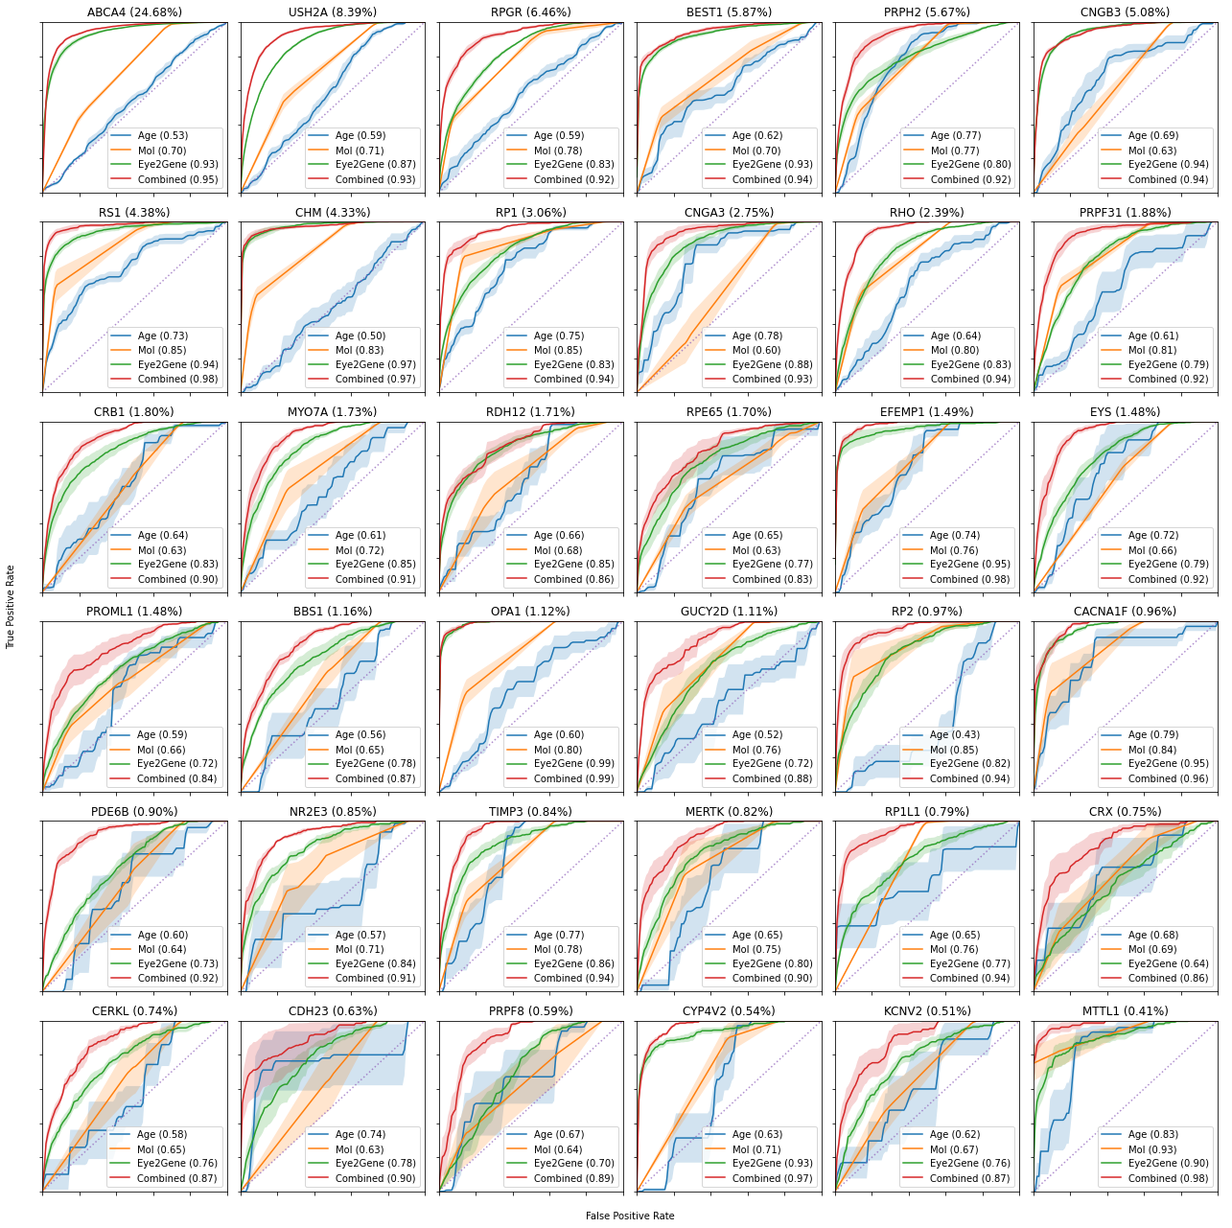
Supplementary Figure 4: Per-gene Receiver Operating Characteristic (ROC) curves for four linear classifiers: one for Age, Mode of Inheritance, or Eye2Gene output, and a combined model. The classifiers were trained using cross-validation on the development data, where a linear model was trained on four folds and tested on the remaining fold. The ROC curves shown are the average over the five folds, with the shaded region being one standard error away from the mean.

Supplementary Table 1: Results on internal test dataset. MOI = Mode of Inheritance.
Features | Age | MoI | Age + MOI | Eye2Gene only | Age + MOI + Eye2Gene
Per image
Acc | 32.0% | 37.4% | 38.6% | 58.2% | 64.7%
Top-2 | 41.7% | 52.1% | 55.0% | 67.9% | 73.5%
Top-3 | 50.9% | 64.1% | 60.5% | 73.7% | 79.4%
Top-5 | 61.1% | 71.8% | 74.0% | 81.5% | 85.6%
Top-10 | 83.2% | 85.2% | 84.2% | 91.1% | 93.1%
First appointment only
Acc | 29.5% | 37.1% | 37.5% | 66.7% | 68.9%
Top-2 | 44.7% | 54.2% | 53.8% | 75.4% | 80.3%
Top-3 | 51.5% | 64.4% | 61.7% | 80.7% | 84.8%
Top-5 | 59.1% | 73.1% | 73.5% | 85.6% | 89.4%
Top-10 | 78.0% | 83.0% | 85.2% | 94.7% | 94.3%
Per patient
Acc | 30.4% | 36.8% | 38.6% | 68.1% | 71.6%
Top-2 | 45.2% | 53.7% | 53.7% | 76.9% | 79.0%
Top-3 | 51.6% | 62.2% | 60.7% | 82.1% | 82.9%
Top-5 | 60.1% | 71.9% | 69.8% | 88.1% | 88.1%
Top-10 | 79.6% | 83.7% | 85.5% | 94.2% | 94.3%

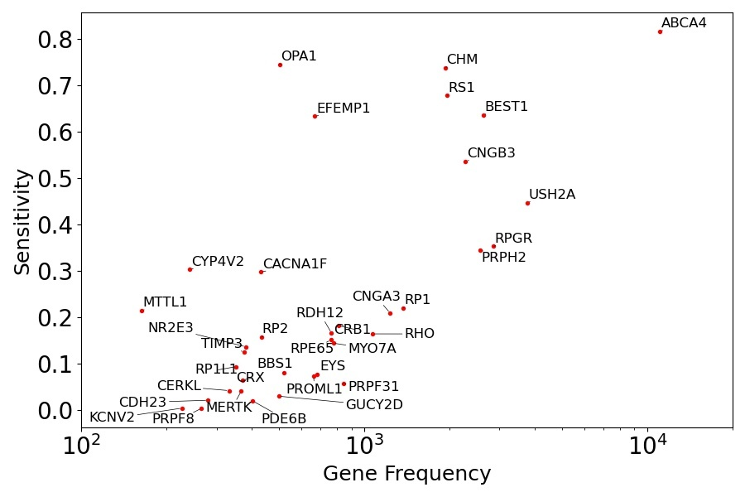
Supplementary Figure 5: Sensitivity of Eye2Gene per gene compared to number of images (log scale) in the training data.

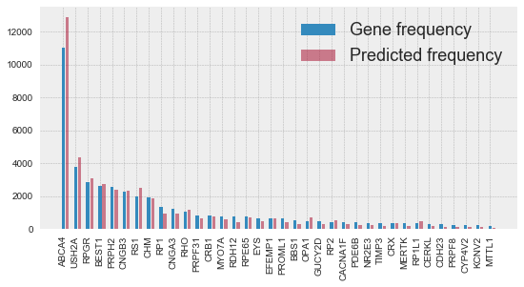
Supplementary Figure 6: Cumulative counts of images of a given gene versus total number of times Eye2Gene predicted that gene across all models on the five patient sets. Eye2Gene tends to overpredict the most common classes and underpredict the rarer ones in the presence of uncertainty.

Supplementary Table 2: Ethnicity coding of Moorfields Eye Hospital Inherited Retinal Disease cohort. 37% of patients do not disclose their ethnicity. A mix of different ethnic backgrounds is represented however certain ethnicities are under-represented. Since IRD gene distributions vary across different populations – mostly due to founder effects ^{2,30} – which is likely to impact the generalizability of Eye2Gene. Hence more data is needed to ensure Eye2Gene is assessed across different ethnicities, as well as across different types of patient populations.

Ethnicity | Percentage
Not stated | 37.00
British | 30.09
Any other ethnic group | 8.20
Unknown | 7.51
Any other White background | 4.65
Indian | 3.41
Pakistani | 1.84
Any other Asian background | 1.57
African | 1.29
Bangladeshi | 1.01
Caribbean | 0.97
Irish | 0.78
Any other mixed background | 0.55
White and Asian | 0.37
Any other Black background | 0.32
Chinese | 0.18
White and Black Caribbean | 0.14
White and Black African | 0.09

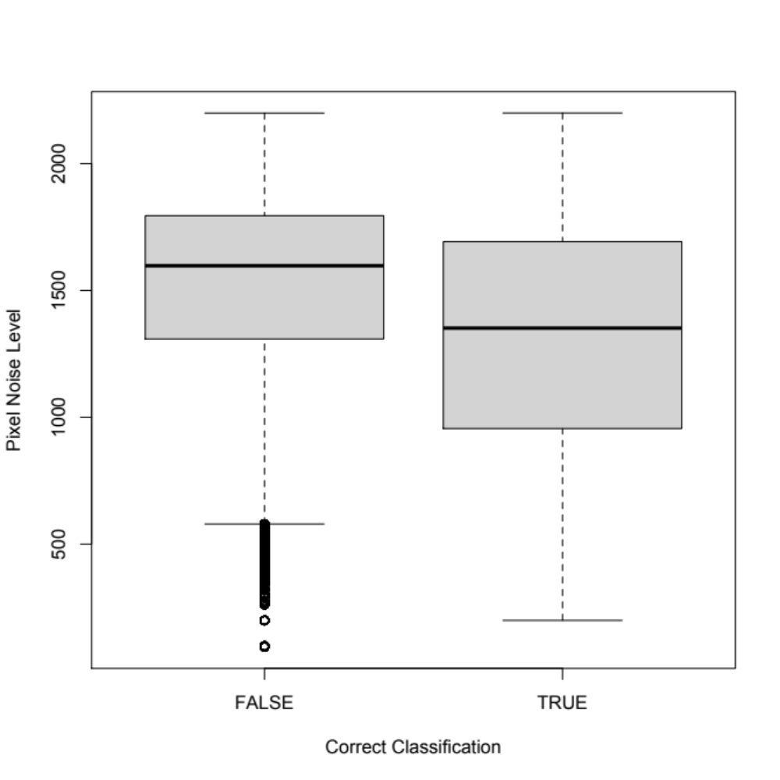
Supplementary Figure 7: Pixel noise level of retinal scans which are correctly and incorrectly classified. Level of noise is significantly higher in incorrectly classified scans.

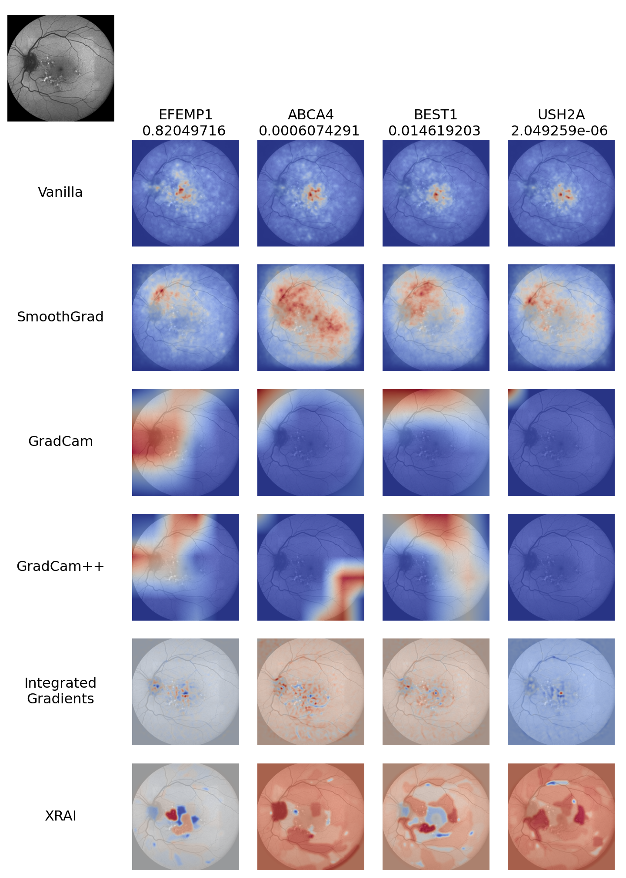
Supplementary Figure 8: Example of applying six different saliency-mapping techniques to an Eye2Gene prediction of a correctly classified EFEMP1-retinopathy retinal scan.

Supplementary Note 1 - Dataset Quality Control and Preparation
Images were divided by modality, with 51,376 blue fundus auto-fluorescence images (FAF), 43,746 infra-red images (IR), and 1,095,082 SD-OCT images (leaving 5,834 images of other modalities). Since SD-OCT produces multiple B-scans, for each B-scan only the image corresponding to the central B-scan that traverses the fovea was used, as it is likely to be the most informative B-scan. Following this, 33,849 OCT B-scans remained.
For all three modalities, we applied the filtering as shown in Supplementary Figure 9. Any corrupted images, and any images in sizes other than 768x768 pixels (for the FAF and IR images) or 512x496 (for the OCT images) were discarded. Both the IR and FAF scans featured two different imaging magnification levels, 30 degrees, and 55 degrees. In each case, only the most common mode (55 degrees for FAF, and 30 degrees for IR) was kept, and all other images were discarded. These two modes were distinguished automatically by checking the number of black background pixels (RGB 0,0,0), where a total of 107,577 black pixels was found to correspond to 55 degrees images.
To remove low-quality and defective images, a number of quantitative filters were applied. The types of filters were determined by initial inspection of the data to identify any issues. Thresholds for these filters were set by examining a sample of images rejected by the filter and adjusting the threshold until over 25% of rejected images were judged to be of a reasonable quality level. In particular, FAF and IR datasets both contained a number of excessively dark images. As such, images with a median pixel intensity below 0.05 for FAF, and 0.1 for IR, were rejected. Additionally, many FAF images featured a large amount of noise. To measure this noise level, we developed a ‘Pixel Noise Level’ score where the original image was compared to a blurred version (using a normalized box filter with a 5x5 kernel) of the same image, taking the sum of the squared difference between the two images. FAF images with a total squared difference of over 2200 were rejected. Many OCT images contained artifacts consisting of large regions with a pixel value of 1.0 (i.e. the maximum). To remove these, any images with a maximum pixel value of 1.0, and also with median intensity greater than 0.2 were rejected. Finally, a BRISQUE score ^{31,32} (a common referenceless image quality metric) was computed for each image, using the PyBRISQUE library, and images above a certain threshold were discarded. This threshold was set at 120 for FAF images, 80 for IR images, and 150 for OCT images.
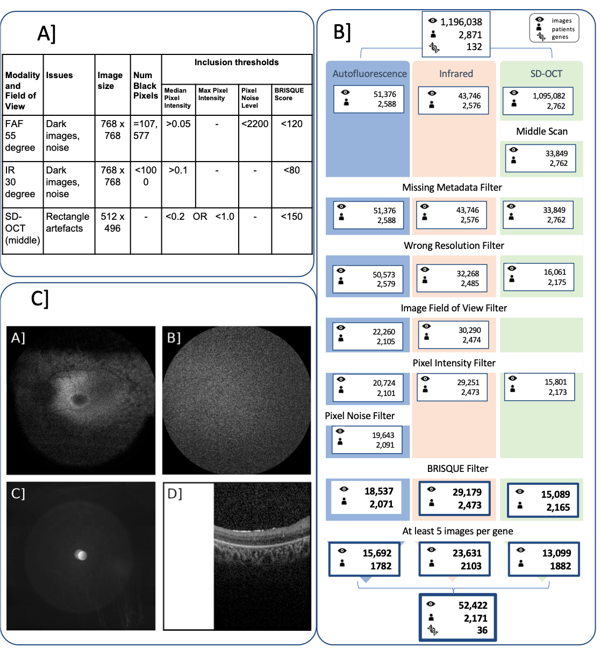
Supplementary Figure 9: A] Quality control steps and inclusion thresholds applied for the three imaging modalities: Fundus Autofluorescence (FAF), Infrared (IR) and Spectral Domain Optical Coherence Tomography (SD-OCT). B] Quality control filtering process on the entire MEH dataset. The missing metadata filter removes scans for which no patient identifier, patient age or gene diagnosis could be found (data that could not be linked). The wrong resolution filter removes scans that do not match the resolution of 768 by 768 pixels for FAF and IR scans or 512 by 496 for SD-OCT b-scans. The image zoom filter removes scans that are not 55 degree scans for FAF or 30 degree for IR. The pixel intensity filter removes scans that have a median pixel intensity less than 0.05 for FAF, 0.1 for IR and 0.2 for SD-OCT. Finally the BRISQUE filter discards scans that have a score greater than 120 for FAF, 80 for IR and 150 for SD-OCT. Following QC, we restrict the dataset to only genes which had at least 5 images. As a result of this filtering, 15,692 FAF, 23,631 IR and 13,099 OCT scans remain in 36 most common genes. C] Examples of poor-quality images rejected by our filters: A.) FAF image which is too dark to make out any details, B.) FAF image with excessive amount of noise, C.) Infra-red image which is too dark to make out any details, D.) SD-OCT image with large artifact obscuring part of image.

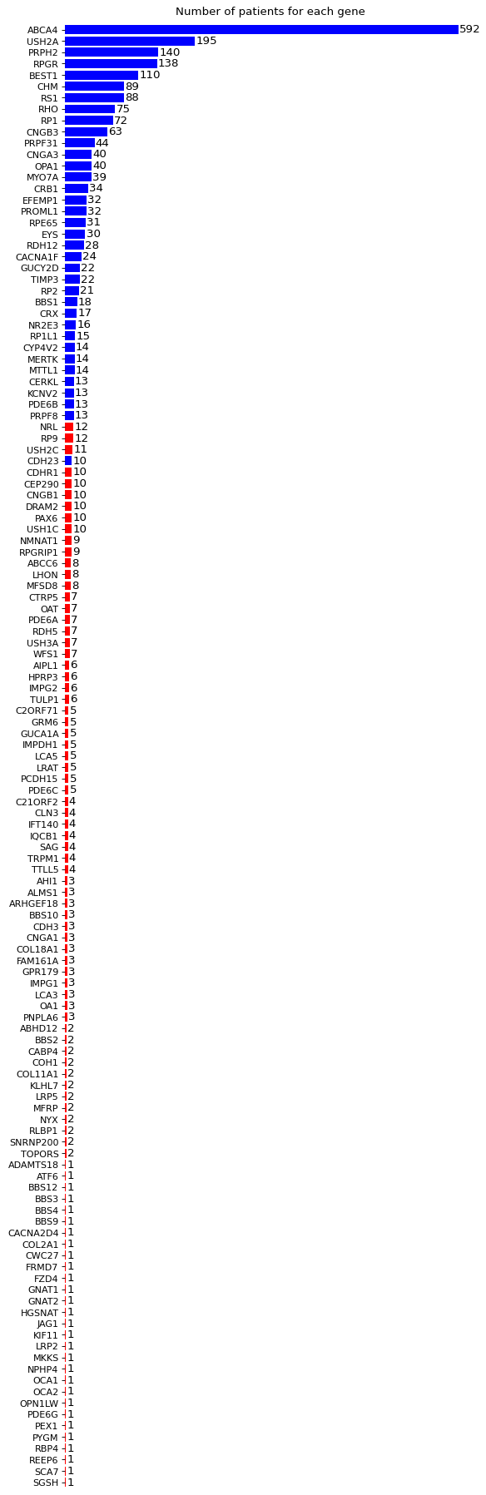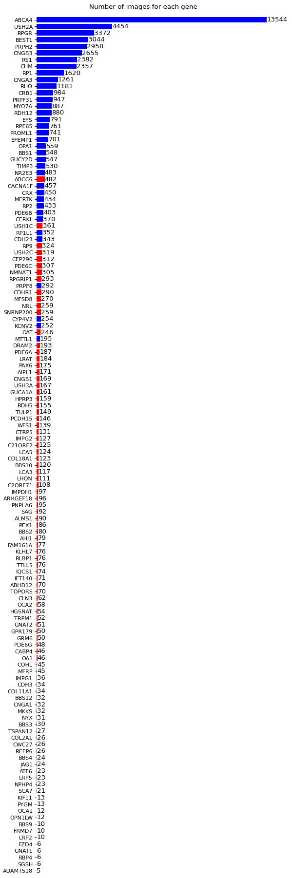
Supplementary Figure 10: Number of patients, and number of images per gene class for all 132 genes. Genes in red had insufficient numbers of patients with enough images to properly allocate at least 5 images to each fold and so were excluded from experiments. 45 genes had at least 10 patients, 58 genes had at least 5 patients.

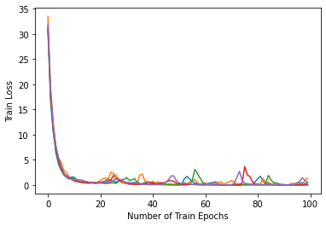
Supplementary Figure 11: Example network training loss curves. 100 epochs was found to be sufficient for training to converge for a wide variety of hyper-parameter settings in preliminary investigations.

Supplementary Table 3: Tested hyperparameter settings with selected values in bold, and highest results for each column highlighted. The hyperparameters used for Run 6 yielded the best results. To obtain values for the various hyper-parameters for training our network, for each of the three modalities we split the first dataset into further training and validation datasets according to a 75:25 split (giving an effective overall 60:20:20 train/validation/test split). Networks were trained on these new training sets using each of the 10 different random hyper-parameter settings, and train-accuracy and average per-gene AUC score on the validation set were recorded. We also tested drop-out in the penultimate layer of the network, with various drop probabilities. A dropout probability of 0% was found to work well across all three modalities, hence a dropout probability of 0% was used throughout experiments, meaning dropout was effectively absent from the final networks.
We note that, for cross-validation, in theory, hyperparameter tuning should be applied across each fold independently to avoid biasing to final test results. However, in practice, this significantly increases the compute requirements, while the benefits are likely to be imperceptible. Thus, the optimal hyperparameter settings from fold 1 are used for the training of the remaining folds as well. This effect only applies to results on our internal development set and does not affect any of the results on the internal or external test sets.

 | Learning Rate | Batch Size | Dropout | FAF Acc | FAF AUC | IR Acc | IR AUC | OCT Acc | OCT AUC
Run 1 | 0.0001 | 32 | 70% | 45.3% | 0.796 | 41.1% | 0.784 | 58.9% | 0.854
Run 2 | 0.00001 | 16 | 30% | 44.6% | 0.786 | 43.8% | 0.805 | 53.6% | 0.844
Run 3 | 0.0001 | 16 | 30% | 43.3% | 0.810 | 43.4% | 0.805 | 54.9% | 0.860
Run 4 | 0.0001 | 16 | 70% | 39.8% | 0.766 | 43.0% | 0.771 | 51.5% | 0.855
Run 5 | 0.000025 | 8 | 70% | 44.2% | 0.792 | 44.7% | 0.774 | 55.1% | 0.838
Run 6 | 0.0001 | 128 | 0% | 49.2% | 0.820 | 46.7% | 0.826 | 57.4% | 0.866
Run 7 | 0.000025 | 128 | 70% | 45.4% | 0.798 | 42.9% | 0.785 | 57.2% | 0.840
Run 8 | 0.00001 | 128 | 0% | 43.6% | 0.798 | 42.7% | 0.782 | 48.6% | 0.810
Run 9 | 0.000025 | 8 | 0% | 45.3% | 0.774 | 43.0% | 0.794 | 54.4% | 0.851
Run 10 | 0.0001 | 16 | 0% | 47.0% | 0.827 | 43.0% | 0.796 | 54.3% | 0.857

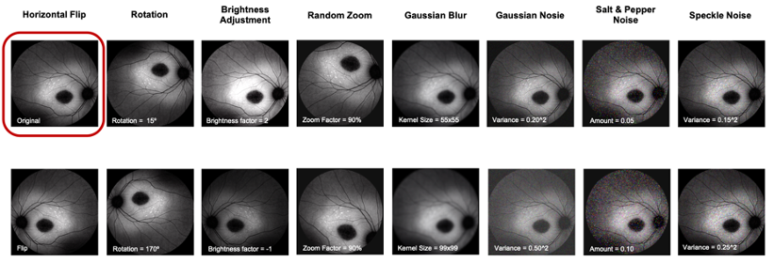
Supplementary Figure 12: Data augmentation transformations applied to the training set. Data augmentation techniques were applied to the training data which were felt to be realistic transformations of the data. These included random brightness adjustment, horizontal flip for all three modalities and rotations by up to 15 degrees.

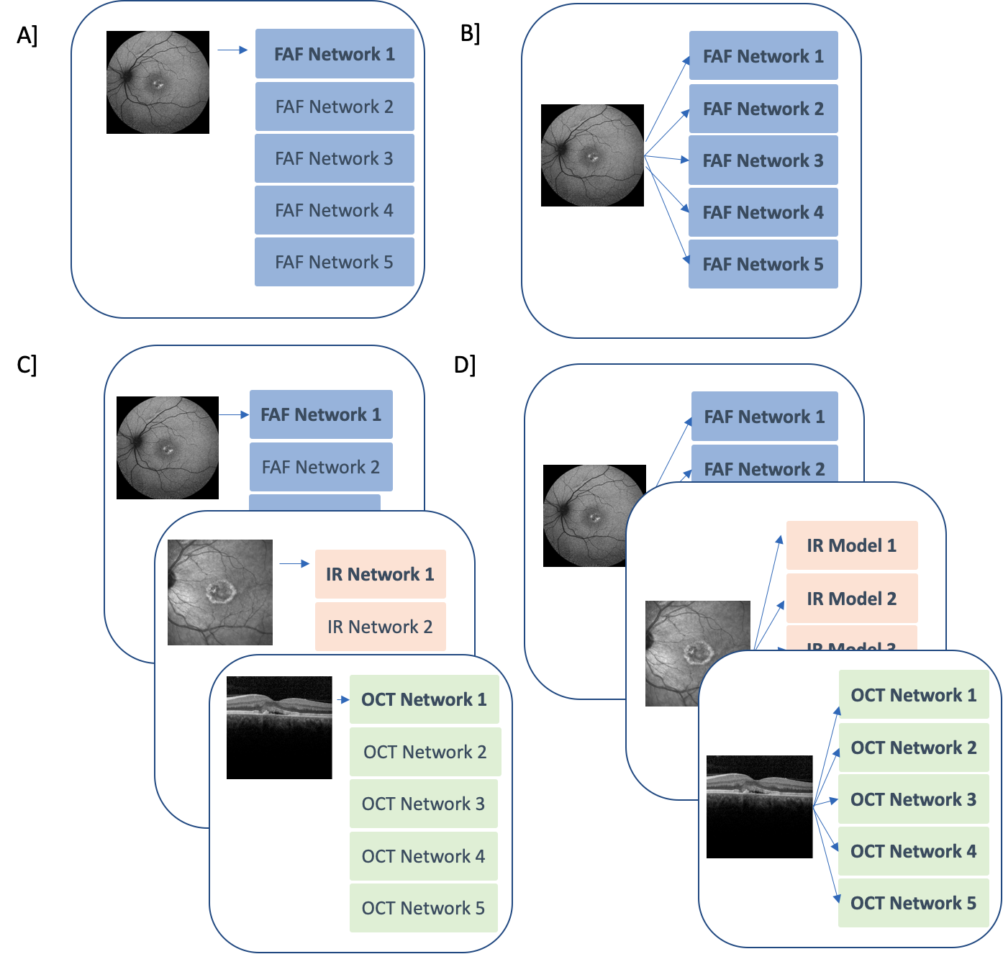
Supplementary Figure 13: The four types of models benchmarked for Eye2Gene. A] The single-image model takes a single image from one eye as input and outputs a single classification probability from a single network. B] The single-image ensemble model (five networks for each modality) takes a single image from one eye as input and outputs classification probabilities from each of the five networks in the ensemble, which are combined into a single classification probability. C] The multi-image model (of a single network for each modality) takes multiple images of different modalities (i.e. FAF, OCT and IR) as input and outputs a classification probability for each image, which are combined into a single classification probability for the patient. D] The multi-image ensemble (of five networks for each modality) takes multiple images of different modalities (i.e. FAF, OCT and IR) as input and output classification probabilities from each of the five networks for each image, which are combined into a single classification probability for the patient.

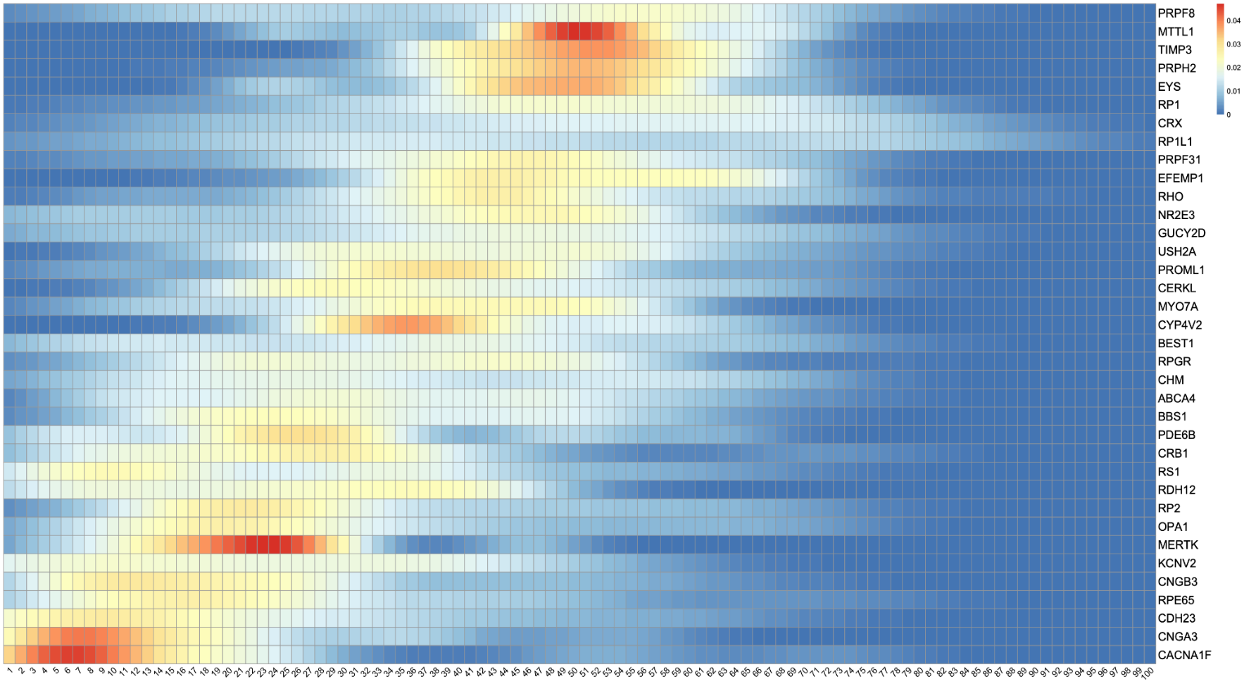
Supplementary Figure 14: Distribution of age at earliest presentation per genetic diagnosis.

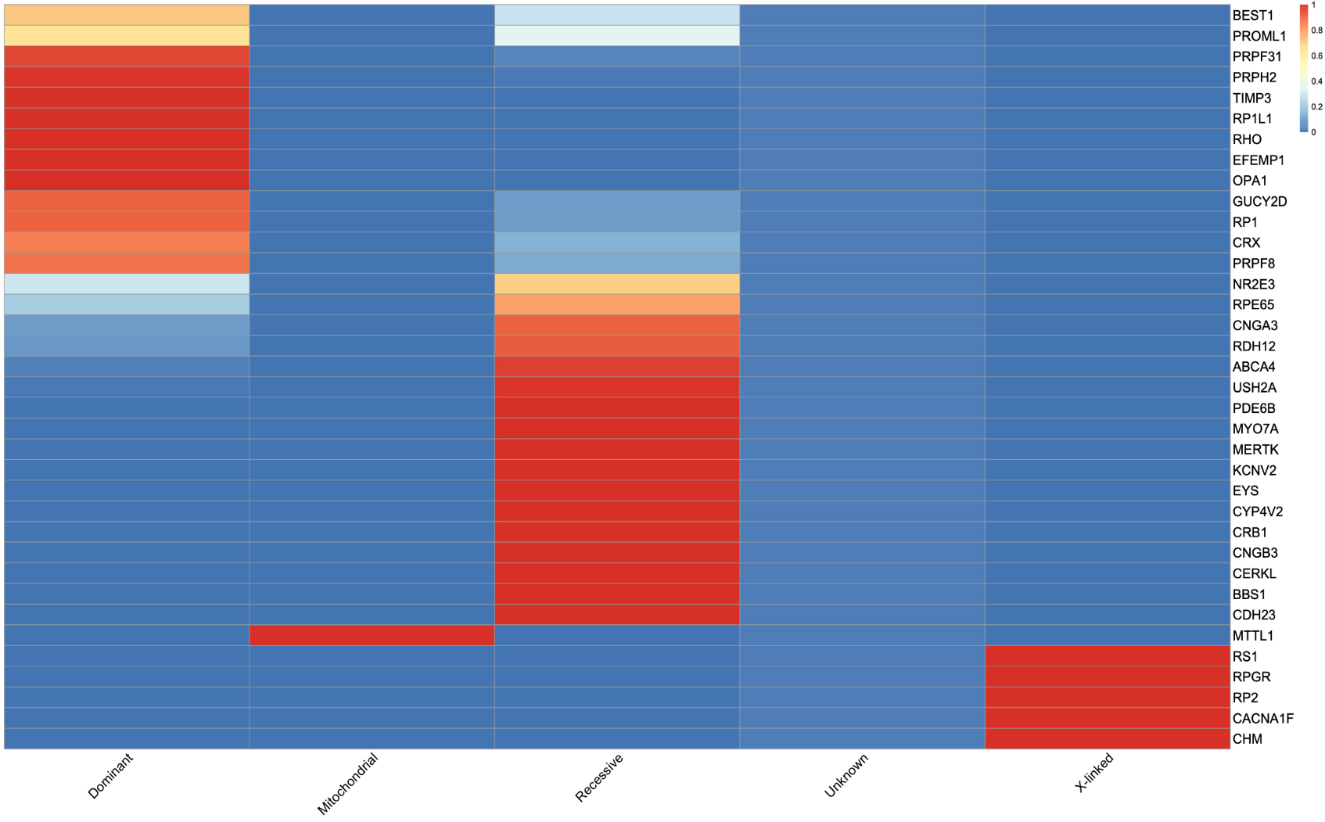
Supplementary Figure 15: Known mode of inheritance per gene. Some genes such as BEST1 and PROML1 can be either dominant or recessive.

Supplementary Note 2 - Evaluation and Results

Results from cross-validation experiments
The constituent neural networks of Eye2Gene were trained via a five-fold cross-validation approach where each individual network was trained on a distinct subset of training data (Supplementary Figure 2).
Based on these results, for the networks trained on FAF images, with cross-validation, we observed an average top-1 accuracy across networks of 44.3% (CI_{95%}= 42.5-46.2), top-5 accuracy of 72.7% (71.0-74.4), and average per-gene ROC AUC of 0.827 (0.812-0.842). For the networks trained on IR images, we observed an accuracy of 45.8% (43.6-47.9), top-5 accuracy of 73.7% (72.2-75.2), and AUC of 0.834 (0.824-0.844). Finally, for the networks trained on SD-OCT images, we observed an accuracy of 51.6% (48.4-54.9), top-5 accuracy of 77.4% (75.2-79.6), and AUC of 0.845 (0.831-0.859) (Supplementary Tables 4-5 left). The confusion matrix from the cross-validation is presented in Supplementary Figure 16. The results on the held-out patient set were similar with a mean accuracy across models of 51.4% for FAF, 46.9% for IR, and 56.3% for SD-OCT models (Supplementary Tables 4-5 right).
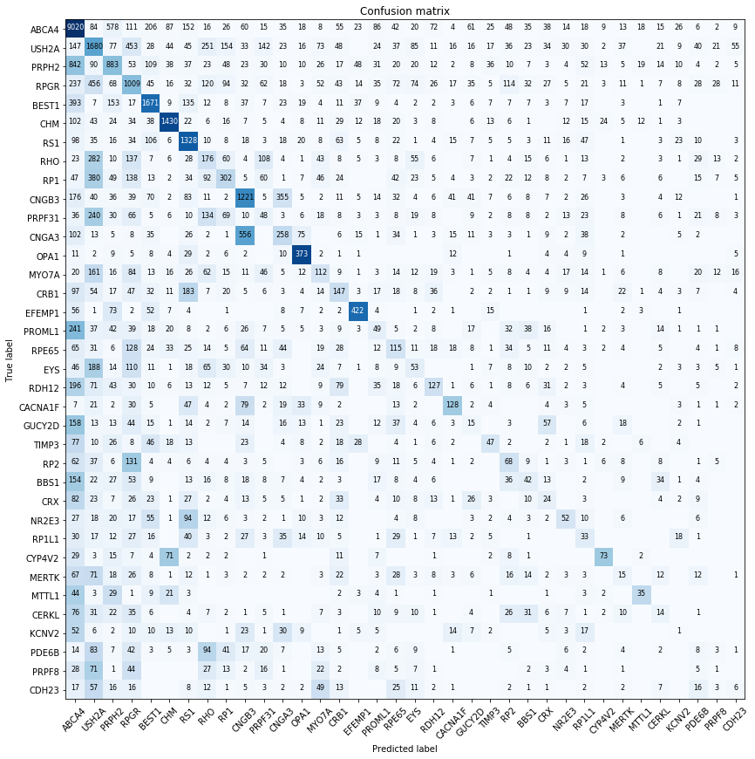
Supplementary Figure 16: Aggregated confusion matrix for single-image gene classification across all individual networks on their respective test folds, ordered by frequency of gene. Intensity of a given cell denotes the normalized count after adjusting for gene frequencies by dividing by the frequency of the true class.

Ensembling improves accuracy both across models and across modalities
For convenience, all predictions were compiled into a single CSV file along with additional data about each image (such as patient ID, gene, appointment date) and the ID of the model used to generate the prediction (available on request).
Eye2Gene combines predictions across multiple models (ensembling) and across multiple images acquired during one or more patient visits. We found both of these contributed to the performance of Eye2Gene.
For applying ensembling of the five models per modality to the individual images we observed accuracies of 59.2% / 55.3% / 61.5% for FAF/IR/OCT, top-5 accuracies of 81.3% / 80.8% / 82.9%, and AUCs of 0.881 / 0.885 / 0.911 (Supplementary Table 4).
For combining individual model predictions across multiple images (without ensembling the 5 models per modality) at the per-visit level. On the held-out test set, we saw an overall mean accuracy across models of 62.8%, top-5 accuracy of 84.6%, and mean AUC of 0.914 (Supplementary Table 5). We also found that combining all images across all three modalities outperformed the best performing modality (i.e. restricting to images of that modality only) on the majority of genes, based on the per-gene ROC AUC (Supplementary Figure 17), demonstrating the advantage of the multi-modality approach.
In both cases these were superior to the single-network results, but inferior to the overall Eye2Gene model, suggesting that both employing ensembling across networks at a per-image level and combining predictions across multiple images, was advantageous (Supplementary Table 6).

Supplementary Table 4: Full single-image results. Individual network test results on both the cross-validation fold (different for each network) and the held-out patient set, including the average across all networks for each modality (AVR). Quantities given are the top-1, -2, -3, -5, and top-10 accuracy, and average per gene AUC.
Dataset | Cross validation |  |  |  |  |  | Internal held-out test dataset
Fold | 1 | 2 | 3 | 4 | 5
Fundus Auto-Fluorescence (FAF)
Networks | FAF 1 | FAF 2 | FAF 3 | FAF 4 | FAF 5 | Mean | FAF 1 | FAF 2 | FAF 3 | FAF 4 | FAF 5 | Mean | Ensemble
Acc | 46.8% | 46.5% | 41.5% | 42.6% | 44.1% | 44.3% | 52.1% | 55.8% | 47.7% | 52.6% | 48.6% | 51.4% | 59.2%
Top-2 | 59.7% | 57.7% | 57.1% | 54.0% | 56.5% | 57.0% | 65.4% | 67.5% | 61.9% | 64.5% | 60.1% | 63.9% | 69.2%
Top-3 | 66.8% | 64.7% | 63.3% | 60.8% | 64.2% | 63.9% | 71.7% | 74.0% | 67.%2 | 70.2% | 67.6% | 70.9% | 74.5%
Top-5 | 76.0% | 73.3% | 71.3% | 70.2% | 72.7% | 72.7% | 78.9% | 82.1% | 75.1% | 77.3% | 75.5% | 77.8% | 81.3%
Top-10 | 86.6% | 84.1% | 82.2% | 83.1% | 84.7% | 84.1% | 87.7% | 89.7% | 85.4% | 87.5% | 85.2% | 87.1% | 90.2%
AUC | 0.832 | 0.859 | 0.820 | 0.808 | 0.822 | 0.823 | 0.836 | 0.863 | 0.805 | 0.844 | 0.826 | 0.835 | 0.881
Infrared (IR)
Networks | IR 1 | IR 2 | IR 3 | IR 4 | IR 5 | Mean | IR 1 | IR 2 | IR 3 | IR 4 | IR 5 | Mean | Ensemble
Acc | 43.0% | 43.2% | 47.8% | 49.2% | 45.6% | 45.8% | 37.9% | 46.9% | 48.9% | 51.8% | 49.0% | 46.9% | 55.3%
Top-2 | 56.6% | 55.6% | 61.5% | 61.9% | 59.5% | 59.1% | 51.0% | 59.5% | 62.7% | 62.2% | 60.7% | 59.2% | 64.4%
Top-3 | 64.1% | 62.5% | 68.2% | 68.1% | 66.2% | 65.9% | 59.5% | 67.%1 | 69.8% | 69.1% | 68.7% | 66.8% | 71.2%
Top-5 | 72.6% | 70.8% | 75.4% | 75.2% | 74.4% | 73.8% | 71.6% | 76.8% | 79.7% | 77.6% | 77.5% | 76.6% | 80.8%
Top-10 | 84.0% | 81.6% | 84.1% | 84.3% | 83.9% | 83.6% | 86.2% | 87.9% | 89.9% | 87.9% | 86.9% | 87.8% | 91.2%
AUC | 0.815 | 0.827 | 0.838 | 0.843 | 0.847 | 0.827 | 0.823 | 0.844 | 0.856 | 0.849 | 0.841 | 0.843 | 0.885
Spectral Domain Optical Coherence Tomography (SD-OCT)
Networks | OCT 1 | OCT 2 | OCT 3 | OCT 4 | OCT 5 | Mean | OCT 1 | OCT 2 | OCT 3 | OCT 4 | OCT 5 | Mean | Ensemble
Acc | 54.6% | 51.5% | 44.5% | 52.9% | 54.6% | 51.6% | 57.6% | 56.1% | 53.0% | 55.6% | 59.0% | 56.3% | 61.5%
Top-2 | 64.8% | 64.1% | 57.3% | 66.1% | 66.6% | 63.8% | 68.1% | 67.1% | 63.8% | 68.3% | 69.3% | 67.3% | 71.0%
Top-3 | 70.6% | 70.8% | 64.5% | 71.6% | 73.7% | 70.3% | 74.1% | 73.6% | 69.4% | 74.4% | 75.1% | 73.3% | 76.8%
Top-5 | 77.3% | 77.4% | 72.8% | 79.2% | 80.2% | 77.4% | 81.2% | 80.1% | 77.%0 | 80.%5 | 83.0% | 81.4% | 82.9%
Top-10 | 86.8% | 86.7% | 84.5% | 87.6% | 88.8% | 86.9% | 90.9% | 89.0% | 86.5% | 89.6% | 90.7% | 89.3% | 91.9%
AUC | 0.850 | 0.841 | 0.820 | 0.843 | 0.870 | 0.841 | 0.875 | 0.884 | 0.854 | 0.879 | 0.890 | 0.876 | 0.911

Supplementary Table 5: Full multi-image/modality test results for combining network predictions across all images from a given appointment, and all images for a given patient, on both the cross-validation fold (different for each network) and the held-out patient set, including the average across all models. Quantities given are the top-1, -2, -3, -5, and top-10 accuracy, and average per gene AUC. F=Fundus Auto-Fluorescence, I=Infrared, O=OCT
Dataset | Cross validation |  |  |  |  |  | Moorfields internal held-out test dataset
Fold | 1 | 2 | 3 | 4 | 5 | -
All images from first patient-visit
Multimodal model | F+I+O 1 | F+I+O 2 | F+I+O 3 | F+I+O 4 | F+I+O 5 | Mean | F+I+O 1 | F+I+O 2 | F+I+O 3 | F+I+O 4 | F+I+O 5 | Mean | Ensemble
Acc | 55.6% | 55.4% | 56.0% | 59.4% | 57.0% | 56.7% | 60.2% | 62.1% | 63.6% | 63.6% | 64.8% | 62.9% | 66.7%
Top-2 | 68.3% | 63.9% | 65.5% | 67.4% | 70.4% | 67.1% | 70.5% | 72.7% | 70.5% | 72.0% | 72.7% | 71.7% | 75.4%
Top-3 | 74.4% | 70.4% | 70.6% | 70.7% | 76.5% | 72.5% | 75.0% | 77.3% | 75.8% | 76.5% | 77.7% | 78.5% | 80.7%
Top-5 | 81.1% | 79.7% | 76.5% | 78.7% | 82.5% | 79.7% | 80.7% | 84.1% | 82.6% | 82.2% | 84.8% | 82.9% | 85.6%
Top-10 | 90.6% | 88.0% | 87.5% | 90.1% | 89.4% | 89.1% | 92.0% | 91.3% | 92.0% | 90.5% | 90.9% | 91.3% | 94.7%
AUC | 0.874 | 0.857 | 0.882 | 0.860 | 0.869 | 0.868 | 0.895 | 0.920 | 0.907 | 0.917 | 0.920 | 0.912 | 0.935
All images per patient-visit
Multimodal model | F+I+O 1 | F+I+O 2 | F+I+O 3 | F+I+O 4 | F+I+O 5 | Mean | F+I+O 1 | F+I+O 2 | F+I+O 3 | F+I+O 4 | F+I+O 5 | Mean | Ensemble
Acc | 57.6% | 57.1% | 55.9% | 57.4% | 56.6% | 56.9% | 60.9% | 63.4% | 63.2% | 63.4% | 63.2% | 62.8% | 68.1%
Top-2 | 68.0% | 66.1% | 67.4% | 67.7% | 69.5% | 67.7% | 70.9% | 74.3% | 71.1% | 71.9% | 73.1% | 72.3% | 78.9%
Top-3 | 72.7% | 71.3% | 72.1% | 73.0% | 75.6% | 73.0% | 76.1% | 79.5% | 76.6% | 77.6% | 79.0% | 77.8% | 82.1%
Top-5 | 79.3% | 79.8% | 78.6% | 79.8% | 82.2% | 79.9% | 83.4% | 85.3% | 83.8% | 85.0% | 85.7% | 84.6% | 88.1%
Top-10 | 88.7% | 88.9% | 87.1% | 88.9% | 90.2% | 88.8% | 91.4% | 91.9% | 91.8% | 92.4% | 92.9% | 92.1% | 94.2%
AUC | 0.872 | 0.881 | 0.877 | 0.884 | 0.885 | 0.876 | 0.902 | 0.921 | 0.907 | 0.917 | 0.923 | 0.914 | 0.937
All images per patient
Multimodal  model | F+I+O 1 | F+I+O 2 | F+I+O 3 | F+I+O 4 | F+I+O 5 | Mean | F+I+O 1 | F+I+O 2 | F+I+O 3 | F+I+O 4 | F+I+O 5 | Mean | Ensemble
Acc | 59.2% | 57.1% | 59.3% | 60.5% | 59.0% | 59.0% | 62.9% | 67.0% | 64.0% | 67.4% | 63.3% | 64.9% | 66.7%
Top-2 | 71.9% | 67.2% | 69.6% | 69.1% | 73.2% | 70.2% | 72.7% | 75.4% | 73.9% | 73.5% | 75.0% | 74.1% | 78.4%
Top-3 | 76.9% | 71.2% | 73.1% | 73.2% | 78.0% | 74.5% | 79.5% | 81.8% | 79.2% | 80.7% | 80.3% | 80.3% | 83.3%
Top-5 | 83.3% | 80.2% | 78.3% | 80.7% | 84.1% | 81.3% | 84.5% | 87.5% | 85.2% | 87.5% | 87.9% | 86.5% | 89.4%
Top-10 | 91.4% | 90.0% | 87.7% | 90.1% | 91.1% | 90.0% | 92.4% | 94.3% | 93.6% | 93.9% | 94.7% | 93.8% | 95.1%
AUC | 0.894 | 0.893 | 0.886 | 0.886 | 0.899 | 0.881 | 0.922 | 0.932 | 0.916 | 0.927 | 0.940 | 0.927 | 0.950

Supplementary Table 6: Overview of test accuracies on held-out patient sets using different methods of combining model predictions. Per visit means all eye scans for each patient visit. Per patient means all eye scans across multiple patient visits.
 |  | Single scan |  |  |  | Multiple scans/modalities
 |  | FAF | IR | SD-OCT |  | First Visit Only | Per Visit | Per Patient
Single model average | Acc | 51.4% | 46.9% | 56.3% |  | 62.9% | 62.8% | 64.9%
Single model average | Top-2 | 63.9% | 59.2% | 67.3% |  | 71.7% | 72.3% | 74.1%
Single model average | Top-3 | 70.9% | 66.8% | 73.3% |  | 78.5% | 77.8% | 80.3%
Single model average | Top-5 | 77.8% | 76.6% | 81.4% |  | 82.9% | 84.6% | 86.5%
Single model average | Top-10 | 87.1% | 87.8% | 89.3% |  | 91.3% | 92.1% | 93.8%
Single model average | Mean AUC | 0.835 | 0.843 | 0.876 |  | 0.912 | 0.914 | 0.927
5-model Ensemble | Acc | 59.2% | 55.3% | 61.5% |  | 66.7% | 68.1% | 66.7%
5-model Ensemble | Top-2 | 69.2% | 64.4% | 72.0% |  | 75.4% | 76.8% | 78.4%
5-model Ensemble | Top-3 | 74.5% | 71.2% | 76.8% |  | 80.7% | 82.1% | 83.3%
5-model Ensemble | Top-5 | 81.3% | 80.8% | 82.9% |  | 85.6% | 88.1% | 89.4%
5-model Ensemble | Top-10 | 90.2% | 91.2% | 91.9% |  | 94.7% | 94.2% | 95.1%
5-model Ensemble | Mean AUC | 0.881 | 0.885 | 0.911 |  | 0.935 | 0.937 | 0.950

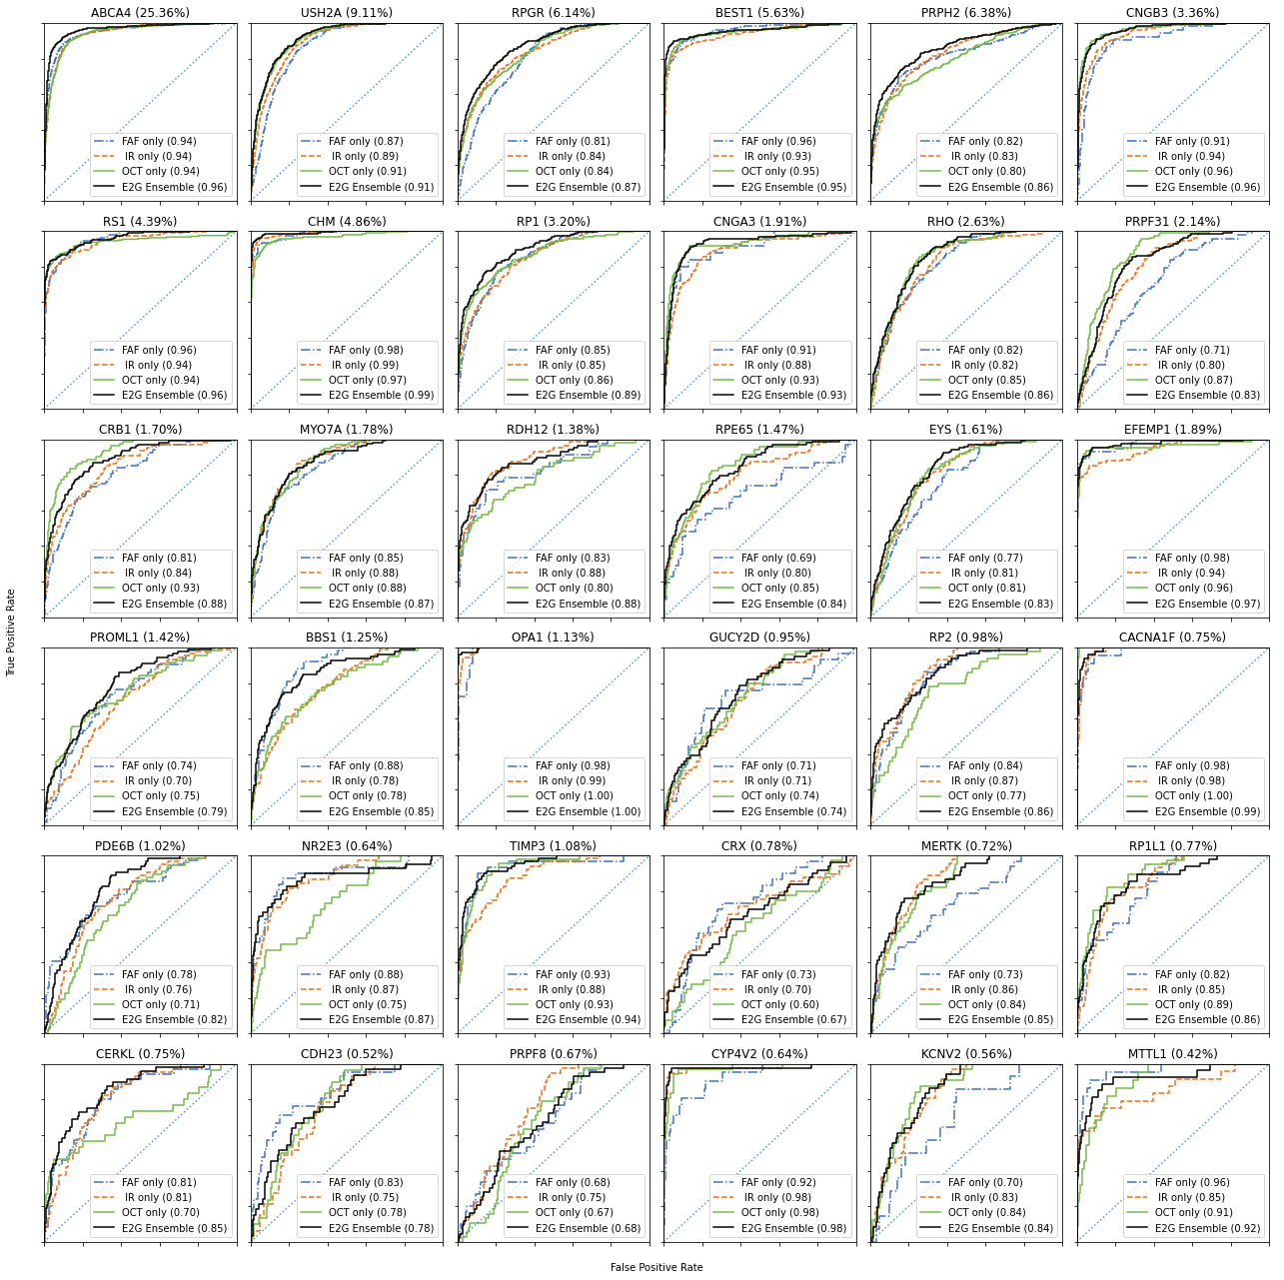
Supplementary Figure 17: Per-gene Receiver Operating Characteristic (ROC) curves from cross-validation data for the combined prediction on all images from a given patient appointment, overlaid on the multi-image ROC curves when restricted to only images of a given modality. Percentages next to gene names denote the percentage of total appointments corresponding to the given gene. ROC curves are ordered by the percentages of total appointments.

Eye2Gene’s predictions are well calibrated
While Eye2Gene outputs predictions in terms of probabilities for each gene, for any given image each underlying network typically predicts confidently for a single gene class, making it difficult to ascertain model confidence from the outputs of any single network alone.
However, we found that, when the constituent network predictions were combined in the Eye2Gene ensemble, other than a consistent over-prediction by 10%, the output predictions appeared relatively well-calibrated, e.g. if Eye2Gene predicted a given gene with 70% probability, that prediction was correct approximately 60% of the time, as shown in Supplementary Figure 18. This is useful for providing accurate and informative feedback to the end user as to the confidence of the model. We use this in the Eye2Gene web-app to identify unclear input scans which may benefit from being retaken, which we do by flagging the individual images below a certain confidence threshold when passed through the model.

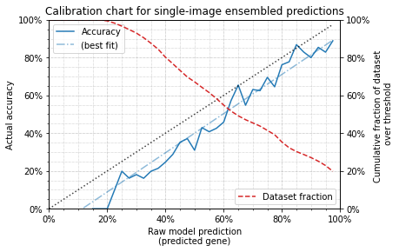
Supplementary Figure 18: Actual accuracy compared to model confidence for Eye2Gene ensemble on individual images, along with line of best fit (slope=1.04, intercept=-11.2%). The ensemble prediction is slightly overconfident compared to a ‘well-calibrated’ 1:1 correspondence with actual accuracy (shown by dotted line). The total proportion of the dataset above each confidence threshold is also shown (dashed line).

Supplementary Table 7: Detailed overview of the test dataset for Eye2Gene. P=patients; FAF=fundus autofluorescence; IR=infrared; OCT=optical coherence tomography;
 | Bonn |  |  |  | Liverpool |  |  |  | Moorfields |  |  |  | Oxford |  |  |  | São Paulo
Gene | P | FAF | IR | OCT | P | FAF | IR | OCT | P | FAF | IR | OCT | P | FAF | IR | OCT | P | FAF | IR | OCT
ABCA4 | 39 | 76 | 0 | 70 | 6 | 12 | 12 | 12 | 80 | 268 | 198 | 133 | 7 | 20 | 16 | 16 | 7 | 14 | 10 | 24
BBS1 | 0 | 0 | 0 | 0 | 1 | 2 | 2 | 2 | 1 | 4 | 2 | 1 | 1 | 2 | 2 | 2 | 0 | 0 | 0 | 0
BEST1 | 16 | 30 | 0 | 24 | 0 | 0 | 0 | 0 | 13 | 36 | 33 | 23 | 7 | 10 | 14 | 14 | 0 | 0 | 0 | 0
CACNA1F | 0 | 0 | 0 | 0 | 0 | 0 | 0 | 0 | 2 | 13 | 4 | 4 | 1 | 0 | 2 | 2 | 0 | 0 | 0 | 0
CDH23 | 0 | 0 | 0 | 0 | 1 | 2 | 2 | 2 | 2 | 20 | 4 | 4 | 1 | 2 | 2 | 2 | 0 | 0 | 0 | 0
CERKL | 0 | 0 | 0 | 0 | 0 | 0 | 0 | 0 | 2 | 2 | 4 | 4 | 1 | 2 | 2 | 2 | 0 | 0 | 0 | 0
CHM | 0 | 0 | 0 | 0 | 0 | 0 | 0 | 0 | 15 | 57 | 30 | 24 | 6 | 10 | 12 | 12 | 7 | 0 | 24 | 24
CNGA3 | 0 | 0 | 0 | 0 | 0 | 0 | 0 | 0 | 1 | 0 | 4 | 2 | 0 | 0 | 0 | 0 | 0 | 0 | 0 | 0
CNGB3 | 1 | 2 | 0 | 2 | 0 | 0 | 0 | 0 | 6 | 9 | 26 | 15 | 1 | 2 | 2 | 2 | 0 | 0 | 0 | 0
CRB1 | 4 | 5 | 0 | 7 | 2 | 4 | 4 | 4 | 5 | 9 | 10 | 10 | 1 | 2 | 2 | 2 | 0 | 0 | 0 | 0
CRX | 0 | 0 | 0 | 0 | 0 | 0 | 0 | 0 | 2 | 4 | 4 | 4 | 1 | 2 | 2 | 2 | 0 | 0 | 0 | 0
CYP4V2 | 0 | 0 | 0 | 0 | 0 | 0 | 0 | 0 | 1 | 0 | 3 | 2 | 0 | 0 | 0 | 0 | 0 | 0 | 0 | 0
EFEMP1 | 0 | 0 | 0 | 0 | 1 | 2 | 2 | 2 | 1 | 0 | 2 | 2 | 1 | 0 | 2 | 2 | 0 | 0 | 0 | 0
EYS | 3 | 6 | 0 | 6 | 1 | 2 | 2 | 2 | 4 | 18 | 16 | 7 | 1 | 2 | 2 | 2 | 0 | 0 | 0 | 0
GUCY2D | 0 | 0 | 0 | 0 | 1 | 2 | 2 | 2 | 3 | 5 | 6 | 5 | 1 | 2 | 2 | 2 | 0 | 0 | 0 | 0
KCNV2 | 0 | 0 | 0 | 0 | 0 | 0 | 0 | 0 | 2 | 3 | 6 | 4 | 0 | 0 | 0 | 0 | 0 | 0 | 0 | 0
MERTK | 0 | 0 | 0 | 0 | 0 | 0 | 0 | 0 | 2 | 12 | 3 | 3 | 1 | 2 | 2 | 2 | 0 | 0 | 0 | 0
MTTL1 | 0 | 0 | 0 | 0 | 0 | 0 | 0 | 0 | 3 | 4 | 6 | 6 | 0 | 0 | 0 | 0 | 0 | 0 | 0 | 0
MYO7A | 2 | 4 | 0 | 4 | 0 | 0 | 0 | 0 | 5 | 11 | 13 | 10 | 0 | 0 | 0 | 0 | 0 | 0 | 0 | 0
 | Bonn |  |  |  | Liverpool |  |  |  | Moorfields |  |  |  | Oxford |  |  |  | São Paulo
Gene | P | AF | IR | OCT | P | FAF | IR | OCT | P | FAF | IR | OCT | P | FAF | IR | OCT | P | FAF | IR | OCT
NR2E3 | 0 | 0 | 0 | 0 | 1 | 2 | 2 | 2 | 3 | 8 | 4 | 2 | 1 | 2 | 2 | 2 | 0 | 0 | 0 | 0
OPA1 | 0 | 0 | 0 | 0 | 0 | 0 | 0 | 0 | 3 | 6 | 10 | 4 | 1 | 0 | 2 | 2 | 0 | 0 | 0 | 0
PDE6B | 0 | 0 | 0 | 0 | 0 | 0 | 0 | 0 | 0 | 0 | 0 | 0 | 1 | 2 | 2 | 2 | 0 | 0 | 0 | 0
PROM1 | 0 | 0 | 0 | 0 | 0 | 0 | 0 | 0 | 3 | 6 | 6 | 6 | 1 | 0 | 2 | 2 | 0 | 0 | 0 | 0
PRPF31 | 6 | 12 | 0 | 12 | 2 | 4 | 4 | 4 | 5 | 13 | 11 | 10 | 1 | 2 | 2 | 2 | 0 | 0 | 0 | 0
PRPF8 | 0 | 0 | 0 | 0 | 0 | 0 | 0 | 0 | 1 | 0 | 2 | 1 | 0 | 0 | 0 | 0 | 0 | 0 | 0 | 0
PRPH2 | 23 | 42 | 0 | 45 | 2 | 4 | 4 | 4 | 17 | 34 | 49 | 33 | 6 | 8 | 12 | 12 | 1 | 2 | 2 | 4
RDH12 | 0 | 0 | 0 | 0 | 0 | 0 | 0 | 0 | 3 | 2 | 5 | 5 | 1 | 2 | 2 | 2 | 0 | 0 | 0 | 0
RHO | 0 | 0 | 0 | 0 | 4 | 8 | 8 | 8 | 6 | 15 | 12 | 12 | 1 | 2 | 2 | 2 | 0 | 0 | 0 | 0
RP1 | 7 | 14 | 0 | 14 | 1 | 2 | 2 | 2 | 10 | 21 | 23 | 20 | 1 | 2 | 2 | 2 | 0 | 0 | 0 | 0
RP1L1 | 0 | 0 | 0 | 0 | 0 | 0 | 0 | 0 | 0 | 0 | 0 | 0 | 1 | 2 | 2 | 2 | 0 | 0 | 0 | 0
RP2 | 0 | 0 | 0 | 0 | 0 | 0 | 0 | 0 | 0 | 0 | 0 | 0 | 1 | 2 | 2 | 2 | 0 | 0 | 0 | 0
RPE65 | 0 | 0 | 0 | 0 | 0 | 0 | 0 | 0 | 0 | 0 | 0 | 0 | 1 | 2 | 2 | 2 | 0 | 0 | 0 | 0
RPGR | 0 | 0 | 0 | 0 | 2 | 4 | 4 | 4 | 17 | 55 | 69 | 36 | 5 | 10 | 10 | 10 | 0 | 0 | 0 | 0
RS1 | 6 | 12 | 0 | 10 | 5 | 10 | 10 | 10 | 11 | 31 | 30 | 21 | 1 | 2 | 2 | 2 | 0 | 0 | 0 | 0
TIMP3 | 0 | 0 | 0 | 0 | 0 | 0 | 0 | 0 | 5 | 7 | 14 | 8 | 0 | 0 | 0 | 0 | 0 | 0 | 0 | 0
USH2A | 20 | 38 | 0 | 38 | 5 | 10 | 10 | 10 | 30 | 60 | 83 | 54 | 5 | 10 | 10 | 10 | 0 | 0 | 0 | 0

Supplementary Table 8: Full results on external data sets. Individual network test results on the Bonn, Oxford, Liverpool and Sao Paulo external validation, including the average across all networks for each modality. Quantities given are the top-1, -2, -3, -5, and top-10 accuracy. M = Mean accuracy, E = Ensemble.
Dataset | Oxford External Test Dataset |  |  |  |  |  |  | Liverpool External Test Dataset |  |  |  |  |  |  | Bonn External Test Dataset |  |  |  |  |  |  | Sao Paulo External Test Dataset
Networks | 1 | 2 | 3 | 4 | 5 | M | E | 1 | 2 | 3 | 4 | 5 | M | E | 1 | 2 | 3 | 4 | 5 | M | E | 1 | 2 | 3 | 4 | 5 | M | E
Fundus Auto-Fluorescence (FAF)
Acc | 50.9 | 50.0 | 49.1 | 48.1 | 44.1 | 48.4 | 52.8 | 32.9 | 31.4 | 34.3 | 38.6 | 32.9 | 34.0 | 38.6 | 61.0 | 62.7 | 59.3 | 56.4 | 59.8 | 59.8 | 66.0 | 12.5 | 37.5 | 25.0 | 0.0% | 12.5 | 17.5 | 12.5
Top-2 | 68.9 | 62.3 | 57.5 | 68.9 | 56.6 | 62.8 | 69.8 | 50.0 | 40.0 | 51.4 | 48.6 | 42.9 | 46.6 | 54.3 | 74.3 | 76.8 | 70.5 | 69.3 | 73.0 | 72.8 | 79.7 | 25.0 | 43.8 | 37.5 | 43.8 | 50.0 | 40.0 | 56.2
Top-3 | 74.5 | 72.6 | 66.0 | 74.5 | 65.1 | 70.5 | 74.5 | 58.6 | 45.7 | 61.4 | 58.6 | 57.1 | 56.3 | 60.0 | 79.7 | 82.6 | 76.8 | 80.1 | 78.8 | 79.6 | 83.8 | 31.2 | 68.8 | 50.0 | 56.2 | 56.2 | 52.5 | 68.8
Top-5 | 81.1 | 80.2 | 79.2 | 81.1 | 73.6 | 79.0 | 81.1 | 67.1 | 64.3 | 71.4 | 71.4 | 64.3 | 67.7 | 68.6 | 88.0 | 87.1 | 83.0 | 87.1 | 86.3 | 86.3 | 89.2 | 68.8 | 68.8 | 56.2 | 75.% | 75.0 | 68.8 | 75.0
Top-10 | 88.7 | 85.8 | 88.7 | 88.7 | 87.7 | 87.9 | 89.6 | 78.6 | 78.6 | 81.4 | 88.6 | 74.3 | 80.3 | 81.4 | 92.1 | 94.2 | 90.9 | 94.2 | 94.6 | 93.2 | 95.4 | 87.5 | 81.2 | 87.5 | 87.5 | 93.8 | 87.5 | 87.5
Infrared (IR)
Acc | 43.3 | 48.3 | 49.2 | 48.3 | 46.7 | 47.2 | 54.2 | 40.0 | 40.0 | 37.1 | 34.3 | 41.4 | 38.6 | 50.0 | - | - | - | - | - | - | - | 66.7 | 61.1 | 77.8 | 77.8 | 80.6 | 72.8 | 80.6
Top-2 | 55.8 | 59.2 | 55.8 | 59.2 | 58.3 | 57.7 | 63.3 | 55.7 | 55.7 | 48.6 | 48.6 | 54.3 | 52.6 | 60.0 | - | - | - | - | - | - | - | 72.2 | 72.2 | 80.6 | 83.3 | 80.6 | 77.8 | 80.6
Top-3 | 61.7 | 67.5 | 61.7 | 67.5 | 66.7 | 65.0 | 68.3 | 65.7 | 62.9 | 54.3 | 57.1 | 67.1 | 61.4 | 70.0 | - | - | - | - | - | - | - | 83.3 | 80.6 | 83.3 | 86.1 | 83.3 | 83.3 | 83.3
Top-5 | 70.0 | 72.5 | 72.5 | 76.7 | 70.8 | 72.5 | 77.5 | 74.3 | 70.0 | 70.0 | 67.1 | 72.9 | 70.9 | 77.1 | - | - | - | - | - | - | - | 86.1 | 88.9 | 83.3 | 86.1 | 86.1 | 86.1 | 83.3
Top-10 | 82.5 | 85.8 | 82.5 | 83.3 | 85.8 | 84.0 | 85.0 | 85.7 | 81.4 | 90.0 | 85.7 | 85.7 | 85.7 | 84.3 | - | - | - | - | - | - | - | 91.7 | 91.7 | 94.4 | 91.7 | 94.4 | 92.8 | 91.7
Spectral Domain Optical Coherence Tomography (SD-OCT)
Acc | 34.2 | 30.0 | 22.5 | 40.0 | 29.2 | 31.2 | 35.8 | 35.7 | 25.7 | 27.1 | 28.6 | 28.6 | 29.1 | 25.7 | 58.2 | 45.3 | 46.1 | 53.4 | 55.6 | 51.7 | 57.8 | 88.5 | 78.8 | 67.3 | 86.5 | 92.3 | 82.7 | 88.5
Top-2 | 50.0 | 43.3 | 30.8 | 52.5 | 48.3 | 45.0 | 48.3 | 45.7 | 31.4 | 40.0 | 41.1 | 37.1 | 39.1 | 38.6 | 69.4 | 57.8 | 58.6 | 63.5 | 64.7 | 62.8 | 67.2 | 88.5 | 86.5 | 73.1 | 88.5 | 92.3 | 85.8 | 88.5
Top-3 | 58.3 | 50.8 | 42.5 | 60.0 | 56.7 | 53.7 | 56.7 | 54.3 | 40.0 | 47.1 | 50.0 | 40.0 | 46.3 | 44.3 | 75.0 | 64.2 | 64.7 | 74.6 | 71.1 | 69.9 | 73.3 | 92.3 | 86.5 | 76.9 | 92.3 | 92.3 | 88.1 | 92.3
Top-5 | 66.7 | 59.2 | 55.8 | 69.2 | 61.7 | 62.5 | 65.0 | 60.0 | 52.9 | 51.4 | 57.1 | 58.6 | 56.0 | 58.6 | 78.9 | 72.4 | 72.0 | 84.5 | 76.7 | 76.9 | 80.2 | 96.2 | 90.4 | 78.8 | 96.2 | 96.2 | 91.6 | 96.2
Top-10 | 83.3 | 74.2 | 71.7 | 79.2 | 75.8 | 76.8 | 85.0 | 75.7 | 68.6 | 70.0 | 70.0 | 74.3 | 71.7 | 72.9 | 89.7 | 86.6 | 78.9 | 92.7 | 88.8 | 87.3 | 90.5 | 100 | 96.2 | 84.6 | 100 | 98.1 | 95.8 | 98.1
Per patient
Acc | 49.2 | 54.2 | 47.5 | 55.9 | 50.8 | 51.5 | 54.2 | 51.4 | 48.6 | 40.0 | 45.7 | 48.6 | 46.9 | 57.1 | 67.7 | 63.8 | 62.2 | 62.2 | 65.4 | 64.3 | 70.1 | 86.7 | 86.7 | 86.7 | 86.7 | 93.3 | 88.0 | 86.7
Top-2 | 61.0 | 61.0 | 57.6 | 66.1 | 55.9 | 60.3 | 62.7 | 60.0 | 57.1 | 60.0 | 60.0 | 60.0 | 59.4 | 65.7 | 78.0 | 71.7 | 74.0 | 71.7 | 73.2 | 73.7 | 80.3 | 93.3 | 86.7 | 86.7 | 86.7 | 93.3 | 89.3 | 86.7
Top-3 | 69.5 | 67.8 | 69.5 | 71.2 | 61.0 | 67.8 | 76.3 | 71.4 | 57.1 | 71.4 | 68.6 | 71.4 | 68.0 | 71.4 | 80.3 | 77.2 | 79.5 | 81.1 | 78.7 | 79.4 | 84.3 | 93.3 | 86.7 | 86.7 | 93.3 | 93.3 | 90.7 | 93.3
Top-5 | 78.0 | 76.3 | 78.0 | 81.4 | 74.6 | 77.7 | 84.7 | 80.0 | 71.4 | 77.1 | 77.1 | 77.1 | 76.5 | 80.0 | 86.6 | 85.8 | 84.3 | 89.0 | 84.3 | 86.0 | 88.2 | 93.3 | 86.7 | 86.7 | 93.3 | 93.3 | 90.7 | 93.3
Top-10 | 91.5 | 91.5 | 91.5 | 91.5 | 88.1 | 90.8 | 93.2 | 88.6 | 88.6 | 80.0 | 88.6 | 82.9 | 85.7 | 88.6 | 94.5 | 92.1 | 93.7 | 94.5 | 93.7 | 93.7 | 94.5 | 93.3 | 93.3 | 86.7 | 100 | 93.3 | 93.3 | 93.3

