Ultrasound-Promoted preparation and application of novel bifunctional core-shell Fe₃O₄@SiO₂@PTS-APG as a robust catalyst in the expeditious synthesis of Hantzsch esters
Peyman Shakib, Mohammad G. Dekamin*, Ehsan Valiey and Shahriar Karami ª
ªPharmaceutical and Heterocyclic Compounds Research Laboratory Department of Chemistry Iran University of Science and Technology. Email: mdekamin@iust.ac.ir

Contents | Page
FT-IR spectra of the Fe₃O₄, Fe₃O₄@SiO₂, Fe₃O₄@SiO₂@CPTS and Fe₃O₄@SiO₂@PTS-APG | 2
Energy dispersive spectroscopy (EDS) pattern of Fe₃O₄@SiO₂@PTS-APG | 3
Field emission scanning electron microscopy (FESEM) images of Fe₃O₄@SiO₂@PTS-APG | 3
X-Ray diffraction pattern (XRD) of Fe₃O₄@SiO₂@PTS-APG | 4
Thermal gravimetric analysis (TGA) of the Fe₃O₄@SiO₂@PTS-APG | 4
Vibrating sample magnetometer (VSM) study of the Fe₃O₄@SiO₂@PTS-APG | 4
Reusability of Fe₃O₄@SiO₂@PTS-APG for the synthesis of 5b (red diagram) and 6a (blue diagram) | 5
FT-IR spectrum of Ethyl 1, 4, 5, 6, 7, 8 – hexahydro – 4 - (4- N, N - dimethyaminophenyl) -7, 7-dimethyl – 5 -oxoquinoline-3-carboxylate (5a) | 6
¹H NMR spectrum of Ethyl 1, 4, 5, 6, 7, 8 – hexahydro – 4 - (4- N, N - dimethyaminophenyl) -7, 7-dimethyl – 5 -oxoquinoline-3-carboxylate (5a) | 7
FT-IR spectrum of Diethyl 4-(4-chlorophenyl)-2,6-dimethyl-1,4- dihydropyridine-3,5-dicarboxylate (6a) | 13
¹H NMR spectrum of Diethyl 4-(4-chlorophenyl)-2,6-dimethyl-1,4- dihydropyridine-3,5-dicarboxylate (6a) | 14

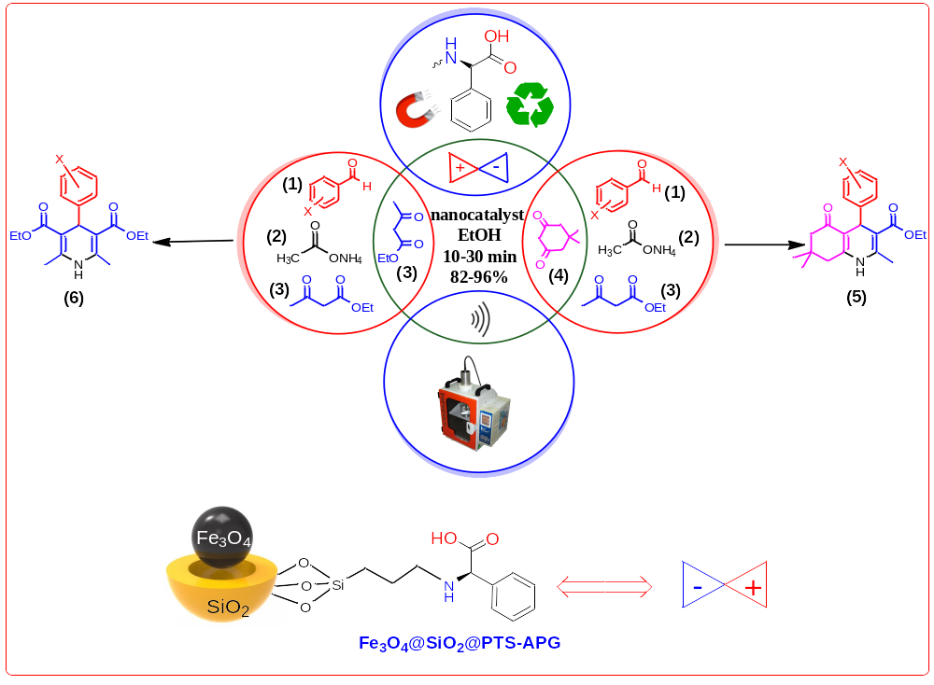

Fig. 1 FTIR spectra of the (a)Fe₃O₄, (b)Fe₃O₄@SiO₂, (c) Fe₃O₄@SiO₂@CPTS and (d) Fe₃O₄@SiO₂@PTS-APG
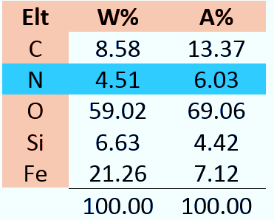
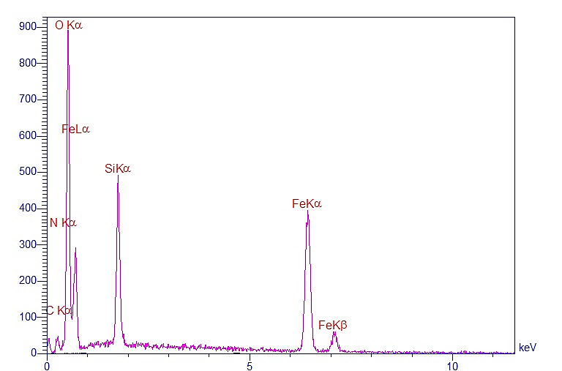
Counts
Energy (kev)

Fig. 2. Energy dispersive spectroscopy (EDS) pattern of the Fe₃O₄@SiO₂@PTS-APG

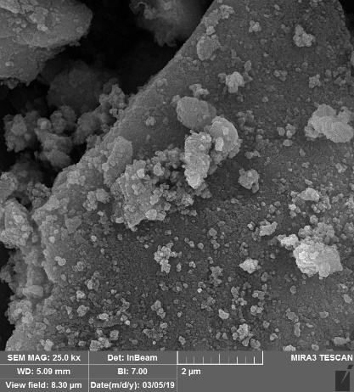  (a) | 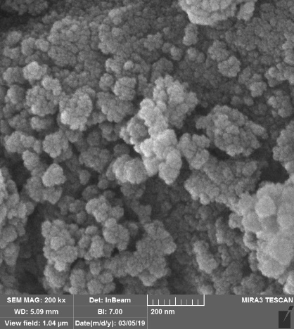  (b)
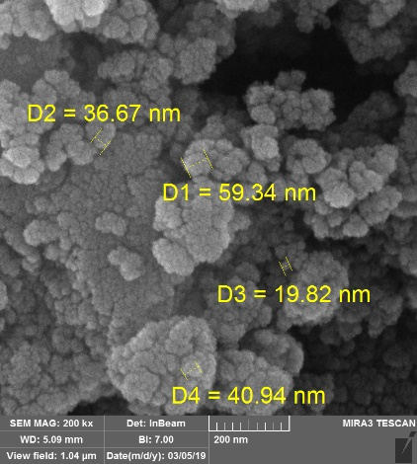  (c) | 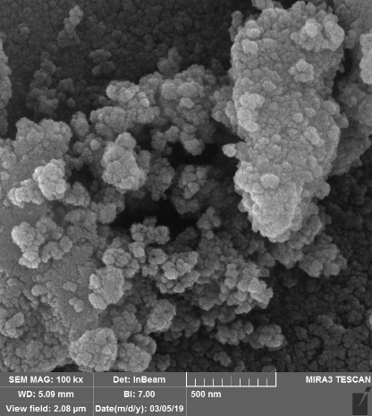  (d)
Fig. 3. FESEM images of the Fe₃O₄@SiO₂@PTS-APG catalyst.

Fig.4. X-Ray diffraction (XRD) pattern of the Fe₃O₄@SiO₂@PTS-APG.

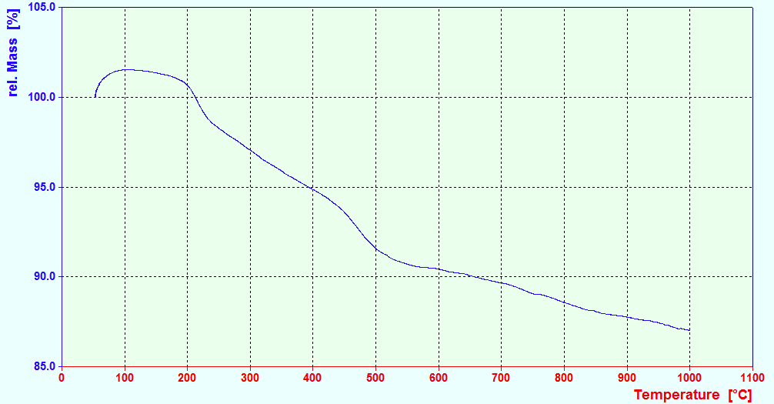
Fig. 5. TGA curve of the Fe₃O₄@SiO₂@PTS-APG catalyst.

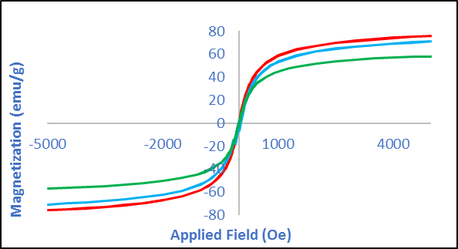

Fig. 6. Magnetization curves of the (red) Fe₃O₄, (blue) Fe₃O₄@SiO₂, (green) Fe₃O₄@SiO₂@PTS-APG.

Fig. 7. Reusability of Fe₃O₄@SiO₂@PTS-APG for the synthesis of 5b (red diagram) and 6a
(blue diagram).

Selected spectral data:
Ethyl 1, 4, 5, 6, 7, 8 – hexahydro – 4 - (4- N, N - dimethyaminophenyl) -7, 7-dimethyl – 5 -oxoquinoline-3-carboxylate (5a)
M.p. 231-233 ºC; FT-IR (KBr, cm⁻¹): υ = 3282, 3205, 3076, 2956, 1704, 1606, 1490, 1380, 1278, 1213, 1107, 1072, 1029, 854, 783, 756; ¹HNMR (CDCl₃, 500 MHz): 0.94 (s, 3H), 1.06 (s, 3H), 1.17-1.20 (t, 3H, j=15 Hz), 2.09-2.22 (m, 7H), 2.29 (s, 6H), 4.04-4.07 (q, 2H, j=15), 5.35 (s, 1H), 6.69 (s, 1H), 7.10-7.12 (d, 2H, j=10.0 Hz), 7.32-7.34 (d, 2H, j=10.0 Hz).
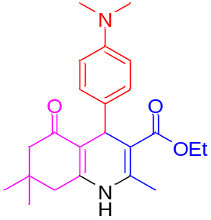

Fig. 8. FT-IR spectrum of Ethyl 1, 4, 5, 6, 7, 8 – hexahydro – 4 - (4- N, N - dimethyaminophenyl) -7, 7-dimethyl – 5 -oxoquinoline-3-carboxylate (5a).
Fig. 9. ¹H NMR spectrum of Ethyl 1, 4, 5, 6, 7, 8 – hexahydro – 4 - (4- N, N - dimethyaminophenyl) -7, 7-dimethyl – 5 -oxoquinoline-3-carboxylate (5a).
Fig. 10. Expanded ¹H NMR spectrum of Ethyl 1, 4, 5, 6, 7, 8 – hexahydro – 4 - (4- N, N - dimethyaminophenyl) -7, 7-dimethyl – 5 -oxoquinoline-3-carboxylate (5a).
Fig. 11. Expanded ¹H NMR spectrum of Ethyl 1, 4, 5, 6, 7, 8 – hexahydro – 4 - (4- N, N - dimethyaminophenyl) -7, 7-dimethyl – 5 -oxoquinoline-3-carboxylate (5a).
Fig. 12. Expanded ¹H NMR spectrum of Ethyl 1, 4, 5, 6, 7, 8 – hexahydro – 4 - (4- N, N - dimethyaminophenyl) -7, 7-dimethyl – 5 -oxoquinoline-3-carboxylate (5a).
Fig. 13. Expanded ¹H NMR spectrum of Ethyl 1, 4, 5, 6, 7, 8 – hexahydro – 4 - (4- N, N - dimethyaminophenyl) -7, 7-dimethyl – 5 -oxoquinoline-3-carboxylate (5a).
Fig. 14. Expanded ¹H NMR spectrum of Ethyl 1, 4, 5, 6, 7, 8 – hexahydro – 4 - (4- N, N - dimethyaminophenyl) -7, 7-dimethyl – 5 -oxoquinoline-3-carboxylate (5a).

Diethyl 4-(4-chlorophenyl)-2,6-dimethyl-1,4- dihydropyridine-3,5-dicarboxylate (6a)
M.p. 142-144 ºC; FT-IR (KBr, cm⁻¹): υ = 3355, 2985, 2958, 1697, 1649, 1487, 1371, 1292, 1213, 1091, 1051, 1016, 827, 783, 744, 669; ¹H NMR: (CDCl₃, 500 MHz): δ = 1.22-1.24 (t, 6H, j= 10 Hz), 2.34 (s, 6H), 4.09-4.11 (q, 4H, j= 10 Hz), 4.97 (s, 1H), 5.55 (s, 1H), 7.17-7.19 (d, 2H, j= 10 Hz), 7.21-7.22 (d, 2H, j= 10 Hz).

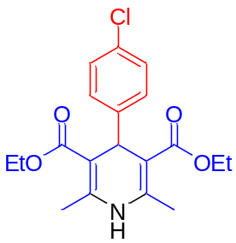

Fig. 15. FT-IR spectrum of Diethyl 4-(4-chlorophenyl)-2,6-dimethyl-1,4- dihydropyridine-3,5-dicarboxylate (6a).

Fig. 16. ¹HNMR spectrum of Diethyl 4-(4-chlorophenyl)-2,6-dimethyl-1,4- dihydropyridine-3,5-dicarboxylate (6a).

Fig. 17. ¹HNMR spectrum of Diethyl 4-(4-chlorophenyl)-2,6-dimethyl-1,4- dihydropyridine-3,5-dicarboxylate (6a).
Fig. 18. Expanded ¹H NMR spectrum of Diethyl 4-(4-chlorophenyl)-2,6-dimethyl-1,4- dihydropyridine-3,5-dicarboxylate (6a).
Fig. 19. Expanded ¹H NMR spectrum of Diethyl 4-(4-chlorophenyl)-2,6-dimethyl-1,4- dihydropyridine-3,5-dicarboxylate (6a).

