Table 1. Optimization of the reaction conditions for the synthesis of 5aª
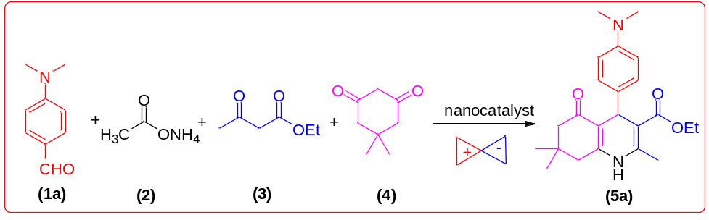

 |  |  | Reaction condition
 |  |  | RT (25 ͦC) |  | Reflux (80 ͦC) |  | MW |  | US
Entry | Catalyst | Solvent | Time  (min) | Yield  (%)^{b} | Time  (min) | Yield  (%)^{b} | Time  (min) | Yield  (%)^{b} | Power  (w) | Time  (min) | Yield  (%)^{b}
1 | - | EtOH | 300 | - | 300 | trace | 10 | trace | 75 | 7 | Trace
2 | Fe₃O₄@SiO₂@PTS-APG MNPs | EtOH | 300 | 25 | 300 | 29 | 10 | 32 | 75 | 7 | 37
3 | FE₃O₄@SiO₂@PTS-APG MNPs | H₂O | 300 | 10 | 300 | 19 | 10 | 24 | 75 | 7 | 28
4 | Fe₃O₄@SiO₂@PTS-APG MNPs | Toluene | 300 | 14 | 300 | 23 | 10 | 26 | 75 | 7 | 31
5 | Fe₃O₄@SiO₂@PTS-APG MNPs | THF | 300 | 12 | 300 | 17 | 10 | 20 | 75 | 7 | 24
6 | Fe₃O₄@SiO₂@PTS-APG MNPs | DMF | 300 | trace | 300 | 10 | 10 | 15 | 75 | 7 | 20
7 | Fe₃O₄@SiO₂@PTS-APG MNPs | EtOH | 360 | 25 | 360 | 45 | 12 | 34 | 80 | 7 | 39
8 | Fe₃O₄@SiO₂@PTS-APG MNPs | EtOH | 420 | 40 | 420 | 47 | 15 | 34 | 85 | 5 | 41
9 | Fe₃O₄@SiO₂@PTS-APG MNPs | EtOH | 480 | 41 | 480 | 50 | 17 | 35 | 90 | 5 | 41
10 | Fe₃O₄@SiO₂@PTS-APG MNPs ^{c} | EtOH | 300 | 43 | 300 | 53 | 20 | 58 | 85 | 10 | 82
11 | Fe₃O₄@SiO₂@PTS-APG MNPs ^{d} | EtOH | 300 | 43 | 300 | 54 | 25 | 59 | 85 | 10 | 82
12 | Fe₃O₄@SiO₂@PTS-APG MNPs ^{e} | EtOH | 420 | 44 | 420 | 58 | 30 | 62 | 85 | 10 | 84
13 | Fe₃O₄@SiO₂@PTS-APG MNPs ^{c} | EtOH | 480 | 45 | 480 | 60 | 35 | 73 | 85 | 12 | 86
14 | Fe₃O₄@SiO₂@PTS-APG MNPs ^{c} | EtOH | 600 | 46 | 600 | 63 | 40 | 77 | 85 | 20 | 90
ª Reaction conditions: 4-(Dimethylamino)benzaldehyde (1a, 1.0 mmol), ammonium acetate (2, 1.0 mmol), ethyl acetoacetate (3, 1.0 mmol), dimedone (4, 1.0 mmol), the catalyst (5 mg) and EtOH (5.0 mL) were charged in a 25 mL Flask. ^{b} Isolated yield. ^{c} 10 mg catalyst loading. ^{d} 15 mg catalyst loading. ^{e} 20 mg catalyst loading.

Table 2. Synthesis of different polyhydroquinoline derivatives using Fe₃O₄@SiO₂@PTS-APG NPs as a catalystª
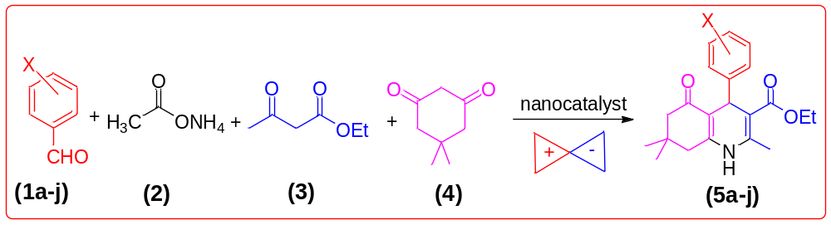
Entry | Aldehyde  1 | Product  5 | Time (min) | Yield (%) | Obs. m.p.  ( ͦC) [Lit.]
1  2  3  4  5  6  7  8  9  10 | 4-(Dimethylamino)benzaldehyde  4-Clorobenzaldehyde  4-Hydroxybenzaldehyde  4-Nitrobenzaldehyde  4-Methoxybenzaldehyde  4-Methylbenzaldehyde  Benzaldehyde  4-Bromobenzaldehyde  2-Chlorobenzaldehyde  2-Nitrobenzaldehyde | 5a  5b  5c  5d  5e  5f  5g  5h  5i  5j | 20  10  15  10  12  10  10  15  15  12 | 90  96  92  94  94  92  95  89  90  92 | 231-233[77]  230-232[56]  231-233[78]  241-243[79]  254-256[79]  258-260[80]  203-205[77]  252-254[81]  207-209[82]  208-210[80]
ª Reaction conditions: aldehyde derivatives (1a-k, 1.0 mmol), ammonium acetate (2, 1.0 mmol), ethyl acetoacetate (3, 1.0 mmol), dimedone (4, 1.0 mmol), and catalyst (10 mg) in 3 mL EtOH with ultrasonic irradiation.

Table 3. Optimization of the reaction conditions for the synthesis of 6aª
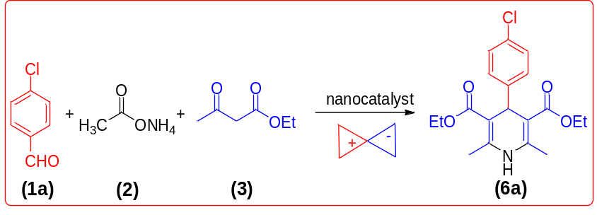
 |  |  | Reaction condition
 |  |  | RT (25 ͦC) |  | Reflux (80 ͦC) |  | MW |  | US
Entry | Catalyst | Solvent | Time  (min) | Yield  (%)^{b} | Time  (min) | Yield  (%)^{b} | Time  (min) | Yield  (%)^{b} | Power  (w) | Time  (min) | Yield  (%)^{b}
1 | - | EtOH | 300 | - | 300 | trace | 10 | - | 85 | 7 | trace
2 | Fe₃O₄@SiO₂@PTS-APG MNPs | EtOH | 300 | 42 | 300 | 52 | 12 | 62 | 85 | 7 | 71
3 | Fe₃O₄@SiO₂@PTS-APG MNPs ^{c} | EtOH | 300 | 44 | 300 | 57 | 15 | 69 | 85 | 7 | 86
4 | Fe₃O₄@SiO₂@PTS-APG MNPs ^{d} | EtOH | 300 | 46 | 300 | 59 | 15 | 71 | 85 | 7 | 87
5 | Fe₃O₄@SiO₂@PTS-APG MNPs ^{e} | EtOH | 300 | 48 | 300 | 61 | 15 | 74 | 85 | 7 | 89
6 | Fe₃O₄@SiO₂@PTS-APG MNPs ^{c} | EtOH | 420 | 50 | 420 | 62 | 20 | 77 | 85 | 12 | 94
7 | Fe₃O₄@SiO₂@PTS-APG MNPs ^{c} | EtOH | 480 | 52 | 480 | 63 | 25 | 80 | 85 | 15 | 94
8 | Fe₃O₄@SiO₂@PTS-APG MNPs ^{c} | EtOH | 600 | 54 | 600 | 66 | 30 | 82 | 85 | 20 | 95
ª Reaction conditions: 4-Chlorobenzaldehyde (1a, 1.0 mmol), ammonium acetate (2, 1.0 mmol), ethyl acetoacetate (3, 2.0 mmol), the catalyst (5 mg) and EtOH (5.0 mL) were charged in a 25 mL Flask. ^{b} Isolated yield. ^{c} 10 mg catalyst loading. ^{d} 15 mg catalyst loading. ^{e} 20 mg catalyst loading.

Table 4. Synthesis of different 1,4-dihydropyridine derivatives using Fe₃O₄@SiO₂@PTS-APG NPs as a catalystª
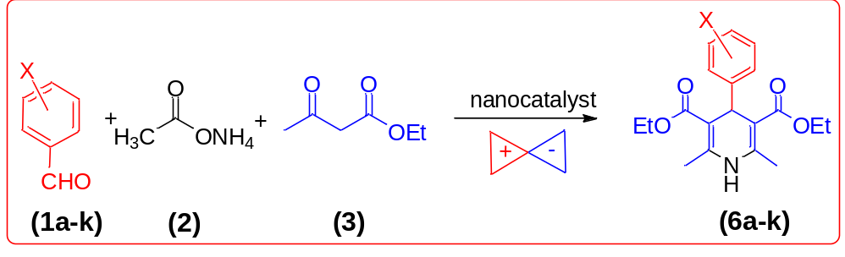
Entry | Aldehyde  1 | Product  6 | Time (min) | Yield (%) | Obs. m.p.  ( ͦC) [Lit.]
1  2  3  4  5  6  7  8  9  10  11 | 4-Clorobenzaldehyde  4-Nitrobenzaldehyde  3-Nitrobenzaldehyde  Benzaldehyde  4-Methylbenzaldehyde  4-Bromobenzaldehyde  4-Hydroxybenzaldehyde  2,4-Dichlorobenzaldehyde  4-Methoxybenzaldehyde  Furan-2-carbaldehyde  Butyraldehyde | 6a  6b  6c  6d  6e  6f  6g  6h  6i  6j  6k | 12  10  10  12  17  12  10  20  15  12  12 | 94  90  87  88  85  90  90  87  90  88  84 | 142-144[85]  129-131[85]  162-164[86]  156-158[87]  137-139[86]  162-164[87]  200-202[88]  188-190[85]  158-160[42]  160-162[42]  121-123[89]
ª Reaction conditions: aldehyde derivatives (1a-j, 1.0 mmol), ammonium acetate (2, 1.0 mmol), ethyl acetoacetate (3, 2.0 mmol), dimedone (4, 1.0 mmol), and catalyst (10 mg) in 3 mL EtOH with ultrasonic irradiation.

Table 5. A comparison on the efficiency of the Fe₃O₄@SiO₂@PTS-APG MNPs with other reported catalysis in the synthesis of different PHQ and 1,4-DHP derivatives
Entry | Product | Catalyst | Reaction condition | Time | Yield (%) | Ref.
1 | 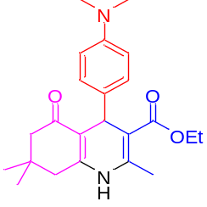  (5a) | Bismuth (III) bromide (2 mol%) | EtOH, RT | 2.5 h | 87 | [90]
1 |  | Fe₃O₄@SiO₂@PTS-APG NMPs (10 mg) | EtOH, sonication | 20 min | 90 | This work
2 | 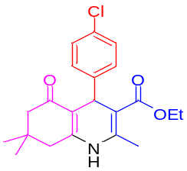  (5b) | Alginic acid (17.6 mg) | EtOH, reflux | 25 min | 95 | [20]
2 |  | V-TiO₂ NPs (5.85 nm, 2 mol%) | solvent-free, 80 ͦC | 14 min | 82 | [78]
2 |  | Fe₃O₄@SiO₂@PTS-APG NMPs (10 mg) | EtOH, sonication | 10 min | 96 | This work
3 | 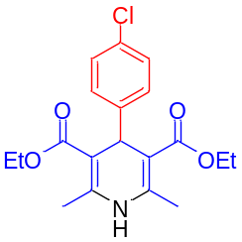  (6a) | AFGONs (25 mg) | EtOH, RT | 2 h | 88 | [45]
3 |  | Sulfated polyborated (5 wt%) | solvent-free, 90 ͦC | 25 min | 92 | [91]
3 |  | Chitosan supported vanadium oxo (5 mg) | solvent-free, 85 ͦC | 45 min | 89 | [92]
3 |  | Fe₃O₄@SiO₂@PTS-APG NMPs (10 mg) | EtOH, sonication | 12 min | 94 | This work
4 | 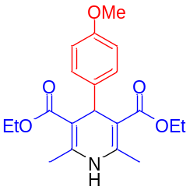(6k) | TBAHS (2:1.5:1 ratio) | solvent-free, 70 ͦC | 70 min | 65 | [85]
4 |  | Fe₃O₄@SiO₂@PTS-APG NMPs (10 mg) | EtOH, sonication | 15 min | 90 | This work

Table 6. Spectral characterization of compounds 5a and 6a
Product | M.p. (◦C) | FT-IR (KBr, cm⁻¹) |  | ¹H NMR (CDCl₃, 500 MHz)
(5a) | 231-233 | 756 | 1606 | 0.94 (s, 3H)
 | 231-233 | 783 | 1704 | 1.06 (s, 3H)
 | 231-233 | 854 | 2956 | 1.17-1.20 (t, 3H, j= 15 Hz)
 | 231-233 | 1029 | 3076 | 2.09-2.22 (m, 7H)
 | 231-233 | 1072 | 3205 | 2.29 (s, 6H)
 | 231-233 | 1107 | 3282 | 4.04-4.07 (q, 2H, j= 15 Hz)
 | 231-233 | 1213 | - | 5.35 (s, 1H)
 | 231-233 | 1278 | - | 6.69 (s, 1H)
 | 231-233 | 1380 | - | 7.10-7.12 (d, 2H, j= 10 Hz)
 | 231-233 | 1490 | - | 7.32-7.34 (d, 2H, j= 10 Hz)
(6a) | 142-144 | 669 | 1292 | 1.22-1.24 (t, 6H, j=10 Hz)
 | 142-144 | 744 | 1371 | 2.34 (s, 6H)
 | 142-144 | 783 | 1487 | 4.09-4.11 (q, 4H, j= 10 Hz)
 | 142-144 | 827 | 1649 | 4.97 (s, 1H)
 | 142-144 | 1016 | 1697 | 5.55 (s, 1H)
 | 142-144 | 1051 | 2958 | 7.17-7.19 (d, 2H, j=10 Hz)
 | 142-144 | 1091 | 2985 | 7.21-7.22 (d, 2H, j= 10 Hz)
 | 142-144 | 1213 | 3355 | -

