Supplementary Information
In Situ Reduced MXene/AuNPs Composite toward Enhanced Charging/Discharging and Specific Capacitance
Zixiang Zheng¹, Wei Wu¹, Tao Yang^{1,}*, Enhui Wang¹, Zhentao Du², Xinmei Hou^{1,*}, Tongxiang Liang³, Hailong Wang⁴
¹ Beijing Advanced Innovation Center for Materials Genome Engineering, Collaborative Innovation Center of Steel Technology, University of Science and Technology Beijing, Beijing 100083, China.
² MOE Key Laboratory of New Processing Technology for Non-ferrous Metals and Materials, Guangxi Key Laboratory of Processing for Non-ferrous Metals and Featured Materials, Guangxi University, Nanning 530004, China
³ School of Materials Science and Engineering, Jiangxi University of Science and Technology, Ganzhou 341000, China
⁴ School of Materials Science Engineering, Zhengzhou University, Zhengzhou 450001, China

Experiment and calculation
Before any measurements, all cells were cycled for 50 times at scan rate of 20 mV s⁻¹. The cells were tested from scan rates of 5 mV s⁻¹ to 100 mV s⁻¹. GCD measurements were performed at current density arranging from 1 A g⁻¹ to 10 A g⁻¹. In order to evaluate the cyclic performance of the MXene/AuNPs electrodes, CV measurements were performed at a scan rate of 50 mV s⁻¹ over 10000 cycles.
The coulombic efficiency was calculated from GCDs according to the following equation:
CE = Δt_{d}/Δt_{c} ×100% (1)
Where, Δt_{d} and Δt_{c} are the times of discharging and charging, respectively, and CE is coulombic efficiency.
The specific capacitance (F g⁻¹) was calculated from CV curves according to the following equation:
$C\text{s}=\frac{∫IⅆV}{mvΔV}$ (2)
Where, ΔV (V) is the potential window, m (g) is the mass of the active material of single electrode, V (V) is the potential versus reference electrode, I (A) is the response current, ν (mV s⁻¹) is the scan rate, C_{s} (F g⁻¹) is specific capacitance.
In the two-electrode cell, C_{s} values of the electrodes in the symmetric supercapacitor can be obtained by the following equation using the CV curves.
$C\text{s}=\frac{2∫IⅆV}{mvΔV}$ (3)
where m (g) is the mass of the single film electrode and s (V s⁻¹) is the scan rate. Volumetric capacitance was obtained by multiplying the gravimetric capacitance by density (ρ) of free-standing film on the working electrode. Volumetric capacitance C_{v} (F cm⁻³) of the electrode in the symmetric supercapacitor is calculated by the following equation:
$C_{v}=C_{s}×ρ$ (4)
Power density P_{v} (W L⁻¹) and volumetric energy density E_{v} (Wh L⁻¹) for the symmetric supercapacitor are calculated by the following equations:
$E_{v}=\frac{C_{v}Δv^{2}}{8×3.6}$ (5)
$P_{v}=\frac{3600E_{v}}{Δt}$ (6)
where ∆t is the discharge time according to the CV curves (∆t = ∆V / s). Therefore, when C_{s} = 278 F g⁻¹ at 5 mV s⁻¹, C_{v} is calculated as 917.4 F cm⁻³, where $ρ$ of MXene/AuNPs is 3.3 g/cm³. Then E_{v} = $\frac{917.4×{0.6}^{2}}{8×3.6}$ = 11.47 Wh L⁻¹, and $P_{v}=\frac{3600×11.47}{120}$ =344.1 W L⁻¹.
The related content of O is calculated in element sensitivity factor method, using the XPS spectrums of O 1s and Ti 2p. The results is calculated by the following equations:
n_{i}/n_{j} = (I_{i}/S_{i})/(I_{j}/S_{j}) (7)
where I_{i} and I_{j} are the photoelectron intensity of i and j elements, respectively. S_{i} and S_{j} are the relative sensitivity factor (RSF) of i and j elements, respectively.

Fig. S1 (a) SEM image of Ti₃C₂T_{x} film, (b) TEM image of Ti₃C₂T_{x}, (c) HRTEM image of Ti₃C₂T_{x}, (d) SAED pattern of Ti₃C₂T_{x}.

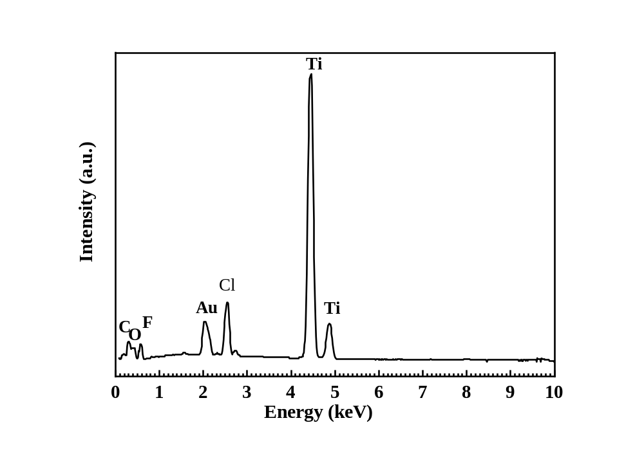
Fig. S2 EDS analysis of MXene/AuNPs-2

Table S1. EDS results of samples
Element | Atom %
Element | Ti₃C₂T_{x} | MXene/AuNPs-1 | MXene/AuNPs-2 | MXene/AuNPs-3
Ti | 31.88 | 27.72 | 36.35 | 36.73
C | 36.61 | 46.33 | 36.61 | 34.80
O | 12.99 | 13.46 | 14.56 | 13.40
F | 13.05 | 9.45 | 9.80 | 10.91
Cl | 3.43 | 2.76 | 3.94 | 3.69
Au | - | 0.28 | 0.35 | 0.47

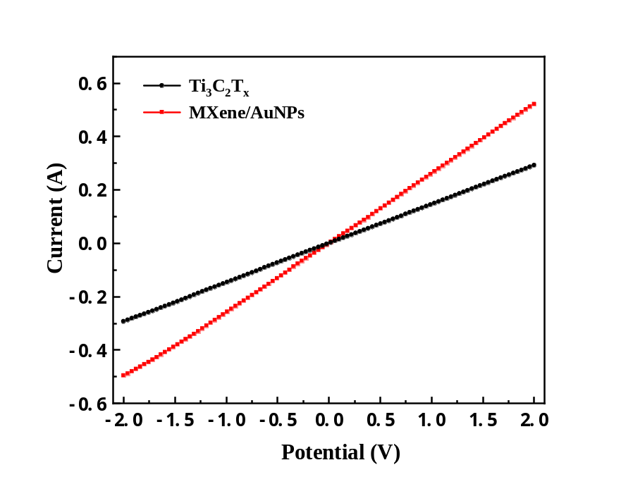
Fig. S3 Conductivity characterization of the Ti₃C₂T_{x} and MXene/AuNPs-2.

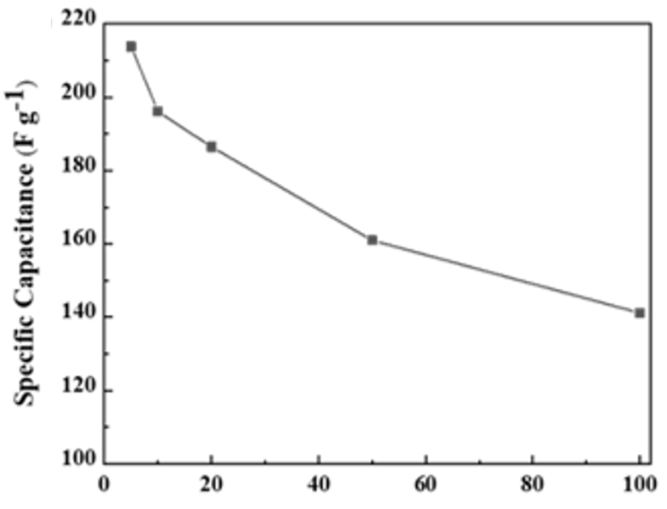
Fig. S4 Specific capacitance of the supercapacitor vs scan rate.

Table S2. Comparison of electrochemical performance of different MXene-based materials as supercapacitor electrodes
Electrode material | Electrolyte | E_{v}  (Wh L⁻¹) | P_{v}  (W L⁻¹) | Ref
MXene/AuNPs | 1 M H₂SO₄ | 8.82 | 264.6 | This work
rGO//MXene | PVA/H₂SO₄ gel | 8.6 | 200 | [1]
Ni-dMXNC//MXene | 1 M KOH | 10.4 | 220 | [2]
Ti₃C₂T_{x} paper | 1 M KOH | 18.5 | 240 | [3]
MP-MX_{1.5} | 3 M H₂SO₄ | 20.7 | 184.8 | [4]

References
[1] Couly C, Alhabeb M, Van Aken KL, et al. Asymmetric flexible MXene‐reduced graphene oxide micro‐supercapacitor, Adv. Electron. Mater. 2018, 4: 1700339.
[2] Xia QX, Fu J, Yun JM, et al. High volumetric energy density annealed-MXene-nickel oxide/MXene asymmetric supercapacitor, RSC Adv. 2017, 7: 11000-11011.
[3] Lukatskaya MR, Mashtalir O, Ren CE, et al. Cation intercalation and high volumetric capacitance of two-dimensional titanium carbide, Science 2013, 341: 1502-1505.
[4] Fan Z, Wang Y, Xie Z, et al. A nanoporous MXene film enables flexible supercapacitors with high energy storage, Nanoscale 2018, 10: 9642-9652.

* Author to whom correspondence should be addressed e-mails: houxinmeiustb@ustb.edu.cn (X. M. Hou), yangtaoustb@ustb.edu.cn (T. Yang)

