Supplementary File 2. Quality control
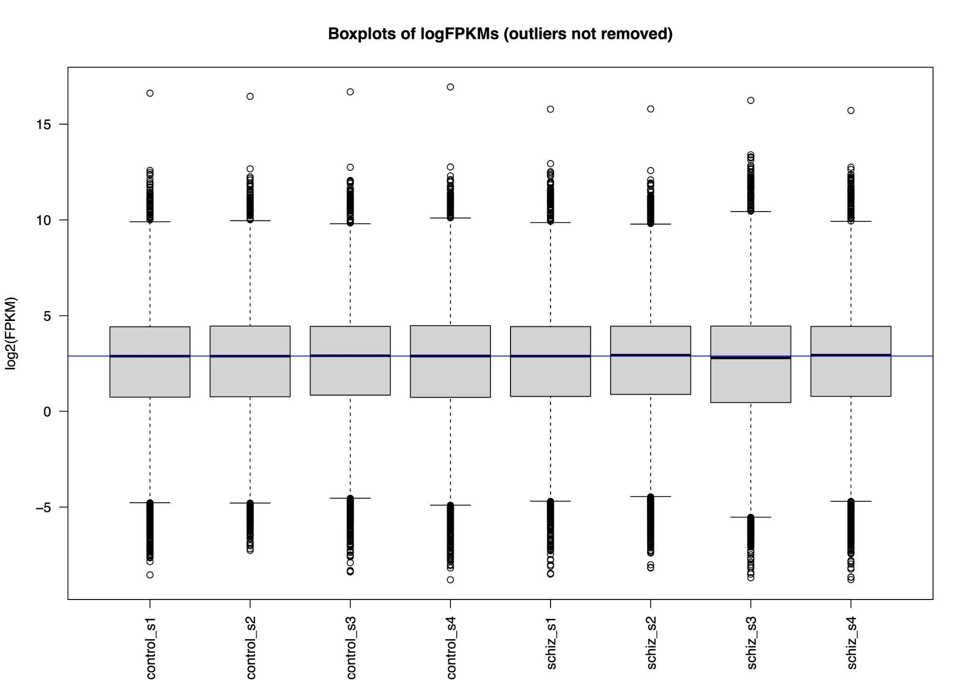

Supplementary Figure 2.1. Boxplots of log2 transformed gene expression data for all samples included in the GSE92874 transcriptomics dataset. Sample names and normalised counts are indicated on the x-axis and y-axis, respectively. The blue line represents the median of all transformed fragments per kilobase of transcript per million mapped reads.

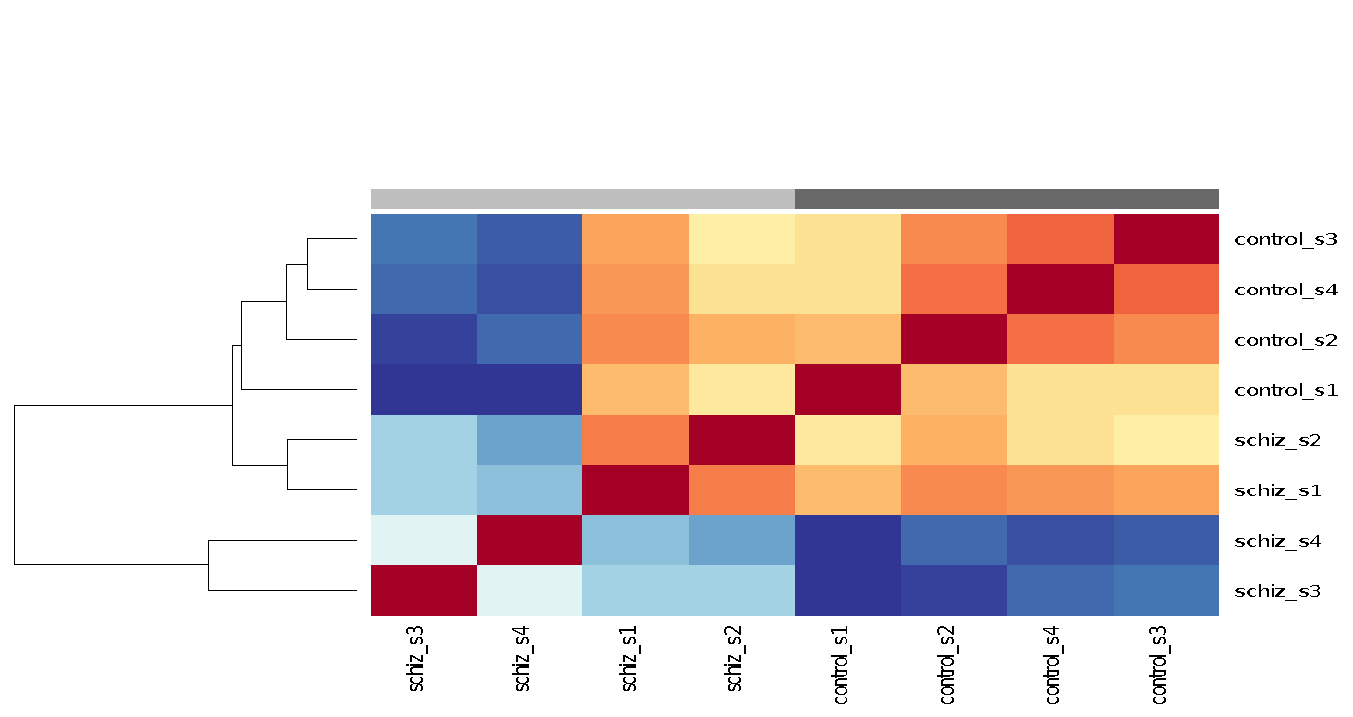
Supplementary Figure 2.2. Heatmap of correlations between samples of healthy control (n=4) and schizophrenia (n=4) subjects. Correlation was determined using the Pearson method. Subsequently, the ward D2 method was used to cluster the samples. Control samples (dark grey) and schizophrenia samples (light grey) cluster together. Colours red and blue indicate small and large distances, respectively. Overall, larger variances were reported between schizophrenia subjects compared to control subjects.

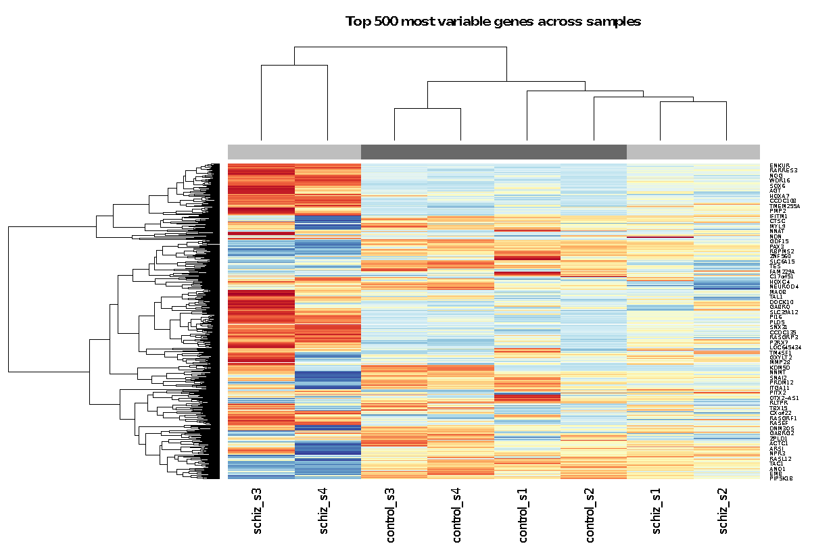
Supplementary Figure 2.3. Heatmap of the top 500 most variable genes across samples of healthy control (n=4) and schizophrenia (n=4) subjects. Gene variabilities were determined by calculating the variances of each gene across samples. Colours represent the z-scores of the fragments per kilobase of transcript per million mapped reads values, with blue indicating increasingly negative and red increasingly positive values. The column and row dendrograms indicate the distances between the genes and samples, respectively. Side bar indicates the disease status of the sample, with dark grey corresponding to control and light grey to schizophrenia subjects. Altogether, the subjects form two clusters, with one subcluster consisting of schiz_s3 and schiz_s4.

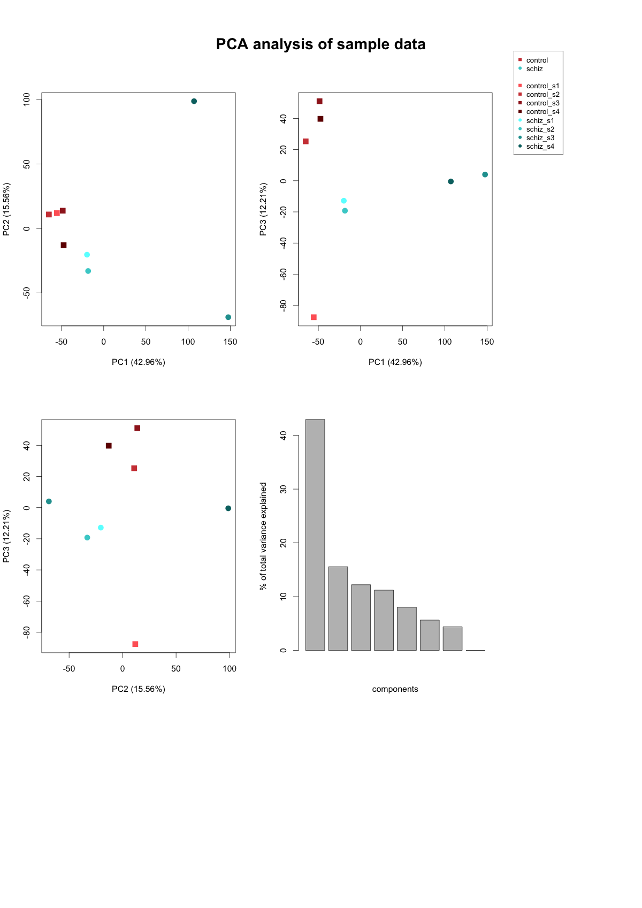

A
B
C
D
Supplementary Figure 2.4. Principal component analysis (PCA) of GSE92784 transcriptomics data. A: PCA of PC1-PC2. B: PCA of PC1-PC3. C: PCA of PC2-PC3. D: Percentages of total variance explained by the principal components. PC1, PC2 and PC3 account for 42.96, 15.56 and 12.21 percent of the observed variance between the samples, respectively.

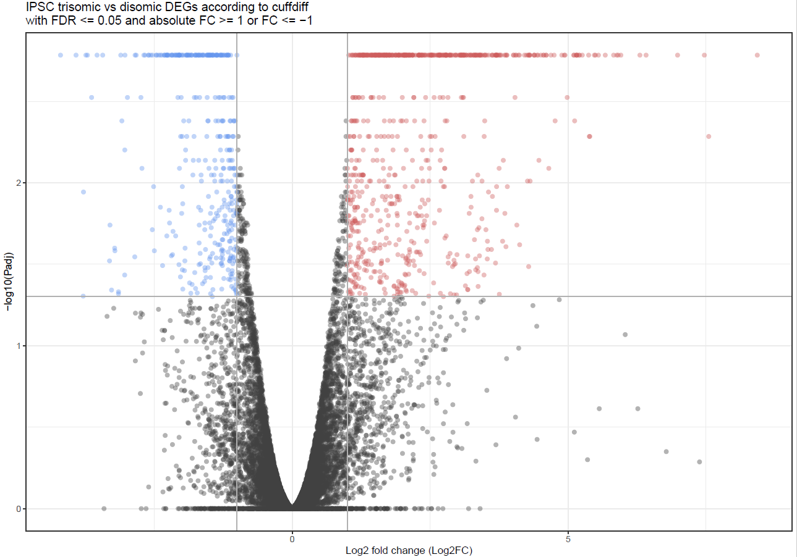
Supplementary Figure 2.5. Volcano plot of GSE92784 transcriptomics data. The -log10 of the false discovery rate adjusted p-value (q-value) and the log2 fold change (log2FC) are represented by the y and x axis, respectively. Two vertical grey lines correspond to the log2FC values of -1 and 1. The horizontal grey line indicates a q-value threshold of .05. Non-differentially expressed genes are indicated by black data points. Downregulated genes are shown in blue and upregulated genes in red.

