Supplementary File 4. Network analysis
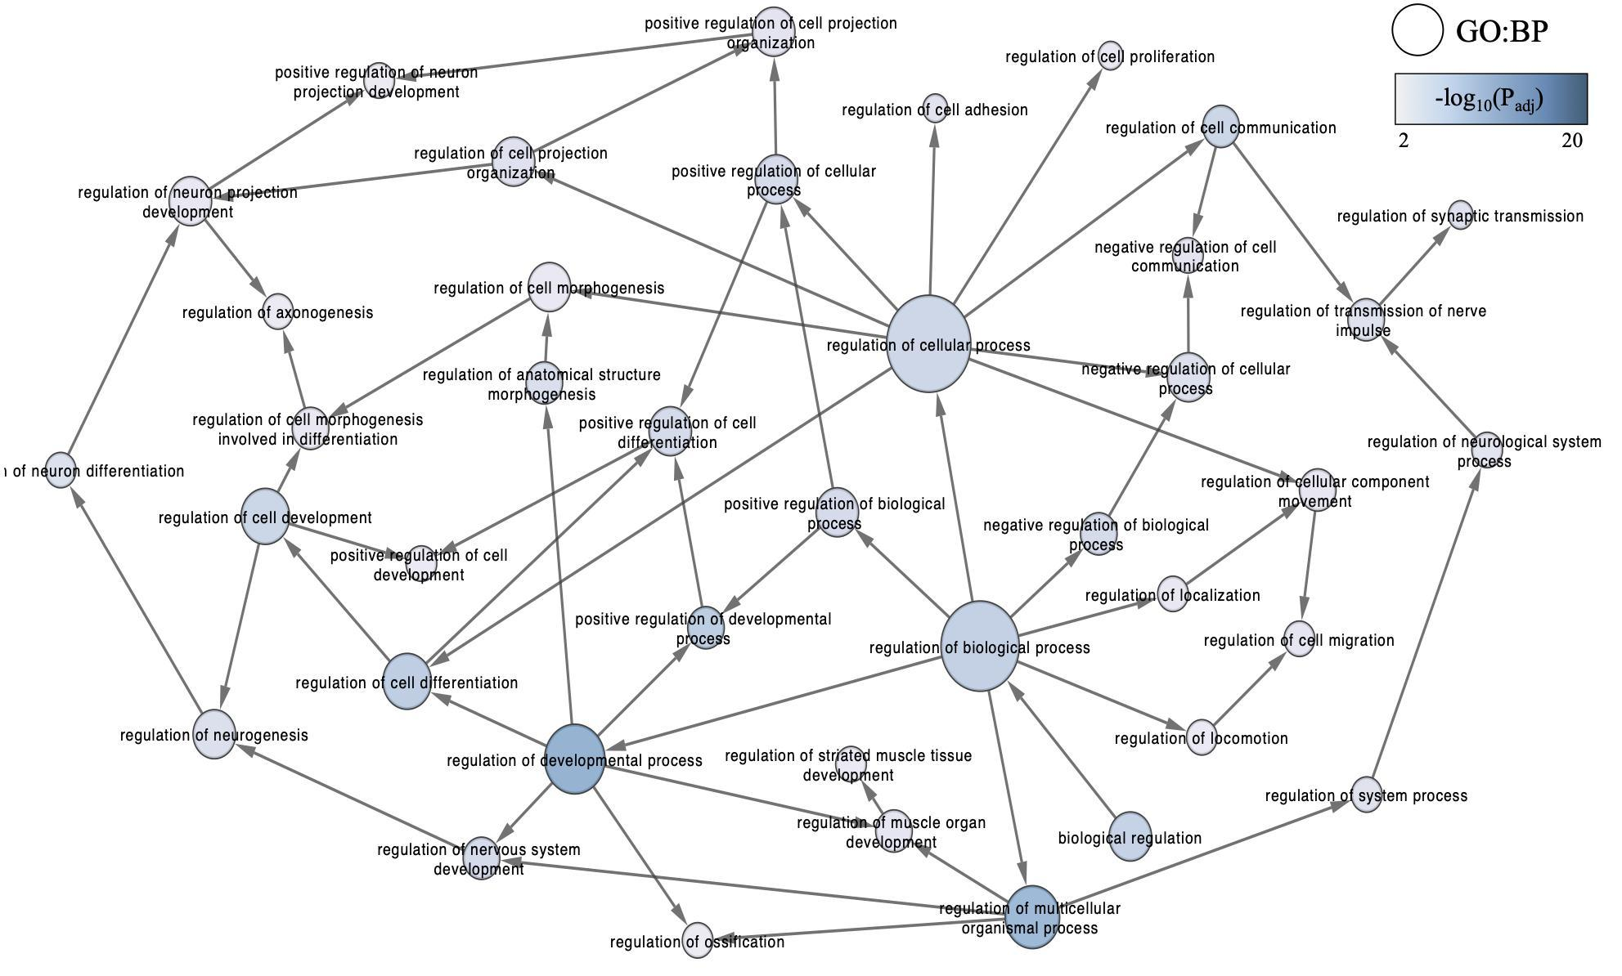
Supplementary Figure 4.1. Subnetwork of regulatory gene ontology (GO) biological processes. BiNGO overrepresentation analysis was performed, whereupon GO terms were filtered for a false discovery rate adjusted p-value (q-value) below .01. The blue colour gradient indicates the significance of the functional enrichment, with darker colours corresponding to smaller q-values. Node size is relative to the degree as determined in the original network.

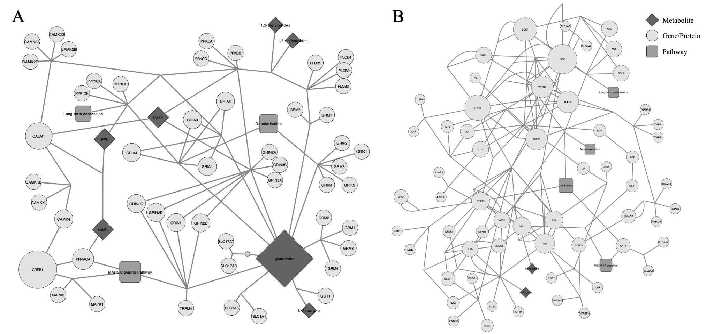
Supplementary Figure 4.2. Subnetworks of WikiPathways WP5083 network. A: Glutamatergic neurons and downstream components. B: Astrocytes, microglia, and inflammatory mediators. Data nodes representing pathways (round rectangle), metabolites (diamond) and genes (ellipse) are distinguishable by shape and a grey colour gradient. Anchors and groups were made invisible. Node size corresponds to the relative degree in the original network.

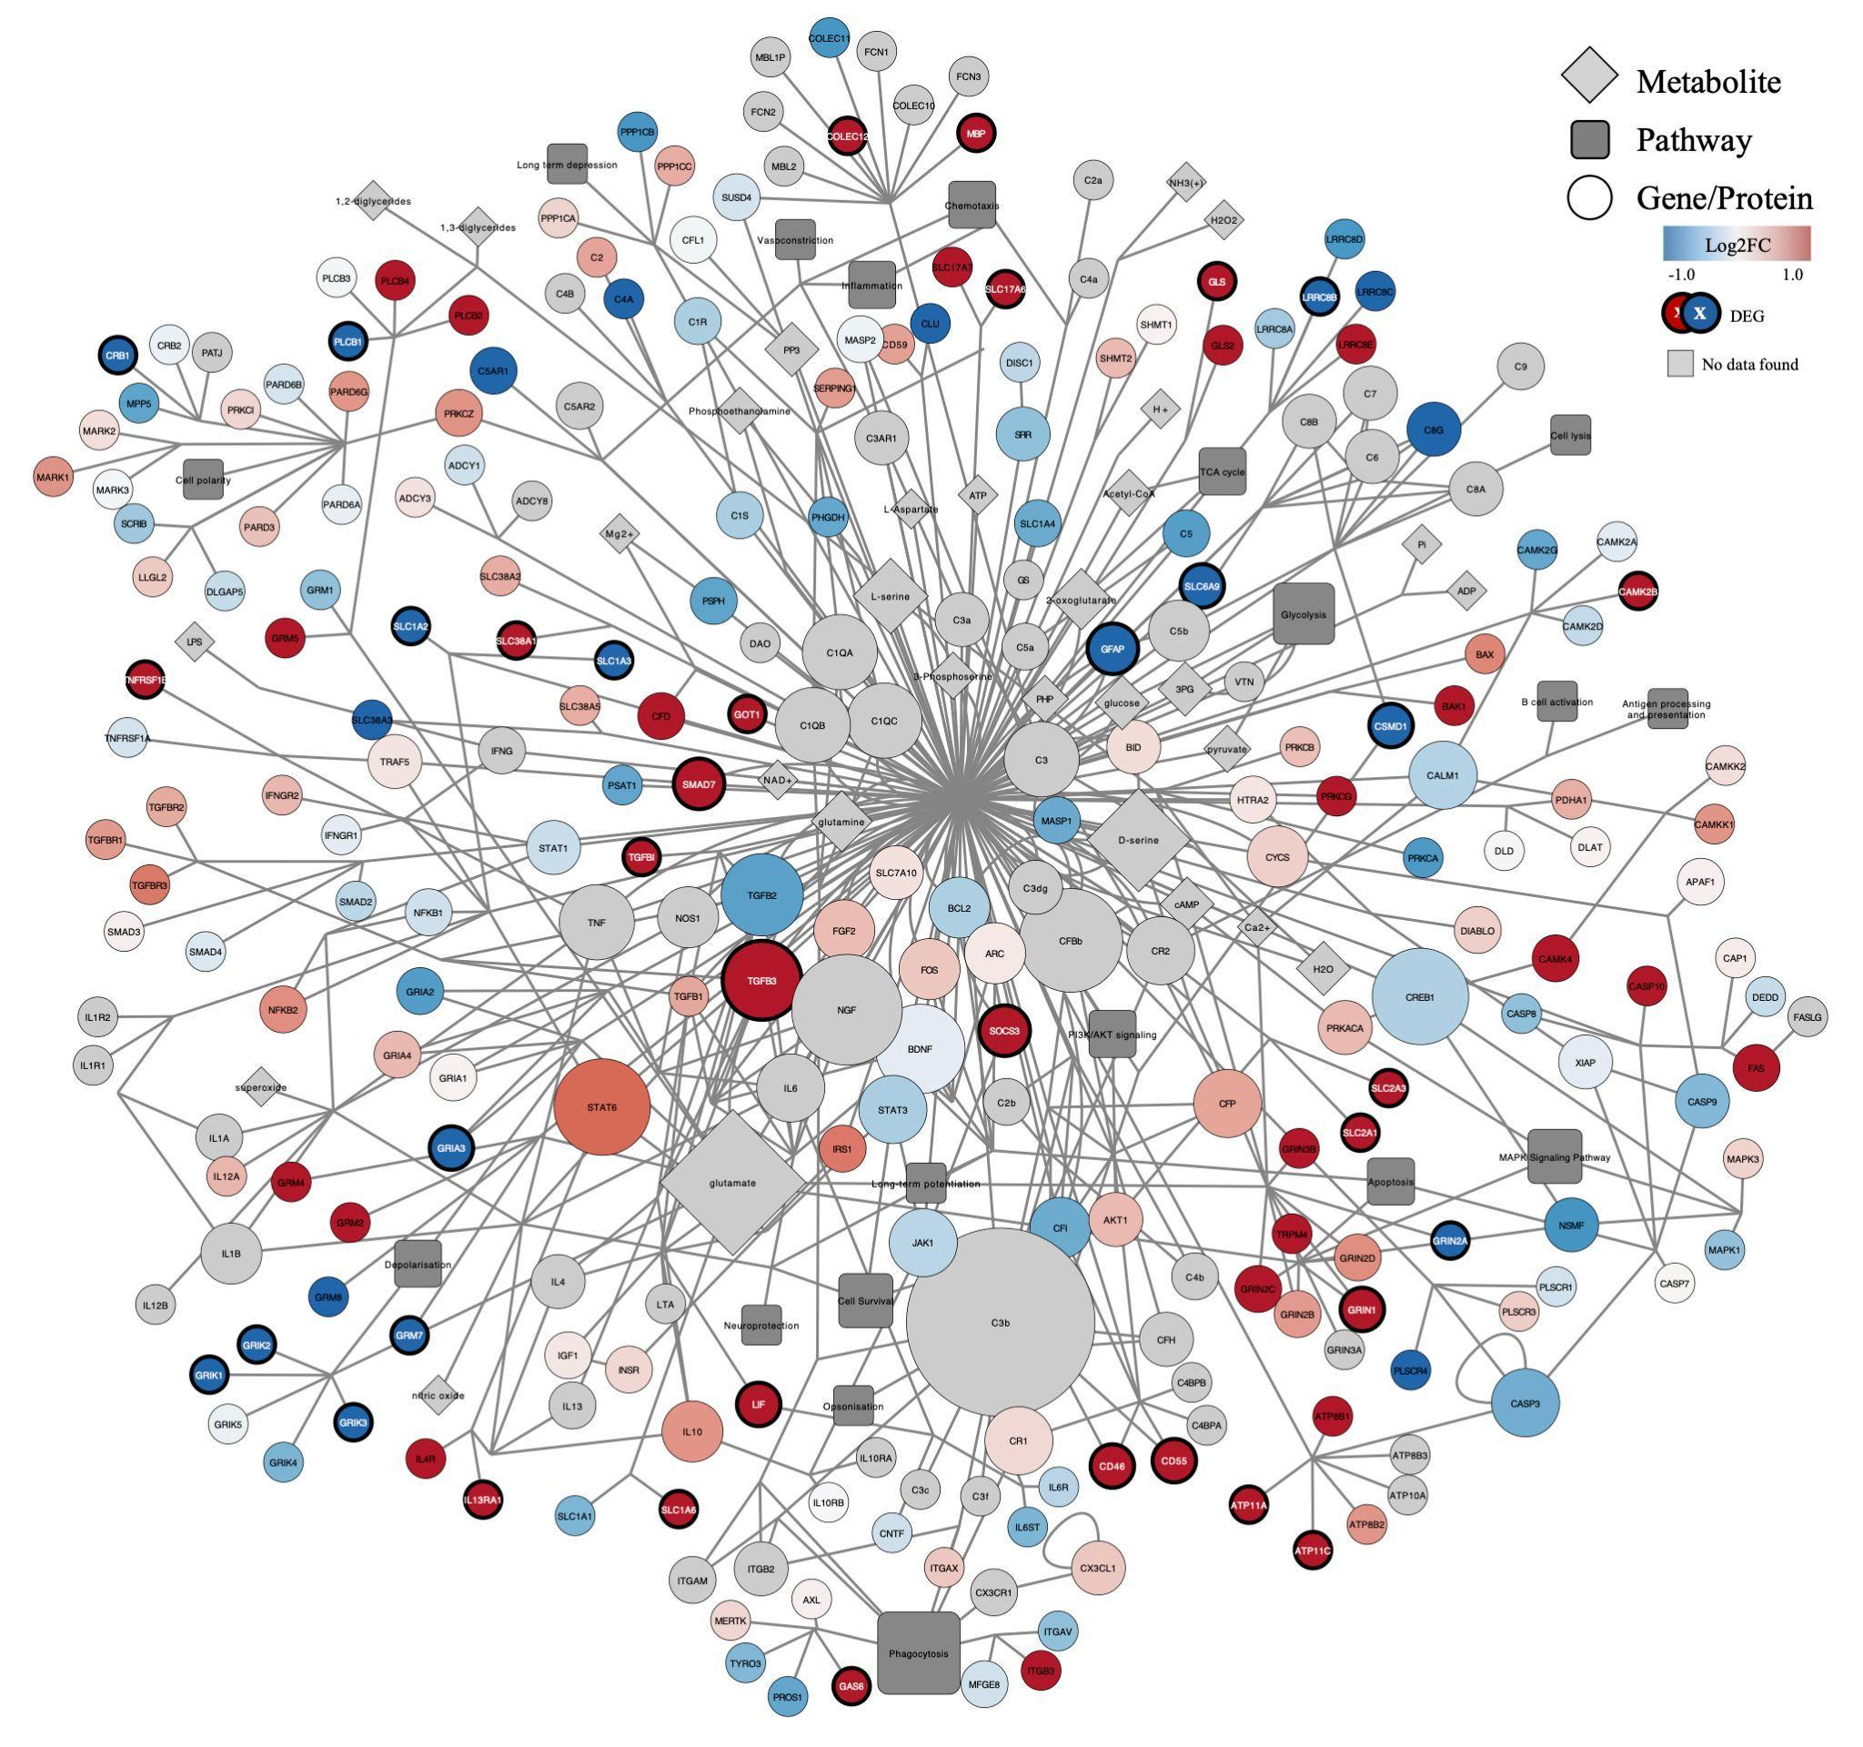

Supplementary Figure 4.3. Network of merged WikiPathways WP5083 and WP5090. Genes (ellipse), metabolites (diamond) and pathways (round rectangle) are differentiated by shape. Log2 fold change values are indicated, with red and blue representing upregulation and downregulation, respectively. Lack of gene expression data is signified by a grey colour. Node size is relative to the degree within the merged network. Anchors and groups were made invisible. Differentially expressed genes have a white label and larger boundary size.

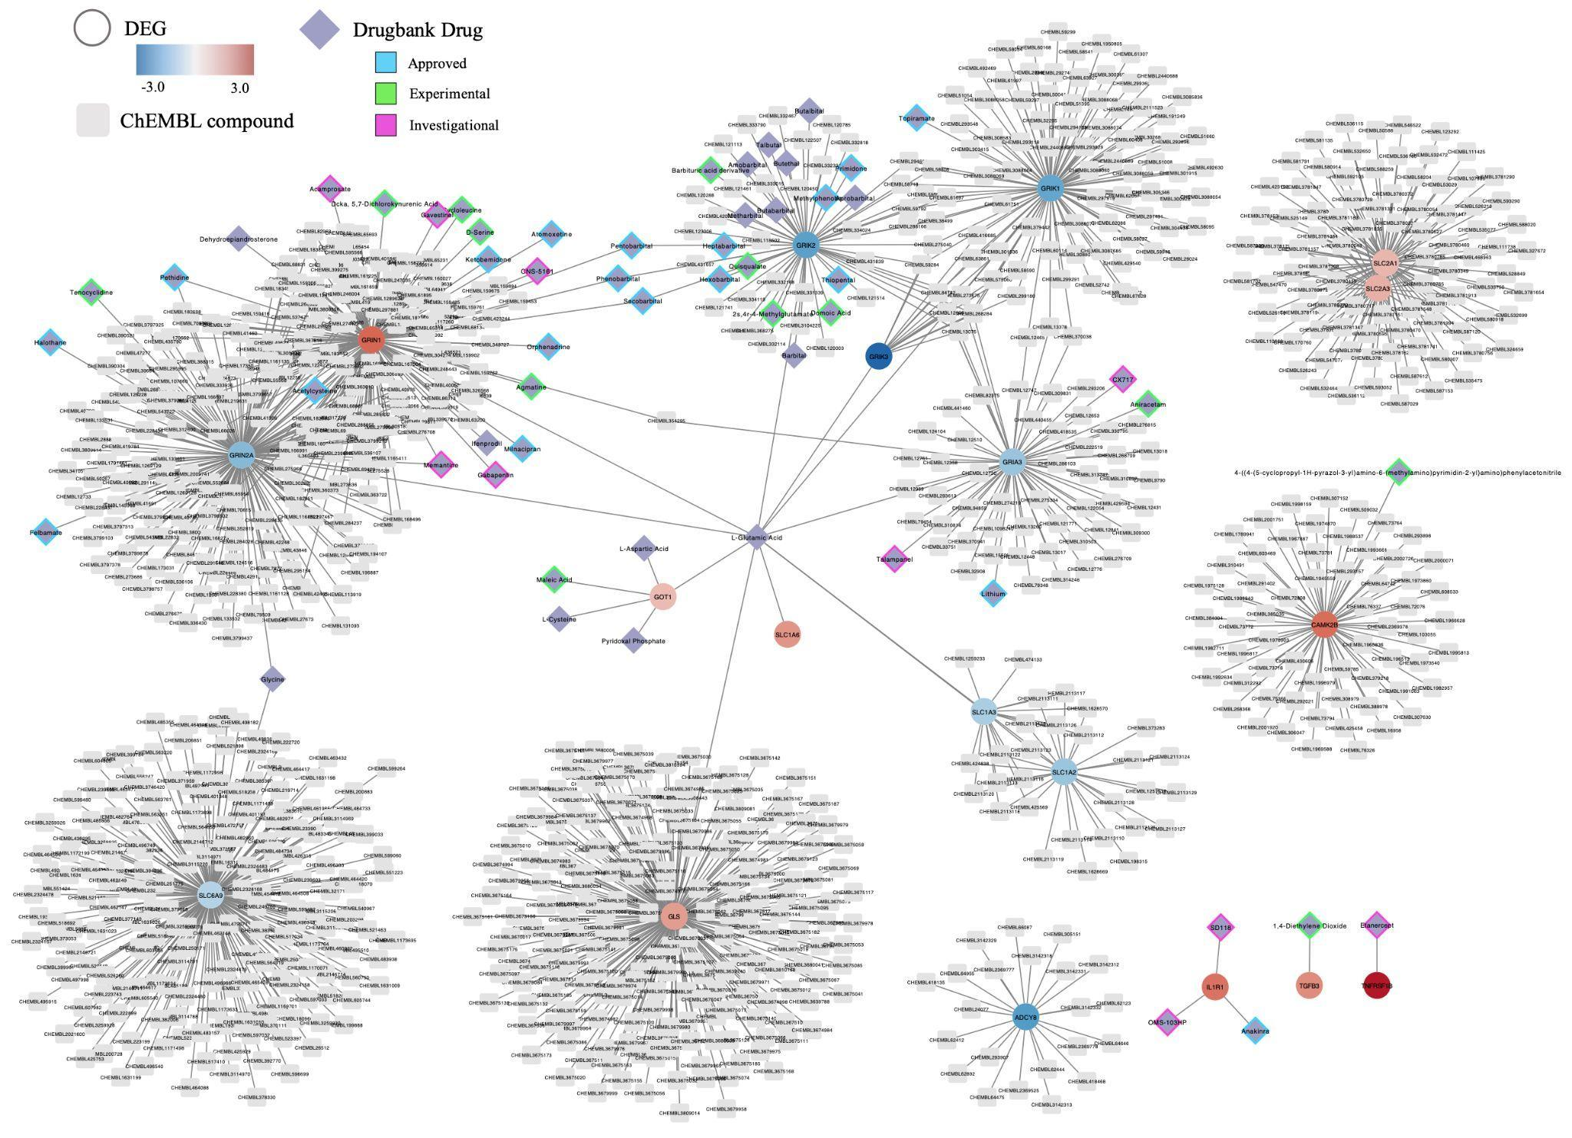

Supplementary Figure 4.4. Network of merged subnetworks extended with the ChEMBL and Drugbank linksets. The subnetworks consisted of the differentially expressed genes included in the WikiPathways:WP5083 pathway. Log2 fold change values are indicated, with red and blue representing upregulation and downregulation, respectively. Compounds (round rectangle), genes (ellipse), and drugs (diamond) are differentiated by shape. Regarding the drugs, investigational (purple), experimental (green) and approved (light blue) drugs are indicated with different coloured borders.

