Supplementary Information for “Prediction of multi-sectoral longitudinal water withdrawals using hierarchical machine learning models,”
Under review in Water Resources Management

Julie Shortridge, Department of Biological Systems Engineering, Virginia Tech
155 Ag Quad Lane
Blacksburg, Virginia USA 24061
jshortridge@vt.edu
ORCID ID: 0000-0003-1612-5740

This supplementary information is organized as follows:
- S1 Predictor Variables
  - Table S1: Summary of socio-economic predictor variables
- S2 Facility Clustering Analysis
  - Figure S1: Kernel density plots of facility withdrawal volume
  - Figure S2: Kernel density plots of facility coefficient of variation
  - Figure S3: Kernel density plots of facility autocorrelation
  - Figure S4: Kernel density plots of facility seasonality
  - Figure S5: Plot of cluster gap statistic when grouping facilities into different numbers of clusters
  - Table S2: Correspondence between facility sector and large cluster (k=3) assignment
  - Table S3: Correspondence between facility sector and small cluster (k=8) assignment
- S3 References Cited

S1. Predictor Variables
A total of thirteen socio-economic and four climatic predictor variables were included as potential predictors of water withdrawal. Socio-economic variables are summarized in Table S1. These variables represented a variety of population, economic, and land-use characteristics that have been shown to have relationships with water withdrawals in previous research (e.g., Sankarasubramanian et al., 2017; Shortridge & DiCarlo, 2020; Worland et al., 2018). Socio-economic predictor variables were obtained from the U.S. Census (US Census Bureau, 2022), U.S. Bureau of Economic Analysis (US Bureau of Economic Analysis, 2022), USDA National Agricultural Statistics Service (United States Department of Agriculture, 2018), the USGS FORecasting SCEnarios of Land-use Change (FORE-SCE) model (Sohl et al., 2007), and the U.S. Energy Information Administration (US Energy Information Administration, 2022). Predictor variables that exhibited trends through time were linearly detrended prior to inclusion in the model (see Table S1).
Additionally, three climatic predictor variables were included to account for widespread evidence of the relationship between weather and water withdrawals (e.g., Brown et al., 2013; House-Peters & Chang, 2011; Lee et al., 2015). This included maximum daily temperature, total precipitation, and daily precipitation variability as quantified by the Gini coefficient (Marston & Ellis, 2019; Rajah et al., 2014). The Gini coefficient is a non-dimensional representation of the inequality in a distribution ranging from 0 to 1, with higher values indicating more inequality. Recent research has demonstrated an increasing trend in Gini coefficient rainfall values in the Eastern U.S., indicating that a larger portion of rainfall is occurring on a smaller number of days (Marston & Ellis, 2019; Rajah et al., 2014); this increase in rainfall variability is also correlated with greater water use (J. Shortridge & DiCarlo, 2020). Gridded daily values of maximum temperature and precipitation from 1990 – 2018 were obtained from the PRISM dataset (Daly et al., 2008) and spatially aggregated to county-level daily values. These county level values were then temporally aggregated to monthly estimate of average high temperature, total precipitation, and precipitation Gini coefficient.
Virginia exhibits several spatial patterns of variability in long-term climate conditions, most notably higher temperatures in the southern inland portion of the state, lower temperatures in the Appalachian and Blue Ridge Mountains, and a rain shadow along the western border of the state. To account for this cross-sectional variability as well as seasonal differences, all monthly climate data were transformed to monthly anomaly values prior to inclusion within the model (Shortridge et al., 2016):

${AN}_{c,t}= \frac{O_{c,t}- {\overline{O}}_{c,m}}{sd(O_{c,m})}$ (2)

where O_{c,t} is the observed value of a climate variable (e.g., total precipitation) in county c and time period t; Ō_{c,m} is the monthly normal (long-term mean from 1990-2018) observation of that variable in that county; and sd(O_{c,m}) is the standard deviation of all observations in that month. In this way, the anomaly value can represent how weather conditions compared to long-term averages for that specific month and location. For instance, an anomaly temperature value of 0.0 would indicate that the temperature in that month and county was exactly equal to the long-term mean temperature in that month and county, while a value of 1.0 would indicate that the temperature was one standard deviation higher than the long-term mean.

Explanatory Variable | Description and Rationale  (temporal and geographic resolution in parentheses) | Source | Sector models
Population | County-level population (detrended); included to account for higher municipal water withdrawals as population grows (annual, county) | US Census | Mun
Per-capita personal income | Percent change (from previous year) in personal income per capita; Spatially-explicit representation of general economic conditions at the county level (annual, county) | US Bureau of Economic Analysis | All
Manufacturing GDP | Virginia GDP in current dollars from manufacturing (detrended); Spatially-general representation of manufacturing sector economic strength (annual, state) | US Bureau of Economic Analysis | Com, Ind, Min
Agricultural GDP | Virginia GDP in current dollars from agriculture (detrended); Spatially-general representation of agricultural sector economic strength (annual, state) | US Bureau of Economic Analysis | Ag, Aq, Com, Irr
USDA Price Ratio | Ratio of USDA Prices Received Index to Prices Paid Index (detrended); Spatially-general representation of economic conditions for agricultural producers (monthly, national) | USDA NASS | Ag, Aq, Irr
Agricultural Land Cover | Percentage of county land use classified as cultivated cropland, hay or pasture; Account for expansion and decline of agricultural land cover over study period (annual, county) | USGS FORE-SCE land cover model | Ag, Aq, Irr
Developed land cover density | Population per square kilometer of developed area; Included to account for differing development densities (annual, county) | USGS FORE-SCE land cover model | Mun
Energy Prices | Virginia total energy prices in dollars per million BTU (detrended); Spatially-general representation of energy prices (annual, state) | US Energy Information Administration | All
Electricity Sales | Virginia retail electricity sales in millions of kWh (detrended); Spatially-general representation of energy consumption (annual, state) | US Energy Information Administration | Thm
Energy Production | Virginia primary energy production in trillion BTU (detrended); Spatially-general representation of energy production (annual, state) | US Energy Information Administration | Min, Thm
Table S1: Summary of socio-economic predictor variables

S2. Facility Clustering Analysis
One limitation with sectoral grouping is that facilities in a single sector might actually exhibit very different pattern of water use, particularly in the industrial and commercial sectors (Attaallah, 2018; McCarthy et al., 2022). Thus, the small and large cluster grouping levels were determined based on the results of a hierarchical cluster analysis (Everitt et al., 2011) that identified coherent facility groupings based on five water use characteristics calculated for each facility:
- Mean withdrawal volume (MG/month), log transformed.
- Coefficient of variation: standard deviation of withdrawal divided by mean.
- Seasonality: the lowest three-month mean withdrawal divided by the highest three-month mean withdrawal, where lower values indicate greater seasonality in withdrawal volume.
- Autocorrelation: maximum degree of autocorrelation observed at any time lag.
- Number of Observations: the number of nonzero withdrawal observations available.
Figures S1 through S4 summarize observed values of withdrawal volume, COV, seasonality, and autocorrelation across facilities in each of the eight sectors analyzed. To determine the optimal number of clusters, facilities were divided into k $∈$ {1, 15} hierarchical clusters based on Euclidian distance using the FactoExtra package in R (Kassambara & Mundt, 2020). Gap statistic estimates for each value of k (included in the supplementary material) exhibited non-monotonic behavior indicating well defined clusters at k = 3 and k = 8 (Figure S5), suggesting that there were three large clusters of facilities that could be further divided into eight smaller subclusters (Tibshirani et al., 2001). An analysis of correspondence between cluster assignment and sector indicated that while certain clusters largely corresponded to a single sector, the majority did not (Tables S2 and S3). This suggests that there are certain patterns of water use behavior that cannot be explained simply by sectoral classifications, echoing previous research that demonstrates significant variability across water use behavior across facilities that are generally grouped into a single sectoral classification (Attaallah, 2018; McCarthy et al., 2022). Thus, models were also fit at the large (k = 3) and small (k = 8) cluster levels, where data from all facilities within a single cluster were combined into a single model. Additional details and results of the cluster analysis are included in the supplementary material.

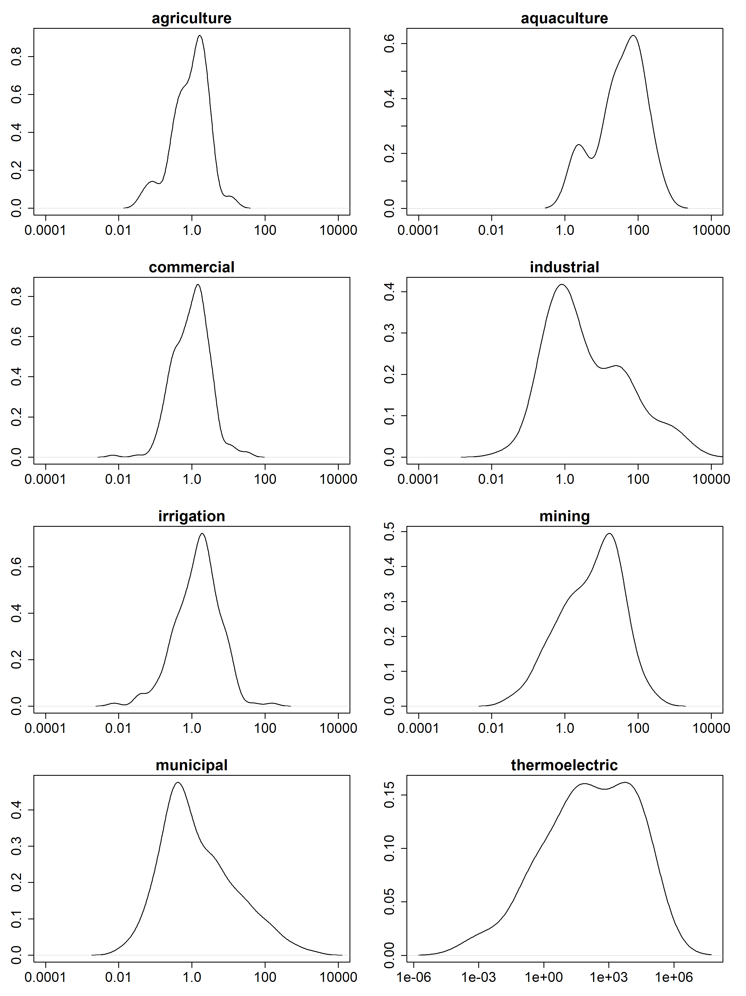
Figure S1: Kernel density plots of facility withdrawal volume in each water use sector
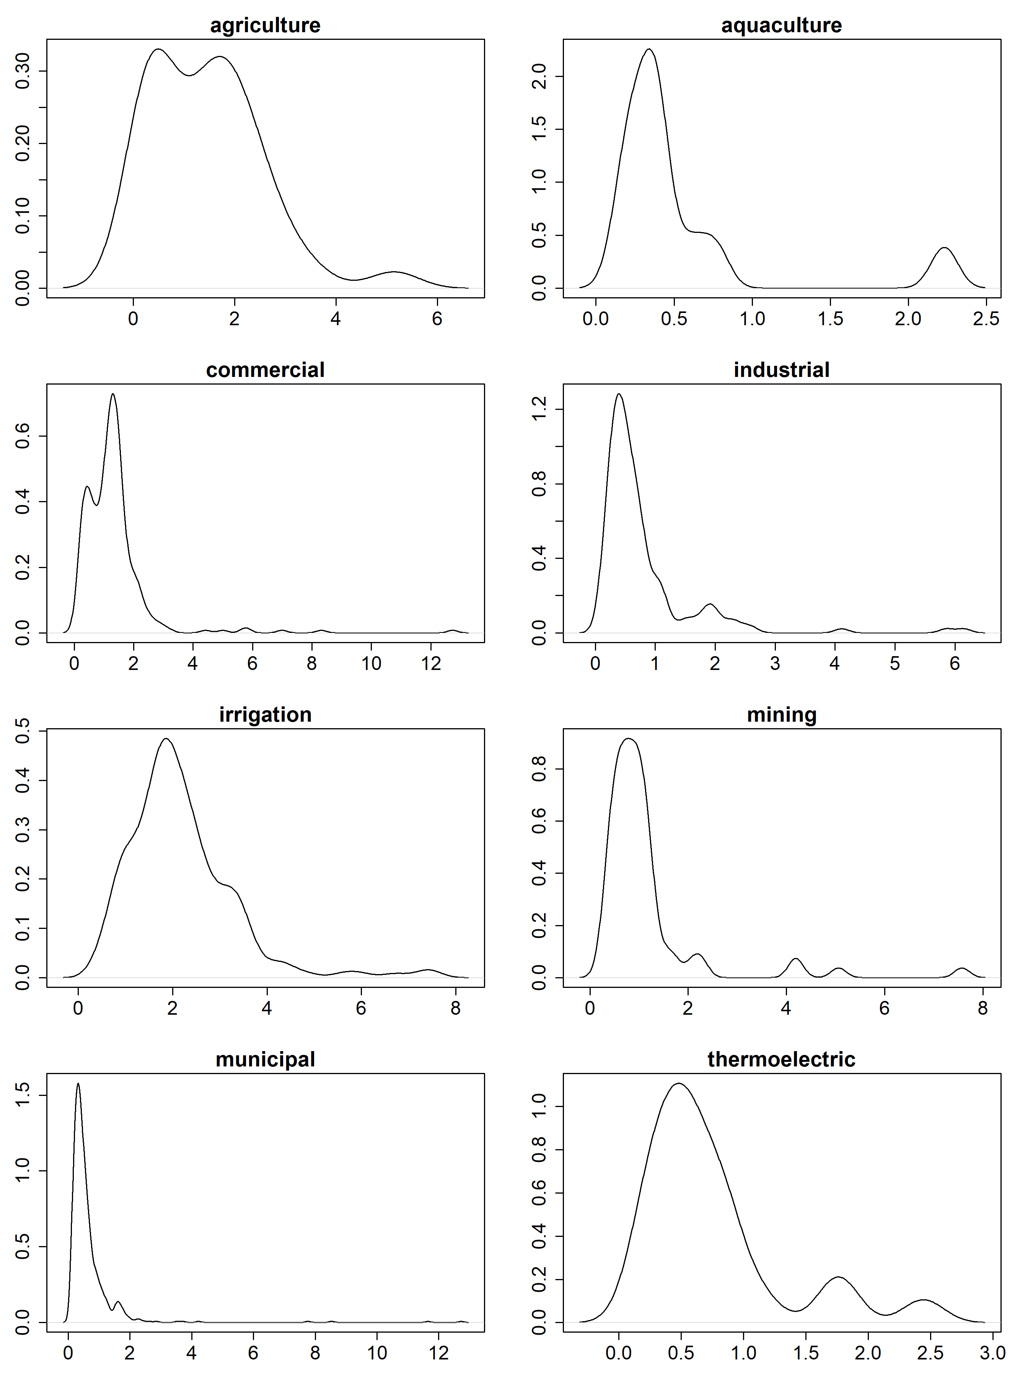
Figure S2: Kernel density plots of facility coefficient of variation
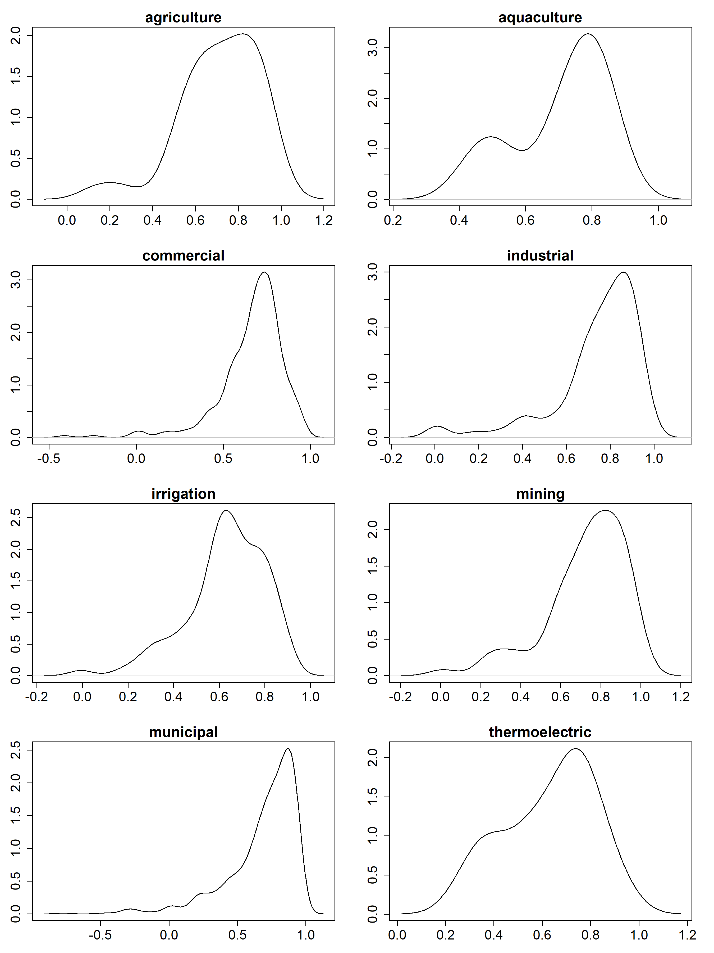
Figure S3: Kernel density plots of facility autocorrelation

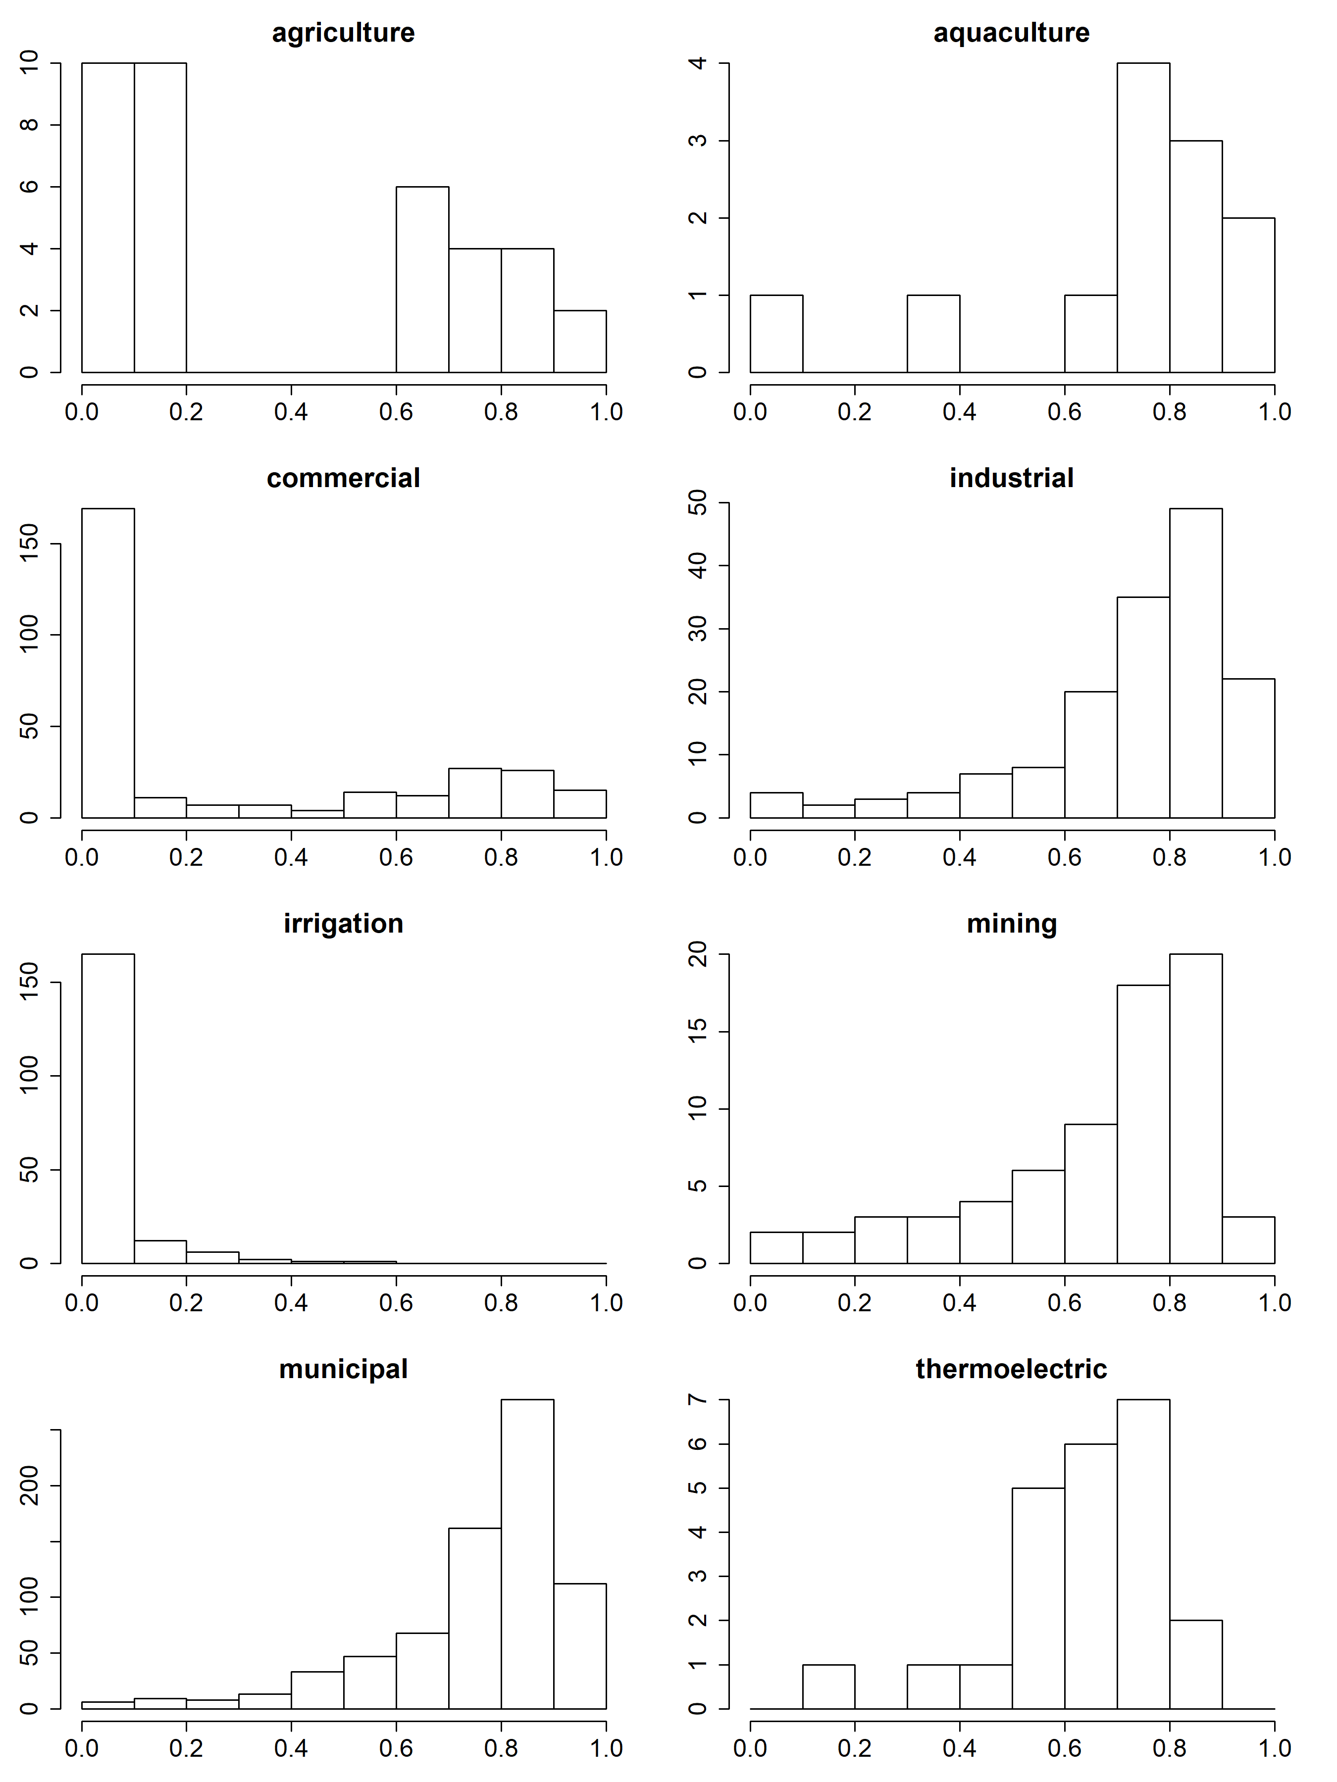Figure S4: Histograms of facility seasonality values

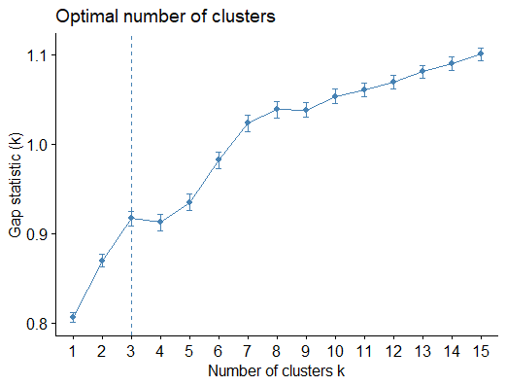
Figure S5: Plot of cluster gap statistic when grouping facilities into different numbers of clusters (k)

 | h_1 | h_2 | h_3
agriculture | 66.2% | 14.7% | 19.1%
aquaculture | 14.3% | 64.3% | 21.4%
commercial | 68.7% | 12.6% | 18.7%
industrial | 5.8% | 50.9% | 43.4%
irrigation | 96.5% | 0.0% | 3.5%
mining | 14.5% | 44.7% | 40.8%
municipal | 4.0% | 48.1% | 47.9%
thermoelectric | 4.2% | 70.8% | 25.0%

Table S2: Correspondence between facility sector and large cluster (k=3) assignment. Percentages indicate the percent of facilities in each sector assigned to a given cluster.

 | h_1 | h_2 | h_3 | h_4 | h_5 | h_6 | h_7 | h_8
agriculture | 39.7% | 14.7% | 16.2% | 2.9% | 10.3% | 11.8% | 4.4% | 0.0%
aquaculture | 7.1% | 0.0% | 7.1% | 0.0% | 0.0% | 7.1% | 14.3% | 64.3%
commercial | 35.6% | 11.9% | 29.3% | 2.3% | 3.8% | 9.1% | 7.3% | 0.8%
industrial | 3.5% | 20.8% | 0.6% | 3.5% | 1.7% | 30.6% | 9.2% | 30.1%
irrigation | 47.0% | 0.0% | 22.3% | 0.6% | 27.2% | 2.9% | 0.0% | 0.0%
mining | 9.2% | 9.2% | 0.0% | 2.6% | 5.3% | 25.0% | 13.2% | 35.5%
municipal | 2.0% | 26.8% | 1.0% | 3.7% | 1.0% | 31.5% | 12.7% | 21.3%
thermoelectric | 0.0% | 0.0% | 0.0% | 4.2% | 4.2% | 4.2% | 16.7% | 70.8%

Table S3: Correspondence between facility sector and small cluster (k=8) assignment. Percentages indicate the percent of facilities in each sector assigned to a given cluster.

S3. References Cited
Attaallah, N. A. M. (2018). Demand Dissagregation for Non-residential Water Users in the City of Logan, Utah, USA (M.S. thesis, Civil and Environmental Engineering). Utah State University, Logan, Utah.
Brown, T. C., Foti, R., & Ramirez, J. A. (2013). Projected freshwater withdrawals in the United States under a changing climate. Water Resources Research, 49(3), 1259–1276. https://doi.org/10.1002/wrcr.20076
Daly, C., Halbleib, M., Smith, J. I., Gibson, W. P., Doggett, M. K., Taylor, G. H., et al. (2008). Physiographically sensitive mapping of climatological temperature and precipitation across the conterminous United States. International Journal of Climatology, 28(15), 2031–2064. https://doi.org/10.1002/joc.1688
Everitt, B. S., Leese, M., Stahl, D., & Landau, Sabine. (2011). Cluster Analysis. London, United Kingdom: John Wiley & Sons.
House-Peters, L. A., & Chang, H. (2011). Urban water demand modeling: Review of concepts, methods, and organizing principles. Water Resources Research, 47(5). https://doi.org/10.1029/2010WR009624
Kassambara, A., & Mundt, F. (2020). Factoextra: Extract and Visualize the Results of Multivariate Data Analyses. R Package Version 1.0.7. Retrieved from https://CRAN.R-project.org/package=factoextra
Lee, S.-J., Chang, H., & Gober, P. (2015). Space and time dynamics of urban water demand in Portland, Oregon and Phoenix, Arizona. Stochastic Environmental Research and Risk Assessment, 29(4), 1135–1147. https://doi.org/10.1007/s00477-014-1015-z
Marston, M. L., & Ellis, A. W. (2019). Change in the uniformity of the temporal distribution of precipitation across the MidAtlantic region of the United States, 1950-2017. Climate Research, 78(1), 69–81. https://doi.org/10.3354/cr01561
McCarthy, M., Brogan, C., Shortridge, J., Burgholzer, R., Kleiner, J., & Scott, D. (2022). Estimating Facility-Level Monthly Water Consumption of Commercial, Industrial, Municipal, and Thermoelectric Users in Virginia. JAWRA Journal of the American Water Resources Association, n/a(n/a). https://doi.org/10.1111/1752-1688.13037
Rajah, K., O’Leary, T., Turner, A., Petrakis, G., Leonard, M., & Westra, S. (2014). Changes to the temporal distribution of daily precipitation: Changing precipitation temporal patterns. Geophysical Research Letters, 41(24), 8887–8894. https://doi.org/10.1002/2014GL062156
Sankarasubramanian, A., Sabo, J. L., Larson, K. L., Seo, S. B., Sinha, T., Bhowmik, R., et al. (2017). Synthesis of public water supply use in the United States: Spatio-temporal patterns and socio-economic controls. Earth’s Future, 5(7), 771–788. https://doi.org/10.1002/2016EF000511
Shortridge, J., & DiCarlo, M. F. (2020). Characterizing Trends, Variability, and Statistical Drivers of Multisectoral Water Withdrawals for Statewide Planning. Journal of Water Resources Planning and Management, 146(3), 04020002. https://doi.org/10.1061/(ASCE)WR.1943-5452.0001175
Shortridge, J. E., Guikema, S. D., & Zaitchik, B. F. (2016). Machine learning methods for empirical streamflow simulation: a comparison of model accuracy, interpretability, and uncertainty in seasonal watersheds. Hydrol. Earth Syst. Sci., 20(7), 2611–2628. https://doi.org/10.5194/hess-20-2611-2016
Sohl, T. L., Sayler, K. L., Drummond, M. A., & Loveland, T. R. (2007). The FORE-SCE model: a practical approach for projecting land cover change using scenario-based modeling. Journal of Land Use Science, 2(2), 103–126. https://doi.org/10.1080/17474230701218202
Tibshirani, R., Walther, G., & Hastie, T. (2001). Estimating the number of clusters in a data set via the gap statistic. Journal of the Royal Statistical Society: Series B (Statistical Methodology), 63(2), 411–423. https://doi.org/10.1111/1467-9868.00293
United States Department of Agriculture. (2018). USDA National Agricultural Statistics Service Quick Stats database. Retrieved May 18, 2018, from https://quickstats.nass.usda.gov/
US Bureau of Economic Analysis. (2022). BEA Data. Retrieved June 24, 2022, from https://www.bea.gov/data
US Census Bureau. (2022). United States Census Data. Retrieved June 24, 2022, from https://data.census.gov/cedsci/
US Energy Information Administration. (2022). Data Tools, Apps, and Maps - U.S. Energy Information Administration. Retrieved June 24, 2022, from https://www.eia.gov/tools/index.php
Worland, S. C., Steinschneider, S., & Hornberger, G. M. (2018). Drivers of Variability in Public‐Supply Water Use Across the Contiguous United States. Water Resources Research, 54(3), 1868–1889. https://doi.org/10.1002/2017WR021268

