Supporting information

An Energy-Dense and High-Power Li-Cl₂ Battery by Reversible Interhalogen Bonds

Pei Li¹, Xinliang Li¹, Ying Guo¹, Ao Chen¹，Rong Zhang¹, Yue Hou¹, Zhaodong Huang^{1,2}, Yanbo Wang¹, Ze Chen¹, Jiaxiong Zhu¹, Minshen Zhu^{*3,4}, Chunyi Zhi *^{1,2,5,6,7}

- Department of Materials Science and Engineering, City University of Hong Kong, 83 Tat Chee Avenue, Kowloon, Hong Kong, 999077 P. R. China
E-mail: cy.zhi@cityu.edu.hk

- Hong Kong Center for Cerebro-Cardiovascular Health Engineering (COCHE), Shatin, NT, HKSAR, China

- Material Systems for Nanoelectronics, TU Chemnitz, 09107, Chemnitz, Germany

- Center for Materials, Architectures, and Integration of Nanomembranes (MAIN), TU Chemnitz, 09126 Chemnitz, Germany
Email: minshen.zhu@main.tu-chemnitz.de

- Center for Advanced Nuclear Safety and Sustainable Development, City University of Hong Kong, Kowloon, Hong Kong, 999077 P. R. China

- Hong Kong Institute for Advanced Study, City University of Hong Kong, Kowloon, Hong Kong, 999077, China

- Hong Kong Institute for Clean Energy, City University of Hong Kong, Kowloon 999077, Hong Kong

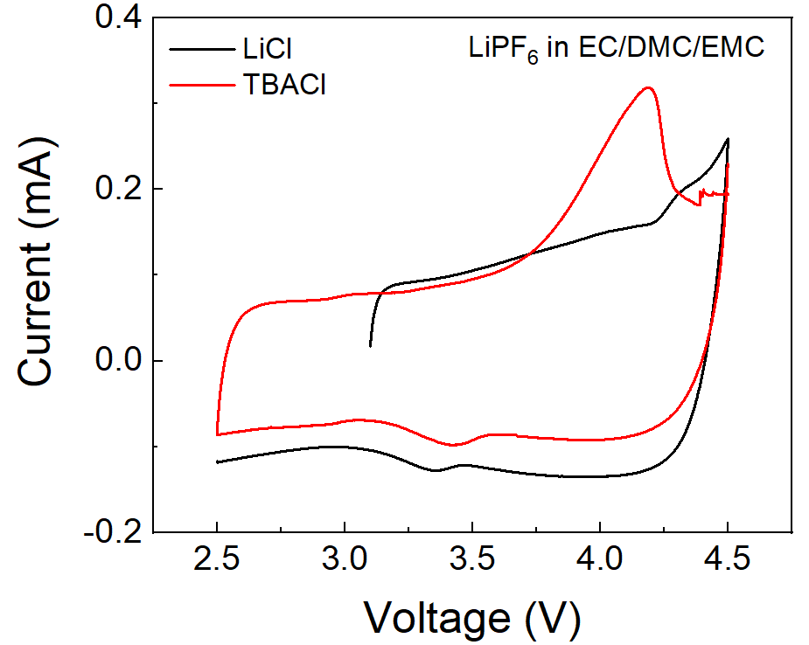
Figure S1. The failure of Cl-/Cl⁰ redox reaction on electrode using lithium chloride (LiCl) or tetrabutylammonium chloride (TBACl) as cathodes using 1M LiPF₆ in EC/DMC/EMC. Due to low solubility of cathodes in ester electrolyte, no obvious redox peaks can be investigated.

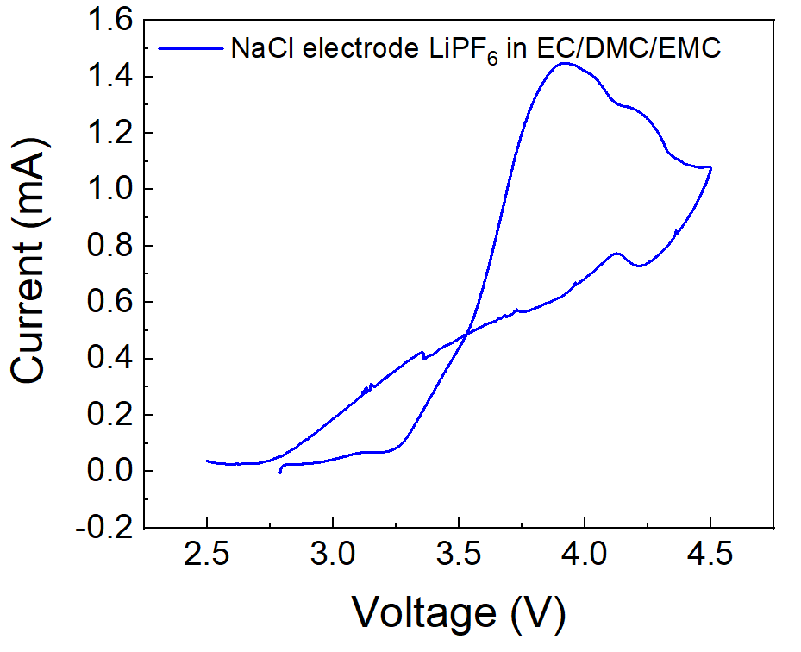
Figure S2. The failure of Cl-/Cl⁰ redox reaction on electrode using NaCl as cathodes using 1M LiPF₆ in EC/DMC/EMC.

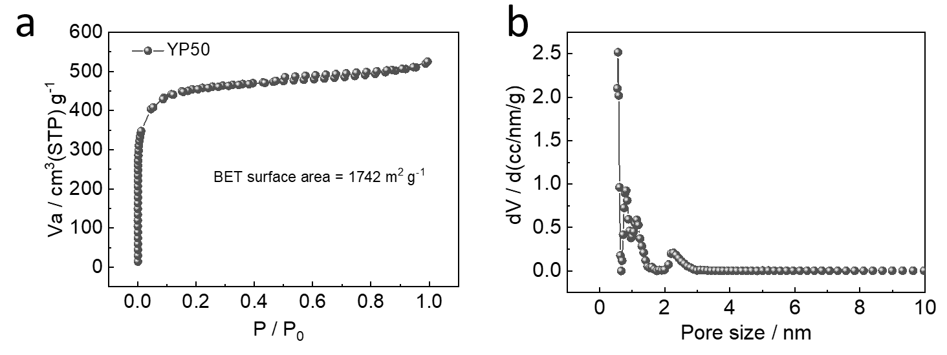
Figure S3. Pore analysis of YP50. (a) N₂ adsorption–desorption isotherm. (b) Pore size distributions analyzed by DFT method.

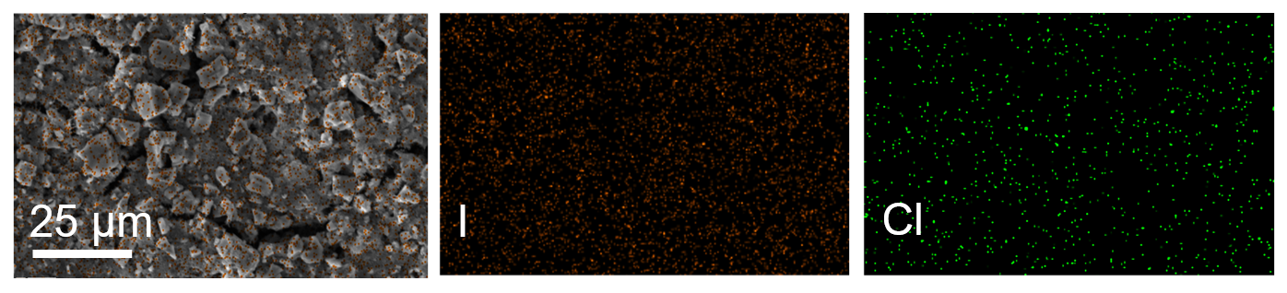
Figure S4. Electrode morphologies and elemental mappings of ICl₃ @ YP50.

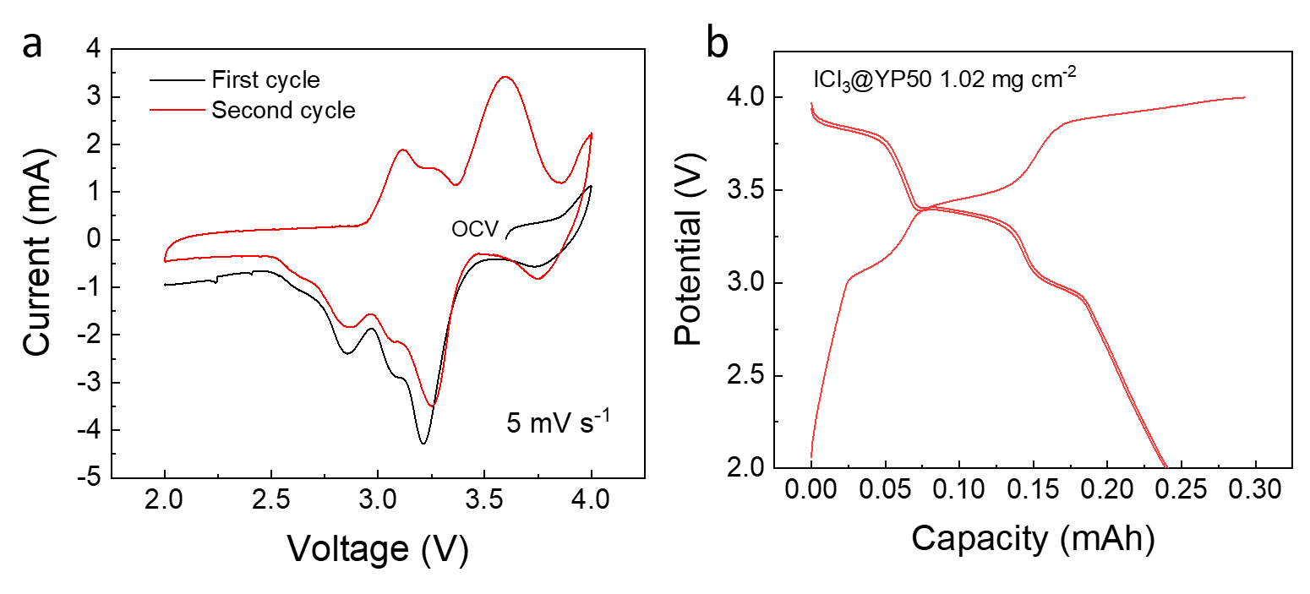
Figure S5. Initial electrochemical curves of ICl₃. (a) Initial CV curves at the scan rate of 5 mV s⁻¹. (b) Galvanostatic charge/discharge at 0.3 mA from the first cycles.

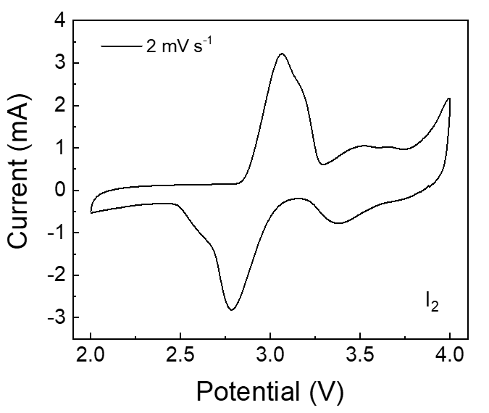
Figure S6. Cyclic voltammetry profiles of the Li-I₂ cell using 1M LiTFSI in DOL/DME.

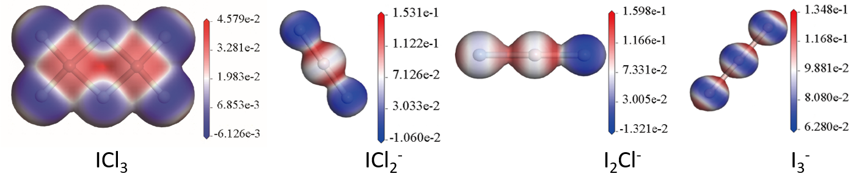
Figure S7. Predicted structures and electrostatic potential analysis of intermediate products.

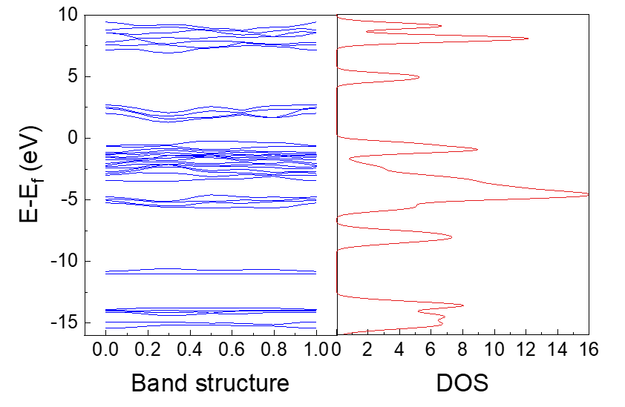
Figure S8. Band structure of ICl₃. The band gap is 1.501 eV, and the zero state at the Fermi level offers in the DOS plot, indicating its nearly insulator behavior.

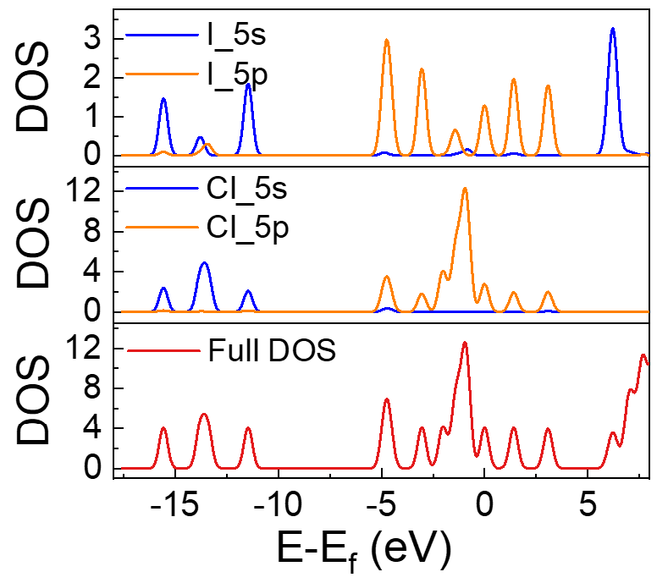
Figure S9. Density of the states (DOS) and partial DOS (PDOS) for I 5s, I 5p Cl 5s and Cl 5p orbitals. The obvious orbit overlapping of I 3s, 3p and Cl 2s, 2p is observed at various electron states, confirming the interhalogens between I and Cl.

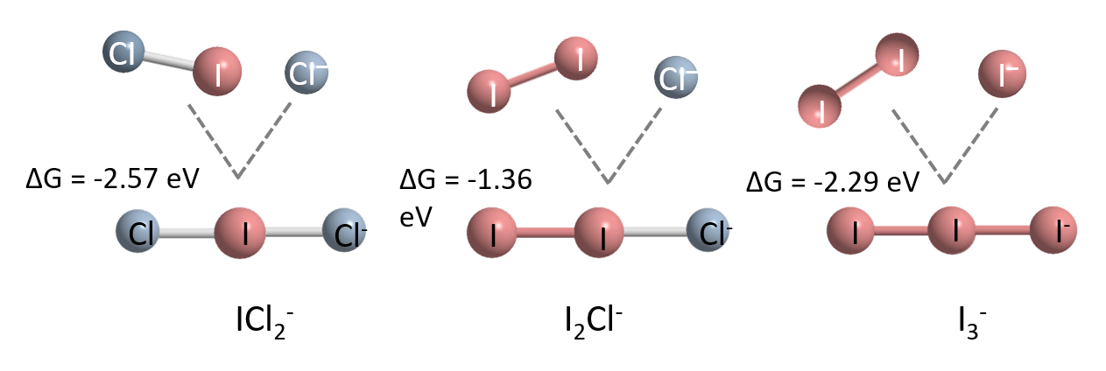
Figure S10. Gibbs energy analysis of intermediate products.

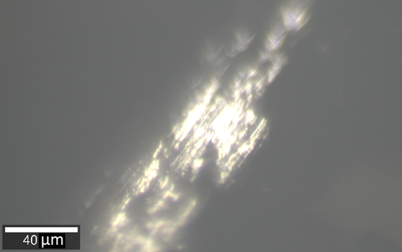
Figure S11. Electrode picture taken during in situ Raman test.

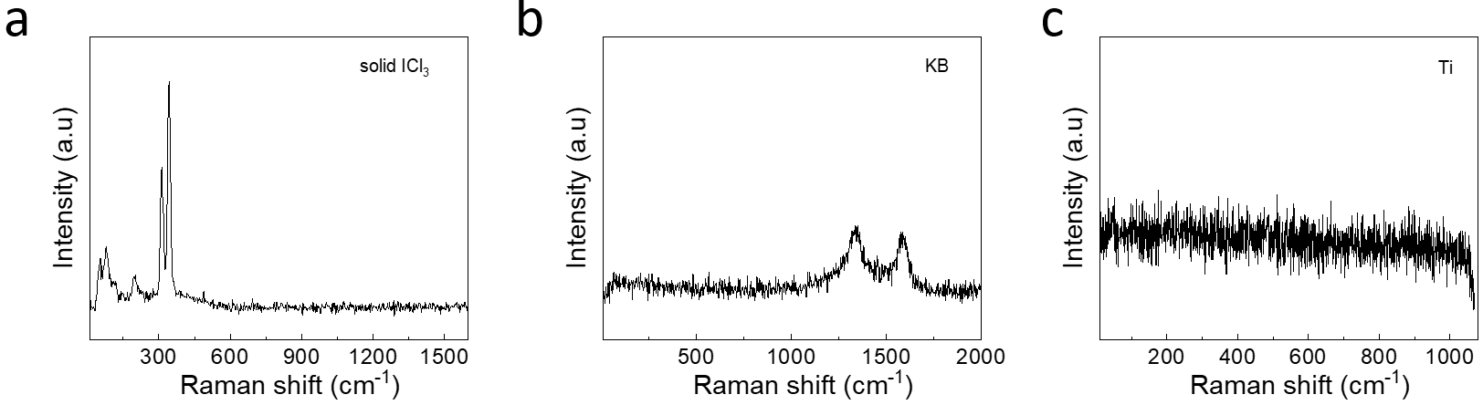
Figure S12. Raman spectra of different solids. (a) Solid ICl₃. (b) Activated carbon. (c) Ti current collector.
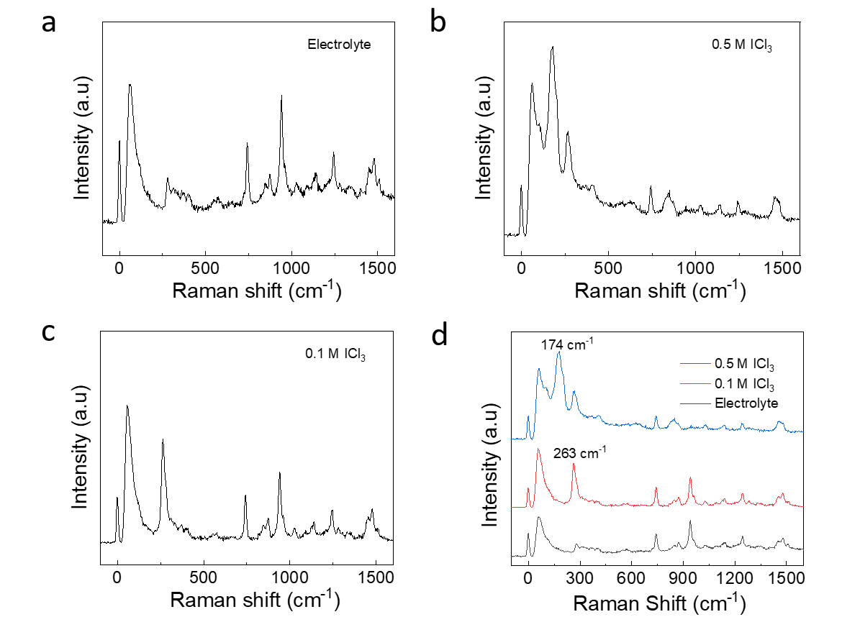
Figure S13. Raman spectra of different solution. (a) Electrolyte of 1M LiTFSI in DOL/DME. (b) 0.5M ICl₃ in electrolyte. (c) 0.1M ICl₃ in electrolyte. (d) Comparison of Raman spectra.

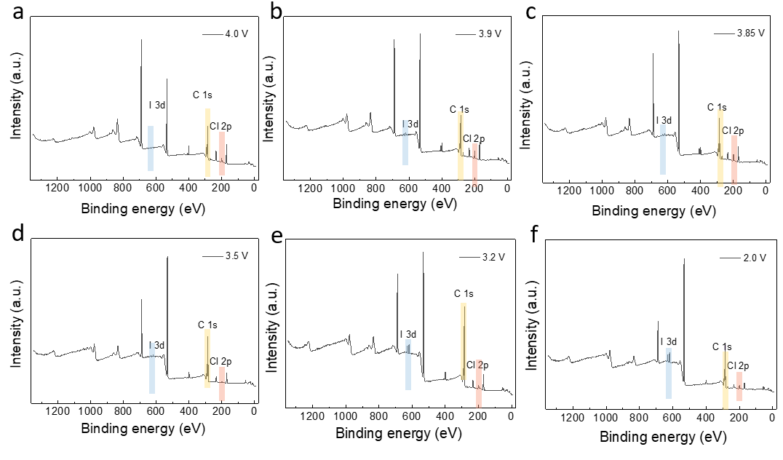
Figure S14. Survey XPS spectra of ICl₃ at various discharging states. (a) 4.0 V. (b) 3.9 V. (c) 3.85 V. (d) 3.5 V. (e) 3.2 V. (f) 2.0 V.

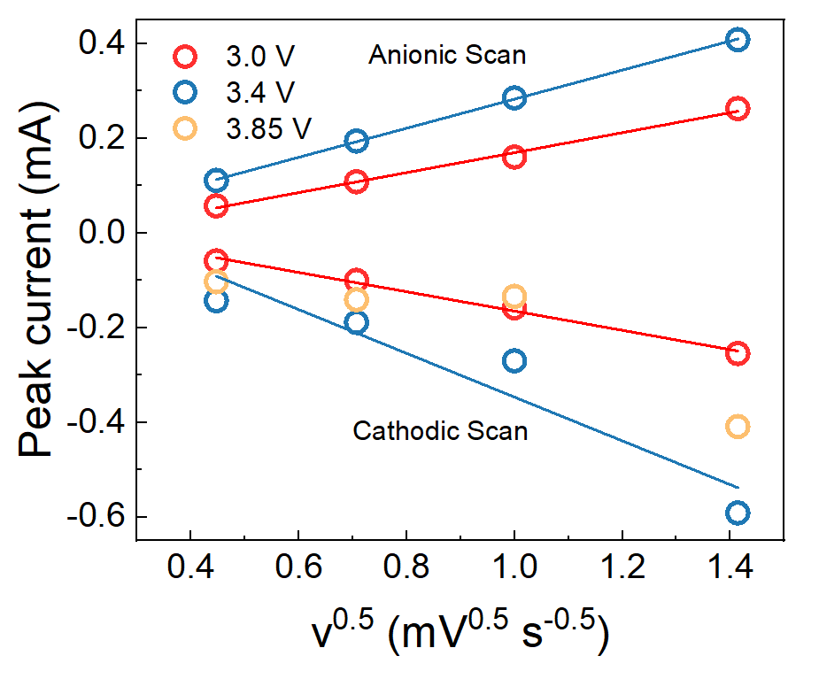
Figure S15. Linear fits of reduction and oxidation peak currents with the square root of sweeping rate.

Table S1. Reported cathodes of lithium-ion batteries.
Type | Cathode materials | Plateaus(V). Li⁺/ Li | Capacity  (mAh g⁻¹) | Ref.
Intercalation-type | LiCoO₂ | 3.7 | 140 | 1
Intercalation-type | LiMn₂O₄ | 3.8 | 148 | 1
Intercalation-type | LiFePO₄ | 3.4 | 170 | 1
Intercalation-type | LiNi_{0.6}Co_{0.2}Mn_{0.2}O₂  (NCM622) | 3.5 | 190 | 1
Intercalation-type | LiNixCoyAlzO₂  (NCA88) | 3.5 | 219.8 | 1
Intercalation-type | Li[LizTM1–z]O₂  （Li2MnO₃） | 3.8 | 250 | 1
Conversion- type | I₂ | 3.0 | 197 | 2
Conversion- type | Br₂ | 3.3 | 89(309 in theory) | 3

Reference
[1]. Liu, Junxiang, et al. "Recent breakthroughs and perspectives of high-energy layered oxide cathode materials for lithium ion batteries." Materials Today 43 (2021): 132-165.
[2]. Su, Zhong, et al. "Robust pseudo-capacitive Li-I2 battery enabled by catalytic, adsorptive N-doped graphene interlayer." Energy Storage Materials 14 (2018): 129-135.
[3]. Xi, Xiaoli, et al. "Non-aqueous lithium bromine battery of high energy density with carbon coated membrane." Journal of energy chemistry 26.4 (2017): 639-646.

